Rehabilitation of HYdropower plants Cañaveral and Rio Lindo – honduras
(HO-L1102)
Annex G –ESMR

This document contains confidential information relating to one or more of the ten exceptions of the Access to Information Policy and, therefore, shall not be disclosed to external Bank audiences. It is available only to a restricted group of individuals within the Bank.

INTER-AMERICAN DEVELOPMENT BANK

HONDURAS

Rehabilitation of HYdropower plants Cañaveral and Rio Lindo – honduras
(HO-L1102)

FINAL ENVIRONMENTAL AND SOCIAL MANAGEMENT REPORT (ESMR)

December 29, 2014

Rehabilitation of HYdropower plants Cañaveral and Rio Lindo – honduras (HO-L1102)

ENVIRONMENTAL AND SOCIAL MANAGEMENT REPORT

I. PROJECT DESCRIPTION

    - Key Project Infrastructure and Components

  - The Project consists of the rehabilitation of two hydro power plants, Canaveral (29 MW) and Rio Lindo (80 MW) located in the Department of Cortes, about 130km North Eats of Tegucigalpa (cf. Fig. 1). These two hydro power plants were built in the 70-80s and are operated under the authority of ENEE. Major maintenance was performed in 1993. After 20 years without any major maintenance, numerous parts of the turbine-generator group are showing signs of deterioration and both plants are experiencing breakdowns more frequently. The operation aims to improve efficiency, increase capacity by 20.8 MW (combined), decrease maintenance cost and increase life duration for at least 30 years.
  - The turbines power at Cañaveral plant (existing 14,700 kW) will be increased to 16,100 kW with a 2% increase of turbine efficiency and increased discharge water. The Cañaveral plant will have at the end of the work a capacity of 32 MW (2 turbines of 16 MW). The turbines power at Rio Lindo plant (existing 24,420 kW) will be increased to 26,370 kW. Rio Lindo plant will have a new capacity of 95.6 MW (4 turbines of 24.4 MW). Minor works would be done at the existing substation and auxiliary equipment. No new access roads are required. The existing physical footprint of the two hydro plants remains the same.

Environmental and Social Setting

  - Both hydro power plants are located about 130 km north east of Tegucigalpa in Santa Cruz de Yojoa municipality in the Department of Cortes. Cañaveral plant is located in Pena Blanca municipality with a total population of 10,800 inhabitants. Rio Lindo is located in Rio Lindo municipality with a population of 17.281 inhabitants. There are residential areas at a distance of about 400 m from Cañaveral plant and about 200 m from Rio Lindo plant. The main economic activities of the communities around the project involves chicken farms (for eggs production), fish farms for the exportation of tilapia, pasture lands and, agriculture of crops such as corn and beans. There is also around lake Yojoa commercial activities related to tourism and various services stores (pharmacies, restaurants, small hotels etc.). According to a field survey and research done by Institute of Archeology of Honduras (INAH), there are no sites of archeological interest in the project area.
  - Based on information provided, the area directly around the hydro plants is covered with broad-leaved forest. Then shrub land and mixed-forest (pine, white cedar) composethe landscape mix with agricultural system, animal husbandry and farmland. The two hydro plants have a natural reservoir in Lake Yojoa which lies at 637 masl. These hydro plants are operated in cascade: water is led first to Cañaveral plant which lies at 490masl then taken to Rio Lindo plant which lies at 80masl, and then water is discharged in Lindo River (cf. Fig. 3). South of the Cañaveral project, there are two national parks: Santa Barbara and Cerro Azul Meambar (cf. Fig. 2). The sub-basin of Lake Yojoa is also listed as a Ramsar site. Santa Barbara northern boundary lies at about 7km south of the Cañaveral, the Ramsar site boundary is at about 5km south while the Cerro Azul northern boundary is at about 18km south.
  - The lake Yojoa is a popular fishing destination (leisure fishing for tourism) and an important source of drinking water and irrigation. The area has a rich biodiversity, almost 400 species of birds and 800 plants species have been identified in the region. Given that no Environemntal Impact Assessment (EIA) was done due to project’s categorization assigned by local environment authority, there is no detailed baseline available on the fauna and flora. Water quality has deteriorated in Lake Yojoa in recent years due to mining activities, illegal fish farming of tilapia, wastewater from restaurants and hotels on the shores of the lake built to accommodate tourists. The regulatory authority has put in place a water purification program and the collection of food oils from the restaurants, which has started recently.
  - The Lake Yojoa has two natural rivers flowing into it, the Pescadero River and Blanco River, there is no natural river flowing out of the Lake. Maximum capacity of the canal to Cañaveral and Río Lindo hydroelectric complex is 23.0 m³/s. Annual average discharge for generation of the last five years is from 14.7 m³/s to 18.2 m³/s in Cañaveral and from 18.0 m³/s to 22.4 m³/s in Río Lindo. Yure dam and Varsovia dam divert (cf. Fig. 3) water to the lake from Yure River and Varsovia River for the compensation of water usage for the hydro plants. ENEE is the monitoring agency for Lake Yojoa water’s balance, the water level is maintained from 631.5m to 637.5m for preserving environmental condition in the lake. According to information presented, as an environmental protection measure the water gate of Lindo River is opened in the dry season in order to maintain a minimum flow determined at 10% of annual average water flow. The annual average flow of Lindo River is 22m³/s, the minimum flow is 12 m³/s and the maximum is 36 m³/s. Downstream of the Rio Lindo plant, there is a tilapia fish farm.

II. COMPLIANCE STATUS AND PROJECT STANDARDS

- Summary
2.1 The Secretaria de Recursos Naturales y Ambiente (SERNA) granted the environmental license for the refurbishment of the two plants in October 2012. SERNA is the regulatory body in Honduras responsible for environmental categorization of projects. A Category 2 - moderate environmental impact – was given by SERNA for this operation. Category 2 projects requires SERNA to conduct a site inspection (environmental audit) prior to issuing the license. Such audit was realized in 2012. SERNA produced an audit report containing several recommendations in order to properly manage potential impacts. For category 2 project in Honduras, no Environmental Impact Assessment is required. Though, ENEE had produced an environmental diagnostic report which presents an environmental and socio-economic characterization of the Project. The report also highlights potential impacts of the Project and presents the environmental, health and safety plans to manage such impacts. The National Institute of Archeology of Honduras (INAH) after investigation determined that there are no archeological sites or artefacts that would be affected by the Project. INAH issued the license in 2012.
EIA and Public Consultation

  - Given that the refurbishment works would not affect any local community, ENEE had not conducted any specific consultation activities regarding the refurbishment works. Per the national regulation, no consultation activities are required for category 2 projects. However, during the due diligence visit it was confirmed that ENEE had various informal interactions with local stakeholders about the refurbishment works namely with HONDULAGO, the governmental organization in charge of legal issues related to Lake Yojoa) and, with AMPRULAGO, the local governmental organization which is in charge of the management of the Lake.
- Compliance with IDB Policies

  - Based on Directive B.3 of the IDB’s Environment and Safeguard Compliance Policy (OP-703), this initiative was classified as Category B by the Project Team due to its potential to generate low to moderate environmental and social impacts and risks for which effective mitigation measures are readily available.
  - The Project triggers the following directives of IDB’s OP-703 Environmental and Safeguards Policy: B1. Bank Policies; B.2, Country Laws and Regulations; B.3, Screening and Classification; B.5, Environmental Assessment; B.6., Consultation; B.7, Supervision and Compliance; and B.9 Natural habitat; B.11 Pollution Prevention and Abatement; and B.12 Project under Construction. The OP-102, Access to Information Policy also applies for this Project. Given that Honduras is prone to natural disasters such as floods, hurricanes, and earthquakes, the Disaster Risk Management Policy also applies. It is important to note that the Involuntary Resettlement Policy (OP-710) and Indigenous Peoples Policy (OP-765) are not triggered for this project since there is no economic and/or physical resettlement of families or affectation to indigenous communities. Based on the available information reviewed to date, it has been determined that the Project is in compliance with all applicable IDB policies and directives.
- Requirements and standards

  - The Project includes provisions for IDB monitoring of compliance with all policy requirements and standards (see Section V). The Project does not convert or degrade critical or natural habitats, affect protected areas or damage cultural sites as per Directive B.9.

III. KEY ENVIRONMENTAL AND SOCIAL IMPACTS AND RISKS:

- Summary

  - As part of the due diligence process, the IDB has analyzed the environmental and social aspects of the Project including a site visit to the Project area. The IDB has confirmed that there are no significant outstanding environmental and social issues related to this Project.
- Environmental impacts and risks

  - As mentioned previously, ENEE plans to increase power output of both plants by 20.8 MW. This will be achieved by efficiency upgrade and increased discharge water by 1.26 m³/s at Cañaveral and by 1.4 m³/s at Rio Lindo. The Lindo River at the discharge channel has enough capacity to safely flow increased amount of water, environmental impact is therefore limited. ENEE intends to increase peak hour generation (2 hours in the morning and 2 hours late afternoon) by taking more water to Cañaveral and Rio Lindo and will reduce the off-peak hour generation in order to maintain the overall water balance of Lake Yojoa. According to information provided, proceeding that way will have very limited impact on the water level. ENEE is the official monitoring agency of Lake Yojoa, and in no instance water level will go below 631.5 m. the minimum level that had been determined to maintain environmental conditions of the Lake. The maximum discharge amount from Rio Lindo plant will be increased from 27 m³/s to 29.2 m³/s. It was confirmed during due diligence that the Lindo River at the confluence of Rio Lindo discharge channel has enough capacity to safely let flow the increased amount of water. Given the operation procedure of ENEE, the start-up operation takes 40 minutes until full operation (discharge 27 m 3/sec), this avoid any rapid water level increase. According to information presented, water usage downstream of the confluence point is rare, there is one tilapia fish farm further down, but it is deemed to be at sufficient distance for not being impacted by flow change. Most fishing activities are concentrated around Lake Yojoa.Drinking water is taken further high in the mountains and delivered to communities. It was also confirmed that the rehabilitation and increased efficiency will have no adverse impacts on the water quality downstream of the two plants and release of the minimum flow.
  - The rehabilitation does not involve any new construction or expansion of the existing perimeter of the plants, the physical footprint will remain the same. No new access roads are required. Therefore, no significant impacts are expected on the fauna and flora in the vicinity of the project.
  - PCBs had been used at both plants on the transformers. ENEE contracted an external foreign firm to verify the level of PCBs and both plants received certification that the quantity encountered is below best industry standards. During the due diligence visit, the Bank noted the seal of certification on the transformers. The due diligence also allowed confirming that asbestos was used as an insulation material in the generators of Rio Lindo. ENEE also contracted an external firm to manage and stored securely this hazardous waste. Given the appropriate management of asbestos and the low level of PCBs encountered, potential impacts of accidental releases in the environment or to workers, are discarded.
- Social impacts and risks

  - Most of the rehabilitation works will take place within the perimeter of the two plants. Given the distance of the plants from any human settlement combined to the fact that rehabilitation works does not involve the transport of heavy machinery and increased traffic, social impacts would be minimal.
- Cumulative Impacts
3.6 No significant cumulative impacts are expected to be generated. There are no hydro power plants on the river.
E. Positive impacts and additionality
3.7 The Project aims to increase the supply of renewable energy to the national grid and will contribute to displace 100,800 CO2-t per year.

MANAGEMENT AND MONITORING OF ENVIRONMENTAL, SOCIAL, HEALTH AND SAFETY AND LABOR IMPACTS AND RISKS:

- Description of management systems and plans

  - The IDB has evaluated the main impacts and risks and confirmed that all Project direct and indirect impacts and risks will be properly and adequately avoided and mitigated through the management plans prepared by ENEE. Such plans includes: hazardous waste, contingencies, health and safety, emergency and preparedness, supervision and monitoring, conservation and reforestation.
4.2 Despite being high level ones, all plans contains adequate measures tailored to the risks and impacts expected i.e. minimal. The supervision and monitoring phase will ensure that actions to manage risk and impacts are followed by ENEE.
- Monitoring and supervision

  - The IDB will monitor and supervise the Project at any time and will require contractual clauses in the Loan Agreement to be complied by the Borrower.

REQUIREMENTS TO BE INCLUDED IN THE LEGAL AGREEEMENTS:

  - Based on the environmental and social due diligence conclusions, the conditions described below are required to be fulfilled in form and substance satisfactory to IDB:

Throughout the life of the Loan

  - The IDB will require within its Loan Agreement that the Project and each Project party (Borrower/Company and other Project/Environmental parties, including construction companies and operators, and any contractors and sub-contractors) will, at all times during the life of the Loan Agreement, comply with the following environmental and social provisions:

- All applicable environmental, social, labor, health and safety, and labor regulatory requirements of Honduras. Specifically, the operation mode of both plants will ensure that water level of Lake Yojoa is maintained between 631.5m to 637.5m and this to preserve environmental conditions in the Lake.
- All requirements associated with any environmental, social, health and safety, and labor related permits, authorizations, or licenses that apply to the Project, the Borrower or any party responsible for executing the Project or its mitigation measures.
- All environmental, social, health and safety, and labor requirements of the Project contracts and any subsequent modifications.
- All aspects and components of all of the Project’s environmental, health and safety, social and labor documents.
- All relevant IDB policies such as the Environment and Safeguards Compliance Policy (OP-703) and the Disclosure of Information Policy (OP-102),
- Applicable IFC Environmental, Health and Safety (EHS) Guidelines; such as the Wind Energy Guidelines
- Notice of any and all noncompliance with any environmental, health and safety, social and labor requirement of the Loan Agreement and any significant environmental, social, labor, health and safety accident, impact, event, claim, material complaint or other known risk.
- Ensuring that all the Borrower’s contractors hired for construction and Project activities comply with the applicable environmental, labor, social and health and safety Applicable Law.
- Implementing ongoing information disclosure and consultation activities related to environmental, labor, social, and health and safety aspects of the Project, including disclosure of Environmental and Social Compliance Reports. Implementing an environmental, health and safety, social and labor management system that is consistent with ISO 14001 and/or OHSAS 18001 and providing adequate resources for its implementation.
- Submit annually an Environmental and Social Compliance Report, in form, content and frequency acceptable to IDB.

Prior to First Disbursement

  - Project is deemed to be in full compliance with IDB standards and no additional conditions are required prior to first disbursement.

Reporting, Monitoring and Supervision

  - During the life of the Loan Agreement, the Borrower must prepare and submit an Environmental and Social Compliance Report, in form, content and frequency acceptable to IDB.
  - The IDB will monitor the Project’s environmental, social health and safety, and labor aspects via direct IDB supervision (e.g., site visits, review of documentation, etc.). This supervision will be conducted by the IDB or its consultants according to the following schedule: 1) up to twice during construction period, 2) once during the first year of operation, 3) every 2-3 years afterwards. All costs of supervision will be covered by the Borrower. Specific attention will be put on the Lake Yojoa water level.
  - In addition, the Loan Agreement shall also provide for:

- Rights for additional inspection, supervision, etc. generally at the expense of the Borrower. The IDB’s right to contract for the performance of independent environmental, social, health and safety, and labor audit(s), or to conduct ad-hoc supervision, if the IDB deems necessary.
- The Borrower’s agreement to provide access to all relevant documentation, facilities and personnel and cooperate fully with any inspection or audit by the IDB or its designated consultants.
- The Borrower’s agreement to cooperate fully with the IDB’s Independent Consultation and Investigation Mechanism (ICIM) should the Project be subject to an investigation, (provided that the ICIM covers its own costs).
Figure 1. Project location
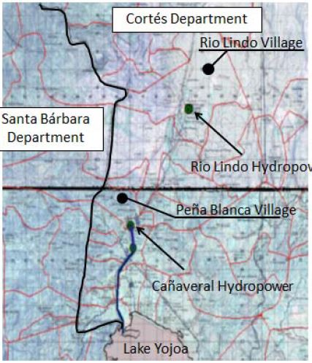

Figure 2. Protected areas around the project’s site
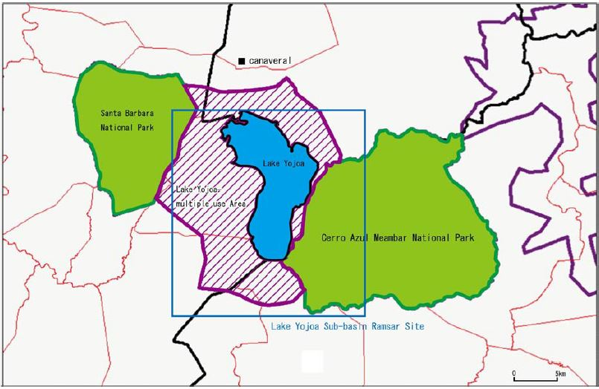
Figure 3. Watershed of Lake Yojoa
