Government of Belize

Ministry of Human Development, Social Transformation and Poverty Alleviation

Community Action for Public Safety II

Resettlement and Livelihood Restoration Plan (RLRP) (Preliminary)

This document was prepared by Christa Hulse, Environmental and Social Consultant
for the Government of Belize, Ministry of Human Development, Social Transformation and Poverty Alleviation
Belmopan, Belize. December 2019.
Table of Contents
List of Figures 4
List of Tables 4
Acronyms 5
Executive Summary 6
Introduction 6
Objectives of the Resettlement and Livelihood Restoration Plan 7
Institutional and Legal Framework 7
Institutional Framework 7
Legal Framework 8
IDP Policy on Involuntary Resettlement (OP-710) 9
Gap Analysis 9
Context of the Project 10
Conceptual project design 10
Size of development 11
Construction logistics 11
Project location 11
Description of the site 12
Evaluation of Alternatives 12
Baseline Survey and Assessment 12
Physical Displacement 13
Informal Dwellers 13
Bus Companies 13
Economic Displacement 13
Sex-Worker 13
Mitigation Options 14
Physical Displacement 14
Informal Dwellers 14
Bus Companies 15
Economic Displacement 15
Sex-worker 15
Resettlement and Livelihood Restoration Framework 15
Eligibility 15
Eligibility Policy 16
Physical Displacement 16
Economic Displacement 16
Establishment of Entitlement Cut-off Date 16
Entitlements 16
Estimation of Eligible Project Affected People 17
Institutional Arrangements 17
Cost Estimate 17
Informal Dwellers 17
Bus Companies 17
Sex-worker 17
Estimated Calendar of Activities 18
Grievance Redress Mechanism 18
Monitoring and Evaluation 19
Evaluation Report 19
References 20
Annex A: Census of Project Affected People 21
Annex B: Photographs of Project Site 22

List of Figures

Figure 1: Location of project site 12
Figure 2: Bus schedule 13
Figure 3: Site map with location of informal dwellers 14

List of Tables

Table 1: Estimation of eligible project affected people 17
Table 2: Total estimated cost of resettlement and livelihood restoration 18
Table 3: Estimated timeline for resettlement and livelihood restoration 18
Table 4: Project monitoring indicators 19

Acronyms

BCC Belize City Council
CAP Chapter
CAPS II Community Action for Public Safety II
CRD Community Rehabilitation Department
DOE Department of Environment
GOB Government of Belize
HSD Human Services Department
IDB Inter-American Development Bank
MHDSTPA Ministry of Human Development, Social Transformation and Poverty Alleviation
MNR Ministry of Natural Resources
PAP Project Affected Person/People
RLRP Resettlement and Livelihood Restoration Plan
WFS Women and Family Support

Executive Summary

This Resettlement and Livelihood Restoration Plan (RLRP), prepared for the Ministry of Human Development, Social Transformation and Poverty Alleviation (MHDSTPA) of the Government of Belize (GOB) as part of the loan requirement for Inter-American Development Bank (IDB) funded, Category B designated projects, provides a situational analysis of the livelihood activities to be adversely impacted by the construction of a wrap-around service center in the south side of Belize City. In addition, it details the measures to be put in place to resettle and restore the livelihoods of the persons affected by the project.

The construction of the service center will cause the physical displacement of three individuals who are informal dwellers of the proposed project site. Further, one individual who conducts income earning activities on the property will also be economically displaced. These four individuals have been classified as socially vulnerable as they have no material resources, lack familial support and are suffering various issues such as drug dependency and mental illnesses. Finally, three bus companies who park their buses, during the day only, on a small lot on the west side of the property will also be physically displaced.

The plan for resettlement and livelihood restoration of the vulnerable individuals is long-term, necessitating the intervention of the Women and Family Support (WFS) Department, also of the MHDSTPA. It involves initial referrals to a number of social institutions that provide shelter, meals, drug rehabilitation, mental health support and job training that will assist these individuals, in as much as possible, regain a level of independence. The WFS has also committed to follow through by working with the various social institutions as well as family members to ensure long-term sustainability.

In terms of a plan to relocate the bus park, the ministry has first to confirm with the Lands and Surveys Department that the lot is a part of the ministry’s property, as ownership is being contested by the bus company owners. Once this has been confirmed, the ministry will work with the bus companies and the Belize City Council to identify another parking space for the buses.

Introduction

The MHDSTPA is undertaking the design and construction of a 2-3 story wrap-around service center in the southside of Belize City, as part of Component 2, of the Community Action for Public Safety II (CAPS II) project. The center will house the Community Rehabilitation Department (CRD), the Human Services Department (HSD), the Accounts Department, and the offices of the Minister and Chief Executive Officer. Bringing these entities together in one place, will be critical in providing clients and their families, the wrap-around services envisioned by the ministry to strengthen their support of families and provide the necessary interventions to deter antisocial behaviors that threaten public safety. Services will include counselling, mental health treatment, educational and vocational training, masculinity and gender violence programs, parenting classes, community workshops, gang mediation and after-school programs for children.

The concept of a wrap-around services is one in which the ministry is seeking to support its clients in a holistic way, by addressing the individual’s many needs, as well as those of his/her entire family, in one facility and within a shorter timeframe. Operationally, the ministry will benefit from better data and case management, through maintaining singular records in one central repository for each client; reduced workload in some areas by streamlining processes and reducing duplication of efforts and finally; having immediate access to finances and decision makers.

Objectives of the Resettlement and Livelihood Restoration Plan

This RLRP has been developed to respond to the following objectives:

- To avoid involuntary resettlement or, when unavoidable, minimize involuntary resettlement, by
  - Designing the project to avoid physical displacement.
  - Locating interventions on uninhabited land.
- To mitigate unavoidable adverse social and economic impacts from land acquisition or restrictions on land use, by
  - Providing timely compensation for loss of assets.
  - Assisting displaced persons to improve or at least restore their livelihoods and living standards.

Institutional and Legal Framework

The following outlines the institutional and legal framework providing guidance for the Community Action for Public Safety II Project:

Institutional Framework

Belize City Council
The BCC comprises a mayor and ten councilors. The council is tasked with the general rule and good governance of the town as accorded in the provisions of the Belize City Council Act, CAP 85 (Rev. Ed. 2000) and any laws relating to it. General powers include the control, care and management of public streets, coordination of activities of utility agencies, and administration of safety regulations as it applies to fences adjoining public streets. The BCC also has authority over markets, slaughter-houses, bath-houses and wash-houses; and additionally manages building hazards, the property numbering system, parks, libraries, cemeteries, garbage collection, drain cleaning and ensures the continued maintenance and development of the town’s conveniences and amenities.

Ministry of Natural Resources (Lands and Surveys Department)
The Ministry of Natural Resources (MNR) is the governing body in charge of the coordination, protection and sustainable management of the natural resources of Belize. The Lands and Surveys department of the Ministry of Natural Resources is responsible for the management and allocation of national lands, registration of land tenure, authentication of plans for all legal surveys, sub-division of lands, valuation of lands, land use planning and land information management.

Ministry of Human Development, Social Transformation and Poverty Alleviation
The MHDSTPA is responsible for the development of the Belizean people, enabling them to realize their full potential and play meaningful roles in their communities. The Department of Human Services promotes, develops and coordinates programs that will help citizens to become self-sufficient. The Woman and Family Support Department’s goal is to promote gender equality and equity by facilitating economic development and empowerment of women, minimizing the incidence of gender violence and advocating for gender sensitive policies, plans, programs and projects.

Department of the Environment
The DOE was first established in 1989 but became a statutory body through the Environmental Protection Act, CAP 328, 1992. The DOE falls under the Ministry of Agriculture, Fisheries, Forestry, the Environment, Sustainable Development and Immigration. Its mission is to ensure the effective management of the environment leading to sustainable development of the country.

Legal Framework

Environmental Protection Act, CAP 328 (Rev. Ed. 2011)
The Environmental Protection Act, Part V, section 20(2) requires that a developer conduct an impact assessment to identify and evaluate the effects of the development on human beings. The assessment must also provide mitigating actions for potential risks and impacts. The aim is to protect and improve human health and living conditions. The final assessment is evaluated by the DOE and then forms part of the Environmental Compliance Plan, which the developer is required to follow.

Prescription Act, CAP 192 (Rev. Ed. 2011)
The Prescription Act set out various timeframes for which title to property or other rights could be legally acquired upon long-term, uninterrupted occupancy of land or use of other property such as easements.

IDP Policy on Involuntary Resettlement (OP-710)

The following are the guiding principles of the Community Action for Public Safety II Project’s, Resettlement and Livelihood Restoration Program:

- Avoid or Minimize Population Displacement – census, consultations, cadastral surveys and site visits were conducted to provide baseline conditions for mitigation.

- Ensure Community Participation – several site visits and various means of consultations were conducted to include all stakeholders.

- Regard Resettlement as an Opportunity for Sustainable Development – the project is ensuring that all displaced people will be relocated to areas where their continued development is ensured. It also is ensuring that those people who are economically displaced are being adequately compensated as outlined by IDB policy and national legislation.

- Define Criteria for Compensation

- Provide an Acceptable Level of Housing and Services

- Provide Compensation at Replacement Cost

- Compensate the Loss of Customary Rights

- Address Security Issues

- Consider Host Populations in Resettlement Plans

- Obtain Accurate Information – several survey visits were conducted and a wide cross-section of stakeholders consulted to provide for accuracy and qualitative depth.

- Include Resettlement Costs in Overall Project Costs

- Consider Appropriate Institutional Framework

- Establish Independent Monitoring and Arbitration Procedures

Gap Analysis

The following outlines a gap identified between the national regulatory and institutional framework and the guiding principles of the IDB’s Policy on Involuntary Resettlement, as it applies to the project. The area for consideration is IDB’s principle, “regard resettlement as an opportunity for sustainable development” which is consistent with the United Nation’s Sustainable Development Goals. Although Belize is one of the countries that was party to the UN’s Sustainable Development Goals that speaks to eliminating issues such as poverty, adequate housing, access to clean water, etc., none of these goals have been brought into domestic legislation, that is, none have been made explicitly actionable by Belize’s law. Therefore, from a legal perspective, the Prescription Act, CAP 192, of the Laws of Belize, would be applied to this project as it relates to the case of informal dwellers and users.

The above IDB guiding principle is based on a social justice philosophy and makes up one of the core values of the organization. As such, it is a central piece of the Policy on Involuntary Resettlement (OP-710). The policy requires that all individuals who will experience involuntary resettlement, regardless of legal right or claim to the property which they occupy, receive “fair and adequate compensation and rehabilitation.” Here, the objective of IDB’s resettlement “should be to improve the living standards, physical security, productive capacity and income levels of all the people affected or, at the very least, restore them to former levels within a reasonable period of time” (IDB, 1999, p. 1). In contrast the Prescription Act stipulate that an individual can only enjoy a profit or benefit from occupying land after having been on that land without interruption and contest for a period of at least 30 years. Individuals who reside on any land without legal title (a Minister’s Fiat Grant) or other authority, such as a Minister’s Fiat Lease, from the Ministry of Natural Resources, for a period of less than 30 years, are consider illegal squatters and are subject to removal without any compensation.

In regard to the above areas, the Community Action for Public Safety II Project will apply the IDB’s Policy guidelines as a first step in addressing the resettlement and livelihood restoration of projected affected people.

Context of the Project

Conceptual project design

The design of the wrap-around service center is still in its conceptual stage. However, the emphasis for the building’s architectural design and space layout will be on its human, spatial, material and training elements, as it is intended to facilitate a seamless flow of diverse people, and complement and align with the proposed services and activities being offered at the center, including:

- Counseling
- Mental health treatment
- Educational and vocational training
- Masculinity and gender violence programs
- Parenting classes
- Other community workshops
- Gang mediation
- After-school programs for children
- Data and case management system operations
- Open spaces for community events.

Additionally, the design of the building will take into consideration and mitigate for risks of natural disasters, including flood, hurricane and earthquakes.

Size of development

The land is approximately 3,000m² and each floor of the building is expected to be about 2,000m² (Cortez, 2019). Occupancy rate in the operational phase will comprise 45 staff members from the Department of Human Services, 30 staff members from the Community Rehabilitation Department and several staff members from the accounts department and administration. An additional 40 – 100 clients are expected to visit the center each day (Cortez, 2019).

Construction logistics

Phase 1: Demolition of derelict bus terminal and foundation and slabs from a previous construction and, clearing and site preparation for new construction.
Phase 2: Construction of new building.
Phase 3: Clean-up of construction debris and, planting and development of landscape features.

Project location

The MHDSTPA has located the property of the city’s famous, old Batty Bus Terminal, which is nestled between Orange, Mosel, Vernon and East Collet Canal Streets, within the heart of the city, as the project site. According to the ministry, this property belongs to the Government of Belize, and is the only piece of land available to them in the city for the purposes of this project. Additionally, they assert that this location is important as it is in the heart of the vulnerable community, which the ministry serves and a stone’s throw away from support services, such as the court system and homeless shelters that work closely with the ministry. The location is therefore accessible to the community and amenable to networking with other support structures.

Figure 1: Location of project site
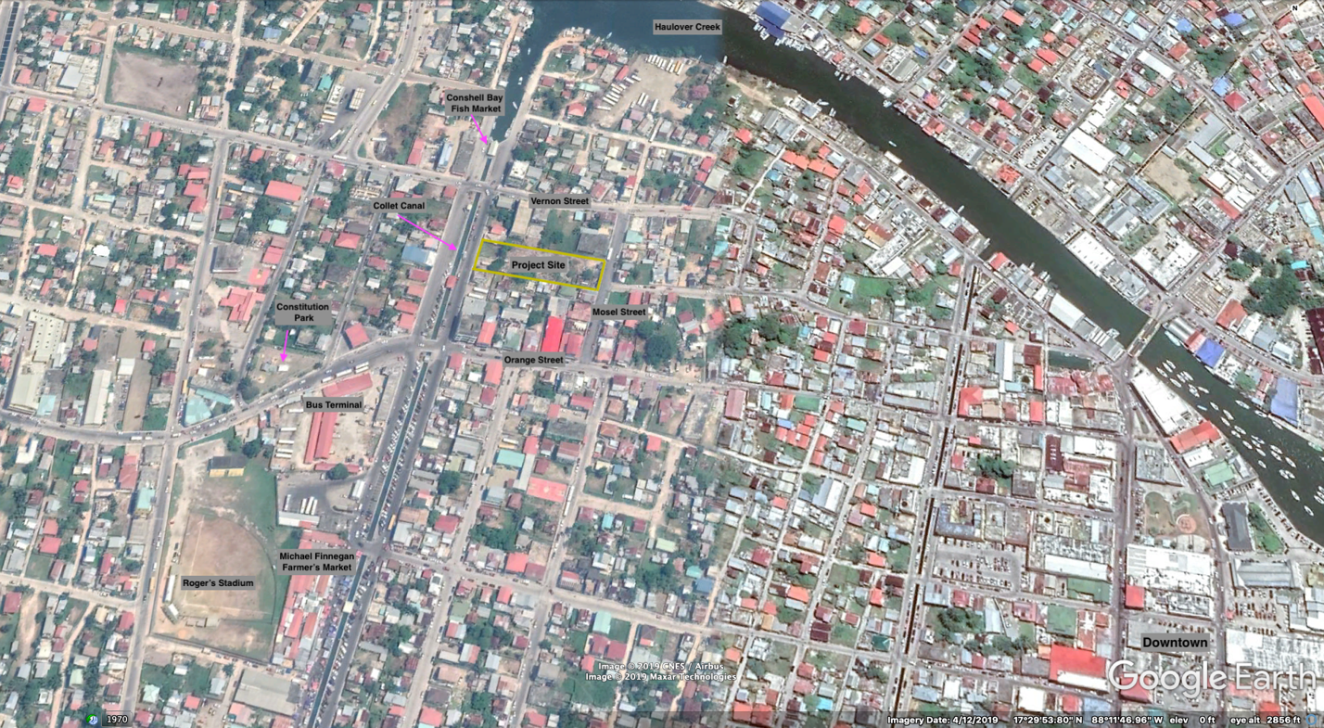
Source: Elaborated from Google Earth

Description of the site

The property has been abandoned for a number of years and as such is mostly overgrown. Tall cutting grass, brush and smaller trees grow throughout the entire lot. The east end is almost entirely enclosed with a large wall, about 16 feet tall, however there is an entrance to the property on the northeast end of the wall. This entrance is guarded by a two-storey tower-like structure that is in severe disrepair. In the far southeast corner is the derelict structure of the old bus terminal. In the middle of the property, there are a number of concrete foundations with slabs from an incomplete infrastructure project. The west end opens into a smaller lot, where three local bus companies park their buses during the day.

Evaluation of Alternatives

There is no alternative for a change in location for this project, the ministry simply does not have another location in the city that it can consider for the construction of the service center.

Baseline Survey and Assessment

The numerous site visits, site survey and census, conducted between November – December, 2019, revealed the actual and potential displacement of the following groups of people:

Physical Displacement

Informal Dwellers

There are three informal dwellers on the site. All are male from middle-aged to elderly. Resident 1 lives in a tent towards the rear of the property. He says he has been living there for a little over a year. Resident 2 lives in the lower flat of the tower and has been living there for the past seven years. Resident 1 and 2 conduct odd-end jobs such as assisting shoppers with carrying groceries, cleaning stalls, and washing vehicles at the nearby Michael Finnegan market. Resident 1 cooks his own meals at the site, while resident 2 finds left-over meals at a local primary school. Both men admit to being dependent on drugs. Resident 3 lives in the upper flat of the tower and has allegedly been living there for about 6 months. Numerous attempts were made to consult with resident 3, however these all failed as he was not at the site during those visits.

Bus Companies

Three bus companies use a small lot on the west side of the site to park four buses throughout the day. These buses travel with workers from Corozal Town, Orange Walk Town and Lemonal each day. Workers exit the buses at the nearby Pound Yard Bridge, located 140m SW of the parking lot. Bus drivers then park the buses at the project site until evening when they return to the village or town of origin.

Figure 2: Bus schedule
Bus Company | Origin | Arrival | Departure
Camal 1 | Corozal Town | 6:30 am | 7:30 pm
Camal 2 | Corozal Town | 12 noon | 5:00 pm
Joshua | Orange Walk Town | 6:30 am | 4:30 pm
Phillips | Lemonal Village | 7:00 am | 7:00 pm

The bus companies have contested the assertion made by the MHDSTPA that the lot on which they park their buses is part of the property belonging to the ministry. According to the bus owners, the lot belongs to a private individual and they have gotten permission from that person to park their buses on his lot free of charge.

Economic Displacement

Sex-Worker

There is a sex-worker, of middle age, who conducts her economic transactions at the project site, however she is an informal dweller in another area of Belize City. She indicated to social workers that she does several odd-end jobs such as cleaning at a health center but that her primary source of income is through sex trade. Each transaction that she conducts yields her about BZE$10.00/US$5.00. She also indicated to social workers that she accesses the Port Loyola Health Center for daily meals, a bath and mental health support. Social workers concluded in their discussion with her that she probably also has a mental health issue.

Figure 3: Site map with location of informal dwellers
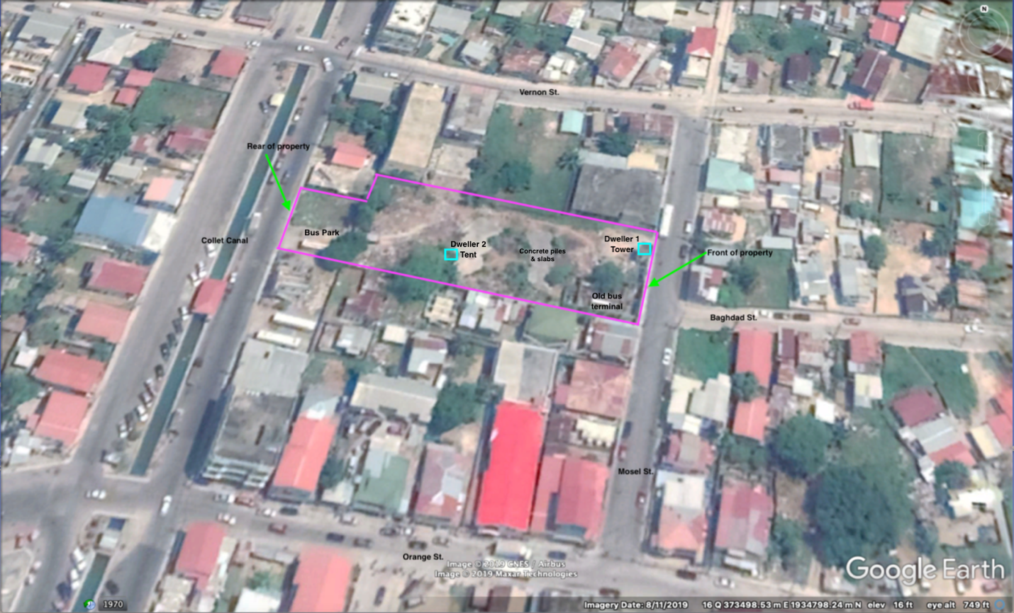
Source: Elaborated from Google Earth

Mitigation Options

Physical Displacement

Informal Dwellers

The MHDSTPA has already assigned each dweller a case worker from within its Women and Family Support (WFS) Department to manage the process of resettlement, rehabilitation and livelihood restoration through the various support structures of the ministry. As none of the informal dwellers have sufficient income to support a rented property or a private residence, their families are currently being engaged to explore the long-term possibility of having their kin reintegrated into a habitable and safe residence of a family member. In the interim, a placement at a homeless shelter within Belize City is being sought. Immediate referral of both residents, to the Good Samaritan Homeless Shelter, is being organized so that they may receive 3 meals for the day.

Both resident 1 and 2 will be engaged by their case workers to enroll in a drug rehabilitation center to address their drug addictions. Additionally, both residents will be given assistance to acquire their birth papers to be able to regain identification and access the various services they may independently require. Finally, both will receive social, non-monetary assistance to access ministry supported job readiness and placement programs to be able to expand their income base.

Resident 3 will also be provided with similar social assistance based on his requirements after successful consultation with him.

Bus Companies

The MHDSTPA is in the process of determining the extent of the property and getting the necessary Land Title transfer done. If it is established that the bus parking lot does not belong to the Government of Belize, then no resettlement and livelihood restoration will be required in the cases of the buses. However, if it is established that the lot belongs to the Government of Belize, then the MHDSTPA will work with the Belize City Council to find an alternative parking area for the buses. If an area cannot be provided by the City Council then an alternative private lot might be required, and if necessary, an arrangement to compensate bus owners for the rental of the lot for a period not to exceed six months. Additionally, all necessary arrangements will be made with the City Council for the project affected buses to temporarily park at the Pound Yard Bridge a few minutes prior to their respective departure time to facilitate the boarding of their passengers.

Economic Displacement

Sex-worker

The sex-worker has been assigned a case worker from the WFS Department in the MHDSTPA. The case worker will follow up with the Port Loyola Health Center regarding the sex-worker’s medical status, including the status of her mental health, to ensure that the necessary support is given to her to maintain any treatment regiment that might be required. Social assistance will also be provided in the form of job readiness and placement programs so that the sex-worker may find alternative employment opportunities if she so desires. Additionally, the sex-worker will be compensated for income lost due to being restricted from working on the property.

Resettlement and Livelihood Restoration Framework

The resettlement and livelihood restoration framework provides the basis for resettling and restoring the livelihoods of project affected people.

Eligibility

This section outlines the eligibility criteria and the measures that have already been undertaken or are yet to be undertaken to determine eligibility.

Eligibility Policy

Physical Displacement

Informal Dwellers – only the above identified informal dwellers (3 residents in total), will be eligible for resettlement.

Bus Companies – Upon confirmation of the ownership of the bus parking lot, only 4 buses (2 belonging to Camal Bus Company, 1 belonging to Joshua and Phillips Bus Companies each) will be eligible for resettlement and depending on the resettlement site, possible livelihood restoration.

Economic Displacement

Sex-worker – only the above identified sex-worker will be eligible to livelihood restoration.

Establishment of Entitlement Cut-off Date

Monday, December 23, 2019, the date of the last site visit to complete the census of inhabitants and users of the site, constitutes the cut-off date for entitlements to be received as a result of physical and economic displacement caused by the construction and operation of the proposed wrap-around service center.

Entitlements

Informal dwellers are entitled to temporary and if alternative familial arrangements cannot be procured, permanent placement at the government owned homeless shelter in Belize City. They are also entitled to 3 meals per day at the Good Samaritan Homeless Shelter. Informal dwellers are also entitled to drug rehabilitation, as well as job readiness and placement programs supported by the MHDSTPA.

Bus companies are entitled to an alternative bus parking lot for 4 buses only as outlined in the “eligibility policy” above. Additionally, they are entitled to mutually agreed (Bus company, MHDSTPA and IDB) compensation for rental cost of replacement parking lot, in the event that free parking cannot be found. The timeframe of the compensation package shall not exceed six months. Finally, bus companies are entitled to an arrangement with the Belize City Council for temporary parking at the Pound Yard Bridge, not to exceed 30 minutes, prior to their respective departure time to facilitate the boarding of their passengers, if so desired.

The sex-worker is entitled to financial compensation of BZ$50.00/US$25.00 per week (not to exceed six months). She is also entitled to a case worker who will follow up and support her medical and mental health through the Port Loyola Health Center. Finally, the sex-worker is entitled to job readiness and placement programs through the MHDSTPA.

Estimation of Eligible Project Affected People

The following table provides an overview of the number of project affected people.

Table 1: Estimation of eligible project affected people
Status of Project Affected People | Number of Project Affected People
Physical Displacement
Informal Dwellers | 3
Bus Companies (owners) | 3
Economic Displacement
Sex-worker | 1
Total | 7

Institutional Arrangements

The Project Steering Committee will serve as a regulatory and strategic board with oversight and policy development responsibilities. The Project Coordinator will work directly with the implementing agencies to execute the Resettlement and Livelihood Restoration Plan. The Project Coordinator will also be the interface between the Steering Committee, Implementing Agencies and affected people.

Cost Estimate

Informal Dwellers

There will be no cost incurred by the project for 1) the placement of the informal dwellers at a government owned homeless shelter, 2) the provision of 3 meals per day, 3) drug rehabilitation and 4) job readiness and placement services. These are all social structures under the ministry’s purview and provided for through the state.

Bus Companies

Cost is estimated at BZ$500.00/US$250.00 per month for the rental of a private lot for parking. Total amount for six months is BZ$3,000.00/US$1,500.00.

Sex-worker

The sex-worker makes approximately BZ$10.00/US$5.00 for each transaction she conducts. At an estimated 5 transactions per week, the total compensation to be provided for 6 months will be BZ$1,200.00/US$600.00. Medical health follow-up and social support, as well as job readiness and placement opportunities will be incurred by the state, through the MHDSTPA and therefore will not be a cost to the project.

The following table provides the total estimated cost of resettlement and livelihood restoration for the project:

Table 2: Total estimated cost of resettlement and livelihood restoration
Project Affected People | Estimated Resettlement and Livelihood Restoration Costs (BZ$/US$)
Physical Displacement
Informal Dwellers | -0-
Bus Companies (owners) | $3,000.00/$1,500.00
Economic Displacement
Sex-worker | $1,200.00/$600.00
Total | $4,200.00/$2,100.00

Estimated Calendar of Activities

IDB’s OP-710 policy requires that all livelihood restoration activities be completed before the commencement of project construction. Assessment of the project timeline for construction activities, indicate that all livelihood restoration activities will need to be completed in the 2nd quarter of 2023 (see Table 3).

Table 3: Estimated timeline for resettlement and livelihood restoration
 | 2023 |  |  |  | 2024
Activity | 1st  quarter | 2nd  quarter | 3rd  quarter | 4th quarter | 1st  quarter | 2nd  quarter | 3rd  quarter | 4th  quarter
Interventions for informal dwellers
Interventions for bus companies
Interventions for sex-worker
Demolition works & site preparation
Construction works
Clean-up & landscaping

Grievance Redress Mechanism

The Grievance Redress Mechanism for this project is outlined in the Consultation and Stakeholder Engagement Plan of this project, available as a separate document. It will also be introduced to affected persons and stakeholders during public consultations.

Monitoring and Evaluation

In order to ensure that interventions are being applied and impacts mitigated, a monitoring system will be implemented. The system will include the following:

Table 4: Project monitoring indicators
Performance Indicators | Data Source | Frequency
Spending of the budget of the RLRP | Financial Statements | Monthly
Detailed inputs against RLRP procurement | Information Management System | Monthly
Detailed outputs against RLRP deliverables | Information Management System | Monthly
Number of PAPs benefitting from intervention | Information Management System | Monthly
Number of public meetings or engagements conducted | Information Management System | Monthly
Number of stakeholder engagement events | Information Management System | Monthly
Average time for grievance processing | Grievance register (database) | Monthly
Number of open grievances | Grievance register | Monthly
Number of closed grievances | Grievance register | Monthly

Monitoring of the Resettlement and Livelihood Restoration Plan will be carried out by the Project Steering Committee. The Project Coordinator will be responsible to submit monthly reports to the Committee. The Project Coordinator will include a status report of the implementation of the RLRP as an annex to the semester execution reports to the IDB.

Evaluation Report

The Project Coordinator will conduct an ex-post evaluation at the end of the implementation of the resettlement process to report on how the resettlement and livelihood restoration was carried out, including a comparison of the living conditions of the affected population before and after the project impacts, including supporting documentary evidence (pictures, signed agreements, etc.), as well as identifying lessons learned in this project that would be helpful for similar projects in the future executed with IDB financing. The draft version of this report will be submitted to the Project Steering Committee and to the IDB for review before it is completed.

References

Cortez, C. A. H. (2019, November). Belize, BL-L1032: Community Action for Public Safety II (CAPS II): Special mission, Back to office report. Inter-American Development Bank.

Inter-American Development Bank. (2019). Involuntary resettlement. Inter-American Development Bank. Retrieved from https://www.iadb.org/en/about-us/about-us-7

Inter-American Development Bank. (1999). Involuntary resettlement in IDB projects: Principles and guidelines. Washington, D.C.: Inter-American Development Bank.

The World Bank. (2017). Environmental and social framework. The World Bank.

Annex A: Census of Project Affected People

Community Action for Public Safety II
Census (Resettlement and Livelihood Restoration Plan)
November – December, 2019

No. | Project Affected Person | Use of Project Site | Length of Occupancy | Gross Income (source & amount) per month
Physical Displacement
1 | Resident 1 | Informal dweller at site | 1 year | n/a
2 | Resident 2 | Informal dweller at site | 7 years | n/a
3 | Resident 3 | Informal dweller at site | ~ 6 months | n/a
4 | Julio Camal | Parks 2 buses at site | Unknown | n/a
5 | Albert Phillips | Parks 1 bus at site | Unknown | n/a
6 | Unknown (owner of Joshua’s Bus Company) | Parks 1 bus at site | Unknown | n/a
Economic Displacement
7 | Sex-worker | Conducts economic transaction at site | Unknown | $200.00/month

Ministry of Natural Resources - http://mnra.gov.bz/natural-resources/lands-surveys/
“Resettlement is considered involuntary when affected persons or communities do not have the right to refuse land acquisition or restrictions on land use that result in displacement” (World Bank, 2017, p. 53).
https://www.iadb.org/en/about-us/about-us-7

