DEPLOYMENT OF CLEANER FUELS AND RENEWABLE ENERGIES IN BARBADOS
BA-L1012
Technical Annex
Regional Integration

Abstract

Caribbean countries’ small size and isolation from producers of fossil fuels has led most to rely on oil products to generate electricity and meet other energy needs. The Bahamas, Barbados, Belize, Dominican Republic, Guyana, Haiti, Jamaica, and Suriname, all import fossil fuels to meet their energy needs (oil products represent on average 86 percent of energy supply).

Replacing oil products with natural gas (NG) in the Caribbean could reduce energy prices and the environmental impact of the regional energy sector. However, wide differences in NG prices in different markets around the world show that importing NG economically in the Caribbean could be difficult. The Dominican Republic is the only one of the countries mentioned that imports large amounts of fossil fuels other than oil products (Haiti imports a small amount of NG by truck from the Dominican Republic).

Most Caribbean countries have been unable to import NG and take advantage of the price difference compared to fuel oil, because their demand is too small to justify investing in the expensive infrastructure needed to import NG, and because tight global supply has made it difficult to contract NG at a competitive rate. However, expectations of large new supplies of tradable NG, cheap NG in the United States and other producing countries, technology advances, and growing pressure to reduce greenhouse gas emissions are creating an opportunity to bring competitive NG to smaller markets, such as the Caribbean.

Despite these positive trends, many challenges remain. The lack of economies of scale in the power sector across the Caribbean makes NG more expensive. NG import projects benefit from economies of scale, suggesting the potential for greater returns from larger markets than from smaller ones. As such, some suppliers may charge a premium for delivering NG in small quantities, as some Caribbean countries would require. This fact reduces the price spread between NG and liquid fossil fuels and therefore makes NG importation less attractive to investors who would have to invest in installing or converting existing liquid fossil fuel based power generation capacity.

A competitive market for NG in the Caribbean would contribute to making NG prices in the region reflective of competitive market dynamics. And to the extent that relatively larger NG demand in countries such as Barbados and Jamaica comes online, a regional market for NG in the Caribbean could arise totally or partially making up for the lack of economies of scale due to the relatively small and isolated markets to which NG would be delivered.

Hence, the use of NG for power generation in Barbados can not only reduce electricity costs in the country but contribute to the establishment of a regional and competitive market for NG in the region. The supply and logistics to serve this market it efficiently and at lower costs will develop in response to a larger demand signal. Suppliers of NG could act as a virtual hub that allows all interested countries to benefit from prices that reflect this larger demand signal.

The objective of this program is to enhance Barbados’ energy security, diversifying its energy matrix and promoting the use of cleaner fuels for power generation and Renewable Energy (RE).

In line with the Sector Strategy to Support Competitive Global and Regional Integration (GN-2565-4) of the Bank, and particularly under two of its four criteria: cross-country focus and national subsidiarity, this document explains how the program supports regional integration through contributing to the establishment of local conditions for an expanded regional supply chain for LNG in the Caribbean. According to the Results Matrix the program will facilitate increasing the number of LNG suppliers to Barbados. The program’s outputs include bidding documents developed to secure 18 million cubic feet per day (mmcfpd) supply of LNG to be used for power generation.

- Introduction and objectives
  - The operation (BA-L1012) has the objective of enhancing Barbados’ energy security, by diversifying its energy matrix and promoting the use of cleaner fuels for power generation and Renewable Energy (RE). Specific objectives include: (i) upgrading existing NG infrastructure to ensure NG service continuity; (ii) increase EE and RE applications within NPC’s and BNOCL’s operations; (iii) enabling implementation of a PPP project to import and supply LNG for power generation; and (iv) providing technical support to NPC and BNOCL to foster organizational and operational efficiency.
  - The Project objectives are reflected and will be accomplished through three components:
    - Component 1. NG Infrastructure;
Sub-component 1.1 – NG Infrastructure upgrade
Sub-component 1.2 – Expansion of Micro LNG Facility at Woodbourne,
    - Component 2.Smart Energy Solutions.
    - Component 3. Institutional strengthening and capacity building;
Sub-component 3.1- NPC and BNOCL amalgamation and strengthening
Sub-component 3.2 – PPP for Very Small (VS) LNG Plant, through the establishment of a PPP to import LNG for power generation

  - The cost of the program is estimated at US$34,000,000 and will be financed by the Bank´s Ordinary Capital (OC) resources.

Component | IDB (OC loan)
Component 1. NG Infrastructure | 25,025,000
Component 2. Smart Energy Solutions | 3,350,000
Component 3. Institutional strengthening and capacity building | 4,050,000
Monitoring and evaluation | 75,000
Project Management | 1,500,000
Total | 34,000,000
  - This document analyzes the DEPLOYMENT OF CLEANER FUELS AND RENEWABLE ENERGIES IN BARBADOS (BA-L1012), presenting the arguments that explain the contribution of the program to the regional integration in the Caribbean, validating its strategic alignment with the regional challenge of economic integration proposed in the Updated Institutional Strategy of the Bank (UIS) 2010-2020 (GN-2788-5).

- Background
  - Located in the Eastern Caribbean, Barbados has a population of 284,644 people living across 431 square kilometers, making it one of the most densely populated islands in the world. Around 25% of the population lives in the capital Bridgetown with a total urbanization rate of 44%. The four main sectors contributing to the Gross Domestic Product (GDP) are retail trade, business and other services, government services and tourism. The largest foreign exchange earning sectors are the tourism and hospitality industry, international business services, manufacturing and agriculture. Electricity costs are ranked by firms as a one of the major constraints to doing business in the island.
  - Power generation depends highly on heavy fuel oil (HFO) which powers almost all of the local utility’s installed capacity of 239.1 MW. Oil dependency affects the cost of living of citizens, who pay one of the highest electricity tariffs in the region, and imposes fiscal constraints on the government.
  - The IDB developed a regional study to assess LNG options in the Caribbean. It shows promising results for Barbados and indicates that replacing HFO with NG for power generation may generate cost savings between 15 - 30% even at currently low oil prices. The study also compares different scenarios for the importation of LNG to Caribbean countries. The study concludes that net benefits to countries are highest in Scenario 2 were demand from different countries and offtakers is aggregated to obtain better conditions from LNG suppliers.
  - The following figure shows the three scenarios analyzed: (i) the Hub and spoke (Scenario 1): a private company in a country in the Caribbean acts as a hub for purchasing large shipments of LNG and redistributing in smaller ships to each of the offtakers in the region; (ii) The Virtual Hub (Scenario 2): the supplier of natural gas acts as a virtual hub that allows all interested countries to be part of the same arrangement and obtain the natural gas at a feasible price; and the Individual Contracts (Scenario 3): each country that finds it economically viable to do so contracts to buy the natural gas on its own.

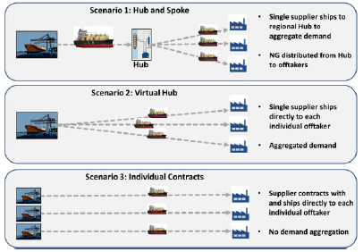
  - To the extent that there is demand in Barbados, and given its geographical position, LNG imports by other islands or territories that would not be economically viable for a potential supplier, may become both technically and financially feasible. Such islands or territories include Antigua and Barbuda, Guyana, Suriname, and The Bahamas, among others.
  - The government of Barbados is working on developing a comprehensive energy policy to promote the generation of electricity from RE sources at utility scale, increase energy security and reliability of the supply of electricity, and reducing the sector’s Greenhouse Gas (GHG) emissions. To this end, and with IDB support, the policy will not only address the use of RE but also consider options for diversifying the energy portfolio including importing NG in the form of LNG to meet local demand in the residential, commercial and industrial sectors and meeting potential future NG demand for power generation. To achieve INDC commitments, Barbados is exploring NG as a baseload fuel that can also enable a transition towards greater RE generation. The local utility has already shown interest in using NG in some of their facilities as some of their units are programed to be decommissioned between 2017 and 2019.
  - BNOCL has already installed an LNG facility at the Woodbourne Terminal (Micro LNG Plant) with capacity to handle iso-containers to supply a NG demand of around 0.5 mmcfpd. However, there is a need to expand its capacity in order to satisfy total demand of 2-3 mmcfpd and avoid costly NG shortages. Additionally, NPC is studying the prospect of establishing a Public-Private Partnership (PPP) to import LNG for power generation.
- Main aspects considered for classifying BA-L1012 as a regional integration operation

  - This project contributes to the establishment of a regional LNG supply chain by creating demand for LNG to be used for power generation in Barbados and supporting efforts to secure a long term contract for the supply of LNG to an island country in the Caribbean. Regarding the domestic use of NG, this operation contributes to expanding the volume of LNG imported and destined to domestic consumption thus consolidating local experience importing and handling LNG.
  - This is accomplished through:
    - Component 3 which facilitates the establishment of a Public Private Partnership (PPP) to import LNG for power generation. Component 1 includes support for the procurement and negotiation process to select a private sector partner and enter into a PPP to build and operate the LNG regasification plant, as well as for the procurement and negotiation process to secure at least 18 mmcfpd supply of LNG using a PPP scheme. Additionally, it provides capacity building for structuring and managing the PPP contract.
    - Component 2 which contributes directly to greater regional trade by increasing installed capacity for importing LNG destined to the domestic market, particularly residential, commercial and industrial NG consumers.
  - The figure below shows the possible regional supply chain that could be established in the Caribbean with different options for regional hubs that already have the installed regasification capacity like Panama, and Dominican Republic. Other countries like Jamaica are planning investments to become a regional hub for LNG in the Caribbean.
Figure 1: Regional LNG supply chain – Hub and Spoke Barbados (2023)
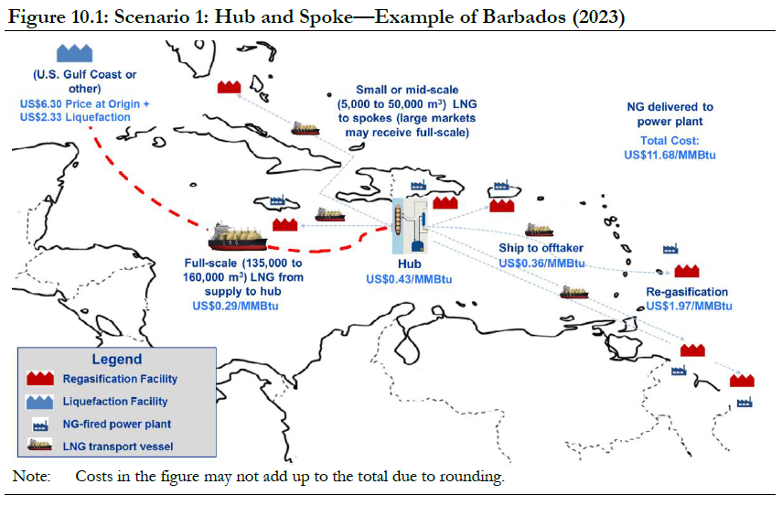

  - Regional LNG supply Chain. In the Hub and Spoke scenario a private investor in a country in the Caribbean develops a hub for purchasing large shipments of LNG and then redistributes LNG in smaller ships to other countries. The figure above illustrates the supply chain of natural gas (under Scenario 1) from acquiring the gas to bringing it to the power plant. Full-sized LNG vessels (~capacity of 149,000 cubic meters) would transport the natural gas from the supply point to the hub. Transshipment facilities would be used to transfer the LNG from storage in the hub onto smaller vessels for shipment to the regional markets. Smaller vessels would transport the LNG from the hub to other countries were the Offtakers are located. The size of these vessels could be different for each of the participating countries depending on their demand. For example, Jamaica would require full-sized vessels with capacity of 149,000 cubic meters, which is similar to the ships used to transport LNG from the liquefaction point to the transshipment facility. The other participating countries would require medium sized vessels with capacity of 45,000 cubic meters each. The LNG would have to be regasified in Regasification facilities in each of the countries. The size of these differs for each of the participating countries depending on their demand.
  - As a result of having a regional supply chain under Scenario 1, Offtakers would receive an average discount on HFO of 30 percent or more (Dominican Republic, Jamaica, and Barbados), between 20 percent and 30 percent (The Bahamas) and between 0 and 20 percent (Suriname, Haiti and Guyana). Figure 1 includes costs for each segment for Barbados in 2023 (in this case, the total cost of natural gas delivered to the power plant would be US$11.68 per MMBtu).
  - This project, particularly through Component 3, contributes to generate demand (18 million cubic feet per day (mmcfpd) for power generation) that contributes to generating critical mass in order to have a regional supply chain. With a demand signal from Barbados, and supply coming online to serve it, other countries can benefit from the increase in economies of scale.

- Validation of Project Criteria with the Integration Strategy Framework
  - According to the Sector Strategy to Support Competitive Global and Regional Integration (GN-2565-4), a regional integration operation is classified as such when it incorporates one of the following non-mutually exclusive indicative criteria: (i) a cross-country focus, (ii) national subsidiarity, (iii) regional additionality, and (iv) compensation of coordination failures. This operation meets the criteria for Cross-Country Focus, and National Subsidiarity as it supports a national investment by the Government of Barbados focused on the goal of upgrading existing NG infrastructure and enabling the local conditions for the implementation of a PPP project to secure the import and supply of LNG. The project will contribute to increase international trade in natural gas.
  - The Results Matrix of this operation includes the following indicators that are related to the project’s alignment to the development challenge of Economic and Regional Integration: (a) Bidding documents developed to secure 18 mmcfpd supply of LNG using a PPP scheme; (b) Successful bidding process completed to select a private sector partner for a PPP LNG project; and (c) Increase the number of international/regional LNG suppliers to Barbados.
  - Finally, the activities that support regional integration and cooperation, globally and regionally can be classified in three main thematic areas: i) infrastructure (hardware), ii) institutional strengthening and capacity development (software), and iii) regional initiatives and regional public goods (functional cooperation). The operation meets the criteria to be classified in the thematic area of infrastructure.

In accordance with the UIS and the Bank´s Sector Strategy to Support Competitive Global and Regional Integration (GN-2564-4)
Achieving Sustainable Energy in Barbados: Energy Dossier; IDB 2016.
In 2015 HFO based generation (819.3GWh) accounted for 85% of produced electricity, while Diesel based generation (148.5GWh) contributed 15%

