Document of the Inter-American Development Bank

**Barbados**

**Deployment of Cleaner Fuels and Renewable Energies in Barbados**

**(BA-L1012)**

**Cost Benefit Analysis**

This document was prepared by the Project Team.

Table of Contents

1 Introduction 8

2 Sub-projects and common assumptions included in the Cost-Benefit Analysis 12

2.1 CO2 Price Assumptions 13

2.2 Natural gas price assumptions 14

2.3 Oil price assumptions 15

2.4 Barbados LNG viable price range 16

3 Cost Benefit Analysis of the Micro-LNG Facility Expansion and Compressor Replacement Sub-Project 17

3.1 Methodology and Assumptions 18

3.1.1 Economic costs of the micro-LNG expansion and natural gas compressor replacement sub-project 19

3.1.2 Economic benefits of the micro-LNG expansion and natural gas compressor replacement sub-project 19

3.1.3 Net Economic Benefits of the micro-LNG expansion and natural gas compressor replacement sub-project 20

3.1.4 Assumptions for the micro-LNG expansion and natural gas compressor replacement sub-project 21

3.2 Economic Costs, Economic Benefits, and Net Economic Benefits of the micro-LNG expansion and natural gas compressor replacement sub-project 22

3.3 Sensitivity Analysis of micro-LNG expansion and natural gas compressor replacement sub-project 22

4 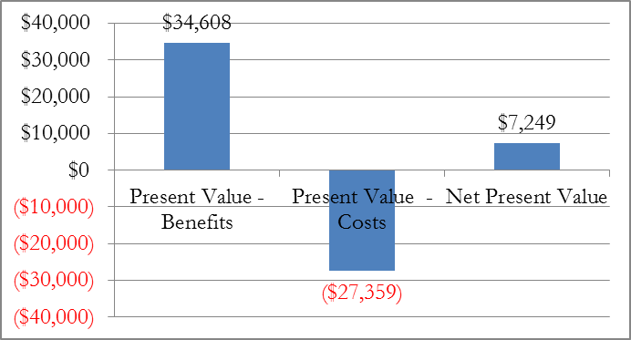Cost Benefit Analysis of the Wind Turbine Sub-Project 25

4.1 Methodology and Assumptions 26

4.1.1 Economic costs of the wind turbine sub-project 26

4.1.2 Economic benefits of the wind turbine 26

4.1.3 Net Economic Benefits of the wind turbine sub-project 27

4.1.4 Assumptions for the wind turbine sub-project 27

4.2 Economic Costs, Economic Benefits, and Net Economic Benefits of the wind turbine 28

4.3 Sensitivity Analysis of the wind turbine sub-project 28

5 Cost Benefit Analysis of Solar Panel Sub-Project 31

5.1 Methodology and Assumptions 32

5.1.1 Economic costs of the PV system sub-project 32

5.1.2 Economic benefits of the PV system 32

5.1.3 Net Economic Benefits of the PV system sub-project 33

5.1.4 Assumptions for the PV system sub-project 33

5.2 Economic Costs, Economic Benefits, and Net Economic Benefits of the PV system sub-project 34

5.3 Sensitivity Analysis of the PV system sub-project 34

6 Cost Benefit Analysis of the Very Small LNG terminal 38

6.1 Methodology and Assumptions 38

6.1.1 Economic costs of the VS LNG terminal 39

6.1.2 Economic benefits of the VS LNG terminal 40

6.1.3 Net Economic Benefits of the VS LNG sub-project 40

6.1.4 Assumptions for the VS LNG terminal 40

6.2 Economic Costs, Economic Benefits, and Net Economic Benefits of the VS LNG terminal 42

6.3 Sensitivity Analysis of the VS LNG terminal 42

7 Cost Benefit Analysis of All Sub-Projects 44

7.1 Total Project with the VS LNG 45

8 Introduction 48

8.1 Financial Analysis Variables and Assumptions 49

9 Financial Analysis of the Micro-LNG Facility Expansion Sub-Project 50

9.1 Financial Analysis 50

9.1.1 Income of the micro-LNG expansion sub-project 50

9.1.2 Expenses of the micro-LNG expansion sub-project 51

9.1.3 Cash flows of the micro-LNG expansion sub-project 51

9.2 Profitability of the micro-LNG expansion sub-project 52

10 Financial Analysis of the Compressor Replacement Sub-Project 53

10.1 Financial Analysis 53

10.1.1 Income of the compressor replacement sub-project 53

10.1.2 Expenses of the compressor replacement sub-project 54

10.1.3 Cash flows of the compressor replacement sub-project 54

10.2 Profitability of the compressor replacement sub-project 54

11 Financial Analysis of the Wind Turbine Sub-Project 56

11.1 Financial Analysis 56

11.1.1 Income of the wind turbine sub-project 56

11.1.2 Expenses of the wind turbine sub-project 57

11.1.3 Cash flows of the wind turbine sub-project 57

11.2 Profitability of the wind turbine sub-project 57

12 Financial Analysis of the PV System Sub-Project 59

12.1 Financial Analysis 59

12.1.1 Income of the PV system sub-project 59

12.1.2 Expenses of the PV system sub-project 60

12.1.3 Cash flows of the PV system sub-project 60

12.2 Profitability of the PV system sub-project 60

13 Financial Analysis of the VS LNG terminal Sub-Project 62

13.1 Financial Analysis 62

13.1.1 Income of the VS LNG terminal sub-project 62

13.1.2 Expenses of the VS LNG terminal sub-project 62

13.1.3 Cash flows of the VS LNG terminal sub-project 63

13.2 Profitability of the VS LNG terminal sub-project 64

14 Financial Analysis of All Sub-Projects 65

**Appendices**

Appendix A: Annual Economic Costs and Benefits of the Loan Sub-Projects 71

#### Appendix B: Annual Cash Flows of the Loan Sub-Projects 76

**Tables and Figures**

Table 2.1: Deployment of Cleaner Fuels and Renewable Energies in Barbados (BA-L1012) Sub-Projects 11

Table 2.2: Annual Average European carbon price (2006-2015) 12

Table 2.3: 5-year and 10-year average European annual average carbon price (2015US$/ton) 13

Figure 2.1: Henry Hub Price outlook under EIA 2016 AEO Oil Price Scenarios (2015 US$ per MMBtu) 14

Table 2.4: Barbados natural gas import parity calculations (2016-2020) 15

Figure 2.2: WTI Price outlook under EIA 2016 Annual Energy Outlook Oil Price Scenarios (2015 US$ per barrel) 15

Figure 2.3: LPG Price outlook under EIA 2016 Annual Energy Outlook Oil Price Scenarios (2015 US$ per gallon) 16

Figure 2.4: Barbados LNG Viability under EIA 2016 Annual Energy Outlook Oil Price Scenarios (WTI premium over Henry Hub in 2015 US$ per MMBtu) 17

Figure 3.1: Net Economic Benefits of the micro-LNG facility expansion and compressor replacement sub-project (‘000 US$) 18

Table 3.1: Assumptions Used to Determine the Economic Costs and Benefits of the micro-LNG expansion and natural gas compressor replacement sub-project 21

Table 3.2: Economic Costs and Benefits of the micro-LNG expansion and natural gas compressor replacement sub-project (US$ ‘000) 22

Table 3.3: CBA Sensitivity to oil and natural gas price (US$ ‘000) 23

Table 3.4: CBA Sensitivity to CO2 price (US$ ‘000) 24

Figure 3.2: Net Economic Benefits of the micro-LNG facility expansion and compressor replacement sub-project under worst case scenario (‘000 US$) 24

Figure 4.1: Net Economic Benefits of the wind turbine (US$ ‘000) 25

Table 4.1: Assumptions Used to Determine the Wind Turbine Economic Costs and Benefits 27

Table 4.2: Economic Costs and Benefits of the Wind Turbine (US$ ‘000) 28

Table 4.3: CBA Sensitivity to oil price (US$ ‘000) 29

Table 4.4: CBA Sensitivity to CO2 price (US$ ‘000) 29

Table 4.5: CBA Sensitivity to capacity factor (US$ ‘000) 30

Figure 4.2: Net Economic Benefits of the wind turbine sub-project under a worst case scenario (‘000 US$) 30

Figure 5.1: Net Economic Benefits of the PV system sub-project (US$ ‘000) 31

Table 5.1: Assumptions Used to Determine the Solar panel Economic Costs and Benefits 33

Table 5.2: Economic Costs and Benefits of the PV system sub-project (US$ ‘000) 34

Table 5.3: CBA Sensitivity to oil price (US$ ‘000) 35

Table 5.4: CBA Sensitivity to CO2 price (US$ ‘000) 35

Table 5.5: CBA Sensitivity to capacity factor (US$ ‘000) 36

Figure 5.2: Net Economic Benefits of the solar panel sub-project under a worst case scenario (‘000 US$) 36

Figure 6.1: Net Economic Benefits of the VS LNG Terminal (US$ ‘000) 37

Table 6.1: Assumptions Used to Determine the Economic Costs and Benefits of the VS LNG terminal 40

Table 6.2: Economic Costs and Benefits of the VS LNG terminal (US$ ‘000) 41

Table 6.3: CBA Sensitivity to oil price (US$ ‘000) 42

Table 6.4: CBA Sensitivity to CO2 price (US$ ‘000) 42

Figure 6.2: Net Economic Benefits of the VS LNG terminal sub-project under a worst case scenario (‘000 US$) 43

Figure 7.1: Net Economic Benefits of the Sub-Projects (not including the VS LNG terminal) (US$ ‘000) 43

Table 7.1: Economic Costs and Benefits of all Sub-Project except the VS LNG terminal (US$ ‘000) 44

Table 6.3: CBA Sensitivity to oil price (US$ ‘000) 45

Figure 6.2: Net Economic Benefits of the total project under a worst case scenario (‘000 US$) 45

Figure 7.2: Net Economic Benefits of the Sub-Projects (including the VS LNG terminal) (US$ ‘000) 45

Table 7.2: Aggregated Economic Costs and Benefits of all sub-project including the VS LNG terminal (US$ ‘000) 46

Table 8.1 Financial Analysis Assumptions and Variables 48

Table 9.2: Financial summary of the micro-LNG expansion sub-project (US$ ‘000) 51

Table 10.2: Financial summary of the compressor replacement sub-project (US$ ‘000) 53

Table 11.2: Financial summary of the wind turbine sub-project (US$ ‘000) 56

Table 12.2: Financial summary of the PV system sub-project (US$ ‘000) 59

Table 13.2: Financial summary of the VS LNG terminal sub-project (US$ ‘000) 63

Table 14.1: Financial Summary of all Sub-Projects except the VS LNG terminal (US$ ‘000) 64

Table 14.2: Financial Summary of all sub-project including the VS LNG terminal (US$ ‘000) 64

Table A.1: Schedule of Annual Economic Costs and Benefits of the micro-LNG facility expansion and compressor replacement sub-project 66

Table A.2: Schedule of Annual Economic Costs and Benefits of the wind turbine sub-project 67

Table A.3: Schedule of Annual Economic Costs and Benefits of the PV system sub-project 68

Table A.4: Schedule of Annual Economic Costs and Benefits of the VS LNG terminal sub-project 69

Table B.1: Schedule of Annual Financial Cash Flows of the micro-LNG facility expansion sub-project 71

Table B.2: Schedule of Annual Financial Cash Flows of the compressor replacement sub-project 72

Table B.3: Schedule of Annual Financial Cash Flows of the wind turbine sub-project 73

Table B.4: Schedule of Annual Financial Cash Flows of the PV system sub-project 74

Table B.5: Schedule of Annual Financial Cash Flows of the VS LNG terminal sub-project 75

# Introduction

The Inter-American Development Bank (IDB) is preparing a loan operation (Loan BA-L1012) for the Government of Barbados (GOB) to support the deployment of cleaner fuels and renewable energies in the country. This operation will be a loan to be executed by the National Petroleum Corporation (NPC) of Barbados. The main objective is to support Barbados’ energy security by enhancing the energy sector as well as promoting the introduction of cleaner fuels such as natural gas (NG) in the form of liquefied natural gas (LNG) and the implementation of smart energy solutions such as photovoltaic power systems for NG production activities and design of new smart and green energy public buildings.

This document presents the Cost Benefit Analysis (CBA) (Section A) and the financial analysis (Section B) of the sub-projects that the loan operation will finance: expansion of the micro-LNG facility at Woodbourne, replacement of natural gas fired compressors with high efficiency electric compressors, installation of an 850 kW wind turbine, and installation of a 300 kW PV and smart energy system. The CBA and financial analysis also examine the possible very small (VS) LNG terminal that may be supported through a Public-Private Partnership, although the loan operation will not fund the construction of the terminal itself.

The methodology to develop the CBA follows the IDB Guidelines for Economic Analysis by calculating the net present value (NPV) of the various sub-projects. The NPV is calculated from the present value of the sub-projects’ estimated benefits and costs. For example, to calculate the benefit of expanding the micro LNG facility, the savings in fuel expenditures and the monetary value of the reduction in greenhouse gas emissions that result from consuming natural gas instead of liquid fuels were estimated. To calculate the cost of expanding the micro LNG facility, the full economic costs of implementing the project, including the costs not financed by the IDB, were estimated. After calculating the difference between these two values for each year of the project period, the present value of that difference was calculated. That NPV is the result of the CBA. If the NPV is positive, the sub-project is economically viable.

Shadow prices were not directly addressed in the CBA analysis because of (i) limited recent data for key variable that are required for a shadow price assessment, (ii) the fuel price analysis already incorporates shadow fuel prices, and, (iii) an ex-ante assessment suggests that applying shadow prices would increase the project's ENPV and EIRR. Shadow prices could be applied to the Barbados dollar exchange rate (with the US dollar), to the price of imported fuels and materials, and to the cost of labor (both skilled and unskilled). An analysis of Barbados shadow prices that was performed in 2001 relied upon government-provided adjustment factors for labor and materials costs. These factors have not been updated by the Barbados government, although the economic conditions in the country have certainly changed in the past 15 years. Applying outdated adjustment factors risks distorting the analysis further rather than removing potential distortions, which is the aim of applying shadow pricing.

Shadow prices have been indirectly addressed, however, in the case of fuel prices. The price of natural gas and liquid fuels for electricity generation (and the impact on retail electricity prices) is directly linked to US market prices (Henry Hub in the case of natural gas and WTI in the case of liquid fuels) via a netback cost analysis. This approach to setting imported fuel prices avoids any potential distortions from non-market pricing in Barbados.

Finally, if the adjustment factors that were defined in the 2001 study were applied to the current project, they would likely result in a higher ENPV and EIRR.  This is likely the case because the economic benefits from the project largely come from reducing the cost of importing fuels (either by importing lower cost natural gas, or reducing the need for liquid fuels through implementing RE and  EE programs).  Applying a shadow exchange rate of B$2.2229 per US$ (as opposed to the official B$2.00 per US$) would increase the value of reducing the cost of dollar-based imports in Barbadian dollar terms. That is, each US dollar worth of import costs avoided would be worth B$2.23 rather than the B$2.00 in the current assessment.  While using the shadow exchange rate would increase some costs in Barbadian dollar terms (such as imported equipment, for example), any potential increase in costs would be less than the increase in benefits because they would (i) represent only a portion of the total costs and, (ii) the total costs are less than the total benefits as shown by the positive ENPV and EIRR in the original analysis. Therefore increasing a portion of the costs while increasing the total benefit by a similar percentage can be expected to result in a higher benefit.

This CBA suggests that the sub-projects noted above generate an aggregate Net Present Value of **US$9.8 million[1]** and an **internal rate of return of 25 percent** over a 25 year period. If the VS LNG terminal is included in the analysis, the aggregate Net Present Value is **US$88.9 million** and the economic **internal rate of return is 28 percent**. Both figures represent the NPV of the project sub-projects compared to a business-as-usual (BAU) scenario without the planned investments. The benefits of the sub-projects will stem from avoided economic losses from natural gas shortages, savings on liquid fuel expenditures, and the monetary value of avoided greenhouse gas emissions related to the displaced consumption of liquid fuels for electricity generation and commercial/industrial uses.

The methodology to develop the financial analysis calculates the net present value (NPV) of the associated cash flows that will accrue to NPC as a result of the sub-projects. This NPV is calculated from the expected income that NPC will receive and the costs that NPC will pay as a result of investing in the sub-project. For example, to calculate the income from expanding the micro-LNG facility, the income from selling the incremental volumes of natural gas was estimated. To calculate the cost of expanding the micro LNG facility, the cost of the imported natural gas, the facility’s operational costs, loan finance charges, and taxes, were estimated. The result of the financial analysis is the net present value of the cash flows, calculated taking into account the asset depreciation. . If the NPV is positive, the project is profitable.

This financial analysis suggests that the sub-projects that were analyzed will generate for NPC an aggregate Net Present Value of **US$9.7 million** and an **internal rate of return of 15 percent** over a 25 year period. This is the profitability of the sub-projects noted above to NPC. If the VS LNG terminal is included in the analysis, the aggregate Net Present Value to NPC is **US$81.2 million** and the **internal rate of return is 16 percent**.

Section A presents the CBA analysis in detail as follows:

* **Loan sub-projects**—presents the investments and projects included in the loan, upon which this CBA is based (Section 2)
* **Cost Benefit Analysis of the micro LNG facility expansion and compressor replacement sub-project**—shows that the expansion of the micro-LNG facility and replacement of the natural gas compressors is economically viable. It does so by showing that the net economic benefits of the sub-project are positive and the economic rate of return exceeds the discount rate. The section also presents the assumptions and methodology used to calculate these results (Section 3).
* **Cost Benefit Analysis of the 850 kW wind turbine sub-project**—shows that the 850 kW wind turbine is economically viable. It does so by showing that the net economic benefits of the wind turbine are positive and the internal rate of returns exceed the discount rate. The section also presents the assumptions and methodology used to calculate these results (Section 4).
* **Cost Benefit Analysis of the 300kW PV system sub-project**—shows that the installation of the 300 kW PV system is economically viable. It does so by showing that the net economic benefit of the PV system is positive and the internal rate of return exceeds the discount rate. The section also presents the assumptions and methodology used to calculate these results (Section 5).
* **Cost Benefit Analysis of the VS LNG terminal**—shows that the VS LNG terminal is economically viable. It does so by showing that the net economic benefits of the VS LNG terminal are positive and the internal rate of returns exceed the discount rate. The section also presents the assumptions and methodology used to calculate these results (Section 6).
* **Cost Benefit Analysis of all Sub-Projects**—aggregates the results presented in the previous sections to show the economic viability of the loan operation sub-projects as a whole (Section 7).

Section B presents the financial analysis in detail as follows:

* **Financial Analysis of the micro LNG facility expansion sub-project**—shows that the expansion of the micro-LNG facility is profitable for NPC. It does so by showing that the sub-project’s NPV is positive and the internal rate of return exceeds the discount rate. The debt coverage ratio is also acceptable throughout the loan period. The section also presents the assumptions and methodology used to calculate these results (Section 9).
* **Financial Analysis of the compressor replacement sub-project**—shows that the replacement of the natural gas compressors is profitable for NPC. It does so by showing that the sub-project’s NPV is positive and the internal rate of return exceeds the discount rate. The debt coverage ratio is also acceptable throughout the loan period. The section also presents the assumptions and methodology used to calculate these results (Section 10).
* **Financial Analysis of the 850 kW wind turbine sub-project**—shows that the 850 kW wind turbine is profitable for NPC. It does so by showing that the sub-project’s NPV is positive and the internal rate of return exceeds the discount rate. The debt coverage ratio is also acceptable throughout the loan period. The section also presents the assumptions and methodology used to calculate these results (Section 11).
* **Financial Analysis of the 300kW PV system sub-project**—shows that the installation of the 300 kW PV system is profitable for NPC. It does so by showing that the sub-project’s NPV is positive and the internal rate of return exceeds the discount rate. The debt coverage ratio is also acceptable throughout the loan period. The section also presents the assumptions and methodology used to calculate these results (Section 12)
* **Financial Analysis of the VS LNG terminal**—shows that the VS LNG terminal is profitable for NPC. It does so by showing that the sub-project’s NPV is positive and the internal rate of return exceeds the discount rate. The debt coverage ratio is also acceptable throughout the loan period. The section also presents the assumptions and methodology used to calculate these results (Section 13).
* **Financial Analysis of all Sub-Projects**—aggregates the results presented in the previous sections to show the profitability and financial viability of the loan operation sub-projects as a whole (Section 14).

Section A: Cost Benefit Analysis

# Sub-projects and common assumptions included in the Cost-Benefit Analysis

This section presents the individual sub-projects that will be supported by the loan operation and the common assumptions that are included in the Cost Benefit Analysis (‘CBA’) for each sub-project, including CO2 price, oil prices, and natural gas prices.

The sub-projects consist of the NPC’s planned investments in:

* expanding the micro-LNG facility at Woodbourne to accommodate up to 7 ISO containers, including electric compressors to replace the current natural-gas compressors used to maintain pressure on the NPC natural gas distribution system.
* a 850 kW wind turbine to supply electricity to the electric compressors
* a 300 kW PV system and smart energy system for NPC’s internal electricity consumption

The analysis also examines the cost-benefit of the proposed Public-Private Partnership (PPP) to develop a very small LNG regasification facility in order to import natural gas for electricity generation.

Table 2.1 presents the details of the four sub-projects plus the PPP described above. The total capital investment for the sub-projects that are expected to be completed under the current loan operation is US$27.25 million. The VS LNG terminal that is proposed to be built under the PPP arrangement is expected to require an additional US$87 million in capital investment. This figure include US$64 million for the LNG terminal and supporting port and natural gas transportation infrastructure, and US$23 million to convert BL&P power plants from fuel oil to natural gas.

Table 2.1: Deployment of Cleaner Fuels and Renewable Energies in Barbados (BA-L1012) Sub-Projects

| **Project** | **Size** | **Unit** | **Total Capex (US$ Million)** | **Estimated Start Year** |
| --- | --- | --- | --- | --- |
| Micro-LNG expansion | 275 | MMcf per year | US$3.90 | 2017 |
| Electric Compressors | 320 | hp | US$0.91 | 2018 |
| Wind Turbine | 850 | kW | US$1.90 | 2018 |
| Solar Panels | 300 | kW | US$0.54 | 2018 |
| **Total – Sub-Projects** |  |  | **US$27.25** |  |
| VS LNG Terminal | 3,500 | MMcf per year | US$64.00 | 2019 |
| Electricity generator conversion | 80 | MW | US$23.00 | 2019 |
| **Total** |  |  | **US$94.25** |  |

Source: Estimated and based on data from NPC

## CO2 Price Assumptions

Each sub-project is expected to contribute to reducing Barbados’ carbon emissions. In order to compare the potential benefits of reducing carbon emissions with the cost of doing so, a carbon price must be set.

The most prominent publicly set price for carbon is through the European emissions trading scheme. Table 2.2 below shows a 10-year history of the annual average price of carbon in euros per metric tonne and the conversion to calculate the price in constant 2015 US$ per short ton.

Table 2.2: Annual Average European carbon price (2006-2015)

|  |  |  |  |  |  |  |
| --- | --- | --- | --- | --- | --- | --- |
|  | Euro Carbon Price | Exchange Rate | US$ Carbon Price | Converted to English tons | Convert to constant US$ | **Constant US$ Carbon Price** |
|  | (EUR / tonne) | (US$ / EUR) | (US$ / Tonne) | (US$ / ton) | (US$ CPI deflator) | **(2015 US$ / ton)** |
| 2006 | 16.27 | 1.25 | 20.42 | 18.56 | 1.18 | **21.82** |
| 2007 | 14.77 | 1.37 | 20.21 | 18.38 | 1.14 | **21.01** |
| 2008 | 21.67 | 1.46 | 31.71 | 28.83 | 1.10 | **31.74** |
| 2009 | 12.65 | 1.39 | 17.59 | 15.99 | 1.10 | **17.67** |
| 2010 | 16.25 | 1.32 | 21.53 | 19.57 | 1.09 | **21.27** |
| 2011 | 17.34 | 1.39 | 24.12 | 21.93 | 1.05 | **23.11** |
| 2012 | 9.51 | 1.29 | 12.22 | 11.11 | 1.03 | **11.47** |
| 2013 | 4.92 | 1.33 | 6.53 | 5.94 | 1.02 | **6.04** |
| 2014 | 6.45 | 1.33 | 8.56 | 7.78 | 1.00 | **7.79** |
| 2015 | 7.84 | 1.11 | 8.70 | 7.91 | 1.00 | **7.91** |

Data sources: <http://www.investing.com/commodities/carbon-emissions-historical-data>; <https://www.oanda.com/currency/average>; http://inflationdata.com/Inflation/Consumer_Price_Index

European carbon prices fell dramatically after the Kyoto Protocol implementation period ended in 2012 without an extension agreement. After hitting a low of just over six 2015 US$/ton in 2013, carbon prices increased steadily to nearly eight 2015 US$/ton in 2015. Table 2.3 below shows the average, high, and low annual average price over the last five-year and ten-year periods.

Table 2.3: 5-year and 10-year average European annual average carbon price (2015US$/ton)

|  |  |  |  |
| --- | --- | --- | --- |
|  | Average | High | Low |
| 2015 | 7.91 |  |  |
| Last 5 years | 11.26 | 23.11 | 6.04 |
| Last 10 years | 16.98 | 31.74 | 6.04 |

Based on these averages, and considering that the carbon price has remained low relative to pre-2012 values, a base price of 10 US$/ton was used for this economic analysis. For the sensitivity analysis, the lowest recorded annual average price of 6 US$/ton was used for the “Low” case. For the “High” case, a value of US$15/ton was chosen—slightly below the 10-year average price and less than half of the peak annual average noted above. This relatively conservative price was chosen owing to the uncertainty of future carbon markets and the high volatility of prices shown in the past.

## Natural gas price assumptions

Natural gas prices used in the economic analysis are based on the US Henry Hub index forecast as provided by the US EIA. The Henry Hub index was chosen for the future prices given its widespread use as a natural gas price index, both within the US and internationally, and the likelihood that natural gas imports to Barbados will be sourced from the United States or will be linked to a US natural gas price. In addition, the natural gas import parity price serves as a shadow price for natural gas in Barbados, avoiding any potential economic distortions from domestic pricing at a level below international parity.

The US Energy Information Agency (EIA) provides an annual forecast of liquid fuel and natural gas prices in the United States through its Annual Energy Outlook (AEO). The AEO provides a Reference case forecast as well as several variations based on different assumptions regarding government policy, economic growth, technology change, and investment levels.

This CBA uses the EIA 2015 AEO Reference case price outlook for natural gas and crude oil (based on the West Texas Intermediate (WTI) price) as the baseline price outlook. Two alternative price scenarios, the “High Oil Price” case and the “Low Oil Price” case were used to examine the analysis’ sensitivity to changes in oil and natural gas prices.

Figure 2.1 below shows the EIA 2015 AEO Henry Hub price forecast to 2040 under the three scenarios. Although the two alternate scenarios were focused on high and low oil prices, they result in high and low Henry Hub prices as well, given the linkages between oil and natural gas markets. It is important to note, however, that the Henry Hub and WTI forecast price paths are not identical under each scenario. This reflects differences in the oil and natural gas markets, including the degree of global integration (much greater for oil markets) and their different primary markets (transportation for oil, electricity generation for natural gas).

Figure 2.1: Henry Hub Price outlook under EIA 2015 AEO Oil Price Scenarios (2015 US$ per MMBtu)

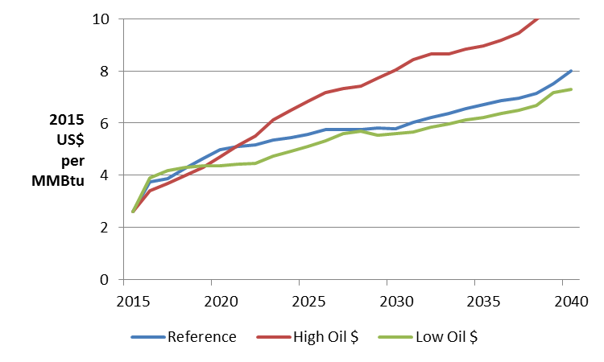

Natural gas prices delivered to Barbados are built up using estimates for the cost to transport the natural gas from the source to a liquefaction terminal in the United States, liquefy it, and ship it to Barbados. This ex-ship price is the added to the calculated costs for each regasification option (micro-LNG using Iso containers and VS LNG terminal) to calculate the final delivered cost of natural gas in Barbados.

Table 2.3 below shows an example of the shipping cost analysis for the first five years of the analysis.

Table 2.4: Barbados natural gas import parity calculations (2016-2020)



## Oil price assumptions

Forecast HFO prices used in the economic analysis are assumed to be linked to the US WTI FOB crude oil index forecast as provided in the EIA AEO. The WTI index was chosen for the future prices given its widespread use as an oil price index, both within the US and internationally. In addition, the HFO import parity price serves as a shadow price for HFO in Barbados, avoiding any potential economic distortions from domestic pricing at a level below international parity.

HFO prices are built up using estimates for the cost to ship the HFO (CIF) from the United States Gulf Coast to Barbados and an estimated differential between the actual price of HFO and the price of crude oil represented by WTI. HFO and crude oil prices generally move in tandem, although variations in supply and demand in HFO can result in a widening or narrowing difference between the two. This analysis assumes a fixed price difference between WTI and HFO as well as a fixed transportation cost.

Figure 2.2 below shows the EIA 2015 AEO WTI price forecast to 2040 under the three scenarios. In both the Reference case and High Oil Price scenarios, WTI prices are expected to recover from recent lows—most dramatically in the high oil price scenario, which envisions WTI reaching well over US$100 per barrel by 2017. The low oil price scenario, however, suggests that WTI will not return above US$50 in real terms until 2035—an exceptionally prolonged period of low prices. Together, these two scenarios describe a very wide range of possible outcomes for the future global oil market.

Figure 2.2: WTI Price outlook under EIA 2015 Annual Energy Outlook Oil Price Scenarios (2015 US$ per barrel)

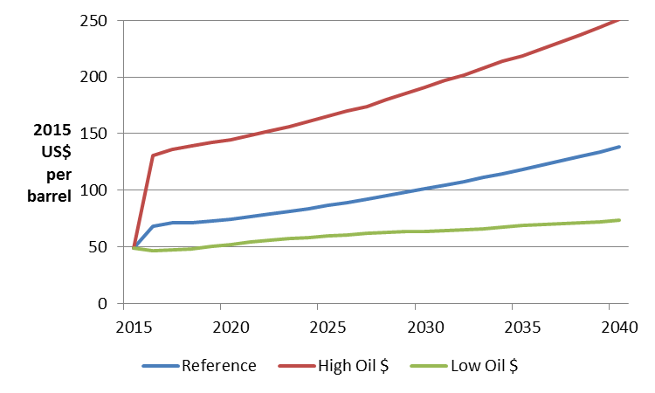

Figure 2.3 below shows the forecast for LPG prices using the same three cases from the 2015 EIA AEO. LPG is produced through both refining crude oil and also processing associated liquids from natural gas. As a result, the price of LPG is influenced by trends in both crude oil and natural gas supply.

Figure 2.3: LPG Price outlook under EIA 2015 Annual Energy Outlook Oil Price Scenarios (2015 US$ per gallon)

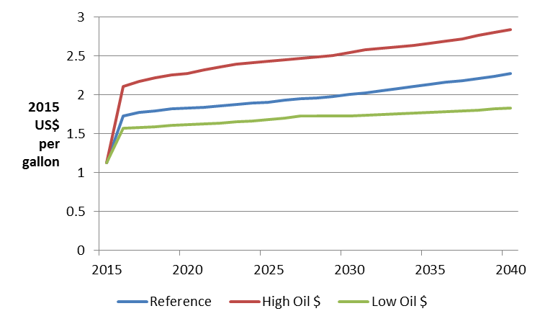

## Barbados LNG viable price range

Because oil and natural gas prices are influenced by both common and disparate factors, they can diverge from each other but rarely do so for extended periods of time. This is shown in the broad similarity of the curves for WTI and HH under each scenario above despite a relatively wide variation in the early years, particularly for the high oil price scenario.

For the Project to be financially viable, the delivered cost of LNG in Barbados must be lower than delivered cost of the alternative fuels, HFO and LPG. After accounting for the different costs in preparing and shipping each fuel, there is a minimum price differential between WTI and Henry Hub that would allow LNG to be competitive in Barbados. Figure 2.4 below shows that LNG is viable in Barbados whenever the price of WTI is more than US$6.50 higher than the price of Henry Hub on a per MMBtu basis. If WTI is between roughly US$1.00 and US$6.50 more than Henry Hub, LNG can be viable depending on the specific costs of the transportation and regasification technologies being used (for example, shipping LNG through ISO containers is more expensive than shipping it through a dedicated LNG tanker). When the premium for WTI is less than US$1.00 above Henry Hub, natural gas is not competitive with HFO in Barbados.

Figure 2.4: Barbados LNG Viability under EIA 2015 Annual Energy Outlook Oil Price Scenarios (WTI premium over Henry Hub in 2015 US$ per MMBtu)

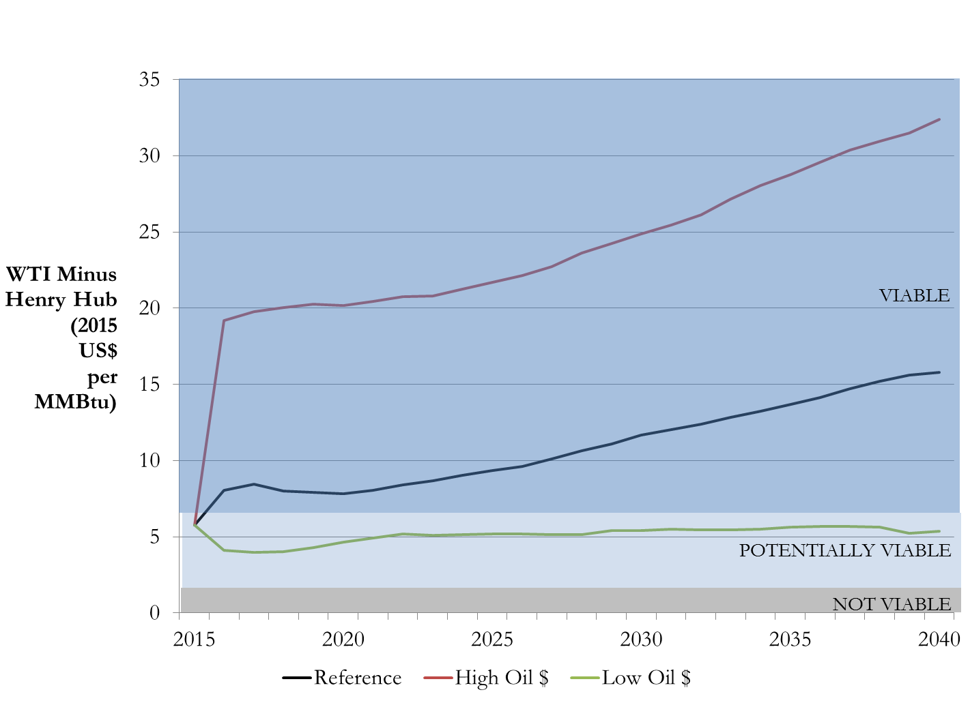

As shown in Figure 2.4, the EIA Reference Case price forecast is well within the Viable range from 2017 onward, while the Low Oil Price scenario remains within the “Potentially Viable” range throughout the period.

# Cost Benefit Analysis of the Micro-LNG Facility Expansion and Compressor Replacement Sub-Project

The purpose of this section is to determine whether the expansion of the micro-LNG facility and replacement of the current natural gas compressors that will be funded under the proposed loan operation (the Project) is economically viable. The Cost Benefit Analysis (CBA) described below finds that these sub-projects have an aggregate net present value (NPV) of approximately US$9.2 million and an economic rate of return of 27% percent. That is, the sub-projects are economically viable.

The analysis to calculate the net present value of the sub-projects is presented as follows:

* Methodology and Assumptions (Section 3.1)
* Economic Costs, Economic Benefits, and Net Economic Benefits of the Component (Section 3.2)
* Sensitivity Analysis of the Component (Section 3.3)

Figure 3.1: Net Economic Benefits of the micro-LNG facility expansion and compressor replacement sub-project (‘000 US$)

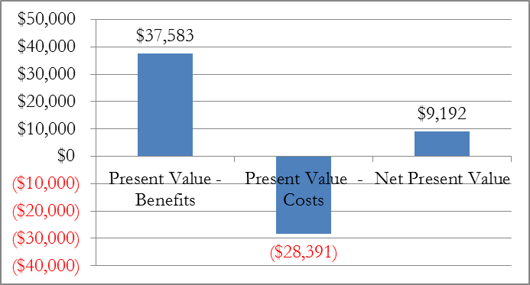

## Methodology and Assumptions

The objective of the CBA methodology is to determine whether or not the micro-LNG facility expansion and the natural gas compressor replacement are economically viable. This is accomplished by estimating the net benefits of the investments that will be financed by the sub-projects.

The sub-project’s net benefits were determined by calculating the difference in fuel import costs and greenhouse gas emissions between the sub-project scenario and the counterfactual scenario. The counterfactual scenario is one in which the proposed investments are not made, representing a “Business as Usual” (BAU) case. In this counterfactual case, declining domestic natural gas production is not replaced by imported natural gas, resulting in economic losses for current natural gas customers. The BAU case also results in continued use of liquid fuels, such as fuel oil, diesel and LPG for those customers that convert to natural gas under the micro-LNG expansion scenario.

The steps to calculate the net benefits of the Program are:

* Estimate the economic costs of expanding the micro-LNG facility and replacing the natural gas compressors (Section 3.1.1)
* Estimate the economic benefits of expanding the micro-LNG facility and replacing the natural gas compressors (Section 3.1.2)
* Estimate the present value of the sub-projects’ net economic benefits (Section 3.1.3).

Each of these steps and the assumptions used in their calculation (Section 3.1.4) are described in more detail below.

### Economic costs of the micro-LNG expansion and natural gas compressor replacement sub-project

The economic costs of the sub-project include:

* **Capital Expenditures (Capex)**—these are the capital investments needed to complete the sub-project. These capital investments include the costs for the physical upgrades to the micro-LNG site, LNG receiving and handling systems to accommodate the increased LNG through-put volumes, on-site LNG storage, additional ISO containers, new electric compressors and associated systems, and related consulting costs for the expansion design, engineering and procurement. NPC provided detailed estimates of the Capex required for the sub-projects as part of the loan procurement plan.
* **Natural gas imports**—these are the annual expenses incurred by increasing natural gas imports through the expanded facility. The economic cost of natural gas imports was calculated as the product of the cost to import a unit of natural gas and the expected incremental volume of imported natural gas. The volume of incremental natural gas imports was calculated as the minimum of Barbados’ incremental natural gas supply gap and the maximum capacity of the expanding micro-LNG facility. The incremental natural gas supply gap was calculated as the sum of cumulative decline in domestic natural gas production from BNOCL (estimated from the reported decline in natural gas production from 2013 to 2015) plus new natural gas demand from NPC’s existing and planned new customers.
* **Incremental CO₂ emissions**—consuming natural gas produces CO₂ emissions, although less than those produced by consuming liquid fuels such as fuel oil, diesel, and LPG. Expanding the micro-LNG facility will allow greater natural gas consumption than in the BAU scenario, thereby resulting in an increase in CO₂ emissions from natural gas consumption. The economic cost of incremental CO₂ emissionswas calculated from natural gas consumption as the product of the expected incremental CO₂ emissions and the social cost of CO₂ emissions. The expected incremental CO₂ emissions is the product of the CO₂ emissions per unit of natural gas consumed and the incremental units of natural gas imported through the expanded facility.

### Economic benefits of the micro-LNG expansion and natural gas compressor replacement sub-project

The economic benefits of the sub-project include:

* **Avoided economic losses**—natural gas shortages will create economic losses for existing natural gas consumers, including residential customers and commercial/industrial customers that do not have the ability to switch to alternative fuels. These losses can be avoided by importing additional natural gas through the expanded micro-LNG facility and increasing the amount of natural gas available for sale to customers by replacing the current natural-gas fired compressors with new, high efficiency electric compressors.

The avoided economic loss to commercial/industrial customers was calculated as the share of revenues lost as a result of natural gas shortages. The annual avoided lost revenue was calculated as the product of the commercial/industrial sector’s share of incremental natural gas supply from the micro-LNG facility expansion and the economic value linked to that natural gas supply. The economic value linked to natural gas was estimated from the average economic product per unit of energy consumed in the manufacturing and tourism sectors (the sectors that would be affected by NG shortages), the share of energy consumed by those sectors that is provided by natural gas, and the share of natural gas supply that was not provided as a result of the shortages.

The avoided economic costs to residential customers were calculated as the avoided loss of consumer surplus that would have occurred as a result of the natural gas shortages. The consumer surplus for any particular good is defined as the product of the volume of the good purchased by the consumer and the difference between the good’s actual price and the price the consumer would be willing to pay. The price-demand curve for residential natural gas in Barbados was estimated from academic studies of international residential natural gas price-elasticities. The potential volume of residential natural gas shortages was estimated from the product of the residential sector’s share of total natural gas demand in Barbados and the calculated annual natural gas shortfall.

* **Avoided liquid fuel costs**—incremental natural gas imports will allow NPC to provide natural gas to new customers that would otherwise have consumed liquid fuels. The avoided costs of importing these liquid fuels is the product of the unit price of imported liquid fuels and the incremental units of natural gas supplied to new customers. The incremental units of natural gas supplied to new customers from the micro-LNG facility expansion is the minimum of NPC’s incremental natural gas demand from new customers and the available import capacity of the expanded micro-LNG facility after meeting current customer’s needs.
* **Reduction in CO₂ emissions**—consuming natural gas produces less CO₂ emissions than consuming liquid fuels such as fuel oil, diesel, and LPG. The economic benefit of the reduction in CO₂ emissionswas calculatedas the product of the expected reduction in CO₂ emissions and the social cost of CO₂ emissions. The expected reduction in CO₂ emissions is the product of the CO₂ emissions per unit of liquid fuel consumed and the units of incremental natural gas demand from new NPC customers that displaces liquid fuels.

### Net Economic Benefits of the micro-LNG expansion and natural gas compressor replacement sub-project

After the sub-project’s economic costs and benefits are estimated, the next step is to calculate the sub-project’s NPV. This is accomplished by subtracting the present value of the sub-project’s costs from the present value of the sub-project’s benefits. The present value of the sub-project’s costs and benefits, was determined using a social discount rate of 12 percent (in real terms). If the present value of the sub-project’s net benefits is greater than zero, the sub-project is economically viable.

### Assumptions for the micro-LNG expansion and natural gas compressor replacement sub-project

To determine the sub-project’s net benefits, the annual economic costs and benefits of the sub-projects, for a period of 25 years, were estimated. Table 3.1 presents the assumptions used to calculate the economic costs and benefits of the sub-projects.

Table 3.1: Assumptions Used to Determine the Economic Costs and Benefits of the micro-LNG expansion and natural gas compressor replacement sub-project

|  |  |  |
| --- | --- | --- |
| **NG Value Chain** |  |  |
| Iso-container delivery cost (ex-NG) | US$/MMBtu | 10.50 |
| NG premium over HH | % | 20% |
|  |  |  |
| **Input costs and prices** |  |  |
| Residential NG price | B$/m^3 | 1.48 |
| Retail electricity price base rate | B$/kwh | 0.1345 |
| CO2 price | US$/ton CO2 | 10.00 |
|  |  |  |
| **NG Demand drivers** |  |  |
| NG demand growth | % growth rate | 1% |
| Pending NG customers demand | MMcf per year | 91 |
| NG Residential D price elasticity | ratio | (0.16) |
| BNOCL production decline rate | % decline/year | 5% |
| Residential share of NG curtailment | % of total | 20% |
|  |  |  |
| Tourism & Manufacturing share of GDP (2015) | B$ million | 179 |
| Share of T&M sectors using NG | % | 20% |
| NG shortage impact on T&M revenue | % of affected revenue lost | 25% |
|  |  |  |
| Tourism & Manufacturing employment | Employees / B$million GDP | 128 |
|  |  |  |
| **Fuel characteristics[2]** |  |  |
| Calorific Value HFO | BTU/BBL | 6,287,000 |
| Calorific Value Diesel | BTU/BBL | 5,551,365 |
| Calorific Value LPG | BTU/lb | 21,561 |
| Calorific Value NG | BTU/ft^3 | 1,050 |
| CO2 content - HFO | lbs / MMBtu | 174 |
| CO2 content - Diesel | lbs / MMBtu | 161 |
| CO2 content - LPG | lbs / MMBtu | 150 |
| CO2 content - NG | lbs / MMBtu | 117 |
|  |  |  |

The assumptions are based on information from NPC, quotes provided by equipment and service providers, studies from reliable sources, and estimations based on similar projects and technologies. Assumptions for the avoided cost of fuel oil generation are based on the capital, operating, and maintenance costs of diesel-based generation in Barbados. The avoided cost of liquid fuel consumption is also based on the EIA’s 2015 yearly oil price projections, adjusted for the delivered cost to Barbados. The 12 percent discount rate is the discount rate suggested in IDB CBA guidelines.

## Economic Costs, Economic Benefits, and Net Economic Benefits of the micro-LNG expansion and natural gas compressor replacement sub-project

This section presents the results of the CBA for the micro-LNG expansion and natural gas compressor replacement. When aggregating the economic cost and benefits of the sub-projects, the aggregated net benefits were found to be positive. That means that expanding the micro-LNG facility and replacing the natural gas compressors with high efficiency electric compressors will generate net economic benefits for Barbados.

Table 3.2 presents the economic costs and benefits of the micro-LNG expansion and natural gas compressor replacement.

Table 3.2: Economic Costs and Benefits of the micro-LNG expansion and natural gas compressor replacement sub-project (US$ ‘000)

|  |  |
| --- | --- |
| Present Value - Benefits | $37,583 |
| Present Value - Costs | ($28,391) |
| Net Present Value | $9,192 |
| IRR | 27% |

A detailed schedule of the annual benefits and costs for the micro-LNG facility expansion and compressor replacement sub-project is included in Appendix A.

## Sensitivity Analysis of micro-LNG expansion and natural gas compressor replacement sub-project

A sensitivity analysis was conducted to estimate how changes in key variables used in the CBA would impact the sub-project’s estimated economic viability. The independent variables included in the sensitivity analysis are the price of oil, the price of natural gas, and the price of CO2. These variables were selected based on the likelihood that they could change and they could have a material impact on the sub-project’s economic viability if they did change.

The sensitivity to variations in the price of oil and the price of natural gas, however, was analyzed in tandem. That is, instead of analyzing each separately, variations in those variables were considered simultaneously. North American natural gas and crude oil prices are influenced by many common factors, including economic growth and investment in hydrocarbon exploration. Because a large share of natural gas production is in the form of associated gas (that is, it is produced alongside crude oil from the same resource), natural gas production can be directly influenced by crude oil prices and investment in crude production. In addition, the two fuels are interchangeable for many applications. For example, both natural gas and crude oil can be used as a feedstock for petrochemical production. As a result, any wide disparity in crude oil and natural gas prices would tend to self-correct as interchangeable demand shifts toward the lower cost option.

For these reasons, the EIA's crude oil and natural gas price projections are linked to demonstrate the impact of the common assumptions that are inherent in each price scenario. Comparing crude oil prices from one scenario with natural gas prices from a different scenario could give a distorted view, as key assumptions that result in the price outlook for one will be different in the other.

The projects remain economically viable when the key variables change to extreme values. Changes in the price of fuel oil and natural gas were found to have the greatest impact on the project, while variations in the price of CO2 had relatively little impact. This section discusses in more detail the effects of:

* a high oil and natural gas price scenario
* a low oil and natural gas price scenario
* Changing the price of CO2

Table 3.3 presents the results of changing the price of oil and natural gas. The table presents the present value of the costs, benefits, and net benefits of the micro-LNG expansion and natural gas compressor replacement for a high case (under the EIA 2015 AEO High Oil Price projection) and low case (under the EIA 2015 AEO Low Oil Price projection) as well as the base case (annual oil price projections are based on the EIA 2015 Reference Case price projection)2015. The table shows that even under the Low Oil Price scenario the sub-project remains economically viable, with an aggregate NPV of US$7.2 million. In the high oil price scenario, the aggregate NPV increases to US$12.8 million.

Table 3.3: CBA Sensitivity to oil and natural gas price (US$ ‘000)

|  |  |  |  |
| --- | --- | --- | --- |
| **Scenario:** | **Base** | **High** | **Low** |
| Present Value - Benefits | $37,583 | $42,816 | $34,608 |
| Present Value - Costs | ($28,391) | ($29,979) | ($27,359) |
| Net Present Value | $9,192 | $12,837 | $7,249 |
| IRR | 27% | 34% | 24% |

Table 3.4 presents the results of changing the price of CO2. The table shows the present value of the costs, benefits, and net benefits of the micro-LNG expansion and natural gas compressor replacement for a high case (annual CO2 prices are US$15 per ton, or 50% higher than the base case projection) and low case (annual CO2 prices are US$6 per ton, or 40% lower than the base case projection) as well as the base case (annual CO2 prices are US$10 per ton). The table shows that after increasing the CO2 price by 50%, the sub-project remains economically viable, with an aggregate NPV of US$9.0 million. In the low CO2 price scenario, the aggregate NPV increases to US$9.4 million.

Unlike other sub-projects that were analyzed, the expansion of the micro-LNG facility showed a lower NPV under the high CO2 price sensitivity. This difference is caused by the increase in natural gas consumption as a result of the facility expansion. In the BAU case without the expansion, consumers facing seasonal shortages are assumed to simply forego the economic benefits from their natural gas consumption, rather than switch to a more carbon intensive liquid fuel. As a result, the investment scenario has higher CO2 emissions than the BAU case.

Table 3.4: CBA Sensitivity to CO2 price (US$ ‘000)

|  |  |  |  |
| --- | --- | --- | --- |
| **Scenario:** | **Base** | **High** | **Low** |
| US$/tCO2: | 10.00 | 15.00 | 6.00 |
| Present Value - Benefits | $37,583 | $37,939 | $37,299 |
| Present Value - Costs | ($28,391) | ($28,980) | ($27,920) |
| Net Present Value | $9,192 | $8,959 | $9,379 |
| IRR | 27% | 27% | 27% |

In a “worst case” scenario in which all three variables are set to the Low value (the low oil and natural gas price scenario and low CO2 price), the Micro-LNG sub-projects remain economically viable. As shown in Figure 3.2, the micro-LNG facility expansion and compressor replacement under this worst case scenario still have an economic NPV of US$7.2 million and EIRR 25%.

Figure 3.2: Net Economic Benefits of the micro-LNG facility expansion and compressor replacement sub-project under worst case scenario (‘000 US$)

# Cost Benefit Analysis of the Wind Turbine Sub-Project

The purpose of this section is to determine whether the proposed 850 kW wind turbine sub-project is economically viable. To determine the wind turbine’s economic viability, a Cost Benefit Analysis (CBA) was performed of the economic costs and benefits of installing the wind turbine. The sub-project was found to have a net present value (NPV) of approximately US$0.57 million and an internal rate of return of 17% percent. That is, the wind turbine sub-project is economically viable.

The analysis to calculate the net present value of the wind turbine sub-project is presented as follows:

* Methodology and Assumptions (Section 4.1)
* Economic Costs, Economic Benefits, and Net Economic Benefits of the wind turbine sub-project (Section 4.2)
* Sensitivity Analysis of the wind turbine sub-project (Section 4.3)

Figure 4.1: Net Economic Benefits of the wind turbine (US$ ‘000)

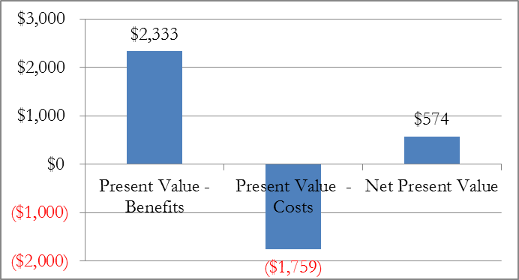

## Methodology and Assumptions

The objective of the CBA methodology is to determine whether or not the wind turbine sub-project is economically viable. This is accomplished by estimating the net benefits of the wind turbine sub-project that will be financed by the loan.

The wind turbine sub-project’s net benefits were determined by calculating the difference in the cost of fuel imports and greenhouse gas emissions between the project scenario and the counterfactual scenario. The counterfactual scenario is one in which the wind turbine is not built and electricity continues to be provided using imported heavy fuel oil in diesel generators.

The steps to calculate the net benefits of the wind turbine sub-project are:

* Estimate the economic costs of the sub-project (Section 4.1.1)
* Estimate the economic benefits of the sub-project (Section 4.1.2)
* Estimate the present value of the sub-project’s net economic benefits (Section 3.1.3).

Each of these steps and the assumptions used in their calculation (Section 4.1.4) are described in more detail below:

### Economic costs of the wind turbine sub-project

The economic costs of the wind turbine sub-project include:

* **Capital Expenditures (Capex)**—these are the capital investments needed to complete the sub-project. The capital investments include the costs for the wind turbine machinery, site preparation, and related infrastructure. NPC provided detailed estimates of the sub-project Capex based on direct quotes from equipment suppliers and construction firms.

### Economic benefits of the wind turbine

The economic benefits of the wind turbine sub-project include:

* **Savings in generation costs**—generating electricity from wind power potentially costs less than generating electricity from fuel oil. Therefore, Barbados will save in generation costs by replacing fuel oil generation with wind generation. The savings to the country were estimated as the difference between the Total Avoided Cost (‘TAC’) of fuel oil generation and the Total Operating Costs (‘TOC’) of wind generation. The TAC is the marginal cost of generating electricity with fuel oil in a diesel generator (the primary electricity generation technology on Barbados). The following formulas were used to calculate the savings in generation costs:
* **Reduction in CO₂ emissions**—generating electricity from wind produces less CO₂ emissions than generating electricity with fuel oil. The economic benefit of the reduction in CO₂ emissionswas calculatedas the product of the expected reduction in CO₂ emissions and the social cost of CO₂ emissions. The expected reduction in CO₂ emissions is the product of the CO₂ emissions per unit of electricity produced from fuel oil and the units of electricity produced from geothermal generation.

### Net Economic Benefits of the wind turbine sub-project

After estimating the wind turbine sub-project’s economic costs and benefits, the next step was to calculate the wind turbine’s NPV. This was accomplished by subtracting the present value of the wind turbine’s costs from the present value of the wind turbine’s benefits. The present value of the wind turbine’s costs and benefits, was determined using a social discount rate of 12 percent (in real terms). If the present value of the wind turbine sub-project’s net benefits is greater than zero, the wind turbine is economically viable.

### Assumptions for the wind turbine sub-project

To determine the sub-project’s net benefits, the wind turbine’s annual economic costs and benefits for a period of 25 years were estimated. Table 4.1 presents the assumptions used to calculate the wind turbine’s economic costs and benefits.

Table 4.1: Assumptions Used to Determine the Wind Turbine Economic Costs and Benefits

|  |  |  |
| --- | --- | --- |
| **Input prices** |  |  |
| CO2 price | US$/ton CO2 | 10.00 |
|  |  |  |
| Retail electricity price base rate | B$/kwh | 0.1345 |
|  |  |  |
| **Heat rate by plant type** |  |  |
|  |  |  |
| Low Speed Diesel, HFO (existing) | Btu/kWh | 7,835 |
| Solar | Btu/kWh | - |
| Wind | Btu/kWh | - |
|  |  |  |
| **O&M Cost (Fixed & Variable) by plant type** | |  |
| Low Speed Diesel, HFO (existing) | US$/kWh | 0.02 |
| Solar | US$/kW/year | 30.00 |
| Wind | US$/kW/year | 46.00 |
| **Fuel characteristics** |  |  |
| Calorific Value HFO | BTU/BBL | 6,287,000 |
| Calorific Value Diesel | BTU/BBL | 5,551,365 |
| Calorific Value LPG | BTU/lb | 21,561 |
| Calorific Value NG | BTU/ft^3 | 1,050 |
| CO2 content - HFO | lbs / MMBtu | 174 |
| CO2 content - Diesel | lbs / MMBtu | 161 |
| CO2 content - LPG | lbs / MMBtu | 150 |
| CO2 content - NG | lbs / MMBtu | 117 |

The assumptions are based on information provided by the NPC, quotes from equipment and service providers, studies from reliable sources, and estimations based on similar projects and technologies. For example, NPC determined that an 850 kW scale turbine would be best suited for their electricity needs and the proposed location of the wind turbine. The wind turbine’s expected capacity factor (31%) was also based on data from the equipment provider and NPC. The data on capital expenditures are based on a detailed quote provided to NPC by Hydro-Star Energy, LLC. Assumptions for avoided cost of fuel oil generation are based on the operating, and maintenance costs of diesel-based generation in Barbados. The avoided cost of fuel generation is also based on the EIA’s 2015 yearly WTI oil price projections, adjusted to reflect the delivered cost of heavy fuel oil in Barbados. The 12 percent discount rate is in line with IDB CBA guidelines.

## Economic Costs, Economic Benefits, and Net Economic Benefits of the wind turbine

This section presents the results of the CBA. After comparing the economic costs and benefits of the proposed wind turbine sub-project, the aggregated net benefits were found to be positive. That means that installing the wind turbine will generate net economic benefits for Barbados.

Table 4.2 presents the economic costs and benefits of the wind turbine sub-project.

Table 4.2: Economic Costs and Benefits of the Wind Turbine (US$ ‘000)

|  |  |
| --- | --- |
| Present Value - Benefits | $2,333 |
| Present Value - Costs | ($1,759) |
| Net Present Value | $574 |
| IRR | 17% |

A detailed schedule of the annual benefits and costs for the wind turbine sub-project is included in Appendix A.

## Sensitivity Analysis of the wind turbine sub-project

A sensitivity analysis was conducted to estimate how changes in key variables used in the CBA would impact the wind turbine’s estimated economic viability. The independent variables included in the sensitivity analysis are the price of oil, the price of CO2, and the wind turbine capacity factor. These variables were selected based on the likelihood that they could change and they could have a material impact on the wind turbine’s economic viability if they did change.

The wind turbine remains economically viable when the key variables change to extreme values. Variations in the price of oil had the greatest impact on the sub-project’s NPV, while variations in the price of CO2 had relatively little impact. This section discusses in more detail the effects of:

* Changing the oil price
* Changing the CO2 price
* Changing the wind turbine capacity factor

Table 4.3 presents the results of changing the price of oil. The table shows the present value of the costs, benefits, and net benefits of the wind turbine for a high case (under the EIA 2015 AEO High Oil Price projection) and low case (under the EIA 2015 AEO Low Oil Price projection) as well as the base case (annual oil price projections are based on the EIA 2015 Reference Case price projection). The table shows that under the Low oil price scenario, the sub-project is marginally economically viable, with an aggregate NPV of US-$0.04 million and a EIRR of 12% (equal to the 12% hurdle rate). In the high oil price scenario, the aggregate NPV increases to US$2.0 million.

Table 4.3: CBA Sensitivity to oil price (US$ ‘000)

|  |  |  |  |
| --- | --- | --- | --- |
| **Scenario:** | **Base** | **High** | **Low** |
| Present Value - Benefits | $2,333 | $3,766 | $1,796 |
| Present Value - Costs | ($1,759) | ($1,759) | ($1,759) |
| Net Present Value | $574 | $2,006 | $37 |
| IRR | 17% | 27% | 12% |

Table 4.4 presents the results of changing the price of CO2. The table shows the present value of the costs, benefits, and net benefits of the wind turbine for a high case (annual CO2 prices are US$15 per ton, or 50% higher than the base case projection) and low case (annual CO2 prices are US$6 per ton, or 40% lower than the base case projection) as well as the base case (annual CO2 prices are US$10 per ton). The table shows that even after lowering the CO2 price by 40%, the sub-project remains economically viable, with an aggregate NPV of US$0.54 million. In the high CO2 price scenario, the aggregate NPV is slightly higher than the base case at US$0.62 million.

Table 4.4: CBA Sensitivity to CO2 price (US$ ‘000)

|  |  |  |  |
| --- | --- | --- | --- |
| **Scenario:** | **Base** | **High** | **Low** |
| US$/tCO2: | 10.00 | 15.00 | 6.00 |
| Present Value - Benefits | $2,333 | $2,382 | $2,294 |
| Present Value - Costs | ($1,759) | ($1,759) | ($1,759) |
| Net Present Value | $574 | $623 | $535 |
| IRR | 17% | 17% | 16% |

Table 4.5 presents the results of changing the wind turbine capacity. The table shows the present value of the costs, benefits, and net benefits of the wind turbine for a high case (capacity factor is increased to 33%) and low case (capacity factor is decreased to 28%) as well as the base case (capacity factor equal to 31%). The high case (33% capacity factor) is based on the estimated capacity factor for wind turbines in Barbados from a 2015 study on wind and solar capacity integration in Barbados that was conducted by GE Energy Consulting[3]. The low case (28% capacity factor) is based on the assumptions used in the 2012 BL&P Integrated Resource Plan.[4] The table shows that even after lowering the capacity factor by 10% (or 3 percentage points), the wind turbine remains economically viable, with an aggregate NPV of US$0.34 million. In the high capacity factor scenario, the aggregate NPV increases to US$0.69 million.

Table 4.5: CBA Sensitivity to capacity factor (US$ ‘000)

|  |  |  |  |
| --- | --- | --- | --- |
| **Scenario:** | **Base** | **High** | **Low** |
| Capacity Factor: | 31% | 33% | 28% |
| Present Value - Benefits | $2,333 | $2,446 | $2,100 |
| Present Value - Costs | ($1,759) | ($1,759) | ($1,759) |
| Net Present Value | $574 | $687 | $341 |
| IRR | 17% | 18% | 15% |

In a “worst case” scenario in which all three variables are set to the Low value (a low oil price, a low CO2 price, and a low utilization rate), the wind turbine sub-project is uneconomic. As shown in Figure 4.2, the wind turbine sub-project under a worst case scenario has an economic NPV of US$-0.18 million and an EIRR of 10% (below the 12% hurdle rate).

Figure 4.2: Net Economic Benefits of the wind turbine sub-project under a worst case scenario (‘000 US$)

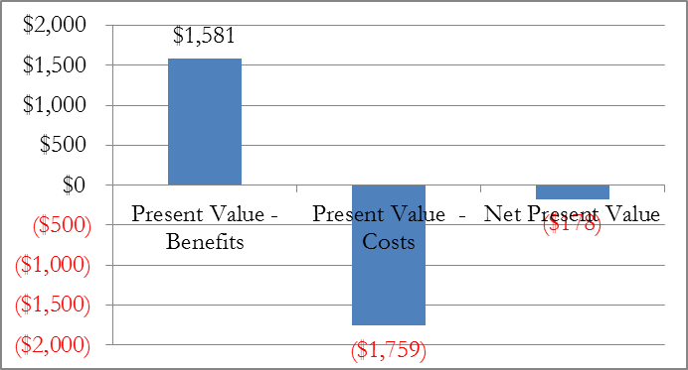

# Cost Benefit Analysis of Solar Panel Sub-Project

The purpose of this section is to determine whether the proposed 300 kW PV system sub-project is economically viable. To determine the PV system sub-project’s economic viability, a Cost Benefit Analysis (CBA) of the economic costs and benefits of installing the PV systems was performed. The sub-project was found to have a net present value (NPV) of approximately US$45,000 and internal rate of return of 13% percent. That is, the PV system sub-project is economically viable.

The analysis to calculate the net present value of the PV system sub-project is presented as follows:

* Methodology and Assumptions (Section 5.1)
* Economic Costs, Economic Benefits, and Net Economic Benefits of the PV system sub-project (Section 5.2)
* Sensitivity Analysis of the PV system sub-project (Section 5.3)

Figure 5.1: Net Economic Benefits of the PV system sub-project (US$ ‘000)

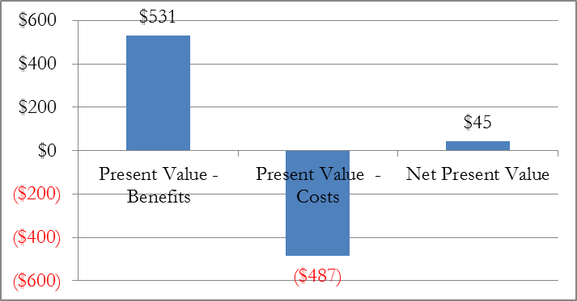

## Methodology and Assumptions

The objective of the CBA methodology is to determine whether or not the PV system sub-project is economically viable. This is accomplished by estimating the net benefits of the PV system sub-project that will be financed by the loan.

The PV system sub-project’s net benefits were determined by calculating the difference in the cost of fuel imports and greenhouse gas emissions between the project scenario and the counterfactual scenario. The counterfactual scenario is one in which the PV system project is not built and electricity continues to be provided using imported heavy fuel oil in diesel generators.

The steps to calculate the net benefits of the PV system sub-project are:

* Estimate the economic costs of the sub-project (Section 5.1.1)
* Estimate the economic benefits of the sub-project (Section 5.1.2)
* Estimate the present value of the sub-project’s net economic benefits (Section 5.1.3).

Each of these steps and the assumptions used in their calculation (Section 5.1.4) are described in more detail below:

### Economic costs of the PV system sub-project

The economic costs of the PV system sub-project include:

* **Capital Expenditures (Capex)**—these are the capital investments needed to complete the sub-project. The capital costs include the costs for the PV system and balance of system, site preparation, and related infrastructure. NPC provided estimates of the sub-project Capex.

### Economic benefits of the PV system

The economic benefits of the PV system sub-project include:

* **Savings in generation costs**—generating electricity from solar power potentially costs less than generating electricity from fuel oil. Therefore, Barbados will save in generation costs by replacing fuel oil generation with wind generation. The savings to the country were estimated as the difference between the Total Avoided Cost (‘TAC’) of fuel oil generation and the Total Operating Costs (‘TOC’) of wind generation. The TAC is the marginal cost of generating electricity with fuel oil in a diesel generator (the primary electricity generation technology on Barbados). The following formulas were used to calculate the savings in generation costs:
* **Reduction in CO₂ emissions**—generating electricity from PV systems produces less CO₂ emissions than generating electricity with fuel oil. The economic benefit of the reduction in CO₂ emissionswas calculatedas the product of the expected reduction in CO₂ emissions and the social cost of CO₂ emissions. The expected reduction in CO₂ emissions is the product of the CO₂ emissions per unit of electricity produced from fuel oil and the units of electricity produced from geothermal generation.

### Net Economic Benefits of the PV system sub-project

After estimating the PV system sub-project’s economic costs and benefits, the next step was to calculate the PV system’s NPV. This was accomplished by subtracting the present value of the PV system’s costs from the present value of the PV system’s benefits. The present value of the PV system’s costs and benefits, was determined using a social discount rate of 12 percent (in real terms). If the present value of the PV system sub-project’s net benefits is greater than zero, the PV system is economically viable.

### Assumptions for the PV system sub-project

To determine the sub-project’s net benefits, the PV system’s annual economic costs and benefits for a period of 25years were estimated. Table 5.1 presents the assumptions used to calculate the PV system’s economic costs and benefits.

Table 5.1: Assumptions Used to Determine the Solar panel Economic Costs and Benefits

|  |  |  |
| --- | --- | --- |
| **Input prices** |  |  |
| CO2 price | US$/ton CO2 | 10.00 |
|  |  |  |
| Retail electricity price base rate | B$/kwh | 0.1345 |
|  |  |  |
| **Heat rate by plant type** |  |  |
|  |  |  |
| Low Speed Diesel, HFO (existing) | Btu/kWh | 7,835 |
| Solar | Btu/kWh | - |
| Wind | Btu/kWh | - |
|  |  |  |
| **O&M Cost (Fixed & Variable) by plant type** | |  |
| Low Speed Diesel, HFO (existing) | US$/kWh | 0.02 |
| Solar | US$/kW/year | 30.00 |
| Wind | US$/kW/year | 46.00 |
| **Fuel characteristics** |  |  |
| Calorific Value HFO | BTU/BBL | 6,287,000 |
| Calorific Value Diesel | BTU/BBL | 5,551,365 |
| Calorific Value LPG | BTU/lb | 21,561 |
| Calorific Value NG | BTU/ft^3 | 1,050 |
| CO2 content - HFO | lbs / MMBtu | 174 |
| CO2 content - Diesel | lbs / MMBtu | 161 |
| CO2 content - LPG | lbs / MMBtu | 150 |
| CO2 content - NG | lbs / MMBtu | 117 |

The assumptions are based on information provided by the NPC, quotes from equipment and service providers, studies from reliable sources, and estimations based on similar projects and technologies. For example, NPC determined that a 300 kW scale solar array would be best suited for their electricity needs and the proposed location of the PV systems. The PV system expected capacity factor (20%) was also based on data from the equipment provider and NPC. Assumptions for avoided cost of fuel oil generation are based on the operating, and maintenance costs of diesel-based generation in Barbados. The avoided cost of fuel generation is also based on the EIA’s 2015 yearly WTI oil price projections, adjusted to reflect the delivered cost of heavy fuel oil in Barbados. The 12 percent discount rate is in line with IDB CBA guidelines.

## Economic Costs, Economic Benefits, and Net Economic Benefits of the PV system sub-project

This section presents the results of the CBA. After comparing the economic costs and benefits of the proposed PV system sub-project, the aggregated net benefits were found to be positive. That means that installing the PV system will generate net economic benefits for Barbados.

Table 5.2 presents the economic costs and benefits of the PV system sub-project.

Table 5.2: Economic Costs and Benefits of the PV system sub-project (US$ ‘000)

|  |  |
| --- | --- |
| Present Value - Benefits | $531 |
| Present Value - Costs | ($487) |
| Net Present Value | $45 |
| IRR | 13% |

A detailed schedule of the annual benefits and costs for the PV system sub-project is included in Appendix A.

## Sensitivity Analysis of the PV system sub-project

A sensitivity analysis was conducted to estimate how changes in key variables used in the CBA would impact the PV system’s estimated economic viability. The independent variables included in the sensitivity analysis are the price of oil, the price of CO2, and the solar plant’s capacity factor. These variables were selected based on the likelihood that they could change and they could have a material impact on the PV system’s economic viability if they did change.

The PV system remains economically viable when the key variables change to extreme values. Variations in the PV system’s capacity factor had the greatest impact on the sub-project’s NPV, while variations in the price of CO2 had relatively little impact. This section discusses in more detail the effects of:

* Changing the oil price
* Changing the CO2 price
* Changing the solar plant capacity factor

Table 5.3 presents the results of changing the price of oil. The table shows the present value of the costs, benefits, and net benefits of the PV system for a high case (under the EIA 2015 AEO High Oil Price projection) and low case (under the EIA 2015 AEO Low Oil Price projection) as well as the base case (annual oil price projections are based on the EIA 2015 Reference Case price projection). The table shows that under the Low oil price scenario, the sub-project is marginally uneconomic, with an aggregate NPV of US$-78,000. This implies that under a low oil price scenario the return from the PV system investment would be less than the 12% discount rate. Indeed, the IRR in this scenario is 9%, slightly below the 12% hurdle rate. In the high oil price scenario, the aggregate NPV increases to US$371,000 and an EIRR of 22%.

Table 5.3: CBA Sensitivity to oil price (US$ ‘000)

|  |  |  |  |
| --- | --- | --- | --- |
| **Scenario:** | **Base** | **High** | **Low** |
| Present Value - Benefits | $531 | $857 | $409 |
| Present Value - Costs | ($487) | ($487) | ($487) |
| Net Present Value | $45 | $371 | ($78) |
| IRR | 13% | 22% | 9% |

Table 5.4 presents the results of changing the price of CO2. The table shows the present value of the costs, benefits, and net benefits of the PV system for a high case (annual CO2 prices are US$15 per ton, or 50% higher than the base case projection) and low case (annual CO2 prices are US$6 per ton, or 40% lower than the base case projection) as well as the base case (annual CO2 prices are US$10 per ton). The table shows that even after lowering the CO2 price by 40%, the sub-project remains economically viable, with an aggregate NPV of US$36,000. In the high CO2 price scenario, the aggregate NPV increases to US$56,000.

Table 5.4: CBA Sensitivity to CO2 price (US$ ‘000)

|  |  |  |  |
| --- | --- | --- | --- |
| **Scenario:** | **Base** | **High** | **Low** |
| US$/tCO2: | 10.00 | 15.00 | 6.00 |
| Present Value - Benefits | $531 | $542 | $522 |
| Present Value - Costs | ($487) | ($487) | ($487) |
| Net Present Value | $45 | $56 | $36 |
| IRR | 13% | 14% | 13% |

Table 5.5 presents the results of changing the PV system capacity. The table shows the present value of the costs, benefits, and net benefits of the PV system for a high case (capacity factor is increased to 22%) and low case (capacity factor is decreased to 18%) as well as the base case (capacity factor equal to 20%). The high case (22% capacity factor) is based on the estimated capacity factor for distributed PV systems in Barbados from a 2015 study on wind and solar capacity integration in Barbados that was conducted by GE Energy Consulting[5]. The low case (18% capacity factor) is based on the assumptions used in the 2012 BL&P Integrated Resource Plan.[6] The table shows that after lowering the capacity factor by 10% (or 2 percentage points), the solar plant is marginally uneconomic, with an aggregate ENPV of US$-9,000and an EIRR in this scenario is 11.7%, slightly below the 12% hurdle rate. In the high capacity factor scenario, the aggregate ENPV increases to US$98,000.

Table 5.5: CBA Sensitivity to capacity factor (US$ ‘000)

|  |  |  |  |
| --- | --- | --- | --- |
| **Scenario:** | **Base** | **High** | **Low** |
| Capacity Factor: | 20% | 22% | 18% |
| Present Value - Benefits | $531 | $584 | $478 |
| Present Value - Costs | ($487) | ($487) | ($487) |
| Net Present Value | $45 | $98 | ($9) |
| IRR | 13% | 15% | 12% |

In a “worst case” scenario in which all three variables are set to the Low value (a low oil price, a low CO2 price, and a low utilization rate), the solar panel sub-project is no longer economically viable. As shown in Figure 5.2, the solar panel sub-project under a worst case scenario has an economic NPV of US$-127,000 and EIRR of 8%, well below the 12% hurdle rate.

Figure 5.2: Net Economic Benefits of the solar panel sub-project under a worst case scenario (‘000 US$)

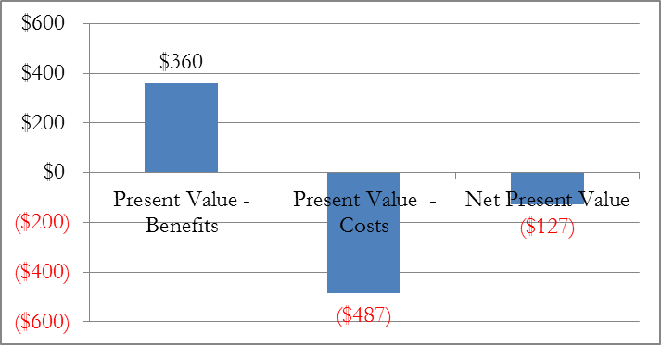

# Cost Benefit Analysis of the Very Small LNG terminal

The purpose of this section is to determine whether the very small (VS) LNG terminal that is proposed to be developed under a Public-Private Partnership arrangement is economically viable. Although the VS LNG terminal will not be directly funded under this loan operation, the loan does provide funding to support the preparation of the PPP structure and bid documents and process to build the proposed VS LNG terminal. To determine the VS LNG terminal’s economic viability, a Cost Benefit Analysis (CBA) was performed on the investment required to build the terminal and convert existing diesel generators running on HFO to burn natural gas instead. The VS LNG terminal was found to have an aggregate net present value (NPV) of approximately US$81 million and internal rate of return of 29% percent. That is, the VS LNG terminal is economically viable.

The analysis to calculate the net present value of the VS LNG terminal is presented as follows:

* Methodology and Assumptions (Section 6.1)
* Economic Costs, Economic Benefits, and Net Economic Benefits of the VS LNG terminal (Section 6.2)
* Sensitivity Analysis of the VS LNG terminal (Section 6.3)

Figure 6.1: Net Economic Benefits of the VS LNG Terminal (US$ ‘000)

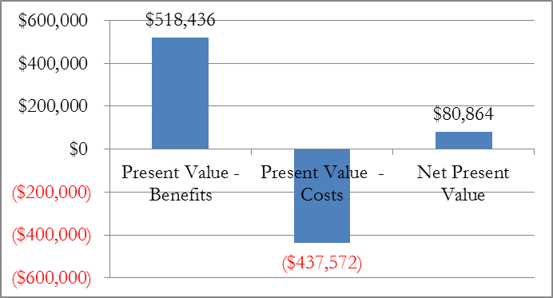

## Methodology and Assumptions

The objective of the CBA methodology is to determine whether or not the VS LNG terminal is economically viable. This is accomplished by estimating the net benefits that the VS LNG terminal will provide.

The VS LNG terminal’s net benefits were determined by calculating the difference in the cost of electricity and greenhouse gas emissions between the project scenario and the counterfactual scenario. The counterfactual scenario is one in which the VS LNG terminal is not built and Barbados’ electricity generation continues to be provided by diesel generators burning imported fuel oil.

The steps to calculate the net benefits of the VS LNG terminal:

* Estimate the economic costs of the VS LNG terminal (Section 6.1.1)
* Estimate the economic benefits of the VS LNG terminal (Section 6.1.2)
* Estimate the present value of the VS LNG terminal’s net economic benefits (Section 6.1.3).

Each of these steps and the assumptions used in their calculation (Section 6.1.4) are described in more detail below:

### Economic costs of the VS LNG terminal

The economic costs of the VS LNG terminal include:

* **Terminal Capital Expenditures (Terminal Capex)**—these are the capital investments needed to complete the project. The capital investments include the costs to design, engineer, and build the proposed VS regasification terminal and related infrastructure in Barbados. Costs associated with the LNG value chain prior to delivery to Barbados (including natural gas production, liquefaction, and LNG shipping costs) are included in the delivered price of LNG.
* **Power Plant Conversion Capital Expenditures (Plant Capex)**— these are the capital investments needed to allow BL&P’s existing units to use natural gas to generate electricity. The capital investments include the costs to retrofit 80 MW of electricity generation capacity and the related infrastructure to bring natural gas to the power plants.
* **Natural gas imports**—these are the annual expenses incurred by importing natural gas through the VS LNG terminal. The economic cost of natural gas imports was calculated as the product of the cost to import a unit of natural gas and the expected volume of imported natural gas. The volume of natural gas imports was calculated as product of the power generation capacity converted to use natural gas, the average capacity factor of the converted power plants, and the heat rate (that is, the efficiency at which they convert fuel to electricity) of the converted power plants. The cost to import natural gas was calculated as the sum of costs to acquire natural gas in the United States, liquefy it, and ship it to Barbados.
* **Incremental CO₂ emissions**—consuming natural gas produces CO₂ emissions, although less than those produced by consuming liquid fuels such as fuel oil, diesel, and LPG. Building the VS LNG terminal will allow greater natural gas consumption than in the BAU scenario, thereby resulting in an increase in CO₂ emissions from natural gas consumption. The economic cost of incremental CO₂ emissionsfrom natural gas consumption was calculated as the product of the expected incremental CO₂ emissions and the social cost of CO₂ emissions. The expected incremental CO₂ emissions is the product of the CO₂ emissions per unit of natural gas consumed and the incremental units of natural gas imported through the expanded facility.

### Economic benefits of the VS LNG terminal

The economic benefits of the VS LNG terminal include:

* **Savings in generation costs**—generating electricity with natural gas potentially costs less than generating electricity from fuel oil. Therefore, the country will save in generation costs by replacing fuel oil generation with natural gas-fired generation. The savings to the country were estimated as the difference between the Total Avoided Cost (‘TAC’) of fuel oil generation and the Total Operating Costs (‘TOC’) of geothermal generation. The TAC is the long run marginal cost of diesel generation. The following formulas were used to calculation the savings in generations costs:
* **Reduction in CO₂ emissions**—generating electricity with natural gas produces less CO₂ emissions than generating electricity with fuel oil. The economic benefit of the reduction in CO₂ emissionswas calculatedas the product of the expected reduction in CO₂ emissions and the social cost of CO₂ emissions. The expected reduction in CO₂ emissions is the product of the CO₂ emissions per unit of electricity produced from fuel oil and the units of electricity produced with natural gas.

### Net Economic Benefits of the VS LNG sub-project

After estimating the VS LNG terminal’s economic costs and benefits, the next step is to calculate the VS LNG terminal’s NPV. This is accomplished by subtracting the present value of the VS LNG terminal’s costs from the present value of the VS LNG terminal’s benefits. The present of the VS LNG terminal’s costs and benefits, was determined using a social discount rate of 12 percent (in real terms). If the present value of the VS LNG terminal’s net benefits is greater than zero, the VS LNG terminal is economically viable.

### Assumptions for the VS LNG terminal

To determine the VS LNG terminal’s net benefits, the annual economic costs and benefits of the VS LNG terminal, for a period of 25 years, were estimated. Table 6.1 presents the assumptions used to calculate the economic costs and benefits of the VS LNG terminal.

Table 6.1: Assumptions Used to Determine the Economic Costs and Benefits of the VS LNG terminal

|  |  |  |
| --- | --- | --- |
| **NG Value chain** |  |  |
| NG premium over HH | % | 20% |
| Liquefaction base cost | US$/MMBtu | 1.75 |
| Liquefaction NG losses | % | 9% |
| Shipping base cost | US$/MMBtu | 1.22 |
| Shipping NG losses | % | 0.75% |
| Regassification OPEX costs | US$/MMBtu | 0.20 |
| Regassification NG losses | % | 1.5% |
|  |  |  |
|  |  |  |
| **Input prices** |  |  |
| CO2 price | US$/ton CO2 | 10.00 |
|  |  |  |
| Retail electricity price base rate | B$/kwh | 0.1345 |
|  |  |  |
| **Fuel characteristics** |  |  |
| Calorific Value HFO | BTU/BBL | 6,287,000 |
| Calorific Value Diesel | BTU/BBL | 5,551,365 |
| Calorific Value LPG | BTU/lb | 21,561 |
| Calorific Value NG | BTU/ft^3 | 1,050 |
| CO2 content - HFO | lbs / MMBtu | 174 |
| CO2 content - Diesel | lbs / MMBtu | 161 |
| CO2 content - LPG | lbs / MMBtu | 150 |
| CO2 content - NG | lbs / MMBtu | 117 |
|  |  |  |
| **Heat rate by plant type** |  |  |
| Low Speed Diesel, HFO (existing) | Btu/kWh | 7,835 |
| Solar | Btu/kWh | - |
| Wind | Btu/kWh | - |
| Low Speed Diesel, NG | Btu/kWh | 7,344 |
|  |  |  |
| **O&M Cost (Fixed & Variable) by plant type** | |  |
| Low Speed Diesel, HFO (existing) | US$/kWh | 0.02 |
| Solar | US$/kW/year | 30.00 |
| Wind | US$/kW/year | 46.00 |
| Low Speed Diesel, NG | US$/kWh | 0.01 |

Assumptions for the avoided cost of fuel oil generation are based on the capital, operating, and maintenance costs of a diesel generator in Barbados. The avoided cost of fuel oil-fired generation is also based on the EIA’s 2015 yearly oil price projections. The 12 percent discount rate is in line with the IDB CBA guidelines.

## Economic Costs, Economic Benefits, and Net Economic Benefits of the VS LNG terminal

This section presents the results of the CBA. When aggregating the economic cost and benefits of the VS LNG terminal, the aggregated net benefits were found to be positive. That means that the VS LNG terminal will generate net economic benefits for Barbados.

Table 6.2 presents the economic costs and benefits of the VS LNG terminal.

Table 6.2: Economic Costs and Benefits of the VS LNG terminal (US$ ‘000)

|  |  |
| --- | --- |
| Present Value - Benefits | $518,436 |
| Present Value - Costs | ($437,572) |
| Net Present Value | $80,864 |
| IRR | 29% |

A detailed schedule of the annual benefits and costs for the VS LNG terminal is included in Appendix A

## Sensitivity Analysis of the VS LNG terminal

A sensitivity analysis was conducted to estimate how changes in key variables used in the CBA would impact the VS LNG terminal’s estimated economic viability. The independent variables that were included in the sensitivity analysis are the price of oil, the price of natural gas, and the price of CO2. These variables were selected based on the likelihood that they could change and they could have a material impact on the VS LNG terminal’s economic viability if they did change.

The VS LNG terminal is most sensitive to changes in the price of oil and the price of natural gas, while it was largely insensitive to changes in the price of CO2. This section discusses in more detail the effects of:

* Changing the price of oil and natural gas
* Changing the price of CO2

Table 6.3 presents the results of changing the price of oil and natural gas[7]. The table shows the present value of the costs, benefits, and net benefits of the VS LNG terminal for a high case (based on WTI and Henry Hub under the EIA 2015 AEO High Oil Price projection) and low case (based on WTI and Henry Hub under the EIA 2015 AEO Low Oil Price projection) as well as the base case (based on annual WTI and Henry Hub price projections in the EIA 2015 Reference Case price projection)2015. The table shows that even under the Low oil price scenario, the VS LNG terminal is economic, with an aggregate ENPV of US$43.1 million and an EIRR of 22%. In the high oil price scenario, the aggregate ENPV increases to US$150 million with an EIRR of 47%.

Table 6.3: CBA Sensitivity to oil and natural gas price (US$ ‘000)

|  |  |  |  |
| --- | --- | --- | --- |
| **Scenario:** | **Base** | **High** | **Low** |
| Present Value - Benefits | $518,436 | $636,476 | $459,224 |
| Present Value - Costs | ($437,572) | ($486,109) | ($416,118) |
| Net Present Value | $80,864 | $150,367 | $43,107 |
| IRR | 29% | 47% | 22% |

Table 6.4 presents the results of changing the price of CO2. The table shows the present value of the costs, benefits, and net benefits of the VS LNG terminal for a high case (annual CO2 prices are US$15 per ton, or 50% higher than the base case projection) and low case (annual CO2 prices are US$6 per ton, or 40% lower than the base case projection) as well as the base case (annual CO2 prices are US$10 per ton). The table shows that even after lowering the CO2 price by 40%, the VS LNG terminal remains economically viable, with an aggregate NPV of US$78 million. In the high CO2 price scenario, the aggregate NPV increases to US$84 million.

Table 6.4: CBA Sensitivity to CO2 price (US$ ‘000)

|  |  |  |  |
| --- | --- | --- | --- |
| **Scenario:** | **Base** | **High** | **Low** |
| US$/tCO2: | 10.00 | 15.00 | 6.00 |
| Present Value - Benefits | $518,436 | $527,754 | $510,981 |
| Present Value - Costs | ($437,572) | ($443,454) | ($432,866) |
| Net Present Value | $80,864 | $84,300 | $78,116 |
| IRR | 29% | 29% | 28% |

In a “worst case” scenario in which all three variables are set to the Low value (a low oil and natural gas price and a low CO2 price), the VS LNG terminal sub-project remains economically viable. As shown in Figure 6.2, the VS LNG terminal under a worst case scenario has an economic NPV of US$33 million and EIRR of 22%.

Figure 6.2: Net Economic Benefits of the VS LNG terminal sub-project under a worst case scenario (‘000 US$)

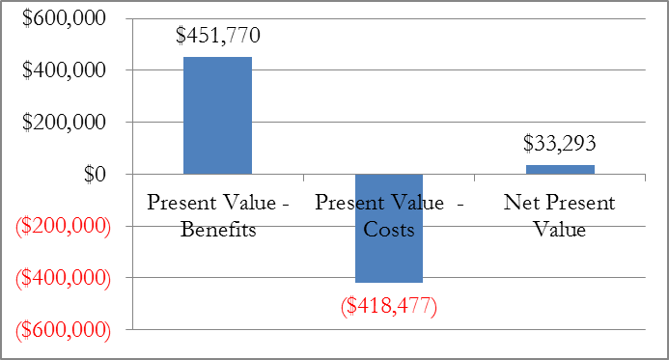

# Cost Benefit Analysis of All Sub-Projects

This section shows the aggregate economic viability of the three main sub-projects of the loan operation. Among other investments, the Program will fund the micro-LNG facility expansion, natural gas compressor replacement, an 850 kW wind turbine, and 300 kW of PV systems.

To determine the aggregate project’s economic viability, a Cost Benefit Analysis (CBA) was performed on the sub-projects that it will fund noted above. The sub-projects were found to have an aggregate net present value (NPV) of approximately US$9.8 million. Figure 7.1 shows the aggregate present value benefits, costs and net present value of the sub-projects included in the analysis.

Figure 7.1: Net Economic Benefits of the Sub-Projects (not including the VS LNG terminal) (US$ ‘000)

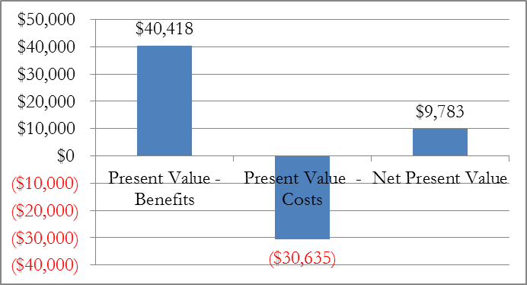

Table 7.1 presents the economic costs and benefits of the aggregated sub-projects.

Table 7.1: Economic Costs and Benefits of all Sub-Project except the VS LNG terminal (US$ ‘000)

|  |  |
| --- | --- |
| Present Value - Benefits | $40,418 |
| Present Value - Costs | ($30,635) |
| Net Present Value | $9,783 |
| IRR | 25% |

The sensitivity analyses that were conducted on each sub-project were aggregated to examine the impact of changing key variables on the total project economic viability. The aggregated results shown here show the impact of a “worst case” scenario.

In a “worst case” scenario in which all variables are set to the Low value (a low oil and natural gas price, a low CO2 price, and low utilization rates for the RE technologies), the total project is still economically viable. As shown in Figure 6.2, the total project under a worst case scenario has an economic NPV of US$6.9 million and EIRR of 22%.

Figure 7.2: Net Economic Benefits of the total project under a worst case scenario (‘000 US$)

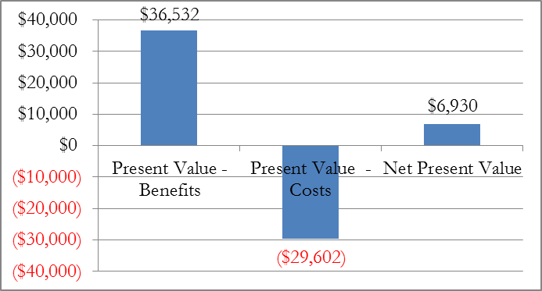

## Total Project with the VS LNG

If the VS LNG terminal is included in the analysis, the aggregate net present value is increased to US$88.9 million owing to the large size of the investment in the VS LNG terminal. The economic internal rate of return increases to 28%. Figure 7.2 and Table 7.2 show the aggregate present value benefits, costs, and net present value for the aggregate sub-projects including the VS LNG terminal.

Figure 7.3: Net Economic Benefits of the Sub-Projects (including the VS LNG terminal) (US$ ‘000)

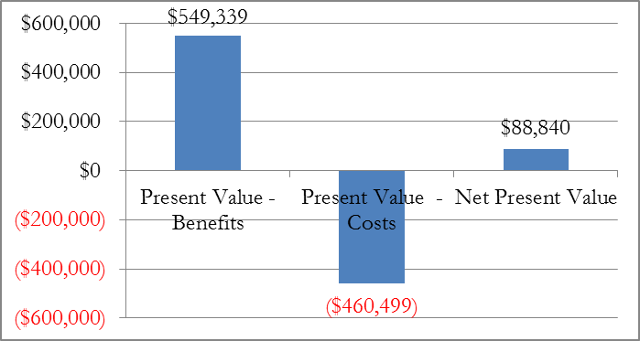

Table 7.3: Aggregated Economic Costs and Benefits of all sub-project including the VS LNG terminal (US$ ‘000)

|  |  |
| --- | --- |
| Present Value - Benefits | $549,339 |
| Present Value - Costs | ($460,499) |
| Net Present Value | $88,840 |
| IRR | 28% |

The sensitivity analyses that were conducted on each sub-project including the VS LNG terminal were aggregated to examine the impact of changing key variables on the total project economic viability. In a “worst case” scenario in which all variables are set to the Low value (a low oil and natural gas price, a low CO2 price, and low utilization rates for the RE technologies), the total project is still economically viable. As shown in Figure 7.4, the total project under a worst case scenario has an economic NPV of US$46.7 million and EIRR of 22%.

Figure 7.4: Net Economic Benefits of the total project under a worst case scenario (‘000 US$)

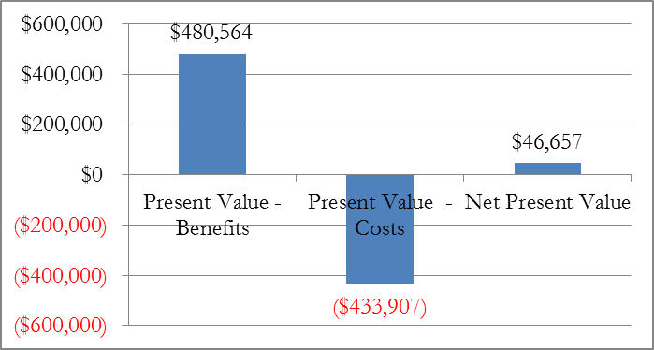

Section B: Financial Analysis

# Introduction

The Inter-American Development Bank (IDB) is preparing a loan operation (Loan BA-L1012) for the Government of Barbados (GOB) to support the deployment of cleaner fuels and renewable energies in the country. This operation will be a loan to be executed by the National Petroleum Corporation (NPC) of Barbados. The main objective is to support Barbados’ energy security by enhancing the energy sector as well as promoting the introduction of cleaner fuels such as natural gas (NG) in the form of liquefied natural gas (LNG) and the implementation of smart energy solutions such as photovoltaic power systems for NG production activities and design of new smart and green energy public buildings.

This Section presents the Financial Analysis of the sub-projects noted in the CBA in Section A. The Financial Analysis is carried out to examine the financial viability of the projects from the point of view of the NPC, the project Executing Agency. The analysis will determine if the individual sub-projects and the project as a whole are financially viable for the company and if the resulting cash flows will be sufficient to cover the costs of the proposed IDB loan operation to finance the investments.

This financial analysis suggests that the sub-projects that were analyzed will generate an aggregate Net Present Value of **US$9.7million[8]** and an **internal rate of return of 15 percent** over a 25 year period for NPC.

This section presents the financial analysis in detail as follows:

* **Financial Analysis of the micro LNG facility expansion sub-project**—shows that the expansion of the micro-LNG facility is profitable for NPC. It does so by showing that the sub-project’s NPV is positive and the internal rate of return exceeds the discount rate. The debt coverage ratio is also acceptable throughout the loan period. The section also presents the assumptions and methodology used to calculate these results (Section 9).
* **Financial Analysis of the compressor replacement sub-project**—shows that the replacement of the natural gas compressors is profitable for NPC. It does so by showing that the sub-project’s NPV is positive and the internal rate of return exceeds the discount rate. The debt coverage ratio is also acceptable throughout the loan period. The section also presents the assumptions and methodology used to calculate these results (Section 10).
* **Financial Analysis of the 850 kW wind turbine sub-project**—shows that the 850 kW wind turbine is profitable for NPC. It does so by showing that the sub-project’s NPV is positive and the internal rate of return exceeds the discount rate. The debt coverage ratio is also acceptable throughout the loan period. The section also presents the assumptions and methodology used to calculate these results (Section 11).
* **Financial Analysis of the 300kW PV system sub-project**—shows that the installation of a 300 kW PV system is profitable for NPC. It does so by showing that the sub-project’s NPV is positive and the internal rate of return exceeds the discount rate. The debt coverage ratio is also acceptable throughout the loan period. The section also presents the assumptions and methodology used to calculate these results (Section 12)
* **Financial Analysis of the VS LNG terminal**—shows that the VS LNG terminal is profitable for NPC. It does so by showing that the sub-project’s NPV is positive and the internal rate of return exceeds the discount rate. The debt coverage ratio is also acceptable throughout the loan period. The section also presents the assumptions and methodology used to calculate these results (Section 13).
* **Financial Analysis of all Sub-Projects**—aggregates the results presented in the previous sections to show the profitability and financial viability of the loan operation sub-projects as a whole (Section 14).

## Financial Analysis Variables and Assumptions

The financial analysis is based on the revenue and expense streams for each of the sub-projects identified in the CBA above. For each sub-project, the CBA assumptions and calculations for the expected benefits and costs were used to calculate the expected annual income and the annual expenses that accrue to NPC as a result of the sub-project. Table 8.1 shows the specific loan terms, including the interest rate and tenor, Barbados’ tax rate, and the straight line depreciation period that were used for the financial analysis. These factors were applied to calculate the sub-projects’ earnings, net cash flow, and debt coverage ratios for each of the 25 years included in the analysis. This series of future cash flows was then used to calculate the NPV and the internal rate of return (IRR) from NPC’s perspective.

Table 8.1 Financial Analysis Assumptions and Variables

|  |  |  |
| --- | --- | --- |
| **Financial variables** |  |  |
| Tax rate | % | 25% |
| Depreciation period (straight line) | years | 15 |
| Interest rate | % | 1.65% |
| Loan period | years | 25 |
| Real discount rate | % | 12% |
|  |  |  |

# Financial Analysis of the Micro-LNG Facility Expansion Sub-Project

The purpose of this section is to determine whether the expansion of the micro-LNG facility that will be funded under the proposed loan operation (the Project) is financially viable for NPC. The financial analysis described below finds that the sub-project has a net present value (NPV) to NPC of approximately US$ 222,000 and internal rate of return of 13% percent. That is, the sub-project would be profitable for NPC. Finally, the financial analysis showed that the debt coverage ratio (defined as the annual cash flow generated by the sub-projects divided by the annual payments required for the loan interest and principle repayments) is never lower than 2.55. This means the project will generate sufficient cash flow to cover operating expenses and debt repayment obligations in any given year.

The analysis to calculate the net present value of the sub-projects is presented as follows:

* Financial Analysis (Section 9.1)
* Profitability (Section 9.2)

## Financial Analysis

The objective of the financial analysis is to determine whether or not the micro-LNG facility expansion is profitable. This is accomplished by estimating the net financial flows that the sub-project will generate.

The sub-project’s net financial flows were determined by calculating the projects income and expenses, applying factors such as the loan interest rate, loan period, depreciation rate, and the Barbados corporate tax rate as described in Section 8.1. This analysis results in the expected cash flows attributable to the project for each year of the loan’s 25 year period. These cash flows are then converted to the sub-project NPV and IRR using a 12 percent real discount rate.

The steps to calculate the sub-project profitability are:

* Estimate the annual income associated with expanding the micro-LNG facility (Section 9.1.1)
* Estimate the annual expenses associated with expanding the micro-LNG facility (Section 9.1.2)
* Calculate the annual cash flows resulting from the associated income and expenses, based on the financial and tax variables noted in section 8.1 above (Section 9.1.3).

Each of these steps and the assumptions used in their calculation are described in more detail below.

### Income of the micro-LNG expansion sub-project

The sources of income associated with the sub-project include:

* **Natural gas sales**—NPC will sell the natural gas that it imports to new and existing customers. The total income from natural gas sales is the product of the number of natural gas units sold and the price per unit.

### Expenses of the micro-LNG expansion sub-project

The costs associated with the sub-project include:

* **Capital Expenditures (Capex)**—these are the capital investments needed to complete the sub-project. The capital investments include the costs for the physical upgrades to the micro-LNG site, LNG receiving and handling systems to accommodate the increased LNG through-put volumes, on-site LNG storage, additional ISO containers, new electric compressors and associated systems, and related consulting costs for the expansion design, engineering and procurement. NPC provided detailed estimates of the Capex required for the sub-projects as part of the loan procurement plan. The estimated Capex for the micro-LNG expansion is US$3.9 million.
* **Operational Expenditures (Opex)**—these are the annual expenses incurred to operate and maintain the micro-LNG facility and related infrastructure. Operating expenses include fixed costs that are not directly dependent on the volume of natural gas processes, such as personnel and land costs, and variable costs that are a function of the volume of natural gas, such as electricity consumed by the natural gas compressors and NG losses in the regasification process.
* **Natural gas purchases**—these are the annual expenses incurred by purchasing natural gas on the international markets to import through the expanded facility. The cost of natural gas imports was calculated as the product of the cost to import a unit of natural gas and the expected incremental volume of imported natural gas. The volume of incremental natural gas imports was calculated as the minimum of Barbados’ incremental natural gas supply gap and the maximum capacity of the expanding micro-LNG facility. The incremental natural gas supply gap was calculated as the sum of cumulative decline in domestic natural gas production from BNOCL (estimated from the reported decline in natural gas production from 2013 to 2015) plus new natural gas demand from NPC’s existing and planned new customers.
* **Loan interest payments**—these are the financing charges for the IDB loan for the capital investment in the sub-project. According to the IDB, the loan terms include an interest rate of LIBOR + 1.15 percent (currently roughly 1.65%) and a 25 year repayment period,
* **Corporate taxes**—these are the taxes that NPC must pay on the profits that are generated by the sub-project. Barbados’ corporate tax rate is currently 25%. This rate was applied to the sub-project earnings after deducting interest and amortization expenses. The sub-project assets were assumed to be amortized with a 15-year straight line depreciation. The full corporate tax rate was assumed to be applied to the sub-project.

### Cash flows of the micro-LNG expansion sub-project

After estimating the sub-project’s associated income and expenses, the next step is to calculate the sub-project’s annual cash flow. This is accomplished by subtracting the present value of the sub-project’s costs from the present value of the sub-project’s benefits. The present value of the sub-project’s costs and benefits, was determined using a social discount rate of 12 percent (in real terms). If the present value of the sub-project’s net benefits is greater than zero, the sub-project is economically viable.

## Profitability of the micro-LNG expansion sub-project

This section presents the results of the financial analysis for the micro-LNG expansion. The sub-project’s net present value is US$ 222,000 and the IRR is 13%. The positive NPV and IRR above the 12% hurdle rate means that expanding the micro-LNG facility will generate a net profit for NPC. In addition, the minimum debt coverage ratio in any given year is 2.55. This indicates that the sub-project will generate sufficient cash flows to cover operating expenses and debt repayment obligations in any given year.

Table 9.2 presents the financial summary of the micro-LNG expansion sub-project.

Table 9.2: Financial summary of the micro-LNG expansion sub-project (US$ ‘000)

|  |  |
| --- | --- |
| Net Present Value | $222 |
| IRR | 13% |

A detailed schedule of the annual cash flow calculations for the micro-LNG expansion sub-project is included in Appendix B.

# Financial Analysis of the Compressor Replacement Sub-Project

The purpose of this section is to determine whether the compressor replacement sub-project that will be funded under the proposed loan operation (the Project) is financially viable for NPC. The financial analysis described below finds that the sub-project has a net present value (NPV) to NPC of approximately US$513,000 and internal rate of return of 20% percent. That is, the sub-project would be profitable for NPC. Finally, the financial analysis showed that the debt coverage ratio (defined as the annual cash flow generated by the sub-projects divided by the annual payments required for the loan interest and principle repayments) is never lower than 3.05. This means the project will generate sufficient cash flow to cover operating expenses and debt repayment obligations in any given year.

The analysis to calculate the net present value of the sub-projects is presented as follows:

* Financial Analysis (Section 10.1)
* Profitability (Section 10.2)

## Financial Analysis

The objective of the financial analysis is to determine whether or not the compressor replacement is profitable. This is accomplished by estimating the net financial flows that the sub-project will generate.

The sub-project’s net financial flows were determined by calculating the projects income and expenses, applying factors such as the loan interest rate, loan period, depreciation rate, and the Barbados corporate tax rate as described in Section 8.1. This analysis results in the expected cash flows attributable to the project for each year of the loan’s 25 year period. These cash flows are then converted to the sub-project NPV and IRR using a 12 percent real discount rate.

The steps to calculate the sub-project profitability are:

* Estimate the annual income associated with the compressor replacement (Section 10.1.1)
* Estimate the annual expenses associated with the compressor replacement (Section 10.1.2)
* Calculate the annual cash flows resulting from the associated income and expenses, based on the financial and tax variables noted in section 8.1 above (Section 10.1.3).

Each of these steps and the assumptions used in their calculation are described in more detail below.

### Income of the compressor replacement sub-project

The sources of income associated with the sub-project include:

* **Natural gas sales**—NPC will sell the natural gas that it saves from converting the compressors to electricity. NPC estimates that converting the compressors will save roughly 90 million cubic feet of natural gas per year (MMcf per year). The total income from natural gas sales is the product of the number of natural gas units that are saved from the conversion and the price per unit.

### Expenses of the compressor replacement sub-project

The costs associated with the sub-project include:

* **Capital Expenditures (Capex)**—these are the capital investments needed to complete the sub-project. The capital investments include the costs for the new compressors, and related consulting costs for the engineering, procurement, and installation. NPC provided detailed estimates of the Capex required for the sub-projects as part of the loan procurement plan. The estimated Capex for the new compressors is US$913,000.
* **Operational Expenditures (Opex)**—these are the annual expenses incurred to operate and maintain (O&M) the compressors and purchase the electricity required to operate them. The compressors’ annual O&M expenses are estimated to be 1.5% of the Capex, or US$13,700 per year. The cost of electricity is estimated to be the product of the electricity consumption and the price NPC pays for electricity. NPC estimated that the compressors would consume 2,050 kWh per year.
* **Loan interest payments**—these are the financing charges for the IDB loan for the capital investment in the sub-project. According to the IDB, the loan terms include an interest rate of LIBOR + 1.15 percent (currently roughly 1.65%) and a 25 year repayment period,
* **Corporate taxes**—these are the taxes that NPC must pay on the profits that are generated by the sub-project. Barbados’ corporate tax rate is currently 25%. This rate was applied to the sub-project earnings after deducting interest and amortization expenses. The sub-project assets were assumed to be amortized with a 15-year straight line depreciation. The full corporate tax rate was assumed to be applied to the sub-project.

### Cash flows of the compressor replacement sub-project

After estimating the sub-project’s associated income and expenses, the next step is to calculate the sub-project’s annual cash flow. This is accomplished by subtracting the present value of the sub-project’s costs from the present value of the sub-project’s benefits. The present value of the sub-project’s costs and benefits, was determined using a social discount rate of 12 percent (in real terms). If the present value of the sub-project’s net benefits is greater than zero, the sub-project is economically viable.

## Profitability of the compressor replacement sub-project

This section presents the results of the financial analysis for the compressor replacement sub-project. The sub-project’s net present value is US$513,000 and the IRR is 20%. The positive NPV and IRR above the 12% hurdle rate means that replacing the compressors will generate a net profit for NPC. In addition, the minimum debt coverage ratio in any given year is 3.05. This indicates that the sub-project will generate sufficient cash flows to cover operating expenses and debt repayment obligations in any given year.

Table 10.2 presents the financial summary of the compressor replacement sub-project.

Table 10.2: Financial summary of the compressor replacement sub-project (US$ ‘000)

|  |  |
| --- | --- |
| Net Present Value | $513 |
| IRR | 20% |

A detailed schedule of the annual cash flow calculations for the compressor replacement sub-project is included in Appendix B.

# Financial Analysis of the Wind Turbine Sub-Project

The purpose of this section is to determine whether the wind turbine sub-project that will be funded under the proposed loan operation (the Project) is financially viable for NPC. The financial analysis described below finds that the sub-project has a net present value (NPV) to NPC of approximately US$1.0 million and internal rate of return of 20% percent. That is, the sub-project would be profitable for NPC. Finally, the financial analysis showed that the debt coverage ratio (defined as the annual cash flow generated by the sub-projects divided by the annual payments required for the loan interest and principle repayments) is never lower than 3.60. This means the project will generate sufficient cash flow to cover operating expenses and debt repayment obligations in any given year.

The analysis to calculate the net present value of the sub-projects is presented as follows:

* Financial Analysis (Section 11.1)
* Profitability (Section 11.2)

## Financial Analysis

The objective of the financial analysis is to determine whether or not the wind turbine sub-project is profitable. This is accomplished by estimating the net financial flows that the sub-project will generate.

The sub-project’s net financial flows were determined by calculating the projects income and expenses, applying factors such as the loan interest rate, loan period, depreciation rate, and the Barbados corporate tax rate as described in Section 8.1. This analysis results in the expected cash flows attributable to the project for each year of the loan’s 25 year period. These cash flows are then converted to the sub-project NPV and IRR using a 12 percent real discount rate.

The steps to calculate the sub-project profitability are:

* Estimate the annual income associated with the wind turbine (Section 11.1.1)
* Estimate the annual expenses associated with the wind turbine (Section 11.1.2)
* Calculate the annual cash flows resulting from the associated income and expenses, based on the financial and tax variables noted in section 8.1 above (Section 11.1.3).

Each of these steps and the assumptions used in their calculation are described in more detail below.

### Income of the wind turbine sub-project

The sources of income associated with the sub-project include:

* **Avoided electricity purchases and excess electricity sales**—NPC will use the electricity generated by the wind turbines to offset its purchases of electricity from BL&P. If the wind turbine generates more electricity than NPC requires, it intends to sell the excess to BL&P. This analysis assumes that the price for both avoided electricity purchases and electricity sales is the same and is equal to the current electricity rate for large industrial consumers. The total income from avoided electricity purchases or excess electricity sales is the product of the amount of electricity produced by the wind turbine and the retail price per unit of electricity.

### Expenses of the wind turbine sub-project

The costs associated with the sub-project include:

* **Capital Expenditures (Capex)**—these are the capital investments needed to complete the sub-project. The capital investments include the costs for the wind turbine and related consulting costs for the wind turbine engineering, procurement and installation. NPC provided detailed estimates of the Capex required for the sub-projects as part of the loan procurement plan. The estimated Capex for the wind turbine is US$1.9 million.
* **Operational Expenditures (Opex)**—these are the annual expenses incurred to operate and maintain the wind turbine and related infrastructure. Operating expenses are largely fixed costs that are not directly dependent on the volume of electricity produced. Wind turbine Opex costs are estimated to be US$46 per kW of installed capacity per year.
* **Loan interest payments**—these are the financing charges for the IDB loan for the capital investment in the sub-project. According to the IDB, the loan terms include an interest rate of LIBOR + 1.15 percent (currently roughly 1.65%) and a 25 year repayment period,
* **Corporate taxes**—these are the taxes that NPC must pay on the profits that are generated by the sub-project. Barbados’ corporate tax rate is currently 25%. This rate was applied to the sub-project earnings after deducting interest and amortization expenses. The sub-project assets were assumed to be amortized with a 15-year straight line depreciation. The full corporate tax rate was assumed to be applied to the sub-project.

### Cash flows of the wind turbine sub-project

After estimating the sub-project’s associated income and expenses, the next step is to calculate the sub-project’s annual cash flow. This is accomplished by subtracting the present value of the sub-project’s costs from the present value of the sub-project’s benefits. The present value of the sub-project’s costs and benefits, was determined using a social discount rate of 12 percent (in real terms). If the present value of the sub-project’s net benefits is greater than zero, the sub-project is economically viable.

## Profitability of the wind turbine sub-project

This section presents the results of the financial analysis for the wind turbine. The sub-project’s net present value is US$1,004,000 and the IRR is 20%. The positive NPV and IRR above the 12% hurdle rate means that expanding the wind turbine will generate a net profit for NPC. In addition, the minimum debt coverage ratio in any given year is 3.60. This indicates that the sub-project will generate sufficient cash flows to cover operating expenses and debt repayment obligations in any given year.

Table 11.2 presents the financial summary of the wind turbine sub-project.

Table 11.2: Financial summary of the wind turbine sub-project (US$ ‘000)

|  |  |
| --- | --- |
| Net Present Value | $1,004 |
| IRR | 20% |

A detailed schedule of the annual cash flow calculations for the wind turbine sub-project is included in Appendix B.

# Financial Analysis of the PV System Sub-Project

The purpose of this section is to determine whether the PV system sub-project that will be funded under the proposed loan operation (the Project) is financially viable for NPC. The financial analysis described below finds that the sub-project has a net present value (NPV) to NPC of approximately US$101,000 and internal rate of return of 15% percent. That is, the sub-project would be profitable for NPC. Finally, the financial analysis showed that the debt coverage ratio (defined as the annual cash flow generated by the sub-projects divided by the annual payments required for the loan interest and principle repayments) is never lower than 2.69. This means the project will generate sufficient cash flow to cover operating expenses and debt repayment obligations in any given year.

The analysis to calculate the net present value of the sub-projects is presented as follows:

* Financial Analysis (Section 12.1)
* Profitability (Section 12.2)

## Financial Analysis

The objective of the financial analysis is to determine whether or not the PV system sub-project is profitable. This is accomplished by estimating the net financial flows that the sub-project will generate.

The sub-project’s net financial flows were determined by calculating the projects income and expenses, applying factors such as the loan interest rate, loan period, depreciation rate, and the Barbados corporate tax rate as described in Section 8.1. This analysis results in the expected cash flows attributable to the project for each year of the loan’s 25 year period. These cash flows are then converted to the sub-project NPV and IRR using a 12 percent real discount rate.

The steps to calculate the sub-project profitability are:

* Estimate the annual income associated with the PV system (Section 12.1.1)
* Estimate the annual expenses associated with the PV system (Section 12.1.2)
* Calculate the annual cash flows resulting from the associated income and expenses, based on the financial and tax variables noted in section 8.1 above (Section 12.1.3).

Each of these steps and the assumptions used in their calculation are described in more detail below.

### Income of the PV system sub-project

The sources of income associated with the sub-project include:

* **Avoided electricity purchases and excess electricity sales**—NPC will use the electricity generated by the PV systems to offset its purchases of electricity from BL&P. If the PV system generates more electricity than NPC requires, it intends to sell the excess to BL&P. This analysis assumes that the price for both avoided electricity purchases and electricity sales is the same and is equal to the current electricity rate for large industrial consumers. The total income from avoided electricity purchases or excess electricity sales is the product of the amount of electricity produced by the PV system and the retail price per unit of electricity.

### Expenses of the PV system sub-project

The costs associated with the sub-project include:

* **Capital Expenditures (Capex)**—these are the capital investments needed to complete the sub-project. The capital investments include the costs for the PV system and related consulting costs for the PV system engineering, procurement and installation. The estimated Capex for the PV system is US$540,000.
* **Operational Expenditures (Opex)**—these are the annual expenses incurred to operate and maintain the PV system and related infrastructure. Operating expenses are largely fixed costs that are not directly dependent on the volume of electricity produced. PV system Opex costs are estimated to be US$30 per kW of installed capacity per year.
* **Loan interest payments**—these are the financing charges for the IDB loan for the capital investment in the sub-project. According to the IDB, the loan terms include an interest rate of LIBOR + 1.15 percent (currently roughly 1.65%) and a 25 year repayment period,
* **Corporate taxes**—these are the taxes that NPC must pay on the profits that are generated by the sub-project. Barbados’ corporate tax rate is currently 25%. This rate was applied to the sub-project earnings after deducting interest and amortization expenses. The sub-project assets were assumed to be amortized with a 15-year straight line depreciation. The full corporate tax rate was assumed to be applied to the sub-project.

### Cash flows of the PV system sub-project

After estimating the sub-project’s associated income and expenses, the next step is to calculate the sub-project’s annual cash flow. This is accomplished by subtracting the present value of the sub-project’s costs from the present value of the sub-project’s benefits. The present value of the sub-project’s costs and benefits, a social discount rate of 12 percent (in real terms). If the present value of the sub-project’s net benefits is greater than zero, the sub-project is economically viable.

## Profitability of the PV system sub-project

This section presents the results of the financial analysis for the PV system. The sub-project’s net present value is US$101,000 and the IRR is 15%. The positive NPV and IRR above the 12% hurdle rate means that expanding the PV system will generate a net profit for NPC. In addition, the minimum debt coverage ratio in any given year is 2.69. This indicates that the sub-project will generate sufficient cash flows to cover operating expenses and debt repayment obligations in any given year.

Table 12.2 presents the financial summary of the PV system sub-project.

Table 12.2: Financial summary of the PV system sub-project (US$ ‘000)

|  |  |
| --- | --- |
| Net Present Value | $101 |
| IRR | 15% |

A detailed schedule of the annual cash flow calculations for the PV system sub-project is included in Appendix B.

# Financial Analysis of the VS LNG terminal Sub-Project

The purpose of this section is to determine whether the proposed VS LNG terminal is financially viable for NPC. The financial analysis described below finds that the sub-project has a net present value (NPV) to NPC of approximately US$20.2 million and internal rate of return of 17% percent. That is, the sub-project would be profitable for NPC. Finally, the financial analysis showed that the debt coverage ratio (defined as the annual cash flow generated by the sub-projects divided by the annual payments required for the loan interest and principle repayments) is never lower than 3.23. This means the project will generate sufficient cash flow to cover operating expenses and debt repayment obligations in any given year.

The analysis to calculate the net present value of the sub-projects is presented as follows:

* Financial Analysis (Section 13.1)
* Profitability (Section 13.2)

## Financial Analysis

The objective of the financial analysis is to determine whether or not the VS LNG terminal is profitable. This is accomplished by estimating the net financial flows that the sub-project will generate.

The sub-project’s net financial flows were determined by calculating the projects income and expenses, applying factors such as the loan interest rate, loan period, depreciation rate, and the Barbados corporate tax rate as described in Section 8.1. This analysis results in the expected cash flows attributable to the project for each year of the loan’s 25 year period. These cash flows are then converted to the sub-project NPV and IRR using a 12 percent real discount rate.

The steps to calculate the sub-project profitability are:

* Estimate the annual income associated with the VS LNG terminal (Section 13.1.1)
* Estimate the annual expenses associated with the VS LNG terminal (Section 13.1.2)
* Calculate the annual cash flows resulting from the associated income and expenses, based on the financial and tax variables noted in section 8.1 above (Section 13.1.3).

Each of these steps and the assumptions used in their calculation are described in more detail below.

### Income of the VS LNG terminal sub-project

The sources of income associated with the sub-project include:

* **Natural gas sales**—NPC will sell the natural gas that it imports to BL&P. The total income from natural gas sales is the product of the number of natural gas units sold and the price per unit.

### Expenses of the VS LNG terminal sub-project

The costs associated with the sub-project include:

* **Capital Expenditures for the VS LNG terminal (Terminal Capex)**—these are the capital investments needed to complete the sub-project. The capital investments include the costs for the physical upgrades to the LNG terminal site, LNG receiving and handling systems, on-site LNG storage, and related consulting costs for the terminal’s design, engineering, procurement, and construction. NPC provided detailed estimates of the Capex required for the sub-projects as part of the loan procurement plan. NPC estimates that the VS LNG terminal Capex will be US$83 million
* **Operational Expenditures (Opex)**—these are the annual expenses incurred to operate and maintain the VS LNG terminal and related infrastructure. Operating expenses include fixed costs that are not directly dependent on the volume of natural gas processes, such as personnel and land costs, and variable costs that are a function of the volume of natural gas, such as NG losses in the regasification process. Opex is estimated to be US$0.20 per MMBtu of imported LNG plus 1.5% of the imported LNG volume lost in the regasification process, plus 5% of the project Capex for transporting the natural gas to BL&P’s power stations.
* **Natural gas purchases**—these are the annual expenses incurred by purchasing natural gas on the international markets to import through the VS LNG terminal. The cost of natural gas imports was calculated as the product of the cost to import a unit of natural gas and the expected volume of imported natural gas. The volume of natural gas imports was calculated as the product of electricity generation capacity to be converted to use natural gas (80 MW according to BL&P), the capacity factor (estimated to be 70%, and the electricity generation technology heat rate (estimated to be 7,344 Btu/kWh). The cost of imported natural gas is calculated as the product of the price of natural gas at the source (Henry Hub), the cost of liquefaction, and the cost of shipping (see Section 6.1.1 for further details on these calculations).
* **Loan interest payments**—these are the financing charges for the IDB loan for the capital investment in the sub-project. According to the IDB, the loan terms include an interest rate of LIBOR + 1.15 percent (currently roughly 1.65%) and a 25 year repayment period.
* **Corporate taxes**—these are the taxes that NPC must pay on the profits that are generated by the sub-project. Barbados’ corporate tax rate is currently 25%. This rate was applied to the sub-project earnings after deducting interest and amortization expenses. The sub-project assets were assumed to be amortized with a 15-year straight line depreciation. The full corporate tax rate was assumed to be applied to the sub-project.

### Cash flows of the VS LNG terminal sub-project

After estimating the sub-project’s associated income and expenses, the next step is to calculate the sub-project’s annual cash flow. This is accomplished by subtracting the present value of the sub-project’s costs from the present value of the sub-project’s benefits. The present value of the sub-project’s costs and benefits, was determined using a social discount rate of 12 percent (in real terms). If the present value of the sub-project’s net benefits is greater than zero, the sub-project is economically viable.

## Profitability of the VS LNG terminal sub-project

This section presents the results of the financial analysis for the VS LNG terminal. The sub-project’s net present value is US$20,161 million and the IRR is 17%. The positive NPV and IRR above the 12% hurdle rate means that expanding the VS LNG terminal will generate a net profit for NPC. In addition, the minimum debt coverage ratio in any given year is 3.23. This indicates that the sub-project will generate sufficient cash flows to cover operating expenses and debt repayment obligations in any given year.

Table 13.2 presents the financial summary of the VS LNG termianl sub-project.

Table 13.2: Financial summary of the VS LNG terminal sub-project (US$ ‘000)

|  |  |
| --- | --- |
| Net Present Value | $20,161 |
| IRR | 17% |

A detailed schedule of the annual cash flow calculations for the VS LNG terminal sub-project is included in Appendix B.

# Financial Analysis of All Sub-Projects

This section shows the aggregate profitability to NPC of the three main sub-projects of the loan operation. To determine the aggregate project’s economic viability, a Cost Benefit Analysis (CBA) was performed on the sub-projects that it will fund noted above. The main sub-projects (not including the VS LNG terminal) have an aggregate net present value (NPV) of approximately US$9.7 million.

Table 14.1 presents the aggregate net present value and IRR of the sub-projects. The combined total of the sub-projects shows positive NPV and an IRR that exceeds the 12 percent discount rate. Therefore the aggregate of the individual sub-projects is profitable for NPC.

Table 14.1: Financial Summary of all Sub-Projects except the VS LNG terminal (US$ ‘000)

|  |  |
| --- | --- |
| Net Present Value | $9,661 |
| IRR | 15% |

If the VS LNG terminal is included in the analysis, the aggregate net present value is increased to US$81.2 million owing to the large size of the investment and cash flows associated with the VS LNG terminal. The internal rate of return increases to 16%. Table 14.2 shows the net present value and IRR for the aggregate sub-projects including the VS LNG terminal.

Table 14.2: Financial Summary of all sub-project including the VS LNG terminal (US$ ‘000)

|  |  |
| --- | --- |
| Net Present Value | $81,191 |
| IRR | 16% |

#### Appendix A: Annual Economic Costs and Benefits of the Loan Sub-Projects

This Appendix presents the schedule of the annual economic costs and benefits of the sub-projects that were analyzed in the CBA. The schedules show the annual net cost-benefit from each sub-project and the net present value and economic rates of return.

Table A.1: Schedule of Annual Economic Costs and Benefits of the micro-LNG facility expansion and compressor replacement sub-project



Table A.2: Schedule of Annual Economic Costs and Benefits of the wind turbine sub-project



Table A.3: Schedule of Annual Economic Costs and Benefits of the PV system sub-project



Table A.4: Schedule of Annual Economic Costs and Benefits of the VS LNG terminal sub-project



#### Appendix B: Annual Cash Flows of the Loan Sub-Projects

This Appendix presents the schedule of the annual income and expenses of the sub-projects that were analyzed in the financial analysis. The schedules show the annual net cash flows from each sub-project and the net present value and internal rates of return.

Table B.1: Schedule of Annual Financial Cash Flows of the micro-LNG facility expansion sub-project



Table B.2: Schedule of Annual Financial Cash Flows of the compressor replacement sub-project



Table B.3: Schedule of Annual Financial Cash Flows of the wind turbine sub-project



Table B.4: Schedule of Annual Financial Cash Flows of the PV system sub-project



Table B.5: Schedule of Annual Financial Cash Flows of the VS LNG terminal sub-project



1. Assuming a real discount rate of 12 percent.
2. Fuel characteristics are based on data from the EIA: https://www.eia.gov/tools/faqs/faq.cfm?id=73&t=11
3. “Barbados Wind and Solar Integration Study” February 12, 2105. Prepared by GE Energy Consulting at the request of BL&P.
4. “2012 Integrated Resource Plan”, completed February 28,2014 by BL&P
5. “Barbados Wind and Solar Integration Study” February 12, 2105. Prepared by GE Energy Consulting at the request of BL&P.
6. “2012 Integrated Resource Plan”, completed February 28,2014 by BL&P
7. As explained above (¶3.3) the EIA's crude oil and natural gas price projections are linked to demonstrate the impact of the common assumptions that are inherent in each price scenario.
8. Assuming a real discount rate of 12 percent.