###### DOCUMENT OF THE INTER-AMERICAN DEVELOPMENT BANK

[](http://www.google.com/url?sa=i&rct=j&q=&esrc=s&source=images&cd=&cad=rja&uact=8&ved=0ahUKEwiNtLjm0qLOAhVE92MKHWtGAGkQjRwIBw&url=http://www.iadb.org/en/salud-mesoamerica-initiative/salud-mesoamerica-initiative-home,1904.html&psig=AFQjCNGp5Oa3W2PkvR5jDsm5QW5A_Mz6ig&ust=1470224203753570)

**BARBADOS LNG STORAGE FACILITY**

**BA-L1012**

**ENVIROMENTAL AND SOCIAL MANAGEMENT REPORT**

**(ESMR)**

**August 2016**

|  |
| --- |
| This document was prepared by the project team consisting of: Christiaan Gischler (INE/ENE), Team Leader; Adriana Valencia (DSP/DCO), Co-Team Leader; Martin Duhart (INO/SMC); Camila González; Joel Hernández; Stephanie Suber and Carlos Sucre (INE/ENE); Vinicio Rodriguez; Denise Salabie and María Padilla (FMP/CBA); Camilo Gómez; Leanne Rapson and Rochelle Franklin (CCB/CBA); Raúl Muñóz (VPS/ESG); Escarlata Baza and Betina Hennig (LEG/SGO). |

**TABLE OF CONTENTS**

I. INTRODUCTION 4

II. PROJECT DESCRIPTION 4

A. Key Project Infrastructure Components and Schedule 4

B. Environmental and Social Setting 5

C. Alternative analysis 5

III. COMPLIANCE STATUS AND PROJECT STANDARDS 6

A. Environmental and Social Appraisal Process: 6

B. Consistency with IDB Policies and Directives 7

IV. ENVIRONMENTAL AND SOCIAL IMPACTS AND RISKS AND MITIGATION 8

A. Key Environmental and Social Impacts and Risks 8

B. Construction Phase 8

C. Operation Phase 9

D. Cumulative Impacts 10

E. Positive Impacts 10

F. IDB Additionality 10

V. MANAGEMENT AND MONITORING OF ENVIRONMENTAL, SOCIAL, HEALTH AND SAFETY AND LABOR IMPACTS AND RISKS 10

A. Management Systems and Plans 10

B. The Environmental and Social Action Plan 11

C. Monitoring and Supervision 12

VI. REQUIREMENTS TO BE INCLUDED IN THE LEGAL AGREEMENTS 12

LIST OF ACRONYMS

BNOCL Barbados National Oil Company Limited

ESA Environmental and Social Assessment

ESHS Environmental, Social, and Health and Safety

ESMP Environmental and Social Management Plan

LNG Liquefied Natural Gas

NPC National Petroleum Corporation

PPP Public-Private Partnership

1. INTRODUCTION

|  |  |
| --- | --- |
| **Summary Table** | |
| Country | | Barbados | |
| Sector | | Energy | |
| Project Name | | Deployment of Cleaner Fuels and Renewable Energies in Barbados | |
| Borrower and / or Sponsor | | Government of Barbados | |
| Executing Agency and / or Company | | National Petroleum Corporation (NPC) | |
| Transaction Type | | Loan | |
| Total Project Cost (in US Dollars) | | US$ 34 million | |
| Environmental Category | | B | |

1. PROJECT DESCRIPTION
2. Key Project Infrastructure Components and Schedule
   1. Barbados is a net importer of fossil fuels; this drives high and volatile electricity prices creates fiscal constraints for the Government of Barbados (GOB). According to the Barbados Statistical Services, the country spent US$427 million in fuel retained imports at the end of 2014 which it represents the 9% of the gross domestic product (GDP).[1] Therefore, the GOB has set as its priorities in the energy sector to reduce electricity prices, increase energy security, and reduce negative environmental impacts. The two most important public institutions in the oil and gas sector are the Barbados National Oil Company Limited (BNOCL) and the National Petroleum Corporation (NPC).
   2. The GOB is exploring options to diversify its current energy portfolio and within those options importing natural gas (NG) in the form of Liquefied Natural Gas (LNG) [2] to meet local NG demand in the residential, commercial and industrial sectors and eventually, at a later stage, for power generation and transport purposes. To that end, GOB is taking actions in the short term which include the installation by BNOCL of an LNG unloading facility at the Woodbourne Terminal (Mini LNG Plant) with capacity to handle iso-containers to supply a NG demand of around 0.5 mmcfpd. However, capacity at this facility needs to be expanded if Barbados is to satisfy total local demand of 3 mmcfpd.
   3. In addition to meeting current demand by expanding capacity of the Mini LNG Plant, the government is planning steps that could eventually enable the use of NG for power generation. Barbados Light & Power Company Limited (BL&P), the local utility, has already shown interest in using NG in some of their facilities. To this end NPC plans to begin the process of establishing a Public-Private Partnership (PPP) to import NG at a medium scale (Medium LNG Plant).
   4. The objective of this project is to support Barbados’ energy security by enhancing the energy sector as well as promoting to the use of cleaner fuels and smart energy solutions. The project includes the following components: (i) institutional strengthening and capacity building; (ii) natural gas infrastructure upgrade; and (iii) implementation of Smart Energy Solutions which entail the increased use of RE for supplying NPC-BNOCL energy needs.
   5. **Component 1**. NG Infrastructure - will finance activities to upgrade and develop NG infrastructure under:
      * Sub-component 1.1 – NG Infrastructure upgrade: (i) develop a geographic information system (GIS) of the current NPC network; (ii) update of the Supervisory Control and Data Acquisition (SCADA) of NG processing and distribution network; (iii) meter replacement/upgrade plan and automated meter infrastructure; (iv) modernization of on-road NG distribution fleet; and (v) replacement, realignment and installation of NG pipelines for transmission and distribution purposes and upgrade of distribution stations;
      * Sub-component 1.2 – Expansion of Mini LNG Plant at Woodbourne, including: (i) LNG unloading facility to iso-container reception to import up to 2 mmcfpd; (ii) cryogenic LNG storage tank and its complement equipment; (iii) office building; (iv) emergency equipment; and (v) gas buffering system.
   6. **Component 2**. Smart Energy Solutions – will finance smart energy solutions to increase EE and the use of RE in NPC-BNOCL facilities including: (i) installation of PV (1MW) and smart systems in NPC-BNOCL facilities; (ii) conversion of compressors from NG fueling to solar PV plus plant retrofits; and (iii) installation of two 850kW wind turbines.
   7. **Component 3**. Technical Advisory Services - will provide necessary technical assistance under:
      * Sub-component 3.1 – Institutional Strengthening: to provide training for NPC/BNOCL in areas including: (a) negotiating and entering into PPP contracts; (b) large infrastructure project design, execution, and management; and (c) quantification of gross and net GHG emissions of projects; and (ii) to develop studies for improving: (a) corporate governance, environmental, legal and regulatory functions; (b) quality management systems ; and (c) information technology applications to monitor and control the NG supply chain;
      * Sub-component 3.2 – establishing a PPP for the construction of a Very Small (VS) LNG Plant: to facilitate the establishment of a PPP to import LNG for power generation including (iv) supporting the procurement and negotiation process to select a private sector partner and enter into a PPP to build and operate the Medium LNG Plant[3]; (v) supporting the procurement and negotiation process to secure at least 18 mmcfpd supply of LNG using a PPP scheme; and (vi) capacity building for structuring and managing the PPP contract.
3. Environmental and Social Setting
   1. The existing BNOCL LNG regasification facility/plant, commissioned in December 2015, is located near Woodbourne, Saint Philip, in the Parish of Christ Church, Barbados This location is one of the areas for crude oil and NG production in Barbados and it is the main area of operation. Here, there is a temporary re-gasification facility which has the capacity to receive LNG iso-containers, it is located 4 km from the Bridgetown Port and is the first LNG facility of the country. The existing LNG facility is located in a rural mixed land use area (industrial/commercial/residential) and is surrounded by oil and NG exploration fields, and far away from any urban center. Since the land is property of BNOCL the access road is limited and controlled by its personal for security purposes. (See figures 1 and 2 in Annex I).
   2. The plant re-gasifies liquefied gas to NG and has the capacity to receive three iso-containers simultaneously. Iso-containers are 40 feet long, with the capacity to hold approximately 9,000 gallons of LNG and are delivered to the plant via trucks from ships landed at the Bridgetown Port facility The plant, located approximately 30 kilometers (km) from the Port, was built to meet the National Fire Protection Association (NFPA) standard 59A (standard for the production, storage, and handling of LNG). At the plant, LNG is re-gasified and processed to NG using ambient air vaporizers. The NG is injected into NPC’s existing distribution system. Currently, this plant can handle three iso-containers per week with a capacity up to 460 thousand cubic feet per day (mcfpd) (See figure 3 and 4 in Annex I). The proposed expansion and upgrades of the existing uploading LNG facility will increase the reception capacity of LNG iso-containers to seven, with a total capacity of 1 million mcfpd. The upgrades of the facility also include the installation of two storage LNG tanks (50,000 gallons each) and the construction of a new gas pipeline (6 inches in diameter) approximately 4 km long from a regulation station in Woodbourne to a connection near the Grantley Adams International Airport
   3. The nearest noise sensitive area (NSA) to the LNG facility is a resident that is approximately 450 m southwest of the facility. The baseline noise levels in the vicinity of the existing facility are not expected to be high. The major source of ambient noise at the project area are the existing LNG re-gasification facility, vehicle traffic on nearby roadways, and farm equipment operating in nearby fields. Ambient day-night noise levels in areas with some commerce or industry are expected to range from 55 to 65 A-weighted decibel (dBA). Ambient day-night noise levels in rural and suburban towns with infrequent traffic are expected to range from 40 to 45 dBA. The increased capacity of the facility proposed by this project is not expected to have impacts on the current ambient air levels of its proximity.
   4. The upgrade of the existing NG transmission line (gas pipeline) include the removal and installation of a new pipeline of 6 inches in diameter to supply NG to the Grantley Adams International Airport that is located due south of the LNG plant. The upgrade includes the installation of new pipeline approximately 4.0 km long that originates in the regulation station in Woodbourne to a connection near the Grantley Adams International Airport. The small diameter pipeline will be installed within an existing pipeline rights-of-way corridor. The pipeline starts at the regulation station at Woodbourne and will run alongside an existing NG main for most of the route. Before joining the Walronds to Charnocks road, the pipeline traverses about 250 meters across an agricultural field, alongside the existing main. Then, it runs within the paved portion of existing roads to its terminus near the airport. No new ROW will be necessary for this pipeline. NPC routinely conducts replacements along its pipeline network and this small diameter pipeline will be done as part of their standard procedures, minimizing disruption to business and private access, as well as traffic (see figure 6 in Annex I).
   5. Regarding the works for the RE component, the upgrade of the regasification facility/plant located in Woodbourne also includes the installation of three wind turbines in the following locations: (i) Wind site 1 located at well site WB148 in Saint Phillip; (2) Wind site 2 located next to the plant in the tank battery; and (iiI) Wind site 3 located in the Mount Gay Plantain in Saint Lucy.Each turbine has the capacity to generate 850 KW of power. Additionally, BNOCL is also planning to install solar arrays at four old well sites in the general vicinity of the plant with the capacity to generate 250 KW of power each. The energy generated by the turbines and solar arrays will beused to power the plant compressors that will be retrofitted to work with electricity rather than NG. In addition, NPC is also planning to install solar panels on the roof of a new corporate headquarters building and parking lot and a pipe storage facility that will be constructed near the existing headquarters facilities located in Woodbourne. The solar arrays on the buildings are expected to generate approximately 800 KW of power that will be used to power the headquarters facilities. Also, as part of the Barbados energy security strategy projects, the Barbados Investment and Development Corporation (BIDC) is planning to install solar arrays on their existing buildings (in the NPC building # 6 and in Spring Garden facilities) to generate approximately 300 KW of power.
4. Alternative analysis and scope of works
   1. To resolve the natural gas (NG) shortage in the Island of Barbados, which affects the country during the very important Christmas season — a critical period for the tourism sector, the National Petroleum Corporation (NPC) and the Barbados National Oil Company Limited (BNOCL) evaluated various strategies/options to manage the county shortfall in NG supply for this critical period, which has also prevented the NPC from expanding its customer base and in doing so has reduced the competitiveness of the Barbadian commercial and industrial sectors. The main objective of the strategies being assessed was to implement short, medium and long-term strategies that will resolve the current problem of shortage of NG and to ensure the security of supply to Barbadians. The alternative selected by NPC for addressing the lack of supply was finally based on two consecutive phases: (i) Phase I, which includes the expansion/upgrade in the short-term of the BNOCL LNG regasification facility/plant located in Woodbourne, the upgrade of NG transmission line, and distribution infrastructure; and (ii) Phase II the construction and operation in the medium- and long-term of an LNG importation facility to supply NG to the power sector (LNG Public-Private Partnership [PPP] project).
   2. The scope of woks covered by this IDB loan is limited to Phase I, for the Phase I strategy expansion/upgrade of the existing LNG in Woodbourne, the upgrade of NG transmission, and distribution infrastructure. All of the proposed upgrades to the existing facility will be located within the existing plant footprint and no new land will be required or disturbed outside of the property. The scope of works for the proposed upgrade includes:

Expansion of the re-gasification facility to handle seven iso-containers per week;

Expansion of the western parking bay to accommodate seven iso-containers trucks;

Installation of two 50,000 gallons horizontal LNG storage tanks;

Expansion of the secondary containment pit;

Relocation of the existing flare gas line;

Installation of new piping from the tanks to existing vaporizers; and

Upgrade of existing NG transmission line (pipeline) from a regulation station in Woodbourne to a connection near the Grantley Adams International Airport.

* 1. The main upgrades to the existing LNG plant include the construction of two storage tanks capable of holding 50,000 gallons of LNG each and expansion of the secondary containment pit. In addition to the construction of seven additional truck iso-containers LNG parking bays; one of the parking bays will be connected to the uploading regasification infrastructure, increasing the number of uploading bays from two to three.
  2. Regarding the transportation and LNG loading, incoming iso-containers are loaded at the Port onto trucks and transported to the Woodbourne Plant. Drivers are trained on safety requirements, per US Department of Transportation guidelines (Code of Regulations Title 49 – Transportation). The training includes LNG Safety and Handling. The main route between the Port and the Plant follows main roads, mostly along two-lane signalized primary roads. In case the main route is affected by any reason, drivers can take one of two alternative routes (see Figure 5 in Annex I). The LNG transportation and loading has been included within the scope of the risk assessment and the emergency response plan developed by NPC and referred bellow in this document.

1. COMPLIANCE STATUS AND PROJECT STANDARDS
2. Environmental and Social Appraisal Process:
   1. Barbados is governed according to the 1966 Constitution of Barbados (as amended). Barbados legislation that encompass environmental protection for new and expanded developments includes several acts as well as the provisions of the Town and Country Planning Act (TCPA), which control and mitigate adverse effects on coastal and heritage resources and in sites of natural scenic beauty. The TPCA requires that new developments and changes to existing developments (i.e., addition of buildings), as well as specific criteria for air emissions and water discharges, be reviewed by the Chief Town Planner. During review of applications for developments, the Chief Town Planner may request an environmental impact assessment, which should follow the Environmental Impact Assessment Guidelines and Procedures for Barbados (1998) prepared by the Government of Barbados, Ministry of Health and the Environment.
   2. There are several government policies that concern sustainable development and biological resources, including the Barbados Sustainable Development Policy, National Physical Development Plan, Coastal Zone Management Plan, and National Strategic Plan. The fourth goal of the National Strategy Plan 2005-2025 is to build of a green economy which requires advancement and protection of the environment, resources, infrastructure while advancing social and economic development.
   3. In addition to national regulatory requirements, the Project and EA process will be consistent with all relevant international standards and requirements. These include international treaties and conventions to which Barbados is a signatory relating to environmental management and community rights (see Table 1 below).

| **Agreement/Convention** | **Notes/Comments** | **Status** |
| --- | --- | --- |
| **Climate Change/Air Quality** |  |  |
| Vienna Convention for the Protection of the Ozone Layer, 1985 | Protection of the ozone layer. | Barbados acceded in 1992. |
| Montreal Protocol on Substance that Deplete the Ozone, 1989 | Protection of the ozone layer. | Barbados acceded in 1992. |
| United Nations Framework Convention on Climate Change (UNFCCC), 1992 | Control of greenhouse gas emissions. | Ratified by Barbados in 1994. |
| Kyoto Protocol, 1977 | Greenhouse gas emissions targets. | Ratified by Barbados in 2000. |
| **Biodiversity/Bio-safety, Traditional Knowledge** | | |
| International Plant Protection Convention, Rome, 1951 | Prevention and control of non-native plants, plant products, pests, and diseases. | Adherence by Barbados in 1976. |
| United Nations Convention on Biological Diversity, 1992 | Promotes development of national strategies for the conservation and sustainable use of biological diversity. Often seen as the key document regarding sustainable development. | Ratified by Barbados in 1993. |
| Cartagena Protocol on Bio-Safety | Protection of biodiversity from living modified organisms. | Barbados acceded in 2002. |
| **Wildlife/Conservation** |  |  |
| Convention of International Trade in Endangered Species, 1972 (CITES) | To ensure that international trade in specimens of wild animals and plants does not threaten their survival and it accords varying degrees of protection to more than 33,000 species of animals and plants. | Barbados acceded in 1992. |
| Convention on Wetlands of International Importance especially as Waterfowl Habitats (RAMSAR), 1971 | The conservation and sustainable utilization of wetlands, i.e. to stem progressive encroachment on and loss of wetlands now and in the future, recognizing the fundamental ecological functions of wetlands and their economic, cultural, scientific, and recreational value. | Ratified by Barbados in 2005. |
| Protocol Concerning Specially Protected Areas and Wildlife to the Convention for the Protection and Development of the Marine Environment of the Wider Caribbean, 1983 | Protection of rare and fragile ecosystems and habitats. | Barbados acceded in 1992. |
| United Nations Convention to Combat Desertification, 1994 | To combat desertification and mitigate the effects of drought through national action programs that incorporate long-term strategies supported by international cooperation and partnership arrangements. | Barbados acceded in 1997. |
| **Marine Protection and Safety** |  |  |
| Convention on the Protection and Development of the Marine Environment in the Wider Caribbean, 1983 (Cartagena Convention) | Protection and development of the marine environment. | Barbados acceded in 1985. |
| Protocol Concerning Cooperation in Combating Oil Spills in the Wider Caribbean, 1983 | Protection of the marine environment from oil spills. | Barbados acceded in 1987. |
| United Nations Convention on the Law of the Sea, 1982 | Protection of the marine environment. | Ratified by Barbados in 1993. |

* 1. During the DD, the IDB Team conducted several meetings with pertinent regulatory agencies and other pertinent governmental entities in Barbados to discuss the project and obtain their opinion on the potential project impacts and regulatory requirements (Table 2). The capacity increase in the Woodbourne plant only requires a construction permit from the Town & Country Development Planning Office. As special contractual condition prior to first disbursement under Components 2 and 3, the EA shall provide evidence that (i) the final ESMP has been finalized and the Program Operations Manual (OM) has been updated with the final ESMP version annexed; and that (ii) all the conditions and obligations established in the OM and ESMR have been complied with. The OM shall establish the requirement that all permits and licenses detailed below will have to be granted prior to the beginning of works.

|  |  |  |
| --- | --- | --- |
| **Entity** | **Meeting Date** | **Comments** |
| Town & Country Development Planning Office | March 15, 2016  June 23, 2016 | No EIA required. Construction permit required — NPC needs to submit a development application to the Town and Country Planning and Development Office. The development application includes a project description and measures to minimize project impacts. [The ESA and ESMP prepared for the project according to IDB policies will be used input for this licensing processed as agreed with the T&C DP Office] |
| Environmental Protection Department | March 15, 2016  June 23, 2016 | No specific authorization required. |
| Fire Service | March 16, 2016 | Discussed existing response plan for the Port. |
| Barbados Port | March 16, 2016 | Confirmed the Port’s operational and safety provisions for iso-container loading and unloading. |
| Coastal Zone Management | March 17,2016 | No specific authorization required. |

* 1. **Public Consultation**
  2. The Environmental Assessment (EA) developed for the project was publicly disclosed by September 15th 2015 at both NPC and IDB websites. Per IDB policy, consultations must be held with all relevant stakeholders, which include, but are not limited to, local community leaders, local business owners, those who own and/or use houses in the existing route of LNG pipeline that need to be upgraded.
  3. NPC conducted two public meetings on July 21, 2016 and on October 27 at the Auditorium of the BOCNL facility at Woodbourne. The public meetings was advertised in the local newspapers and media and a presentation was prepared and delivered during the session to explain the project, its benefits and impacts and the mitigation and control measures proposed. Both consultation meetings followed the OP-703 and OP-102 requirements.

1. Consistency with IDB Policies and Directives
   1. The present ESMR is based on IDB missions conducted, and the ESA prepared for the Program during the Due Diligence as requested by IDB environmental and social safeguards policies. This ESA not just addresses the potential impacts associated with the implementation of the Phase I (expansion/upgrade of the existing LNG in Woodbourne, the upgrade of NG transmission, and distribution infrastructure), but also provides a brief comparison of alternative sites for the terminal and storage component of the Phase II project (out of the scope of the Program). Additionally, and as part of the Loan activities and budget, an Environmental Assessment of the conceptual plan for the Phase II project will be prepared separately during the Program execution phase. This will serve as basis to ensure environmental and social sustainability of the future works to be financed by a PPP according to international best practices and standards.
   2. The Project, based on the nature of scope of works as described above has been classified as Category B for its potential mostly local and short term negative environmental and associated social impacts. One public consultation session was also carried out according to OP-703 for Cat B. Projects.
   3. Table below summarizes the status of Project compliance with applicable IDB Safeguard Policies and Directives:

|  |  |  |
| --- | --- | --- |
| **Policy / Directive** | **Applicable aspect** | **Status of compliance with the requirements** |
| **OP-703** |  |  |
| B.1 | Bank’s Policies | Assessment of compliance with Bank’s Safeguard Policies was performed during project preparation, and will continue during project construction. |
| B.2 | Country laws and regulations | No EIA is required by local authorities for the works to be financed. The ESA prepared to comply with IDB standards will serve in order to process the environmental permit to be granted by the Town & Country Development & Planning Office. The EA will have to present this permit to the IDB as condition prior to the beginning of works. |
| B.3/B.5 | Project has undergone or will undergo an adequate assessment process | Project is categorized as B based on its environmental and social potential impacts and risks. An ESA and an ESMP have been developed for the Program. |
| B.6 | Consultation | Two rounds of consultations (July 21 and October 27) were carried out in compliance with IDB’ Social and Environemntal Safeguards. These consultations were properly advertised and documented. |
| B.7 | Supervision and Compliance | The Bank will monitor the executing agency/borrower’s compliance with safeguard requirements as defined in the ESA and ESMP, including a monitoring plan to be implemented for the Project. |
| B.9 | Natural habitats and cultural sites | No impacts to cultural sites are anticipated in this Project. |
| B.10/B.11 | Hazardous materials - Pollution Prevention and Abatement | The project has minimal risk for pollution, as it has minimal sources of pollution. This risk will be limited to construction phase. Specific management procedures are included in the ESMP, together with relevant pollution mitigation measures. |
| OP-710 | Resettlement | The need for physical resettlement has not been identified for the project. The LNG pipeline will be upgraded upon its current route, and there is no need for additional ROW. |

1. ENVIRONMENTAL AND SOCIAL IMPACTS AND RISKS AND MITIGATION
2. Key Environmental and Social Impacts and Risks
   1. Project construction activities will be confined to inside the existing plant site, with no disturbance to new, undeveloped areas. Operation of the expanded facility will be of similar intensity as current operations. Traffic impacts will be minor, as the number of additional trips is minimal. The project is not expected to result in any major adverse impact and only two are considered minor impacts (i.e., vapor release from the potential rupture of the storage and iso-container tanks and fire hazard), the rest of the potential impacts are expected to be negligible. To further mitigate the risks of an accidental LNG release from a LNG tank or iso-container, BNOCL has developed an emergency response plan to handle and mitigate any emergency at the plant or accident during the transportation of the iso-containers from the port to the plant. BNOCL has also conducted a fire risk analysis for the LNG plant to evaluate the risks of fires at the plant.
   2. The negligible to minor impacts of the project will be mitigated and managed with the application of industry-standard best practices according to the Environmental and Social Management Plan prepared for the project. Any contractor or supplier that may be involved in the project will be required to incorporate the proposed mitigation measures and management controls within their own working procedures and plans.
   3. The main Project’s impacts identified in the ESA and mitigation measures included in the ESMP are summarized in the table attached in Annex II.
3. Cumulative Impacts
   1. No other development / project was identified that would raise any concern related to cumulative impacts.
4. Positive Impacts
   1. The project will enhance the energy supply of the Country by supporting NPC to resolve the current problem of shortage of NG and to ensure the security of supply to Barbadians, especially in order to cover pic demands, critical to sustain the tourism sector, main pilar of Barbados economy.
5. IDB Additionality
   1. Even though it is out of the scope of works under this new Loan operation, and in order to ensure the environmental and social sustainability of the future project (Phase II) to be developed by a PPP contract according to internationally accepted standards, the Program includes the preparation of the Environmental Impact Assessment for the future construction and operation in the medium-and long-term of a LNG importation facility.
   2. Finally, and considering the accidental vapor release from the LNG facility as the main risk associated with the project, the Program is also funding a vapor dispersion analysis (VDA) model to assess potential accidental releases at the Woodbourn LNG Facility in Barbados according to NFPA59A-2009 Standard (PHAST based). This model will provide NPC with the technical input needed to update the existing fire risk assessment and the emergency response plan for Woodbourn Facilty considering its increased capacity once the project is executed.
6. MANAGEMENT AND MONITORING OF ENVIRONMENTAL, SOCIAL, HEALTH AND SAFETY AND LABOR IMPACTS AND RISKS
7. Management Systems and Plans
   1. The ESA includes a draft ESMP which presents the principles and/or basic procedures of the main mitigation plan / measures to be implemented by the Project, among others for:
      * Waste and hazardous material management
      * A Health and Safety (including Occupational Health and Safety Procedures and related training plans, and an Emergency Response Plan)
      * Mitigation measures applied for works (e.g. excavation) and auxiliary activities such as borrow pits, concrete production (as the case may be).
   2. The ESMP will be included in the bidding documents, and a final ESMP (developed by NPC) will be provided to IDB prior to beginning the works.
8. The Environmental and Social Action Plan
   1. Key Environmental and Social actions are:
      * Finalizing ESMP prior to beginning the works
      * Finalizing the Project’s Operation Manual, including the ESMP’s principle and requirements prior to beginning of works.

1. Monitoring and Supervision
   1. The ESMP includes monitoring and supervision principles for both construction (erosion control, noise levels, dust generation, H&S procedures..) and operation (physical environment, occupational K&S, community grievances..) phases.
   2. Quarterly reporting with regard to ESMP will be performed, and will include details of progress made on each action identified.
   3. ESG supervision will be carried out at least once a year during construction phase.
2. REQUIREMENTS TO BE INCLUDED IN THE LEGAL AGREEMENTS
   1. The following covenants and requirements will be included in the Legal Agreement with the Client:
   2. the Project, the Beneficiary and the Executing Agency will, at all times during the life of the Grant Agreement, comply with the following requirements:

* Conditions and requirements in the ESMP and ESA;
* All relevant IDB policies such as the Environment and Safeguards Compliance Policy (OP-703), the Involuntary Resettlement policy (OP-710), the Disaster Risk Management Policy (OP-704); and the Access to Information Policy (OP-102); Hazardous Materials (B.10); Pollution Prevention (B.11); and their respective guidelines;
* All applicable ESHS and labor regulatory requirements of Barbados and best internationally accepted best practices;
* Notify promptly to the Bank of any environmental and social non-compliance and any accidents or other new environmental and social risks and impacts related to the Project, and corrective actions taken;
* Consult with IDB before approving or implementing any and all substantive changes to the Project or its timetable, which could potentially have negative environmental, social, or health and safety effects.
* Implement the Monitoring Plan described in the ESMP, including: Beneficiary’s environmental and social staff, budget, scope of work and institutional arrangements;
* Include in Bidding Documents:
  1. Requirements for the contractor’s compliance with the ESMP and ESA;
  2. Prohibit any Project related activity (e.g. exploitation of borrow pits and quarries, disposal of fill material) in environmentally and socially sensitive areas, including Key Biodiversity Areas and riverbeds;
  3. Covenant to design and built infrastructure according to international safety standards for natural hazards (seismic and hurricanes in particular).

* 1. The Beneficiary presents to the Bank's satisfaction prior to beginning the works:
* Authorizations, licenses or permits which are necessary for the execution of the civil works and the ownership and clearance of any the right-of-way that might be needed for the project;
* Final ESMP in place by NPC;
* If the need for physical resettlement for the project is identified, a Resettlement Action Plan (RAP), including the budget and proof of ownership of the land needed for its implementation;
* EPC contracts that might be needed for executing the works including environmental specifications as set forth in the ESMP.

**ANNEX I**

**FIGURES**

Figure 1: Project location in Barbados

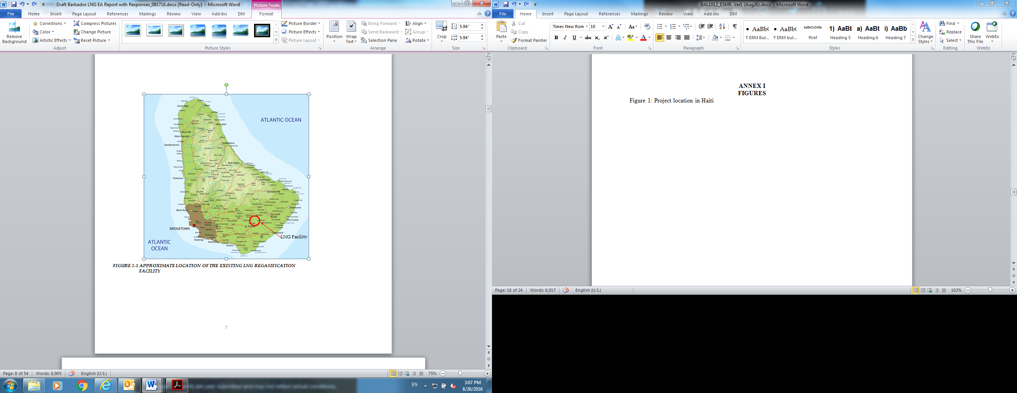

Figure 2: Area of influence of LNG Facility at Woodbourne, St Philip



Figure 3: Existing LNG Plant Facility Layout

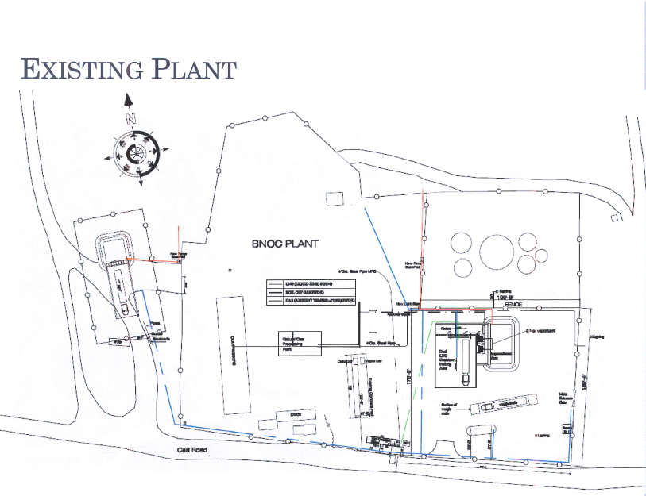

Figure 4: ISO-Containers/tanks/unloading parking area and vaporizers

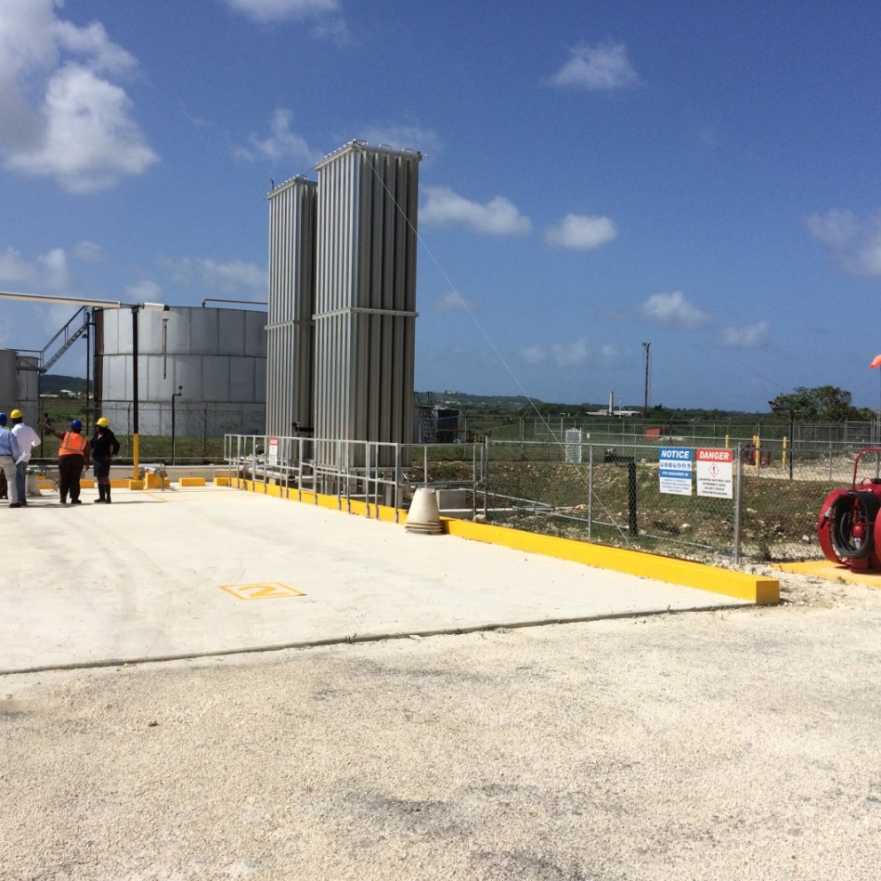

Figure 5: Transportation routes between the port and the Woodbourne plant

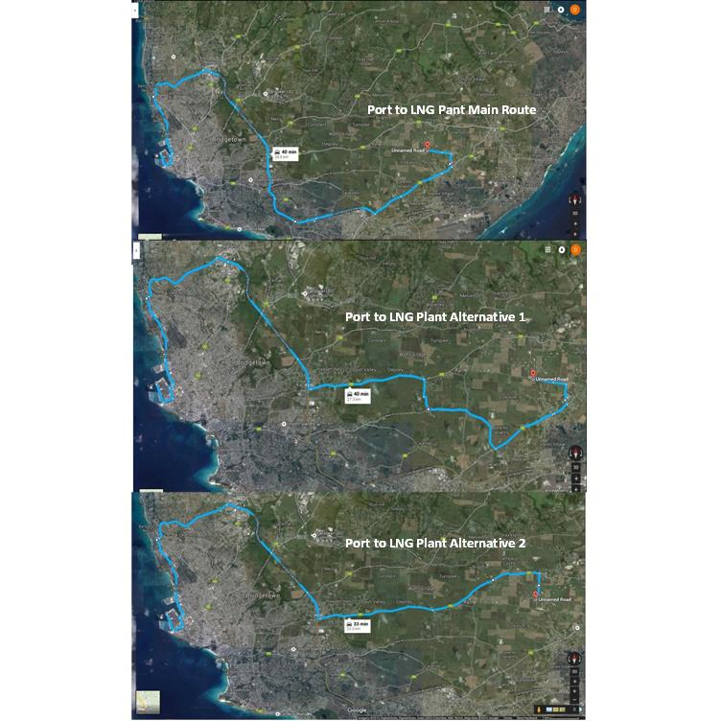

Figure 6: Approximate location of the upgraded pipeline

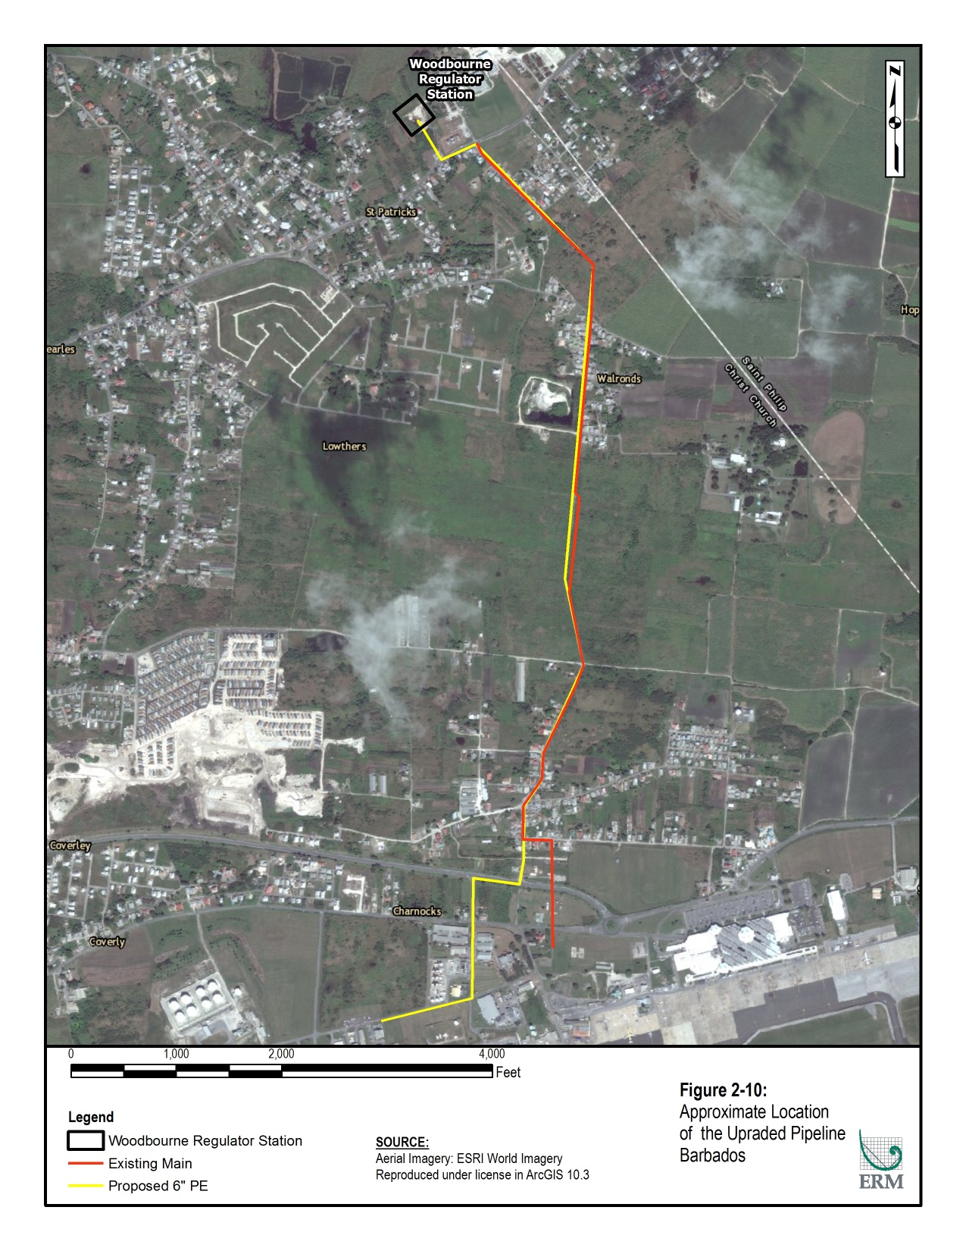

**ANNEX II**

**MAIN PROJECT’S IMPACTS AND MITIGATION MEASURES**

| **Resource** | **Source of the Impact and Existing Vulnerability** | **Recommended Mitigation/ Management Measure** | **Impact Significance After Mitigation** |
| --- | --- | --- | --- |
| ***Physical*** | | | |
| Climate and Air Quality | * Wheel generated dust/surface disturbance during operation of diesel powered earth-moving construction equipment (e.g. bulldozers, graders, excavators, cranes, dump trucks) at the construction site. * Fuel combustion emissions from exhausts of iso-container trucks transporting LNG from the port to the LNG facility. * Construction workers commute vehicles (or company bus) to and from site. | * Reschedule earthwork activities during periods of high wind if visible dust is blowing off-site. * Provide dust suppression as needed. * Ensure that all construction equipment is maintained in accordance with manufacturer’s specifications. * Stabilize disturbed areas as soon as possible. | **Negligible** |
| Geology, Topography, and Soils | * Landscape grading and recontouring required for installation of the new infrastructure to ensure proper drainage and stability. * Vegetation clearance and landscape grading. | * Implementation of soil erosion, storm water runoff, and sedimentation control measures. | **Negligible** |
| Hydrology | * Sedimentation from construction activities. * Contamination from accidental spills (e.g., fuel and lubricants if handled on site). * Pipeline construction/ replacement activities involving crossings of ephemeral streams or drainage structures. | * Implementation of improved and effective soil erosion, stormwater runoff, and sedimentation control measures. * Exercise controls for inspecting equipment and Implement a Spill Prevention and Countermeasures Plan (SPCC). | **Negligible** |
| Noise | * Operation of diesel powered earth-moving construction equipment such as bulldozers, front-end loaders, or dump trucks. * Vehicular traffic. * Operation of pumps and compressors. | * Ensure that all contractors on site undertake regular inspection and maintenance of all vehicles and construction equipment in accordance with manufacturer’s specifications. * Ensure that all equipment operating at the facility (i.e., pump and compressor, ambient vaporizers, etc) are maintained and operate in accordance with manufactures’ specifications. * Implement a monitoring program to monitor noise levels at the facility and nearby receptors. * Employ best available work practices on-site to minimize occupational noise levels. * Select truck routes for construction traffic entering and leaving the site to ensure noise levels at noise sensitive receptors are kept to a minimum. | **Negligible** |
| LNG storage or iso-container tank failure risk | * Accidental spill of LNG from a tank rupture. * Accidental spill of LNG from an iso-container/tank accidental rupture from a traffic accident. | ***LNG Tank Rupture***   * Plant designed with embedded layers of protection:   + **Sitting and design** – designed to meet international standards (e.g., NEPA 59A – distance requirements from LNG plant, materials resistant to the cryogenic temperatures, and equipment anchoring/grounding against high winds and electricity);   + **Control and Monitoring** – detection equipment throughout the site (methane and flame detectors as well as various other sensors to detect any leaks and wind monitoring to determine the direction any potential vapors);   + **Preventio**n – audible and visual alarms as well as automatic emergency shutdown valves;   + **Protection** – impoundment pit to contain any spilled LNG (fire response equipment and vapor control equipment – foam and water curtains);   + **Plant emergency response** – trained operators to ensure rapid response; and   + **Community emergency response** – emergency plan shared with the emergency services. * ***Iso-containers Rupture***   + All personnel hired to transport the containers have been trained to US Department of Transpiration standard for LNG drivers;   + The route has been selected to ensure that only major roads that can handled the size and weight of the iso-containers are travelled;   + The transport of the LNG containers from the Bridgetown Port to the LNG Terminal will occur in off-peak hours (between 23:00 and 05:00) as the vehicles are oversized. Each convoy will be escorted by an out-rider and the Royal Barbados Police Force shall be notified to facilitate road closures to ensure that no other road users can be impacted by the containers.   + Iso-containers have built in safeguards to protect against roadside accidents (insulated and double walled, all valves are recessed within the confines of the container frame, valve cluster encased within a steel cabinet, and remote monitoring – pressure values can be monitored remotely to alert personnel to any issues prior to the container arrival)***.*** | **Minor** |
| Fire hazard risk | * Accident release of LNG – LNG is classified as highly flammable gas. | * Distance requirements stipulated by NEPA 59A provide a buffer around the re-gasification facility where no ignition sources are present (no ignition sources within 100 feet of storage tanks, e.g., liquid fuel storage, motors, highways, and unrated electrical appliances). * Large wheeled dry powder fire extinguisher units (350 pounds) stationed around the transfer bay. * Fire water system (30,000 gallons tank and pump) used to cool surrounding infrastructure in the event of a fire. * Foam blocks in the impoundment pits to provide constant passive response (does not require operator intervention. | **Minor** |
| Natural Disasters | * Hurricanes and natural fires | * Storage tanks will be built to withstand hurricane force winds and earthquakes. * Natural vegetation fires (flame detectors also detect fires external to the plant and result in a shutdown of operation). | **Negligible** |
| ***Biological*** | | | |
| Flora and Fauna | * Ground clearing and grading for the emplacement of infrastructure. * Increase noise from construction and operation activities. | * To avoid potential collisions with fauna, limit speeds on roads. * Provide dust suppression as needed. * Implementation of improved and effective soil erosion, storm water runoff, and sedimentation control measures. * Site has no vegetation, so no vegetation loss is anticipated. | **Negligible** |
| ***Human Resources*** | | | |
| Construction-related effects on the public | * Temporal increase of noise and dust from construction activities. | * Ensure that all contractors on site undertake regular inspection and maintenance of all vehicles and construction equipment in accordance with manufacturer’s specifications. * Ensure that all equipment operating at the facility (i.e., pump and compressor, ambient vaporizers, etc) are maintained and operate in accordance with manufactures’ specifications. * Employ best available work practices on-site to minimize occupational noise levels. * Reschedule earthwork activities during periods of high wind if visible dust is blowing off-site. * Provide dust suppression as needed. * Stabilize disturbed areas as soon as possible. | **Negligible** |
| Socioeconomic | * Project induced economic activity will result from contracting of materials and services during the construction and operations phases including mechanical equipment, piping, building materials, civil construction works; telecommunications equipment, and other materials. * Increase availability of natural gas for economic development. * Increase employment. | No additional mitigation measures are proposed. | **Positive** |

1. Source: http://data.centralbank.org.bb/ForeignTrade.aspx
2. The IDB developed a study to analyze the feasibility of establishing a competitive commercial supply chain for Natural Gas in the Caribbean region. The study concludes that for seven of the eight IDB-borrowing countries that import fossil fuels, including Barbados, the introduction of natural gas for electricity generation would reduce the cost of electricity generation under a variety of market scenarios, by between 17% and 40%.
3. The Medium LNG Plant would be comprised of receiving facilities, a regasification plant and transmission pipelines