**INTERAMERICAN DEVELOPMENT BANK DOCUMENT**

**HAITI**

**Institutional Strengthening and Reform of the Transport Sector II**

**(HA-L1099)**

**ECONOMIC ANALYSYS**

This document was prepared by Marcio Cracel, with the cooperation of Carlos Mojica and Elkin Bello from INE/TSP and the Consultant Roberto Suarez.

1. **EXECUTIVE SUMMARY**
   1. The Transport Sector Policy Based Grant (PBG) under the operation HA-L1099 would become effective at the beginning of FY 2014/15. The Policy Based Grant operation main objective is to contribute to the improvement of the quality of transport in Haiti increasing the country’s competiveness, through: (i) the institutional strengthening and modernization of the road sector; and (ii) the reform and modernization of the port sector.
   2. The key impact and results of the transport sector reform will be to: Impacts - (i) Increase the quality of Roads and Port infrastructure according to the Global Competitiveness index (1-7). Results - (i) Increase the extension of the eligible road network receiving basic maintenance; (ii) decrease the Vehicle Operating Cost (VOC); (iii) increase the extension of roads covered by road safety programs; (iv) increase loading/unloading of containers Port capacity; (v) increase the number of private operators working under a result based contract (concession); (vi) decrease the time gap between APN external audits.
   3. The present study was prepared to estimate the financial/economic benefits to be generated by the introduction of a set of transport sector policy actions. In this context, through a Cost Benefit Analysis (CBA), the expected results of the Program’s transport sector reform components are evaluated. These results are oriented to strengthen the institutional capacity of the road sector, to modernize the regulatory framework, and strengthen the institutional capacity of the port sector.
   4. On a conservative basis, it is estimated that the transport sector reform will generate, from US$2,5 million in 2019 to 61 million in 2023 savings on Vehicle Operating Costs, and a savings on Vessels’ costs of approximately US$5,3 million starting in FY 2017/18.
   5. The Program’s Cost Benefit Analysis (CBA) presents an Internal Rate of Return (IRR) of 16.1% with a Net Present Value of US$ 16,7 million. This justifies the US$58 million investment by the Inter-American Development Bank. It is important to mention that the additional costs associated with the annual maintenance of the roads, for primary roads, performed by the Government of Haiti were taken into consideration.
   6. Based on this CBA, it is recommended to continue with the financial and technical support from the Bank, through the implementation of the Institutional Strengthening and Reform of the Transport Sector I (HA-L1099).
2. **INTRODUCTION**
   1. The Government of Haiti (GoH) requested the Bank to support the implementation of a set of transport sector policies aimed to contribute to the improvement of the quality of transport in Haiti increasing the country’s competiveness, through: (i) the institutional strengthening and modernization of the road sector; and (ii) the reform and modernization of the port sector..
   2. The present study is directed to estimate the economic benefits to be generated after the implementation of a set of transport sector policies to be introduced by the Institutional Strengthening and Reform of the Transport Sector I Program. The benefits are expected from the savings to be generated by vehicle operating costs, as well as by increasing the Port productivity with consequent reduction on Vessel’s operating costs.
   3. Experience from similar programs indicates that it is difficult to carry out a precise CBA without accounting for all the economic and financial variables affected by the Program’s activities. Analysis of the Program’s activities will allow for a partial estimation of the Program’s financial benefits in order to generate an Internal Rate of Return (IRR) and the corresponding Net Present Value (NPV) of the Program’s road and Port sectors components.
   4. The CBA demonstrates that the Program’s policies will generate important benefits. The Program’s CBA presents an Internal Rate of Return (IRR) of 16.1% with a Net Present Value of US$ 16,7 million. This justifies the US$58 million investment by the Inter-American Development Bank. It is important to mention that additional costs associated with routine and periodic maintenance of the roads done by the Government of Haiti were taken into consideration.
   5. It is also important to highlight that this CBA does not consider the indirect benefits (the results of which could only be evaluated over the long term) related to results from social investments in sectors that contribute to poverty reduction and an increase in human development.
   6. The Program is structured as three independent operations, each technically integrated under the programmatic modality, comprising financing resources of US$19 million in the first operation, US$27 million in the second operation, and US$12 million in the third operation.
3. **ASSUMPTION AND METHODOLOGY**
   1. Specifically, the CBA will evaluate the Road and the Port components through an economic analysis. The calculation was based on the Government’s information provided by the Ministry of Public Works, Transport and Communications (MTPTC), “National Port Authority” (APN), as well as by the Inter-American Development Bank and the World Bank (WB).
   2. The methodology to quantify the costs and benefits is based on calculating savings on vehicle operating costs and savings on vessels’ operating costs as a result of the transport sector policies to be implemented, which were prepared by the Bank and validated by GoH. On the other hand, the resources for the Program and for the annual road maintenance costs are considered in the financing costs. The estimations considered the IDB standard discount rate of 12%.
4. **ECONOMIC AND FINANCING ANALYSIS**

Transport Policies FY 2014/2018

|  |
| --- |
| ***“Assumption 1: An economic benefit is generated from savings on Vehicle Operating Costs (VOC)***[1] ***because of the strengthening of the MTPTC institutional capacity in managing road maintenance.”*** |

* 1. **Context:** Transport in Haiti, be it by land, air or sea, endures a series of critical limitations, most of which derive from the dual impact of historic low levels of investment in the sector and the chronic weaknesses of its institutions. In addition, Haiti has endured numerous natural disasters through the years—most recently, the earthquake of January 12, 2010—that have damaged key infrastructures, and thus rendered progress in the sector furthermore onerous. The country’s shortcomings in transport have certainly acted as constraints for economic growth, people’s access to basic services, and general social development, even more so now in the context of the international post-disaster reconstruction efforts.
  2. The transport sector in Haiti basically comprises the following institutions: (i) the Ministry of Public Works, Transport and Communications (MTPTC), which leads the sector; (ii) the Ministry of Economy and Finance (MEF), which is responsible for preparing and obtaining approval of the country’s budget, and as so is responsible for collecting all transport-related taxes and surcharges, especially those levied on fuels; (iii) the Road Maintenance Fund (FER), which is responsible for administering national resources allocated for the conservation and maintenance of the national road network; (iv) the Maritime and Navigation Service (SEMANAH), which is an autonomous organism adjoined to the MTPTC in charge of regulating navigational services and ensuring maritime and port safety; and (v) the National Port Authority (APN), which is in charge of managing and exploiting all public ports in the country, as well as controlling private ports. The APN is under the jurisdiction of the MEF.
  3. Road transport is the leading mode of transportation for cargo and passengers in Haiti and henceforth the improvement of the road infrastructure is a fundamental mechanism for economic development and for the intra and inter-regional integration of the country’s regions. The national road network has a total length of 3,572 km, consisting of 953 km of primary roads (27%), 1,315 km of secondary roads (37%) and 1,304 km of tertiary roads (36%). This reflects very low coverage levels for both the size of the population (0.4 km/1,000 inhabitants) and the surface area of the country (0.12 km/km2). In addition to that, the road network has poor infrastructure and maintenance conditions reflected in high transportation cost and travel time for both individual users and firms. The road infrastructure in urban areas is also of poor quality affecting the safety of its users and creating an environment nuisance from dust of passing vehicles.
  4. The state of road infrastructure in Haiti was already very limited prior to the earthquake. Road density levels, both, based on the country’s surface area (0.12 km/km2) or the size of the population (0.4 km/1,000 hab.) were below the averages for Latin America and the Caribbean (0.14 km/km2, 7.1 km/1,000 hab., respectively)—and the differences were even larger if only the paved network were taken into account. In addition, as referenced above, the existing roads were in very poor condition and rapidly deteriorating, as a significant length of the network is prone to destruction from insufficient drainage, deformation of the road surface, and unstable banks, all problems that can be corrected with adequate engineering solutions. Only 10% of the road network receives some form of maintenance. In general, all these factors combined, are indicative of very low levels of service provided by the road network as a whole, and therefore very high transport costs throughout the country. The poor state of the road network seems to be the outcome of the interplay of two critical factors: (i) insufficient levels of investment in road development and maintenance, and (ii) institutional capacity problems at MTPTC.
  5. **Problematic.** The inadequate state of transport infrastructure and services in Haiti reflects poorly on the MTPTC. While insufficient levels of investment in the sector can justify some of the evident limitations in coverage and levels of service offered, elements such as the degree of deterioration of key infrastructures even prior to the earthquake, the inefficiencies in procuring works and the recurrence of cost overruns, among others, are indicative of problems within the institutions themselves. The main reasons behind these undeniable weaknesses are the following.

1. **Insufficient road maintenance.** While the rehabilitation effort continues and fund exists for this purpose, maintenance activities are insufficient to maintain the roads newly rehabilitated and to prevent further deterioration of the network. The main cause associated with this problem is the unsatisfactory institutional capacity and insufficient human resources to manage road maintenance[2]. Another problem comes from lack of planning. There is no road maintenance plan and sound technical criteria for what type of maintenance is more appropriate for a particular road section.
2. **Lack of an adequate organizational structure to manage the road maintenance works.** Despite of the existence of a maintenance cell within MTPTC to manage the maintenance activities, these are neither optimized nor standardized[3]. The main causes associated with this problem are: (i) Lack of adequate organizational structure; and (ii) there are no modern planning tools.
   1. **Proposed Solution.** Improvement of the efficiency and sustainability of road infrastructure management, by strengthening the institutional capacity of the MTPTC comprising the following actions:
      * 1. Enhancement of road sector management through the establishment of an institutional strengthening plan for the MTPTC, including the description of the new functions, the specific deliverables and the timetable for implementation;
        2. Improvement of road maintenance management through the establishment of a reinforcement plan for the existing maintenance organizational structure, including the diagnostic of the existing maintenance organizational structure, the recommendations for improvement and its respective work plan;
        3. Modernization of planning tools, inventory and road asset management tools such as the Highway Development and Management Model HDM-4[4] and preparation of road investment plans that include maintenance programs.
   2. **Benefits Calculation:**

**Methodology for calculation of Vehicle Operating Costs (VOCs)**

1. **Objective:**

The main objective of this methodology is to calculate over the analysis period the savings in vehicle operating costs in Haiti comparing the situation with the roads’ maintenance improved by the Policy Base Grant Program versus an scenario without improving maintenance standards. For this purpose, two basic scenarios were considered:

1. The level of maintenance performed by the government continuous to be at the same level presented in 2013;
2. The level of maintenance performed by the government improves because of the strengthening of the institutional capacity of the Ministry of Public Works, Transport and Communications (MTPTC).
3. **Condition of the Haiti Road Network in 2014**

Table1 shows the road network condition in 2014, broken-down by road type and corresponding classification of road condition.

**Table 1: Basic Data of Haiti Road National Network**



**Source: UCE/MTPTC 2014**

1. **Methodology**

The methodology consists in modelling road maintenance standards over the period of economic analysis of the “without-project” scenario vs “with-project” scenario for representative sections of the Haitian road network classification as detailed in Table 1. These representative road sections for each road network are defined in terms of geometric characteristics, pavement structure, traffic values and vehicle composition.

The table shows the basic data of the road network in Haiti; these data is the necessary to analyze road maintenance levels needed to run strategic analysis using Highway Development and Management Model HDM-4. For the rest of the factors average values included in the HDM algorithms were used. The analysis has been carried in a methodic strategic analysis in HDM-4 for the representative road sections considered. Since no road inventory exists in Haiti, and there is lack of reliable data, this becomes an adequate approach for analyzing the impact of the policies of the PBG in the maintenance practices, taking on account a conservative approach as described in this report.

The analysis for the primary and secondary paved network is reliable; nevertheless, for the secondary non paved network, a conservative approach was assumed, since HDM is not capable of modeling with similar precision graveled roads.

In the case of the tertiary road network, it could only be modelled the “good condition” but the feasibility is barely positive since there is a short difference between maintaining and major rehabilitation. For the cases “medium condition” and “bad condition” that correspond to graveled roads, where the usual maintenance concepts cannot be applied as they are usually understood; but the information is not enough to apply them.

Regarding best practices for maintenance, international engineering standards define the minimum requirements for the life-cycle of paved and unpaved roads; these standards do not depend on Haiti but in concepts of “minimum quality” for each type of road normally accepted. Obviously, how and when these standards can be achieved depends on the conditions of Haiti (geometry, weather, traffic, etc.). Although, there could be technical discussion on those minimum standards, it would only be regarding the value of the parameters (i.e. for asphalt pavement the maximum IRI is 6 mm/m instead of 5mmm/m), however these variations will not significantly modify the results of the analysis.

The economic analysis compares the benefits and costs of the options with and without project during the period of analysis. Next, the without and with projects alternatives are described:

**Without project:** Without maintenance, except cleaning of drainage and roadway. However, since pavement deterioration accelerates with time, when the road attains a condition that makes traffic flow difficult (almost-destruction), a reconstruction is scheduled (this is precisely what occurs, when a good maintenance is not carried out and what currently occurs in Haiti). It is important to schedule the reconstruction in this final stage; otherwise the failure of the road pavement would occur, which is not socially acceptable.

**With project:** With maintenance, in order to keep the road with adequate standards (depends on the type of road); and includes (drainage cleaning etc.), potholing, crack sealing and periodic maintenance (periodic maintenance such as asphalt overlays is very important and should be considered as part of maintenance even though it is considered as extraordinary maintenance, etc.). The timing of these works is defined in the HDM after triggers that limit the number of potholes, IRI, etc. in a way that the roadway is maintained in good quality (this means, when a certain deterioration condition reaches a maximum acceptable value, the trigger will set the maintenance work activity required to improve the road condition).

In order to estimate the results of the PBG it was assumed in a conservative basis that only 50% of the primary roads (477km) will be appropriately maintained under international recognized best practices; while the benefits from applying these policies to secondary and tertiary road were not included in the final economical evaluation. This goal is very conservative and seems reasonable for Haiti. For this purpose only one part of the road network was analyzed since the results are enough to justify the Project feasibility. If a longer road network was considered, there would have been more benefits. In the long run, once the primary, secondary and tertiary roads currently in poor condition are rehabilitated it is to be expected that 100% of the road network will be appropriately maintained.

**Costs**

The analyzed economic costs consider in the analysis, include the Government investment/maintenance costs. These costs were analyzed for representative road sections in each of the cases; later they are used for economic analysis calculations.

**Table 2: Costs of work activities for Maintenance and improvement in Haiti**



**Source: HDM-4 Inputs from estimates of costs in Haiti**

1. **Savings in Vehicle Operating Costs**

The following table 3 shows a summary of the vehicle operating costs using the results obtained with the HDM-4 model, taking into consideration 2 scenarios - with and without project:

**Table 3: Savings in Vehicle Operating Costs for 477 km of the primary road network**



From the table, the results on the analysis show that the transport sector policies will generate, from US$2,5 million in 2019 to US$61 million in 2023 savings on Vehicle Operating Costs.

The implementation of appropriate maintenance systems have very high benefits that justify the institutional strengthening program that will ensure such implementation is actually achieved as can be seen on Table 8: Economic Analysis for Base Case Scenario.

The results have shown that it is economically feasible to do efficient maintenance instead of not doing it and having to recur to reconstruction of the road when it is about to attain its full deterioration. Annex II shows the deterioration curves in terms of IRI over time for each studied case. Annex III shows the results of VOCs for the with-project and without projects scenarios.

It must be said, that all costs have been considered: (i) for “with maintenance”, all maintenance and rehabilitation variables; (ii) for “without maintenance”, the reconstruction when the maximum limit for adequate traffic flow is reached. A conservative length has been chosen; in the future MTPTC may expand it if the maintenance “culture” becomes rooted in Haiti. The important is that the best maintenance practices are effectively applied. The results indicate the need of starting a serious maintenance program concentrating efforts on the primary road network in the first place and on the secondary and tertiary road network in second place.

* 1. **Conclusion:** Because of the implementation of policy actions for the strengthening of the MTPTC institutional capacity, it is expected that the transport sector reform will generate, from 2,5 million in 2019 to 61 million in 2023 savings on Vehicle Operating Costs. The Program’s Cost Benefit Analysis (CBA) shown on Table 8: Economic Analysis for Base Case Scenario presents an Internal Rate of Return (IRR) of 116.1% with a Net Present Value of US$ 16,7million. This justifies the US$ 58 million investment by the Inter-American Development Bank.
  2. **Sensitivity Analysis I** (¶5.2)**.** This scenario considers that only 40% of the primary road network is covered by the maintenance policies introduced by the PBG. See table 4 and table 8. Even with conservative approach the results show very high benefits. If the road length covered by good practices was only 381 km of primary roads the benefits will be in the order of US$ 50 MM for year 2022, with which the costs of the PBG are covered easily.

**Table 4: Savings in Vehicle Operating Costs for 381 km of the primary road network**



**Justification:** The justification for the results presented on the HDM4 is based on the strengthening of the MTPTC institution capacity, which will comprise the following advantages:

1. Opportune intervention on the road sections that need to be maintained will avoid incurring on expensive rehabilitation works to improve their conditions.
2. Planning road maintenance activities in advance will allow to perform periodic maintenance and reduce deterioration levels; (improvements I and II is expected to be reached through the implementation of an appropriate road inventory and road asset management tools)
3. Providing training to road workers will result in better productivity allowing to extend the road maintenance capacity;
4. Improving the decision making process to define what type of road maintenance work activity is more adequate for a particular road section and when it should be intervened.
5. Providing training to managers will improve maintenance resource allocation, increasing efficiency.
6. Prioritize maintenance projects according to technical criteria and efficient use of available resources

A very similar operation was carried out by the World Bank in Armenia and demonstrated that strengthening the institutional capacity of organizations in charge of the roads’ maintenance can substantially decrease the pace of roads’ deterioration. (<http://lnweb90.worldbank.org/oed/oeddoclib.nsf/DocUNIDViewForJavaSearch/8525682E0068603785256A4E00633ADC?OpenDocument>)

|  |
| --- |
| ***“Assumption 2: An economic benefit is generated from the savings on vessels’ operating cost because of the strengthening of the APN institutional capacity in managing Port processes, especially those related to loading and unloading containers”*** |

* 1. **Context**: There are only two seaports in the country that service international maritime transport: Port-au-Prince and Cap Haitien. The primary port is Port-au-Prince, focusing most of its area on containerized freight and general fractioned freight, and other docks and warehouses specializing in grains.5 In recent years, Port-au-Prince’s moved close to 1 million tons/year. In addition, there are seventeen smaller ports along the country’s seacoast, equipped only for short distance maritime travel vessels.
  2. Although freight movement through Port-au-Prince’s seaport had increased considerably over the last few years, it continued to be underused prior to the earthquake due to outdated equipment, inefficient operations, and high port fees. The earthquake completely destroyed the North berth and caused severe damages to the South berth. Warehouses, security buildings, the perimeter fence and the access roads were all practically destroyed11. Very few of the current assets may be re-used for a permanent port infrastructure. A temporary barge arrangement has been effective in restoring cargo throughput, and should suffice for the next couple of years until a permanent new north berth is constructed. Currently, the total cost for commercial importers in Haiti are, by far, the largest among regional peers: up to US$580 per container versus an average among peers is US$150.
  3. **Problematic.**

1. **Lack of resources for rehabilitation of ports infrastructure:** The port of Port-au-Prince (PAP) concentrates 98% of the international trade, and currently operates at the limit of its capacity[5]. The port was strongly affected by the 2010 earthquake and currently operates with barges as temporary berths, which implies low productivity and high tariffs[6]. Investments to improve the capacity and efficiency of the port of PAP are urgently needed and the National Ports Agency (APN) is prospecting complementary sources of financing for the reconstruction[7], including non-sovereign loans. In order for APN to get external funding, lenders have required, among other things, a better visibility of the commercial and financial prospects for the agency and a clear path for a policy reform.
2. **Inefficiencies in the regulatory framework and in the market of private operators:** Existing contracts with private operators are short term and there is a lack of legal framework to support them, preventing investments, creating oligopolies and increasing tariffs[8]. Studies commissioned by the Bank[9] and other donors[10] agree that in parallel to the reconstruction of the port of PAP, a sector reform is essential to increase the competitiveness of ports and must include: (i) improving of regulatory and operational functions; and (ii) the development of a stable regulatory framework that allows private participation, including a comprehensive policy to establish the business model and guide the development of the legal framework.
3. **Insufficient transparency and accountability presented by the Port institutions.** The Port institutions present insufficient transparency and accountability to manage their financial and commercial functions, assets, liabilities, land ownerships, contract obligations and legal commitments, among others[11]. The main causes associated with the problem are: (i) the audits of the Port institutions are not made publicly available; and (ii) there is no inventory providing information about the Port institutions’ assets, liabilities, and contracts obligations.
4. **Inadequate Human resource capacity to manage the maritime institutions functions[12].** Despite of the existence of periodic training program for the APN personnel, this is carried without efficacy due to the lack of the following information: (i) there is no comprehensive inventory of the maritime institutions personnel; (ii) absence of personnel evaluation to identify background and skills; (iii) absence of a comprehensive training program based on the skills and functions; and (iv) Absence of a Human Resource policy to guide the maritime institutions career-stream, including hiring, development, evaluation, and retirement.
   1. **Proposed Solution:** increase the efficiency and sustainability and promote more efficient institutions of the port sector by supporting a policy reform comprising the following policy actions:
5. Improvement of the effectiveness of the Port management and operation, beginning with the creation of a task force which will pilot the Port reform;
6. Enhancement of the regulatory framework for the Port Sector management and operation, though the establishment of a Policy that will serve as input for the draft law on the Port Sector Reform, including the institutional structure and the port development strategy;
7. Enhancement of transparency and accountability of Port Institutions through the strengthening of the APN’s audit mechanism and the reinforcement of the decision making process by having a reliable inventory of APN’s assets, liabilities, land ownerships, contract obligations, and legal commitments, environmental and social aspects. (Etat des lieux);
   1. Improvement of the human resources capacity through the identification of the APN’s employee’s skills, in order to carry out the tasks of the two future organizations which will respectively be in charge of Port regulations and management.
   2. **Benefits Calculation.**

Table 5 provides an estimation of the savings generated by the reduction of the vessels’ operating costs[13], because of the intensification of Port productivity; increasing the number of containers loaded/unloaded from:

* In FY 2015/16 – 12.47 (current productivity of the port) containers per hour without project to 15 (region average) containers per hour with project.
* In FY 2017/2018 – 17 (before earthquake)[14] containers per hour without project to 25 containers per hour with project. With specialized equipment like a portic crane which is characteristic of concession projects.

**Table 5: Estimation of Savings from the Reduction on Vessels Costs**



For the calculation of the benefits the following information was presented on table 5:

* + - 1. **Port Working days / Year –** It was assumed that the Port works 365 days a year.
      2. **Port Working hours / Day –** It was assumed that the Port works 24 hours a day.
      3. **Capacity of Loading / Unloading Containers / Hour** – is the capacity of the Port in loading and unloading containers in 1 hour.
* Year 2013 – Was calculates based on the information provided by APN comprising all vessels with containers from 9/29/2012 – 11/30/2013.

**Table 6: Snapshot of Data of Port Statistics from APN**

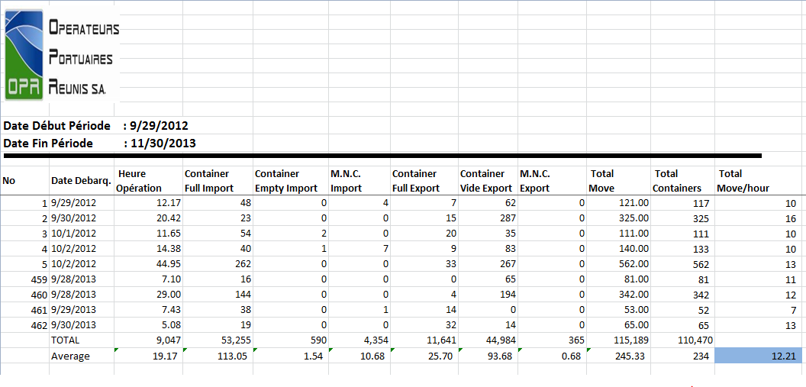

* FY 2015/16 without project – the performance keeps the same presented in FY 2012/13.
* FY 2015/16 with project – was estimated that the performance increases approximately 2.5% based on the institutional strengthening of the Port. ¶ 4.17 provides the justification and the evidences to justify the productivity increase.
* FY 2017/18 without project - was estimated based on the performance of the Port before the earthquake (17 containers/hours – APN), considering that the dock will be rebuild and the productivity will return to the previous rates.
* FY 2017/18 with project – was estimated based on the institutional strengthening of the Port, in addition to the reconstruction of the dock. Paragraph 4.18 provides the justification and the evidences to justify the productivity increase. Note that the reconstruction of the dock is not computed as a benefit of this operation; however, the institution strengthening takes advance of this improvement in terms of productivity.

**Port Traffic**

* + - 1. **Number of Containers / Year –** totalnumber of containers loaded / unloaded per year.
      2. **Number of Vessels with Containers/ year –** total number of vessels loading/unloading containers per year.
      3. **Average Number of Containers / Vessel –** average number of containers in one vessel. This number was calculated dividing the total number of containers by the total number ships.
      4. **Average Number of hours one vessel stays docked –** this number was calculated dividing the average number of container in one vessel by the capacity of the port in loading / unloading containers per day.

**Vessel Costs**

* + - 1. **Average operating cost of a medium vessel / day –** according to the GoH, the daily cost of a vessel varies from US$10,000 to US$50,000, depending on the size of the vessel. For the estimation of this indicator, was used the average cost of a medium (US$30,000) vessel.
      2. **Average operating cost of a medium vessel / hour –** this amount was calculated multiplying the average cost of a medium vessel per day by the average number of days required to load/unload a vessel.
      3. **Average Cost of one Vessel loading/unloading its containers / day –** this amount was calculated multiplying the average operating cost of a medium vessel / hour by Average Number of Hours one Vessel stays docked for loading/unloading.
      4. **Total yearly cost for all ship Loading / Unloading containers –** this amount was calculated multiplying the average cost for one ship load/unload its containers by the total number of vessels docking at the Port.
      5. **Benefits in FY 2015/16 and FY 2017/18–** is calculated subtracting the total yearly cost for all vessels Loading / Unloading containers with and without project.
  1. **Justification:** The increase of the Port productive from 12,47 containers/hour to 15 containers / hour in FY 2015/16 and from 17 containers/hour to 25 containers / hour is based on the strengthening of the APN institution capacity comprising the following improvements:

1. Strengthening the APN’ planning capacity will help to previously identify the vessels characteristic and better assign the appropriate equipment and human resources to carry out the loading/unloading containers;
2. Increasing the number of Port private operators with contracts based on results (concessions), will dramatically increase the productivity of the Port.
3. Reforming the legal framework, will provide the necessary support to allow the private sector operator participation.
4. providing training to the port workers in the procedures and in the equipment operation, will increase productivity and be able to increase the number of containers loaded/unloaded per hour;
5. Setting up a maintenance plan for the Port equipment, will reduce machinery failures and will decrease delays in loading/unloading containers.
6. Providing training to the APN’s managers will increase the efficiency in managing the Port resources, increase the amount of services to be contracted, increasing the Port productivity.
   1. In order to provide evidence that institutional strengthening is one of the key factors that contributes to the improvement of the Port productivity, it is important to mention an a study prepared by “Peru – Autoridad Portuaria” aiming to compare the Vessels’ waiting time at the Callao Port, before and after the introduction of the concessions for private operators. (<http://www.apn.gob.pe/c/document_library/get_file?p_l_id=28267&folderId=1260007&name=DLFE-7734.pdf>)

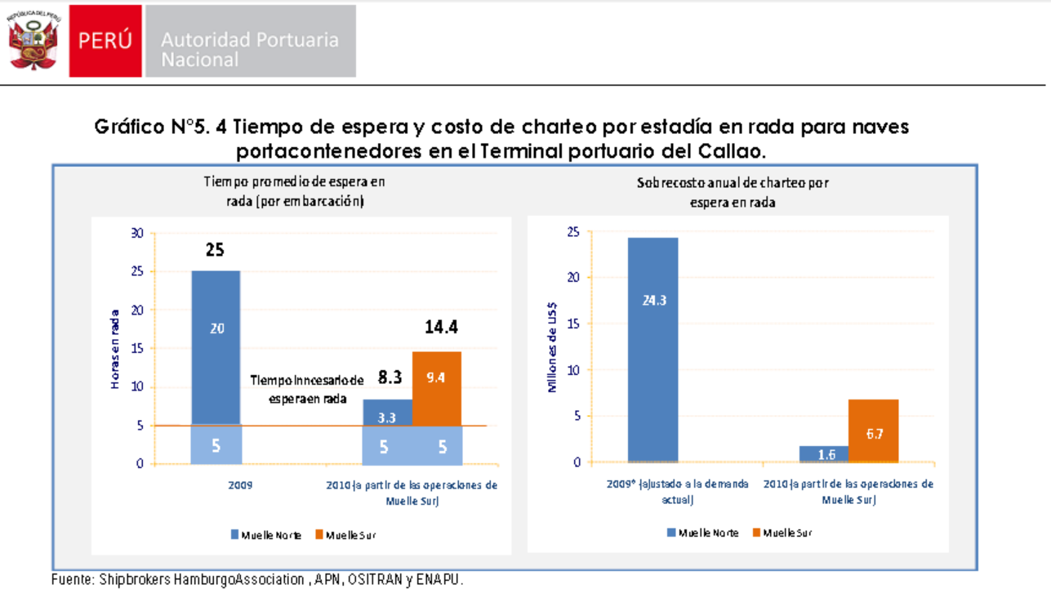

* 1. **Conclusion:** Because of the implementation of policy actions for the strengthening of the APN institutional capacity, it is expected savings in vessels’ operating costs of approximately US$ 2,0 million starting in FY 2015/16 and of approximately US$ 5,3 million in FY 2017/18.
  2. **Sensitivity Analysis 2** (¶5.3).The productivity of loading / unloading containers increases only 20 instead of 25 moves/hour in FY 2017/18 with project.

**Table 7: Estimation of the Savings in Vessels Cost**



1. **ESTIMATION OF** THE **BENEFITS IN PRESENT VALUE**

**BASE SCENARIO**

* 1. As a result of the action policies to be introduced in the Transport Sector, it is expected that, at the end of the implementation of all institutional strengthening of MTPTC and PBG, that the transport sector reform will generate, from 2,5 million in 2019 to 61 million in 2023 savings on Vehicle Operating Costs, and a savings on Vessels’ costs of approximately US$5,3 million starting in FY 2017/18. The Program’s Cost Benefit Analysis (CBA) presents an Internal Rate of Return (IRR) of 16.1% with a Net Present Value of US$ 16,7 million. This justifies the US$ 58 million investment by the Inter-American Development Bank. It is important to mention that the additional costs associated with the annual maintenance of the roads, for primary roads, performed by the Government of Haiti were taken into consideration. The estimations considered the IDB standard discount rate of 12
  2. `Based on this CBA, it is recommended to continue with the financial and technical support from the Bank, through the implementation of Institutional Strengthening and Reform of the Transport Sector I (HA-L1099).

**Table 8: Economic Analysis for Base Case Scenario**



1. **SENSITIVITY ANALYSIS**
   1. Three scenarios were considered for the sensitivity analysis: (i) scenario 1: 40% Km of the primary road stays is covered by the maintenance policies from the PBG; (ii) scenario 2: productivity of loading/ unloading containers increases only to 20 instead of 25 moves per hour (iii) scenario 3: a worst case combining both previous scenarios:
   2. **Scenario 1** refers to the variation of one of the key factors affecting the results of the project in the economic evaluation. In this regards, the length of the roads covered by adequate maintenance policies from PBG varies from 50% of the primary road network (477 km) in the base case (which is a conservative figure since 100% of the primary road network should receive maintenance based on best practices), to 40% of the primary road network (381 km) in this scenario. This 40% value of the primary roads is considered as a minimum since efficient routine maintenance must be carried at least in the recently rehabilitated roads. This scenario could occur in case the budget for maintenance is severely reduced by Government.
   3. **Scenario 2** presents a traditional sensitivity test, in which a variation in the productivity of the PAP port in terms movements per hour to load/unload ships (a key factor in port performance) is expected to increase only to 20 moves/hour instead of 25 moves/hours as expected in the base case. This reflects a reasonable risk for this key variable since from experience in a port with concession of “Container Terminal” a typical Portic Crane has a minimum performance of 25 moves/hour; for an annual capacity of about 100.000 moves/year (The PBG policies promote the concession of container terminal) . A capacity of 20 moves/hours is similar to that of the Port of Corinto in Nicaragua or Puerto Quetzal in Guatemala. This scenario could occur for the port in PAP in the case of a delay in the construction of the north berth, which is out of the control of the proposed operation.
   4. **Scenario 3**. Presents a worst case scenario in the hypothetical case that scenarios 1 and 2 will occur simultaneously.
   5. The results of the simulation do not modify the decision in relation to the viability of the Program, because the Net Benefit Accumulated in Present Value presents a positive result in each of the three different scenarios and the IRR also remains above 12% in the worst scenario, as shown in the following table:

**Table 9: Results and Sensitivity Analysis Summary**

|  |  |  |  |  |
| --- | --- | --- | --- | --- |
| **Indicators** | **Base Scenario** | **Scenario 1:**  **40% Km of the primary road stays is covered by the maintenance policies from the PBG)** | **Scenario 2:**  **productivity of loading / unloading containers increases only 20 instead of 25 moves per hour** | **Scenario 3:**  **Scenario 1 + Scenario 2** |
| Net Benefit (Present Value) US$ million | 16,7 | 7,0 | 13,4 | 3,0 |
| Internal Rate of Return (%) | 16.1 | 13,9 | 15,4 | 12,8 |

**Table 10: Economic Analysis for Sensitivity I Scenario**

**SENSITIVITY I**



**Table 11: Economic Analysis for Sensitivity II Scenario**

**SENSITIVITY II**



**Table 12: Economic Analysis for Sensitivity III Scenario**

**SENSITIVITY III**



**Annex I. HDM-4 Input Parameters and Economic User Costs**



**Annex II. Deterioration curves in terms of IRI over time**

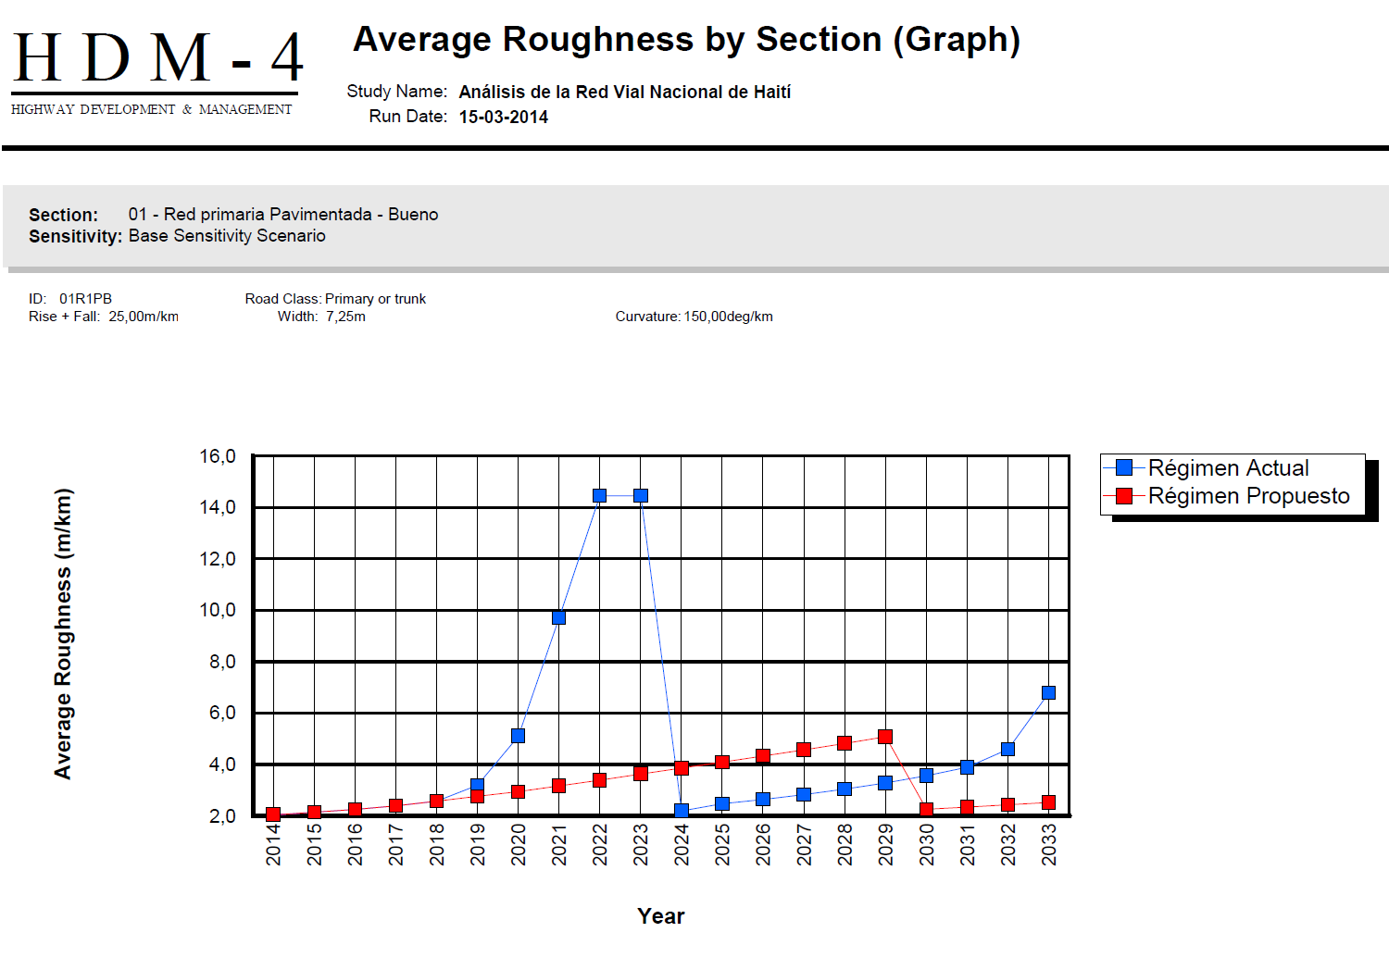

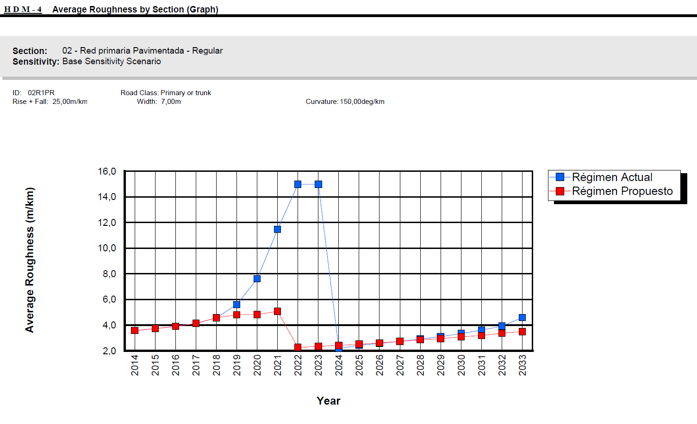

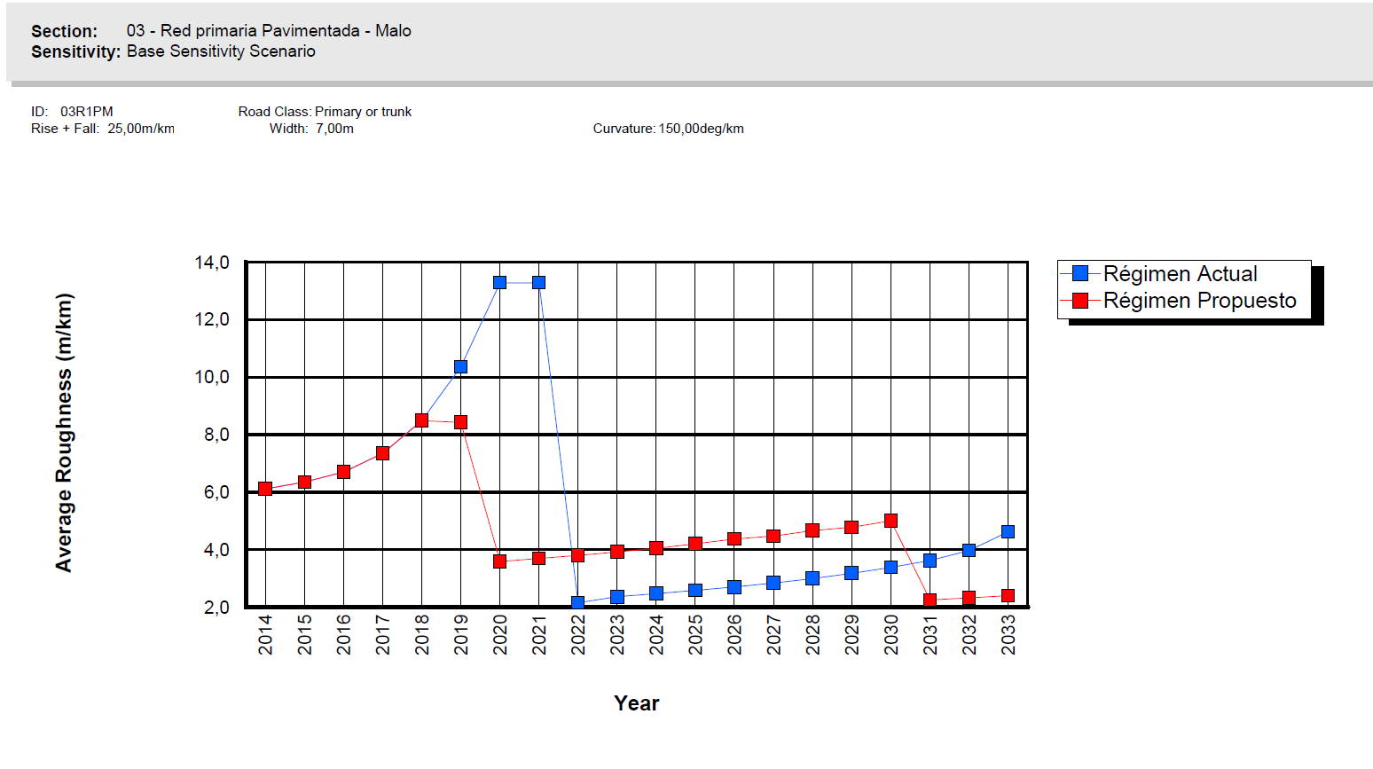

**Annex III. Vehicle Operating Costs for each Case**







1. Vehicle operating costs refer to costs that include fuel, tires, maintenance, repairs, and vehicle depreciation costs.
2. There are only 2 MTPTC employees to coordinate road maintenance agreements with the Fond d’Entretien Routier (FER) and 10 Departmental Directions).
3. None of the processes are documented.
4. HDM-4 uses empirical data form numerous real projects carried in developing countries around the world.
5. The average of the Haiti’s Ports is only four containers per hour, while the average of the region is 14.
6. Tariffs per container varies from US$230 y US$580, other ports in the region charge around US$150, International Finance Corporation (IFC), 2011.
7. APN has started a tender process for the reconstruction of the north berth using its own budget.
8. All of the 15 private operators at international ports work under permit without a contract.
9. Strategic Studies for Ports in Haiti – CTS, 2011 (HA-T1135).
10. US Trade and Development Agency (USTDA) and International Financial Corporation (IFC).
11. Last external audit was performed at the end of 2004, presenting a 9 years gap between audits. The best practice in this area recommends that audits have to be carried out with intervals of 2 years.
12. In a degree of satisfaction using a range from 0 to10, the level of satisfaction of the APN’s employees is x, demonstrating that the APN does not provides an adequate work environment for its personnel.
13. Costs to operate the Vessels, such as: (i) crew salaries, Vessel rental, combustible, port fees, equipment (crane) rental, etc.
14. With specialized equipment like cranes which is characteristic of concession projects.