BAHAMAS

Government Procedure

REGISTERING PROPERTY / LAND

Ciro Alonso

IDB Consultant

Government Digital Transformation to Strengthen Competitiveness

BH-L1045

**INDICE**

1 INTRODUCTION 3

Project Profile 3

2 REGISTERING PROPERTY 3

Conveyancing and Registration of Deeds 3

Registration of Titles and the Fiscal Cadastre 3

Cadastre 4

Land Administration Tools 4

GIS Mapping 4

Procedure for Registering Property (Mapping) 5

Main Problems 5

Available Solutions 5

3 Annex A 7

Doing Business Report 2018 7

Registering Land 8

Case study assumptions 8

Description of Procedures 9

# INTRODUCTION

## Project Profile

The main problem identified by this program in The Bahamas is the limited competitiveness of its economy. Several determinants constrain the competitiveness of The Bahamas, among them: a weak infrastructure network, structural problems within the labor market, high energy costs, inadequate air and maritime connectivity, water and sanitation matters, poor access to credit and high financing costs, rising crime, vulnerability to negative climate change impacts and natural disasters, low fiscal space and increasing debt, as well as the **inefficiency of government bureaucracy** and low levels of transparency.

This document focus on the last one express by one critical procedure for the economy:

1. Registering Property

# REGISTERING PROPERTY

Registering land or property is a complex procedure in Bahamas, as it might change the procedure if its is done by a national, resident or nor-resident person, also the nature of the land (crown, public, private), so these complexity and duration of the procedure might warn foreign investors and delay, or inhibit the investment in the Bahamas.

We will try to explain how the procedures work in Bahamas, trying to identify the main problems, and how can it be solved in the present loan with IDB

## Conveyancing and Registration of Deeds

Private or Notorial Conveyancing is the prevailing method of Land Transfer in the Bahamas.The owner is compelled under the Law of Property and Conveyancing (Condominium) Act toprove succession of title (“root of title”) for a period of 30 years.

The existing system of record rights in land is Registration of Deeds (ROD). ROD is merely mechanical in nature by recording alldocuments which are lodged with simple checks for omitted signatures and dates.

It is advisable, but not compulsory, for owners to record their documents on the **General Register** under the Registration of Records Act.

ROD adds a greater degree of security asregistered deeds have priority and can only be challenged by litigation.

## Registration of Titles and the Fiscal Cadastre

Registration of Titles (ROT) is similar to ROD with the main exception being that all documents must be registered and are scrutinised for authenticity and integrity. The owner, property description, measurements (size and area), property rights (easements, profits, and others), and charges (liens and mortgages) are recorded on the general ROT register with absolute finality. Due to the certainty of this type of system, the State guarantees the title to the land. A bill for Registration of Titles in the Bahamas was submitted to parliament in 1967, but it was never passed.

Documents recorded in a ROT system also have a survey plan attached which is lodged with the Surveyor General in finality so that there is no encroachment or squatting. There is a general register of survey plans, called the Master Survey Drawing (MSD), which is prepared at relevant scales. The Fiscal Cadastre is similar to the ROT system but was formulated on the basis of Taxation.

The system which is in place at the BLVU mirrors a Fiscal Cadastre because it lacks the compulsion element for recording deeds and documents. It is well suited for easy implementation of a Fiscal Cadastre with a smooth transition from the old to the new system. However, a ROT system must be enacted by parliament.

## Cadastre

Modern Cadastres embrace wholeheartedly the concept Interoperability – the use of information which is exchanged between two or more systems which possess the ability to perform such an exchange. Interoperability varieties include:

(a) semantic – comprehending terms and concepts;

(b) human/political – training initiatives and governmental policies; and

(c) technical – software interaction, format, and machine inter communication.

Standards for Metadata , equipment, and software are also key elements of modern day cadastres. Some countries are working on the blockchain technology for their cadaster.

## Land Administration Tools

The Land Information System (LIS) which prevails in the Bahamas is mainly discreet in nature. Many records exist about land and property rights, however they are often stored manually in files, large manual books of documents in volumes, or archived on microfilm.

The main instrument for Land Administration Systems is GIS Mapping. Land Administration in the Bahamas must involve primarily a Land Information Service for prospective users.

## 

## GIS Mapping

The main purpose of Mapping is to create a geo-reference for an object to which property rights are being claimed. It must be noted that no new rights will be created during the mapping process.

Why not continue with Manual Mapping? This a pertinent argument as it has worked well for so many years and most primary data providers (Land Surveyors) enjoyed a particular comfort zone. However, the use of digital data in the Bahamas has been proven to be:

* more applicable to a variety of subsequent uses;
* easier to modify and update; cheaper to maintain and archive;
* Easier to distribute.

Land Use Policy and Administration Project (LUPAP) requires the cooperation of three key governmental agencies namely **BLVU** (Business Licence/Valuation Unit), **the Registrar General’s Department** (RGD), and the **Department of Lands and Surveys** (DLS). The success of the Project depends on their institutional strengthening and collaboration.

## Procedure for Registering Property (Mapping)

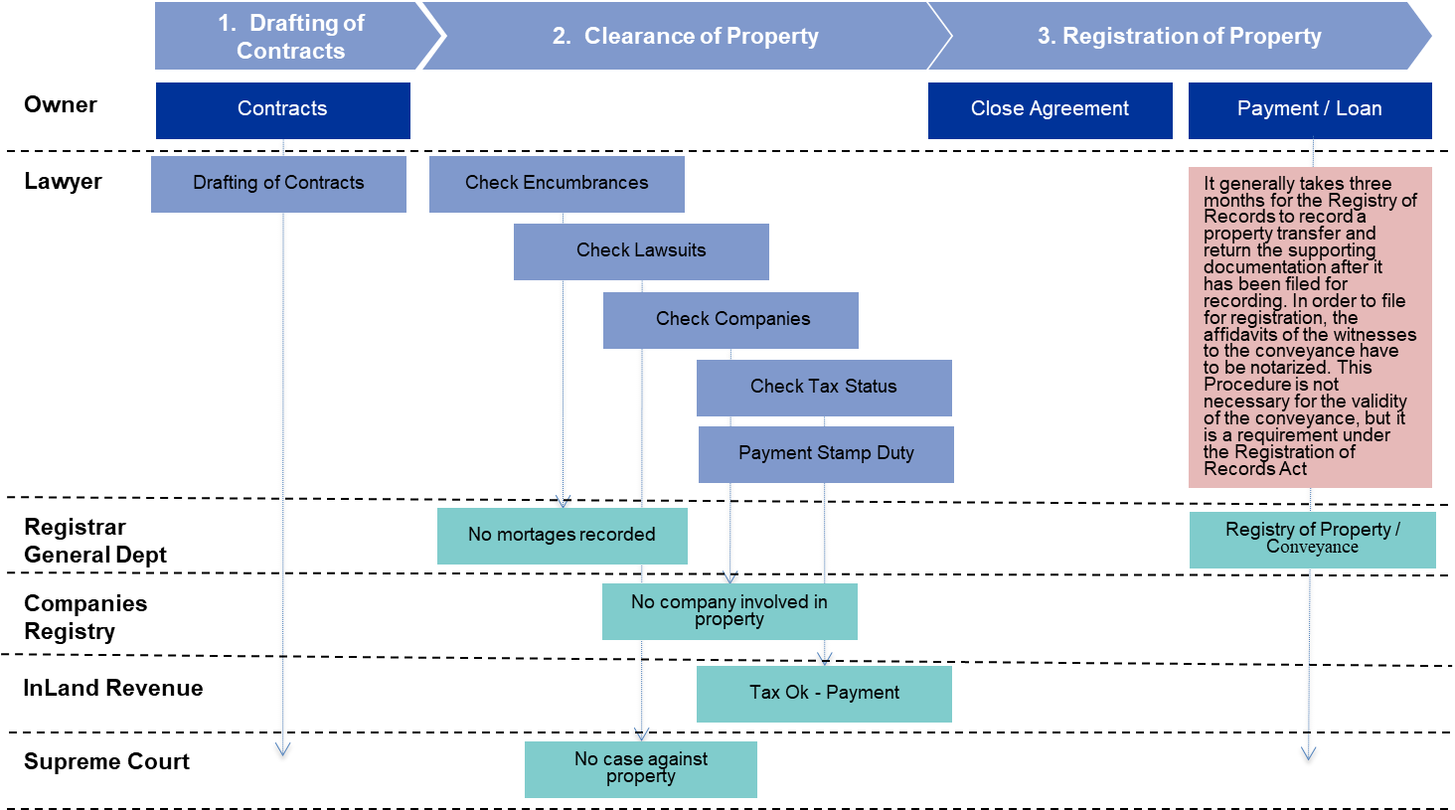

Illustration: Land / Property Registration in Bahamas

In green – The result from a interaction with a Government Agency

## Main Problems

1. No obligation to register property, so it is difficult to prove the real owner of the land/property and the liabilities against the land/property
2. Inexistence of Cadaster (no LIS), and separation on for tax purposes (Inland Revenue)
3. Different entities involved in the processes and no interoperability

## Available Solutions

This mission tries to improve the present situation of this important business requisite in component 1:

* **Component 1. Simplifying and digitizing government procedures**
  + **(ii) Updating the legal framework related to the provision of digital services;**
    - Review of the current legal framework
    - Identify gaps for eGoverment (digital signature, electronic documents, keeping of digital records, privacy and data protection, citizen centered government services, digital identity,…)
    - Assurance of compliance with Data Protection Act
    - Prepare draft legistlation for digital agenda governance and the provision of digital services
  + **(iv) setting up an interoperability scheme including standards, regulation and technological platform;**
    - Definition of the Interoperability Standards and data exchange in Bahamas, and selection of platform (technical requirements)
    - Elaboration of legal documents to regulate interoperability
    - Setting up the Interoperability Platform and implementing 20 web services from 10 Entities (First NIB Identification) in the cloud
  + **(vi) digitizing government procedures related to property registration**
    - Digitizing paper-based property records
    - Documenting, mapping and reengineering al property registry related procedures in a BPM
    - Upgrading the Property / Land Registration Platform and preparing eBRF (Electronic Business Registration Forms) to be publish in the eGov Portal
    - Updating the GIS Platform and uploading property information (Coordinate with Bahamas National Geographical Information System)
    - Modernise with new search functionalities with GIS and AI functionality
    - Inventory of Land (Crown Land, Goverment Land and Private Land), digitalization of files
    - Interoperability between Land Registration and Inland Revenue Adm
    - Blockchain pilot for land registration

Sources:

1. GIS Case Study for a Fiscal Cadastre and Improved Land Tenure in The Bahamas by Thomas Ferguson
2. Doing Business Report Bahamas 2018 – Registering Property
3. Project Profile
4. Bahamas Government Portal (<http://www.bahamas.gov.bs>) regarding the property procedures, forms and documentation, agencies involved.

# Annex A

## Doing Business Report 2018

An expression of **inefficiency of government bureaucracy** can be found in the Doing Business Report 2018, especially in two areas of the report:



Illustration: Doing Business Report 2018



Illustration: Doing Business Report 2018

## Registering Land

This topic examines the steps, time and cost involved in registering property, assuming a standardized case of an entrepreneur who wants to purchase land and a building that is already registered and free of title dispute. In addition, the topic also measures the quality of the land administration system in each economy. The quality of land administration index has five dimensions: reliability of infrastructure, transparency of information, geographic coverage, land dispute resolution, and equal access to property rights. The most recent round of data collection for the project was completed in June 2017.According with the Doing Business Report, starting a Business in Bahamas (Limited Liability Company) require the following effort:



Illustration: Doing Business Report 2018

## Case study assumptions

To make the data comparable across economies, several assumptionsabout the parties to the transaction, the property and the procedures areused.

The parties (buyer and seller):

* Are limited liability companies (or the legal equivalent).
* Are located in the periurban area of the economy’s largest business city.
* Are 100% domestically and privately owned.
* Have 50 employees each, all of whom are nationals.
* Perform general commercial activities.

The property (fully owned by the seller):

* Has a value of 50 times income per capita, which equals the sale price.
* Is fully owned by the seller.
* Has no mortgages attached and has been under the same ownership forthe past 10 years.
* Is registered in the land registry or cadastre, or both, and is free of titledisputes.
* Is located in a periurban commercial zone, and no rezoning is required.
* Consists of land and a building. The land area is 557.4 square meters(6,000 square feet). A two-story warehouse of 929 square meters (10,000square feet) is located on the land. The warehouse is 10 years old, is ingood condition, has no heating system and complies with all safetystandards, building codes and legal requirements. The property,consisting of land and building, will be transferred in its entirety.
* Will not be subject to renovations or additional construction following thepurchase.
* Has no trees, natural water sources, natural reserves or historicalmonuments of any kind.
* Will not be used for special purposes, and no special permits, such as forresidential use, industrial plants, waste storage or certain types ofagricultural activities, are required.
* Has no occupants, and no other party holds a legal interest in it.

## Description of Procedures

|  |  |  |  |
| --- | --- | --- | --- |
| # | Procedure | Time to complete | Associated Costs |
|  | Drafting of contracts and exchange of contracts once agreed  **Agency : Lawyer's office**  The contract stage, which can last 1-5 days, depending on the complexity of the transaction, would include the following steps:  (1) The Seller's lawyer prepares a draft Agreement for Sale and submits it to the Buyer's lawyer for approval. (2) The Seller's lawyer forwards the final Agreement for Sale (in duplicate) to the Buyer's lawyer for execution. (3) The Buyer's lawyer returns a signed Agreement for Sale (and deposits part of the payment, usually 10% of the purchase price).  After the contract stage, the Buyer's lawyer would conduct the due diligence included in procedures 2, 3, and 4. As part of the due diligence, the Buyer’s lawyer may forward requisitions. Once the due diligence is completed, the buyer's lawyer forwards the draft Conveyance to the seller's lawyer for approval.   The Bahamas Bar Association has a sliding scale of fees for property transactions, which is based on the valued of the property: 2.5% of the value of the property is payable on the first B$500,000 2% of the value of the property is payable for that part which is in excess of B$500,000, but does not exceed B$1,000,000 1% of the value that is in excess of B$1,000,000, but does not exceed B$5,000,000. | 1 day | 2.5% of the value of the property is payable on the first B$500,000 2% of the value of the property is payable for that part which is in excess of B$500,000, but does not exceed B$1,000,000 1% of the value that is in excess of B$1,000,000, but does not exceed B$5,000,000. |
|  | Lawyer or his clerk checks for encumbrances at the Registry of records (regarding any mortgages on the property)  **Agency : Registry of Records**  Searches are conducted by search clerks or lawyers. Documents recorded at the Registry of Records are available on microfilm up to 2003. From 2003 onwards documents recorded have been scanned and may be accessed online.   When the parties hire a large law firm, the firm usually does this Documents search, together with the Court Cause List search of Procedure 3 and the Company Search of Procedure 4, in house. The firm does not charge an extra fee for these searches, i.e. it is included in the conveyance fee. When an independent party is hired to conduct the searches, the fee is 300-350 USD per lot searched. | 1 - 2 months (simultaneous with Procedures 3, 4, and 5) | Cost included in lawyer's fees (Procedure 1) |
|  | Lawyer checks for judgments against the property at the Supreme Court  **Agency : Supreme Court**  This search is conducted to check if there are any judgments affecting the property, since charges imposed by judicial decisions could be levied on the property, regardless of who the owner is. | 1 day (simultaneous with Procedures 2, 4 and 5) | Cost included in lawyer's fees (Procedure 1) |
|  | Lawyer checks for other companies using the same property at the Company Registrar  **Agency : Company Registry**  Searches are done at the Companies Registry only if a company now owns or previously owned the land. Searches are done to ensure that the company was existing and duly incorporated during the period of its ownership of the property and to ensure that any conveyance executed by it was executed in accordance with the Articles of Association. | 1 day (simultaneous with Procedures 1,2 and 5) | Cost included in lawyer's fees (Procedure 1) |
|  | Real property tax status enquiry with the Valuation office of the Ministry of Finance.  **Agency : Department of Inland Revenue**  Starting January 2015 it is required to submit a certificate of good standing in property taxes signed by the chief valuation officer of the Inland Revenue Department. If the seller hasn’t paid the taxes in the past, the new owner will inherit them. In addition to this Procedure, the buyer's lawyer might also chose to make an inquiry with utility companies (water, electricity and phone/cable). Such inquiry could be conducted within two weeks. | 1 day (simultaneous with Procedure 2, 3, and 4) | Cost included in lawyer's fees (Procedure 1) |
|  | Payment of Stamp Duty  **Agency : Department of Inland Revenue**  Stamp duty is payable as a percent of the value of the property. Paid at the Public Treasury. The rates for stamp duty are as follows: Stamp duty is payable as a percent of the value of the property.  The rate of stamp duty applicable to deeds of conveyance, assignments or transfers of realty, as per the Stamp (Amendment) Act of 2015 effective July 1, 2015 is 2.5% of the property's value. | 1 day | 2.5% of the value of the property (a VAT tax of 7.5% of the property's value is applicable for properties having a value above USD 100,000) |
|  | Lawyer checks for judgments against the property at the Supreme Court  **Agency : Supreme Court**  This search is conducted to check if there are any judgments affecting the property, since charges imposed by judicial decisions could be levied on the property, regardless of who the owner is. | 1 day (simultaneous with Procedures 2, 4 and 5) | Cost included in lawyer's fees (Procedure 1) |
|  | Lodge the conveyance for recording at registry of records  **Agency : Registry of Records**  It generally takes three months for the Registry of Records to record a property transfer and return the supporting documentation after it has been filed for recording. In order to file for registration, the affidavits of the witnesses to the conveyance have to be notarized. This Procedure is not necessary for the validity of the conveyance, but it is a requirement under the Registration of Records Act (Ch. 187 Statute Laws of The Bahamas, 2000 Edition) to record the transfer. Any licensed notary public can do it at a cost of BSD 30.00 to BSD 50.00, and in most cases lawyers have a notary public licence, in which case they may do it themselves. In this case, the fee is included in the lawyer's overall fees charged in Procedure 1. | 2-3 months | BSD 4.50/page |