**ANNEX**

**Public Consultation Report of August 14, 2017**

**Social Analysis: Gender Equality and Safeguards in Security Strengthening Project**

**Ministry of National Security**

**Kingston, Jamaica**

**Introduction**

On Monday, August 14, 2017 between 10:00 a.m. to 12:00pm, a Public Consultation for Social Analysis: Gender Equality and Safeguards in the Security Strengthening Project,was held in the Ministry of National Security, NBC Towers 2 Oxford Road, Kingston 5 Jamaica, in the training conference room of the 4th floor.

  
Building of the Ministry of National Security, Kingston, Jamaica

The Public Consultation was conducted by Latoya Morris-Dale, the program manager of the Strengthening Security Project, representing the Ministry of National Security (MNS) and Denisse Wolfenzon, gender consultant at the Bank. Moreover, seven civil society organizations participated in the discussion, including four gender-based organizations, two universities and the Private Sector Organization of Jamaica. In addition, other members of the MNS and the IDB participated and contributed to the conversation.

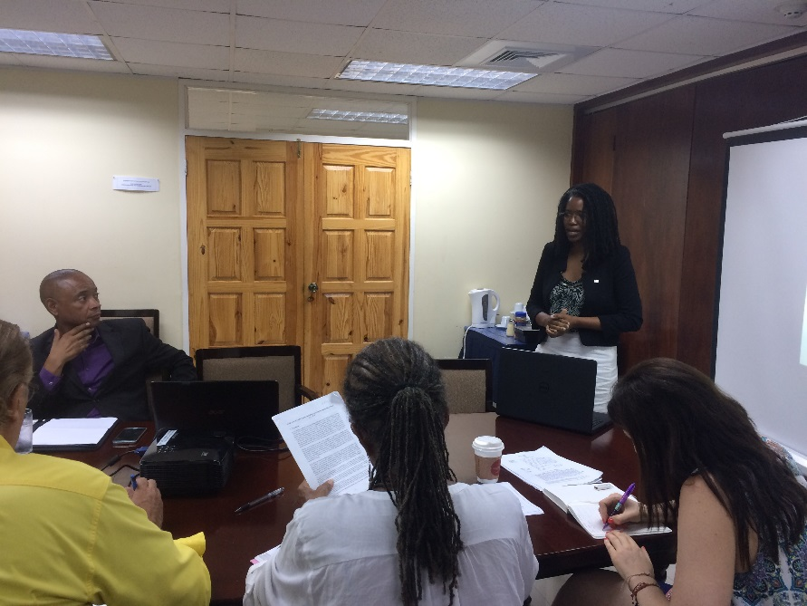

**Analysis of Participants**

The total number of participants at the public consultation was 14, 5 out of them were men and 9 were women. However, the gender composition of the participants who represented the civil society organizations was more balanced. Out of the 7 representatives, four were women and three were men, all adults between the ages of 37 and 72. The participation of men in the discussion and work towards the elimination of violence against women is crucial to properly address causes and symptoms of the problem.

The participating organizations are part of the platform for collaboration and consultation (ConSOC), which is promoted by the IDB Group in the country office of Jamaica. The ConSOC-Jamaica is integrated by representatives of different Civil Society Organizations, including non-governmental organizations (NGOs), community organizations, community groups, and groups of residents directly affected by IDB-financed projects, non-profit organizations, business associations, universities, academia, research centers and professional associations whose field of study makes significant contributions to the IDB, religious institutions and groups of Indigenous and Afro descendant peoples.

**Ministry of National Security** ([MNS](https://mns.gov.jm/content/vision-and-mission))

The Ministry of National Security will be the Model of National Security Excellence in the Caribbean Region, characterized by a highly trained and motivated staff, sophisticated and flexible policy development capacity, effective and efficient deployment of resources, the employment of modern technology and best practices in crime fighting, crime prevention and protecting the nation from external threats.

**National Integrity Action** ([NIA Jamaica](https://niajamaica.org/who/who-2))

NIA was registered as a not-for-profit organization in March 2011 with the objective of combatting corruption in Jamaica on a non-partisan basis

**The Private Sector Organisation of Jamaica** ([PSOJ](http://psoj.org/about-us/))

-was established in 1976. It is a national organization of private sector associations, companies and individuals working together to promote a competitive and productive private sector.

**University of the West Indies (Mona Campus) - Institute for Gender & Development Studies** ([IGDS](https://www.mona.uwi.edu/igds/aboutus_intro.php)**)**

Gender Studies is an interdisciplinary field of study that draws on all established disciplines to address issues of gender and ways in which relations of gender impact development at national and regional levels. To achieve this, the Institute has developed partnerships with staff in a number of departments and therefore has access to academic expertise or in-kind support from the range of faculties on the campuses. Other faculties and departments often draw on the expertise of IGDS staff to deliver lectures and/or modules in gender and development.

The University of the West Indies designed and trained trainers to facilitate the domestic violence curriculum at the Police College of Jamaica.

**Women’s Resource and Outreach Centre (**[WROC](http://www.dogoodjamaica.org/organizations/women_s_resource_and_outreach_centre)**)**

A non-profit non-governmental organization that provides a place for women and youth in the Lyndhurst and Greenwich community to learn the route to self-empowerment.

**Friedrich Ebert Stiftung** **(Jamaica and the Eastern Caribbean)** [FES](http://www.dogoodjamaica.org/organizations/freidrich_ebert_stiftung_jamaica_the_eastern_caribbean)

The Friedrich Ebert Stiftung (FES) was founded in 1925, and is a private, non-profit foundation, which subscribes to the ideals of social democracy. The foundation takes its name from the first democratically elected German President, Friedrich Ebert, and continues his legacy of giving political expression to freedom, solidarity and social justice.

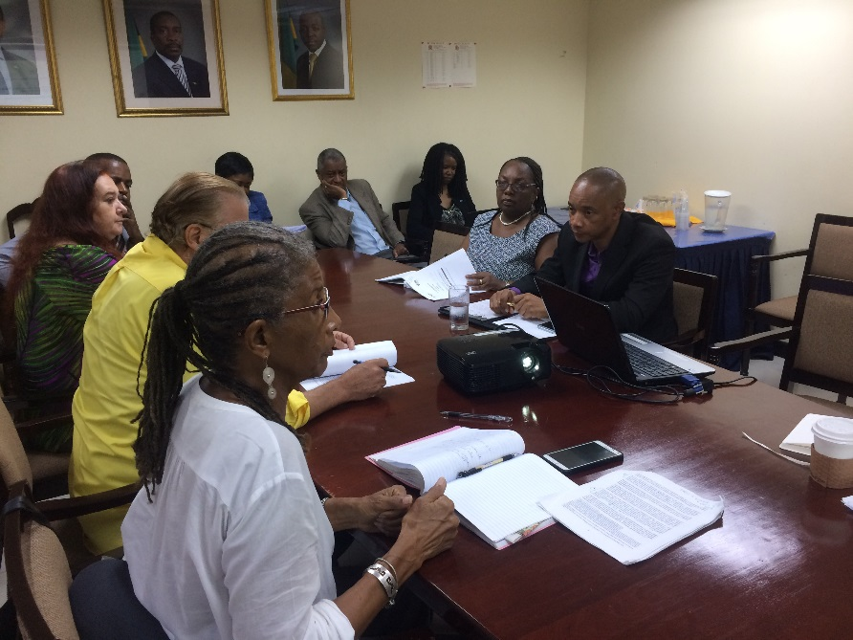

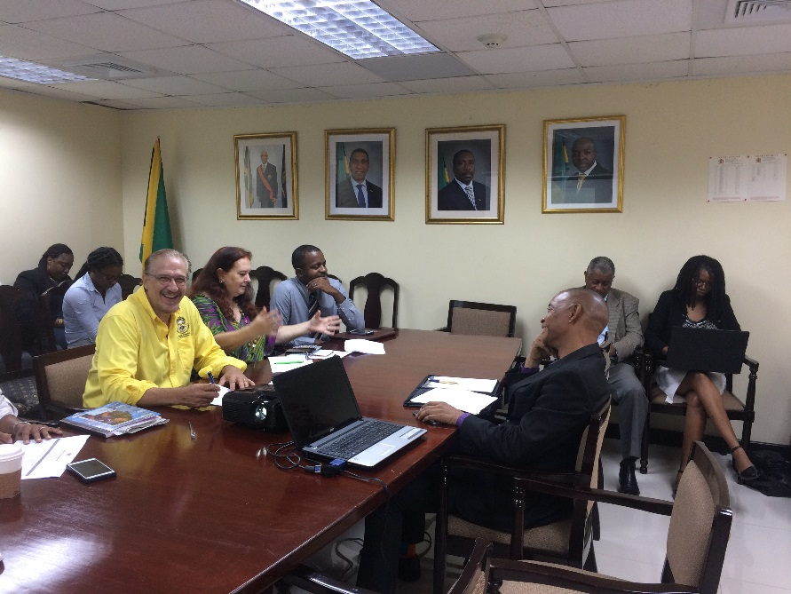

**Development of consultation**

The consultation process took place in a small training conference room to provide a friendly environment among the different organizations that participated in the meeting (MNS, the IDB and the civil society organizations). All the participants were seated at a round table which allowed them to have an active and engaged exchange of ideas, and almost all present offered their own opinions.

The participants were welcomed and introduced themselves to create a more relaxed environment among participants and the government. Afterwards, the program manager, Latoya Morris Dale, made a presentation about the objectives of the Security Strengthening Project, and the two components of the project: (i) prevention of violent crime, and (ii) improving investigative capabilities for homicides. The second part of the presentation was led by Denisse Wolfenzon, the gender consultant, who explained the main risks identified in the project and the mitigation activities planned to address them.

More than an hour of the consultation was dedicated to the facilitation of an in-depth discussion amongst the participants. Several suggestions for improvement of the risks and the mitigation activities which had been identified were aired, and the participants shared their thoughts and perspectives freely and openly. Finally, the participants were informed of what actions would be taken next in terms of the project moving forward and how their comments may be taken into account (to the extent that is possible and taking care not to promise responses or actions if they aren’t certain to take place), and a form of communication that will be accessible in case participants or anyone else would like to express concerns or ask questions in the future regarding the project.

**Content of interventions**

All participants agreed that domestic violence is a serious problem in the country, and that coordinated work among different stakeholders is necessary to address not only the symptoms but also the root causes of the problem. To adjust the expectations of the participants, it was explained at the very beginning of the consultation that the project would not address the values and cultural norms (acceptance of violence, shame, etc.) that support and contribute to the high prevalence of domestic violence in Jamaica and the low rate of reporting to the police.

The conversation was guided by the following five questions posted after the presentation:

1. Do you think these problems identified in the project are critical issues to better address domestic violence within the JCF?

All participants agreed that the risks and problems explained in the presentation (the low trust in the police, under-reporting/under-registration of cases and the lack of human rights approach when it comes to treat victims of violence) are main problems that need to be addressed.

The civil society organizations explain that domestic violence is not reported because victims believe that nothing will be done when they make reports to the police. In addition, victims are of the view that the police do not take domestic violence seriously and tend to re-victimize the victim when she/he finally decides to report an incident. Another reason for not reporting is the fear that is experienced due to the perceived lack of protection from the perpetrator once the incident is reported or the loss of financial support from the perpetrator once s/he is arrested. The participants also pointed out that children should feel that they can report and that action will be taken, but that often children do not know or fully understand their rights, as domestic violence is a socially accepted norm in some informal communities.

Participants also exposed that some of the agencies and entities that deal with domestic violence are underfunded and do not have the capacity to respond effectively when cases are referred to them. It was concluded that greater funding and capacity development is required for these agencies to effectively carry out their work.

1. Do you think the activities proposed would help redress the issues of under-registration, low trust in the police, and human rights approach in trainings? Is there any other activity that we should consider?

All participants agreed that the activities proposed in the project would in some way address the problems identified. However, they showed concerns that the scope of the project would not directly address changes in social and cultural norms that accept and encourage domestic violence; nor would the project address the lack of victim protection either from reprisal from the perpetrator or financial loss if the perpetrator provides financial support to the victim.

Participants found that on-duty police should receive additional trainings on how to handle cases of domestic violence with a human rights approach, in addition to the domestic violence curriculum that they receive in the Police College of Jamaica. It is worth noting that participants demonstrated interest in the new case management system that would allow the Government of Jamaica to (i) collect more detailed data of the victims, the abusers and specifics of the domestic violence episodes/cases as a way to better prevent other incidents, and (ii) track and follow up cases and increase accountability to resolve cases. With better recording of data and higher trust in the police, it is expected that the police will better prevent the escalation of violence and reduce the likelihood of female homicides.

1. Are there protocols on how to treat and record incidents of domestic violence at the police stations?

Some procedures are in place regarding the recording of incidents of domestic violence, but these have not been standardized. The JCF has developed a form with questions that should be completed by the police, however, the participants shared that police do not always fill out all the questions required and information gets lost. It was reported by the participants that the quality of information among police station varies greatly.

The participants reported that the GOJ recently approved the National Strategic Action Plan to Eliminate Gender-Based Violence in Jamaica 2016-2026.

They also acknowledged that the police receive training on domestic violence, and that to their knowledge each police station should have the guidelines printed and on display within the station. However, the participants were not confident that these guidelines were being followed when police deal with a victim of domestic violence.

1. Is it easy to recognize cases of domestic violence in the police forms?

The participants reported that the definitions of domestic violence and intimate partner violence within the context of the Jamaican legal framework are not clear. As was reported, domestic violence is considered as such when it occurs between people living in the same household, regardless of the relationship. The participants reported that the current police form does not capture intimate partner violence, as the police are limited by the definitions provided by the legal framework.

1. Is there any kind of relationship between NGOs and the police to address issues related to DV?

Most of the participants responded yes to this question. The Private Sector Organization of Jamaica meets with the police every month to discuss the issue of crime and violence on behalf of its members. Participants also accompany victims of domestic violence to report episodes of violence, to follow up cases and to obtain data and information on the issue of violence.

**Conclusions:**

Based on the scope of the project these are the main conclusions of the public consultation:

* Low trust in Police results in under-registration and under-reporting of cases of domestic violence.
* Domestic violence and intimate partner violence are poorly defined within the legal framework of Jamaica.
* The main factors contributing to the high prevalence of domestic violence in Jamaica are values and cultural norms.
* The fragmentation and the quality of data on domestic violence inhibits the Ministries, Departments and Agencies (MDAs)ability to design effective solutions to respond to domestic violence.
* There are gaps in the police forms to adequately collect domestic violence data, and there are inconsistencies in the procedures followed at different police stations. There are more questions that need to be asked by the police.
* There are trainings on domestic violence, but they are not systematic.
* Civil society organizations have continuous communication with the police and receive data from Statistics and Information Management Unit.

**Recommendations**

Enhance the positive impact of the project by:

* The Planning Institute of Jamaica should develop a map of all the Gender-Based Violence, Intimate Partner Violence and Domestic Violence players (NGOs, IOs and MDAs) working on domestic violence programs and projects.
* Involve grassroots organizations and schools which have assigned Security Officers in the data collection.
* Expand data collection on victims and perpetrators profiles as well as the characteristics of the incidents of domestic violence (time, location, etc.)
* Update/review of existing protocols to be aligned to international standards (Belen do Para protocol)
* Publish sex offenders’ registry database (if the current legal framework allows it).
* The MNS should study the root causes of domestic violence, intimate partner violence and gender based violence in order to develop meaningful responses.
* Provide trainings on how to handle cases of domestic violence with a human rights approach to the police officers.
* Provide trainings on how to adequately record incidents of domestic violence to capture high quality information that can be used to prevent the escalation of violence.
* The protocols should be visibly written at each police station for public knowledge.