**Government of Guyana through Inter-American Development Bank**

16

**Support of Sustainable Agricultural Development Program (GY – LO1060)**

**Initial Studies for Civil Works of Agricultural Centers and Pilot Initiatives**

**Prepared by Kelvin Clarke**

Contents

[1.0 Executive Summary 3](#_Toc461631916)

[2.0 AC- 9 3](#_Toc461631917)

[2.1 Objective 3](#_Toc461631918)

[2.2 Components 3](#_Toc461631919)

[2.2.1 Geospatial Planning 6](#_Toc461631920)

[2.2.2 Water Catchment 6](#_Toc461631921)

[2.2.3 Power 8](#_Toc461631922)

[2.2.4 Accommodation 8](#_Toc461631923)

[2.3 Intervention Priortization – Implementation Strategy 8](#_Toc461631924)

[2.4 Cost Estimates 9](#_Toc461631925)

[3.0 AC- 10 10](#_Toc461631926)

[3.1 Design Criteria 10](#_Toc461631927)

[3.2 Descritpion of Components 10](#_Toc461631928)

[3.2.1 Water Supply 10](#_Toc461631929)

[3.2.2 Electricity Supply 10](#_Toc461631930)

[3.2.3 Buildings 11](#_Toc461631931)

[3.2.4 Roads 12](#_Toc461631932)

[3.3 Intervention Priortization – Implementation Strategy 12](#_Toc461631933)

[3.5 Cost Estimates 12](#_Toc461631934)

[4.0 Meat Processing Facility 13](#_Toc461631935)

[4.1 Description 13](#_Toc461631936)

[4.1.1 Site Options 13](#_Toc461631937)

[4.2 Functional Components 15](#_Toc461631938)

[4.2.1 Power generation System 15](#_Toc461631939)

[4.2.2 Pure Water Supply System 16](#_Toc461631940)

[4.2.3 Waste Water Treatment 16](#_Toc461631941)

[4.2.4 Inedible Waste Disposal 17](#_Toc461631942)

[4.3 Cost Estimates 19](#_Toc461631943)

[5.0 Bibliography 21](#_Toc461631944)

[APPENDIX 1 – Water Catchment Analysis Case 1 22](#_Toc461631945)

[APPENDIX 2 – Concept Layouts for AC-9 Buildings 25](#_Toc461631946)

[Appendix 3 – AC-9 Accomodation Size Plan 26](#_Toc461631947)

[APPENDIX 4 - Abattoir Support Infrastructure Estimates 31](#_Toc461631948)

[Appendix 5 – AC-9 Accomodation Size Plan 36](#_Toc461631949)

**List of Figures**

[Figure 1: Proposed Location of Manari Research Center 3](#_Toc461631950)

[Figure 2: Water Supply Pump at Ebini 10](#_Toc461631951)

[Figure 3: Overhead Storage Tank at Ebini 10](#_Toc461631952)

[Figure 4: Diesel Generator at Ebini 11](#_Toc461631953)

[Figure 5: Generator house and transmission pole connection 11](#_Toc461631954)

[Figure 6: Typical building conditions 11](#_Toc461631955)

[Figure 7: Proposed training faclity 11](#_Toc461631956)

[Figure 8: Rehabilitation of exisiting building 11](#_Toc461631957)

[Figure 9: repairs to the roof structure of an existing building 11](#_Toc461631958)

[Figure 10: Location Plan of Abattoir Site Alternatives 14](#_Toc461631959)

[Figure 11: Relationship of functional components of Abattoir 15](#_Toc461631960)

[Figure 12: Potable Water Supply System 18](#_Toc461631961)

[Figure 13: 22](#_Toc461631962)

[Figure 14: Accumulated Water Storage for Research Catchment 23](#_Toc461631963)

[Figure 15: AC- 9 Proposed Room Layout for Student Dormitory 25](#_Toc461631964)

[Figure 16: AC – 9 Proposed Room Layout for Staff Accommodation ( 25](#_Toc461631965)

[Figure 17: Proposed Layout for 2500sq ft Abattoir 37](#_Toc461631966)

**List of Tables**

[Table 1: Water Demand by Agricultural Activity for Research Center 7](#_Toc461631967)

[Table 2: Estimate for AC-9 Buildings 9](#_Toc461631968)

[Table 3: Estimate for AC-9 Support Infrastructure 9](#_Toc461631969)

[Table 4: Comparison of Abattoir Site Alternatives 15](#_Toc461631970)

[Table 5: Comparison of Electrical Generation Alternatives 16](#_Toc461631971)

[Table 6: Comparison of Water Supply System Alternatives 16](#_Toc461631972)

[Table 7: Comparison of Inedible Waste Disposal Alternatives 17](#_Toc461631973)

[Table 8 26](#_Toc461631974)

[Table 9 27](#_Toc461631975)

[Table 10 28](#_Toc461631976)

[Table 11: Design Criteria – AC-9 Administrative Building 29](#_Toc461631977)

[Table 12: Design Criteria AC-9 Training and Research Building 30](#_Toc461631978)

[Table 13: Estimate for Inedible Waste Disposal for Abattoir 31](#_Toc461631979)

[Table 14: Abattoir Water Supply Cost Estimates 32](#_Toc461631980)

[Table 15: Abattoir Waste Water Treatment Estimates 33](#_Toc461631981)

[Table 16: Abattoir Power Generation Cost Estimates 34](#_Toc461631982)

[Table 17: Abattoir Construction Estimate 35](#_Toc461631983)

# Executive Summary

# 2.0 AC- 9

The pposed site for developemnt of the Agriculture Research Center in Region is Manari. An intial assessment to determine the most sutiatbel location was conducted by the Ministry of Agriculture.

The primary intention was that the facility demonstrated techniques that could be employed to conserve water resources during periods of excess, for use during periods of scarcity. The selection of the site was base on the proximity to water, ease of construction of support infrastructure, availability of land and given consideration to social an enivronmental impacts.

|  |  |
| --- | --- |
| Figure : Proposed Location of Manari Research Center |  |

## 2.1 Objective

This report sets out to identify and prioritize the needs in terms of infrastructural need for the establishment of an Agriculture Research Center at Manari Region 9.

## 2.2 Components

The following areas of infrastructure needs are proposed.

* Buildings - Office
  + Facility for NARIE
  + Facility for NDIA
  + Facility for GLDA
  + Facility for Training and Research
  + Facility for Labarotary
* Buildings – Accomodation
  + Student Dormitory
  + Staff Quarters
* Facility for MoA Hydromet Department
* Support Infrastructure
  + Access Road
  + Internal Roads
  + Water Catchment
  + Electrical Power Generation
  + Electrical Power Distribution
  + Waste Disposal Facility
  + Mechanical Workshop and Equipment Storage

EXTENSION STAFF QUARTERS

15 persons

ORCHARDS

Annual Crop Lands

AREA = XXX Ha

Forage Crop Lands

AREA = XXX Ha

**EQUIPMENT SHED**

* Mechanics Workshop
* Farming Equipment Shed

Cattle Pens

AREA = 50m2

Sheep Pens

AREA = 50m2

Reserved Farm Lands

Perennial Crop Lands

AREA = XXX Ha

Pasture Lands

TRAINING AND RESEARCH

* Classrooms
* Library
* Laboratory

INFIRMARY

WEATHER STATION

**ELECTRICAL POWER GENERATION**

**POTABLE WATER WELL**

Pasture Lands

**AREA = XXX Ha**

ADMINISTRATIVE BUILDING

* NDIA Department
* NAREI Department
* GLDA Department
* GSA Department
* Fisheries Department

GUYANA SCHOOL OF AGRICULTURE

Student Dormitory

RECREATION GROUNDS

Rainwater Storage Tanks

Rainwater Storage Tanks

WATER CATCHEMENT

WATER CATCHEMENT

WATER CATCHEMENT

WATER CATCHEMENT

Figure Concept Layout of AC 9

Rainwater Storage Tanks

Feed Storage

FISH PONDS

Rainwater Storage Tanks

Rainwater Storage Tanks

Rainwater Storage Tanks

Control Structure

Spill Weir

RECREATION FACILITY

KITCHEN AND DINING FACILITY

### 2.2.1 Geospatial Planning

The topography of the proposed site for the Manari Agricultural Research Center is a mix of undulating savannah lands at the base of a mountain range. One of the distinctive features will be the construction of a water catchment which will lend to the achievement of one of the primary goals of this loan program ie ….

The dam of catchment reservoir is sited at the base of the mountain to intercept rainfall runoff. In addition the Research Center will also provide accommodation for staff and student, areas for crop cultivation and grazing. It becomes necessary, therefore that a foundation for geospatial planning be setup. This should focus on the following

In order to accurately develop and determine the level of storage capacity of the based on the area being proposed it would be necessary to conduct some level Collection all available topographical data, reference points, maps available for the Manari Site

* Conducting terrestrial surveys to produce digital elevations models upon which the reservoir dams can be modeled
* Making the output from terrestrial surveys compatible for use in AutoCAD Civil 3D or other terrestrial CAD program
* The specific terms are detailed in the Terms of Reference for the study

### 2.2.2 Water Catchment

The water catchment is aimed at ensuring a sustainable supply of water resources for the planned agriculture station. Runoff from the Mountains in the North East at the proposed site in Manari, would be intercepted by a constructed earthen dam before it reaches the Takutu River. This trapped body of water would essentially for this catchment.

This section of the reviews the preliminary analysis of the sizing parameters of the catchment based on the historical rainfall data and projected water usage of the Research Center as set out in the Report Prepared by Ministry of Agriculture and makes a proposal for the design of a catchment based on the findings of the Agricultural Expert

#### CASE 1 – Review Water Demand

**The water demand of the research facility is premised on the proposed varying agricultural activities and their. A summary**

**Water Usage**

* An area of 22,000 Acres of catchment was determined to satisfy the stead state demand of the Agricultural Center
* The available land initially proposed could not support this demand where the acreage for catchment was 1641Acres
* An extension to the scheme was proposed where the catchment was increased to 10,512 acres

**Review Analysis**

The analysis examined the inflows and usage cycles over a six year period which coincided with the project execution period for development of the agricultural scheme. It was based on a gradual development of all the acreages and assuming that the steady state demand condition was not met until after 6 years, when the scheme was assumed to be fully developed.

The assumptions taken during this analysis were

* Year 1 – No agricultural water demand present as reservoir is being constructed
* Year 2 – 25% agricultural demand
* Year 6 – 50% agricultural demand
* 22,000 Acres would allow for a continuous. It would completely satisfy the demand of the facility with a significant amount of water being lost

**Findings**

* The cost to construct
* The amount of land required to sustain the agricultural activities at the proposed levels …

#### Case 2 – Research Proposal

* A similar analysis was carried out based on the research program proposed by the Agricultural Expert during this study, for crops and livestock in the proposed Manari Research Center. The absence of research in aquaculture farming lends to a significant reduction in water demand for the proposed research program scheme. The water demand parameters were calculated based on the number of heads, crop type and acreages of land identified by the agriculture expert for the research program.

Table : Water Demand by Agricultural Activity for Research Center

|  |  |  |  |
| --- | --- | --- | --- |
|  | **RESEARCH CENTER** | | |
|  |  |  |  |
| Description | Quantity | Rate | Water Demand |
| {1} | {2} | {3} | {4} ={2} x {3} |
| Consumption | **(heads)** | **(l/day)** | **(30/1000) m3/month** |
| Cattle | 50 | 60 | 90 |
| Ruminants | 100 | 11 | 33 |
|  |  |  |  |
| Consumptive Use | **(acres)** | **(mm/day)** | **(4046 x 30/1000) m3/month** |
| Aquaculture | 0 | 7.5 | 0 |
|  |  |  |  |
| Reservoir (loss) | 125 |  |  |
|  |  |  |  |
| Pasture | 10 | 10 | 12138 |
| Crops | 10 | 10 | 12138 |
| Rice | 0 | 12 | 0 |
|  |  |  |  |
| Reserve | 20 | 10 | 24276 |
|  |  |  |  |
| Total | TOTAL |  | **48,675** |

* Using the prosed it was found that a catchment with capacity of … cubic meters was capable of sustaining the activities for the Research Center. The catchment required the construction of about … m of dam at .. m high. The estimated cost being US$ as detailed in Table 3: Estimate for AC-9 Support Infrastructures.

### 2.2.3 Power

The remoteness of the Manari Location necessitates the need for a self-generating facility to provide electrical power to the Research Center. The options proposed are:

* Solar
* Diesel generation
* Bio gas

### 2.2.4 Accommodation

## 2.3 Intervention Priortization – Implementation Strategy

It is proposed that the construction of the research Center be done in two phases to immediately initiate the intended operational works for the Research Center. The focus being on commencement of Extension Activities since a significant staff size is present within the Region 9 at St. Ignatius.

Phase 1 –

* Construction of Catchment
* Construction of Circulation Access Roads
* Construction of Administrative Building
* Construction of Staff Quarters
* Construction of livestock pens and stables

Phase 2

* Construction of Training and Research Building
* Construction of Student Dormitory

## 2.4 Cost Estimates

Table : Estimate for AC-9 Buildings



Table : Estimate for AC-9 Support Infrastructure



# 3.0 AC- 10

## 3.1 Introduction

## 3.2 Descritpion of Components

### 3.2.1 Water Supply

The primary source of water in the Ebini Agriculture Research Center is from surface water. Water is pumped from the Ebini Creek which supplies an overhead storage tank.

|  |  |
| --- | --- |
| https://lh3.googleusercontent.com/807u1tL0p2n52RFzA2kRxxkrytJHanVUTNg2AHCDutXddSk5qdu9iqw4ESmgtkhFbQBICyfgDa1TPz0gXjsF5M5bFuwgEkZmuQ7H4ussBjuSRK0d-nAnF3D2EY6MphnTo6kqSYahxzNuebWxnGgR3fjJ8TGwExbwIziVk_Hlsdf3xq3nyryNIbdcp4M84gQzt8LsONgTDefWnKgQejhWpo5Ub4RgYHbnKLXHIkSLvAMeoZqV052KSQr2tz8zFhmdwD6tWcFUcO-6LmjzCH-3vPHnQUedD8PYHh6CPy3-INkVpr2VEmFkzf-ZQexVNfOpyI20EUWCYkAjHhINSxhS8Bgn6eYaOlsjloI23ma92SmWkp1VhjuKAejdunxcYS-p2DjsRaFgMfTOKs6U3md6BnSGX1pl-aePb9lDouuTSkilw4ps6I6JWU7ilTtfQzjkSEfaFweKyvcYkTKshpma7AnM35-0Ai94pUlqOnpSMGIvG1HyumosZKNesWcdRWe1N65aChMUsQHyvr9jxDF-dI-c8lafU8I2RCgzBGlinOwqu8X75LbA0QmVGo--Wg4bmcPIpS1pIt_Bpk23hMsrUSvwY4YXK4Gh=w943-h707-no  Figure : Water Supply Pump at Ebini | https://lh3.googleusercontent.com/ID6ZNb_uFG6fMDFitddQGjQ9hqbzOmgruMDYUxZAx2mrTIxqZNK15NdKtaJe9x_CgF5_2hQQGspiL2LW5YvRBHclq3Zj8-GiK9J_BKJ5A9bwKnExWCWNtKPiFPmml3GWQ0HDy1fySk1_gRYn3BXR_HoOnK8_J5yvWXBwC9vjlqznKX-mRtRh3IsFSCN1Fn1_oFZy7HWtqYKPei24Mwv55-4i7yJF-jbmWrTGU6-FuSNw3C8xrOhlPYEJ76IoNemTcXCTsloEg5oy_OxE9mdPnBW6f7KtcITW2MT9EGx32em0v1qix65xnnmnLWAjDrbRKV8lbvd7n-7pIt_DYYmpSsBGNAHKEJY7-MqLNjK3ZGAnKd9KCaxNcuE0mFIFzmkKmyjPHxcd5_YpmVyR8Q4yeUYy6gHJoMhyVl-VFd4Xvr9C63_GdFv0dG1psA5Y2mXRrzalIZqwp9VGaWAByK1z04hN6ZZk-FoVu7bNNHT6WgBMnMYkvhb54GcosJEEWYbDU1frOO1j43xUwEVBFmEI7pAeTnGQh4-t1I1cmxJOjwIpWlBhDQhCCIPg9VribrCg2f_C67IiF4znU6hjWNHrcQ4IMK8OydTU=w943-h707-no  Figure : Overhead Storage Tank at Ebini |

### 3.2.2 Electricity Supply

Ebini’s electricity is supplied by a diesel powered generator. This electricity is distributed by transmission lines on timber poles. The distribution network covers the majority of the Research Center with the exception of the main office complex. There is however no electricity link from this generator to the main office complex. This distance is approximately 1km and requires the installation of timber poles and running transmission wires.

|  |  |
| --- | --- |
| Figure : Diesel Generator at Ebini | C:\Users\KelvinC\Downloads\IMG_20160625_113015840.jpg  Figure : Generator house and transmission pole connection |
|  |  |

### 3.2.3 Buildings

|  |  |
| --- | --- |
| C:\Users\KelvinC\Dropbox\_IADB\GL 1060 - Min of Agriculture\IMG_20160625_100500884.jpg  Figure : Typical building conditions | C:\Users\KelvinC\Dropbox\_IADB\GL 1060 - Min of Agriculture\IMG_20160625_123859917.jpg  Figure : Proposed training faclity |

|  |  |
| --- | --- |
| C:\Users\KelvinC\Dropbox\_IADB\GL 1060 - Min of Agriculture\IMG_20160625_095733186.jpg  Figure : Rehabilitation of exisiting building | C:\Users\KelvinC\Dropbox\_IADB\GL 1060 - Min of Agriculture\IMG_20160625_095848885.jpg  Figure : repairs to the roof structure of an existing building |

### 3.2.4 Roads

Roads at Ebini are unsurfaced and should be described as trails with formations of the native sandy savannah soil. These roads are well compacted and perform well during the dry season but suffer severely from potholes during the wet season.

The maintenance program for these roads consists of reshaping the roads with a tractor grader to fill potholes. This is effective once the interventions are routinely applied, otherwise pothole develop which renders the road impassable.

## 3.3 Intervention Priortization – Implementation Strategy

The Agricultural Research Facility at Ebini

* Upgrade to building facilities
* Repairs and upgrade to water supply system
* Extension of the electrical transmission lines
* Purchase of equipment and tools
* Implementation of a routine maintenance program for access roads

## 3.4 Cost Estimates

# 4.0 Meat Processing Facility

## 4.1 Description

In addition to the provision of a slaughtering facility, the following was deemed necessary by the GLDA for the complete operating process of the abattoir facility. The absence of any one of these components would certainly aid in noncompliance with local regulations and international.

* Truck transport of cattle to facility
  1. Limits the need for a cattle access trail as currently
* Onsite Refrigeration facility
* Refrigerated transport of meat from the facility
* Waste processing
  1. Slaughter house waste
  2. Contaminated carcass disposal

### 4.1.1 Site Options

The proposed site options are depicted on the layout shown in Figure 6: Location Plan of Abattoir Site Alternatives. The general characteristics of each are described in relation to functional suitability of locating the meat processing facility at each site.

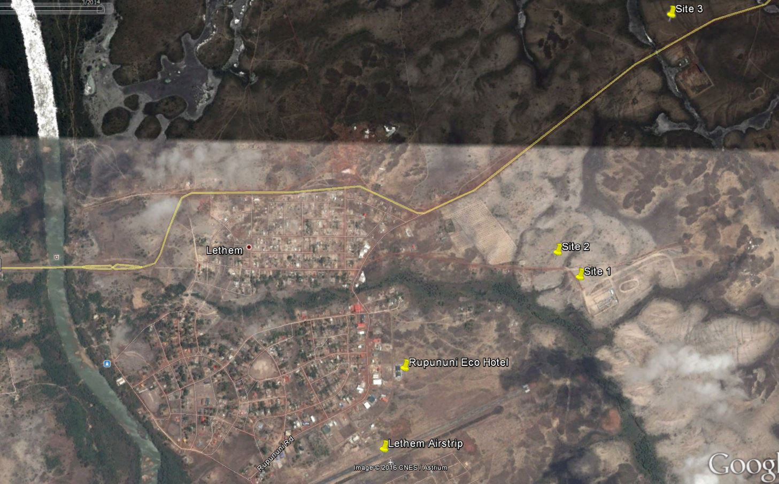

Figure : Location Plan of Abattoir Site Alternatives

Table : Comparison of Abattoir Site Alternatives

|  |  |  |
| --- | --- | --- |
|  | **PRO’s** | **CONS** |
| Site 1 | * Accessible to power network | * Within town limits |
| * Accessible to water supply network |  |
|  |  |
| Site 2 | * Locate on higher ground than Site 1 | * Within town limits |
| * Accessible to power network |  |
| * Accessible to water supply network |  |
|  |  |
| Site 3 | * No fuel cost attached to operation |  |
|  | * Inaccessible to water supply network |
| * Utilizes Green abundant free energy source |  |
| * Low maintenance |  |
|  |  |

Based on the various proposed sites, Site 3 was identified as the most suitable location for the abattoir at Region 9.

## 4.2 Functional Components

Functional Description Details

* Meat handling
* Slaughter of small ruminants and cattle
* Waste disposal

Supporting

Water supply

Power

Figure : Relationship of functional components of Abattoir

### 4.2.1 Power generation System

Given the proximity of the site to electrical transmission line connection to the electrical grid would be the most obvious option. This could feasible be facilitated through the application to the power company and payment of the necessary set up costs.

Power production in Lethem is heavily dependent on transportation of fuel from the coast of Guyana. Emergency repairs to bridges along the road or washed out sections of the road have resulted in breakage of the ground transportation link between Lethem and Georgetown which affects the delivery of fuel for power generation. Lethem has suffered from periods of prolonged blackout and any power generation system must provide for backup electrical supply. Two such alternatives are proposed:

1. Grid supplied power + Standby generator
2. Grid supplied power + PV (solar) back up system

An examination of the benefits of these alternatives is provided in Table 5: Comparison of Electrical Generation Alternatives.

Table : Comparison of Electrical Generation Alternatives

|  |  |  |
| --- | --- | --- |
|  | **PRO’s** | **CONS** |
| Grid supplied power + Standby generator | * Cheap to set up | * Dependent on one fuel supply chain |
|  | * Toxic exhaust fumes |
|  | * Noisy during operation |
|  |  |
| Grid supplied power + PV (solar) back up system | * No fuel cost attached to operation | * Relatively expensive equipment |
| * Utilizes Green abundant free energy source | * Depends on the availability of sunlight |
| * Low maintenance |  |
|  |  |

### 4.2.2 Pure Water Supply System

The selected location of the Abattoir benefits from its’ proximity to a fresh water supply.

|  |  |  |
| --- | --- | --- |
|  | **PRO’s** | **CONS** |
| Grid supplied power + Standby generator | * Cheap to set up | * Dependent on one fuel supply chain |
|  | * Toxic exhaust fumes |
|  | * Noisy during operation |
|  |  |
| Grid supplied power + PV (solar) back up system | * No fuel cost attached to operation | * Relatively expensive equipment |
| * Utilizes Green abundant free energy source | * Depends on the availability of sunlight |
| * Low maintenance |  |
|  |  |

### 4.2.3 Waste Water Treatment

Table : Comparison of Water Supply System Alternatives

|  |  |  |
| --- | --- | --- |
|  | **PRO’s** | **CONS** |
| Septic Tank + Waste Stabilization Ponds | * Cheap to set up | * Large space needed for ponds |
| * Not dependent on electricity supply | * Possible Mosquitoes breeding ground |
|  |  |
|  |  |
| Packaged waste water treatment Plant | * Small space needed for installation | * Electricity dependent |
| * Quick setup |  |
|  |  |
|  |  |

### 4.2.4 Inedible Waste Disposal

Table : Comparison of Inedible Waste Disposal Alternatives

|  |  |  |
| --- | --- | --- |
|  | **PRO’s** | **CONS** |
| Rendering | * Cheap to set up |  |
| * Not dependent on electricity supply | * Electricity dependent |
| * By products can be used for livestock feed | * Relatively Expensive |
|  |  |
| Incineration | * Small space needed for setup | * Electricity dependent |
|  | * Relatively Expensive |
|  |  |
| Composting | * Not dependent on electricity supply | * Electricity dependent |
| * By products can supplement fertilizer |  |



Figure : Potable Water Supply System

## 4.3 Cost Estimates

Base on the findings for the Abattoir research the following are the proposed Cost Estimate for the various implementation schemes. Schemes 2 and 5 represent the proposal for the Abattoirs at Region 9 and Region 5 respectively.



AB1 3000 sqs ft building with equipment

AB2 1500 sq ft builiding with equipment

AB3 Mobile slaughter house with equipment

WS1 Well Drilling and Development

WS2 Creek as Water Source

PG1 Power Generation Source - Solar Power

PG2 Power Generation Source - Diesel Generator 25kW

IWD1 Inedible Waste Disposal - Composting

IWD2 Inedible Waste Disposal - Incinerator

IWD3 Inedible Waste Disposal - Rendering

WWT1 Waste Water Treatment - Packaged Plant

WWT2 Waste Water Treatment - Septic Tank + Waste Stabilization Ponds

# 5.0 Bibliography

1. *UNIFIED FACILITIES CRITERIA (UFC) Lodging Facilities.* 2012. UFC 4-720-01.

2. *FACILITIES CRITERIA (FC) NAVY AND MARINE CORPS.* 2013. FC 4-722-01N.

3. *FACILITIES CRITERIA (FC) NAVY AND MARINE CORPS.* 2012. FC 4-721-10N.

4. **Clayton F. Brasington, Jr., and Donald R. Hammonds.** *LAYOUT GUIDE FOR SMALL MEAT PLANTS.* s.l. : Agricultural Research Service, U.S. Department of Agriculture. Marketing Research Report No. 1057.

5. *Guide to Designing a Small Red Meat Plant.* s.l. : Iowa State University of Science and Technology, 2009. PM 2077.

# APPENDIX 1 – Water Catchment Analysis Case 1

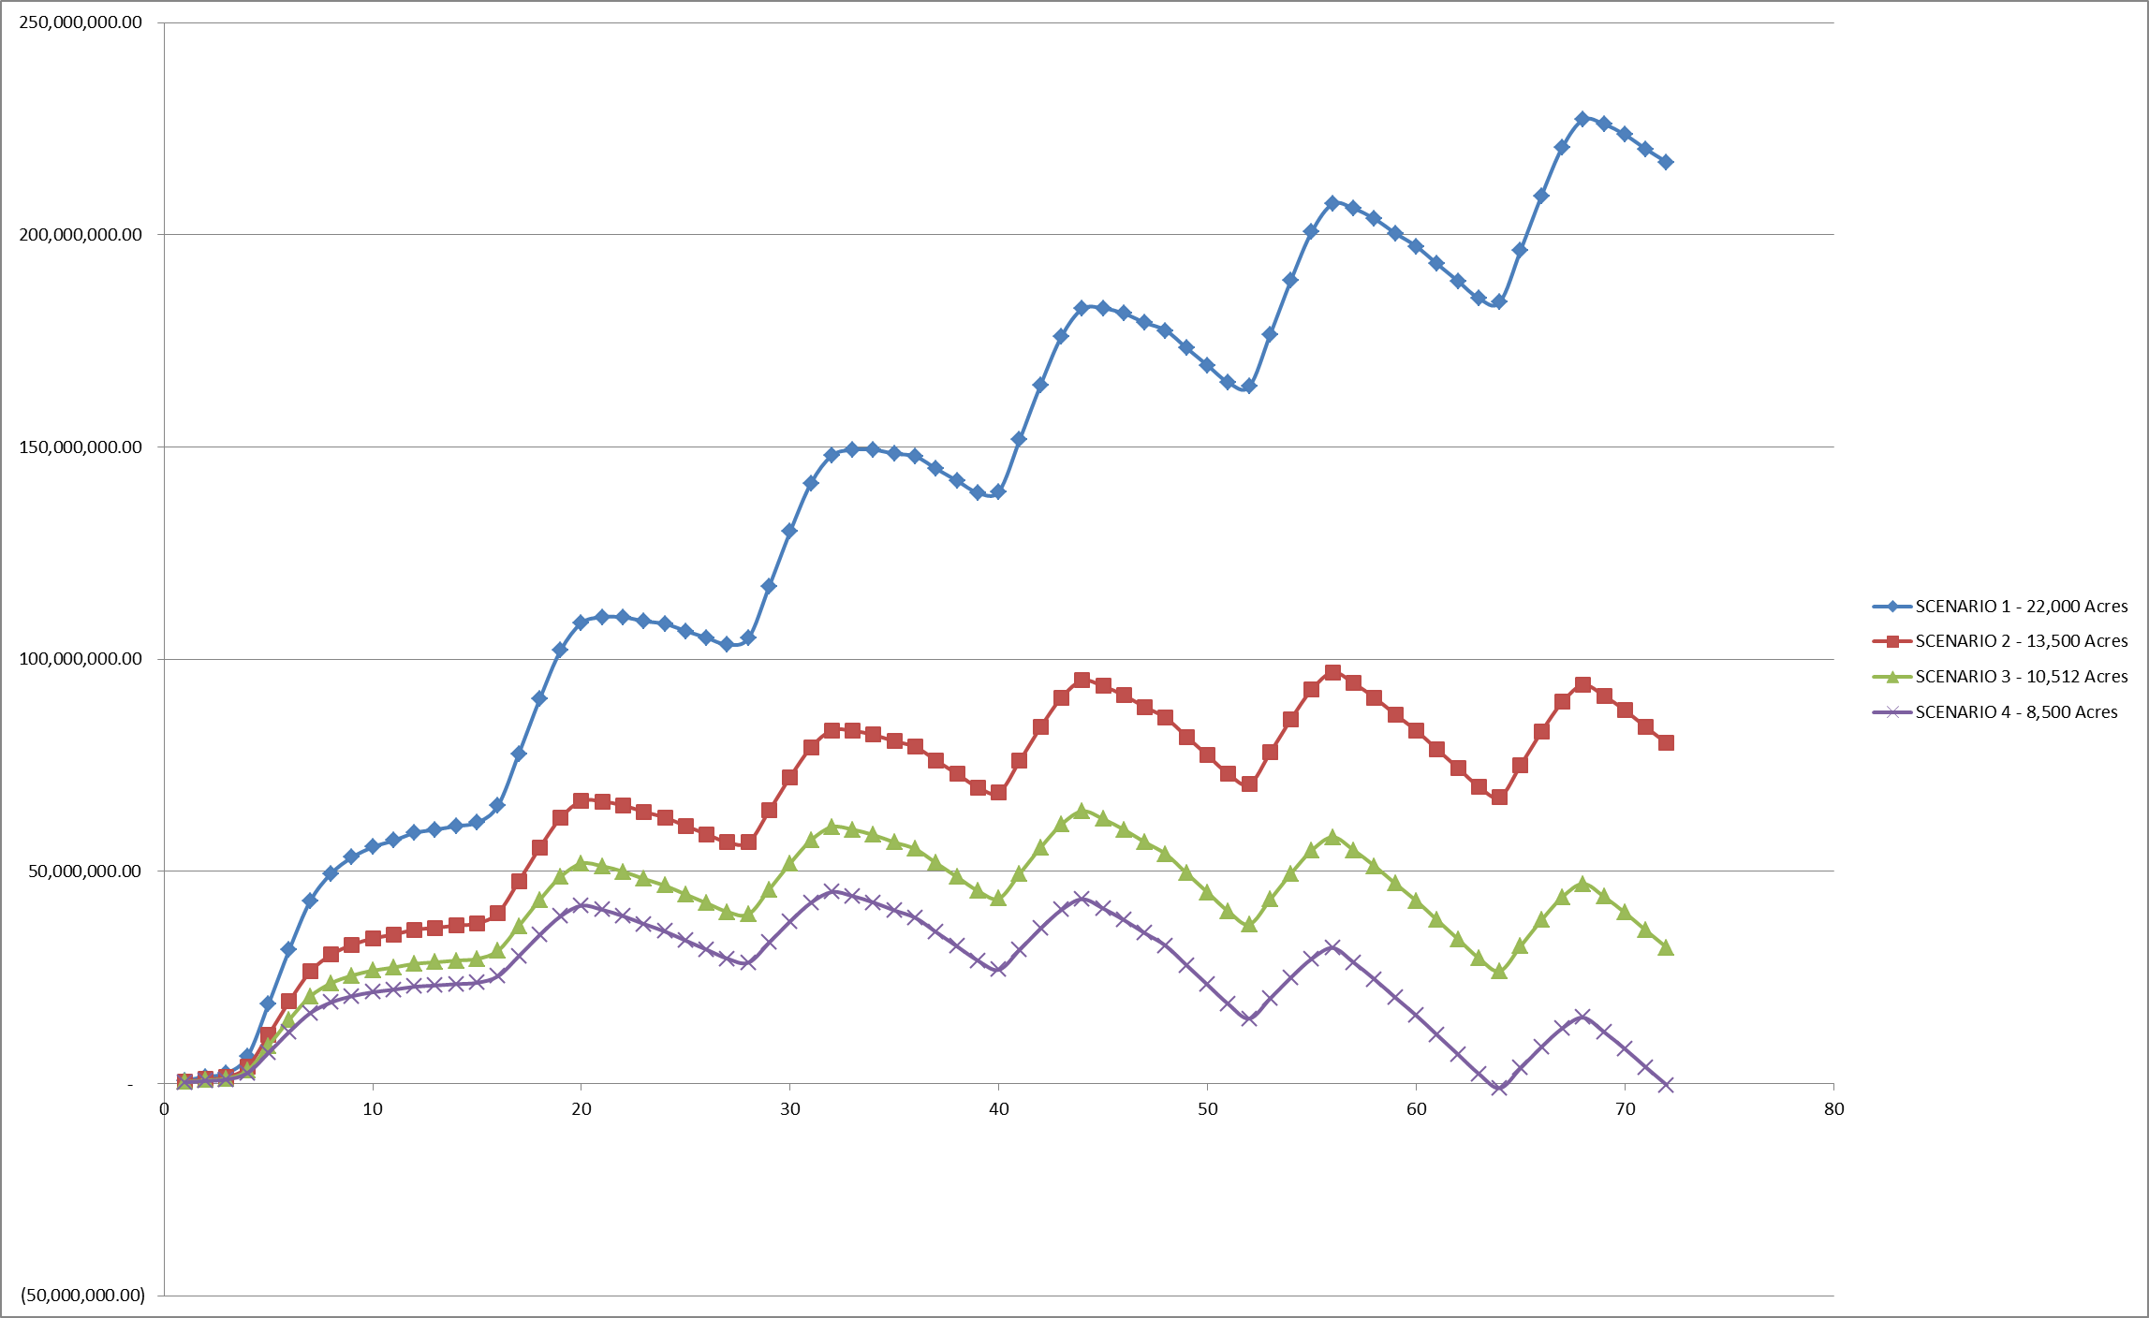

Figure :

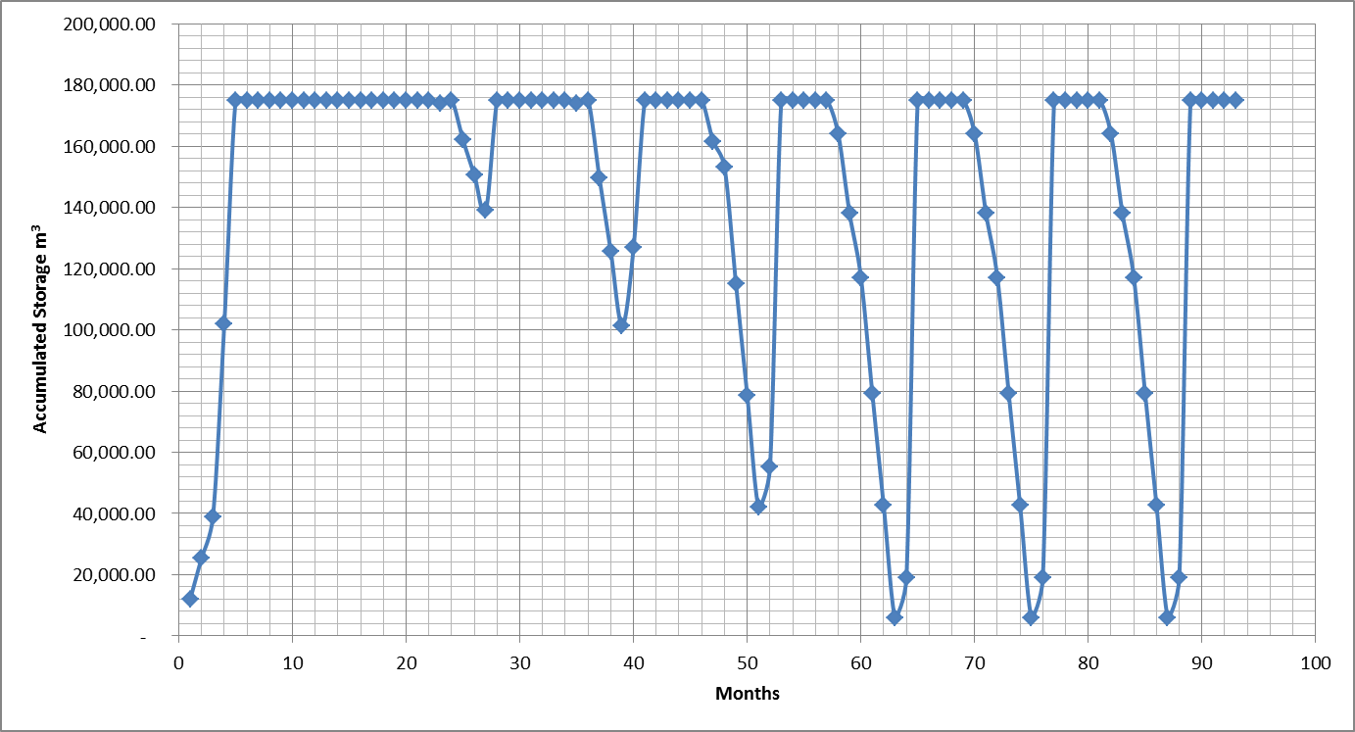

Figure : Accumulated Water Storage for Research Catchment

# APPENDIX 2 – Concept Layouts for AC-9 Buildings

|  |  |
| --- | --- |
| Figure : AC- 9 Proposed Room Layout for Student Dormitory | Figure : AC – 9 Proposed Room Layout for Staff Accommodation ( |

# Appendix 3 – AC-9 Accomodation Size Plan

Table : Design Criteria – AC-9 Dormitory and Living Quarters



Table : Design Criteria – AC-9 Staff Quarters



Table : Design Criteria – AC-9 Dining Facility



Table : Design Criteria – AC-9 Administrative Building



Table : Design Criteria AC-9 Training and Research Building



# APPENDIX 4 - Abattoir Support Infrastructure Estimates

Table : Estimate for Inedible Waste Disposal for Abattoir



APPENDIX 4

Table : Abattoir Water Supply Cost Estimates



Table : Abattoir Waste Water Treatment Estimates



Table : Abattoir Power Generation Cost Estimates



Table : Abattoir Construction Estimate



# Appendix 5 – AC-9 Accomodation Size Plan

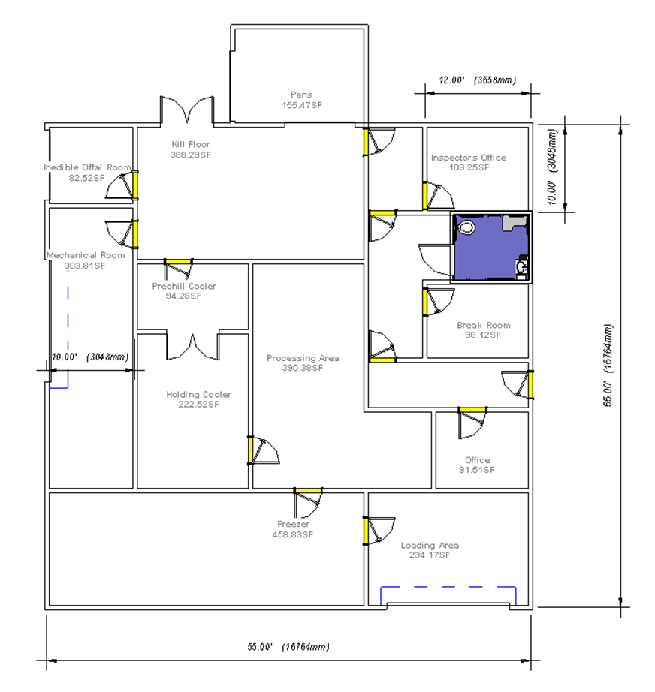

Figure : Proposed Layout for 2500sq ft Abattoir