**DOCUMENT OF THE INTER-AMERICAN DEVELOPMENT BANK**

**SURINAME**

**STRATEGIC SHORT TERM INVESTMENT PROGRAM**

**IN EPAR ELECTRICITY SYSTEM**

**ECONOMIC ANALYSIS ANNEX**

**Revision 1**

**August 13th, 2013**

**Prepared by: Alberto Brugman, Consultant**

**STRATEGIC SHORT TERM INVESTMENT PROGRAM**

**IN EPAR ELECTRICITY SYSTEM**

Contents

I. Introduction 2

II. Assumptions and Methodology 3

a. Economic benefits associated to reduction of power service interruptions 3

b. Increases in transmission and distribution capacities 4

c. Economic benefits associated to electricity consumption 7

d. Economic benefits associated to reduction in O&M costs 9

III. Economic Benefits 10

IV. Economic Costs 11

V. Economic Return 12

VI. Sensitivity analysis 13

VII. Conclusions 14

**STRATEGIC SHORT TERM INVESTMENT PROGRAM**

**IN EPAR ELECTRICITY SYSTEM**

# I. Introduction

Suriname´s power sector consists of a number of individual power systems operated by EBS (Energie Bedrijven Suriname): the EPAR system (the system serving Paramaribo and the surroundings), the ENIC system (for New Nickerie in West Suriname) and other smaller systems. Electricity supply in EPAR system was 1,166.7 GWh in 2011 serving 87,431 users, according information provided by EBS. Historical electricity consumption has been increasing 7.5 % per year since 2000 but investments in the expansion of the transmission and distribution system has been very limited, implying lower service quality for final consumers. Even though, recent decisions have been taken and the EPAR generating system will be expanded at two locations: a) The BEM plant, adjacent to the Saramacastraat plant, in two stages: 63 MW in 2013, and 21 MW second phase, and b) The SPCS expansion in two stages: i) 34 MW in 2013, and 68 MW second phase.

Power service reliability indexes in EPAR system indicate average interruptions per costumer of 81.4/year and 2.57 Hours/interruption, implying economic costs for the users. Several components of the power system are today insufficient to support a reliable service and the grid automatization is limited permitting service interruptions that could be avoided. It is expected that new investments in a SCADA system will provide significant improvements in service continuity and quality.

Also, it has been identified significant load increases in the Northern and Southern sectors of Paramaribo and current nominal ratings at 33 kV level of Substations C and D are imposing limitations to the transmission and distribution operations of the power grid. Specifically, the short circuit rating on 33 kV level in those substations is now being violated by recent expansions in the generation and transmission system and these limitations will be increased with the new generation expansions. This means a serious hazard to personnel and equipment, also a low reliability in those Southern and Northern sectors of Paramaribo that will impact the rest of the system as well. In this order of ideas, EBS has established that the remodeling of the oldest and insufficient substations C and D will provide significant improvements in service continuity and quality.

Total investment costs in the extension of the SCADA system and in the upgrade of substations C and D amounts US$ 12.89 million. This report contains its economical evaluation.II. Assumptions and Methodology

EBS faces several technical, operational and financial challenges which require Government’s intervention with adequate regulations and management practices to, among others, address financial sustainability issues with the review of the tariff structure adapting the average electricity rate of around US¢ 7/kWh in order to reflect the real generation, transmission and distribution costs. Current power service in Suriname implies significant subsidies to final consumers that are basically assumed by the State. Such subsidies constitute financial transferences among national agents not constituting costs or benefits from the standpoint of the national economy.

# a. Economic benefits associated to reduction of power service interruptions

Several components of the EPAR power system are today insufficient to support a reliable service and the grid automatization is limited permitting service interruptions that could be avoided. Supervisory Control and Data Acquisition (SCADA) systems have traditionally played a vital role by providing utilities with valuable knowledge and capabilities that are key to a primary business function - delivering power in a reliable and safe manner. A quality SCADA solution is central to effective operation of a utility's most critical and costly distribution, transmission, and generation assets. Modern SCADA systems are already contributing and playing a key role at many utilities towards achieving: i) New levels in electric grid reliability – increased revenue, ii) Proactive problem detection and resolution – higher reliability, iii) Meeting the mandated power quality requirements – increased customer satisfaction, iv) Real time strategic decision making – cost reductions and increased revenue. EBS already has part of the EPAR transmission grid connected to a SCADA system and with the SCADA extension project it is planning is to connect the entire EPAR grid to this system.

Economic benefits of this project were estimated with the expected reduction of interrupted energy associated to this project. This was estimated through an analysis of the System Average Interruption Frequency Index (SAIFI) and the System Average Interruption Duration Index (SAIDI), which are commonly used as reliability indicators by electric power utilities. SAIFI is measured in units of interruptions per customer and SAIDI is the average outage duration for each customer served, and is usually measured in hours. Both are measured over the course of a year. Next graphs illustrate the historical SAIFI and SAIDI indexes in EPAR system.

**EPAR HISTORICAL RELIABILITY INDEXES**



SAIDI and SAIFI indexes in EPAR system during 2010, 2011 and 2012 indicate that had occurred significant service interruptions of around 30-50 hours/month during three months of the year, implying economic costs for the Surinamese economy. Total average annual interruptions per costumer were 81.4/year and 2.57 Hours/interruption during last three years (see ANNEX 1).

It is expected that with the new investments in a SCADA system these indexes will be improved. To evaluate this, EBS conducted an analysis of the contributions of the SAIDI index in 2012 that could be reduced with the SCADA extension project finding a potential reduction of 8% in total duration of the interruptions (see ANNEX 1). Associated benefits were estimated with EPAR demand forecast (see ANNEX 2) and considering 8.2% of transmission and distribution electricity losses, as informed by EBS. Economic benefits were estimated with the expected reduction of interrupted energy associated to this project, valued at US$ 500/MWh[1] as indicative unitary economic cost of non served energy and considering a long run affectivity factor of 0.9.

# b. Increases in transmission and distribution capacities

**i. Upgrade of substation C**

Substation C receives power from substations T and A2 (which in turn are connected to the power plants). Basically it play a role of transmission and distribution of power to final users supplied from substations Q and C, through existing distribution transformers totaling an existing capacity of 28 MVA in such substations that will be expanded to 50 MVA with the project.

Currently, a fault in the 33 kV switchgear of substation C will imply a short circuit current of 14 kA, higher than its Short Circuit Rating (SRC) of 8.7 kA, implying out of regulations and non safe operations. To evaluate the upgrade of substation C it was estimated, through short circuit analysis, the transmission and distribution capacity in substations C and Q that will not violate the SCR of substation C. The results obtained in the analysis done by EBS indicated that with the upgrade of this substation the SCR of substation C at 33 kV level will be increased from 8.7 kA to 25 kA permitting the increase of safe power distribution through substations C and Q from the existing 28 MVA distribution capacity to the future 50 MVA capacity, as presented in the following two schemes.





To evaluate this Project it was estimated that its operative capacity under the situation “without” its upgrade is 28 MW and "with" its upgrade 50 MW. This analysis considered the additional 33/12.6 kV distribution capacity to be installed in this substation. ANNEX 3 contains the results of the technical analysis done by EBS and the basic information used in the evaluation of this project: i) Maximum transfer and distribution of power in substations C (and Q) “with” and “without” the upgrade project (related to permitted SCR under these two situations), ii) Peak demand statistics in substations Q and C, iii) Characterization of the electricity demand supplied from substations Q and C (% residential, % industrial, % commercial and % others and average tariffs for each sector), iv) Characterization of electricity distribution losses in substations C and Q (% of technical losses and % of non technical losses), v) Investment costs related to the upgrade of substation C, and vi) Annual Operation and Maintenance costs (men-hours per year) of substation C “with” and “without” the upgrade

**ii. Upgrade of substation D**

Substation D receives power from substations R and J (which in turn are connected to the power plants). Basically it plays a role of transmission and distribution of power to final users supplied from substations O, N, E and D through distribution transformers totaling an existing capacity of 74 MVA in such substations. Operating those substations at that capacity, a fault in the 33 kV switchgear of substation D will imply a short circuit current of 14 kV, higher than its SRC of 8.7 kV, implying out of regulations and non safe operations. According EBS analysis, to maintain safe operations power distributed in those substations should be limited to 40 MVA.

With the upgrade of this substation the short circuit rating (SCR) of substation C at 33 kV level will be increased from 8.7 kA to 25 kA permitting the increase of safe transmitted and distributed power in substations D, N, E and Q up to the existing installed capacity of 74 MVA, as presented in the following two schemes.





To evaluate this Project it was estimated that its operative capacity under the situation “without” its upgrade is 40 MW and "with" its upgrade 75 MW. ANNEX 4 contains the results of the technical analysis done by EBS and the basic information used in the evaluation of this project: i) Maximum transfer and distribution of power in substations D, O, N and E “with” and “without” the upgrade project (related to permitted SCR under these two situations), ii) Peak demand statistics in substations D, O, N and E, iii) Characterization of the electricity demand supplied from substations D, O, N and E (% residential, % industrial, % commercial and % others and average tariffs for each sector), iv) Characterization of electricity distribution losses in substations D, O, N, E and D (% of technical losses and % of non technical losses), v) Investment costs related to the upgrade of substation D, and vi) Annual Operation and Maintenance costs (men-hours per year) of substations D “with” and “without” the upgrade

# c. Economic benefits associated to electricity additional consumption

The upgrade of substations C and D will permit an increment of electricity consumption in the Northern and Southern sectors of Paramaribo, given that without these projects EBS would have to restrict power supply up to the current transmission and distribution capacities determined for these two substations (to 28 MVA and 40 MVA, respectively). From the view point of the country, one of the economic benefits associated to these projects will consist in the increase of EBS power sales plus its associated consumer's surplus in the residential sector[2] as permitted by the higher capacity of the upgraded substations (50 MVA and 75 MVA, respectively)[3]. Main assumption of the study was the consideration of a referential "cost effective average tariff" of US$ 162/MWh to final consumers in its area of influence (see ANNEX 5).

Next figure illustrates the demand curve in a future time (t=i). From a user´s perspective, benefits associated to the increase of electricity consumption are estimated as its value according to the willingness to pay by the consumers (area FACG which includes consumer´s surplus given by area BAC), plus the subsidy received by the users (area BDEC).

**BENEFIT ESTIMATION OF ADDITIONAL RESIDENTIAL CONSUMPTION**





In the graph Pi correspond to the cost effective tariff (US$ 162/MWh). As indicated in the graph, consumer's surplus benefits represents around US$ 14-63/MWh while subsidies to the power service would be around US$ 92/MWh under the assumption of maintaining the existing average tariff P0 of US$ 70/MWh to final consumers[4]. In this way, with energy costs estimated equal to the cost effective tariff (US$ 162/MWh), net energy benefits estimated for the upgrade of substations C and D are equal only to the consumer´s surplus.

Consumer's surplus was estimated from the definition of Price – Elasticity (*Ε* ): it follows that the derivative of Price p with respect to the quantity q at the point Pi and quantity Qi is given by:

*dp/dq = Pi/Qi x 1/Ε*

The price that a consumer is willing to pay for a quantity *Qi - Δq* is given by:

*Pmi = P0 – dp/dq x Δqi*

And the consumer’s surplus is calculated as:

Consumer’s surplus = (*Pmi* – *P0*) x *Δqi / 2*

In the equation Δqi is the increase of electricity consumption in year i associated to the projects (Δqi = Qmi - Qi), Pmi is calculated with P0, E and the percentage Ri of additional electricity consumed attributable to the substations upgrade as Pmi = P0 x (1 - Ri/E). Pi corresponds to the “cost effective tariff” (US$ 162/MWh). It was applied a Price-Elasticity of -0.6, according typical estimations of similar electricity markets in Latin America[5] and Ri (Ri = Δqi/Qi) was estimated from demand forecasts and distribution & transmission capacities.

Demand forecasts of power distributed in each substation were obtained from historical peak demand in 2012 (in MVA) and applying future demand increase estimated by EBS for each substation (2.4% per year for substations C and Q and 3.4% per year for substations D, O, N and E, see ANNEX 6). Energy demand forecasts in MWh/year in each substation was obtained from peak MVA forecasts by applying 0.9 as Power Factor, 0.71 as EPAR annual average Load Factor (see ANNEX 6) and 0.9 as Peak Load Diversity Factor. Electricity consumption of final users in MWh/per year was obtained considering 8.2% as Loss Factor, as informed by EBS.

# d. Economic benefits associated to reduction in O&M costs

Today, the power supply of substations C and D implies significant Operation and Maintenance costs that will be reduced with the upgrade projects. EBS has estimated reductions of 720 men-hours of specialized labor per substation per year associated to these projects. With US$ 18.5/ men-month basic salary and additional worker benefits this will imply annual savings of US$13,320 in O&M costs in each substation.

# III. Economic Benefits

Next table summarizes annual benefits estimated for each project and for the Strategic Short Term Investment Program in EPAR Electricity System (see ANNEX 7 for details about benefit calculations).

**PROGRAM BENEFITS (US$ K)**



# IV. Economic Costs

Next table summarizes the investment costs in the three projects included in the Strategic Short Term Investment Program in EPAR Electricity System.

**INVESTMENT COSTS (US$)**

SCADA Extension ........................ $ 6'000.000

Upgrade of Substation C .............. $ 4'626.000

Upgrade of Substation D .............. $ 2'260.000

Total ............................................. $ 12'886.000

The upgrade of the Substations C and D will reduce O&M costs, which are counted as benefits. The O&M costs of the SCADA Extension were estimated in US$ 120.000/year. Also, a total generation, transmission and distribution cost of the additional energy supplied by these projects was estimated equal to the "cost effective tariff" of US$ 162/MWh[6].

Next table summarizes total Annual costs estimations for the Program.

**PROGRAM COSTS (US$ K)**



# V. Economic Return

Next table contains the itinerary of Benefits and Costs associated to the Strategic Short Term Investment Program in EPAR Electricity System. The economic rate of return (ERR) estimated for the entire program is 19.2% and the present value of its net benefits (at 12% discount rate) is USD 8.12 million.

The economic rate of return estimated for the SCADA extension is 15.8% and its net present value is USD 1.50 million; benefits evaluated for this project were the expected economic savings associated to the reduction of energy shortages in Paramaribo and it were not considered other project benefits as increasing customer satisfaction by meeting the mandated power quality and cost reductions and increased EBS revenues due to improvements in real time strategic decision making.

The economic rate of returns estimated for the upgrade of substations C and D are 21.6% and 20.8%, respectively, and their net present values are USD 3.58 million and USD 3.03 million, respectively.

**PROGRAM ECONOMIC RETURN (US$ K)**



# VI. Sensitivity analysis

A sensitivity analysis of the Cost - Benefit evaluation to variations in the following main parameters included in the analysis was done: a) investment costs, b) average tariff to final consumers, c) unitary economic cost of electricity interruptions, d) demand forecasts, f) actual transmission and distribution capacities estimated for substations C and D, and g) estimated shortages reduction associated to the SCADA extension. Next table contains the results obtained.



Results obtained indicates that + 15% and -15% variations in main parameters intervening in the economic evaluation imply always results higher than 12% for the economic rate of return for the entire program. Most significant parameters affecting the economical evaluation are demand forecasts and current estimated transmission and distribution capacities of substation C and D: a 15% variation in those estimations reduces to 13.5% and 14.8%, respectively, total program's economic return. The economic rate of return of the SCADA extension and the upgrade of substations C and D resulted always higher than 12%.

# VII. Conclusions

The following conclusions are obtained for this report.

* SAIDI and SAIFI historical indexes in EPAR system show the occurrence of significant service interruptions implying economic costs for the Surinamese economy. Total average annual interruptions per costumer were 81.4/year and 2.6 Hours/interruption during last three years and it is expected that with the new investments in a SCADA system total duration of the interruptions will be reduced in around 8%.
* The SCADA extension project represent USD 6 million of investment costs, its expected economic rate of return is 15.8% and its net present value is USD 1.5 million of benefits related to reduction of energy shortages in Paramaribo. Other project benefits were not quantified, as increases in customer satisfaction by meeting the mandated power quality and cost reductions due to improvements in real time strategic decision making.
* Several components of the EPAR power system are today insufficient to support a reliable power supply and it has been identified load increases in the Northern and Southern sectors of Paramaribo were current transmission and distribution capacities of Substations C and D are imposing limitations to the operations of the power grid. The upgrade of such substations will imply investments costs of USD 4.63 million and USD 2.26 million, respectively. The economic rate of returns estimated for the upgrade of substations C and D are 21.6% and 20.8%, respectively, and their net present values are USD 3.58 million and USD 3.03 million, respectively. Net benefits estimated for these projects were the consumers’ surplus associated to the additional electricity supplied and the reduction in O&M costs in those substations.
* Total investment cost of the entire program is USD 12.89 million, its economic rate of return is 19.2% and the present value of its net benefits (at 12% discount rate) is USD 8.12 million. Results obtained indicates that + 15% and -15% variations in main parameters intervening in the economic evaluation imply always results higher than 12% for the economic rate of return for the entire program and for each project.

**ANNEX 1**

**EPAR: SAIFI & SAIDI INDEXES**



Next graphs summarizes the results of the analysis of 8% potential reduction of SAIDI index in EPAR system.



 

TOTAL: 14.5 TOTAL: 15.5

**ANNEX 2**

**EPAR: DEMAND FORECASTS**

### I. Historical electricity demand

Next table shows the national growth of the electricity demand in generation buses for Suriname, starting from the year 2000.

**SURINAME: HISTORICAL ELECTRICITY DEMAND (kWh)**



Source: EBS

From table the average growth of the electricity demand over the past 11 years is 6.5%. Annual demand growth in EPAR area (6.6%) is higher than in the Districts (5.6%), being Nickerie demand growth the most significant (5.9%). The demand of Rosebel Goldmines is not included in the table.

### II. Energy demand forecasts

Energy demand forecasts were estimated using future annual average growths similar to historical growth: 7.0% for Epar and Nickerie and 6.0% for the disctricts. It was considered that future Epar demand covers the specific loads of the refinery expansion and the governmental housing programs. However, the incremental demand of the gold industries (Rosebel and Newmont) were estimated separately. Next table summarizes the forecasted energy demand for each of the systems and for the gold mines (the demand for the gold industry was estimated with peak demand reaching 50 MW for Rosebel in 2017 and 70 MW for Newmont in 2019 and with 0.84 as load factor).

**ENERGY DEMAND FORECAST (GWH)**



Source: EBS

**ANNEX 3**

**UPGRADE OF SUBSTATION C**

* Maximum power transfer capacity in substation C:
* Limiting factors for maximum power transfer capacity:
* Transmission grid transport capacity
* Substation transformer capacity
* Short-circuit Current Rating (SCR) based on total active generation capacity.
* *Without the upgrade project:*
  + Short-circuit Current Rating (SCR) of existing 33 kV switchgear has been exceeded;

14 kA simulated short-circuit fault current compared to SCR of 8.7 kA for existing 33 kV switchgear.

* + Current power transfer level already in violation based on above.

* *With the upgrade project:*
  + Short-circuit Current Rating (SCR) for new 33 kV switchgear determined to be 25 kA;

Sufficient SCR based on planned generation capacity expansion.

* + Maximum power transfer capacity set by total planned substation transformer capacity of 50 MVA.
* Additional 33/ 12.6/ 6.3 kV distribution capacity to be installed:

*Distribution capacity without the upgrade project (existing distribution capacity):*

* 3 x 7 MVA for 12.6 kV distribution voltage level.
* 1 x 7 MVA for 6.3 kV distribution voltage level.

**Total existing capacity: 28 MVA**

*Distribution capacity after implementation of the upgrade project:*

* 1 x 25 MVA for 12.6 kV distribution voltage level. (second 25 MVA for 12.6 kV will be added at later stage)
* 1 x 25 MVA for 6.3 kV distribution voltage level.

**Total planned capacity: 50 MVA (75 MVA at later stage)**

* Peak demand:

**Note:**

Peak demand data not available for September 2012, December 2012 and February 2013.

Substation C:

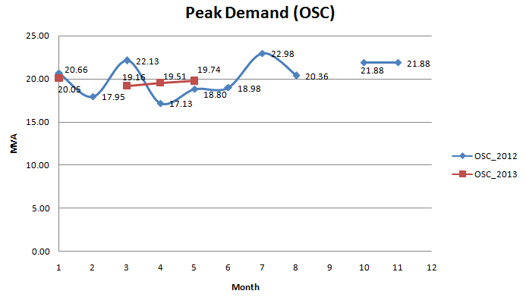

Substation Q:

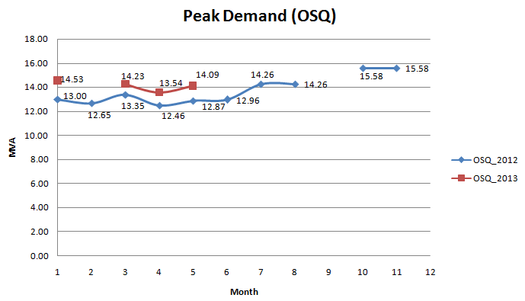

Future expansion of transmission grid with:

1. Substation Ringweg (25 MVA 33/ 12.6 kV substation transformer)
2. Substation Torarica (25 MVA 33/ 6.3 kV substation transformer)

* Characterization of electricity demand:

**Note:**

The data presented is from April 2013 and is for the total EPAR-system (excluding Rosebel Gold Mines (RGM)).

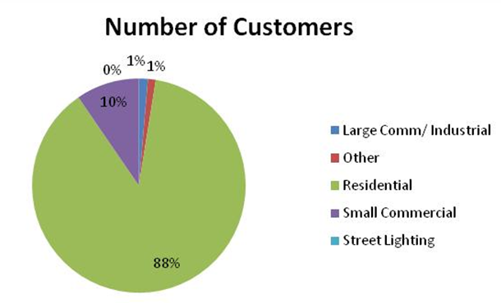 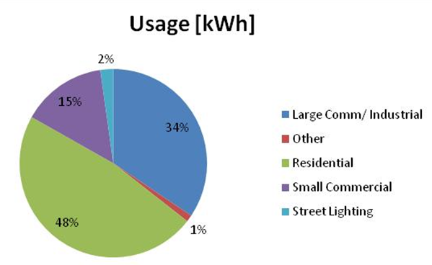

* Average tariff: between 0.05 USD and 0.07 USD
* Characterization of electricity distribution losses:

Substation C and Substation Q:

* + 8 % of technical losses
  + < 1 % of non-technical losses
* Project investment cost:

Upgrade substation C (SSC): USD 4.626.000

* Annual Operation & Maintenance cost of substation C:
* *Without the upgrade project:*

Personnel: 832 man hours/ year

Equipment: 208 hours/ year

Maintenance: 720 man hours/ year

* *With the upgrade project:*

Personnel: 832 man hours/ year

Equipment: 208 hours/ year

**ANNEX 4**

**UPGRADE OF SUBSTATION D**

* Maximum power transfer capacity substation D:
* Limiting factors for maximum power transfer capacity:
* Transmission grid transport capacity
* Substation transformer capacity
* Short-circuit Current Rating (SCR) based on total active generation capacity.
* *Without the upgrade project:*
  + Short-circuit Current Rating (SCR) of existing 33 kV switchgear has been exceeded;

21 kA simulated short-circuit fault current compared to SCR of 8.7 kA for existing 33 kV switchgear.

* + Current power transfer level already in violation based on above.
* *With the upgrade project:*
  + Short-circuit Current Rating (SCR) for new 33 kV switchgear determined to be 25 kA;

Sufficient SCR based on planned generation capacity expansion.

* + Maximum power transfer capacity set by total planned substation transformer capacity of 75 MVA.
* Additional 33/ 12.6/ 6.3 kV distribution capacity to be installed:

*Distribution capacity without the upgrade project (existing distribution capacity):*



**Total existing operative capacity: 40 MVA**

*Distribution capacity after implementation of the upgrade project:*

**

**Total future operative capacity: 75 MVA**

* Peak demand:

**Note:**

Peak demand data not available for September 2012, December 2012 and February 2013.

Substation O:

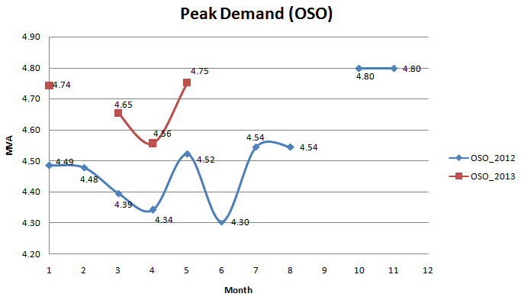

Substation N:

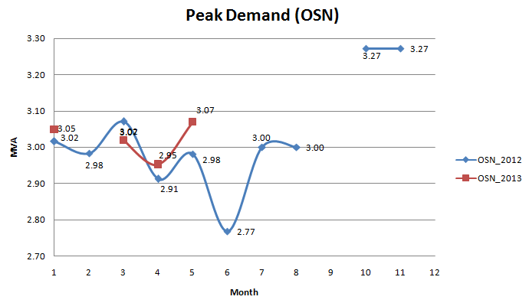

Substation E:

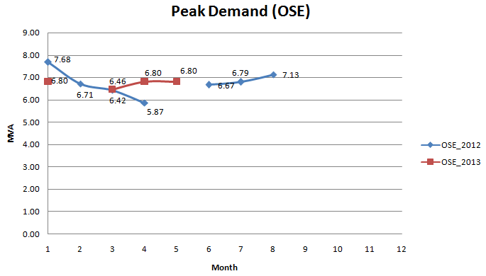

Substation D:

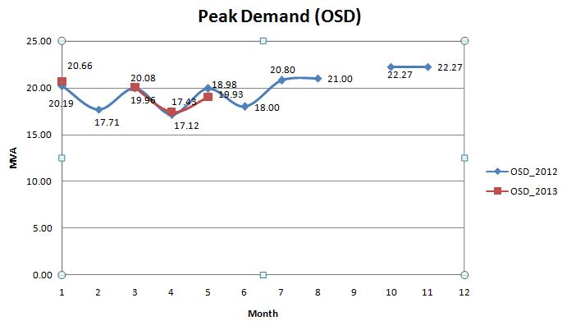

* Characterization of electricity demand:

**Note:**

The data presented is from April 2013 and is for the total EPAR-system (excluding Rosebel Gold Mines (RGM)).



* Average tariff: between 0.05 USD and 0.07 USD
* Characterization of electricity distribution losses:

Substation O, Substation N, Substation E and Substation D:

* + 8 % of technical losses
  + < 1 % of non-technical losses
* Project investment cost:

Upgrade substation D (SSD): USD 2.260.000

* Annual Operation & Maintenance cost of substation D:
* *Without the upgrade project:*

Personnel: 832 man hours/ year

Equipment: 208 hours/ year

Maintenance: 720 man hours/ year

* *With the upgrade project:*

Personnel: 832 man hours/ year

Equipment: 208 hours/ year

**ANNEX 5**

**ESTIMATION OF THE "COST EFFECTIVE TARIFF" IN EPAR SYSTEM**

A "Cost Effective Tariff" for final users in EPAR system was estimated considering an average of 36% of hydroelectric energy supply (at USD 70/MWh representative of expected purchase prices) and the remaining 64% with the unitary generation cost of Diesel motors with heat recovery using Heavy Fuel Oil, on the basis of the following components:

A. Fixed Tariff, consisting of: i) Fixed Operations & Maintenance cost: USD 26.3/kW/year, and ii) Investment cost: USD 1,200/kW

B. Variable Tariff, consisting of: i) Variable Operations & Maintenance cost : USD 0.009/kWh, ii) Fuel cost (HFO): 14.5 US$/MBTU, iii) Heat Rate of 7.195 BTU/KWH ; iv) Lubricants cost:2.35/MWh v) Variable Costs of US$ 9/MWH.

The generation cost was estimated in USD 141/MWh for EPAR system and the cost effective tariff in US$ 162/MWH, including a transmission and distribution tariff of USD 40/MWH based on the experience in other similar systems, as follows:

COST EFFECTIVE TARIFF IN SURINAME



**ANNEX 6**

**EPAR: POWER DEMAND IN 2011**



**EPAR: PEAK DEMAND FORECASTS BY SUBSTATION**



**ANNEX 7**

**ECONOMIC BENEFITS**

Next table summarizes interrupted energy benefits estimated for the SCADA extension project during its 15 years of estimated useful life.

**SCADA PROJECT: BENEFITS ASSOCIATED TO NON SERVED ENERGY**



Next table summarizes energy consumption benefits estimated for each project during its 25 years of estimated useful life.

**UPGRADE OF SUBSTATION C: ENERGY CONSUMPTION BENEFITS**



**UPGRADE OF SUBSTATION D: ENERGY CONSUMPTION BENEFITS**



Economic benefits associated to the upgrade of substations C and D due to reduction in O&M costs were estimated in US$ 34,000/year for each substation.

1. Energy rationing cost, also called “failure cost”, is the cost per kilowatt-hour paid (or economic benefit lost), on average, by the users when energy is not available and henceforth, it needs to be generated with emergency units or is not consumed, representing economic costs for final users. For reductions in electricity consumptions an alternative definition is the price at which potential users would be willing to pay for non-available energy. Reference values of such cost vary greatly in Latin America, mainly due to market, methodological, and regulatory differences. Its calculation varies across the region, but on average such calculation reflects an increasing variable cost that is added to supply a given level of demand. For such reason, some countries have different rationing costs for each segment of demand (residences, commercial, industrial), and others according to the percentage of demand affected by the shortage (eg. 5%, 10%, above 20%); other countries use single values (like Brazil, calculated using the generating costs of an hydro emergency unit and valuing the water in reservoirs). Suriname does not count with a specific calculation of rationing cost. This study uses US$500/MWh as Failure Cost for a 100% demand failure in order to use one value in the middle range of some of its Latin American benchmark peers and considering that the shortages reduced by the extension of the SCADA system will be associated to 100% of demand temporary reductions in specific sectors of the city. For instance, Chile failure cost is about US$552/MWh for failures greater than 20% of demand while for the same demand percentage, Uruguay uses US$2000/MWh; Colombia uses US$455/MWh for residential segment up until 1877 US$/MWh for medium industrial and commercial segment; Peru uses US$746/MWh, Dominican Republic uses US$167.8/MWh, and Brasil US$270/MWh. However, the latest two values are basically related to the cost of temporary high capacity backup power sources, situation that would not be the case of the electricity consumption reductions (or partial costly local backup power based on liquid fuels) originated by low reliability power supply as it would be the case in Paramaribo without the extension of the SCADA system.
2.
3. Residential consumption represents 48% in the influence areas of substations C and D. And for other sectors (Commercial, Industrial, etc.) benefits were estimated equal to the "Cost Effective Tariff", without consumer's surplus.
4. This assumption will imply that future electricity consumption per capita in Suriname will remain similar to its current value of around 2.230 kWh per capita/year. However, in case of a significant tariff readjustment to levels similar to the “cost effective tariff” (implying increases of around 130%), this consumption most probably will be reduced significantly (for example other similar economies with higher electricity tariffs have lower per capita electricity consumption, as Honduras, 669 kWh per capita/year, Guatemala 559 kWh per capita/year, Bolivia 603 kWh per capita/year, etc.)
5. Price elasticity of electricity demand is a measure used in economics to show the responsiveness, or [elasticity](http://en.wikipedia.org/wiki/Elasticity_(economics)), of the quantity demanded of electricity to a change in its price. More precisely, it gives the percentage change in quantity demanded in response to a one percent change in price (holding constant all the other determinants of demand, such as income). Another indicator is Income elasticity of demand which relates percentage change of demand related to percent income variation. Both indicators permit the modeling of the behavior of the consumers to price and income variations permitting the estimation of the economic value of the consumed electricity. This situation has been empirically and theoretical supported in several Latin American countries. Suriname does not count with specific studies at this respect, for this reason in this study it was applied the experience in other Latin American countries. In Chile, recent studies indicates that the price elasticity of residential demand is -0.27 for one year and -0.39 for longer terms. Westley estimated it in -0.5 for Paraguay (1984) and in -0.45 for Costa Rica (1989) and Berndt & Samaniego in -0.47 for México (1984). In summary, available studies indicate that long term price elasticity of residential demand is in the order of -0.4 to -0.5. Based on such experiences, for the study it was adopted -0.6 as a conservative average price elasticity of electricity demand for residential sector in EPAR system of Suriname.
6. This is assumed equal to the average tariff received by EBS of US$ 70/MWh plus the average subsidy received by the users of US$ 92/MWh. In this way, net energy benefits estimated for the upgrade of substations C and D correspond to the consumer´s surplus.