

Copyright © 2015 Inter-American Development Bank. This work is licensed under a Creative Commons IGO 3.0 Attribution-Non Commercial-No Derivatives (CC-IGO BY-NC-ND 3.0 IGO) license (<http://creativecommons.org/licenses/by-nc-nd/3.0/igo/legalcode>) and may be reproduced with attribution to the IDB and for any non-commercial purpose.  No derivative work is allowed.

Any dispute related to the use of the works of the IDB that cannot be settled amicably shall be submitted to arbitration pursuant to the UNCITRAL rules. The use of the IDB’s name for any purpose other than for attribution, and the use of IDB’s logo shall be subject to a separate written license agreement between the IDB and the user and is not authorized as part of this CC-IGO license.

Note that link provided above includes additional terms and conditions of the license.

The opinions expressed in this publication are those of the authors and do not necessarily reflect the views of the Inter-American Development Bank, its Board of Directors, or the countries they represent.

Notes on adapting survey materials

This portal contains materials aimed at easing the work of those that wish to carry out an impact evaluation that includes the surveying of households, persons, establishments (health, schools, etc.) or other entities.

The material included contains the following examples and tools:

* Sample survey questionnaires for:
  + - households;
    - community leaders;
    - health facilities;
    - education facilities (schools)
* Data entry programs for the cited questionnaires
* Letters of informed consent for the sample questionnaires
* Examples of teaching materials developed for surveying households
* Enumerator’s manual for the cited examples
* Supervisor’s manual
* Data Entry Manager’s manual

To help you use these materials, some of these documents include notes that assist you in adapting the material.

# Sample Questionnaire

The sample questionnaires that are included have been developed in accordance with best practices and have been inspired by a collection of surveys implemented in different countries.

In the examples, the lists of possible answers whose content may vary from one country to another have been colored red and left in parentheses. For example, the list of possible health insurance plans in question (4.01) must be determined during the process of adapting the material:

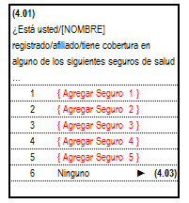

It is likely that none of these questionnaires will completely meet your needs after being adapted; you must analyze the relevance of each one of the different questionnaire models’ sections and the bearing of each one of the questions in relation to the objectives of the impact evaluation.

If you want to use the questionnaire’s appendix material, such as the data entry program, the training material or the manuals, then you must keep in mind that all these materials explicitly reference question numbers. For example, question (4.11) corresponds to the place where the respondent sought medical attention in the past 30 days, and the manual references this number, in the training material and in the data entry program.

|  |  |
| --- | --- |
| **Questionnaire** | DEP |
|  |  |

|  |  |
| --- | --- |
| Manual | Training |
| “*4.11: Note that this question is answered by (1) those who sought consultation for the illness mentioned in 4.07 and those who sought consultation for that health problem, but visited a health center during the past 30 days, for whatever reason.* ” |  |

For these reasons we suggest that you adhere to the following recommendations:

1. *New Sections (or modules)*: They must be added at the end of the questionnaire; but if the nature of the new section indicates that it should be inserted between two pre­-existing sections –for example to ease the flow of the interview-, then label it using a letter after the number of the section that precedes it. For example, if you wish to insert a module called “Access to services” after the section 4: HEALTH, in the example household questionnaire, then label it “SECTION 4A: ACCESS TO SERVICES”, and the questions must be numbered “(4A.01), (4A.02), etc.
2. *New questions in a preexisting section*: Our advice is simple. Insert the new questions at the end of the Section. But if you need to insert one, then number it adding a letter to the number of the question that precedes it.
3. *Question that you wish to remove*: Physically remove from the questionnaire, but keep the numbers of the remaining questions.

## Note on the numbering of the questions in the questionnaires

The numbers of the questions have been defined using formulas from Excel. In this way, you only write the number of the first question of a section, and for the remaining question numbers you use a formula. Next we explain how to do it:

* The numbers must be in the “Number” format, with two decimals and a parenthesis for negative numbers:

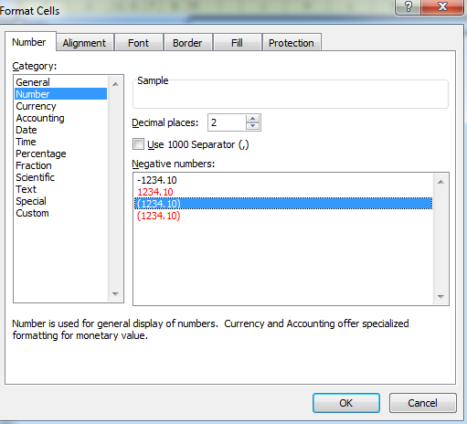

* The first question of the section is numbered like this: “-X.01” where “X” is the number of the section. For example, for section 8, it would be like this: “-8.01”.
* By defining it as a negative number with the format specified above, it will appear like this: “(X.01)”. In the example: “(8.01)”

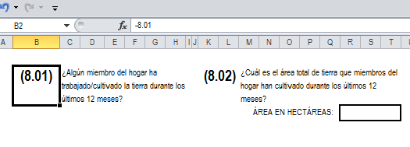

* To number the second question, you use the following formula: It’s the number of the previous question minus “0.01”, in the example:

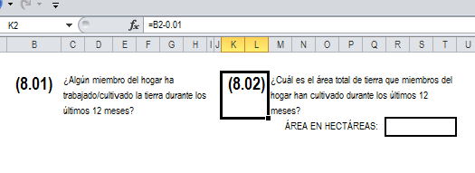

The sample questionnaires in this portal are the following:

|  |  |
| --- | --- |
| Household Survey | Household Questionnaire_Ing.xlsx |
| Health Center Survey | Health Facility Questionnaire_Ing.xlsx |
| School Establishment Survey | Education Facility Questionnaire_Ing.xlsx |
| Community Leader Questionnaire | Community Leader Questionnaire_Ing.xlsx |

You can find many more examples of questionnaires and questions at the website [www.ihsn.org](http://www.ihsn.org).

# Data Entry Programs (DEP)

On the site you will find data entry programs, developed using the LSD-2010 platform, for each one of the sample questionnaires, which if used must be adapted in accordance to the changes that you make for your investigation questionnaire. LSD-2010 is based on Visual Basic for Excel. At the end of this chapter we explain each DEP.

These data entry programs contain range validations and certain consistency controls for the inputted information, which can be modified by a user that is familiar with the Visual Basic language, and also allows for, if desired, the incorporation of additional controls.

If you add sections or questions you must adapt the data entry program to create new fields in which to enter the data from the new questions or new sections. The same applies for eliminating sections or questions: these input fields must be eliminated.

If you remove questions, it’s possible that the DEP may give you an error message. For example, if there is a validation between the members of the household’s age and their date of birth, and you eliminate the date of birth question; the DEP will give you an error message because the date of birth variable no longer exists. And this will halt the execution of all the validations.

The “LSD-2010 Manual.doc” document explains how to create/remove variables, and also how to create/remove consistency controls. It also explains that there is a designer’s DEP (for the person who “creates” the program) and another one for the data entry manager. Basically, the difference is that in the designer’s DEP the menu has more options; which allows the person to create/eliminate/modify variables, create consistency controls, define ranges, skips, etc. While the manager’s DEP only allows them to enter data and validate it.

Among the designers more important options is the exporting of data to Stata or SPSS.

## Note on how to assign names to the variables

The dictionary of internal variables used when creating the DEP follows the following convention: the “names” of the variables start with the letter “s” (for section), plus two digits for the number of the section, an underscore “_”, and finally two digits for the number of the question. For example:

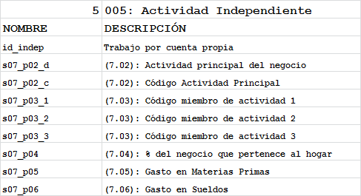

And once exported to Stata will look like this:

|  |
| --- |
|  |

## Note on how data is stored

The data on a household (school, health center, etc.) are saved in a text file with a fixed format, on the hard drive of the computer where the questionnaires have been stored. In the case of the DEP for the household, the data will be saved under “C:\PeI_DEP\Household\Data.” There’s a data archive for each household, and its name is the household identifier. In this case the identifier is composed of the letter “H” (for household) plus two variables: UPM + No. of the Household.

For example, if the manager has entered the data for the UPM 00001, households 1, 2 and 3, then you will see the three following archives in the data directory:

C:\PeI_DEP\Household\Data\H0000101

C:\PeI_DEP\Household\Data\H0000102

C:\PeI_DEP\Household\Data\H0000103

When you –as designer– “export” the data onto Stata or SPSS, the DEP will take care of consolidating all these archives into a single registry (see “LSD-2010 Manual.doc” manual). But before that you must copy all the data archives into your own computer.

In this portal you will find the following DEPs:

* Household Questionnaire DEP: “DEP Household_Ing.doc”
* Community Leader Questionnaire PED: “DEP Community Leader_Ing.doc”
* Health Facility Questionnaire PED: “DEP Health Facility_Ing.doc”
* Education Facility Questionnaire PED: “DEP Education Facility_Ing.doc”

The designer’s program should, of course, not be given to the managers. In the Data Entry Manager’s manual it is labeled “Data Entry Manual_Ing.doc.”

# Letters of informed consent

Surveys used in impact evaluations in general, consider as part of their practices the obtainment of informed consent on the part of the respondents to be surveyed. This letter of consent has the objective of informing the respondent about the interview and the study, about the inherent risks of any eventual bio-medical tests, informs them of the safeguards used to maintain the confidentiality of the information obtained, and insists on the voluntary nature of participating.

The examples included must be modified according to each evaluation. Each document contains the essential text and all parts that must be modified have been clearly indicated. Keep in mind that the Committee on Ethics that validates the study can solicit some of these modifications.

# Manuals

For each one of the sample surveys we have developed a specific Enumerator’s manual, as well as a supervisor’s manual.

These manuals normally have a common body that explains how to conduct the interviews, and a specific part that explains in detail the content of each questionnaire.

In the body of each manual we have incorporated notes that will assist you in adapting the content to the specific context of the study.

Although you must explain in the detail the questionnaire, these explanations must be given with the objective of given additional information to complement the contents of the questionnaire. It doesn’t make sense, for example, to explain the variable on gender, or to once again explain the questionnaire codes, but it might make sense to explain how to confront the presence of visitors in the household, in other words how to register or not register them. The idea is for the manual to offer complementary information that will reduce the risks of ambiguous interpretations by the enumerator.

# Training the field personnel

Training the field personnel is without a doubt one of the most undervalued components of the design and implementation of household surveys, and one that causes the most debate at the moment of establishing the agenda and the budget for the operation. While some assume that the training can be done in a few hours or days (or even can be done simply with written instructions), anyone who has been involved in a real survey in the past will want to measure the time in weeks, and assign a budget that is consistent with the duration and the logistics associated with such a training.

Independent of their previous survey experience, the training of an interviewer must include three basic components: [1] formal learning, through plenary academic sessions, [2] transforming knowledge into behavior, through small group exercises, [3] practice in the field, with real households. Since components [2] and [3] require dedicating an instructor and an assistant for each group of, at most, 30 enumerators, training a large group of enumerators will require the previous training of the instructors.

The specific details of the process depend largely on each particular survey.

We include an agenda titled “Training Agenda_Ing.xlsx,” that was developed for the sample household questionnaire.

Note: In this document, we use the terms “Training,” “Capacity building” and “Formation” as synonyms.

We also include in this portal an example of the training material that can be used during the training of field personnel (supervisors, enumerators). This material is composed of a set of PowerPoint presentations developed *specifically for the sample household questionnaire*.

To facilitate the use of the presentation during the training, and also due to its large byte size, we have divided it into *a presentation for each Section* of the household questionnaire, plus an introduction:

* PeI_household_capacit_Intro_Ing.pptx
* PeI_household_capacit_s00_Ing.pptx
* PeI_household_capacit_s01_Ing.pptx
* PeI_household_capacit_s02_Ing.pptx
* ….
* PeI_household_capacit_s20_Ing.pptx
* PeI_household_capacit_s21_Ing.pptx
* PeI_household_capacit_s22_Ing.pptx

This material must be adapted in accordance to the final content of the questionnaires. We recommend keeping in mind the following recommendations on adapting this material and on the training in general:

* If your project has a logo, add it to the background template of the slides.
* Obviously, if you have added or removed questions/sections, you must replace the slides affected by the changes.
* To insert into the slides parts of the questionnaire as they appear on the paper, use “Copy” + “Paste Special” + Bitmap
* We recommend using “PowerPoint animation” –prudently- for the texts and images, in order to keep the participants’ captivated attention.
* Add as many examples as you can in the presentations.
* A large part of the explanatory text of the presentations can be taken from the corresponding manual.
* Show on the slides all the questions that appear in the questionnaire, even if you find them trivial. This gives the participants the opportunity of carefully reading them and asking questions, if there are any that are not clear.
* If you must train more than 30 people, we recommend dividing them in groups and creating a “Teacher Trainer” for each group, who will be responsible for training the trainees assigned to him/her. In this case, the training must be centralized (all the groups in the same place); to allow for interaction between the trainers and the trainees. This helps to standardize the training.
* Of course if the survey includes the taking of biological samples, cognitive tests or other, then the duration of the training will be longer.