Document of the Inter-American Development Bank

JAMAICA

Energy Efficiency and Conservation Program
(JA-L1056)

Category B Project

Environmental and Social Management Report
(ESMR)

August 2016

Prepared by: Javier García (INE/ENE)

TABLE OF CONTENTS

I. Introduction

II. Project description

III. Compliance status and project standards

IV. Key environmental and social impacts and risks

V. Management and monitoring of environmental, social, health and safety and labor impacts and risks

VI. Requirements to be included in the legal agreements

I. INTRODUCTION

A. Summary Table
Country | Jamaica
Sector | Energy
Project Name | Energy Management and Efficiency Program
Borrower | Government of Jamaica
Executing Agency and/or Company | Petroleum Corporation of Jamaica (PCJ)
Transaction Type | Loan
Total Project Cost (in US Dollars) | US$30 million
IDB A-Loan (if applicable) | ORC US$15 million
B-Loan/Co-lenders | JICA US$15 million
Environmental Category | B

B. Background
  - Jamaica is the third largest island in the Caribbean region with an area of 11,000 square kilometers and a population of 2.72 million people. Jamaica has a small, open economy, characterized by low growth and high debt. Like many Caribbean countries, Jamaica relies on fossil fuels, importing over 90% of its energy needs and consuming on average of 20.4 million barrels of oil equivalent (BOE) of petroleum products per year.
  - Between 2010-2015, the import of petroleum products cost an annual average of US$1.9 billion or 13.5% of Gross Domestic Product (GDP). Of these petroleum products, the main users are: road and rail which accounted for 30%, electricity 28%, shipping and aviation 18% and bauxite/alumina processing 18%. With transportation featuring as the prominent user, fuel consumption in public transportation between 2010-2014 increased by 34%, costing the Government of Jamaica (GOJ) from US$11.1 to US$16.1 million. During the same period, the electricity sector consumed 28% of petroleum products, mainly in the form of fuel oil and diesel, to generate an average of 3,993GWh of electricity (or consume 6.08 million BOE). In 2015, total electricity generation was 5,344GWh where 393GWh (7.4% of total electricity generated or 750,660 BOE as fuel oil) were consumed by Public Sector Facilities (PSF), costing GOJ around US$36 million in BOE (due by power generation) an estimated US$102 million in electricity bills (final electricity demand).
  - The impact of the oil imports cannot be overstated: they represent more than one-third of Jamaica’s total import bill, and more than 125% of the country’s total merchandise exports. After decades of struggling with high debt levels (currently at 125%) and given progress with an International Monetary Fund (IMF) stabilization program, the current focus of GOJ is on strict fiscal policy measures and growth-promoting programs. Decades of high public debt and interest bills have hindered public service provision, including security, education, and energy. Therefore, freeing resources through lower government bills and reduced oil imports, will help the GOJ to stay the course on the IMF program, further reducing debt and creating the fiscal space for productive spending
  - In addition, as a party to the United Nations Framework Convention on Climate Change (UNFCCC), Jamaica signaled its commitment to reduce emissions, as described in its Intended Nationally Determined Contribution (INDC). This commits the country to mitigate the equivalent of 1.1 million metric tons of carbon dioxide (CO₂) per year by 2030 versus the Business-As-Usual (BAU) scenario. The reduction target is based on the Government’s National Energy Plan (NEP), in particular, focusing on energy efficiency (EE) initiatives in the electricity and transportation sectors. Currently, the national inventory data for Jamaica (base year 2012) shows a total of 14.29 million tons of CO₂ emissions, with 19.8% produced by electricity and heat production, followed by transportation contributing 12.4%.
  - Recognizing the costly implications of oil import dependency and the importance of contributing to an international agenda to reduce GHG emissions, the GOJ has made important efforts over the past few years to diversify the energy matrix. Supported by the NEP which seeks to create a modern, efficient, diversified and environmentally-sustainable energy sector for the island, and under the National Renewable Energy Policy 2010-2030 (NREP), efforts are underway to achieve 20% of the country’s energy mix from RE by 2030, with Liquefied Natural Gas (LNG) replacing oil as the main energy source. As of 2015, renewable energy (RE) on the grid stood at 8.5%, but with new wind and solar energy coming on-line, renewables could contribute up to 10.5% by the end of 2016. LNG is expected at the newly converted Bogue Power Plant (120MW) by mid-September 2016 and at Old Harbour (190MW) by 2018, enabling a further diversification to 8.0% of LNG in the total energy mix.
  - A recent IMF study for energy in the Caribbean , estimates that an improvement of 1% in EE could be accompanied by an increase in GDP per capita by 0.2% in the long-run; whereas an increase in 1% of gross capital formation per capita is associated with a 0.15% increase in long-run GDP per capita. Therefore, as investments in EE are accompanied by a stronger increase in long-term GDP than would result from capital investment in other sectors there is a compelling fiscal argument for highlighting EE as a priority diversification action for the energy sector in Jamaica.

- PROJECT DESCRIPTION

2.1 Objective: The objective of this Program is to contribute to the Government’s National Energy Conservation and Efficiency Policy (NECEP) and Jamaica’s Intended Nationally Determined Contribution (INDC) target by supporting energy efficiency measures in government facilities and through fuel conservation in the transport sector. The specific objectives and expected results of this Program are: (i) reduced electricity consumption within government facilities; (ii) decreased fuel consumption through improved traffic control management, (iii) reduced GHG emissions and (iv) an increased capacity to promote and supervise electricity planning in Jamaica

2.2 Component 1 (US$27.10 million) - will finance EE and EC measures in approximately 73 HEPA government facilities. This includes deep retrofits in approximately 23 government facilities and LED lighting retrofits in about 50 facilities. Activities in this component include: (i) Investment Grade Audits for approximately 24 facilities, (ii) the purchase, installation, operation and maintenance of EE and ER technologies measures in government facilities; (iii) training workshops and manuals for facilities personnel and waste disposal activities ; (iv) a communications and raising awareness campaign focused on disseminating the results of the Program and sensitizing the public and private sector to EE standards, particularly those highlighted within the Building Code.
  - Component 2: Fuel Efficiency in the Transport Sector (US$3,5 million) will finance the purchase and installation of equipment to complete the UTMS in Kingston . This will consist of: (i) communications equipment; (ii) central control software; (iii) peripheral devices; (iv) maintenance equipment; and (v) a package of training and capacity building for NWA staff to support the operation and maintenance of the UTMS.
  - Component 3: Support to Electricity Planning and Supervision (US$1.91 million): will provide MSET with additional expertise and systems capacity. The component will finance: (i) training and coaching; (ii) contracting of technical experts knowledgeable in EE and demand side management, electricity sales and rates, and transmission and distribution to supplement MSET staff and provide on-the job- training; (iii) technical studies to develop Jamaica’s Integrated Energy Plan (IEP) and complete the National Energy Efficiency Plan, (iv) a diagnostic study to understand the most appropriate software/IT platform required for implementing IRP data coordination among energy agencies, and (v) the purchase and installation of appropriate software for IRP implementation.
  - Project management (US$3,3 M). Complementing the Operational-Support Technical Cooperation (JA-T1120) this component will support the Project Executing Unit (PEU) through the contracting of a Program Manager, Financial and Procurement Officers for 5 additional years, whilst ensuring additional support from experts covering: environmental impact management, electricity safety and compliance, quantity surveying, communications/training and monitoring and evaluation

D. Environmental and Social Setting

2.4 The planned works will occur within existing building sites in various parts of the country with regards to Component I. Planned works under Component II will occur along existing road corridors and no new road alignments will be constructed. Component III entails capacity building and will not involve any construction.

2.5 Details regarding the exact environmental and social conditions surrounding the project works areas are described in the EIA.

E Project Schedule and Workforce

2.6 The implementation of the EE works is estimated to begin in the second quarter of 2017 and should be completed by 2022. Much of the works involves unskilled labor and job opportunities will be provided preferentially to local workers.

III. COMPLIANCE STATUS AND PROJECT STANDARDS
A. Appraisal Process and Local Requirements
3.1 Administrative framework:
3.1.1 Petroleum Corporation of Jamaica (PCJ): it is a statutory corporation under Ministry of Science Energy & Technology (MSET), mandated to develop and promote energy supply, diversification and EE. Since 1978, PCJ has been involved with energy security for the country, operates the PetGen refinery, and until recently, operated a network of retail gas stations (PetCom) across the country. However, that business was recently sold. In addition to its involvement with fossil fuels, PCJ is also charged with developing renewable energy sources and energy efficiency. PCJ will be the Project Executing Agency and, with the Ministry of Finance (MoF), will staff the
Project Execution Unit (PEU).

3.1.2 Ministry of Finance: The Asset Management Unit (AMU) of the MoF provides policy advice and documentation on all areas of asset management, including development of asset management policies and systems.

3.1.3 Ministry of Science Energy & Technology: (MSET) is a ministerial body with a broad range of functions related to science, technology, energy and mining.

3.1.4 National Works Authority National Works Authority (NWA) is responsible for managing all aspects of the road network of Jamaica, including its safety, reliability, availability, efficiency and growth. To meet these objectives, NWA conducts routine maintenance, develops new roads, and optimizes the road network to reduce congestion.

3.1.5 National Environment and Planning Agency National Environment and Planning Agency (NEPA) is the primary environmental regulator in Jamaica and provides technical and administrative mandate of three statutory bodies: (i) Natural Resources & Conservation, Authority (NRCA), (ii) Town & Country Planning Authority (TCPA), and (iii) Land

3.1.6 National Solid Waste Management Authority (NSWMA) is responsible for managing solid waste in Jamaica.

3.2 Legislative framework:

3.2.1 Energy Policies: The National Energy Conservation and Efficiency Policy 2010-2030 (NECEP) provides the overarching framework for EE in Jamaica, seeking a reduction in energy consumption of 15% in the short to medium term. By diversifying the country’s fuel mix, the current National Energy Policy (NEP) seeks to create a modern, efficient, diversified and environmentally-sustainable energy sector for the island, and under the National Renewable Energy Policy 2010-2030 (NREP), the objective is that 20% of the country’s energy mix should be derived from Renewable Energy (RE) by 2030, with Liquefied Natural Gas (LNG) replacing oil as the main energy source.

1.2.2 Waste Policies: The most recent waste policy, the National Solid Waste Policy of 2000, is obsolete. NSWMA was established in 2001 and has the sole jurisdiction for solid waste management in the country. However, NEPA also provides guidance on environmental protection relative to disposal and handling of some wastes. Prior to the establishment of the NSWMA, garbage collection was vested under the respective Parish Councils within each parish. NSWMA was given its legal mandate with the enactment of the National Solid Waste Management Policy and the National Solid Waste Management Act (2002). Most hazardous materials are currently sent for disposal in landfills. NSWMA doesn’t have any international agreements for waste disposal. Also worth noting that the Ministry of Economic Growth and Job Creation (MEGJC) is currently finalizing a policy for hazardous waste management in Jamaica and e-waste regulations.

3.2.3 National Environmental Requirements: No Environmental Impact Assessment (EIA) is required for the proposed works, as described in the Guidelines for Conducting Environmental Impact Assessment, 2007, nor is a building permit, as described in the Town and Country Planning Act, 2001. The applicable local requirements include:
- The Natural Resources (Hazardous Wastes) (Control of Transboundary Movements) Regulations, 2002
- User’s Guide Natural Resources (Hazardous Wastes) (Control of Transboundary Movements) Regulations, 2015
- Guidelines for the Management of Asbestos, 2014
- Procedures for Handling of Asbestos, 2014
- Code of Practice for the Refrigeration and Air-conditioning Industry, 200822
- Building Operations and Works of Engineering Construction (Safety, Health and Welfare) Regulations, 1968

B. IDB Safeguard Policies
3.3 The Project triggers the following directives of IDB’s OP-703 Environmental and Safeguards Policy: B.1, Bank Policies; B.4, Other Risk Factors; B.10, Hazardous Materials; B.11, Pollution Prevention; B.15, Co-financing Operations; B.17. Procurement; B.2, Country Laws and Regulations; B.3, Screening and Classification; B.5, Environmental Assessment; B.6., Consultation and; B.7, Supervision and Compliance.. The OP-102, Disclosure of Information Policy also applies for this Project. OP-704 Disaster Risk Management and OP-761 Gender Equality are also triggered. Based on available documentation, it is not expected that OP-710 on involuntary resettlement will be triggered for this Project.
C. Project Requirements and Standards
3.4 Energy Policies: The National Energy Conservation and Efficiency Policy 2010-2030 (NECEP) provides the overarching framework for EE in Jamaica, seeking a reduction in energy consumption of 15% in the short to medium term. By diversifying the country’s fuel mix, the current National Energy Policy (NEP) seeks to create a modern, efficient, diversified and environmentally-sustainable energy sector for the island, and under the National Renewable Energy Policy 2010-2030 (NREP), the objective is that 20% of the country’s energy mix should be derived from Renewable Energy (RE) by 2030, with Liquefied Natural Gas (LNG) replacing oil as the main energy source.

3.5 Waste Policies: The most recent waste policy, the National Solid Waste Policy of 2000, is obsolete. NSWMA was established in 2001 and has the sole jurisdiction for solid waste management in the country. However, NEPA also provides guidance on environmental protection relative to disposal and handling of some wastes. Prior to the establishment of the NSWMA, garbage collection was vested under the respective Parish Councils within each parish. NSWMA was given its legal mandate with the enactment of the National Solid Waste Management Policy and the National Solid Waste Management Act (2002). Most hazardous materials are currently sent for disposal in landfills. NSWMA doesn’t have any international agreements for waste disposal. Also worth noting that the Ministry of Economic Growth and Job Creation (MEGJC) is currently finalizing a policy for hazardous waste management in Jamaica and e-waste regulations.

3.6 National Environmental Requirements: No Environmental Impact Assessment (EIA) is required for the proposed works, as described in the Guidelines for Conducting Environmental Impact Assessment, 2007, nor is a building permit, as described in the Town and Country Planning Act, 2001. The applicable local requirements include:
- The Natural Resources (Hazardous Wastes) (Control of Transboundary Movements) Regulations, 2002
- User’s Guide Natural Resources (Hazardous Wastes) (Control of Transboundary Movements) Regulations, 2015
- Guidelines for the Management of Asbestos, 2014
- Procedures for Handling of Asbestos, 2014
- Code of Practice for the Refrigeration and Air-conditioning Industry, 200822
- Building Operations and Works of Engineering Construction (Safety, Health and Welfare) Regulations, 1968

Table 1: Relevant International Agreements
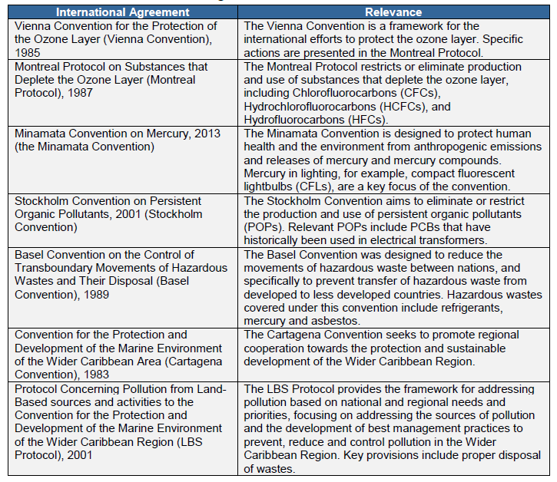

Table 2: Compliance with IDB Policies and Directives
Policy / Directive | Applicable Aspect | Compliance Rationale
OP-703 Environmental and Safeguards Compliance
B.1 Bank Policies | Compliance with applicable IDB policies | The Project triggers the following directives of IDB’s OP-703 Environmental and Safeguards Policy: B.1 Bank Policies; B.4 Other Risk Factors; B.10. Hazardous Materials; B.11 Pollution Prevention; B.15. Co-financing Operations; B.2, Country Laws and Regulations; B.3, Screening and Classification; B.5, Environmental Assessment; B.6., Consultation and; B.7, Supervision and Compliance.. The OP-102, Disclosure of Information Policy also applies for this Project. OP-704 Disaster Risk Management and OP-761 Gender Equality are also triggered. Based on available documentation, it is not expected that OP-710 on involuntary resettlement will be triggered for this Project.
B.2 Country laws | Compliance with country laws and regulations | Country laws have been reviewed and compliance is guaranteed as per section C.
B.3 Screening and Classification | Application of appropriate classification | The project has been screened and classified as a Category B.
B.4 Other Risk Factors | Vulnerability to disasters | The risk of natural hazards to the project was assessed in the EA and deemed to be low risk.
B.5 ESA Requirements | Application of adequate assessment process | An ESA was prepared for the project
B.6 Consultations | Project has undergone appropriate public consultation | A public consultation was conducted on September 22, 2016. A record was kept of the meeting.  More information in the the Public Consultation Report. (IDBdocs #40727550)
B.7 Supervision and Compliance | Internal supervision and reporting | The IDB will supervise the implementation of the project
B.8 Transboundary Impacts | N/A | N/A
B.9 Natural Habitats and Cultural Sites | N/A | N/A
B.10 Hazardous Materials | Waste management | The project has a detailed ESMP which contains appropriate waste management practices including the potential for handling and disposal of hazardous wastes
B.11 Pollution Prevention | Pollution control and CO₂ emissions | The project has a detailed ESMP which contains appropriate measures to control pollution.
B.12 Projects Under Construction | N/A | The project is not under construction
B.13 Non-Investment and Flexible Lending Instruments | N/A | The project is not an Flexible Lending
B.14 Multiple Phase Loans | N/A | Project is not a multiple phase loan
B.15 Co-Financing Operations | Potential presence of other lenders | JICA and EU-CIF are co-lenders
B.16 In-Country Systems | N/A | The project will adopt IDB requirements in full
B.17 Procurement | Contracting services | N/A
OP-710 Involuntary Resettlement | N/A | No physical resettlement will occur as a result of the project
OP-765 Indigenous Peoples | N/A | No indigenous people will be affected by the project
OP-704 Disaster Risk Management Policy | Hurricane and earthquake prone area | The risk of natural hazards to the project was assessed in the ESA and deemed to be low risk.
OP-761 Gender Equality | Avoiding gender discrimination within the Project or as a result of the Project. | The project will introduce women into the workforce where possible and women will participate in the public consultation process
OP-102 Access to Information Policy | Project information disclosure | The ESA has been posted to the IDB website.

IV. KEY ENVIRONMENTAL AND SOCIAL IMPACTS AND RISKS

A. Summary of Key Impacts and Risks

4.1 The primary impacts identified in the ESA include: potential contamination of soil and groundwater; hazardous waste generation and management, including asbestos and mercury; occupational health and safety risks; and natural hazards including flood, earthquake, landslides, heavy winds and hurricane.

B. Environmental Impacts and Risks
4.1 The scope of activities is largely consistent with minor building renovations, thus the environmental, social, health and safety (ESHS) and labor impacts and risks associated with the program are expected to be limited. The program is expected to be classified as low-medium risk Category “B”, largely because of the lack of waste management infrastructure in Jamaica.

4.3 There are four key potential ESHS concerns:
- Potential contamination of soil and groundwater from improper hazardous waste Management
- Capacity of facilities to accept non-hazardous solid wastes
- Risks to workers from occupational, health and safety hazards
- Risks to facility upgrades from natural disaster

4.4 In addition, there are a number of positive impacts from the project, including:
- Reduction of greenhouse gas (GHG) emissions by reducing electricity consumption
- Reduction in traffic congestion and associated benefits (improved air quality, better fuel efficiency, well-being of commuters, etc.)

4.5 Potential Contamination of Soil and Groundwater from Improper Hazardous Waste
Management; EE upgrades will result in generation of wastes from renovation of government buildings. Most of the waste streams (i.e. scrap wood, concrete, glass, and cardboard) can be safely disposed of in available landfills. However, there are three waste stream that cannot, including:
- Fluorescent light bulbs and thermostats that contain mercury
- Air conditioning units that contain refrigerants gases (e.g. hydrofluorocarbons)
- Asbestos containing materials
In addition the above, other potential sources of hazardous solid wastes could be generated (e.g. used oils). Management of other hazardous wastes is included in the Waste Management Plan found in Appendix EA and ESMS studies carried out for the loan.

4.6 Fluorescent Light Bulbs and Thermostats that Contain Mercury: There are eight active disposal sites in Jamaica (Table 6-1). While outdated, the National Solid Waste Policy of 2000 notes there are no sanitary landfills in Jamaica and the sites have a number of environmental concerns, including Leaching of toxic and hazardous substances into the ground and surface water bodies at the disposal sites because they are unlined
- Transmission of infections to sorters and livestock that rummage through waste which often includes medical and hazardous wastes
- Uncontrolled burning as a result of spontaneous combustion from wastes with low flash points and/or buildup of methane
- Foul odors, vermin and flies resulting from uncovered waste

Research indicates little, if any, progress has been made since 2000 to address these issues. Lighting upgrades will be performed in up to 50 buildings. This will result in large volumes of fluorescent lightbulbs and the associated ballasts containing mercury that will need disposal. Thermostats containing mercury may also be replaced and need disposal. There are no regulations or guidelines in Jamaica for disposal of mercury, and NEPA indicates all wastes containing mercury are currently sent to the Riverton City dump24. As noted above, no waste facility in Jamaica is lined, and none are adequate for disposal of mercury or other hazardous materials. While fluorescent bulbs could be re-used locally, they will eventually need to be sent to a landfill which would result in uncontained mercury entering the environment. Further, Jamaica is a signatory of the Minamata Convention and is required to control disposal of mercury. Mitigation measures are required to ensure no mercury enters the soil, groundwater and/or surface waters.

4.7 Air Conditioning Units that Contain Refrigerants: It is envisioned that inefficient air conditioning units will be replaced as part of the program. It is unknown what type of refrigerants are used in the old units, but it is likely that they could be Freon ® or other chlorinated hydrocarbon substances that deplete the ozone and are controlled under the Montreal Protocol. This kind of refrigerant gases has a highest global warming potential, taking into account that only one molecule has up 1,500 times negative impact to the atmosphere than 1 molecule of CO₂. Mitigation measures are required to ensure no refrigerants are vented to the atmosphere.

4.8 Asbestos Containing Materials: While the EE upgrades are largely focused on replacement of windows, lighting and other activities that are unlikely to disturb asbestos, some of the buildings are >100 years old and, particularly the hospitals, could contain asbestos. If asbestos is present and needs to be abated, additional mitigation is required. This is largely a human health risk, but it is significant from an environmental perspective also.

4.9 Capacity of Facilities to Accept Non-hazardous Solid Wastes: Waste facilities in Jamaica do not meet good international industry practice guidance. In addition to the poor practices described above, local waste facilities likely:

  - Allow third party access to site unrestricted
  - Do not have a clear system for segregation and storage
  - Allow large quantities of waste to be piled in the open with no compaction or other treatment
  - Have poor housekeeping
  - Do not manage stormwater runoff
  - Have little to no inspection or safety/environmental mitigation

In 2006 it is estimated that Jamaica produced approximately 1,463,900 cubic tonnes of solid waste from residential, commercial and institutional sources. 23 Relative to the whole of Jamaica, non-hazardous waste volumes to be generated by this program will be negligible. Despite this, however, additional mitigation measures are required to minimize impacts of nonhazardous solid waste disposal.

4.10 Risks to Workers from Occupational, Health and Safety Hazards: The program may involve numerous hazards that pose risks to worker health and safety, including:

  - Working at heights
  - Heavy lifting
  - Use of machinery and power tools
  - Exposure to natural elements (i.e. heat)
  - Slips, trips and falls
  - Exposure to asbestos containing materials

While many of these are standard to the construction industry, and are readily managed by standard controls (i.e. use of personal protective equipment) it is unclear if such practices are common in Jamaica. Further, most of the buildings to be renovated have not had asbestos surveys, and the types of activities to be conducted at each building is not defined, so it is unclear if EE upgrades may involve disturbance and/or removal of asbestos containing materials. While replacement of windows and air conditioning units are unlikely to involve asbestos, installation of solar panels into roofing tiles and activities involving boilers have a higher likelihood. Uncontrolled disturbance of potentially friable asbestos would pose significant risks to worker (both construction workers as well as others using the buildings) health and safety and mitigation would be required to address this concern.

4.11 Risks to Facility Upgrades from Natural Hazards: There are a number of natural hazards present in Jamaica that could damage EE upgrades, and climate change could increase the risk of many of these hazards. A 2014 probabilistic hazard and risk assessment study conducted on behalf of IDB for Montego Bay, Jamaica identified the following hazards:
  - Pluvial inundation (flooding from rivers)
  - Coastal inundation (sea level rise and storm surge)
  - Wind
  - Seismicity
  - Landslides
While the audit of four sampling buildings to be upgraded suggest facilities to be upgraded are in good to excellent condition, risks from natural hazards exist, as described below, and mitigation measures are required.

4.12 Pluvial Inundation: Flooding from Rivers: Pluvial flooding is flooding of rivers, streams, or channels. Pluvial flooding is characterized by:
  - Temporary inundation caused by precipitation
  - Stormwater accumulation in the lowest elevations
  - Inundation conditions exacerbated by impermeable surfaces and drainage problems (natural/soil or anthropogenic)
  - Short periods of inundation

Areas most affected are those located adjacent to or near rivers (within historic floodplains). The 2014 IDB Probabilistic Hazard and Risk Assessment found that flood extent and water depth did not change significantly due to climate change over 25, 50 and 100 year return periods. Therefore, risk of pluvial inundation damaging EMEP works is limited if the building has no history of pluvial inundation.

4.13 Coastal Inundation: Sea Level Rise and Storm Surge: Coastal inundation can be caused by storm surge and/or sea level rise. Storm surge is characterized by:
  - Temporary coastal inundation
  - Damage to coastal properties and resources (i.e. aquifers)
  - Worsened coastal erosion, loss of beach front and damage to coastal infrastructure Sea level rise is characterized by:
  - Slow, but permanent sea level rise
  - Degradation of shoreline structures and supporting infrastructure as a result of increased coastal flooding

The 2014 IDB Probabilistic Hazard and Risk Assessment found sea level in Jamaica is
expected to rise by between .16 - .30 m by 2095. Sea level rise is generally related to climate change. Storm surge is most often associated with storms, and whereas the frequency of storms is expected to decrease, the intensity is expected to increase. However, in spatial terms (as in the case of pluvial inundation), storm surge impacts is expected to remain the same. Therefore, risk of coastal inundation damaging EMEP works is limited if the building has no history of pluvial inundation.

4.14 Wind: Strong winds, mostly associated with tropical depressions and storms, or hurricanes, can cause significant damage to structures. It is unclear what level of exposure buildings to be renovated by the EMEP will face, but is expected highest wind speeds will occur on windward facing areas (i.e. north and east) near the coast. The 2014 IDB Probabilistic Hazard and Risk Assessment found the effects of climate change on wind patterns is unclear. With more intense storm events, wind speeds will also be more intense, but the number of storms is expected to decrease so the risk of damage from wind could be considered similar to the current conditions. Nevertheless, damage to EMEP building infrastructure from wind could result, particularly impacting external features (i.e. solar PV cells and windows).

4.15 Seismicity: As described in Section 3, Jamaica is seismically active with over 200 earthquakes per year. Generally, earthquakes in Jamaica are less than 4.0 magnitude which are considered fairly minor, although large earthquakes that have caused significant damage to buildings have been reported. Seismic activity can result in significant damage to buildings and infrastructure, either from direct or secondary impacts (i.e. fire). While seismic activity occurs independent of climate change, and thus is not expected to increase, earthquakes could damage EMEP works.

4.16 Landslides: Jamaica, and Kingston in particular, is subject to routine landslides resulting from a combination of geology, seismicity and precipitation.Landslides cover approximately 4.77% of Kingston's mountainous terrain and the frequency is increasing with urbanization and development of geologically active slopes. Increased storm intensity from climate change may trigger additional landslides, however given the location of buildings to be updated is unknown, it is unclear what level of risk landslides may cause on the project.

D. Cumulative Impacts

4.17 The proposed operation will generate only minor to moderate impacts which can be easily managed by the implementation of the project ESMP.

E. Positive Impacts
4.18 Reduction of Greenhouse Gas Emissions: The specific objectives and expected results of this project are:
- Reduced electricity consumption within government facilities
- Decreased fuel consumption through improved traffic control management;
- Reduced GHG emissions
- Increased capacity to promote and supervise electricity planning in Jamaica.

The program will reduce electricity and fuel use significantly, thus the project will result in a significant reduction of GHGs. Building upgrades may have additional indirect benefits, including improved patient, student and worker well-being from better air conditioning and lighting. These indirect benefits are likely positive, but of low significance.

4.19 Reduction in Traffic Congestion: Preliminary models show that the fuel efficiency component could increase average car speeds in corridors of Kingston from the current 22 km/h to 28 km/h, and this would imply reducing the traffic fuel consumption in those corridors by 40%. This reduction in traffic congestion would have many indirect benefits on human well-being, including lowering GHG, improving air quality in Kingston, increase fuel efficiency and lower fuel costs, and reduce stress caused by traffic. A cost benefit analysis will be conducted

V. MANAGEMENT AND MONITORING OF ENVIRONMENTAL, SOCIAL, HEALTH AND SAFETY AND LABOR IMPACTS AND RISKS

A. Description of Management Systems and Plans

5.1 The program has prepared an EIA with a detailed Environmental and Social Management Plan (ESMP) to document the management and monitoring of environmental and social issues. For details, see table below:

Table 2: Environmental and Social Management Plan (ESMP)

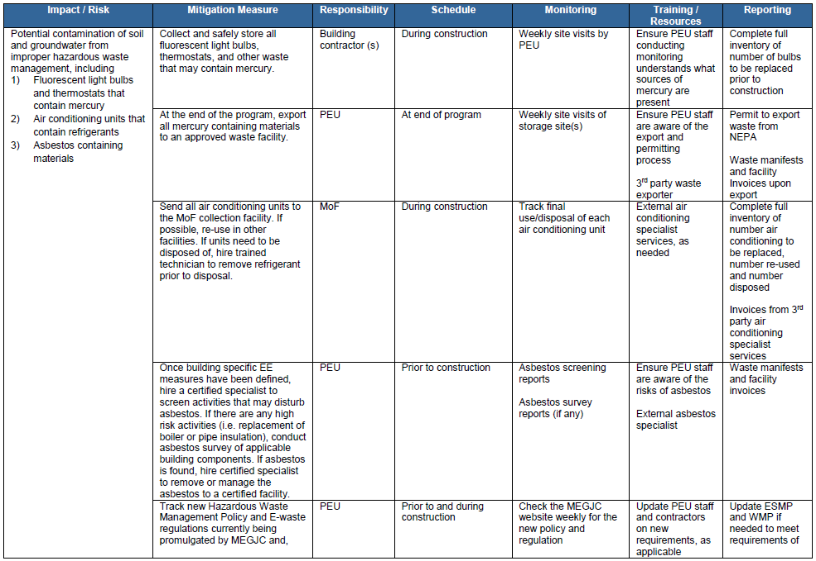

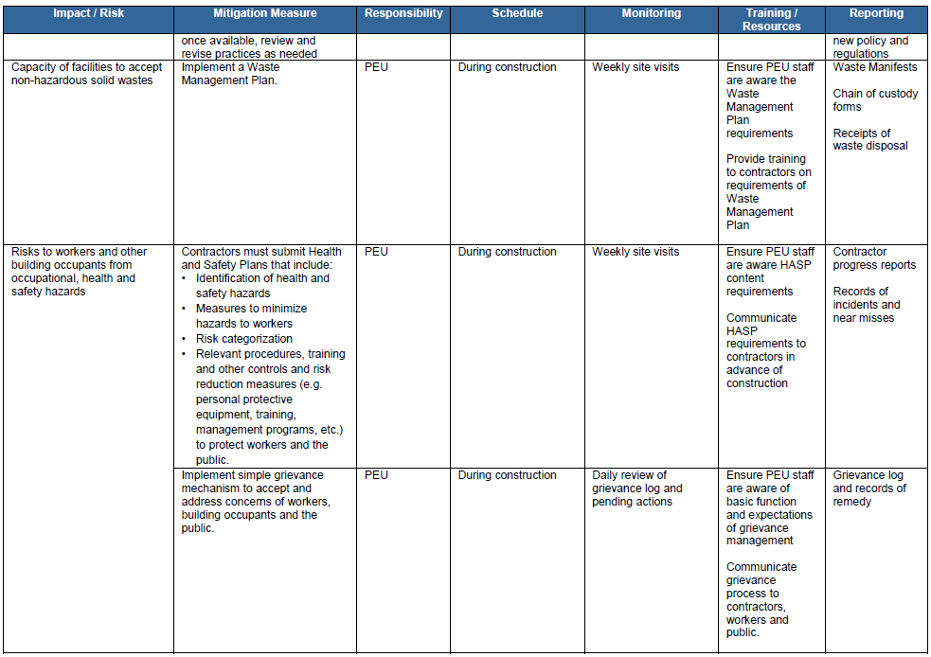

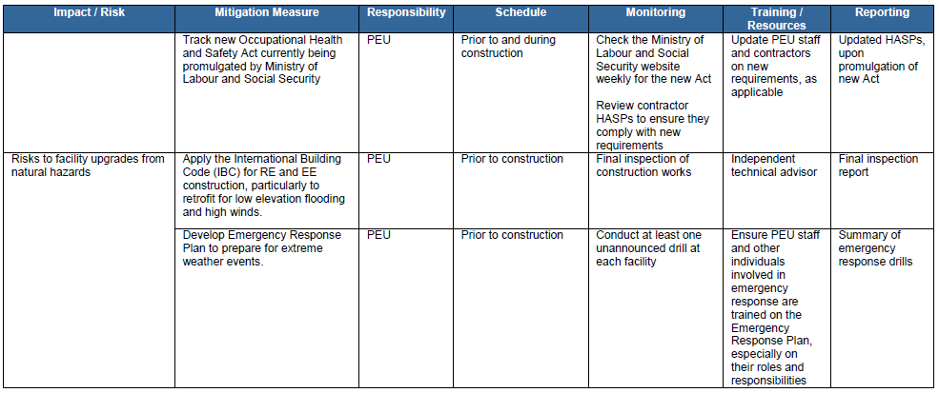

5.2 Waste Management Plan: Developing and consistently applying an EMEP-specific Waste Management Plan will ensure that all wastes from the program are properly managed in accordance with applicable laws and regulations and relevant international standards. Having a Waste Management Plan in place will help prevent accidental release of wastes by presenting safe handling, storage and disposal methods for each waste generated during program activities. The ESA team has prepared a Waste Management Plan for this project. The Waste Management Plan includes:

  - Description of the types of wastes that will be generated
  - Waste minimization opportunities
  - Waste management methods
  - Recordkeeping practices, including manifest and waste tracking forms

5.3 Health and Safety Plan: To ensure worker health and safety, the selected contractor(s) must submit a Health and Safety Plan (HASP) to the PEU for review prior to starting work. The HASP should include:

  - Identification of health and safety hazards
  - Measures to minimize hazards to workers
  - Risk categorization
  - Relevant procedures, training and other controls and risk reduction measures (e.g. personal protective equipment, training, management programs, etc.) to protect workers and the public.

The HASP should be kept at each construction site for reference. The implementation of the HASP will mitigate or minimize health and safety impacts by ensuring that workers understand

B. Monitoring and Supervision
5.4 The PEU has ultimate responsibility for ensuring program compliance with the ESMS and applicable regulations. The PEU must dedicate personnel to review contractor performance against ESMS requirements. Weekly site visits should be conducted and contractors should submit routine progress reports with ESHS related information. Progress reports should contain records of any incidents, including near misses, as well as waste manifests and chain of custody forms as describe in the WMP. The IDB will carry out annual supervision missions and very compliance.

C. Indicators

No Impact indicators.

Outcomes:
Outcome Indicators | Indicator | Units | Base Level (2015) | Final Target (2022) | Means of Verification
Reduced electricity consumed in 73 Health, Education and Public Agency (HEPA) government facilities | Annual electricity consumed in 73 HEPA government facilities | kWh | 31,377,402 | 16,004,807 | Biannual Report from Petroleum Corporation of Jamaica (PCJ)  M&E consulting firm report
Reduced CO₂ emissions resulting from reduced electricity consumption in 23 HEPA government facilities | Annual GHG emissions resulting from kWh consumed in 73 HEPA government facilities | Tons of CO₂ equivalent | 52,401.25 | 26,728.53 | Biannual Report from PCJ  M&E consulting firm report
Avoided annual transport fuel consumed in the Kingston Metropolitan Region (KMR) | Annual Fuel consumption in the KMR | Million litres | 296.8 | 192.7 | Biannual report from National Works Agency (NWA)  Independent M&E Report
Avoided annual CO2 emissions resulting from avoided reduced transport fuel consumed in the KMR | Annual CO2 equivalent emissions resulting from transport fuel consumed in KMR. | Tons of CO2 equivalent | 579,203 | 376,044 | Biannual Report from PCJ  M&E consulting firm report
Reduced hours of annual travel time in the KMR | Annual hours of travel time in the KMR | Million hours | 155.2 | 99.96 | Biannual Report from National Works Agency (NWA)  M&E consulting firm report
Number of formal updates or revisions of the Integrated Resource Plan (IRP) performed by Ministry of Science, Energy and Technology (MSET) | Number of formal updates or revisions of the Integrated Resource Plan (IRP) performed by Ministry of Science, Energy and Technology (MSET) | # | 0 | 1 | Ministry has approved the formal update or revision.  Biannual report from MSET  Independent M&E Report

VI. REQUIREMENTS TO BE INCLUDED IN THE OPERATION MANUAL
6.1 Based on the ESDD conclusions, the conditions described below are required to be included in the Project Operating manual of the Project which approval, to the satisfaction of the Bank, will be a condition to disbursement of the Loan. In order to accomplish that, the Project Operating Manual will include the following conditions and obligations:

Obligations Throughout the Life of the Loan
6.2 The Borrower will comply and will require in its Project Agreement with each Project party (Sponsor/Borrower/Company) and other Project/Environmental parties, including construction companies and operators, and any contractors and sub-contractors, to comply at all times during the life of the Project with the following:
- All applicable environmental, social, health and safety, and labor regulatory requirements of Jamaica.
- All requirements associated with any environmental, social, health and safety, and labor related permits, authorizations, or licenses that apply to the Project, the Borrower or any party responsible for executing the Project or its mitigation measures.
- All environmental, social, health and safety, and labor requirements of the Project contracts and any subsequent modifications.
- All aspects and components of all of the Project’s environmental, health and safety, social and labor documents.
- All relevant IDB policies such as the Environment and Safeguards Compliance Policy (OP-703), the Disaster Risk Management Policy (OP-704) and the Disclosure of Information Policy (OP-102), the Involuntary Resettlement Policy (OP-710), the Operational Policy on Indigenous Peoples (OP-765) and the Gender and Equity in Development Policy (OP-270), as these may be amended from time to time, and their respective guidelines.
- Comply with all the requirements indicated in the Environmental and Social Action Plan (ESAP), in the event an ESAP is required.

Conditions Prior to First Disbursement

6.3 The Borrower will implement the project specific ESMP to assess and mitigate the negative impacts associated with the Project. All project contractors will also be required to comply with the actions described in the ESMP.

6.4 The Borrower will appoint an Environmental and Social Specialist for the duration of the construction period to prevent and manage potential impacts and supervise and monitor mitigation measures.

6.6 Copies of relevant permits, contracts, and agreements shall be submitted to the Bank.

Condition to Each Disbursement Request
6.7 The Borrower shall certify that, to the best of its knowledge, it is in compliance with all environmental, social, health and safety and labor requirements in the loan agreement, including any Corrective Action Plans if applicable.

Condition Prior to Operations

6.8 The IDB or an E&S consultant appointed by the IDB, and paid for by the IDB shall certify compliance with the ESMP, including any Corrective Action Plans, if applicable.

MSET Petroleum Import statistics online. http://mset.gov.jm/statistics-data
Due to the decline of crude oil prices, fuel imports in 2015 were lower at US$1.1 billion or 8.0% of GDP in spite of higher demand.
Data from National Works Agency (NWA), Jamaica, 2016.
Including losses of 21.3% of the national grid.
Jamaica: Intended Nationally Determined Contribution of Jamaica - Communicated to the UNFCCC, 2015. 1.1 million metric tons CO₂ is a reduction of 7.8% of emissions versus BAU. Jamaica will conditionally increase its ambition to a reduction of GHG emissions of 10% below the BAU scenario, subject to the provision of international support.
Source: National GHG Emissions Inventory report of Jamaica, 2006-2012, Dr. C. J. Dore, November 2015.
In 2016, wind energy from Wigton Wind Farm Ltd Phase 3 (24MW) was commissioned into service; wind energy from BMR Jamaica Wind Ltd (36.6MW) was synchronized to the grid and undergoing commissioning tests and solar energy from Content Solar (20.0MW) is expected to be commissioned into service by August, 2016. It is also expected that additional renewables will be connected through the net billing and auxiliary connections programs.
It is the case of the HCFC-22 (or R-22) that is commonly used in A/C systems, and has a global warming potential 1,500 times than 1 molecule of CO₂ according with the UNFCCC.

