ENERGY MANAGEMENT AND EFFICIENCY PROGRAM (JA-G1003)

COMUNICATION AND VISIBILITY PLAN

A- Objectives

- Overall communication objectives

The general objective of this operation is to expand the EMEP (3877/OC-JA) actvities by promoting a more efficient use of energy resources that would free public funds (through avoided oil imports and lower government electricity bills public facilities) helping the GOJ to further reduce debt and create the fiscal space for productive spending, whilst also contributing to GHG emissions reduction. The specific objectives and expected results of this program are: (i) reduced electricity consumption in 7 public hospitals which will also contribute to avoided GHG emissions within Jamaica; and (ii) improved electricity planning in Jamaica

The Communications and Visibility Plan will be a product in component I of the Program and it will also contribute to the whole EMEP, including the loan approved in 2016. It is aimed at promoting the “National Energy Policy 2009-2030” and the EU contribution to its implementation, particularly, to raise awareness of EE/ER saving possibilities within the public sector and other end users participating in the overall EME Program. The Communications program will also include campaigns around the EE aspects of the Building Code in Jamaica , will seek providing training to Facilities’ Managers of the beneficiary agencies, and to demonstrate an implementation model for EE measures that could serve as a pilot for the market. The Communication and Visibility Plan will also support public initiatives concerning distributed generation opportunities, promoting application to programs and access to tools developed by the Government.

2. Target groups
- Facilities Managers
- Senior Officers from Beneficiary Agencies
- Technical/Maintenance Staff
- Energy Conservation Committees
- Contractors
- Facilities Environmental Managers
- Government Environmental Officers
- General Public-Private companies providing EE and ER retrofits
- Other FI institutions and NGOs

3. Specific objectives for each target group, related to the action's objectives and the phases of the project cycle
- Facilities Managers and Technical staff: to ensure they receive equipment maintenance and general service guidelines
- Senior Officers from Beneficiary Agencies: to ensure that during implementation they are aware of EE/EC and RE equipment operating guidelines and maintenance requirements, including new technology. Also, to raise awareness about saving possibilities of EE and ER measures in buildings and by a better management of traffic flows, creating a reference for the development of future programs.
- Energy Conservation Committees: to raise awareness of employee behavior guidelines and any Government Standards regarding Energy Conservation best practices.
- Contractors: to raise awareness of Government Building Codes as they relate to their contracts and project implementation
- Facilities Environmental Managers and Government Environmental Officers: to raise awareness of Environmental Disposal Guidelines, Standards and Best Practices.
- Private companies providing EE and ER retrofits: raise awareness of contracting possibilities for EE and ER retrofits in buildings, piloting ESCO models and having Investment Grade Audits as reference.
- General public: to raise awareness of Governmental Energy Efficiency initiatives , the EU contribution to sustainable energy initiatives, the need of saving energy, the decrease in the energy bill and to the fuel expenses in private vehicles thanks to the program.
- Other FI institutions and NGOs: raise awareness of a model of Energy Efficiency Programs implementation.

B- Communication Activities

4. Main activities that will take place during the period covered by the communication and visibility plan
- Workshops and Seminars in EE management & maintenance.
- Building Code Development and Sensitization Seminars
- Media Campaign and Public Awareness/Education
- Environmental Management Awareness Seminars

The PEU will be responsible of contracting the appropriate firms to implement the plan.

5. Communication tools chosen
- Media Campaign: it will include deliverables for radio and television, in addition to print features and the placement of print and electronic material within JIS programs and print media products
- Manuals: they will be produced and presented to Beneficiary Agencies with respect to Equipment Operations and Maintenance Guidelines
- Handouts and Papers: they will also be presented at each Workshop/Seminar

6. Completion of the communication objectives
- Media Campaign review-Timely Completion of each deliverable (i.e. print media placements, TV and Radio ads etc.)
- Preparation and presentation of manuals
- Preparation and Presentation of Handouts

7. Provisions for feedback (when applicable)

The PEU will canalize communication with the managing team in the building and will address public concerns regular channels (mail, email, phone) or presence. Participants in meetings will be allowed to provide feedback on the workshop sessions, both written and in Q&A format

C- Resources

8. Human Resources
- Communications Specialist- One (1) over six (6) years of the Project
- Technical Assistance on electrical safety review and compliance (Electrical Consultant)- One (1) over six years of the Project
- Technical Presenters as required for each Workshop
- Members of the management team responsible for communication activities: Project Manager, MSET and NWA Sub Managers. Support provided by other member of the PEU

9. Financial resources: direct and related.

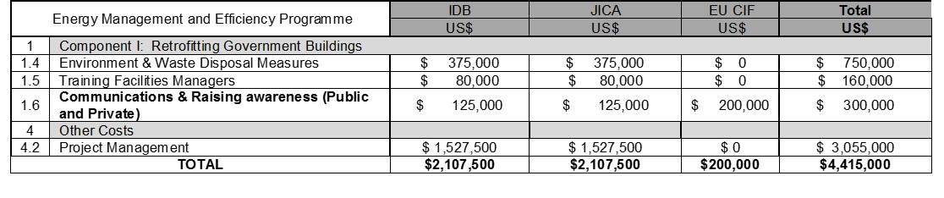
Activities shown in the table are all those related with the communication activities.

- Environment & Waste Disposal Measures: handling and disposal manuals will be developed in collaboration with the NEPA (National Environment and Planning Agency) as well as support for location and verification of disposals, particularly, hazardous.
- Training Facilities Managers: Trainings on how to maintenance and operation of the energy efficiency measures installed will be developed. These training will seek also raising awareness on the saving and business opportunities these measures have.
- Communications & Raising awareness (Public and Private): These activities are the ones described in this annex, strategy that will be extended to all facilities retrofitted. EU-CIF funds will be focused on the 7 hospitals retrofitted.
- Project Management: among the people that will form part of the PEU staff, a communications specialist will be contracted given the demonstrative importance of the project

