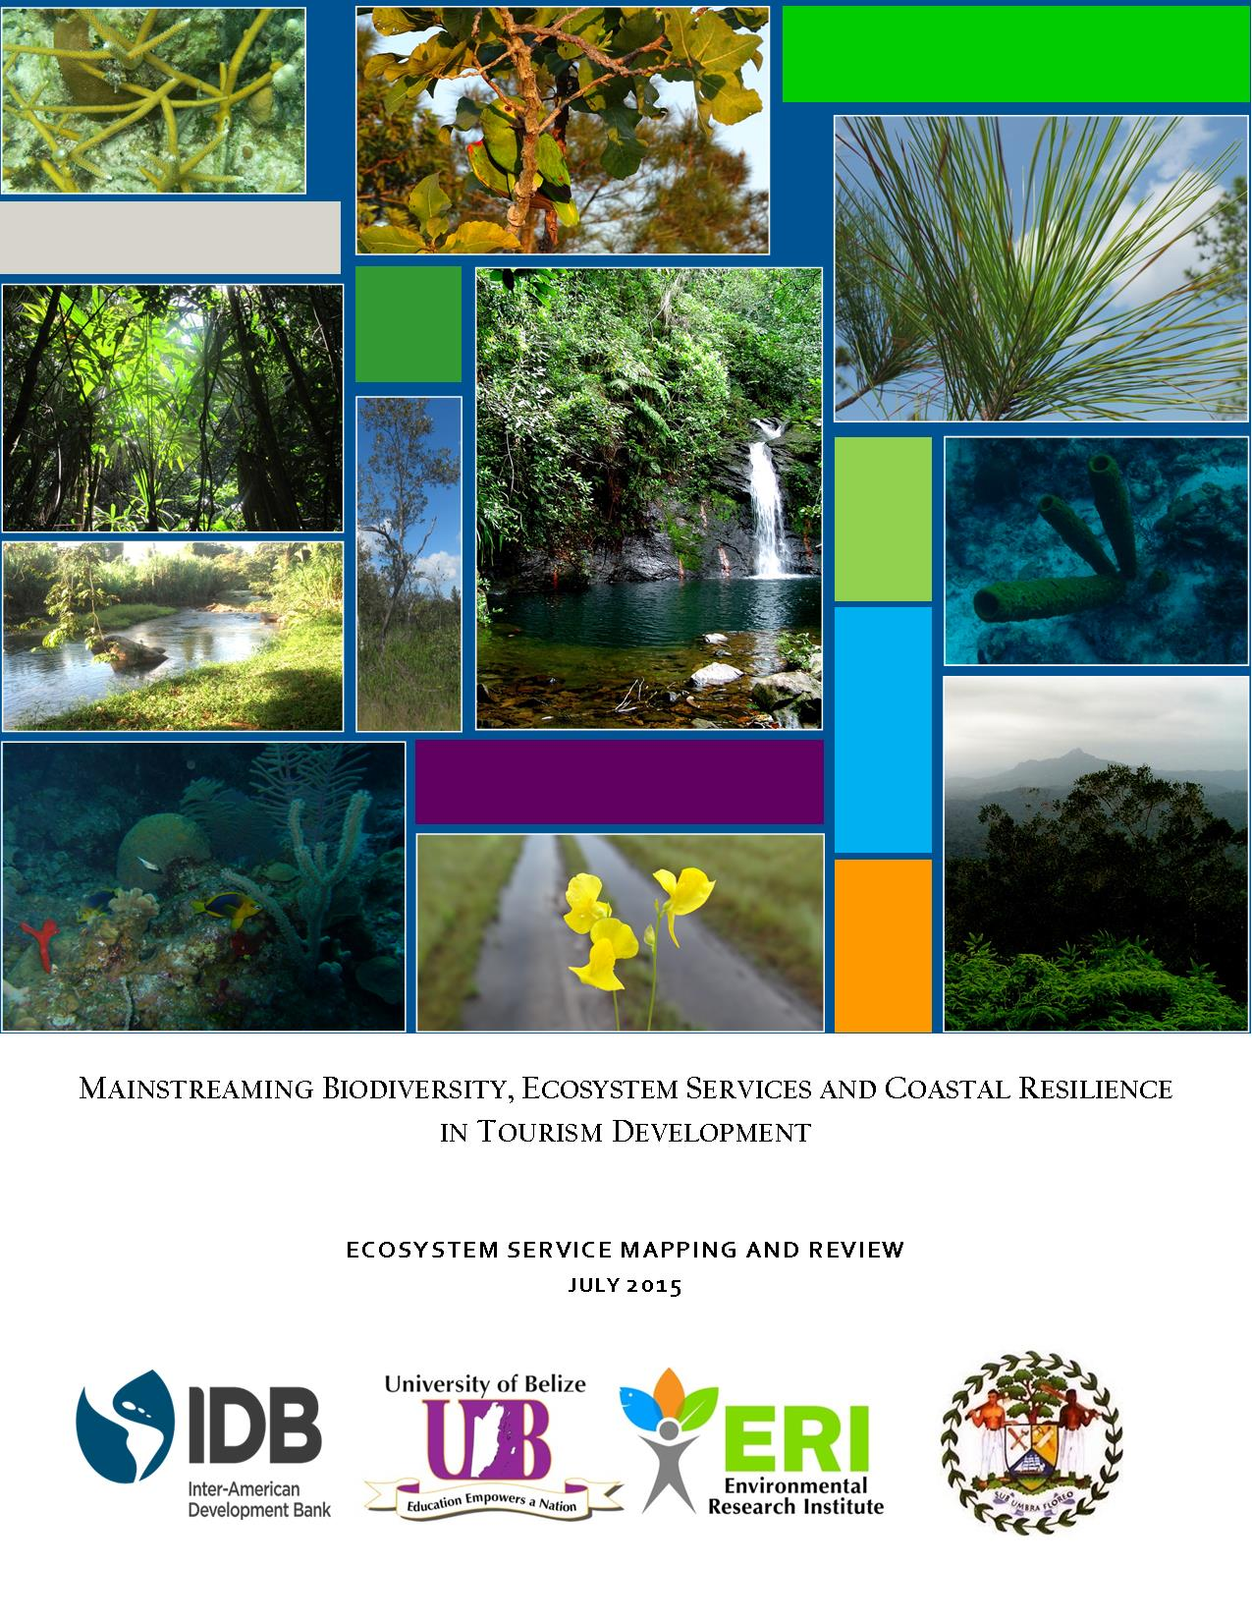
Table of Contents

List of Table and Figures v
List of Acronyms x
Acknowledgements xii
Executive Summary xiii
1. INTRODUCTION 1
2. BACKGROUND 3
2.1. PRELIMINARY MAPPING RESULTS 3
2.1.1. Corozal Area 5
2.1.2. Caye Caulker Area 10
2.1.3. Chiquibul-MPR Complex 12
2.1.4. Toledo Area 16
2.2. CORRIDOR CONNECTIVITY 24
2.2.1. North East Corridor 24
2.2.2. Central Belize Corridor 25
2.2.3. Southern Corridor 25
3. METHODOLOGY 27
3.1. SPATIAL DATA 27
3.1.1. Data Acquisition and Processing 27
3.1.2. Data Inputs and Mapping 28
3.2. ECONOMIC VALUATION 29
3.2.1. Economic Valuation approaches 29
3.2.2. Total Economic Value 31
3.2.3. Valuation approaches used 33
3.2.3.1. Tourism 33
3.2.3.2. Mangroves 34
3.2.3.3. Carbon 35
3.2.3.4. Timber 36
3.2.3.4.1. Timber value of Corozal 39
3.2.3.4.2. Timber value of the Chiquibul Maya Mountains 39
3.2.3.4.3. Timber value of the Mountain Pine Ridge Forest Reserve 40
3.2.3.4.4. Timber value of Toledo 40
3.2.3.4.5. Timber species grouping: 41
3.2.3.4.6. Timber value 42
3.2.3.5. Water Supply 43
4. LIMITATIONS 46
4.1. SPATIAL DATA 46
4.2. ECONOMIC VALUATION DATA 47
5. MAIN FINDINGS AND MAPS 48
5.1. BIODIVERSITY RESOURCES, ECOSYSTEM SERVICES AND CLIMATE RESILIENCE 48
5.1.1. Biodiversity 50
5.1.1.1. Corozal District 50
5.1.1.2. Caye Caulker 53
5.1.1.3. Chiquibul-MPR Complex 54
5.1.1.4. Toledo 56
5.1.2. Ecosystem Services 60
5.1.2.1. Corozal 60
5.1.2.2. Caye Caulker 62
5.1.2.3. Chiquibul-MPR Complex 63
5.1.2.4. Toledo 65
5.1.3. Climate Resilience 66
5.1.3.1. Corozal 68
5.1.3.2. Caye Caulker 70
5.1.3.3. Chiquibul-MPR Complex 72
5.1.3.4. Toledo 74
5.1.3.5. Sea level rise 76
5.2. ECONOMIC VALUATION OF ECOSYSTEM SERVICES 77
5.2.1. Shoreline Protection 77
5.2.2. Tourism 78
5.2.3. Coastal Ecosystem Services 81
5.2.3.1. Mangroves 81
5.2.3.2. Seagrass Beds 83
5.2.3.3. Estuaries 84
5.2.3.4. Coral Reefs 85
5.2.4. Carbon 86
5.2.5. Timber 90
5.2.6. Water Supply 94
5.3. THREATS TO BIODIVERSITY AND ECOSYSTEM SERVICES IN BELIZE 96
5.3.1. Corozal 99
5.3.2. Caye Caulker 103
5.3.3. Chiquibul-MPR Complex 106
5.3.4. Toledo 108
5.4. SUMMARIZED MAIN FINDINGS 114
6. RECOMMENDATIONS 118
6.1. GENERAL RECOMMENDATIONS 118
6.2. COROZAL AREA 120
6.3. CAYE CAULKER 122
6.4. CHIQUIBUL-MPR COMPLEX 123
6.5. TOLEDO AREA 124
7. REFERENCES 126
8. APPENDICES 132
Appendix 1: Protected Areas by Study Area 132
Appendix 2: List of protected areas that form the Maya Mountain Marine Corridor (MMMC Conservation Action Strategy 2008) 133
Appendix 3: Mean annual change in rainfall for major watersheds in proposed tourism development areas for 2050, under best (RCP2.6) and worst case (RCP8.5) scenarios for select global climate change models (Adapted from Cherrington et. al. (2015)). Figures in red denote negative changes. 134
Appendix 4: Extent of mangroves in hectares by study area 135
Appendix 5: Average Daily Expenditure ($US) by Purpose of visit by Places Stayed¹, 2014 136
Appendix 6: Mangrove, Seagrass, Coral Reef and Estuary Ecosystem Values (Hargreaves-Allen 2011) 137
APPENDIX 7: FIGURE NUMBER AND THE SOURCE OF DATA LAYERS USED 141

List of Table and Figures

Figure 1: Belize’S bIOLOGICAL CORRIDORS AND PROTECTED AREAS BY TYPE 4
Figure 2: COROZAL AREA WATERSHEDS, Waterbodies AND PROTECTED AREAS BY TYPE 5
Figure 3: COROZAL CORRIDOR AND PROTECTED AREAS BY TYPE 6
Figure 4: COROZAL AREA SETTLEMENTS 7
Figure 5: LAND COVER FOR COROZAL AREA BASED ON 2010 DATA LAYER 7
Figure 6: COROZAL AREA ECOSYSTEMS BASED ON 2011 DATA LAYER 8
Figure 7: FOREST COVER FOR COROZAL AREA BASED ON 2014 DATA LAYER 9
Figure 8: MANGROVE AREAS IN COROZAL BASED ON 2014 DATA LAYER 10
Figure 9: Caye Caulker area ecosystems (2011) and protected areas (2014). Black circle indicates location of the split on the island. 11
Figure 10: Caye Caulker area 2014 forest cover and protected areas (lANDSAT image (left) and map (right). Pink circle indicates location of the split on the island 12
Figure 11: CHIQUIBUL-MPR COMPLEX WITHIN BELIZE AND BELIZE RIVER WATERSHED (LEFT) AND ITS PROTECTED AREAS (RIGHT) 13
Figure 12: Land cover (2010) of protected areas in the Chiquibul-MPR Complex 14
Figure 13: Ecosystems (2011) of the Chiquibul-MPR Complex 15
Figure 14: Forest cover (2014) of protected areas in the Chiquibul-MPR Complex 16
Figure 15: Toledo area watersheds, waterbodies and protected areas by type 17
Figure 16: Toledo area corridors and protected areas by type 17
Figure 17: Toledo area settlements 19
Figure 18: Toledo area land cover (2010) 20
Figure 19: Toledo area ecosystems (2011) 21
Figure 20: Toledo area forest cover (2014) 22
Figure 21: Toledo area mangrove cover (2014) and protected areas) 22
Figure 22: COMPONENTS OF TOTAL ECONOMIC VALUE (SOURCE: HARGREAVES-ALLEN 2011) 31
Figure 23: OUTLINE OF METHODOLOGY TO DETERMINE TIMBER VALUE IN THE AREAS OF INTEREST 36
Figure 24: LOCATION OF TIMBER INVENTORY DATA OR LITERATURE THAT CAN BE SOURCED 37
Figure 25: SPECIES GROUPING RUBRIC SHOWING THE GRAPH SPACE OCCUPIED BY SPECIES OF EACH GROUP WITH REPECT TO SIX DIFFERENT PROPERTIES 40
Figure 26: Components of biodiversity that provide human well-being 48
Figure 27: Distribution of available records of species of conservation concern within the Corozal district 51
Figure 28: Distribution of records of species of conservation concern for Caye Caulker 53
Figure 29: Distribution of records of species of conservation concern for Chiquibul-MPR Complex 54
Figure 30: Distribution of species of conservation concern within the Toledo District 58
Figure 31: Major watersheds providing water provision and regulation services in Corozal 60
Figure 32: Coastal protection services offered by coastal vegetation (mangroves) along the Corozal district 60
Figure 33: Coastal protection services offered by coastal vegetation (mangroves) along Caye Caulker 62
Figure 34: Major watersheds providing water provision and regulation services in Chiquibul-MPR Complex 63
Figure 35: Major watersheds providing water provision and regulation services in Toledo Area 64
Figure 36: Coastal protection services offered by coastal vegetation (mangroves) along Toledo 65
Figure 37: Changes in precipitation for B1 and A2 scenarios for Corozal 67
Figure 38: Changes in air temperature for B1 and A2 scenarios for Corozal 68
Figure 39: Climate change predictions and resilience for Northern Belize 69
Figure 40: Changes in precipitation for B1 and A2 scenarios for Caye Caulker 70
Figure 41: Changes in air temperature for B1 and A2 scenarios for Caye Caulker 70
Figure 42: Changes in precipitation for B1 and A2 scenarios for Chiquibul-MPR Complex 71
Figure 43: Changes in air temperature for B1 and A2 scenarios for Chiquibul-MPR Complex 72
Figure 44: Climate change predictions and resilience for upland forest of the Maya Mountain Massif 72
Figure 45: Changes in precipitation for B1 and A2 scenarios for Toledo 73
Figure 46: Changes in air temperature for B1 and A2 scenarios for Toledo 74
Figure 47: Climate change predictions and resilience for Southern coastal forests - pine and broad leaved 74
Figure 48: PREDICTED IMPACT OF SEA LEVEL RISE FOR ALL FOUR AREAS 75
Figure 49: ABOVE GROUND CARBON DISTRIBUTION FOR COROZAL AREA 85
Figure 50: ABOVE GROUND CARBON FOR THE CHIQUIBUL (INCLUDING BUFFER AREAS) AND TOLEDO 86
Figure 51: Timber production forests in the Corozal Study Area based on - species composition of the ecosystem and legal status of the land 88
Figure 52: Timber production forests in the Chiquibul-MPR Complex based on - species composition of the ecosystem, legal status of the land and slope 89
Figure 53: Timber production forests in the toledo study area based on - species composition of the ecosystem, legal status of the land and slope of the land 90
Figure 54: Deforestation hotspots in the Corozal Area for 2010-2014 98
Figure 55: FIRE RISK FOR COROZAL AREA 98
Figure 56: Impact of human activities in the Corozal Area 99
Figure 57: Tourism USe in the Corozal Area 100
Figure 58: Vulnerability and sensitivity to sea level rise in the Corozal Area 101
Figure 59: Hotspots of deforestation for Caye Caulker for 2010-2014 102
Figure 60: Impact of human activities in Caye Caulker 103
Figure 61: Tourism Use for Caye Caulker 104
Figure 62: Deforestation hotspots in the Chiquibul Mountain Pine Ridge Complex 2010-2014 105
Figure 63: Fire risk in the Chiquibul Mountain Pine Ridge Complex and Toledo Area 106
Figure 64: Deforestation hotspots of the Toledo Area 2010-2014 108
Figure 65: Impact of human activities in the Toledo Area 109
Figure 66: Tourism use in the Toledo Area 110
Figure 67: VULNERABILITY AND SENSITIVITY TO SEA LEVEL RISE IN THE TOLEDO AREA 111

Table 1: TOTAL AREAS FOR EACH STUDY AREA: CORORAL AREA, CAYE CAULKER, CHIQUIBUL-MPR COMPLEX AND TOLEDO AREA 3
Table 2: COROZAL PROTECED AREAS AND SIZE 6
Table 3: COROZAL LAND COVER TYPES AND SIZE BASED ON 2010 DATA LAYER 8
Table 4: COROZAL AREA ECOSYSTEMS WITH CORRESPONDING SIZE AND PERCENTAGE TOTAL BASED ON 2011 DATA LAYER 8
Table 5: CAYE CAULKER PROTECTED AREAS AND SIZE 10
Table 6: CAYE CAULKER ECOSYSTEMS CORRESPONDING SIZE AND PERCENTAGE TOTAL 11
Table 7: CHIQUIBUL-MPR COMPLEX PROTECTED AREAS AND SIZE 13
Table 8: CHIQUIBUL-MPR COMPLEX LAND COVER AND SIZE BASED ON 2010 DATA LAYER 14
Table 9: CHIQUBUL-MPR COMPLEX ECOSYSTEMS CORRESPONDING AREAS AND PERCENTAGE TOTAL 15
Table 10: TOLEDO PROTECTED AREAS AND SIZE 18
Table 11: TOLEDO LAND COVER AND SIZE BASED ON 2010 DATA LAYER 20
Table 12: TOLEDO AREA ECOSYSTEMS CORRESPONDING SIZE AND PERCENTAGE TOTAL 21
Table 13: Data sources used in the ecosystems mapping and review 26
Table 14: Mangrove Ecosystem Service Values based on service provided (Hargreaves-Allen, 2011) 33
Table 15: LIST OF SOME TIMBER SPECIES BY GROUP 41
Table 16: PREVAILING MARKET PRICES PER BOARD FEET OF ROUGH SAWN LUMBER 42
Table 17: RUNOFF AND RIVERFLOW FOR WATERSHEDS IN THREE STUDY AREAS 43
Table 18: PRECIPITATION CHANGES FOR WATERSHEDS WITHIN COROZAL, CHIQUIBUL-MPR COMPLEX AND TOLEDO 66
Table 19: Avoided damage value of mangroves in the various study areas using Cooper et al., 2009 methodology 76
Table 20: Avoided damage value of mangroves in the various study areas using the average annual value of US$2,775 – $4,000 per ha per year for mangroves within 1 km of the coast (Cooper et al., 2009). 77
Table 21: Total revenue from tourism for Caye Caulker, Corozal, Mountain Pine Ridge and Toledo. 77
Table 22 a & b: Additional revenue generated from diving and snorkeling on northern cayes (San Pedro/Caye Caulker) by visitors to Corozal District. 78
Table 23: Total direct and indirect impact of tourism for Caye Caulker, Corozal, Mountain Pine Ridge and Toledo 79
Table 24 a-c: Mangrove Ecosystem Service Values for Corozal, Caye Caulker and Toledo 80
Table 25 a-c: Seagrass Ecosystem Service Values for Corozal, Caye Caulker and Toledo 82
Table 26 a-b: Estuary Ecosystem Service Values for Corozal, Caye Caulker and Toledo 83
Table 27 a-b: Coral Reef Ecosystem Service Values for Corozal, Caye Caulker and Toledo 84
Table 28: Biomass values for Corozal, Chiquibul and buffer areas, and Toledo 87
Table 29: Total carbon and estimated total carbon values for Corozal, Chiquibul INCLUDING ITS buffer areas and Toledo 87
Table 30: total current values for timber stocks in Corozal Area 91
Table 31: Total current values for timber stocks in the Chiquibul-MPR Complex 91
Table 32: Total current values for timber stocks in Toledo Area 92
Table 33: Water supply by watershed in three study areas - Corozal, Chiquibul-MPR Complex and Toledo 92
Table 34: Current and net present value of water supply in the three study areas 93
Table 35: Threats to major ecosystems within Corozal, Caye Caulker, Chiquibul-MPR Complex and Toledo. 94
Table 36: FIRE RISK FOR COROZAL AND CHIQUIBUL-TOLEDO AREA 96
Table 37: DEFORESTATION OF COROZAL, CHIQUIBUL-MPR COMPLEX AND TOLEDO AREA 97
Table 38: SUMMARY TABLE OF BIODIVERSITY, SPECIES OF CONSERVATION CONCERN, SPECIEAL FEATURES AND THREATS BY AREA 112
Table 39: SUMMARY TABLE OF ECOSYSTEM SERVICES WITH CORRESPONDING VALUES AND CLIMATE RESILIENCE 115

List of Acronyms

AGB Above Ground Biomass
APAMO Association of Protected Areas Management
BDFT Board Foot
BERDS Belize Environmental Resource Database System
BGC Below Ground Carbon
BNR Bladen Nature Reserve
BTB Belize Tourism Board
CA Coast ‘Damage’ Avoidance Approach
CBWS Cockscomb Basin Wildlife Sanctuary
CRF Chiquibul Forest Reserve
CRFR Columbia River Forest Reserve
CSFI Corozal Sustainable Future Initiative
CVM Contingent Valuation Method
CZMAI Coastal Zone Management Authority and Institute
DOE Department of the Environment
ESVD Ecosystem Services Value Database
ETS Emission Trading Schemes
FCD Friends of Conservation and Development
FCFR Freshwater Creek Forest Reserve
GDP Gross Domestic Product
GIS Geographic Information Center
GLAS Geoscience Lazer Altimeter System
GSCP Golden Stream Corridor Preserve
Ha Hectares
HCNP Honey Camp National Park
IDB Inter-American Development Bank
IUCN International Union for Conservation of Nature
LIC Land Information Center
LIDAR Light Detection and Ranging
LUC Land Use Change
MGL Maya Golden Landscape
MMM Maya Mountain Massif
MMMC Maya Mountain Marine Corridor
MODIS Moderate Revolution Imaging Spectrodiometer
MP Market Price Approach
MPR Mountain Pine Ridge
MTCCA Ministry of Tourism, Culture and Civil Aviation
NGO Non-Governmental Organization
NIWRA National Integrated Water Resource Authority
NOAA National Oceanic and Atmospheric Administration
NPAS National Protected Areas System
N-SPECT Non-Point Source Pollution and Erosions Comparison Tool
NSTMP National Sustainable Tourism Master Plan
NTFP Non Timber Forest Products
PA Protected Area
PCNP Payne’s Creek National Park
PHMR Port Honduras Marine Reserve
REDD Reduced Emissions for Deforestation and Forest Degradation
SACD Sarteneja Alliance for Conservation and Development
SCS Soil Conservation Service
SIB Statistical Institute of Belize
SNR Shipstern Nature Reserve
STP I Sustainable Tourism Program I
STP II Sustainable Tourism Program II
SWAT Soil and Water Assessment Tool
TEV Total Economic Value
TIDE Toledo Institute for Development and Environment
TNC The Nature Conservancy
UB ERI University of Belize Environmental Research Institute
UN United Nations
VCS Verified Carbon Standard
WRI World Resource Institute
WWF World Wildlife Fund
Ya’axché Ya’axché Conservation Trust

Acknowledgements

We would like to thank the following organizations and people for graciously providing information to complete this report: BAS, in particular Amanda Acosta Burgos and Dominique Lizama; SACD, particularly Joel Verde; Ya’axché Conservation Trust, particularly Christina Garcia and Lee McLoughlin; TIDE, especially Celia Mahung and Stephene Supal; FCD, particularly Rafael Manzanero; Fisheries Department especially James Azueta, Jamie Villanueva and Ramon Carcamo; CSFI, particularly Heron Moreno; Institute of Archaeology especially Hector Hernandez; Statistical Institute of Belize especially Diana Castillo-Trejo and Javier Romero; Land Information Center especially Rafael Lima; Department of Local Government and Rural Development specifically Eugene Palacio. In particular we acknowledge the efforts of Terry Wright and Juliet Neal at the Ministry of Tourism for their tireless efforts to facilitate data acquisition from various organizations. In particular we thank the following organizations for data sharing, the Land Information Center in the Ministry of Natural Resources and the Environment; The Nature Conservancy and the National Emergency Management Organization.

Executive Summary

INTRODUCTION

The Belize Tourism Industry is one of the cornerstones of the Belizean economy contributing anywhere from 18% to 25% of the total GDP and accounting for about 28% of total employment. In light of the tourism industry’s key role, the health of Belize’s economy is closely related to the vitality of the tourism sector. Four destinations comprise over 80% (approx. 250,000 in 2013) of the annual overnight tourist visitation: San Pedro / Ambergris Caye, San Ignacio / Cayo, Placencia and Belize City. All of these benefited from public investments and enhancement in the Sustainable Tourism Program I (STP I) loan to the Government of Belize from the IDB.
Belize’s tourism industry is eco-tourism and culture based and depends on the country’s natural and cultural assets, in particular its marine resources including the Belize Barrier Reef. Belize’s system of 103 protected areas (LIC, 2014) constitutes approximately 22.6% of its national territory and in 2014, 35.8% of the country’s land territory (Cherrington, 2014).
It is these areas of high biodiversity, cultural wealth and scenic beauty that provide ecosystem services, which form the foundation of a sustainable tourism industry. The country of Belize is highly vulnerable to tropical storms and hurricanes that frequently affect the tourism sector. The most recent significant damage and losses to the industry from hurricanes was caused by Hurricane Keith in 2000, a total of US$80.2 million losses on tourism-related physical plant and services concentrated in vulnerable coastal zones. With the increasing and ever present threat of climate change storm surge and coastal erosion are degrading Belize’s coastal and marine ecosystems (coral reefs and mangroves). This in turn reduces these ecosystems’ ability to buffer and protect coastlines from flooding and beach erosion, as well as to be sources of productive fisheries and recreation. Riverine flooding also affects terrestrial ecosystems. As a result the function of these ecosystem services are then compromised and with this the potential economic value of the protection services they provide. Climate variability, climate change and sea level rise are among the biggest threats to tourism competitiveness and development in Belize. These threats negatively affect the country’s ability for continued economic growth and the welfare of the population especially in coastal areas.
The IDB Country Strategy with Belize (2013-2017; GN-2746) identified tourism as one of four priority areas for support, and a 2014 Programming Mission confirmed a second phase of the Sustainable Tourism Program (STP II). This loan will continue supporting the implementation of the National Sustainable Tourism Master Plan 2012-2030 (NSTMP) and increasing the contribution of the tourism sector to the economy through enhancement and diversification of the tourism product and improved sector management. The general objective of this program is to mainstream the value of biodiversity and ecosystem services (‘natural capital’), including those related to coastal resilience, into tourism sector planning and investments. The specific objectives are to: (a) fully integrate natural capital, including coastal resilience, in the feasibility analysis of the Sustainable Tourism Program II (STP II) (BL-L1020), including economic, environmental and institutional studies in four selected tourism destinations; and (b) build local capacity for mainstreaming natural capital, including those services related to coastal protection for disaster risk reduction and climate adaptation, in the planning, development and management of Belize’s tourism sector. It will focus on the promotion of inclusive tourism in four emerging destinations: the Corozal District, Punta Gorda and the eastern portion of Toledo District, Chiquibul-Caracol Complex (including buffer zone) and Caye Caulker.
In preparation for the STP II program, the IDB requires baseline mapping of existing biodiversity data and identification of ecosystem services and coastal resiliency in these four areas to be able to inform the development of the program. This is being accomplished through a defined short-term consultancy undertaken by the University of Belize Environmental Research Institute (UB ERI). The main goal of the consultancy is to provide baseline mapping of existing data on biodiversity, ecosystem services and coastal resiliency to inform the development of the Sustainable Tourism Program II in Belize. The objective is to review and map the existing data on biodiversity, ecosystem services and coastal resiliency in Belize with a particular focus on Corozal District; Punta Gorda, including eastern Toledo District; Chiquibul-Caracol Complex, including its buffer zone and Caye Caulker, including its associated marine ecosystem. In addition, the consultancy had the following specific objectives:
- Complete a literature review of existing data on biodiversity, ecosystem services and coastal resiliency
- Compile readily available geo-referenced data on the distribution of species and habitats of particular significance (both terrestrial and marine)
- Compile available economic valuation of environmental assets information (i.e., recreational value for birding, diving, etc.) with a particular focus on available spatial data
- Compile readily available geo-referenced data on threats and vulnerability facing Belize’s ecosystems.

BACKGROUND

PRELIMINARY MAPPING RESULTS

The following section describes the four areas of focus for the ecosystem mapping and review based on baseline mapping of key political divisions, major landscape and seascape features including biological corridors and protected areas, as well as current roads, tourism infrastructure and land use. Figure 1 below shows the country of Belize with its protected areas and its three main biological corridors. Highlighted in Figure 1 are the four areas being proposed for tourism development under STP II. The areas proposed under the consultancy were: the Corozal District, Punta Gorda and the eastern portion of Toledo District, Chiquibul-Caracol Complex (including buffer zone) and Caye Caulker. Based on the recommendations from discussions at the meeting on 25 February 2015 with the IDB and Ministry of Tourism team, and for greater clarity, the areas of interest that were mapped are as follows: Corozal area, which includes the land portion of the Corozal District as well as the entire Corozal Bay Wildlife Sanctuary; Caye Caulker area, which includes the land portion of the caye as well as the Caye Caulker Marine Reserve; Chiquibul-Mountain Pine Ridge (MPR) complex, which includes the Chiquibul National Park, the Chiquibul Forest Reserve, the Caracol Archaeological Reserve, the Mountain Pine Ridge Forest Reserve; and the Toledo area, which includes the land portion of the district and the associated Port Honduras Marine Reserve (Figure 1). Since the latter two areas are actually contiguous when including buffering protected areas to them, in some instances these were mapped together to reflect a more holistic picture. Table 1 below contains the total area in hectares for each of the defined study areas selected. In the case of Corozal and Toledo the marine areas of the Corozal Bay Wildlife Sanctuary and Port Honduras Marine Reserve were include in the calculation.

Table 1: TOTAL AREAS FOR EACH STUDY AREA: CORORAL AREA, CAYE CAULKER, CHIQUIBUL-MPR COMPLEX AND TOLEDO AREA
Destination | Area (ha) | Area Protected (ha) | % Total of Destination in PAs
Caye Caulker | 4,297.57 | 3,951.31 | 91.94%
Corozal | 264,335.05 | 93,917 | 35.53%
Chiquibul – MPR Complex | 219,561.16 | 219,561.16 | 100%
Toledo | 471,258.96 | 421,904.86 | 89.53%

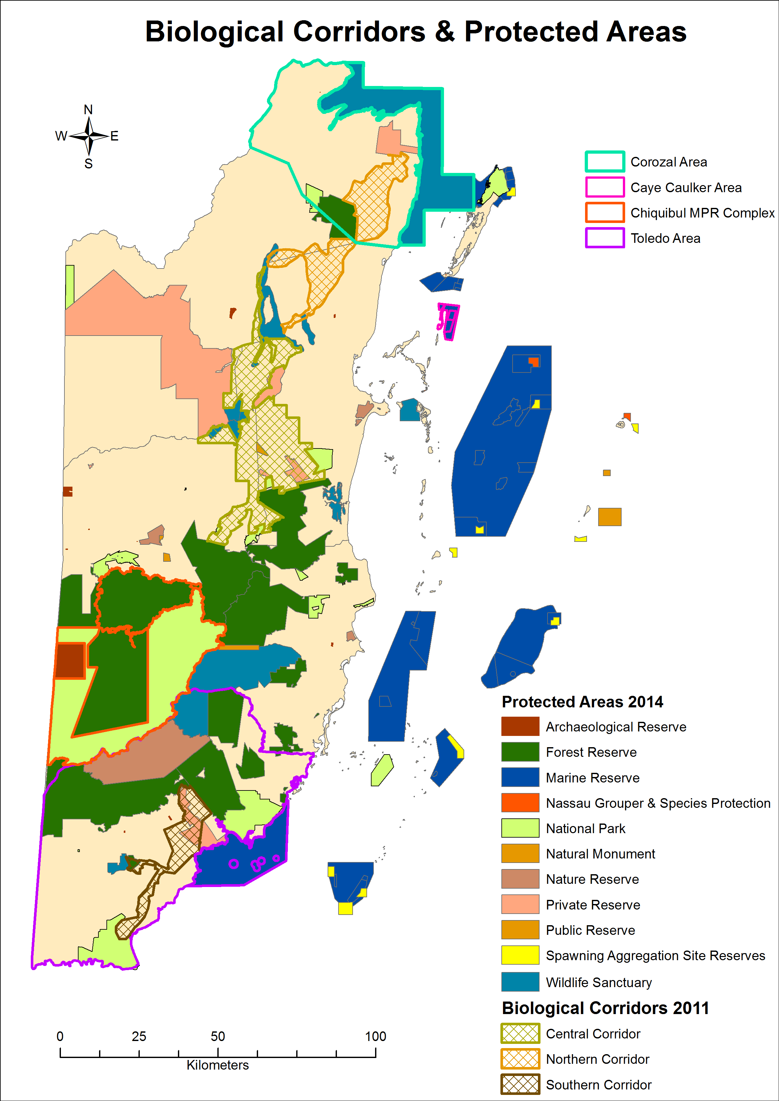
Figure 1: Belize’S bIOLOGICAL CORRIDORS AND PROTECTED AREAS BY TYPE
(Source: Berds 2011; NPAS 2014)

Corozal Area
Figure 2 shows the various protected areas by type for the Corozal area and its associated watersheds and waterbodies. Majority of the road infrastructure and settlements are concentrated on the western portion of the district (shown in Figure 4) with the biological corridor areas, protected areas and vast extent of the inland water bodies located on the south central and eastern portion of the district (Figure 2 and Figure 3). For greater clarification the size of the various protected areas shown in Figure 3 can be located in Table 2 below. The 2010 land and 2011 ecosystems cover for the area coincide with this pattern as shown in Figure 5 and Figure 6 respectively. Figure 5 and Figure 6 show primary agriculture activity concentrated in the western and central portions of the district; broadleaf forest cover concentrated in the north central region (east of Chunox and Copperbank), south central region, south of Shipstern Nature Reserve and east of Freshwater Creek Forest Reserve; and with mangrove and wetland areas concentrated in the eastern part of the district towards the coast. Table 3 details the size of land cover types based on the 2010 data layer used to map Figure 5. Table 4 contains the size of ecosystems and agricultural land use mapped in Figure 6. It is worth noting that a significant portion of the broadleaf forest cover in the south central region of the Corozal District is protected through Honey Camp National Park and Freshwater Creek Forest Reserve. The Shipstern Nature Reserve itself encompasses little broadleaf forest but protects a considerable area of mangrove forest.
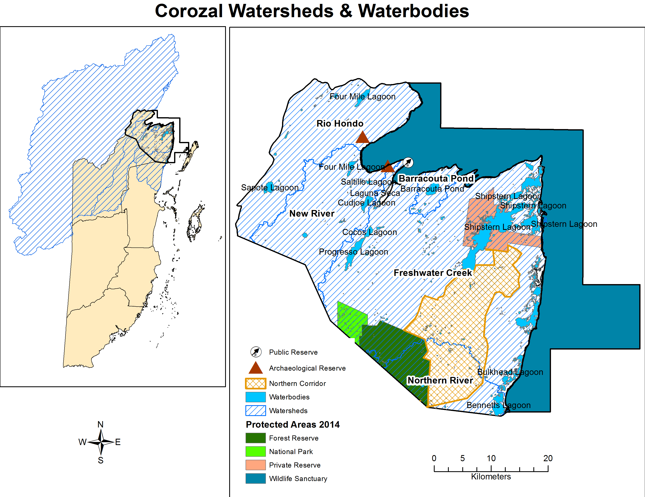
Figure 2: COROZAL AREA WATERSHEDS, Waterbodies AND PROTECTED AREAS BY TYPE
(Source: NPAS 2014)
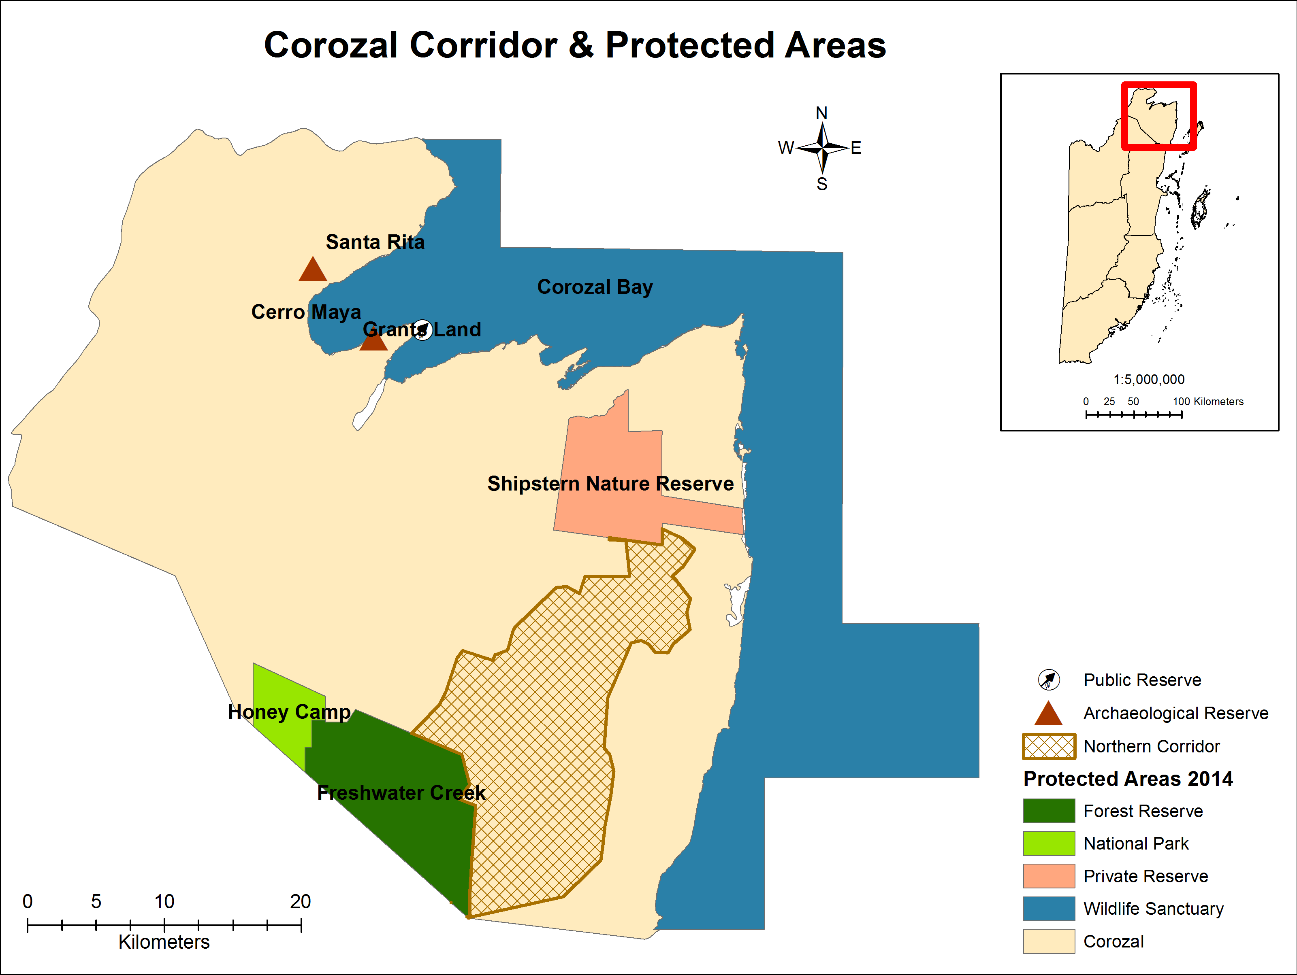
Figure 3: COROZAL CORRIDOR AND PROTECTED AREAS BY TYPE
(Source: BERDS 2011; NPAS 2014)

Table 2: COROZAL PROTECED AREAS AND SIZE
Destination | Protected Area | Area (ha)
Corozal | Cerro Maya Archaeological Reserve | 17.73
 | Corozal Bay Wildlife Sanctuary | 73549.42
 | Freshwater Creek Forest Reserve | 10245.33
 | Grants Land Public Reserve | 0.33
 | Honey Camp National Park | 2456.81
 | Santa Rita Archaeological Reserve | 1.5
 | Shipstern Private Reserve | 7645.88

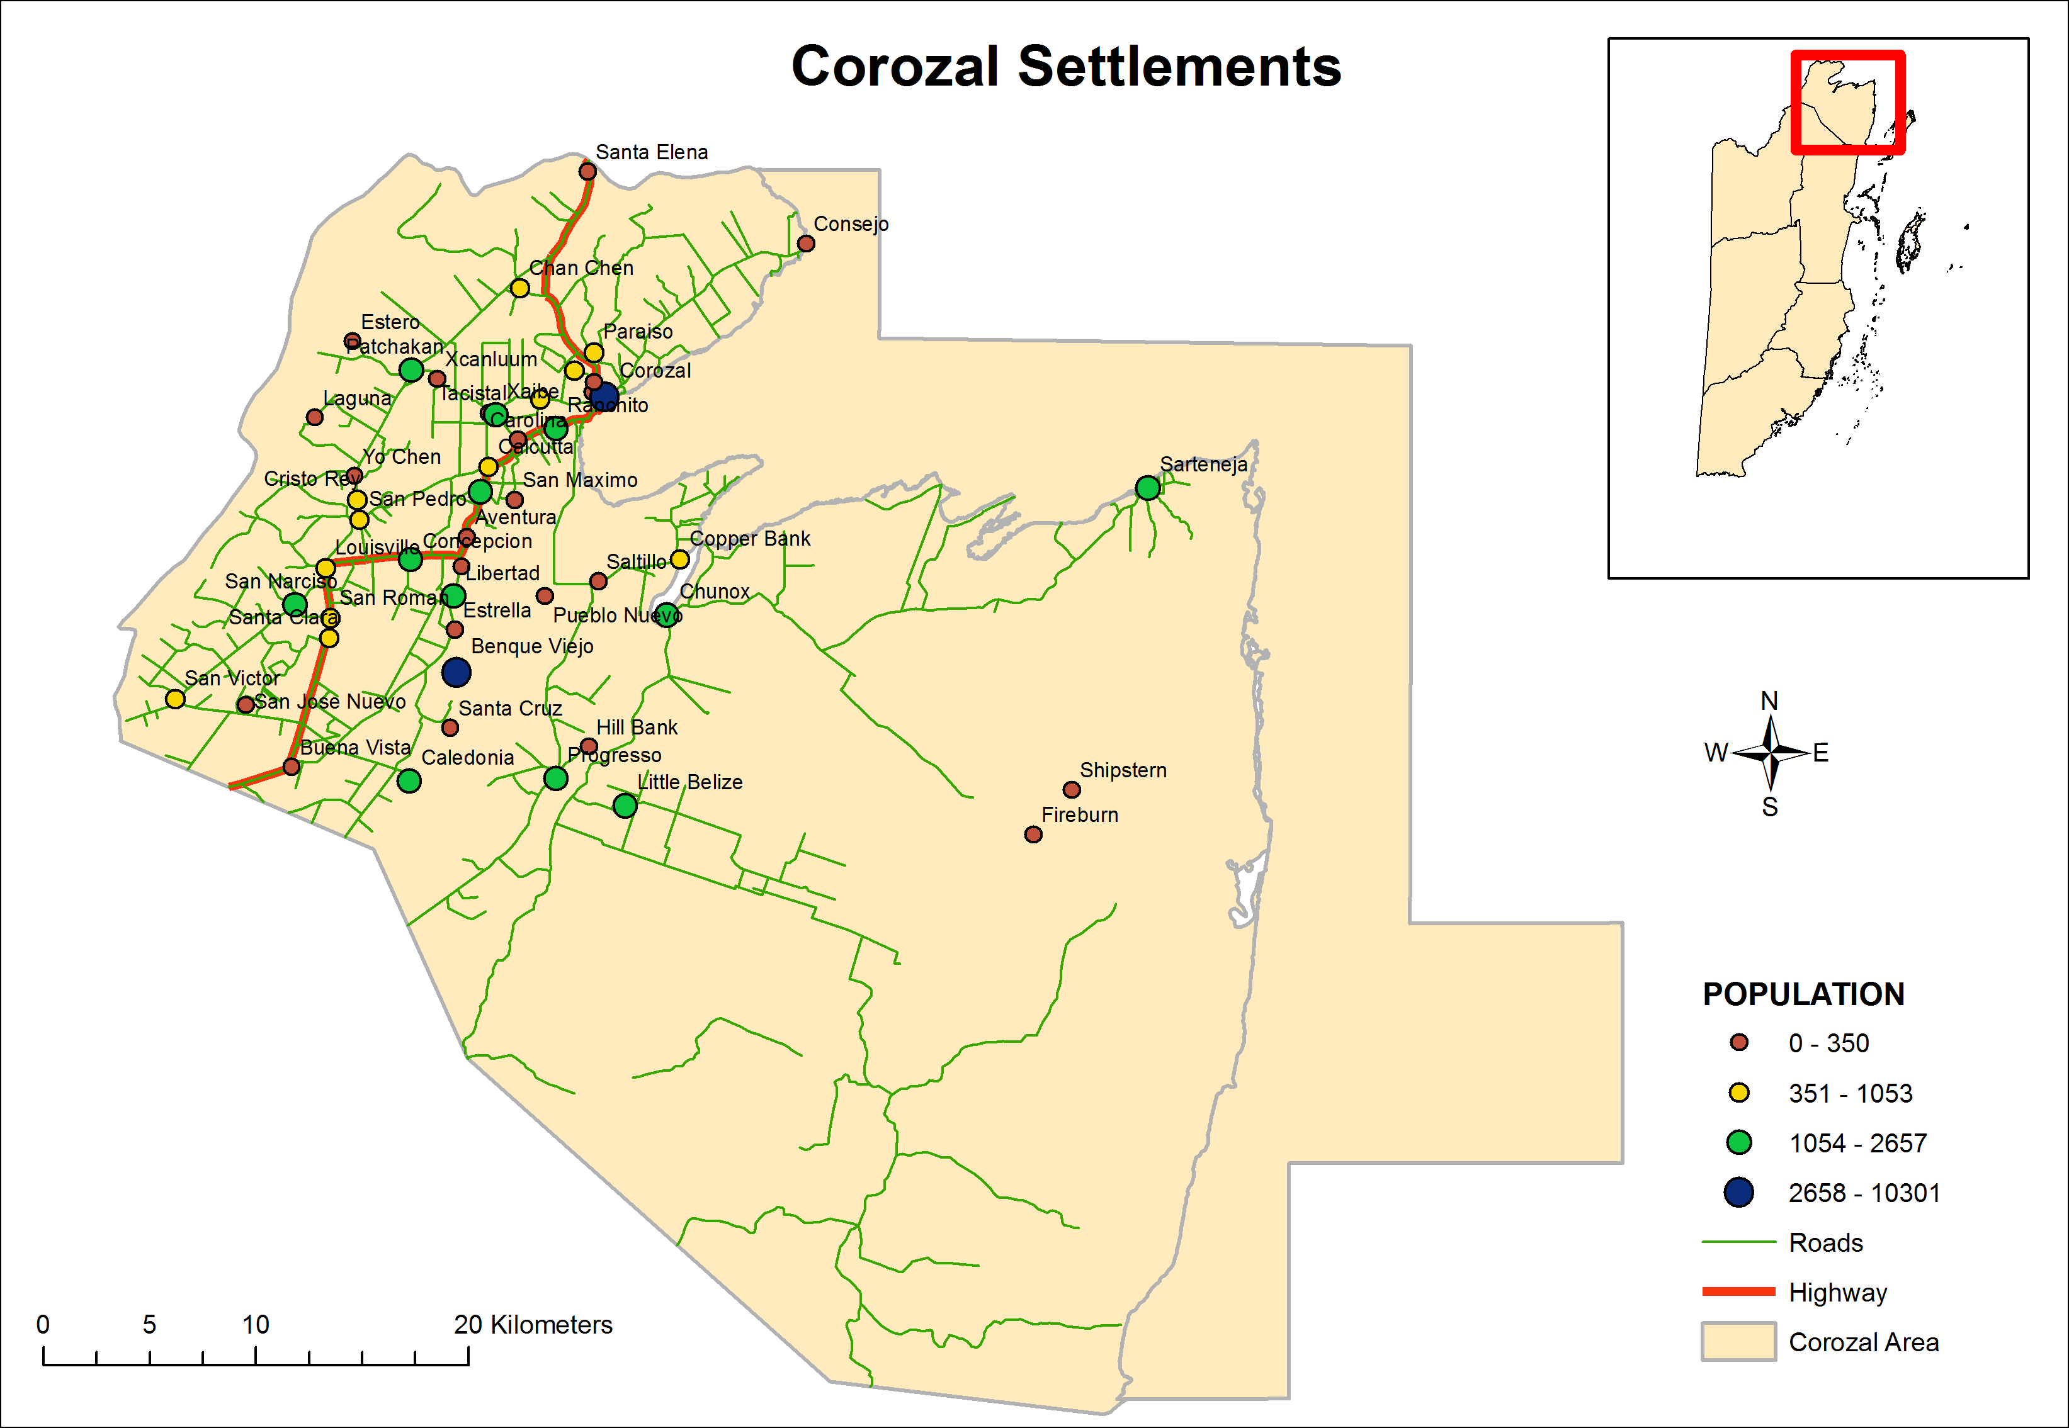
Figure 4: COROZAL AREA SETTLEMENTS
(Source: BERDS 2010)
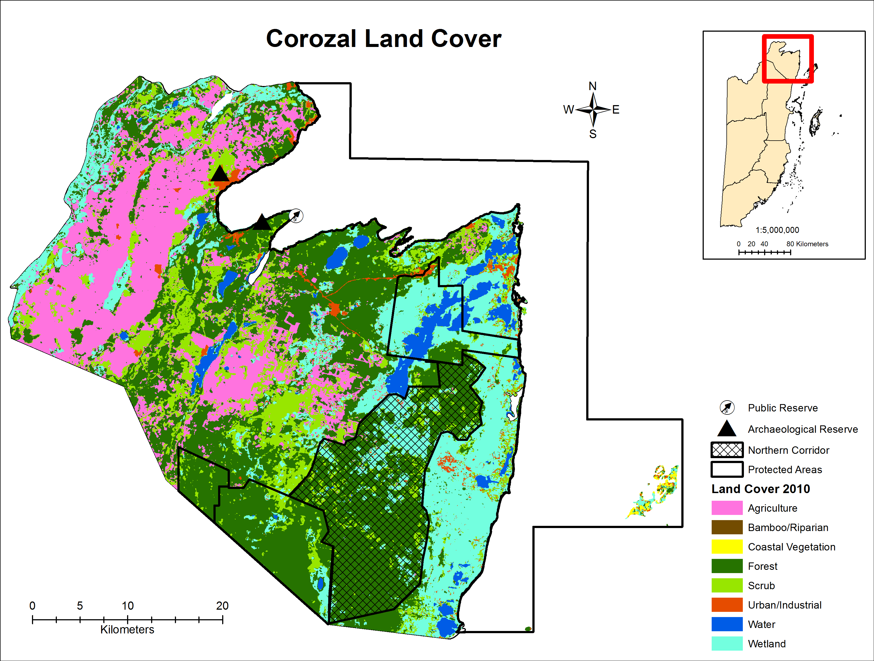
Figure 5: LAND COVER FOR COROZAL AREA BASED ON 2010 DATA LAYER
(Source: Emil Cherrington, 2010)

Table 3: COROZAL LAND COVER TYPES AND SIZE BASED ON 2010 DATA LAYER
Destination | Land Cover | Area (ha)
Corozal | Agriculture | 38193.56
 | Coastal Vegetation | 324.98
 | Forest | 75264.99
 | Urban | 3349.33
 | Water | 7341.64
 | Wetland | 39730.91
 | Other (bamboo/riparian & scrub) | 26853.03

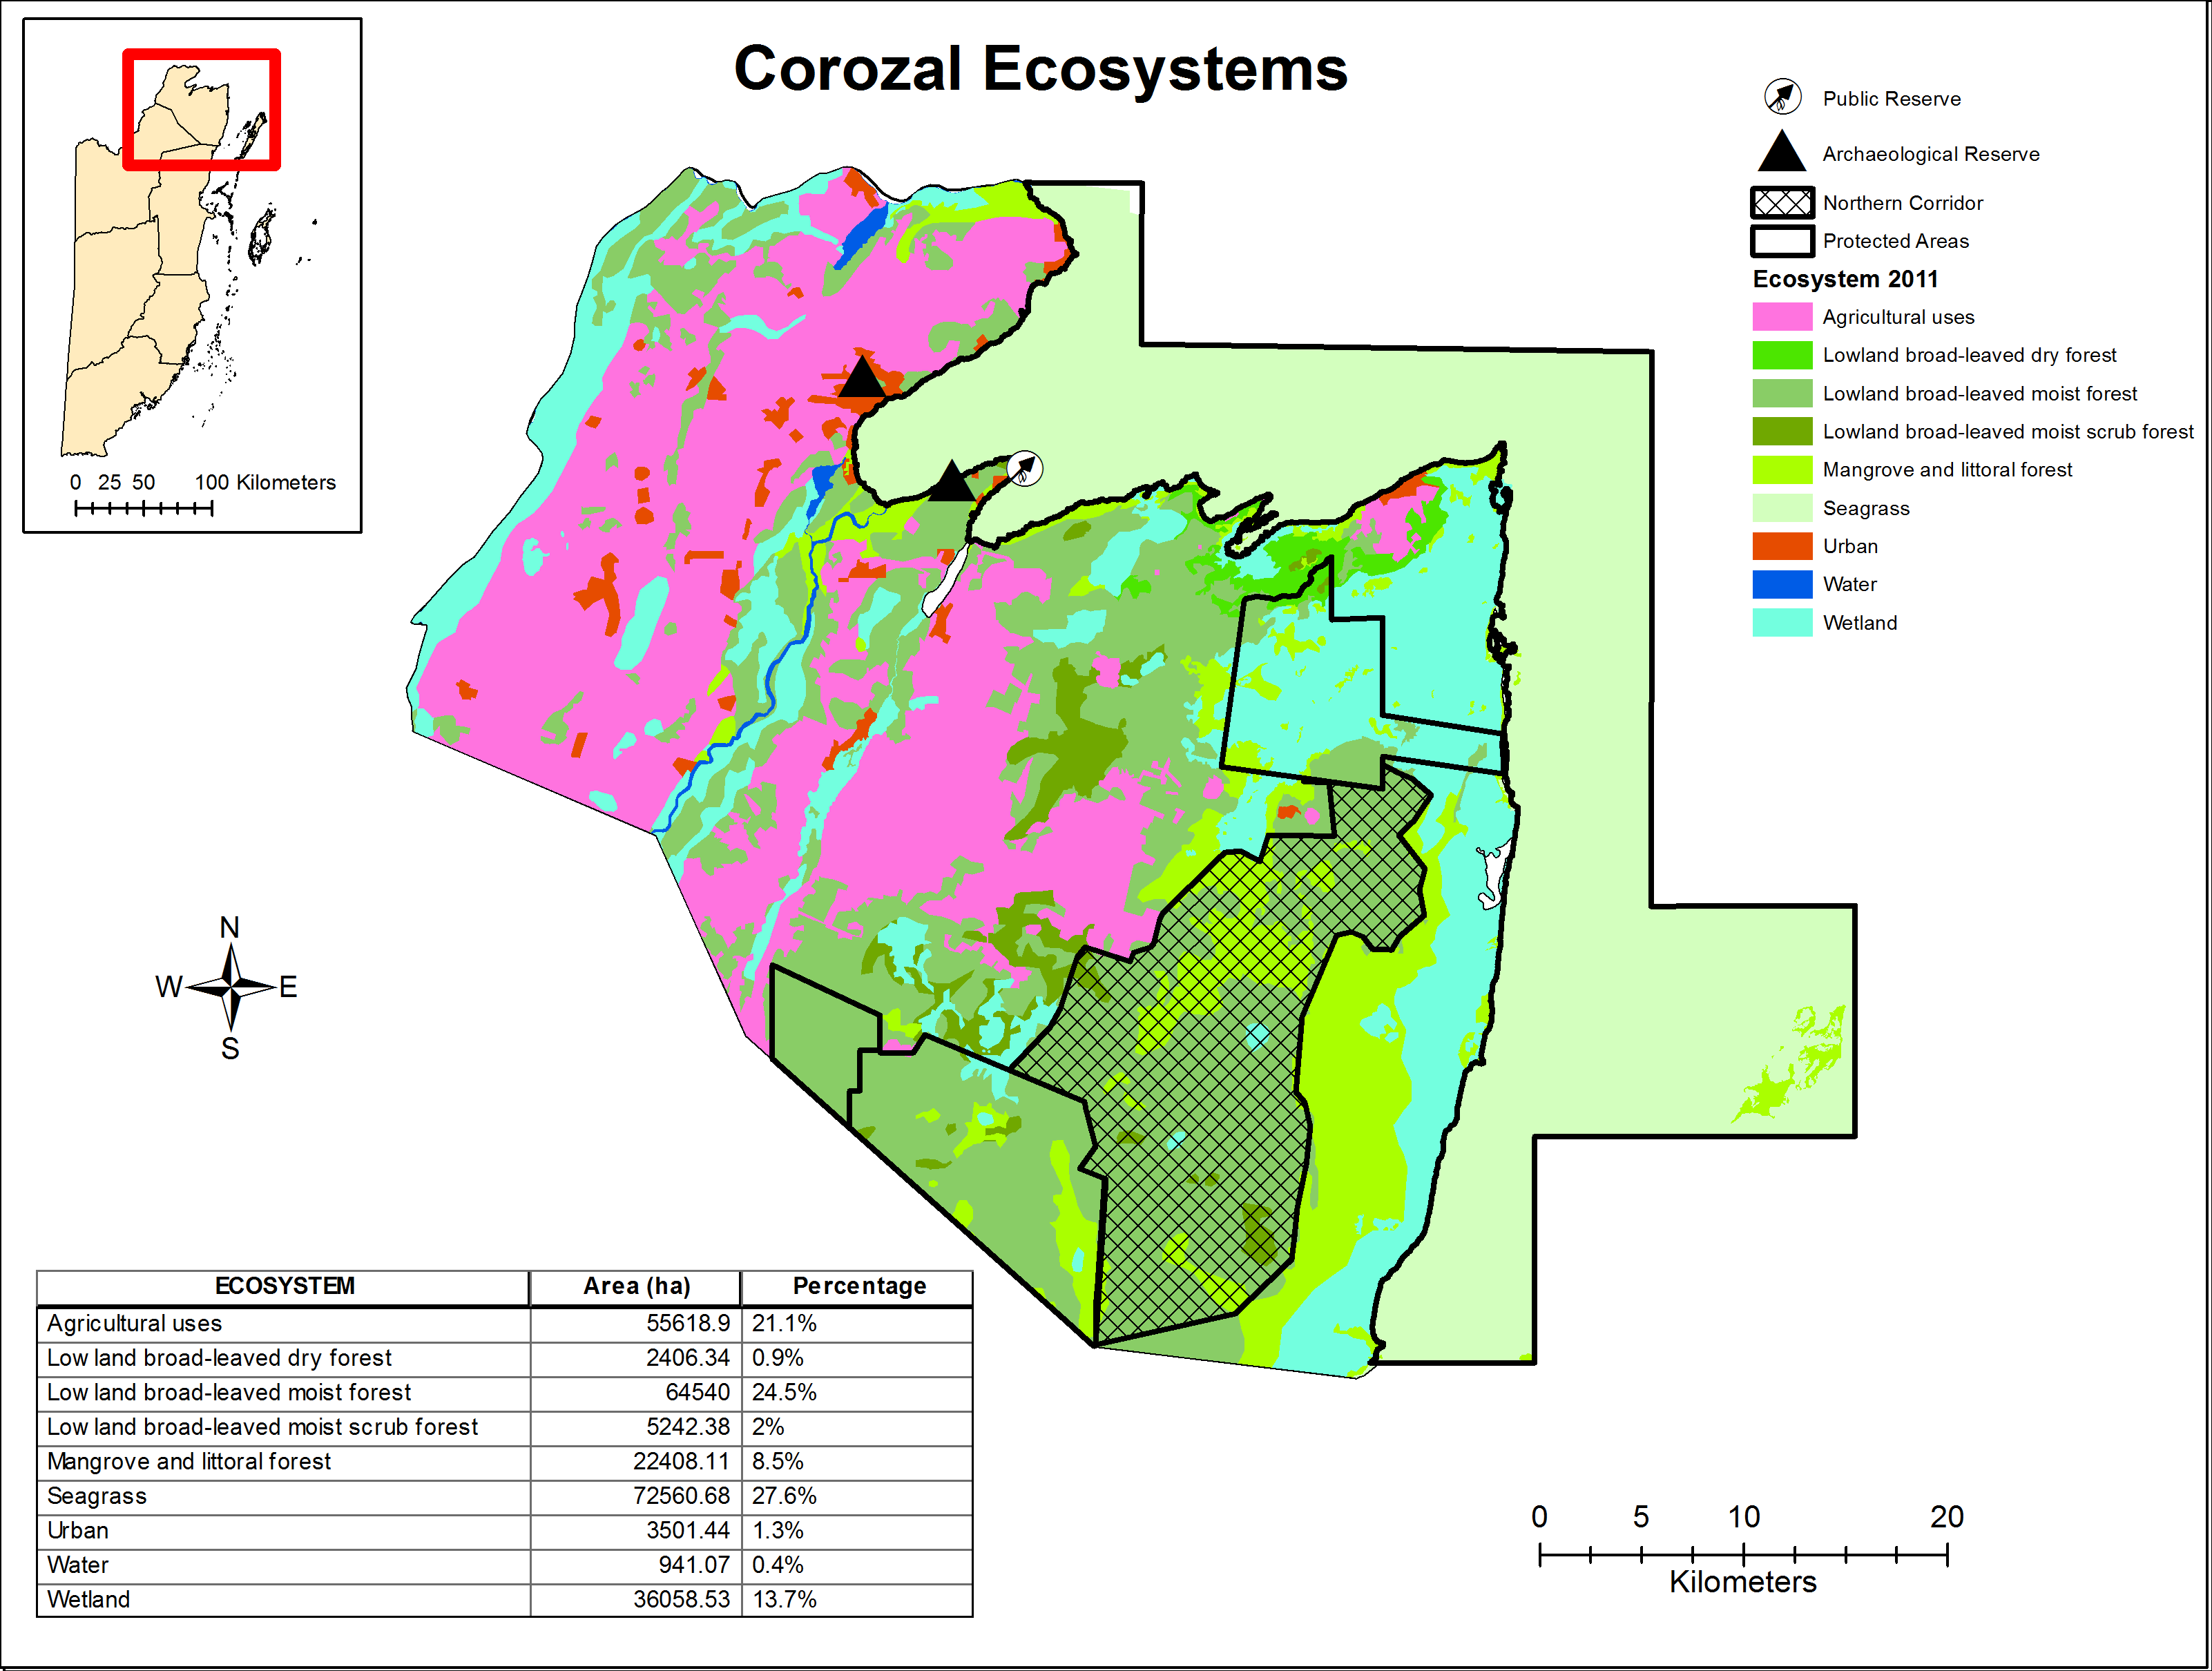
Figure 6: COROZAL AREA ECOSYSTEMS BASED ON 2011 DATA LAYER
(Source: BERDS 2011)

Table 4: COROZAL AREA ECOSYSTEMS WITH CORRESPONDING SIZE AND PERCENTAGE TOTAL BASED ON 2011 DATA LAYER
Destination | Ecosystem | Area (ha) | Percentage
Corozal | Agricultural uses | 55618.9 | 21.1 %
 | Low land broad-leaved dry forest | 2406.34 | 0.9 %
 | Low land broad-leaved moist forest | 64540 | 24.5 %
 | Low land broad-leaved moist scrub forest | 5242.38 | 2 %
 | Mangrove and littoral forest | 22408.11 | 8.5 %
 | Seagrass | 72560.68 | 27.6 %
 | Urban | 3501.44 | 1.3 %
 | Water | 941.07 | 0.4 %
 | Wetland | 36058.53 | 13.7 %
Figure 7 shows the 2014 forest cover for the Corozal area and at a coarser scale gives an updated picture of agricultural expansion from what is shown in Figure 5 and Figure 6. Although it should be noted that the non-forest class in Figure 7 encompasses agriculture, as well as agricultural areas under secondary growth and vegetation types such as lowland savanna that are not classified as forest (based on the Cherrington et al. (2010) methodology used to create the data layer). The Corozal area has little of these non-forest vegetation types and hence, the non-forest class in Figure 7 closely matches areas under agriculture. This means that based on Figure 7, for the Corozal area, there still appears to be a concentration of forests in the north central region east of Chunox and Copperbank, in the south central region, and south of Shipstern Nature Reserve. However, a sizable portion of the forest shown east of Freshwater Creek Forest Reserve in Figure 5 and Figure 6, and as part of the Northern Biological Corridor in Figure 1 is now seen as non-forest in Figure 7. This is due to large-scale deforestation for the development of Neulands, a new Mennonite settlement and agricultural area. Expansion of Neulands continues in 2015 as observed by many on the ground (E. Kay and Z. Walker, pers. obs.) and as detected via remote sensing (E. Cherrington and A. Lloyd, pers. comm.). Verification is also needed to confirm the extent of lands being leased and/or sold to Mennonites for agriculture in the forests of the north central region, east of Chunox and Copperbank.
Apart from forest and non-forest areas, Figure 7 also shows the 2014 extent of wetland areas for Corozal. The distribution of mangroves within these wetland areas, the rest of Corozal and Corozal Bay Wildlife Sanctuary, is more specifically illustrated in Figure 8.
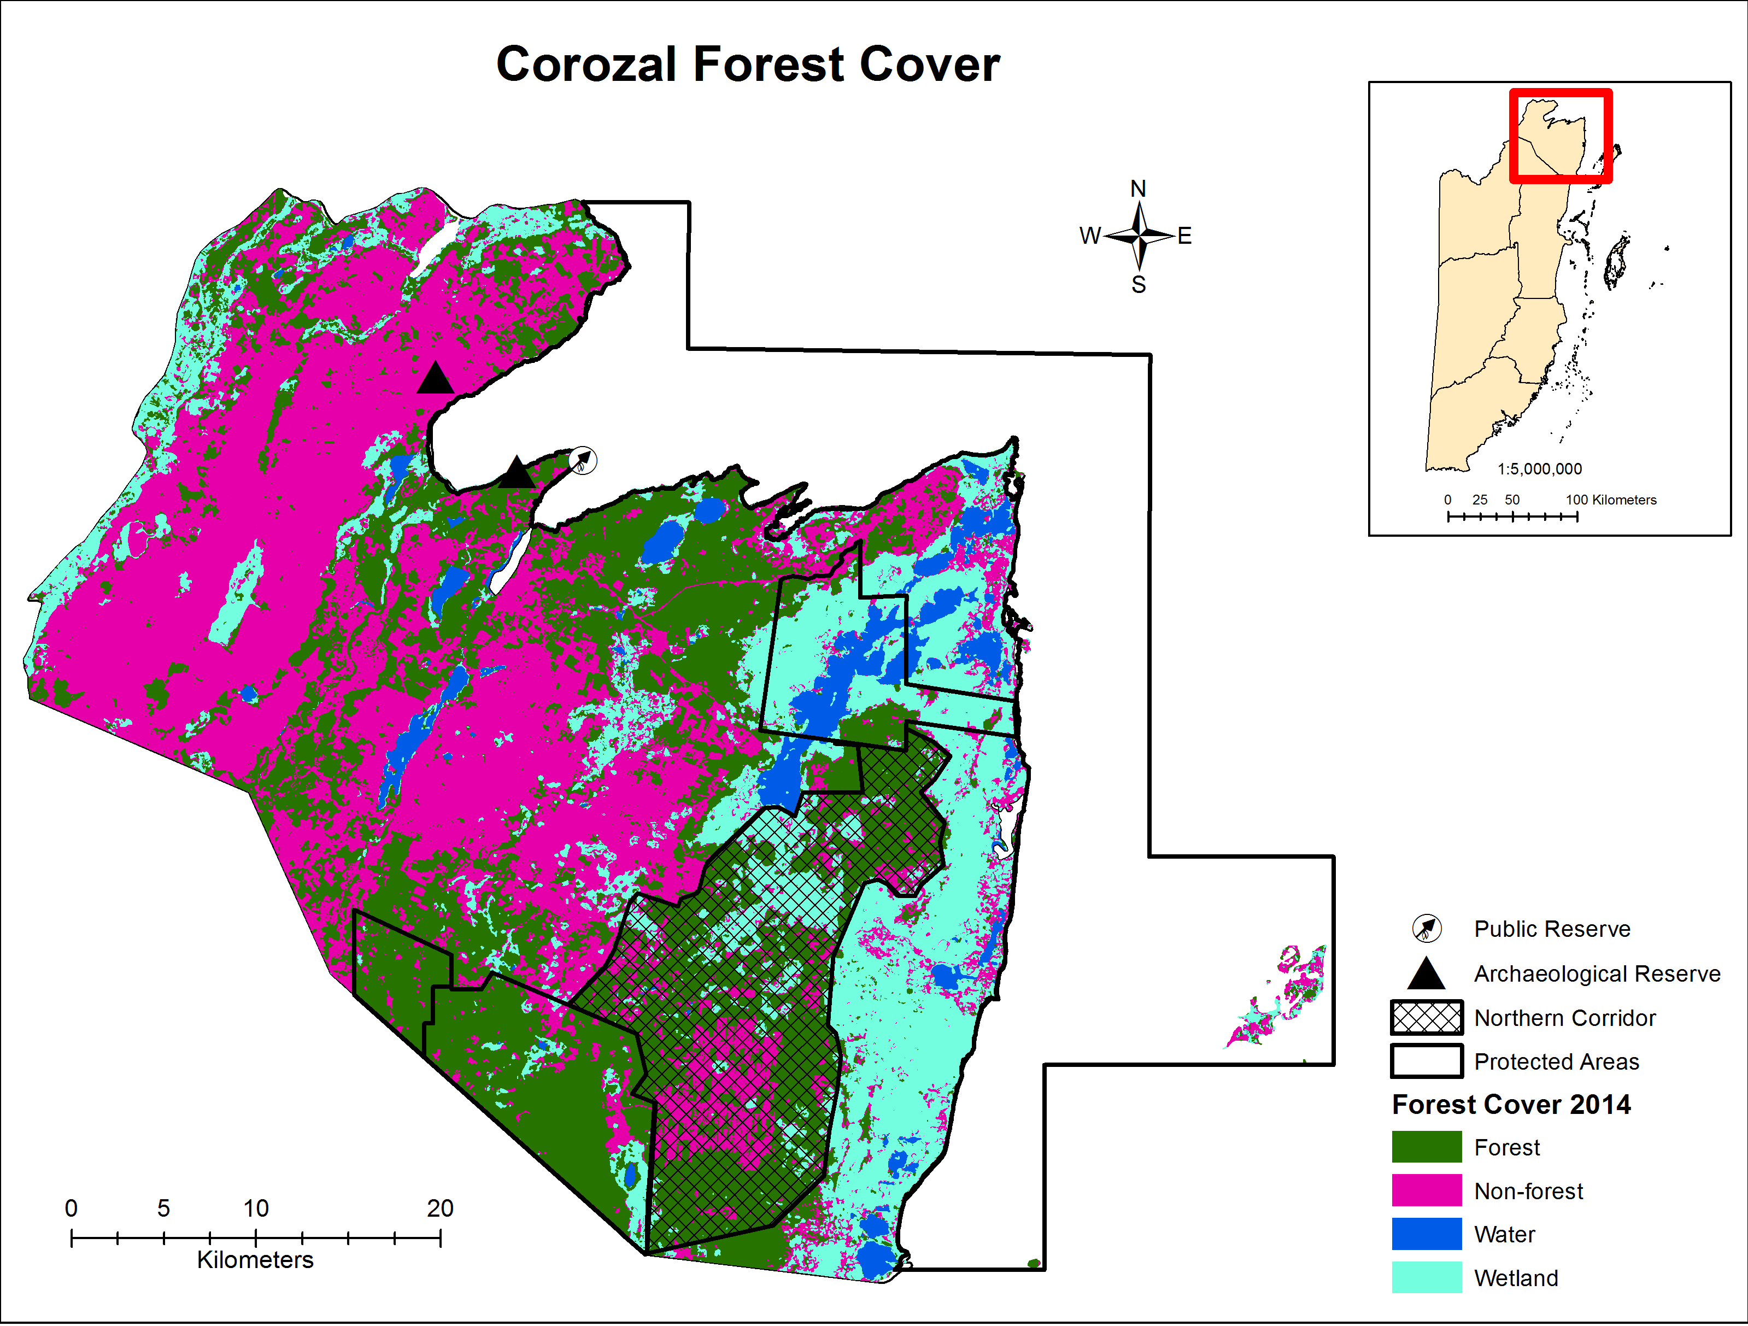
Figure 7: FOREST COVER FOR COROZAL AREA BASED ON 2014 DATA LAYER
(Source Emil Cherringtion, 2014)
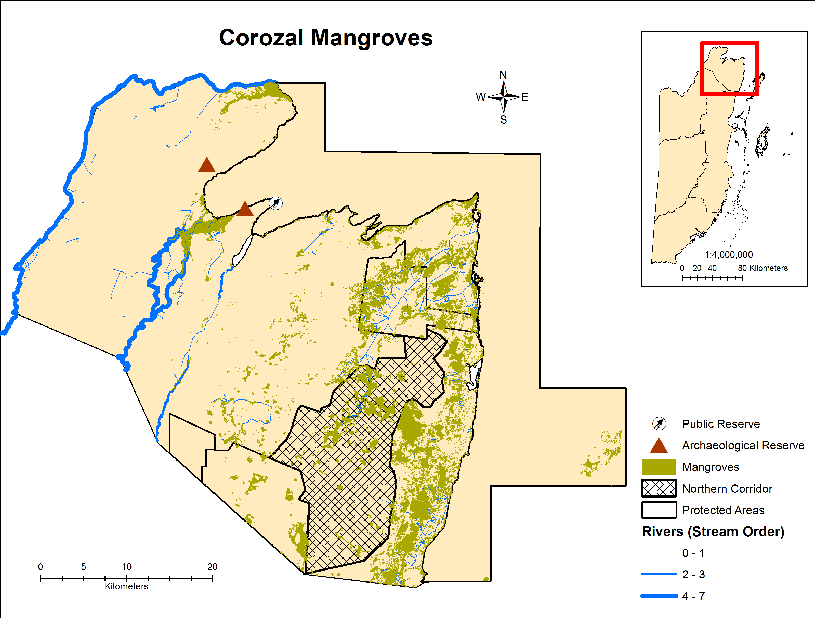
Figure 8: MANGROVE AREAS IN COROZAL BASED ON 2014 DATA LAYER
(Source Emil Cherrington, 2014)

Caye Caulker Area
Figure 9 illustrates the Caye Caulker area and its ecosystems both on the island and within the Caye Caulker Marine Reserve. The ecosystems layer used to create this map is from 2011 and in Figure 10, which illustrates the 2014 forest cover for the area, significant clearing of mangrove and littoral forests both north and south of the split can be observed. Deforestation south of the split is more uniform while deforestation north of the split is patchier. Table 5 shows the size of the Caye Caulker Forest and Marine Reserves mapped in Figure 9, while Table 6 details the ecosystems of the area with their corresponding size and total percentage coverage.

Table 5: CAYE CAULKER PROTECTED AREAS AND SIZE
Destination | Protected Area | Area (ha)
Caye Caulker | Caye Caulker Forest Reserve | 37.91
 | Caye Caulker Marine Reserve | 3913.4

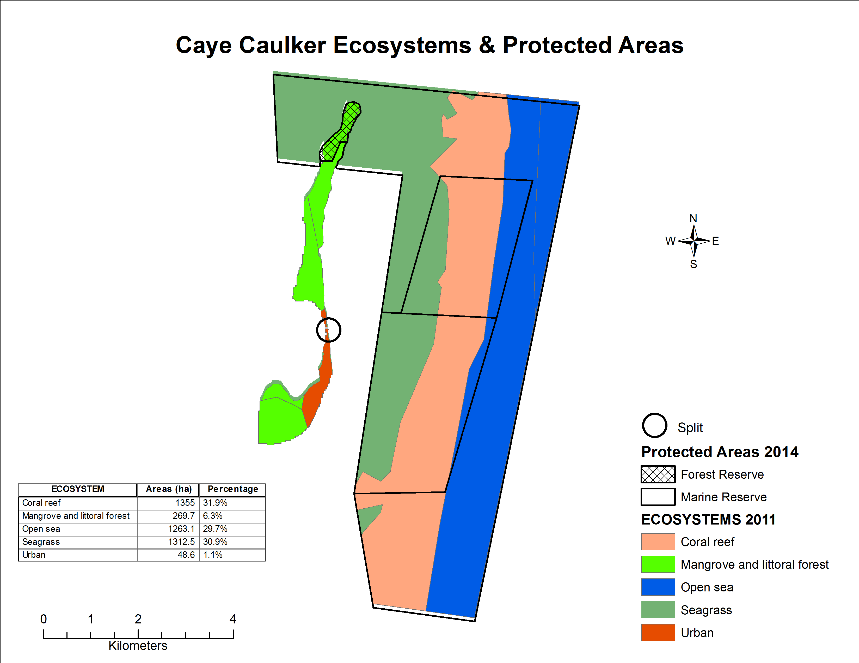
Figure 9: Caye Caulker area ecosystems (2011) and protected areas (2014). Black circle indicates location of the split on the island.
(Source: BERDS 2011; NPAS 2014)

Table 6: CAYE CAULKER ECOSYSTEMS CORRESPONDING SIZE AND PERCENTAGE TOTAL
Destination | Ecosystem | Area (ha) | Percentage
Caye Caulker | Coral reef | 1355 | 31.9 %
 | Mangrove and littoral forest | 269.7 | 6.3 %
 | Open sea | 1263.1 | 29.7 %
 | Seagrass | 1312.5 | 30.9 %
 | Urban | 48.6 | 1.1 %

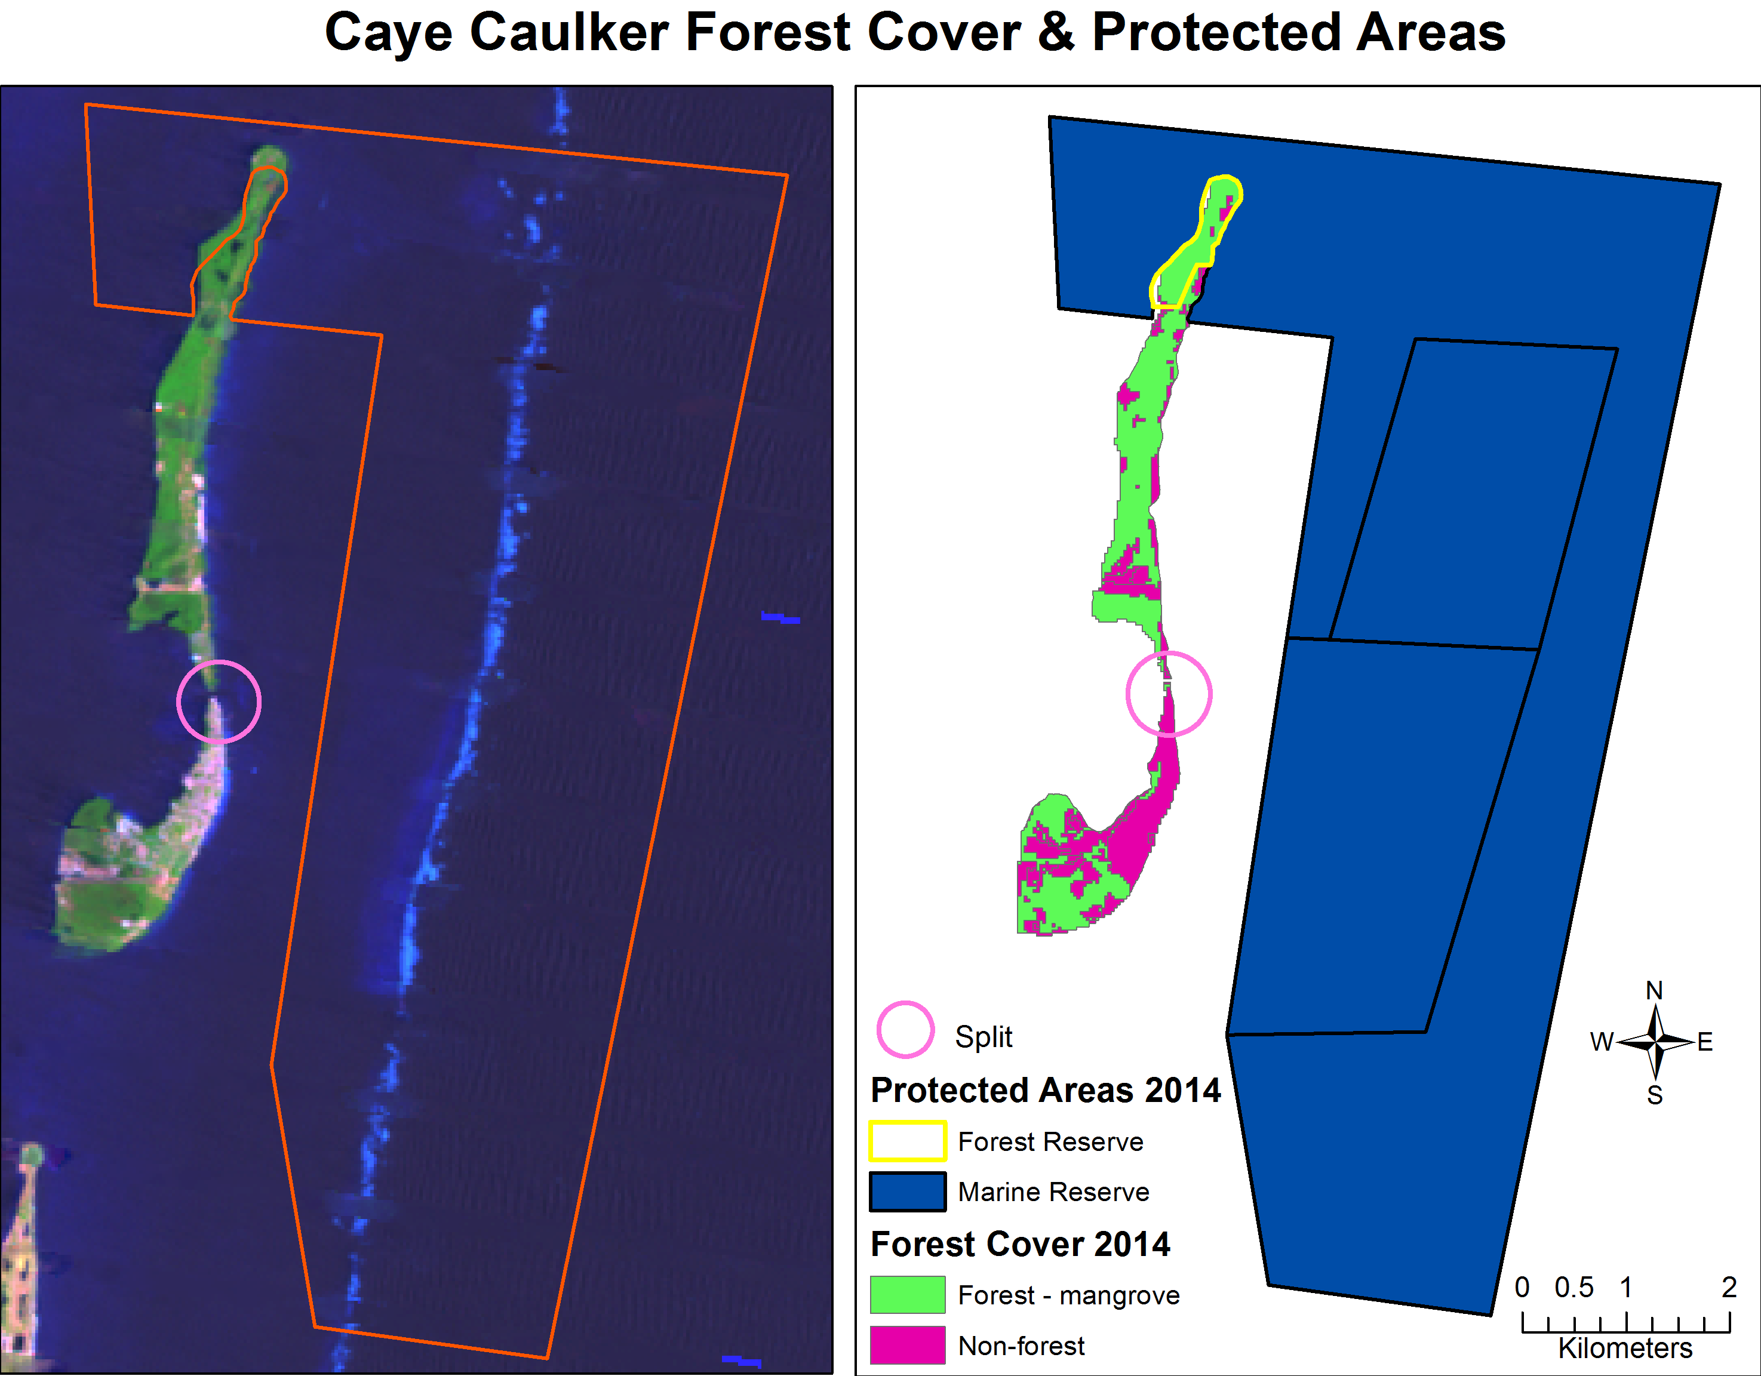
Figure 10: Caye Caulker area 2014 forest cover and protected areas (lANDSAT image (left) and map (right). Pink circle indicates location of the split on the island
(Source: Emil Cherrington 2014; NPAS 2014)

Chiquibul-MPR Complex
Figure 11 illustrates the location of the Chiquibul-MPR complex within Belize and the Belize River watershed and shows that the complex is comprised of two forest reserves (Chiquibul and MPR), the Chiquibul National Park and the Caracol Archaeological Reserve. See Table 7 for the size of the latter PAs within the complex. The Chiquibul-MPR complex is a critical component of Belize’s most important watershed, not just because of the extent of the watershed it covers but also because that is where the headwaters of the Belize River watershed originate (Boles, Buck & Esselman, 2008). Figure 11 also illustrates the location of the Chalillo Dam and associated lake and river area, which are technically not a part of the MPR Forest Reserve (white area in Figure 11). The MPR is shown as having an extensive secondary road network, which is currently not well maintained in all areas. This network was originally developed by the British to provide firebreaks within the reserve, most of which is comprised of a fire-adapted ecosystem. Currently, the secondary road network is still used for the purposes of fire management although few personnel of the Forest Department are posted within the reserve to carry out this work and maintain the roads compared to an entire community that was responsible for the management of the reserve until the 1990’s. Nevertheless, the base for developing primary road infrastructure is present within the MPR Forest Reserve.
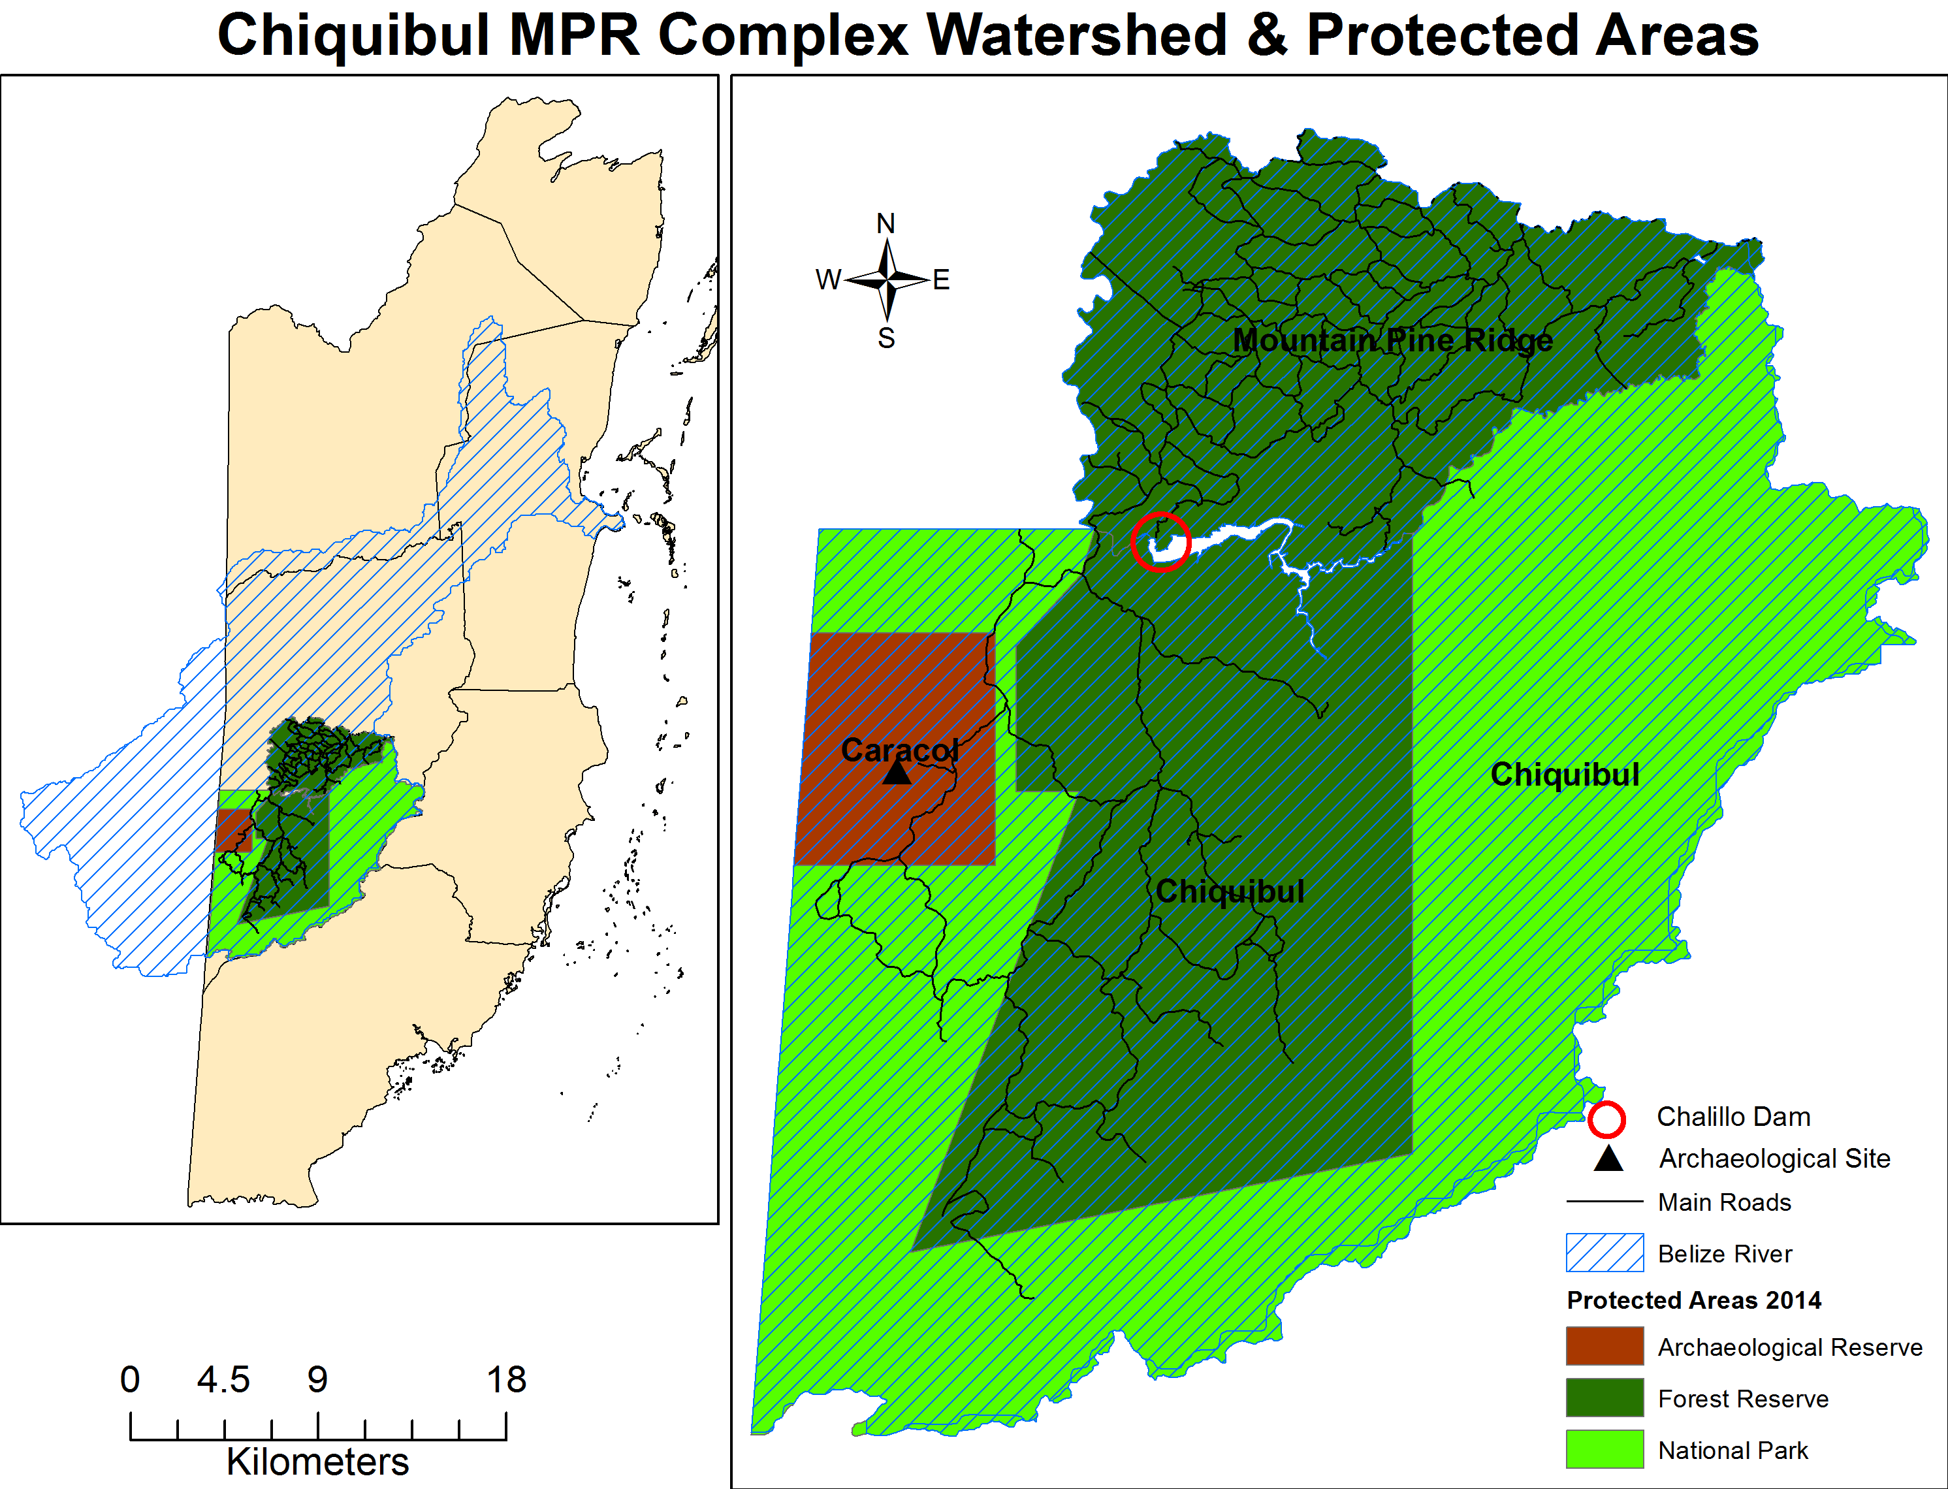
Figure 11: CHIQUIBUL-MPR COMPLEX WITHIN BELIZE AND BELIZE RIVER WATERSHED (LEFT) AND ITS PROTECTED AREAS (RIGHT)
(Source: NPAS 2014)

Table 7: CHIQUIBUL-MPR COMPLEX PROTECTED AREAS AND SIZE
Destination | Protected Area | Area (ha)
Chiquibul – MPR Complex | Caracol Archaeological Reserve | 10324.23
 | Chiquibul Forest Reserve | 59540.13
 | Mountain Pine Ridge Forest Reserve | 42911.66
 | Chiquibul National Park | 106785.14

Figure 12 illustrates that the Chiquibul-MPR complex is mainly comprised of broadleaf forests with the MPR portion of it comprised largely of savanna and pine forest (see Table 8 for size of land cover categories mapped). Agriculture in the area is concentrated near the Belize-Guatemala border inside the Chiquibul National Park and the Caracol Archaeological Reserve mainly as a result of illegal agricultural incursions from Guatemala (Cherrington, 2014). Figure 12 clearly shows the San Pastor savanna within the Chiquibul Forest Reserve. Figure 13 also reflects this same pattern but further subdivides the forest areas into specific ecosystem types; the main ecosystem type of the Chiquibul-MPR complex is submontane broad-leaved moist forest but the area contains several pockets of lowland broad-leaved moist forest, a swath of submontane broad-leaved wet forest in the south and lowland and submontane pine forests mainly in the MPR forest reserve. Both Figure 12 and Figure 13 reflect some urban areas within the MPR forest reserve. On the ground these are mainly comprised of a private farm, a few resorts, the Douglas D’Silva Forest Station and more recently a de-reserved area now owned by Mennonites (E. Kay, pers. obs.). The area and corresponding percentage of ecosystems mapped in Figure 13 can be seen in Table 9. Figure 14 illustrates the 2014 forest cover for the area. However, in this map the majority of the MPR’s savannas and pine savannas show as non-forest since these systems do not meet the forest definition used by Cherrington et al. (2010) in their classification.
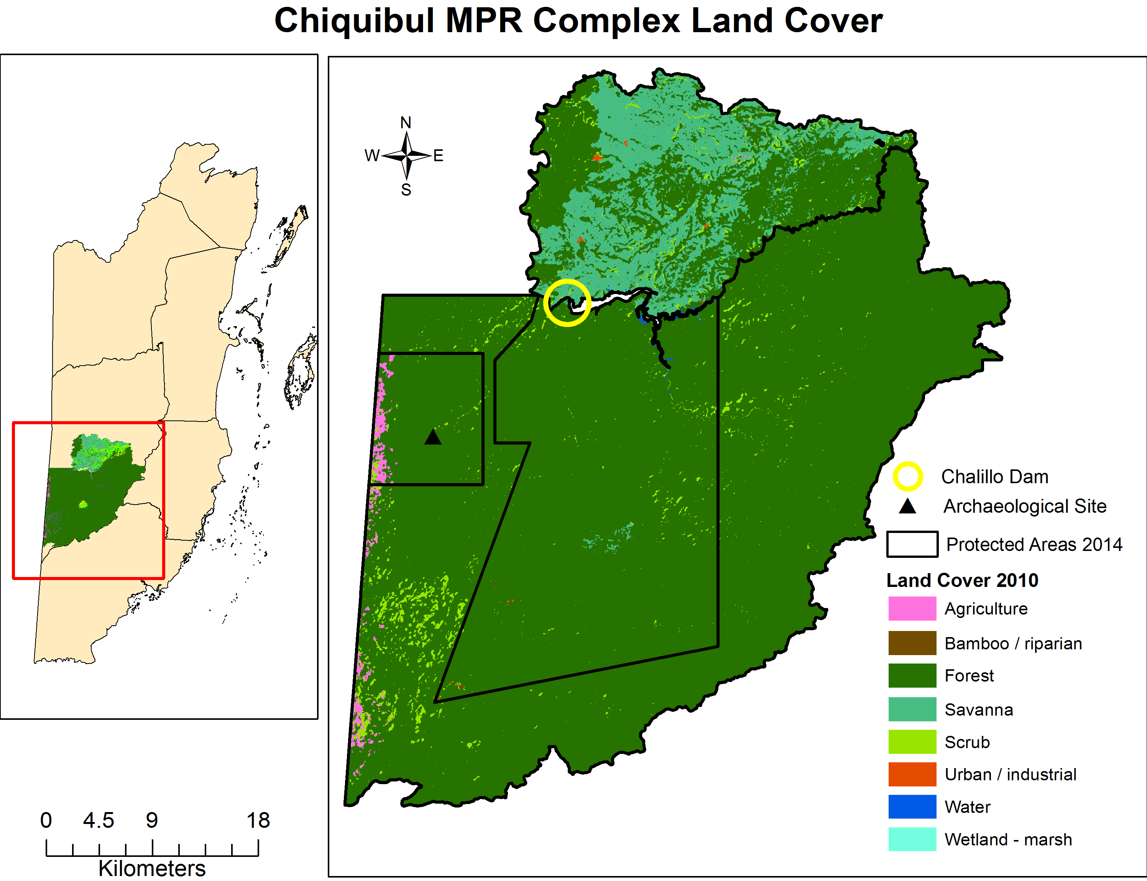
Figure 12: Land cover (2010) of protected areas in the Chiquibul-MPR Complex
(Source: Emil Cherrington, 2014;NPAS 2014)

Table 8: CHIQUIBUL-MPR COMPLEX LAND COVER AND SIZE BASED ON 2010 DATA LAYER
Destination | Land Cover | Area (ha)
Chiquibul – MPR Complex | Agriculture | 1422.19
 | Forest | 193025.85
 | Urban | 66.24
 | Water | 294.94
 | Wetland | 31.63
 | Other (bamboo/riparian, savanna & scrub) | 24701.14

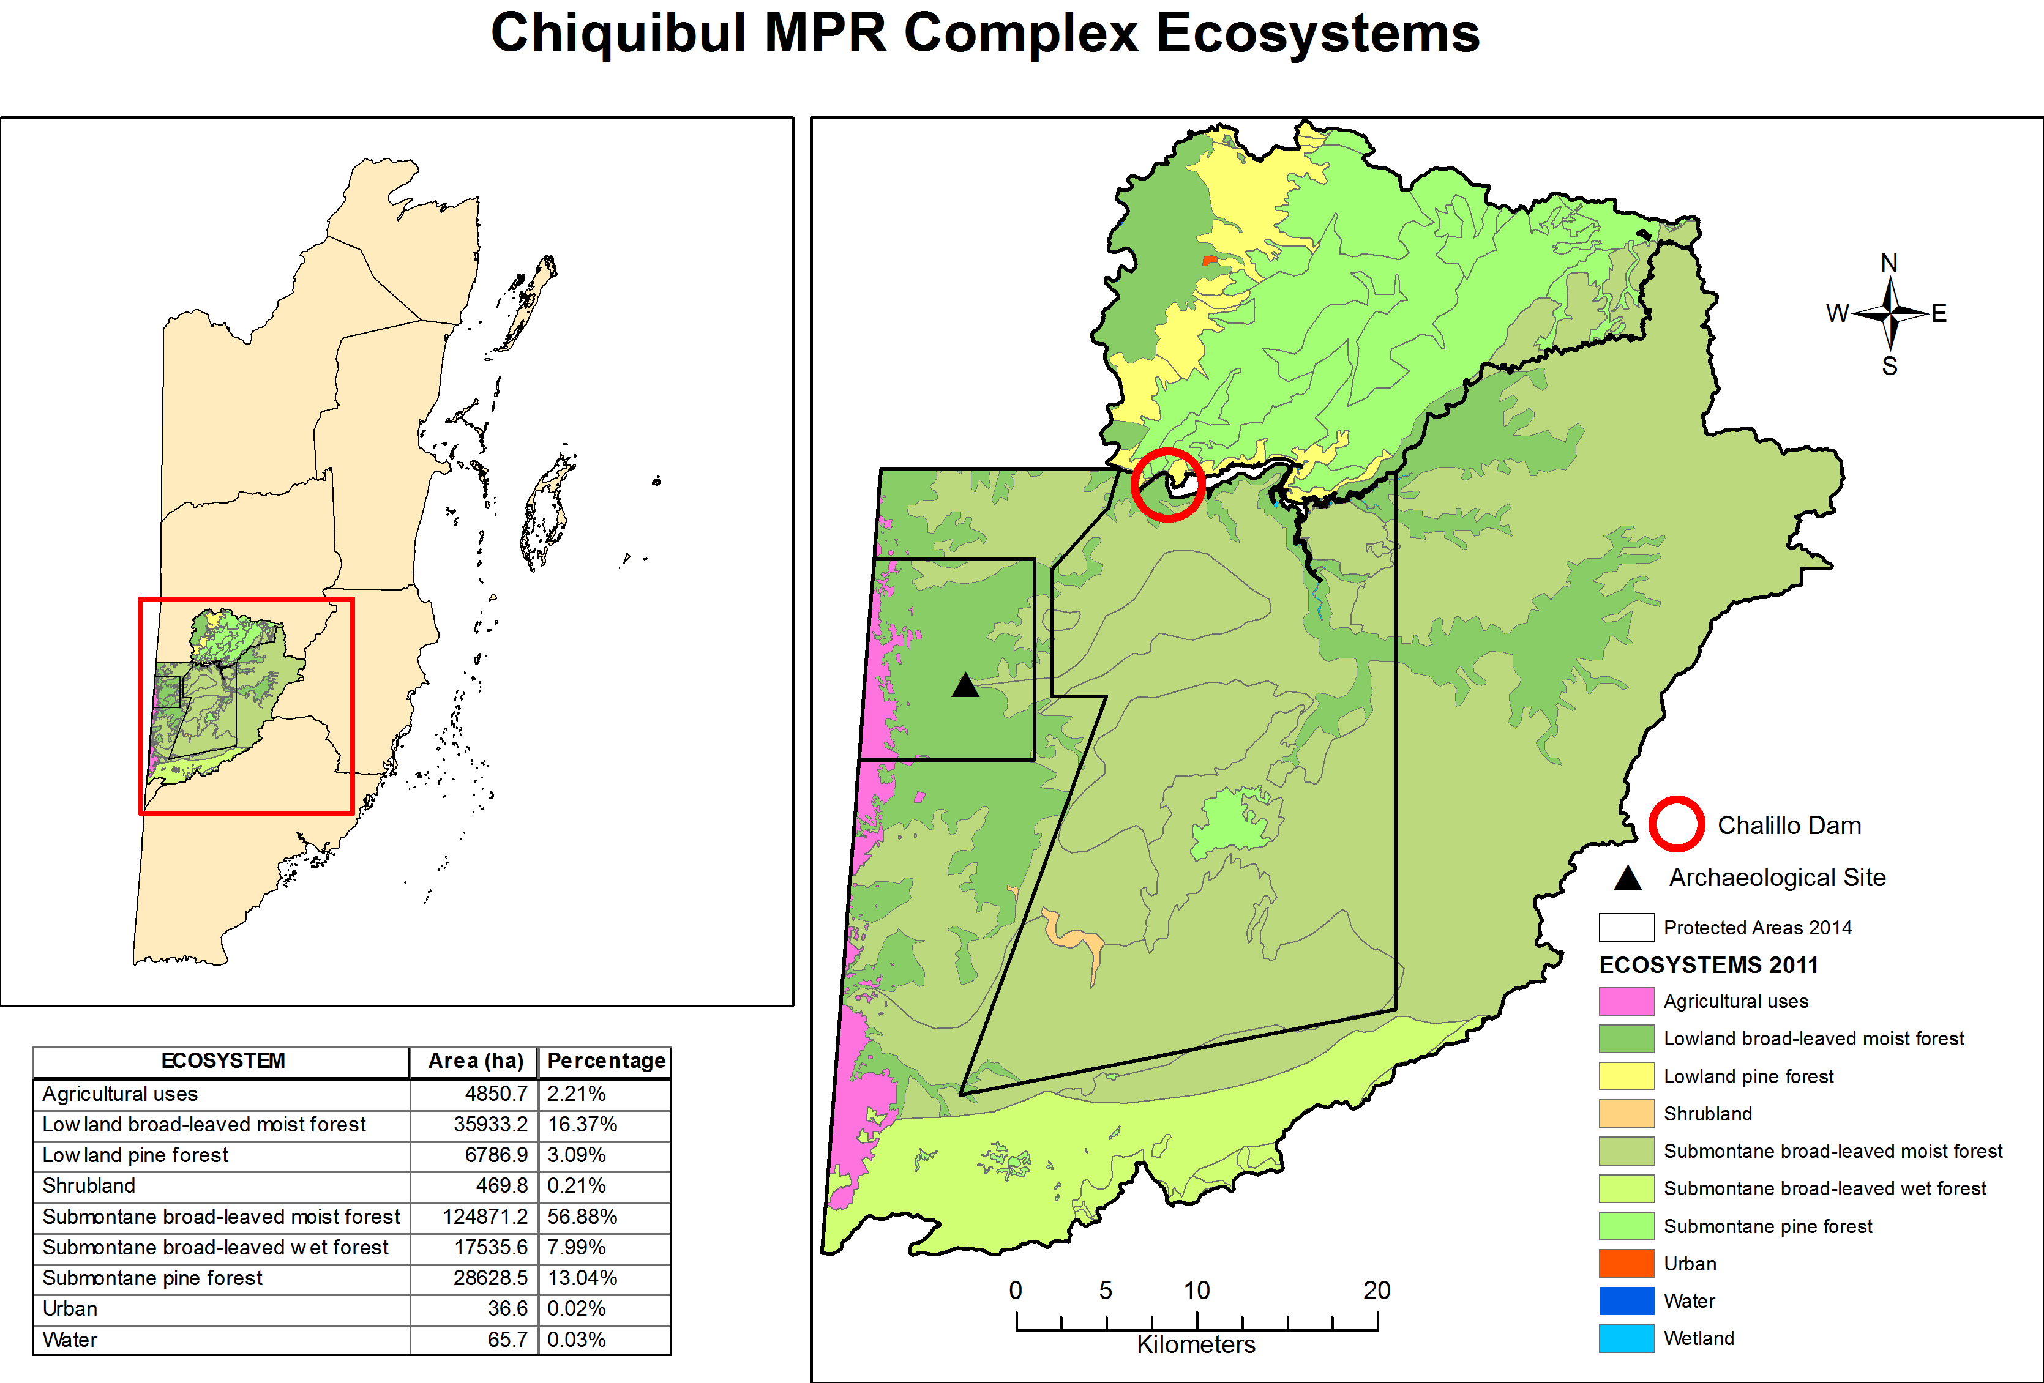
Figure 13: Ecosystems (2011) of the Chiquibul-MPR Complex
(Source:Berds, 2011)

Table 9: CHIQUBUL-MPR COMPLEX ECOSYSTEMS CORRESPONDING AREAS AND PERCENTAGE TOTAL
Destination | Ecosystem | Area (ha) | Percentage
Chiquibul – MPR Complex | Agricultural uses | 4850.7 | 2.21 %
 | Low land broad-leaved moist forest | 35933.2 | 16.37 %
 | Low land pine forest | 6786.9 | 3.09 %
 | Shrubland | 469.8 | 0.21 %
 | Submontane broad-leaved moist forest | 124871.2 | 56.88 %
 | Submontane broad-leaved wet forest | 17535.6 | 7.99 %
 | Submontane pine forest | 28628.5 | 13.04 %
 | Urban | 36.6 | 0.02 %
 | Water | 65.7 | 0.03 %

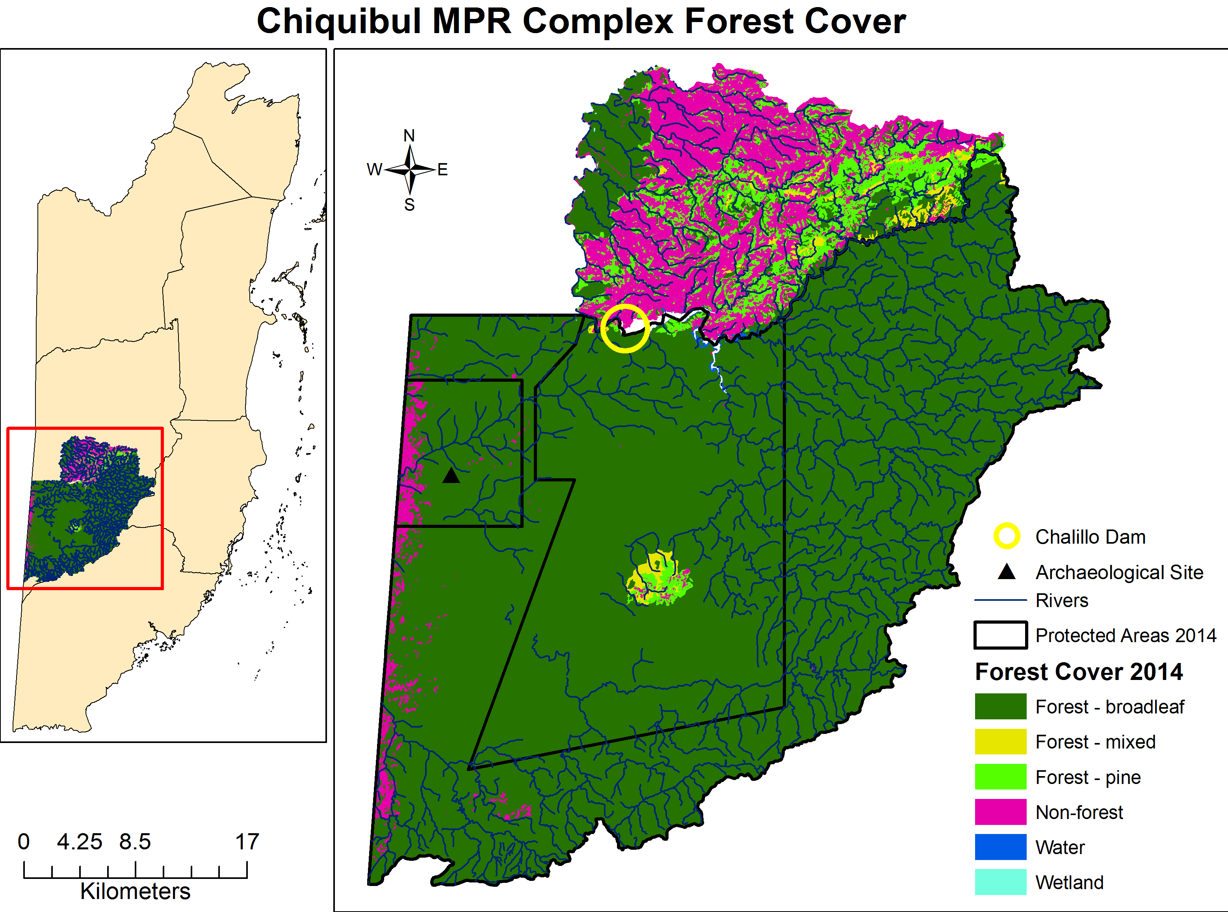
Figure 14: Forest cover (2014) of protected areas in the Chiquibul-MPR Complex
(Source: Emil Cherrington, 2014; NPAS 2014)

Toledo Area
Figure 15 illustrates the Toledo area in the wider context of its watersheds and waterbodies. Except for the Sarstoon, Moho and Temash River watersheds, which extend into Guatemala, numerous watersheds are located entirely within the Toledo area. As Figure 15 and Figure 16 shows, a portion of the Cockscomb Basin Wildlife Sanctuary and the entire Bladen Nature Reserve are located within the Toledo area. Together with the Chiquibul-MPR complex, these two protected areas in fact constitute the Maya Mountain Massif (MMM), a critical area where the headwaters of the Belize River and the major southern watersheds originate (Boles et al., 2008; Walker, Walker, Awe & Catzim, 2008). Figure 16 shows the Southern Biological Corridor and the significant network of Forest Reserves in the Toledo area, the size of these PAs can be found in Table 10. Figure 17 shows roads concentrated near settlement areas as well as the Deep River Forest Reserve. Figure 17 also shows the Toledo area settlements by name and their corresponding population size.
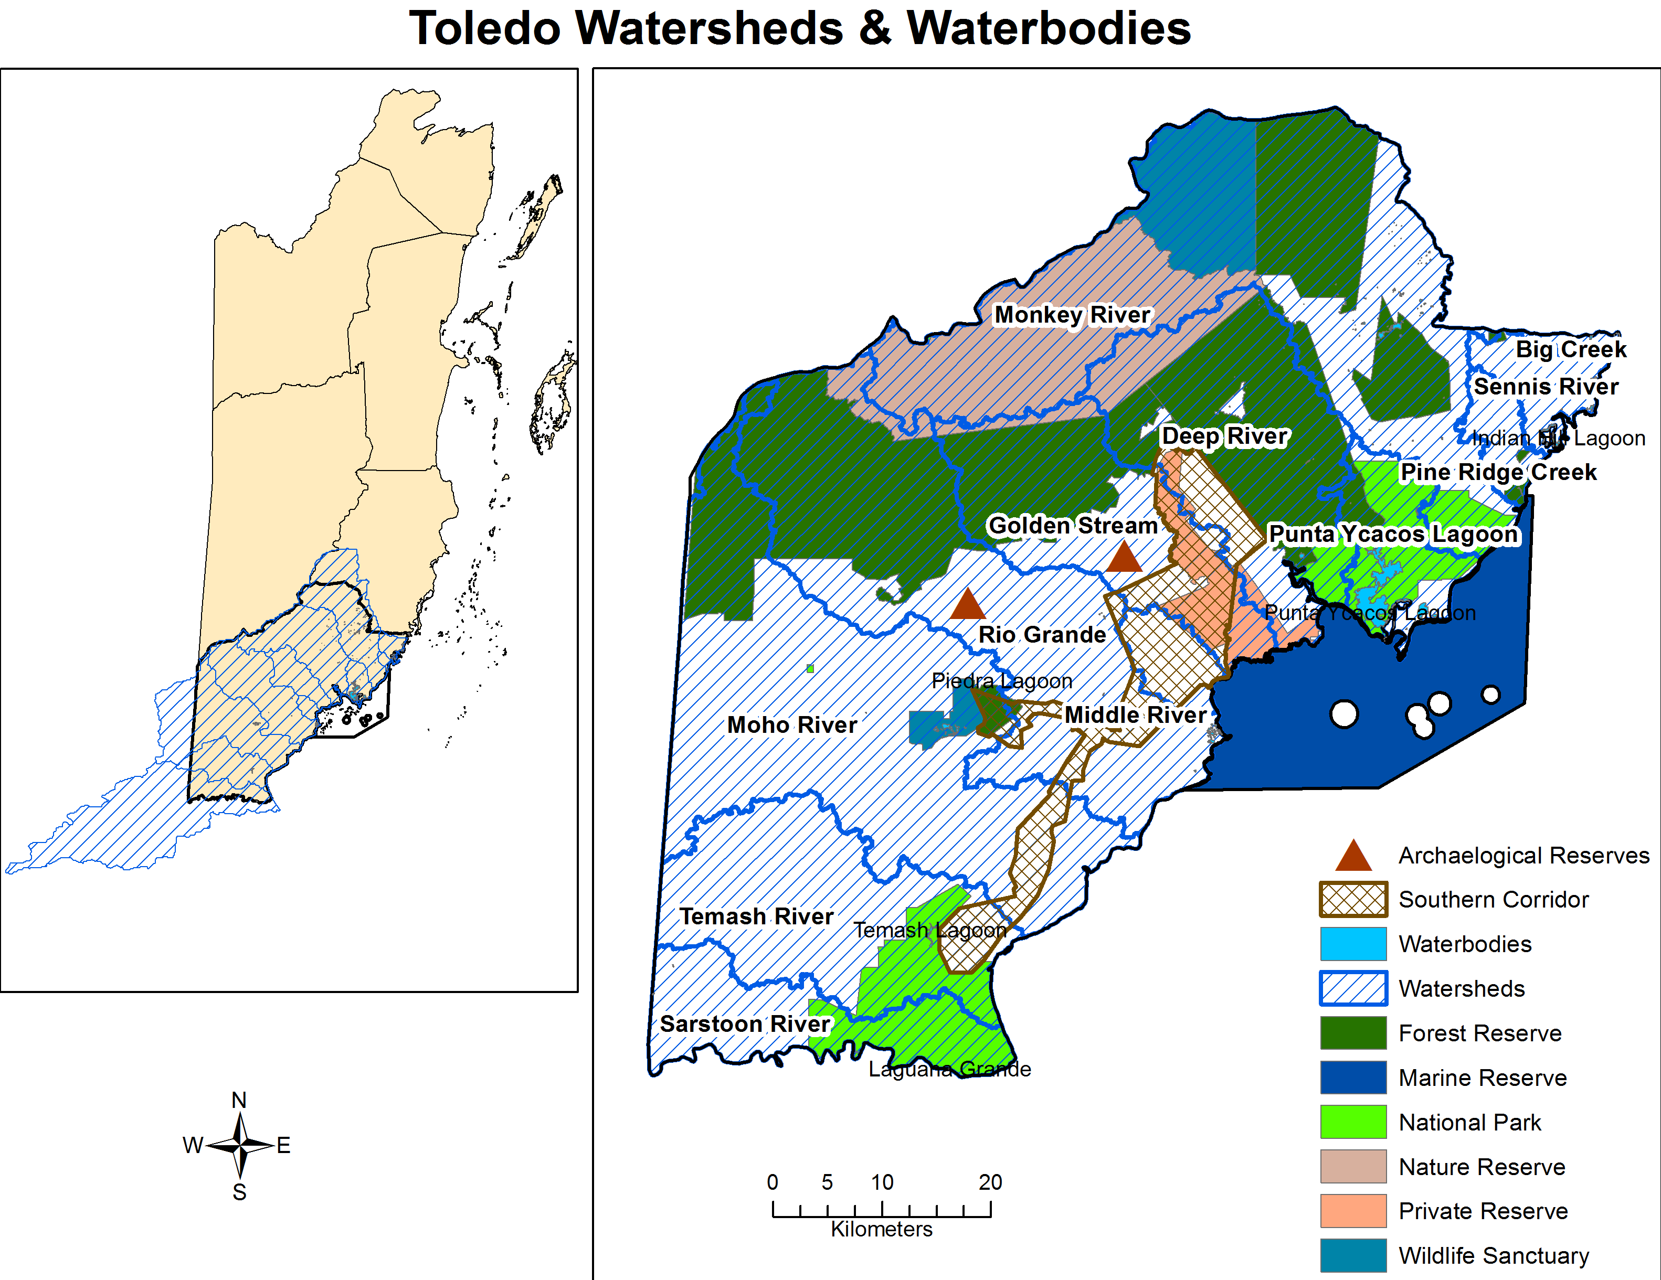
Figure 15: Toledo area watersheds, waterbodies and protected areas by type
(Source:Berds, 2011; NPAS 2014)

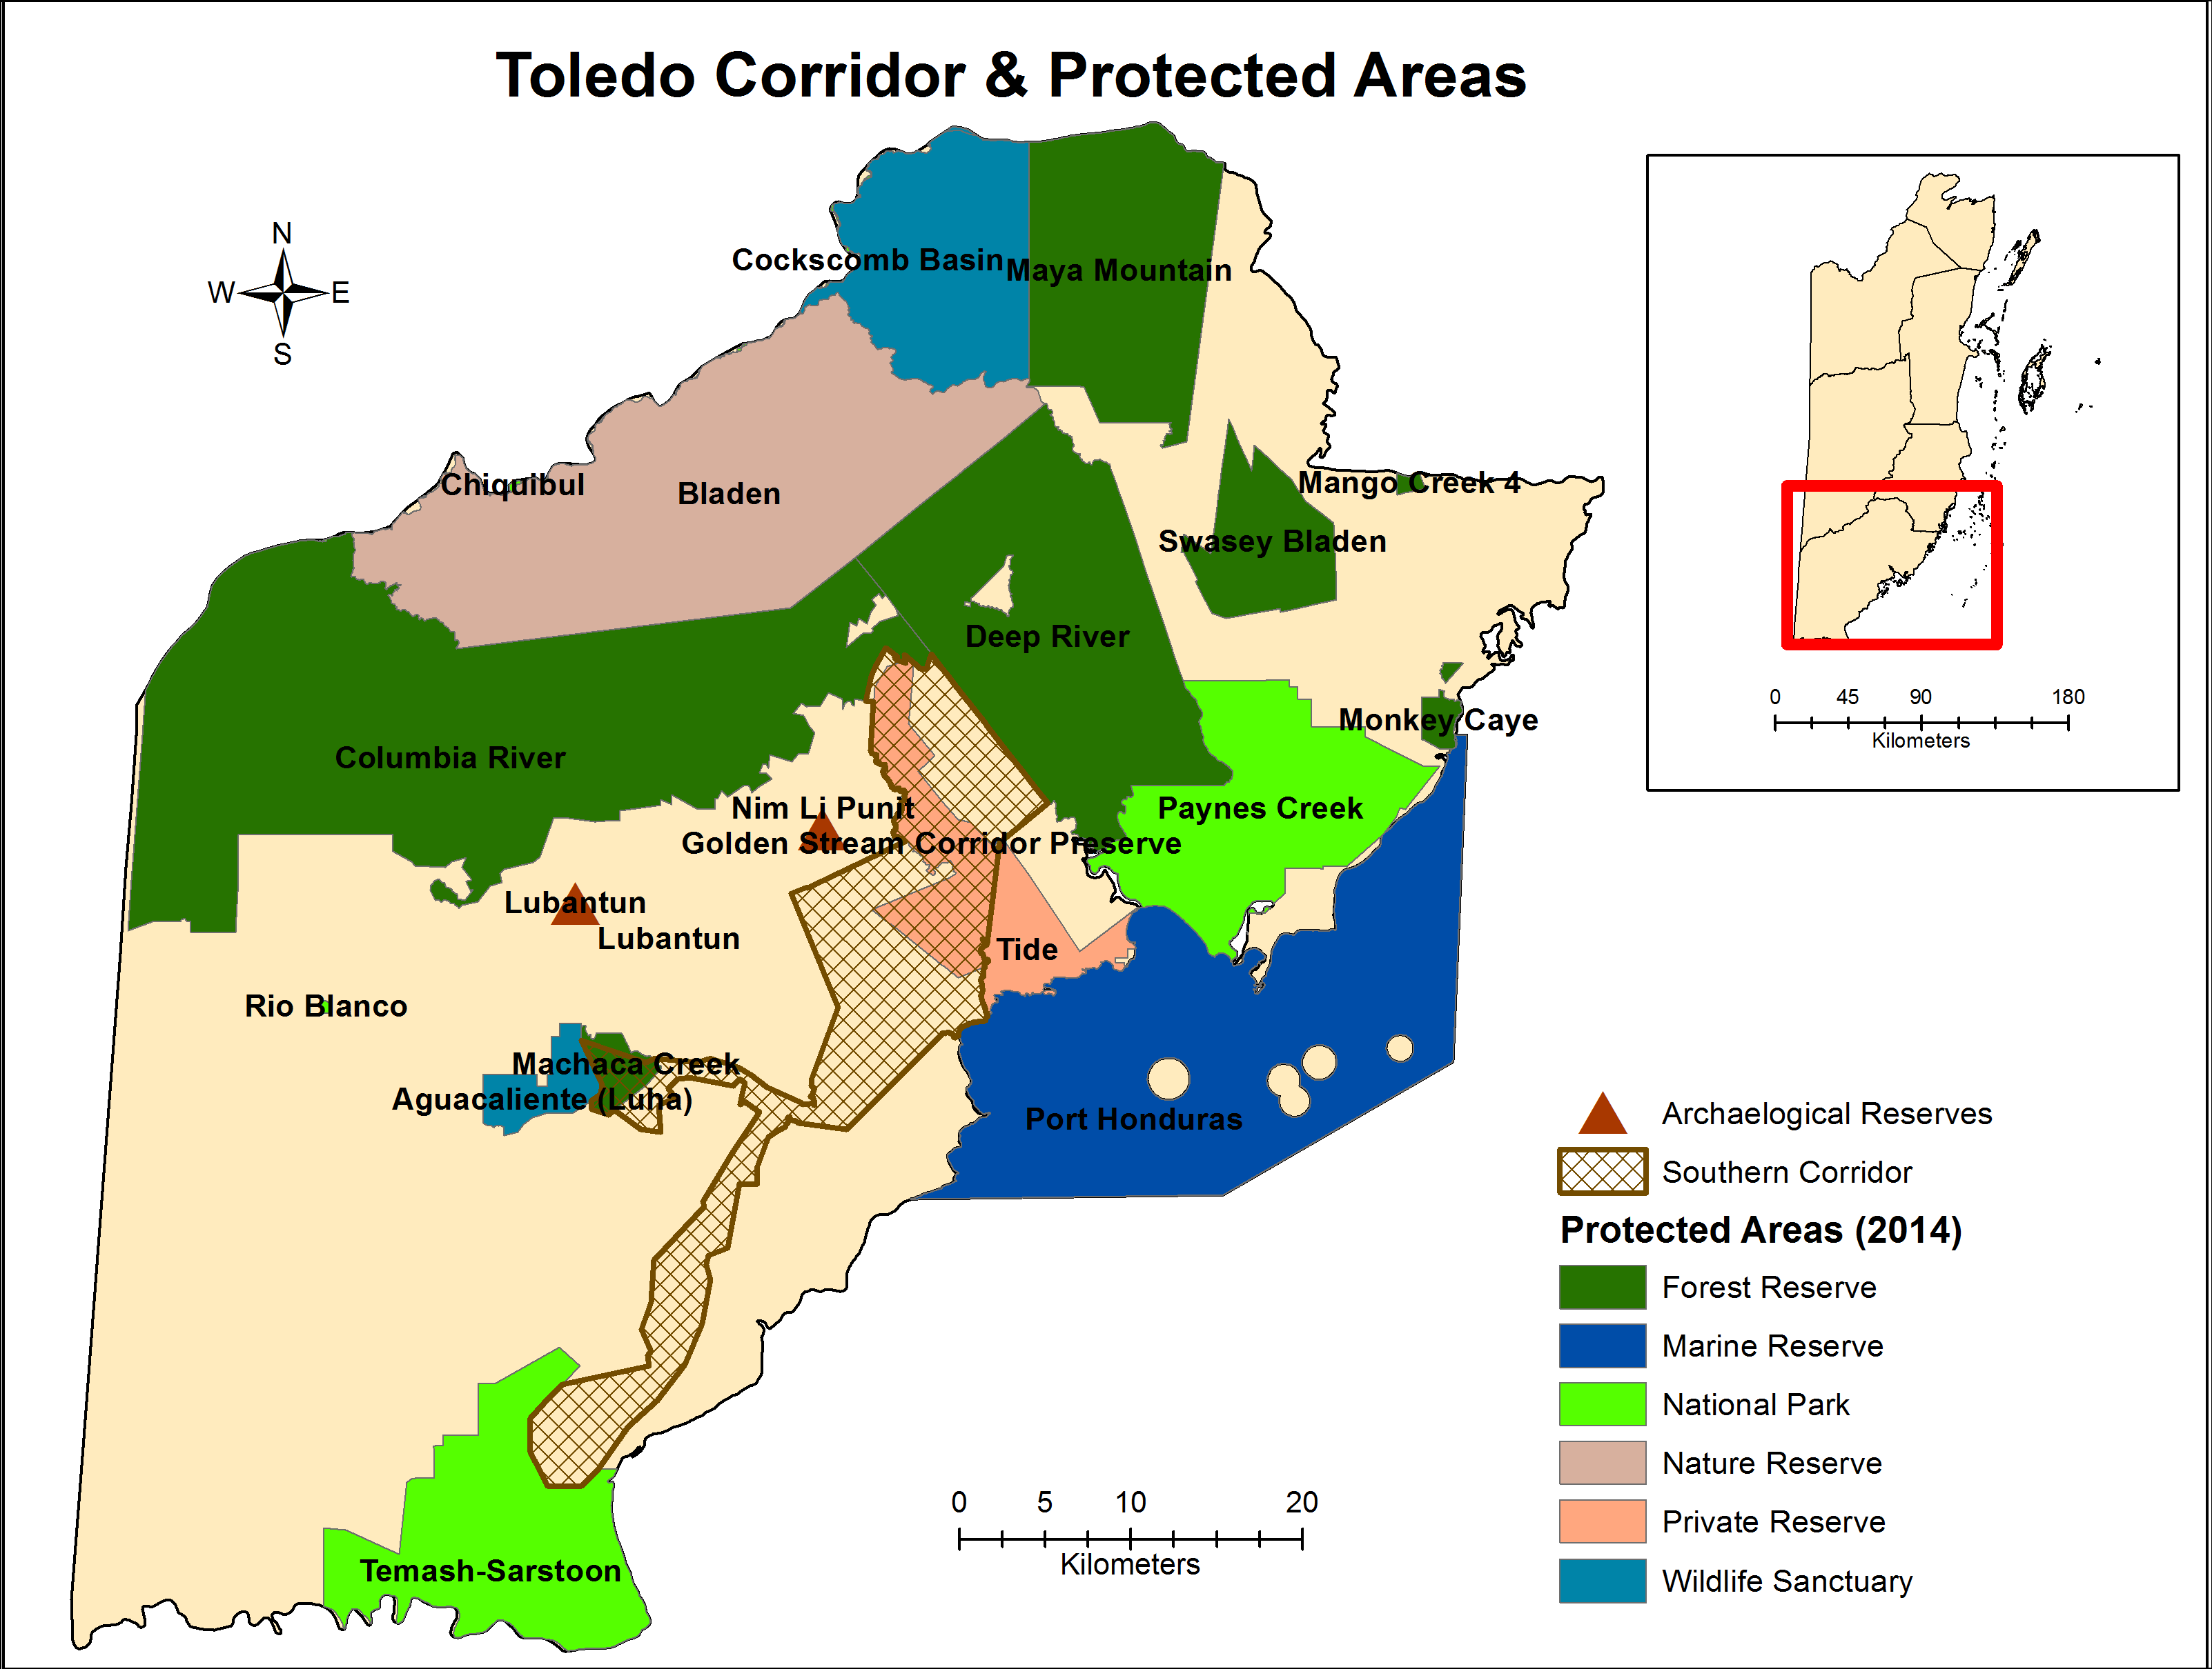
Figure 16: Toledo area corridors and protected areas by type
(Source:Berds, 2011; NPAS 2014)

Table 10: TOLEDO PROTECTED AREAS AND SIZE
Destination | Protected Area | Area (ha)
Toledo | Aguacaliente Wildlife Sanctuary | 4445.35
 | Bladen Nature Reserve | 80607.60
 | Chiquibul National Park | 114.2
 | Cockscomb Basin Wildlife Sanctuary | 13955.33
 | Columbia River Forest Reserve | 112,834.93
 | Deep River Forest Reserve | 54408.68
 | Golden Stream Corridor Preserve | 12249.8
 | Lubantun Archaeological Reserve | 32.38
 | Machaca Creek Forest Reserve | 2524.04
 | Mango Creek 4 Forest Reserve | 146.69
 | Maya Mountain Forest Reserve | 16644.34
 | Monkey Caye Forest Reserve | 668.58
 | Nim Li Punit | 98.34
 | Paynes Creek National Park | 31735.43
 | Port Honduras Marine Reserve | 39054.63
 | Rio Blanco National Park | 76.32
 | Swasey Bladen Forest Reserve | 11961.44
 | Temash-Sarstoon National Park | 32927.24
 | Tide Private Reserve | 7419.54

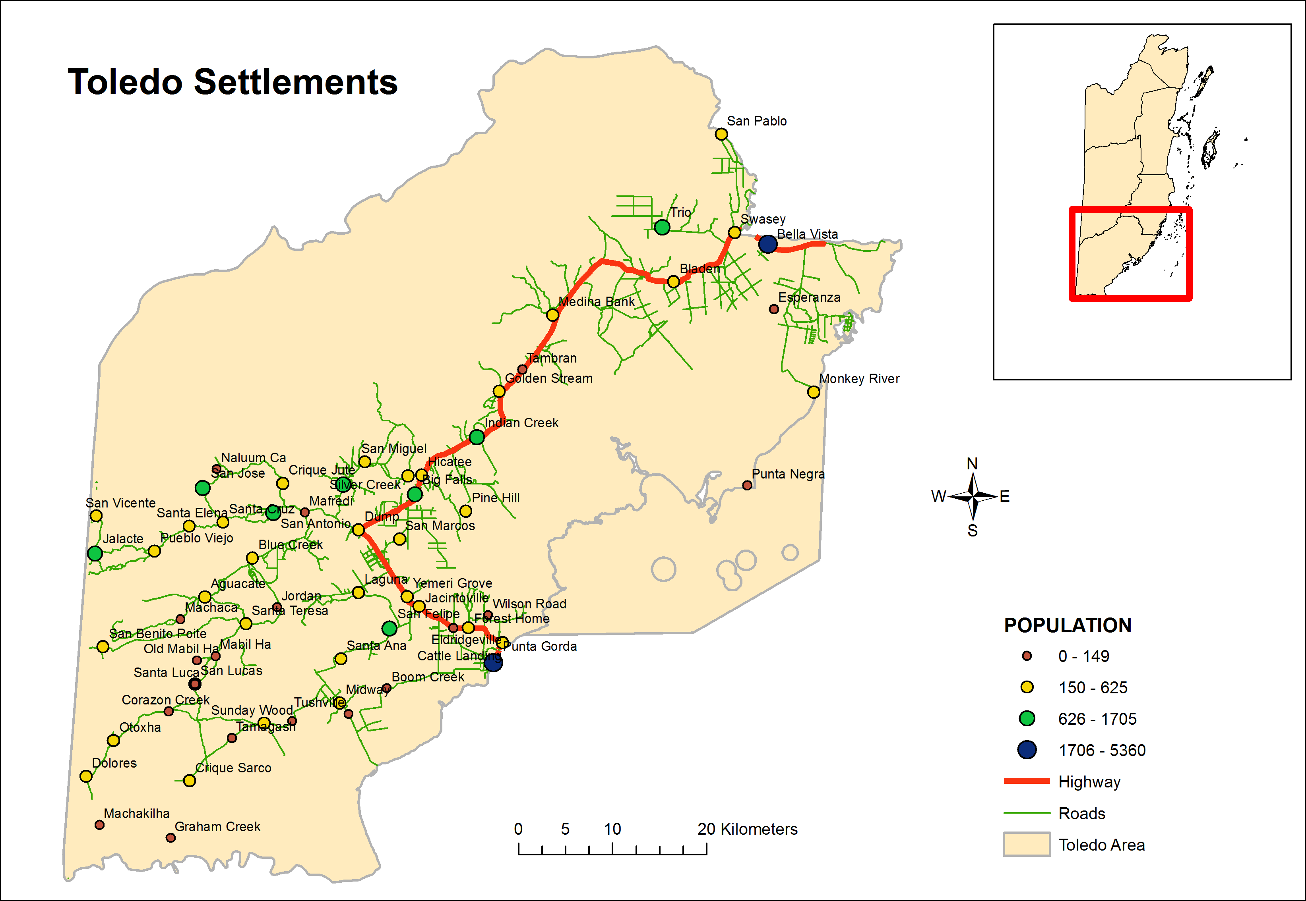
Figure 17: Toledo area settlements
(Source: Berds, 2010)

Figure 18 shows that in 2010, the entire northern portion of the district was forested as well as a central to southeastern swath (see Table 11 size of land cover categories). Interestingly, Figure 19, which is based on the 2011 ecosystems data layer shows what appears to be a more extensive portion of the district under agriculture than that shown in Figure 18. In Figure 19, agriculture is concentrated in the western and central portions of the district as well as the northeastern tip where settlements are concentrated. Figure 19 also shows that the forested areas of Toledo are diverse and include: lowland broad-leaved wet forest, lowland broad-leaved moist forest, submontane broad-leaved wet forest and submontane broad-leaved moist forest (see Table 12 for the size and percentage total of the ecosystems mapped). There are also some extensive portions of lowland savanna concentrated in the Deep River and Paynes Creek area in the northeastern portion of the district. Figure 20, which is based on 2014 data, actually reflects a similar picture to that illustrated by Figure 19, which is based on the 2011 ecosystems map for Belize. In Figure 20, the lowland savanna areas around Deep River and Paynes Creek are classified as non-forest. Finally, Figure 21 shows that in 2014 the majority of the Toledo District’s mangroves are concentrated on the coastal portion of the Port Honduras Marine Reserve between Monkey River and Punta Gorda and within the marine reserve itself. There are also some mangrove pockets north of Monkey River and within the Sarstoon-Temash National Park.

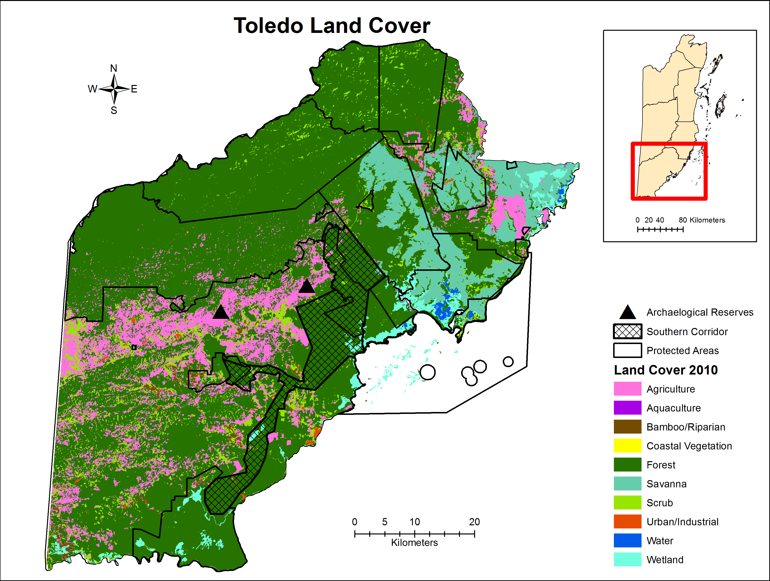
Figure 18: Toledo area land cover (2010)
(Source: Emil Cherrington, 2010)

Table 11: TOLEDO LAND COVER AND SIZE BASED ON 2010 DATA LAYER
Destination | Land Cover | Area (ha)
Toledo | Agriculture/Aquaculture | 52467.78
 | Coastal Vegetation | 177.88
 | Forest | 302500.75
 | Urban | 931.27
 | Water | 1219.68
 | Wetland | 10395.94
 | Other (bamboo/riparian, savanna & scrub) | 59791.14

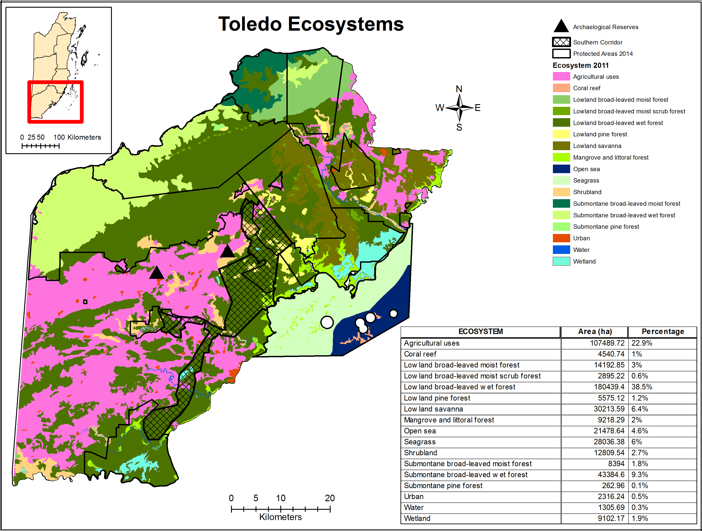
Figure 19: Toledo area ecosystems (2011)
(Source: Berds, 2011)

Table 12: TOLEDO AREA ECOSYSTEMS CORRESPONDING SIZE AND PERCENTAGE TOTAL
Destination | Ecosystem | Area (ha) | Percentage
Toledo | Agricultural uses | 107489.72 | 22.9 %
 | Coral reef | 4540.74 | 1 %
 | Low land broad-leaved moist forest | 14192.85 | 3 5
 | Low land broad-leaved moist scrub forest | 2895.22 | 0.6 %
 | Low land broad-leaved wet forest | 180439.4 | 38.5 %
 | Low land pine forest | 5575.12 | 1.2 %
 | Low land pine savanna | 30213.59 | 6.4 %
 | Mangrove and littoral forest | 9218.29 | 2 %
 | Open sea | 21478.64 | 4.6 %
 | Seagrass | 28036.38 | 6 %
 | Shrubland | 12809.54 | 2.7 %
 | Submontane broad-leaved moist forest | 8394 | 1.8 %
 | Submontane broad-leaved wet forest | 43384.6 | 9.3 %
 | Submontane pine forest | 262.96 | 0.1 %
 | Urban | 2316.24 | 0.5 %
 | Water | 1305.69 | 0.3 %
 | Wetland | 9102.17 | 1.9 %

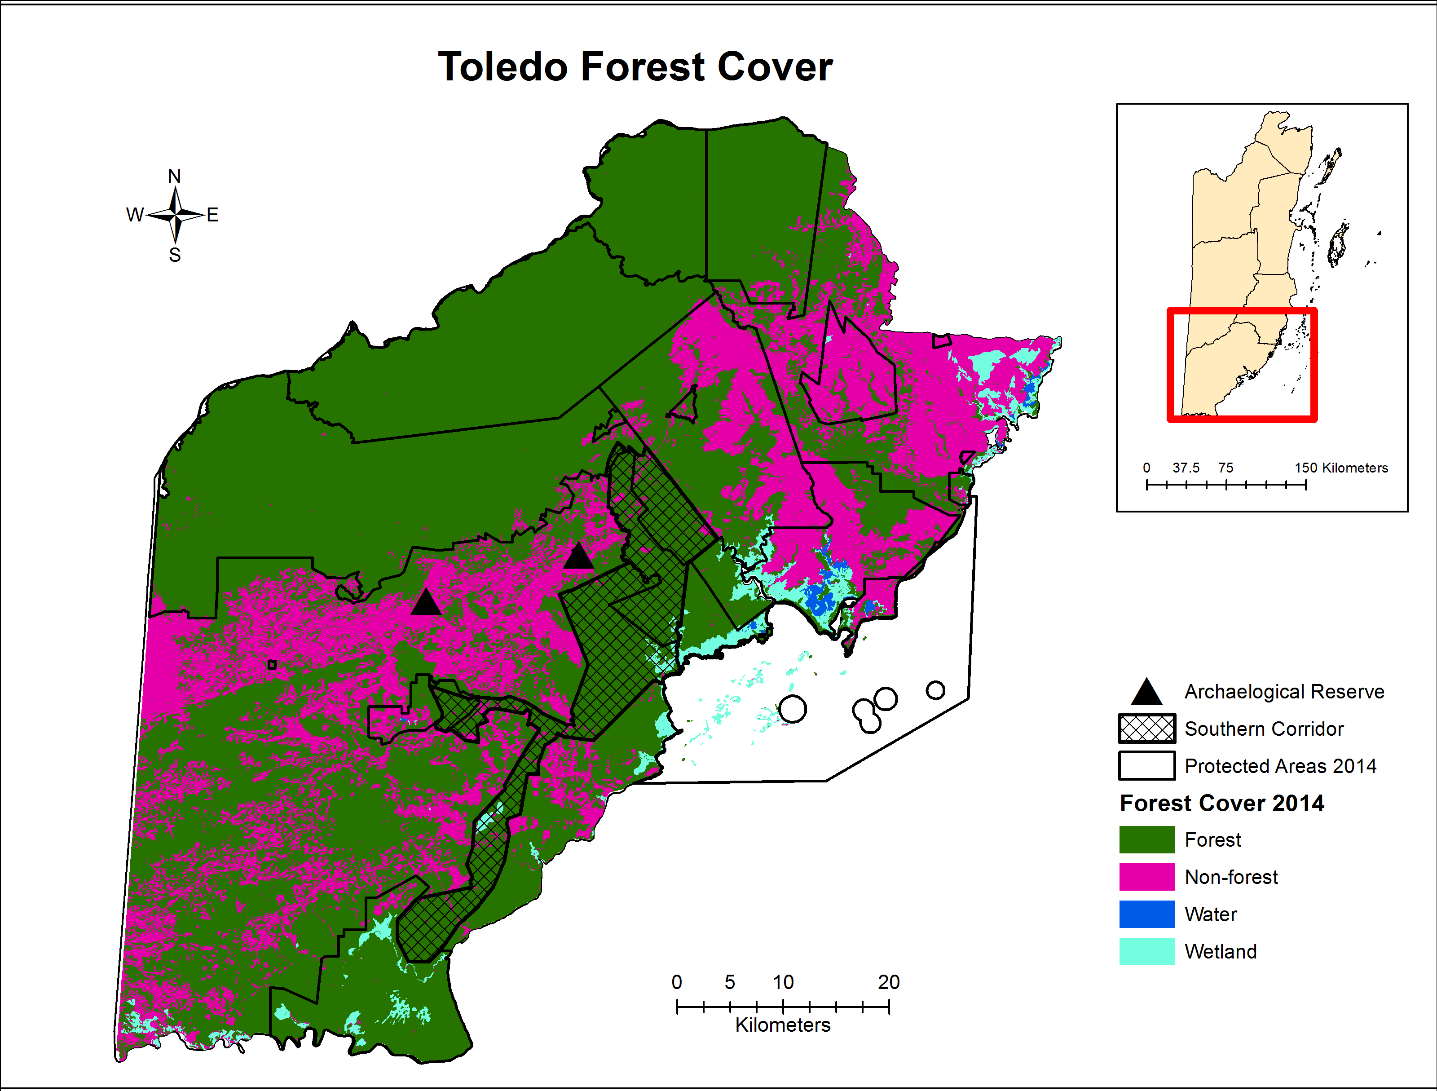
Figure 20: Toledo area forest cover (2014)
(Source: Emil Cherrington, 2014)
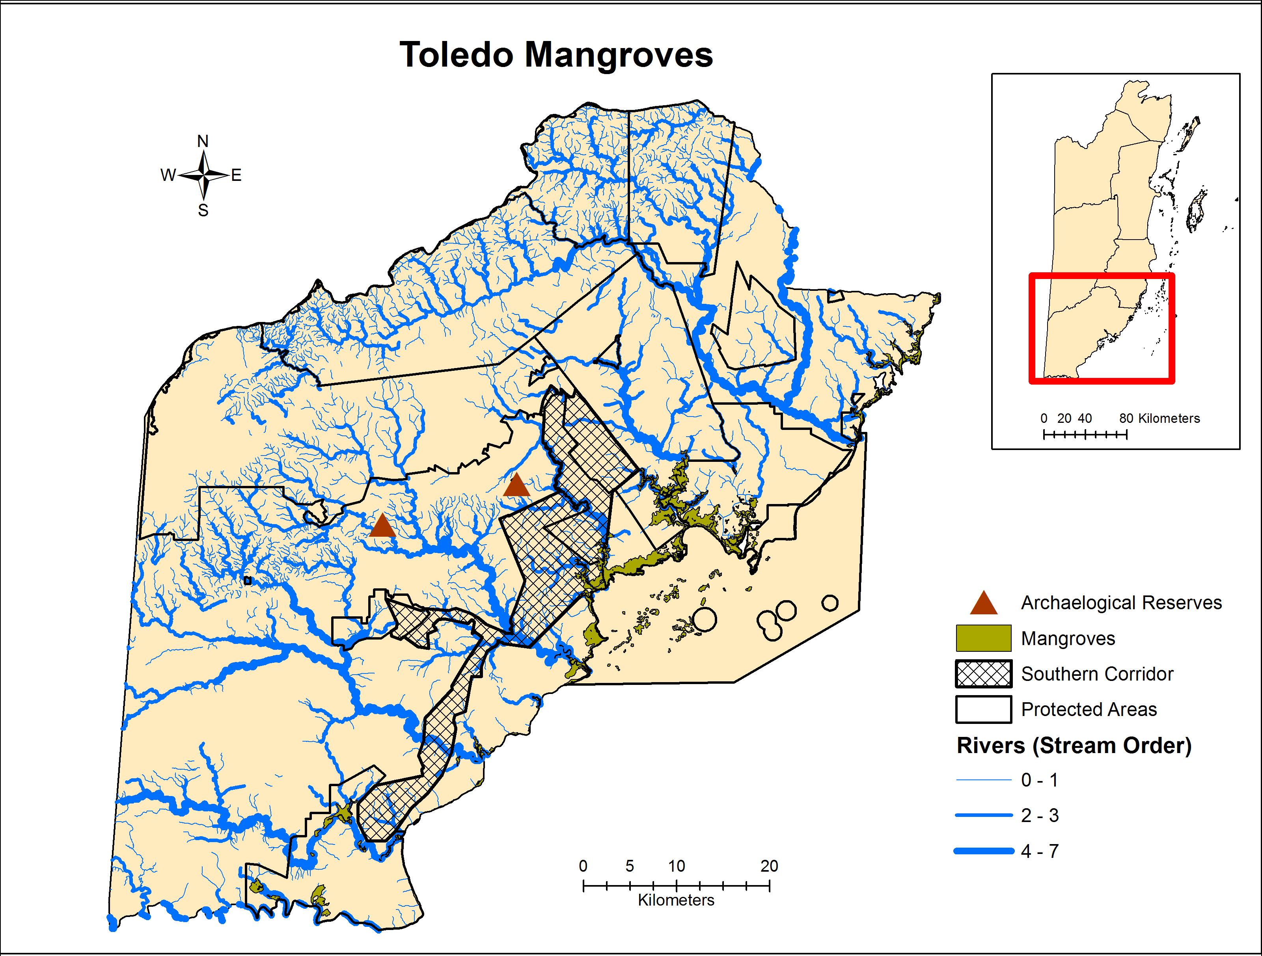
Figure 21: Toledo area mangrove cover (2014) and protected areas)
(Source: Emil Cherrington, 2014)

CORRIDOR CONNECTIVITY

The PA rationalization report (Wildtracks, 2013) contains an entire section on connectivity through the country’s three biological corridors, the North East Biological Corridor, the Central Belize Corridor and the Southern Belize Corridor. Corridors are key in linking main forest nodes, protecting hydro-ecological systems and as transboundary linkages for regional connectivity. They are necessary for maintaining species diversity and ecosystem services by ensuring that genetic flow and migration can occur. This is particularly critical for adaptation and building resilience to climate change (Wildtracks, 2014). Currently, there is no legislative framework in place for the protection of corridors or special guidelines for development within corridors. However, on June 26, 2015, a new National Protected Areas System Bill was first read at the House of Representatives as the first step in the process of enacting a bill into law. This Bill in fact allows for the declaration of corridors as special management areas, a new category of protected area. In the event that any portion of the corridor becomes private land, the bill stipulates that the landowner or developer owning the area would have to agree to this declaration. For this reason, on June 13, 2015, the UB ERI and six protected area organizations jointly presented recommendations to strengthen the corridor and private protected areas of the bill to a special Natural Resources and Environment Committee. These recommendations include making provisions in the bill for private land owners to receive fiscal and other incentives, and/or compensation for declaring their private lands as corridor special management areas or private protected areas; the protection of riparian buffers within all biological corridors and maintenance of a certain percentage of forest cover, exclusive of the riparian zone within these areas.

North East Corridor
The North East Corridor is the northern most corridors found in the country of Belize. It expands across portions of the Corozal, Orange Walk and Belize Districts (Figure 1). The corridor is deemed as ‘critical for climate change-related migration of the drier forest ecosystems southwards’ (Wildtracks, 2013). The drier Yucatan forest types, which are predicted to migrate southwards, are provided the best connectivity by the Shipstern/Fireburn node of the corridor. This migration is presumed as an impact of climate change that may occur with the loss of natural vegetation in the sugar cane belt in the western portion (Wildtracks, 2013). The Shipstern/Fireburn node is also critical for the maintenance of populations of game species, including the national threatened indicator species the white lipped peccary, in north east Belize. The latter is due to the extensive intact forest structure of the area. The corridor also contains an expanse of tropical evergreen seasonal broad-leaved lowland swamp forest tall variant, which is an under-represented ecosystem. The Shipstern/Fireburn node is linked to Freshwater Creek via a natural functional forest corridor, which crosses saline savanna (Wildtracks, 2013). The main challenge for this northern corridor relate to deforestation and Land Use Change (LUC) in the area. The PA Rationalization Report noted the establishment of new Mennonite community (‘Neulands Community’) east of Freshwater Creek, which has resulted in the extensive removal of more than 3,000 acres of forest for agriculture in 2012. Based on communications with Emil Cherrington in 2015, the cleared area is now close to 7,000 acres. To further compound the problem there is active allocation of land and the cutting of survey lines within Freshwater Creek Forest Reserve (Wildtracks, 2013). The result of which will be a loss of the areas viability as a connection between Shipstern/Fireburn node and the Selva Maya/Rio Bravo node. There are still portions of the corridor that are established as national lands, which gives the government and conservation groups the opportunity to control activities within the North East Corridor. With the development permits issued for the new Mennonite community, The Department of Environment has included condition for the maintenance of the corridor areas that fall within their lands, There has also been interest in the community member in a land exchange for land that falls within the corridor route (Wildtracks, 2013).

Central Belize Corridor
The Central Belize Corridor (CBC), a part of the regional Mesoamerican Biological Corridor, has been identified as the most critical corridor of the three found within Belize (Kay et al., 2015). Similar to other corridors, the CBC is a vital component for the maintenance of biodiversity within Belize and the region (Figure 1). This corridor forms a link between the northern forest block Selva Maya/Rio Bravo node and the MMM (Wildtracks, 2013). Additionally the Central Belize Corridor connects forests in Belize to other portions of the Selva Maya forest in Mexico and Guatemala. Composed mainly of freshwater ecosystems, broadleaf forest, savanna and pine savanna the CBC supports an array of flora and fauna including those that require large undisturbed blocks of forest for their survival: jaguars, puma and the white lipped peccary. Other endemic and threatened species are also common to the area. The PA Rationalization Report identified the Peccary Hills and Freshwater Creek as an important habitat for the Central American River Turtle, Yucatan black howler monkey and the Central American spider monkey (Wildtracks, 2013). Main conservation challenges in the area are unsustainable hunting, illegal logging and the ongoing removal of forested areas for agricultural development. These challenges have imposed further threats to the species in the area inclusive of agricultural runoff, habitat conversion and intrusion of vital habitat, fires and the lack of prey for cat species.

Southern Corridor
The Southern Corridor, mostly located in the Toledo District, links the MMM/Chiquibul to the Sarstoon Temash National Park (Figure 1). It also includes a sub-corridor to the Aguacaliente Wildlife Sanctuary (AWS), which protects the entirety of the tropical evergreen broad-leaved lowland swamp forest Aguacaliente variant in Belize (Wildtracks, 2013). Aguacaliente WS also serves as an important flood sink for agricultural land and settlements further downstream. Unlike the other corridors the Southern Corridor provides a ridge to reef connectivity, facilitating the movement of larger mammals from the MMM to the Southern Coastal Plain. The latter provides for an altitudinal migration of the mammals that would aid their adaption to climate change impacts. The corridor contributes to water security for the southern portion of Belize via its expanse of forest cover and water catchment properties. Along Golden Stream there is a ridge to reef protected hydro-ecological and riparian corridor, only one of its kind in Belize. As stated below in the threats section, Land Use Change (LUC) particularly for agriculture is a major challenge in the area, even to the integrity of the Southern Corridor. Within the AWS there is the need for effective management, considering the unique properties of the PA. Like many other systems and PAs in Belize, water pollution is a potential impact for the Southern Corridor via the connected riparian areas that are inhabited by communities (Wildtracks, 2013). The latter is also a potential impact for the AWS. The PAs Rationalization report also highlighted the need for the precise defining of the Southern Corridor, which would allow for better forest connectivity especially through an eastward shift. Nevertheless, there is key opportunity for active NGO involvement in corridor establishment and management (TIDE and Ya’axché Conservation Trust).

METHODOLOGY

The data used in the preparation of the ecosystem services mapping and review were all based on existing spatial data layers and secondary data from previous work done on Belize in the four project areas: Corozal, Caye Caulker, Chiquibul-Mountain Pine Ridge Complex and Toledo. The main methodology used in the review required the collection, review and extraction of data on political divisions, infrastructure, protected areas, watersheds, biodiversity, ecosystem services, climate projections, resilience and major threats, among others from existing spatial data layers of the country. This information was obtained through requests to the various organizations and individuals that possessed the spatial data layers and technical reports, including protected area management plans, environmental assessments, monitoring reports and through available literature on the internet.

SPATIAL DATA

Data Acquisition and Processing
Below is the complete list of all data layers that were accessed and used for the review along with the year the data was created. Land use data in particular was outdated (2009) and incomplete so land cover data (2010) was used instead. Land cover was not at a detailed scale except in municipalities that had specific work done such as Corozal Town or Punta Gorda. Other layers were more current with the most updated being the protected areas layer and forest and mangrove cover layers (Table 13).
Table 13: Data sources used in the ecosystems mapping and review
Data Layer | Source | Year
Belize Districts | U.K. Directorate of Overseas Surveys | -
Biological Corridors | BERDS | 2011
Climate Change Projections | TNC | 2012
Ecosystems | BERDS | 2011
Forest Cover | Emil Cherrington | 2014
Land Cover | Emil Cherrington | 2010
Mangrove Cover | Emil Cherrington | 2014
Protected Areas | NPAS | 2014
Rivers | Esselman et al. | 2003
Roads | BERDS | 2011
Settlements | BERDS | 2010
Waterbodies | BERDS | 2010
Watersheds | - | -
Fire Risk | BERDS | 2004
Endangered Species | NPSAP/BERDS | -
Coastal Protection | CZMAI | 2010
Species Distribution (sea turtles, dolphin, crocodiles) | CZMAI | 2010
Species Distribution (manatee sightings) | CZMAI | 2012
Coastal Development | CZMAI | 2010
Marine Recreation | CZMAI | 2010
Marine Dredging | CZMAI | 2010
Fishing Area | CZMAI | 2010
Oil Exploration | CZMAI | 2010
Agricultural Runoff | CZMAI | 2010
Hotels (small & large) | MTCCA | 2012/13
Biomass | Baccini et al. | -

In regards to processing, the initial step was to overlay the Districts and Protected Areas layers in ArcGIS in order to clip the four study areas from that overlay. Once the study areas were defined, original data layers (outlined in Table 13) were overlaid with each study area layer and clipped in ArcGIS to obtain only the data that fit within those study areas. The clipping exercise eliminates data laying outside of the defined study areas since they are not necessary for the purposes of this project.

Data Inputs and Mapping
The clipped layers (protected areas, ecosystems, watersheds etc.) were then overlaid in ArcGIS and symbolized accordingly (colors, patterns and/or symbols) to produce legible maps. Symbology for the data layers/parameters was standardized across the study areas to aid in better interpretation of the maps and the amount of data layers overlaid on a map depended on the purpose of the maps. For the vulnerability and climate change projections data (air temperature, precipitation, sea level rise etc.), the clipped layers were also overlaid in ArcGIS and symbolized based on the original data layer to reflect the appropriate color scales and values.
Some maps reflect area (hectares) of certain parameters, such as watersheds and ecosystems, which was calculated within ArcGIS and displayed in table format on the maps. Area of forest and mangroves cleared for the period 2010-2014 was also calculated in ArcGIS based on a new data layer that was created from the clipped forest cover and mangrove cover layers for the study areas. A summation of the cleared area (ha) within each study area was then conducted to determine the total area (ha) that has been cleared for the period 2010-2014 and then used to reflect hotspots.
Above ground biomass figures for specific areas in Belize were obtained from the national dataset of above ground live woody biomass density that is freely available for scientific, conservation and educational purposes from http://www.whrc.org/mapping/pantropical/carbon_dataset.htm (Baccini et al., 2012). This dataset has a spatial resolution of circa 500 m derived from field data/LIDAR(GLAS)/MODIS and builds on accuracy and spatial resolution from previous biomass estimates for tropical systems. Limitations to the dataset include the extent of calibration of remote sensing imagery with actual field data and any uncertainties from the measurement of ground plots, for example misidentification of trees or wood densities. However, these limitations will exist for most datasets. In addition, global analysis as in Saatchi et al. (2011) and Baccini et al. (2012) may incorporate non-random errors based on the use of more general allometric equations that may not reflect country-specific forest types. Downscaling of estimates at the sub-national level may decrease the degree of accuracy of the estimates.

ECONOMIC VALUATION

The methodology for the ecosystem service mapping and review will be elaborated on in this section from presenting the data layers and data sources used for the mapping as well as figures used for extrapolation of value of ecosystem services (e.g. the value of avoided damages from shoreline protection by mangroves based on extent of coverage of this ecosystem within the study areas and previous studies quantifying shoreline protection). The main ecosystem services we will be focusing on mapping and quantifying are those for which the relevant data exist. These include shoreline protection by mangroves, tourism, water supply, standing timber and carbon stocks.

Economic Valuation approaches
There have been a multitude of studies conducted on the economic valuation of ecosystems across the globe. These studies have employed numerous methodologies/approaches to ascertain the value of indispensable natural resources, ecosystems and ecosystems services. In some cases the total economic evaluation constitutes the valuing of both use and non-use aspects associated with an ecosystem. Use and non-use valuation require different and specific methodologies. Methodologies employed include those that were based on market data, non-market approaches, states preference methods and methods that rely on existing valuation estimates. Those based on market data included: the market price approach (MP), the replacement cost approach, the cost ‘damage’ avoidance approach (CA) and the production function approach. Approaches that are based on non-market values include: revealed preference methods, travel cost method and the hedonic pricing method. Stated Preference Methods include the Contingent Valuation Method (CVM) and Choice Modeling. Lastly, the benefits transfer approach, meta-analysis and economic impact analysis all rely on existing valuation estimates.
This study relies on three main approaches for the economic evaluation of ecosystem services, biodiversity and coastal resilience in Belize; namely the MP approach, the CA approach and the benefits transfer approach. According to Schuhmann (2012), the MP approach ‘constructs estimates of total expenditure by purchasers based on market prices and quantities’ (p. 4). Estimates often exclude the cost of providing the goods and services. In the economic valuation of coral reef and mangrove-associated fisheries in Belize, Cooper, Burke and Bood (2009) applied the market-based approach to ‘estimate gross revenues for commercial fishing and associated processing activities’ (p. 53). This approached was used to valuate two of the three sectors for commercial fisheries: export sales and local sales both through the Fishermen’s Cooperatives. Assessment of the third sector, other local sales (restaurants, markets and subsistence use), required the application of the benefits transfer method. The combination of these two methodologies allowed for a holistic valuation of coral reef and mangrove based fisheries (Cooper et al., 2009).
The CA approach estimates the costs incurred ‘to prevent, diminish or avoid harmful effects associated with degradation of a natural resource’ (Schuhmann, 2012, p. 6). Constanza et al. (2008) used this method to assess the value of coastal wetlands for hurricane protection. Wetlands like many other ecosystems are vital for human functioning include water security, water related ecosystem services, and maintaining the water cycle (Russi et al., 2013). Via the multiple regression analysis, data from 34 hurricanes that that hit the US was used as a foundation for valuation. The latter was limited to hurricanes that occurred since 1980 for which data on total damages were available. Relative damages, wind speed and wetland area were the variables used for the analysis. The analysis facilitated the estimation of value variations with respect to location, area of remaining wetland, proximity of built infrastructure and storm probability (Constanza et al., 2008). Similarly, the assessment of shoreline protection by coral reefs and mangroves in Belize required the application of the CA approach. Cooper et al. (2009) referred to the method as the ‘avoided damages’ approach; the basic principles for its application are similar to those of the cost ‘damage’ avoidance approach. Based on property values Cooper et al. (2009) estimated the ‘possible economic losses in the event of a storm, both with and without the presence of reefs and mangroves’ (p. 7). The difference in values, with and without reefs and mangroves, was the established avoided damages value.
For the utilization of the benefits transfer approach estimates of environmental benefits from other case studies are used directly in the new study or are applied via an empirical model. The application of the empirical model allows for a more precise and accurate transfer and application of the data into the new study. The benefits transfer method is useful in cases where time or monetary constraints restrict primary data collection for the evaluation of an ecosystem. It can also be used to ‘identify potential values of unstudied ecosystems’ (Hargreaves-Allen, 2011, p. 26). Hargreaves-Allen utilized this method in the 2011 total economic evaluation of the Exuma Cays in the Bahamas. From existing economic valuation literature, values were extracted for ‘the estimation of annual benefits generated for each km² in the six identified habitats of the area’ (Hargreaves-Allen, 2011, p. 26). Habitat areas were defined via satellite analysis. To reduce the uncertainty of the values, previous literature for inclusion were selected based on proximity to the Exuma Cays and those with similar habitat characteristics, inclusive of those conducted in Florida, the Caribbean and Central America. The selection however, attempted to exclude studies with estimates generated on a global scale. The same approach was used by de Groot et al. (2012) for the global estimation of ecosystems and their services. The authors estimated the monetary value of 10 main biomes based on existing case studies from across the globe. These values were transferred to an Ecosystems Services Value Database (ESVD) and further analyzed. The criterion for values to be included in the database extended to studies that ‘are an original case study; assign a monetary value to a given ecosystem service which can be attached to a specific biome/ecosystem and a specific time period; provide information on the surface area to which the ecosystem service value applies; provide information about the valuation method used; provide the location of the case study site, the surface area and the scale of the study’ (de Groot et al., 2012, p. 54). The values within the database are all comparable as they were standardized to the 2007 international dollar/ha/year. Analysis encompassed the calculation of mean values for each of the 22 ecosystem services for the individual biomes. The summation of the mean values of ecosystem services provided an ‘estimate of the total mean values for the bundle of all services that can be provided by the biome on a sustainable basis’ (de Groot et al., 2012, p. 54). Similarly, Turner et al. (2002) conducted the valuation of four broadly categorized ecosystem types: temperate forest, tropical forest, temperate wetland and mangrove and coral reefs using the benefits transfer method. Turner incorporated both ex ante and post ante studies for the evaluation of the four ecosystems. Ex ante studies ‘examined the value potentially lost if pristine ecosystems are not conserved’, while ex post studies ‘examined potential values if previously destroyed ecosystems were restored’ (Turner et al., 2002). In order to assess the economic value of coral reefs Cesar (2000) and Cesar, Burke & Pet-Soede (2003) also relied on previous literature.

Total Economic Value
This study attempted to provide an estimate for the total economic value of the major ecosystems and their services in the study areas using the benefits transfer methodology, in particular the approach and values from Hargreaves-Allen (2011). Total economic value (TEV) is a framework used to understand and account for the full range of economic values provided by species and ecosystems. The TEV of an ecosystem is comprised of both use values and non-use values (Figure 22).
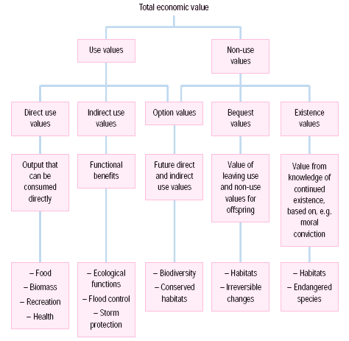

Figure 22: COMPONENTS OF TOTAL ECONOMIC VALUE (SOURCE: HARGREAVES-ALLEN 2011)

Use values are based on the actual or planned use of goods, either directly or indirectly. Direct uses are often extractive such as fisheries and timber but can also be non-extractive as in the case of tourism and recreation (Hargreaves-Allen, 2011). Indirect uses relate to the provision of services that support activities such as water regulation, carbon storage or coastal protection and are difficult to measure (Hargreaves-Allen, 2011). Option values describe the benefits gained from preserving the resource and saving the option to use it in the future. For example, there is a large potential option value for reef organisms that may contain bioactive compounds that may have large financial value in the future for pharmaceutical products. Non-use values are comprised of two main components, existence and bequest values. Existence values, as explained by Hargreaves-Allen (2011) are determined based on the satisfaction gained from simply knowing that something exists, regardless of any intention to use the resource. Bequest values are based on the satisfaction gained from preserving a resource to pass onto future generations for future use (Hargreaves-Allen, 2011). These values become less tangible and more theoretical from left to right (Figure 21) and as a result are increasingly difficult to put a financial cost to. Based on these limitations, TEV is not used to measure the true value of an ecosystem but is more a relative concept that looks at the benefits provided to humans.

Valuation approaches used

Tourism
Belize’s tourism industry is based largely on marketing the country as an eco-tourism destination and as a result Belize’s natural wealth of resources are what supports this important industry. Visitors to Belize spend their time enjoying the beauty of our forests, reefs, mangroves, beaches, lagoons, protected areas, wildlife and mountains, among other natural history. This generates the majority of income from tourism. The economic impact of tourism on the four areas: Corozal, Caye Caulker, Chiquibul-Caracol-MPR Complex and Toledo was calculated based on the market based approach methodology, from Pendleton (2008) and Cooper et al. (2009), and using the most recently available unpublished statistics for Belize (2014) acquired from the Belize Tourism Board (BTB) and the Statistical Institute of Belize. The revenue derived from the direct impact of tourism was generated using annual visitation rates by destination combined with the average daily expenditure and average length of stay. The average daily expenditure is by destination and it includes accommodations, meals, incidentals, tours and other expenses, not inclusive of airline tickets and insurance (pers. comm. Terry Wright, Ministry of Tourism). We were unable to obtain literature from the Statistical Institute of Belize (SIB), source of the data, which defines the various types of data included in the calculation of the average daily expenditure. This is being investigated further to see if we can get more details on the data components. For the Chiquibul-Caracol-MPR area, since hotel accommodations are only in the MPR area, we used visitation data from San Ignacio. This was combined with the results of the 2015 IDB/Ministry of Tourism exit survey of visitors (unpublished, IDB), which reflected that 17.2% of San Ignacio visitors visited the Mountain Pine Ridge and Caracol areas. This percentage is the only site-specific information we found for attractions by study region and was applied to the 2014 visitation data for San Ignacio with the assumption that the percentage of San Ignacio visitors to the Mountain Pine Ridge and Caracol areas would be the same for the previous year. This number of visitors was used to calculate the direct impact of tourism for the Chiquibul-Caracol-MPR area.
In terms of indirect revenue from tourism a multiplier was used as recommended in previous studies and work done in Belize (Cooper et al., 2009; Fedler, 2008). This multiplier conservatively estimates what the indirect revenue from tourism would be for the four areas based on benefits to the wider economy beyond spending on hotel accommodations, tours, entrance fees, diving/snorkeling, etc. These indirect benefits include food sourced from local farmers and fishers, fuel for transportation obtained through local fuel suppliers. Since this information is not readily available the multiplier serves as a conservative estimate of the indirect impact of tourism. We used the 1.2-1.4 multiplier cited by Cooper et al. (2009) in our calculations.

Mangroves
Mangroves provide important ecosystem services that help to maintain and support the Belizean economy, and in particular the tourism and the fisheries industries, through the provision of nursery areas for fish of commercial importance and buffering of the shoreline against storms and erosion. The economic contribution of mangroves to the tourism industry, while regularly cited as important, has only been determined from one major study by the World Resources Institute (WRI) in 2009 entitled Coastal Capital: Belize (Cooper et al., 2009). The study looked at the value of mangroves in protecting shorelines and avoiding damage from storms or hurricanes. The cost damage avoidance or avoided damages value for mangroves was calculated for three of the four study areas that contain mangroves: Corozal, Caye Caulker and Punta Gorda. Data on the extent (area in Ha) of mangroves in each of these areas were determined from the 2014 Mangrove Habitat GIS layer. The 2009 WRI study is the most comprehensive mangrove valuation literature for Belize, in relation to shoreline protection. All calculations and modeling data were reference from this study and adapted for the current valuation, factoring in updated extent of mangrove areas and updated land value figures. All the inherent assumptions and uncertainty with the data from the 2009 study have been applied and transferred to this valuation, since there are no other similar published studies in this region or Belize.
A more conservative approach (with a large degree of uncertainty) was applied using the benefit transfer approach and data from Hargreaves-Allen (2011) for mangrove ecosystems in the study areas. The economic value of mangroves in these areas was calculated using the total area in km² and multiplying the total area by an annual value of US$49,261/km² (Hargreaves-Allen, 2011). This annual value includes a very low estimate for coastal protection (Table 14).
Table 14: Mangrove Ecosystem Service Values based on service provided (Hargreaves-Allen, 2011)
Mangrove Ecosystem Service Values | US$ value /km² /year (2009) | Likely accuracy
Fisheries support | 8,100 | High
Biodiversity | 7,060 | High
Water generation | 2,000 | Low
Water filtration | 943 | High
Coastal protection | 9,100 | Low
Raw materials | 4,980 | Medium
Amenity | 1,210 | Low
Carbon storage | 12,568 | Medium
Recreational CS | 3,300 | Medium
Total | 49,261

Carbon
Carbon stocks were estimated based on above ground biomass figures. Above ground biomass figures specific areas in Belize were obtained from the national dataset of above ground live woody biomass density that is freely available for scientific, conservation and educational purposes from http://www.whrc.org/mapping/pantropical/carbon_dataset.htm (Baccini et al. 2012). This dataset has a spatial resolution of circa 500 m derived from field data/LIDAR(GLAS)/MODIS and builds on accuracy and spatial resolution from previous biomass estimates for tropical systems. Limitations to the dataset include the extent of calibration of remote sensing imagery with actual field data and any uncertainties from the measurement of ground plots, for example misidentification of trees or wood densities. However, these limitations will exist for most datasets. In addition, global analyses as in Saatchi et al.(2011) and Baccini et al. (2012) may incorporate non-random errors based on the use of more general allometric equations that may not reflect country-specific forest types. Downscaling of estimates at the sub-national level may decrease the degree of accuracy of the estimates.
Total carbon stocks (TC) were quantified from biomass estimates by using the following formula TC = 0.5 (ABG + BGB). The standard 0.5 coefficient (Baccini et al., 2012; Chave et al., 2005; Saatchi et al., 2011) was used in the formula as the actual amount of carbon content in the dry biomass of trees is usually 50%. Variation across species may slightly increase or decrease the actual amount of carbon content in the dry biomass of trees from this standard amount (Baccini et al., 2012). The BGB was estimated as a function of AGB as in Saatchi et al. 2011 using the formula BGB = 0.489 AGB^{0.89}.
The estimated average value of the total carbon stocks in each geographic area was calculated based on the 2013 volume weighted average price per tonne in voluntary carbon markets (Forest Trends’ Ecosystem Marketplace, 2014); thus far these are the only markets under which private Verified Carbon Standard (VCS) projects in Belize have traded. We consider this a relatively conservative value given that current carbon prices for emissions trading schemes (ETS) are US$4-38 per tonne of carbon and < US$1-130 for carbon tax schemes (World Bank 2015). The estimated range of values for carbon in each geographic area was calculated based on current high and low carbon price values (US$4-13) within which all of the price clustering occurs for ETS. The only exception to this is of the price of US$38 per tCO² under the Tokyo Cap and Trade (CaT) scheme (World Bank 2015). The US$4-13 reflects the price of carbon as of April 2015 (World Bank 2015) but likely encompasses the price range under which most carbon credits have been sold for VCS projects in Belize thus far (E. Kay, pers. obs.). The main limitation with the carbon value estimates for the geographic areas of interest are inherent inconsistencies in biomass calculations, which could then be carried over into carbon stock estimates and the fluctuation of prices in the carbon market.

Timber
Figure 23 below represents an outline of the methodology employed for the economic valuation of timber in Corozal, the Chiquibul-MPR Complex and Toledo. Figure 24 shows a map of the country and the sources of data that were used to determine timber volume to be used in the economic valuation. It is important to note some assumptions in employing the proposed methodology include: mean timber values are applicable across the landscape and no disturbances have occurred which may have reset timber value or put them on a new path since the data was collected; the rates of mean annual increment for timber species can be generalized to all forested areas and through all time; and export potential remains through for all time and for all markets.
Volume of broadleaf timber species was calculated as rough sawn board feet volume (assuming 50% conversion efficiency) recoverable from all trees of size equal to or greater than the minimum cutting diameter but less than 90 cm in diameter at breast height. This is the size range that is merchantable and therefore saleable. The resultant volume is considered potentially recoverable from the forest and is the volume typically used in forest valuation. It is not to be confused with the sustainable harvest volume, which will be determined by market conditions, preference of the logger, and the outcome of yield analysis. Potentially recoverable volume is preferred over sustainable harvest volume for this purpose since the latter will exclude species that are too low in stocking to allow a sustainable harvest and species which are not desired by the logger. For forest valuation, the total potential recoverable volume from the forest provides a better estimation of overall forest value.
Pine lumber volume was estimated as rough sawn board feet volume (assuming 50% conversion efficiency) recoverable from all trees of size equal to or greater than 15 diameters at the small end of the log.

GIS analysis to determine the forested ecosystems of importance for timber production within each study area

Elaboration of the timber species classification groups and their export potential

Data analysis or literature review to obtain values of mean per hectare timber stocking in different blocks of forests within each study area (see Fig. 1)

If the timber stocking values used are more than 5 years old, a secondary analysis to forward the values to present day using mean growth rates for each species group

Analysis to extrapolate values of mean per hectare timber stocking for different species groups to the total area of their respective forest blocks

Summation of total timber value of the different forest blocks within each study area

Produce table showing breakdown of total timber value by different species groups under different export scenarios

Figure 23: OUTLINE OF METHODOLOGY TO DETERMINE TIMBER VALUE IN THE AREAS OF INTEREST

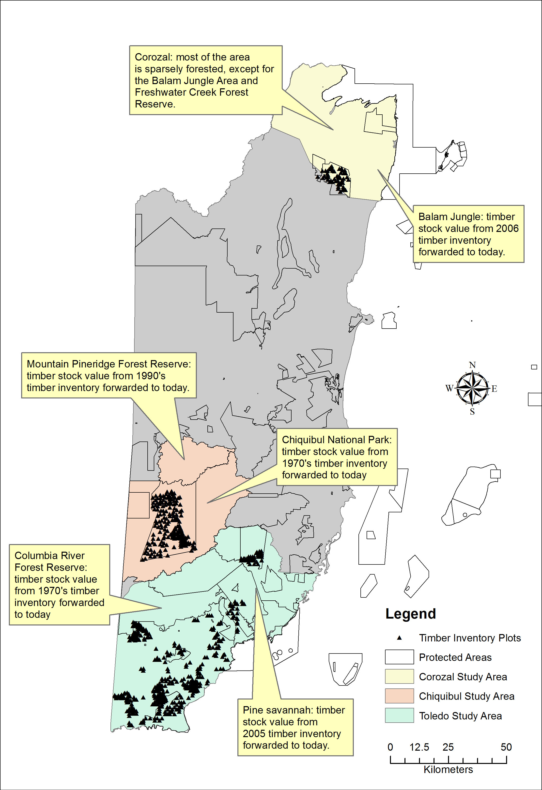
Figure 24: LOCATION OF TIMBER INVENTORY DATA OR LITERATURE THAT CAN BE SOURCED

Timber value of Corozal
- The Meerman and Sabido (2011) ecosystems map was used to locate the ecosystems which potentially have timber stocks based on expert knowledge of typical large tree species composition of the different ecosystems. These productive ecosystems included Lowland broadleaf dry forest and Lowland broadleaf moist forest.
- The 2014 forest cover map was then used to locate the remaining productive forests, especially considering the recent deforestation of the Neulands area.
- The productive forests were further clipped to include only forests within forest reserves, national and private lands, which represent the legally exploitable proportion.
- The total hectares of broadleaf forest were then calculated.
- Estimates of timber stocking contained within the Balam Jungle Forest Management Plan of 2006 was used to estimate per hectare stocking of different species in the average hectare of broadleaf forest. Since growth rates in the northern forests are suspected to be substantially slower than wetter forests in the central and southern regions, and since Hurricane Dean struck the area in 2007, any increase in volume since 2006 was assumed to be negligible. Therefore, the 2006 timber stocking was used in the calculation of present timber value.
The estimated stocking in the average hectare of broadleaf forest was then extrapolated to the area of all exploitable broadleaf forest in the study area and multiplied by timber prices in order to obtain total timber value of the broadleaf forest.

Timber value of the Chiquibul Maya Mountains
- The Penn et al. (2006) vegetation map of the Chiquibul Maya Mountains was used to locate the ecosystems which potentially have timber stocks based on expert knowledge of typical large tree species composition of the different ecosystems. These productive ecosystems included Broadleaf Seasonal forest, Broadleaf Seasonal high forest, Broadleaf Deciduous forest, Broadleaf High evergreen forest, Broadleaf Dry deciduous forest, Broadleaf Deciduous western forest, Broadleaf Semi-evergreen forest (lowland), Broadleaf Semi-evergreen forest, Broadleaf Semi-evergreen forest (broken ridge), Savannah Pine forest, and Savannah Oak and Pine per the Penn et al. (2006) classification.
- The productive ecosystems was clipped to the Forest Reserve boundaries, which represent the legally exploitable proportion, since the National Park and Archaeological Reserve designation currently prohibit extractive use.
- The productive ecosystems were further clipped to exclude all areas of the land with estimated slope greater than or equal to 15 degrees, which is considered the limit for safe operation of logging machinery. This was performed using a slope surface derived from the Shuttle Radar Topography Mission Digital Elevation Model coverage for the area.
- The remaining productive ecosystems were then grouped into two large categories: broadleaf and pine; and the total hectares of each were then calculated.
- The most recent forest inventory data for the Chiquibul Forest Reserve dated 2014 was used to estimate per hectare stocking of different species in the average hectare of broadleaf forest.
The estimated stocking in the average hectare of broadleaf forest was then extrapolated to the area of all exploitable broadleaf forest in the study area, including the broadleaf working circle in the Mountain Pine Ridge Forest Reserve, and multiplied by timber prices in order to obtain total timber value of the broadleaf component of the Chiquibul study area.

Timber value of the Mountain Pine Ridge Forest Reserve
Recent estimates of pine timber stocking in the pine forests of the Mountain Pine Ridge Forest Reserve are not readily available as there has been no recent inventories in the area. The estimates from the 1991 inventory can no longer be used to approximate pine stocking following the bark beetle outbreak of 2000 which devastated the forest killing approximately 90% of all trees where the outbreaks occurred. Instead, data from pre-harvest sampling performed for the first time in 2015 will be used to approximate per hectare timber stocking in a representative area of the reserve. In the pre-harvest sample, a total of 35 0.1 ha plots were installed to sample 86.3 ha of production pine forest in 19 individual stands in the upland area of the reserve. Stand age ranged from young to medium to mature and included dense uneven aged stands, which represented a wide range of stand ages that can be found in the Mountain Pine Ridge Forest Reserve. The data, although from a small area, was therefore considered to be more or less representative of pine forest stands throughout the reserve.

Timber value of Toledo
- The Meerman and Sabido (2011) ecosystems map was used to locate the ecosystems which potentially have timber stocks based on expert knowledge of typical large tree species composition of the different ecosystems. These productive ecosystems included Lowland broadleaf moist forest and Lowland broadleaf wet forest, Lowland pine forest, Submontane broadleaf moist forest, Submontane broadleaf wet forest and Submontane pine forest.
- The 2014 forest cover map was then used to locate the remaining productive forests, especially considering recent deforestation in the south.
- The productive forests were further clipped to include only forests in forest reserves, national and private lands, which represent the legally exploitable proportion.
- The productive forests were then clipped again to exclude all areas of the land with estimated slope greater than or equal to 15 degrees, and areas landlocked by such steep slopes, which are considered the limit for safe operation of logging machinery. This was performed using a slope surface derived from the Shuttle Radar Topography Mission Digital Elevation Model coverage for the area.
- The remaining productive ecosystems were then grouped into two large categories: broadleaf and pine; and the total hectares of each were then calculated.
- Data from a 2014 inventory of the Toledo District were used to compute per hectare stocking of different species in the average hectare of broadleaf forest.
The estimated stocking in the average hectare of Broadleaf forest was then extrapolated to the area of all exploitable broadleaf forest in the study area and multiplied by timber prices in order to obtain total timber value of the broadleaf forest.
Estimates of pine timber stocking in the pine forests of the Southern Coastal Plains of Toledo was obtained from the 2005 Sustainable Forest Management Plan for the area.

Timber species grouping:
Timber species were grouped according to the national standard for timber species grouping, namely: prime, elite and select. This classification system is based on six properties: wood quality, workability, durability, growth rate, log form and large tree abundance. Figure 25 shows the grouping in relation to the six properties while Table 15 lists the species by group.

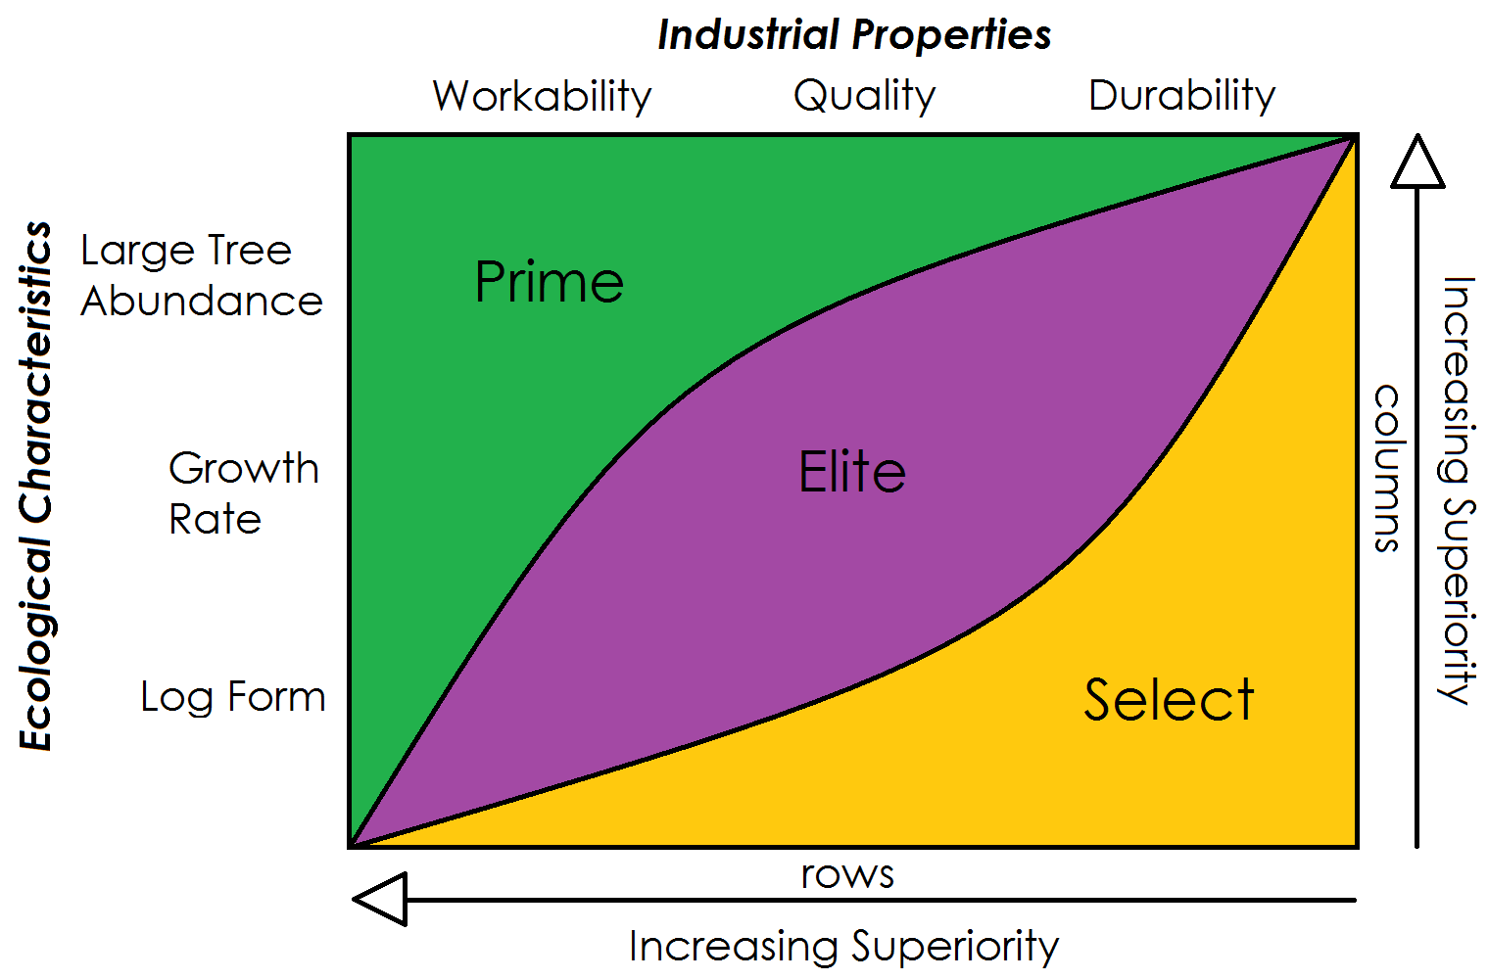
Figure 25: SPECIES GROUPING RUBRIC SHOWING THE GRAPH SPACE OCCUPIED BY SPECIES OF EACH GROUP WITH REPECT TO SIX DIFFERENT PROPERTIES
Arrows represent direction of increasing superiority for a given attribute on a row or column.

Table 15: LIST OF SOME TIMBER SPECIES BY GROUP
Prime | Elite | Select
Mahogany (Swietenia macrophylla) | Barbajolote (Cojoba arborea) | Bullet Tree (Terminalia buceras)
Cedar (Cedrela mexicana) | Bastard Rosewood (Swartzia cubensis) | Hormiga (Platymiscium dimorphandrum)
 | Beefwood (Hieronyma alchorneoides) | Nargusta (Terminalia amazonia)
 | Billywebb (Sweetia panamensis) | Redwood (Erythroxylum areolatum)
 | Black Cabbage Bark (Lonchocarpus castilloi) | San Juan Macho (Ilex belizensis)
 | Black Poisonwood (Metopium brownii) | Santa Maria (Calophyllum brasiliense)
 | Chicle Macho (Manilkara chicle) | Sapodilla (Manilkara zapota)
 | Granadillo (Platymiscium yucatanum) | Red Sillion (Pouteria amygdalina)
 | Hobillo (Astronium graveolens) | Timbersweet (Licaria peckii)
 | Mayflower (Tabebuia rosea) | Tzalam (Lysiloma latisiliquum)
 | Prickly Yellow (Xanthoxylum sp.) | Yemeri (Vochysia hondurensis)
 | Red Mylady (Aspidosperma desmanthum)
 | Rosewood (Dalbergia stevensonii)
 | Salmwood (Cordia alliodora)

Timber value
Prevailing local market prices per boardfoot of rough sawn lumber in Belize were used to estimate timber value. Export price for Mahogany rough sawn lumber was used to estimate value under an export scenario. These are as presented in Table 16.

Table 16: PREVAILING MARKET PRICES PER BOARD FEET OF ROUGH SAWN LUMBER
Species | Species group | BZ $ per bdft
Barbajolote | Elite | 1.25
Bastard rosewood | Elite | 1.25
Billy webb | Elite | 1.25
Cabbage bark (black) | Elite | 1.25
Chico zapote | Elite | 1.25
Granadillo | Elite | 2
Hobillo | Elite | 1.25
Mylady (red) | Elite | 1.25
Poisonwood (black) | Elite | 2
Prickly yellow | Elite | 1.25
Rosewood | Elite | 4
Pine | Pine | 2.10
Cedar | Prime | 3.25
Mahogany | Prime | 3.25 (8 export)
Bullet tree | Select | 1
Hormiga | Select | 1.25
Nargusta | Select | 1.25
Redwood | Select | 1
Rosewood | Elite | 4 (12 export)
Santa maria | Select | 1.25
Sapodilla | Select | 1.25
Yemeri | Select | 1.25

Water Supply
River flow, which is indicative of surface water supply for all of Belize’s watersheds, is not available. Therefore, water supply was calculated as in Cherrington et al. 2014. The proportion of runoff as a reasonable percentage of river flow is estimated as well as runoff for all watersheds; river flow is then extrapolated for all watersheds from the runoff figures based on this percentage. The Soil & Water Assessment Tool (SWAT) of Texas A&M University and the USDA (Neitsch et al. 2011) was used to estimate the proportion of runoff as a percentage of river flow. Calibration in SWAT was done using existing data on river flow from the Hydrology Division (currently a part of the National Integrated Water Resource Authority, NIWRA) for the Belize River. The resulting estimate of runoff as 33.6% of baseline river flow for this watershed was then applied across all watersheds to obtain the river flow per watershed (Table 17).

Table 17: RUNOFF AND RIVERFLOW FOR WATERSHEDS IN THREE STUDY AREAS
Study Area | Watershed | Runoff  (million L) | River flow* (million L)
Corozal | Barracouta Pond | 32.03 | 95.32
 | Rio Hondo | 221,007 | 657,758.93
 | New River | 130,811 | 389,318.45
 | Northern River | 7,806.31 | 23,233.06
 | Freshwater Creek | 4,044.46 | 12,037.08
 | TOTAL | 363,700.80 | 1,082,442.84
Chiquibul-MPR Complex | Belize River | 1,110,950 | 3,306,398.81
 | TOTAL | 1,110,950 | 3,306,398.81
Toledo | Deep River | 89,232.60 | 265,573.21
 | Golden Stream | 69,874.30 | 207,959.23
 | Middle River | 11,801.60 | 35,123.81
 | Moho River | 827,663 | 2,463,282.74
 | Monkey River | 9,634.68 | 28,674.64
 | Pine Ridge Creek | 68.29 | 203.23
 | Rio Grande | 427,483 | 1,272,270.83
 | Sarstoon River | 1,383,890 | 4,118,720.24
 | Sennis River | 814.81 | 2,425.03
 | Temash River | 431,346 | 1,283,767.86
 | Big Creek | 1,092.03 | 3,250.09
 | TOTAL | 3,252,900.31 | 9,681,250.91

Estimates of runoff were obtained using the Non-Point Source Pollution & Erosion Comparison Tool (N-SPECT) developed by the U.S. National Oceanic & Atmospheric Administration (NOAA) and using the mean annual rainfall for 1950-2000 from the WorldClim database (version 1.4, release 3) as the baseline climatology; for more details refer to Hijmans et al. (2005). Runoff estimates are also based on 2010 forest cover data for Belize from Cherrington et al. (2010). Underlying N-SPECT are two basic models which were used to evaluate the runoff component of the hydrological cycle and erosion. As detailed in NOAA (2008), the runoff calculations are done on a cell-by-cell basis based on the Soil Conservation Service (SCS) curve number method. Since the calculations were done on a cell-by-cell basis, for instance, rainfall data and other inputs are distributed across the watersheds, and results later accumulated at the watershed level.
In order to obtain the annual water supply for each of the study areas, river flow for each watershed in the area was multiplied by the percentage of each individual watershed encompassed within the area, and these values were added. Percentages used to estimate water supply by watershed in each of the study areas were estimated by using the values of the areas of each individual watershed encompassed in the study areas and the values for the total area of each watershed as determined in GIS.
Total current value and net present value were calculated for the water supply in each of the study areas based on per gallon costs and prices. Official rates for price per gallon of water for rural areas were obtained from the Ministry of Rural Development for villages in the Corozal District and Toledo East rural area. In order to attain a conservative estimate we used the lowest per gallon rate reported for any one village in either of these areas. For Corozal, the lowest per gallon rate was 0.005 BZD for Buena Vista and Patchakan and for Toledo East, the lowest rate was 0.0067 for Bella Vista. We did not obtain rural rate information for the Cayo and Belize Districts, which are the districts that supplied with water from the Chiquibul-MPR Complex; therefore, we applied the lowest rural rate, 0.005 BZD, to estimate the total current value for the Chiquibul-MPR Complex water supply based on rural per gallon rates. Several villages in both of these areas use a flat rate; however, in the absence of information on average consumption per household, we could not determine a per gallon rate from these. Official rates per 1,000 USG of water in urban areas were obtained from a public notice issued by the Belize Public Utilities Commission for the Full Tariff Period of April 1, 2015 to March 31, 2020 (PUC, 2015). This Public Notice shows approved tariffs for water for urban mainland areas and Caye Caulker, as well as water and sewer tariffs for Belmopan and San Pedro. However, in order to provide a conservative estimate of total current value, we calculated this based on the lowest urban tariff on the Public Notice; this was 8.72 BZD per 1000 USG mainland areas. Net present value was also calculated for the water supply in the study areas. This was calculated using a per gallon rate obtained from subtracting the average cost per gallon of treated water from the price per gallon paid by the consumer. The cost per gallon of treated water applied was 0.0039 based on the highest cost per gallon reported by Hammond, Busby and Hartwell (2011). This rate was calculated from production, distribution and operating costs data from April 2009 to March 2010 (Hammond et al., 2011). The price per gallon paid by the consumer used to calculate net present value was 0.0087 as per the lowest price per gallon for mainland areas issues by the Public Utilities Commission.

LIMITATIONS

SPATIAL DATA

Access to spatial data, required for the review and analysis, was limited as data was not readily available in most cases. As we discovered, organizations required formal data agreements with the Ministry of Tourism to disseminate information, particularly more recent spatial data. Specific data layers requested from organizations such as the Coastal Zone Management Authority and Institute (CZMAI) were not approved for distribution to outside parties. The data agreement specified that this information could not be shared with a third party. Similarly data that were deemed sensitive were not accessible, such as timber stock data and those related to forest reserves and archaeological sites.
Additional spatial data layers, located in the list below, were not available as in the case of water quality data or earthquake vulnerability data. Neither of these was available for the Belize. Some data were only available for certain areas of the country, as in the case of coastal hazards such as flooding where data was only available for Belize City and physical assets where data was site specific and not much available for the study areas. Land tenure was not available overall as this is treated as sensitive information and is not widely shared outside of the Lands Department. Spatial data for coastal erosion was also unavailable. Very little spatial data existed on major human threats and pressures. The primary data source available was deforestation data from change in land use cover, fire risk and coastal vulnerability (hurricanes, sea level rise, storm surge and elevated temperatures). Below is a list of unavailable spatial layers:
- Indicators of water quality
- Type and distribution of coastal hazards; and associated vulnerability and risk assessments
- Land tenure
- Physical assets
- Major human threats and pressures
- Earthquake vulnerability
In regards to metadata and details on the data input and sources, there were also quite a bit of limitations in getting access to metadata or receiving spatial data with complete metadata and supporting information. Although some of the data layers contain metadata, which provided details on source and creation of the data layer, most of the data layers had missing metadata. All data layers received from CZMAI lacked metadata, so determining units for certain parameters, for example those related to coastal protection, was not possible. Determining which activities were included in the marine recreation data layer posed a similar problem. Hence, it was not possible to provide a detailed explanation on what the values may signify for the areas. In some cases, details on criteria for values or how certain data layers were created such as biomass and fire risk, among others was not known due to lack of metadata as well.
In regards to vulnerability and climate change projections data, details were lacking as well as to why the two specific scenarios were used and criteria used to determine the ranks of very high, high, medium, low etc.

ECONOMIC VALUATION DATA

The major limitation in regards to economic valuation data was the dependence on secondary data since this study did not involve any primary data collection. Economic valuation studies are quite limited on Belize and the study relied to a large part on a couple publications for Belize (Cooper et al., 2009; Fedler, 2008; Hammond et al., 2011) and utilized benefits transfer methodologies (Hargreaves-Allen, 2011) for similar studies in similar areas.
In addition, accessing country statistics on tourism, fisheries, timber and water resources was very difficult and most often data was not readily available or shared with the public. The only exception was the tourism data, which was accessible through the BTB and SIB. Also, data was not disaggregated by areas and was only available at the country level, as in the particular case of the fisheries data. No data on timber or water resources was obtained from in country, as this information was deemed sensitive or unavailable by the respective agencies.
Potential limitations on above ground biomass data used to estimate carbon stocks are discussed above in section 1.1.3.3. In summary, the main limitation with the carbon value estimates for the geographic areas of interest are inherent inconsistencies in biomass calculations, which could then be carried over into carbon stock estimates, and the fluctuation of prices in the carbon market.
For the timber value section it is important to consider that some assumptions are inherent in the approach used. These include that mean timber values are applicable across the landscape and no disturbances have occurred which may have reset timber value or put them on a new path since the data was collected; that the rates of mean annual increment for timber species can be generalized to all forested areas and through all time and that export potential remains through for all time and for all markets.
Finally, in the water supply analysis a possible limitation is that for simplicity's sake we assumed runoff as a fixed percentage of river flow based on actual river flow data available for the Belize River. This assumes the percent changes in river flow correspond to the same percent changes in runoff. This may not likely be the case.

MAIN FINDINGS AND MAPS

BIODIVERSITY RESOURCES, ECOSYSTEM SERVICES AND CLIMATE RESILIENCE

There are a variety of ecosystems found in each of the target areas, which contain a wealth of species and biodiversity value. Biodiversity, which is the number, variety and variability of species and how these change from one area to the next, plays a crucial role in maintaining ecosystem health and the services they provide (Millennium Ecosystem Assessment, 2005). The loss of essential species and changes in interactions between species can interrupt the provision of ecosystem services (benefits people derive from ecosystems) for an extended period. Since biodiversity forms the basis of ecosystems, it affects human well-being through services such as provisioning services - food, water, timber and genetic resources; regulating services - regulation of climate, floods, pollination and water quality; supporting services - soil formation, nutrient cycling, photosynthesis and cultural services - recreational and aesthetics (Figure 26) (Millennium Ecosystem Assessment, 2005). These ecosystem services in turn help to build resilience to climate change and other disturbances and ensure greater adaptation by both ecosystems and the communities that they support. The UN Millennium Ecosystem Assessment found that “two-thirds of ecosystem services worldwide are in a decline which is having a negative effect on the well-being of the people who depend on them” (Millenium Ecosystem Assessment, 2005). Failing to understand the value of ecosystems may result in poor planning and decision-making and the loss of these services due to degraded ecosystems. Identifying the value of ecosystem services helps us to influence policies and decisions, determine compensation for damage, create sustainable financing mechanisms and raise awareness on the importance of the ecosystems (Mumby et al., 2014).
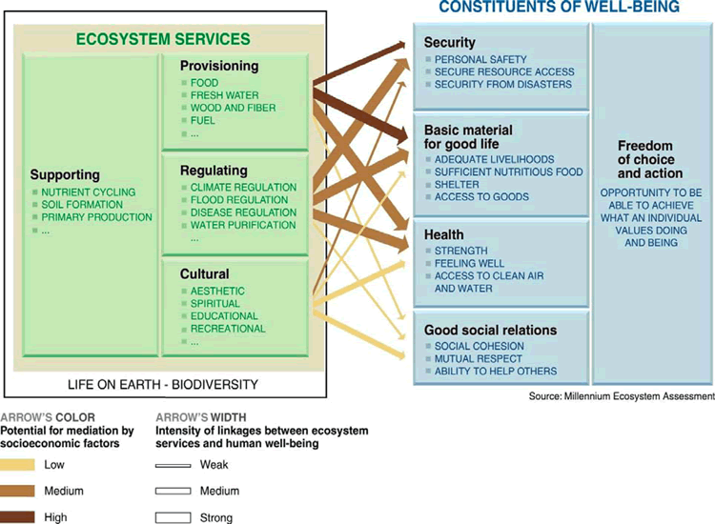
Figure 26: Components of biodiversity that provide human well-being

For all instances of resource use, whether it is developing an area to increase tourism or protecting natural habitat, we place a value on biodiversity by looking at the services that are provided by these natural areas. This value is then traded-off against the perceived benefits that can be gained from development. When we place an economic value on ecosystem services we are better able to quantify the benefits that they provide and this helps us to predict the impacts on human well-being if these services are changed. A monetary value for ecosystem services allows decision-makers to factor in the real economic value of ecosystems, their functions and services into decisions (Mumby et al., 2014). In the Caribbean, coral reefs provide three major ecosystems services: dive tourism, fisheries and coastal protection, which combined are worth more than US $3 billion annually (Mumby et al., 2014).
Especially in the context of tourism development, resilience is an important consideration that must be factored into any development planning. Resilience, whether in response to the impacts of climate change or other development impacts, is defined as:

The ability of a system and its component parts to anticipate, absorb, accommodate, or recover from the effects of a potentially hazardous event in a timely and efficient manner, including through ensuring the preservation, restoration, or improvement of its essential basic structures and functions. (Lavell et al., 2012, p. 34)

There exists a wealth of climate impact projections for Belize, which predict the major impacts, in particular those due to elevated air and sea temperatures, sea level rise, and increasing frequency and intensity of storms and hurricanes. Due to the infrequent nature of natural disasters such as earthquakes, there is little to no spatial data on areas vulnerable to earthquakes. Similarly, although we have periodic flooding events occurring with natural disasters such as hurricanes or severe storms there is very little data indicating flooding pathways.

Belize has a most effective means of response to climate change through its system of protected areas, which form an essential part of the global response to climate change.

Protected areas assist in addressing the cause of climate change by reducing greenhouse gas emissions, and they assist society in coping with climate change impacts by maintaining essential services upon which people depend. Without these environmental service provided by protected areas, the challenges would be even greater, with protected areas providing a number of responses to the climate crisis. (Dudley et al., 2010)

Protected areas can contribute to the two main responses to climate change through: mitigation and adaptation. Under mitigation, protected areas can help prevent the loss of carbon present in vegetation and soils and help to capture or sequester carbon dioxide from the air into natural ecosystems. For adaptation, protected areas help to maintain ecosystem integrity, which buffer local climate and reduce risks and impacts to people from extreme events. They also maintain essential ecosystem services that help us cope with changes in water supply, fisheries, productivity and disease due to climate change (Wildtracks, 2012).

Biodiversity

Corozal District
The Corozal district contains several key biodiversity areas, which fall within protected lands. These include the Corozal Bay Wildlife Sanctuary, Shipstern Nature Reserve, Honey Camp National Camp and Freshwater Creek Forest Reserve. The Corozal Bay Wildlife Sanctuary is one of the largest marine protected areas (73,049 Ha) and is an important trans-boundary estuarine system. This marine protected area is critical for reef health in northern Belize, continuously filtering sediment and contaminants from the rivers before they get to the Northern Barrier Reef. It is an important protected area for the Antillean Manatee providing sheltered waters for feeding and calving (Wildtracks 2015). This marine protected area contains the only known stromatolite formation in Belize and contains a large expanse of shallow water behind Ambergris Caye that is an important sport fishing habitat. The Corozal Bay Wildlife Sanctuary is managed by the community-based organization, Sarteneja Alliance for Conservation and Development (SACD), in partnership with the Forest Department and in close collaboration with the Fisheries Department and it supports many traditional local fishermen and their families in the northern communities of the Corozal District (Wildtracks 2015). The Corozal Bay Wildlife Sanctuary is contiguous with the northern barrier reef complex along Ambergris Caye down to Caye Caulker, forming the Northern Belize Coastal Complex. It contains a vast network of inter-connected mangroves, littoral forest, sand beaches, seagrass beds and reef, creating habitat for at least twenty four species of international concern, including the critically endangered Goliath grouper, hawksbill turtle and Acropora corals, in addition to the Antillean manatee, an endangered, regional sub-species of the West Indian manatee (Wildtracks 2015). This entire Northern Belize Coastal Complex, of which the Corozal Bay Wildlife Sanctuary is an important estuarine filter with its diverse flora and fauna across various reef types (patch reefs, spur and groove and reef crest), attracts many visitors annually supporting the tourism-based economy of the cayes. The network of mangroves, lagoons and creeks and extensive seagrass beds of this large estuary provides important nursery habitat for commercial marine species that support the fishing industry (Wildtracks 2015).
The Shipstern Nature Reserve is one of Belize’s oldest private protected areas established since 1987 and contains 10,058 Ha of northern hardwood forests, saline lagoon systems and mangrove habitats important for fauna, such as jaguar and tapir, crocodiles and a wintering site for North American waterfowl (Meerman & Boomsma, 1993; Wiltracks, 2011). Its lagoon system and its mangrove islands contains habitat critical for breeding birds. The forests in Shipstern Nature Reserve represent recovered secondary forests that have regenerated with little or no disturbance since 1955. Fauna within the protected area is very diverse with 47 species of mammals, including peccaries, agouti and deer, important prey species for jaguar and puma and all five species of cats (Meerman, 1993d)). Mammalian species of international concern, Baird’s Tapir and the West Indian Manatee, have also been recorded within the reserve. There are 87 species of amphibians and reptiles, which is over half of the total species found in Belize (Meerman, 1993b). Shipstern Nature Reserve contains 274 species of birds including the endemic Black Catbird found only in the Yucatan, with Shipstern being the only mainland occurrence of this species, along with several other bird species that don’t occur elsewhere in the country (Meerman, 1993a;Wildtracks, 2011). The lagoon system contains 26 species of fish and once supported abundant sawfish populations now extinct (Meerman, 1993c). The flora of the area is equally diverse with over 267 species recorded (Meerman, 1993e). It is the only location in Belize where the medium-sized, semi-deciduous Yucatan forest can be found along with another more rare forest type, the Kuka Palm Yucatan coastal dry forest. This forest type is not only extremely rare in Belize but is only known from four small areas in the whole of the Yucatan Peninsula. Distribution of some species of conservation concern based on available spatial data is presented in Figure 27 below. Data is largely available only for areas along the coast and primarily based on point counts and sightings. It should be noted that the absence of species in an area does not indicate the absence of that species but may simply be due to a lack of records.
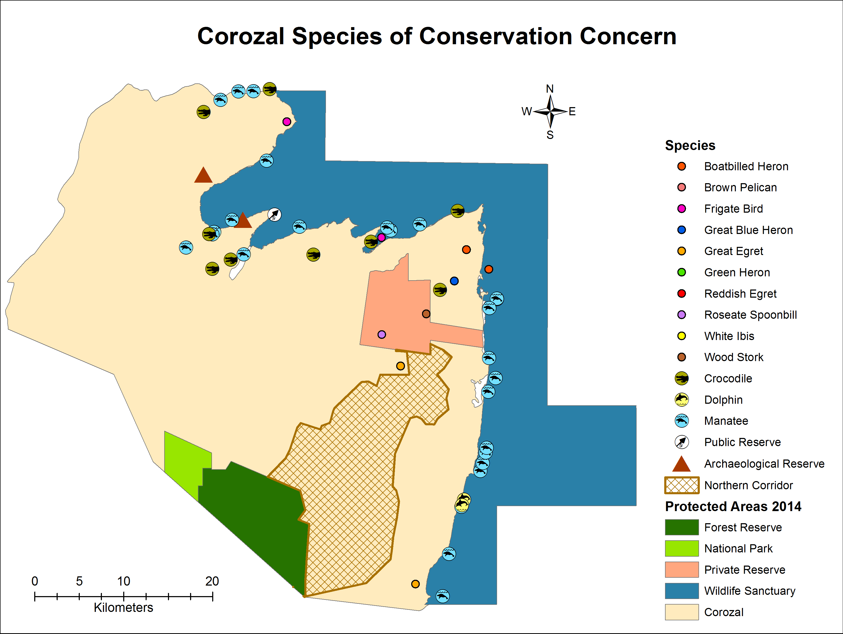
Figure 27: Distribution of available records of species of conservation concern within the Corozal district
(Source: NPSAP/BERDS/CZMAI, 2010 & 2012)

The Honey Camp National Park (HCNP) adjoins the Freshwater Creek Forest Reserve (FCFR) and both these protected areas host a diversity of species similar to the forests of the Shipstern Nature Reserve. Honey Camp National Park is 3,150 Ha of continuous lowland broad leaved moist forest cover (APAMO, 2011). The Freshwater Creek Forest Reserve covers an area of 13,513 Ha and contains hardwood species, including mahogany, and is being managed for sustainable forestry, primarily logging (APAMO, 2011). There is not much data on the biodiversity resources within these two protected areas since co-management was recently formalized with the Government of Belize in 2013. The Corozal Sustainable Future Initiative (CSFI) and the International Tropical Conservation Fund manage these three protected areas.
The Protected Area (PA) Rationalization exercise identified several key biodiversity areas within the Corozal District that require further action through either greater protection or creation of new protected areas (Wildtracks 2013). In particular the exercise recommended that the northern coastal lagoon system and saline savannah around Shipstern lagoon, along with 2 miles of the Rio Hondo (Belize side) from the river mouth be included within the Corozal Bay Wildlife Sanctuary and that the integrity of the Freshwater Creek and Honey Camp protected areas be maintained. Wildtracks (2012) also recommended the formal creation of the Northern Corridor, which encompasses these two protected areas. The PA rationalization recommended the establishment of 3 new protected areas: Kakantulix, the second largest Maya site in northern Belize located next to Fireburn; Whitewater Lagoon, a long narrow freshwater lagoon near Freshwater Creek, with abundant and diverse aquatic life found nowhere else in Belize including the red phase bay snook and Central America river turtle; and Salt Creek, a northern coastal lagoon thought to be unique in its estuarine qualities and for which very little is known (Wildtracks 2013).

Caye Caulker
Caye Caulker, the second largest offshore tourism destination, forms one of the many sand and mangrove cayes within the Belize Barrier Reef Complex and lies 21 miles east of Belize City. This small island also hosts two protected areas: the Caye Caulker Forest Reserve and the Caye Caulker Marine Reserve, which contains a wide range and diversity of species. These two protected areas encompass five habitats – mangrove, littoral forests, lagoon marsh-lands, seagrass beds and coral reefs. The marine reserve with 3,913 Ha is located to the east and north of the tourism destination of Caye Caulker while the forest reserve of 40.5 Ha is located to the north of the island (Figure 28). The marine reserve boasts several reef types including spur and groove reefs, reef crest and patch reefs, with abundant marine life, providing excellent snorkeling and diving opportunities for visitors. Several species of international concern including critically endangered staghorn and elkhorn corals (Acropora), as well as the critically endangered hawksbill and endangered green and loggerhead turtles are found within the marine reserve (McRae, 2004). Data from coastal surveys indicate the presence of dolphins, manatees, turtles and crocodiles based on point counts (Figure 28). The vulnerable West Indian manatee and bottlenose dolphins also frequent the marine reserve. The forest reserve contains both mangrove and littoral forest with 173 birds species including endemic species such as the Black Catbird, Cabot’s Bananaquit and Caribbean Elaenia and species of conservation concern such as the White crowned pigeon and the Yucatan vireo (McRae, 2004). There are 67 recorded species of plants within the marine and forest reserve. McRae (2004) also recorded an additional 147 species of fishes, 21 insects, 5 mammals and 14 reptiles. Unlike the other PAs, those based primarily on land, the Caye Caulker Marine Reserve contains 44 species of gastropods (including the queen conch and reef squid), 55 crustaceans (shrimps and crabs), 17 echinoderms (urchins and brittle stars), 8 shark and rays species, 48 species of algae, 6 sponges, 38 hard and soft corals, 7 Anemones and 6 species of jellies (McRae, 2004) The littoral forests of Caye Caulker are a highly endangered ecosystem type found only sandy cayes, which is fast disappearing due to coastal development. Based on this, the PA rationalization exercise recommended increased protection and security for the Caye Caulker Forest Reserve by designation of a stricter category such as a national park (Wildtracks, 2012).
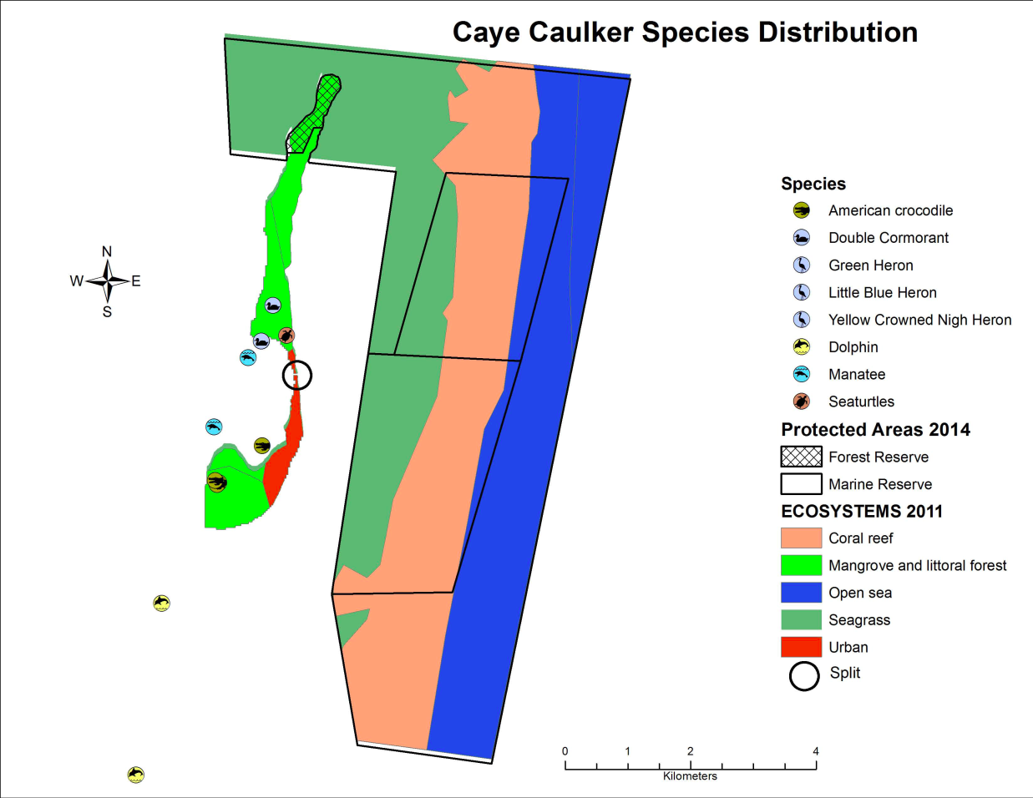
Figure 28: Distribution of records of species of conservation concern for Caye Caulker
(Source: NPSAP/BERDS/CZMAI, 2010 & 2012)

Chiquibul-MPR Complex
The Chiquibul and MPR complex is one of Belize’s innermost biodiversity hotspots located far west near the border with Guatemala and nestled in the more mountainous region of the country. This wealth of biodiversity is concentrated within four previously mentioned protected areas, which total an area of 221,275 Ha, the Chiquibul National Park and Forest Reserve, Caracol Archaeological Reserve and Mountain Pine Ridge Forest Reserve. These four protected areas also make up the majority of the undisturbed forests of the Maya Mountain Massif (MMM) (Hammond et al., 2011). The Chiquibul-MPR complex is dominated by forests, which constitute 94% of the area (Hammond et al., 2011). This contiguous area contains at least five different forest ecosystem types including several lowland broadleaf and submontane forests and savannah. Broad-leaf varieties make up the overwhelming portion of the area including submontane forest types not found anywhere else in the country (Walker et al., 2008). It holds one-fifth of all lowland broadleaf forests in the country and lowland pine forests make up nearly half of that remaining area in the country. Although the area does not have a high level of endemism with only 15 endemic plant species, 1 amphibian species and 2 freshwater fish; it is the national biodiversity storehouse for higher plant and animal life. It houses over 5000 species of fauna and 662 species of flora, as many as half to 90% of known species in Belize (Hammond et al., 2011; Meerman and Moore, 2009; Salas and Meerman, 2008) and is home to several rare and endangered species including the jaguar, ocelot, margay, scarlet macaw and Baird’s tapir. Despite the high level of threat and disturbance to the Chiquibul-MPR Complex, the biodiversity stored here forms the basis for many of the important ecosystem services and use values attached to the area, including timber, non-timber forest products (NTFP) and tourism (Hammond et al., 2011). The full extent of biodiversity in the Chiquibul-MPR Complex is still largely undocumented with species records and distribution maps based on sightings and surveys conducted (Figure 29).
Within the Chiquibul National Park there are 662 recorded species of plants (Salas and Meerman, 2008). Species of conservation concern include a critically endangered endemic cycad (Zamia decumbens), endangered ﬁddlewood (Vitex gaumeri), and the big-leaved mahogany (Swietenia macrophylla). Of the 41 recorded endemic plant species of Belize, 37% are found in the Chiquibul-MMM, specifically the highly restricted Belizean Pine Eco-region and its ﬁre-adapted savanna ecosystems (Briggs et al., 2013). There have been 786 species of fauna recorded in the Chiquibul-MMM: 584 insects, 10 fish, 26 amphibians, 44 reptiles, 94 birds and 28 mammals. Of the latter records only the fish and amphibian numbers come close to the actual values believed to exist in the area. Endemic fauna include the Maya Mountain frog, and two species of ﬁsh: the Cave Chulin (Rhamdia typhla) and the Mountain Molly (Poecilia teresae). Species of international concern include the black howler monkey, the Central American spider monkey, Morelett’s treefrog, the Baird’s tapir and jaguar. Scarlet Macaws areas also know to nest in the areas and are poached by illegal immigrants.
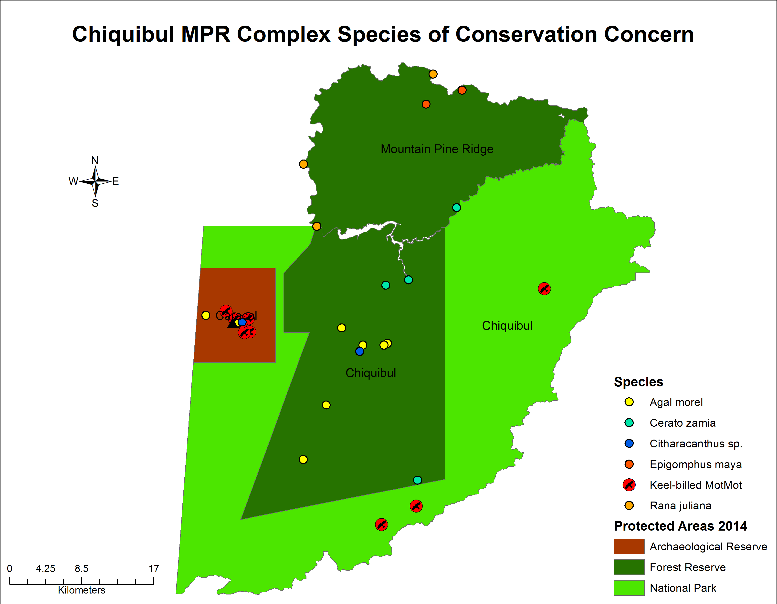
Figure 29: Distribution of records of species of conservation concern for Chiquibul-MPR Complex
(Source: NPSAP/BERDS)

Toledo
Toledo is the study area with the greatest number of protected areas, a total of 18 (Appendix 1). These form a significant amount of biodiversity in the southern region of the country with several unique and rare ecosystem types. These protected areas range from mountainous forests to mangroves and coral reefs. Upland portions of this study area, such as Cockscomb Basin, Bladen Nature Reserve and Columbia Forest Reserve, form the Maya Mountain Massif and these have biodiversity, ecosystems and species, similar to the Chiquibul-MPR complex in some areas. The Toledo District contains the Maya Mountain Marine Corridor (MMMC), a ridge-to-reef conservation approach of interconnected, biologically significant areas including over 12 protected areas (Appendix 2) and six watersheds: Payne’s Creek, Deep River, Golden Stream, Middle River, Rio Grande and Monkey River, as well as the Port Honduras Marine Reserve, which receives the waters directly discharged from these watersheds. It connects the Maya Mountains Massif and its protected areas with the coastal waters and reefs of the Gulf of Honduras (MMMC Conservation Action Strategy, 2008). The area contains at least 43 distinct ecosystem types grouped into seven ecosystems: upland forests, coastal plain broad leaf forests, pine savannas, freshwater systems, near shore estuaries, seagrass beds, and coral reefs. These ecosystems in turn support a variety of endangered and threatened species such as the jaguar, and many endangered bird species including the yellow-headed parrot. The species of Fauna and Flora in the terrestrial protected areas are similar to those found in the MMM, however there are a few ecosystem types of particular significance found only in this area, such as the tropical evergreen seasonal broad-leaved lowland swamp forest, tall variant in the TIDE private lands (Wildtracks, 2012).
Further south in the Aguacaliente and Sarstoon Temash National Park more unique ecosystem types can be found such as the tropical evergreen seasonal broad-leaved lowland swamp forest Aguacaliente variant, the tropical evergreen broadleaf lowland hill forest: Calophyllum variant, tropical evergreen broadleaf lowland swamp forest: permanently waterlogged, tropical evergreen broadleaf lowland swamp forest: Manicaria variant, and Tropical Evergreen Lowland Peat Shrubland with Sphagnum (Meerman, Herrera & Howe, 2003; Wildtracks, 2013). These protected areas represent a swamp-based ecosystem with flora and fauna species commonly found in swamp areas. The Aguacaliente Wildlife Sanctuary (AWS) covers 2,222 Ha of wetlands with a total of ten ecosystems occur within the wildlife sanctuary. Two of the ecosystems are unique to the area: swamp grassland without trees or shrubs and the previously mentioned tropical evergreen broadleaved lowland swamp forest (Meerman et al., 2006). There are 213 plants species occurring within the wildlife sanctuary, including some that are characteristic of the area. Data on fauna within the wildlife sanctuary is minimal, with available studies indicating a total of 146 bird species documented due to the lagoons, which serve as an important habitat for migrating bird species as well as endangered species such as the Jabiru stork (Hammond et al., 2011). Some species of concern found in the area are the Roseate Spoonbill, Great Blue Heron, Muscovy Duck, Black-Bellied Whistling Duck, Snowy Egret, Green Heron, Great Egret and the American Wood Stork. Rapid ecological assessments of the AWS confirm the presence of 23 species of butterflies (data for other insects is nonexistent), 11 species of fish, 4 species of amphibians, 13 species of mammals and 8 species of reptiles (including the Morelet’s Crocodile, Green Iguana and Common Slider Turtle) (Meerman et al., 2006).
The Bladen Nature Reserve (BNR), located in southern Belize, covers a land area of 40,380 Ha (APAMO, 2011). The Golden Stream Corridor Preserve (GSCP) covers a smaller land area of 6,058 Ha and serves as an important link between the forests of the MMM to the Port of Honduras Marine Reserve and the TIDE Private Reserve (APAMO, 2011). The Bladen Nature Reserve and Golden Stream Corridor Preserve are jointly managed by the Ya’axché Conservation Trust as the Maya Golden Landscape (MGL). The Ya’axché Conservation Trust conducts yearly studies to monitor biodiversity health within the MGL. The studies are limited to the monitoring of indicator species including, 19 large mammals (the Agouti, Jaguarundi, Margay and Ocelots), 30 birds (Yellow Headed Parrot, Chestnut-sided Warbler and Keel-billed motmot), bats, and snails (Gartzia, 2014).
Meerman and Sabido 2001 and 2004, identified a total of 20 varying ecosystems occurring within the BNR (Miller et al., 2011). The BNR protects the only tropical evergreen broad-leaved shrubland on steep karstic hills in Belize (Miller & Wicks, 2011). The BNR also plays a crucial role in the conservation of tropical evergreen broad-leaved sub-montane palm forest, which occurs on tracts of non-calcareous soils as 74.9% of the country’s total coverage is located within the reserve. This protected area is a fundamental link within the Maya Mountain Massif, between the Cockscomb Basin Wildlife Sanctuary to the north and Columbia River Forest Reserve to the south (Miller & Wicks, 2011). A total of 93 species of mammals, 337 species of birds, 19 freshwater fishes, 92 species of herptiles, and approximately 300 species of plants have been reported from the Bladen Nature Reserve (Miller & Wicks, 2011). Astonishingly, one of the ecosystems within the BNR possesses 73% of the reported plant species, which are specific to that ecosystem. There has been limited biodiversity studies in the higher elevations of the BNR, it is expected that further research in these areas would cause an increase in the number of species in the reserve. The GSCP is dominated by lowland broad-leaved wet forest and coastal plain shrubland (Wicks, 2012). A 2009 study of the MGL revealed the presence of 62 species of mammals, 240 species of birds, 46 species of reptiles, 19 species of amphibians, 23 species of fish and 171 species of vascular plants within the area (Wicks, 2009). Based on its interconnection with the Bladen Nature Reserve, it is expected that the species list for the GSCP will be the same as that of BNR and the MGL. Species of international concern within MGL include the Yucatan black howler monkey, Central American Spider Monkey, water opossum, Alston’s mouse opossum, Thomas’ sac-winged bat, puma, jaguar, Morelet’s Treefrog, Maya Mountain Frog, Limestone Rain Frog, Sabrinus Rain Frog, Morelet’s Crocodile, Narrowbridge Musk Turtle and the Mexican Giant Musk Turtle.
The Cockscomb Basin Wildlife Sanctuary (CBWS) covers 49,476 Ha of land in close proximity to the Maya Mountain Massif. There are twenty-one ecosystems found within the CBWS of these nineteen are terrestrial (APAMO, 2011). Tropical evergreen seasonal broadleaf lowland hill forest covers 47% of the wildlife sanctuary. The upper elevation also includes a unique ecosystem the tropical evergreen seasonal broad-leaved submountane elfin shrubland and woodland of which 100% of its national coverage is found within the CBWS (Wildtracks, 2004). There have not been extensive studies of plant species within the CBWS, with studies to date limited to areas in close proximity to the headquarters. Based on these prior studies, 233 species of plants have been recorded within CBWS; three of which are of conservation concern (Vulnerable status): the Mountain Pimento, Mahogany, and the Spanish Cedar (Wildtracks, 2004). Similar to that of plant species, there have been limited studies on fauna within the area. Studies have focused mainly on the jaguar and black howler monkey. However, a total of 96 species of mammals, 323 species of birds, 53 species of reptiles, 26 species of amphibians, 161 species of butterflies and 18 species of freshwater fish recorded from the CBWS (Wildtracks, 2004).
Colombia River Forest Reserve (CRFR) covers 60,016 Ha of land with 12 different ecosystems, two of which are endemic to the MMM. The tropical evergreen broad-leaved submontane palm forest and the tropical evergreen broad-leaved submontane forest on rolling karstic hill can only be found in the MMM, with national coverage of 18.6% and 70.6% occurring within the CRFR, respectively (Wildtracks, 2009). Within the submountane forests of the reserve, 35 new vascular plants species have been discovered for Belize (Wildtracks, 2009). A total of 58 species of mammals, 224 bird species, 27 amphibians, 41 reptiles and over 800 species of plant have been recorded within the reserve (Parker, Holst, Emmons & Mayer, 1993; Wildtracks, 2009). Of the 800 species of plants a new species of cycad, Zamia decumbens, was discovered that is endemic to the CRFR. A total of 30 migratory species of birds from the north have been recorded in the CRFR highlighting the importance of the reserve in supporting migratory species (Parker et al., 1993). This includes two neotropical migrants, Chuck-Will’s-widow and the warbling vireo (Miller et al., 2011). The reserve serves as habitat for 10 endangered species and 15 vulnerable species (Wiltracks, 2009). Species of international concern include Van Gelder’s Bat, White-lipped Peccary, Black Howler Monkey, Cerulean Warbler, Keel-billed Motmot, the Great Curassow and the Coffeus rain frog.
The Payne’s Creek National Park (PCNP) spans over 15,248 Ha of land, brackish and freshwater wetlands and mangroves (TIDE, 2005). There are a total of 14 different ecosystem types found within the borders of the PCNP. This national park provides a link between the MMM and the southern Belize Barrier Reef. To date 152 plant species have been recorded in the park but studies have been limited to trees and predominant shrubs, and the true floral biodiversity of the area is unknown. There are 309 bird species reported from the PCNP, similar to those found in the other protected areas on the Toledo District with a fairly large breeding population of the Yellow Headed Parrot. Thirty-nine (39) fish species have been recorded from the park including the goliath grouper, parrot fishes, hogfish and rays; along with 41 species of amphibians and 29 species of mammals.
On the coastal side of the area, a variety of reef structures and assemblage of ecosystems make up the Port Honduras Marine Reserve (PHMR) The PHMR is an important estuarine based system which covers 40,468 Ha along the coast of southern Belize, extending approximately 8 kilometers out into the Caribbean Sea (Foster, Mosher, Daly, Heller & Walker, 2012). There are four distinct ecosystems found within the PHMR: coastal and tidal wetlands, marine lagoonal habitats, and fringing reefs. Over 118 species of fishes have been recorded from PHMR. Flora of the marine reserve include: red, black and white mangroves, buttonwood, turtle grass, and manatee grass (Foster et al., 2012). All of which support a wide assemblage of fauna through their various life stages, including species of conservation concern. Endangered species found in the area include the goliath grouper, the great hammerhead, elkhorn and staghorn coral, Nassau Grouper, the West Indian manatee, hawksbill turtle, loggerhead and green turtles (Foster et al., 2012; Wildtracks, 2008). Commercially valuable species of finfish, queen conch and the Caribbean spiny lobster are also present in the reserve.
Basic data exists for the distribution of species of conservation concern utilizing mainly sightings, point counts and aerial surveys. The available spatial data on distribution of species of conservation concern is shown in Figure 30 below. The main groups of species highlighted are birds, turtles, manatee, crocodile, amphibians and timber species. Based on the diversity of ecosystem types and species found within the Toledo District and across these 18 protected areas, this area undoubtedly forms an important part of Belize’s wealth of biodiversity that supports numerous communities through the provision of important ecosystem services.
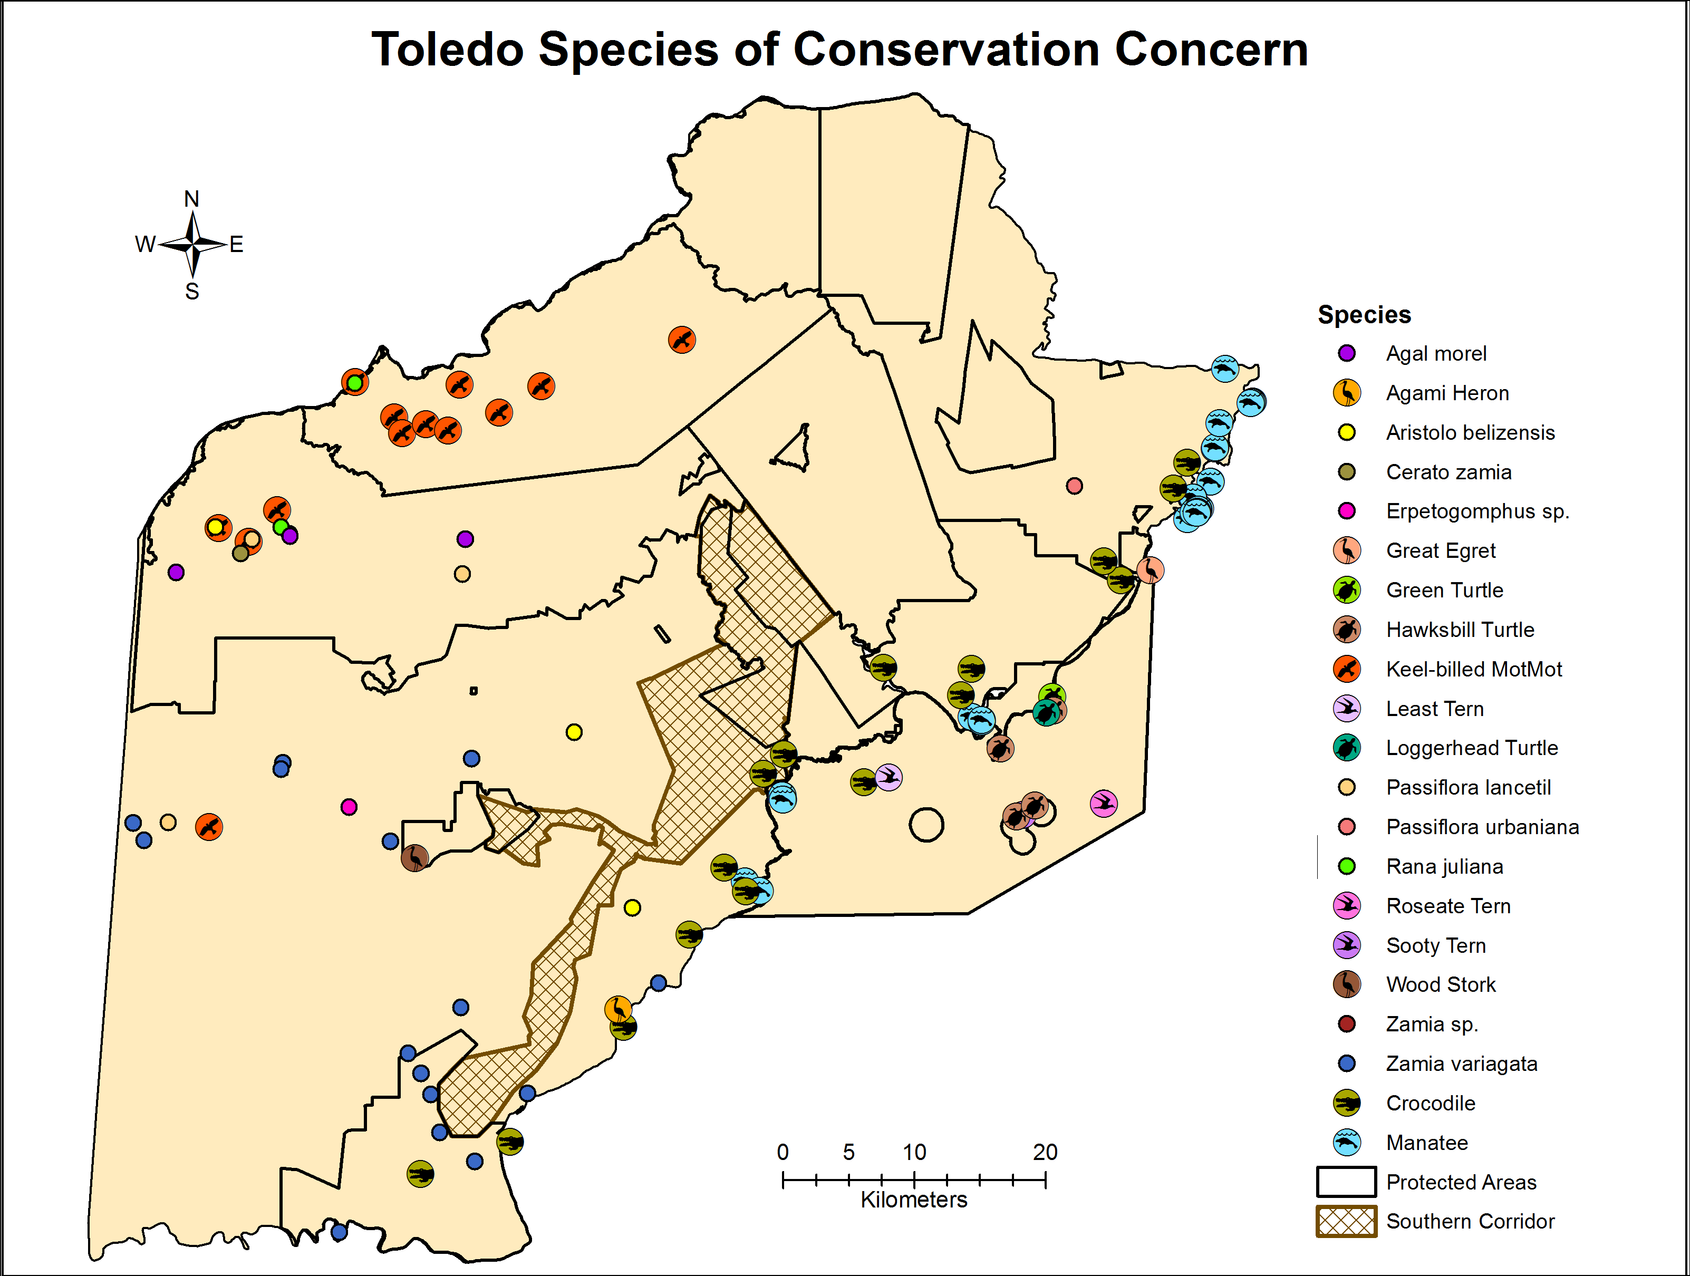
Figure 30: Distribution of species of conservation concern within the Toledo District
(Source: NPSAP/BERDS/CMAI, 2010 & 2012)
The PA rationalization report (Wildtracks 2013) has flagged the need provide further protection to areas such as the Deep River river-mouth and to expand the area under protection for the tropical evergreen seasonal broad-leaved lowland swamp forest, tall variant in the TIDE lands and fully protect the tropical evergreen seasonal broad-leaved lowland swamp forest Aguacaliente variant found in the AWS and ensure continued protection of the Sanctuary.

Ecosystem Services

As illustrated in Figure 31, the Corozal area includes one minor watershed, Barracouta Pond, in its entirety, a vast portion of the Freshwater Creek watershed, and only a small portion of three major watersheds: namely, the Rio Hondo, the New River and Northern River watersheds. The Chiquibul-MPR complex is located in its entirety within the Belize River watershed (Figure 34), the country’s primary and most important watershed given its size, the fact that most of its extension is located within Belizean territory and because it is the country’s most populated watershed (Cherrington, Kay & Waight-Cho, 2015). The headwaters of this watershed are located within the Chiquibul-MPR complex (Boles et al., 2008). Figure 35 shows that the Toledo District encompasses the entire major watersheds of Rio Grande, Golden Stream and Deep River, vast portions of the Monkey, Moho and Temash River watersheds, a small portion of the Sarstoon River watershed, which has its vast majority located in Guatemala, and entire or vast portions of three other minor watersheds.

Corozal
The protected areas in the northern district of Corozal provide key ecosystem services to the host of local communities that surround them. In particular the Corozal Bay Wildlife Sanctuary provides important water quality control via the Rio Hondo and Barracouta Pond watersheds, enabling filtration of sediments and preventing nutrients and agrochemicals from reaching the reef (Figure 31). It is also an important source of fish for both subsistence, from direct catches, and commercial fisheries from the numerous nursery habitats it supports. In addition, the wildlife sanctuary provides important shoreline protection from storms through its mosaic of mangrove creeks that shelter the coast. While there is no readily available data on the value of these ecosystem services, it is accepted that these areas are crucial in supporting the economy and livelihoods of coastal communities such as Sarteneja, Copper Bank and Chunox. Coastal protection data from the CZMAI highlight the protection offered by the mangroves in reducing wave height and surge (Figure 32).
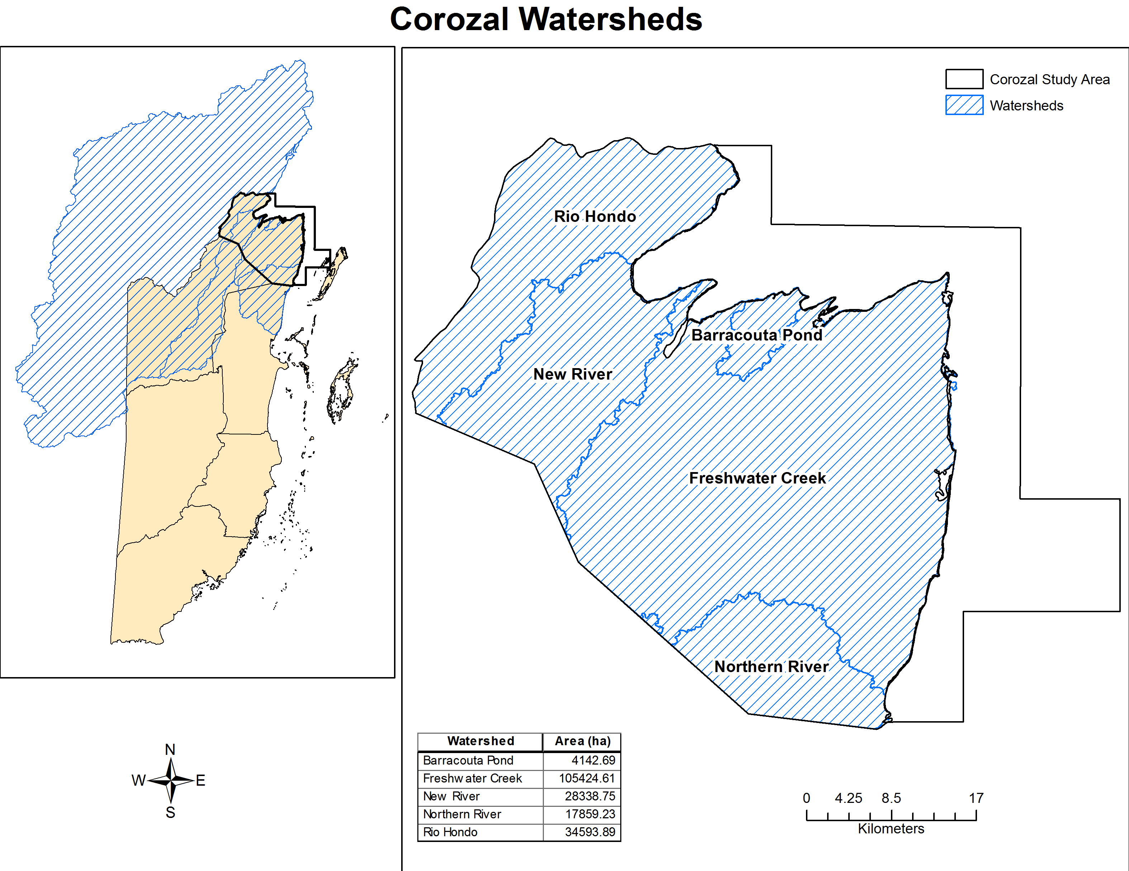
Figure 31: Major watersheds providing water provision and regulation services in Corozal
(SOURCE: HydroSHEDS, 2007)
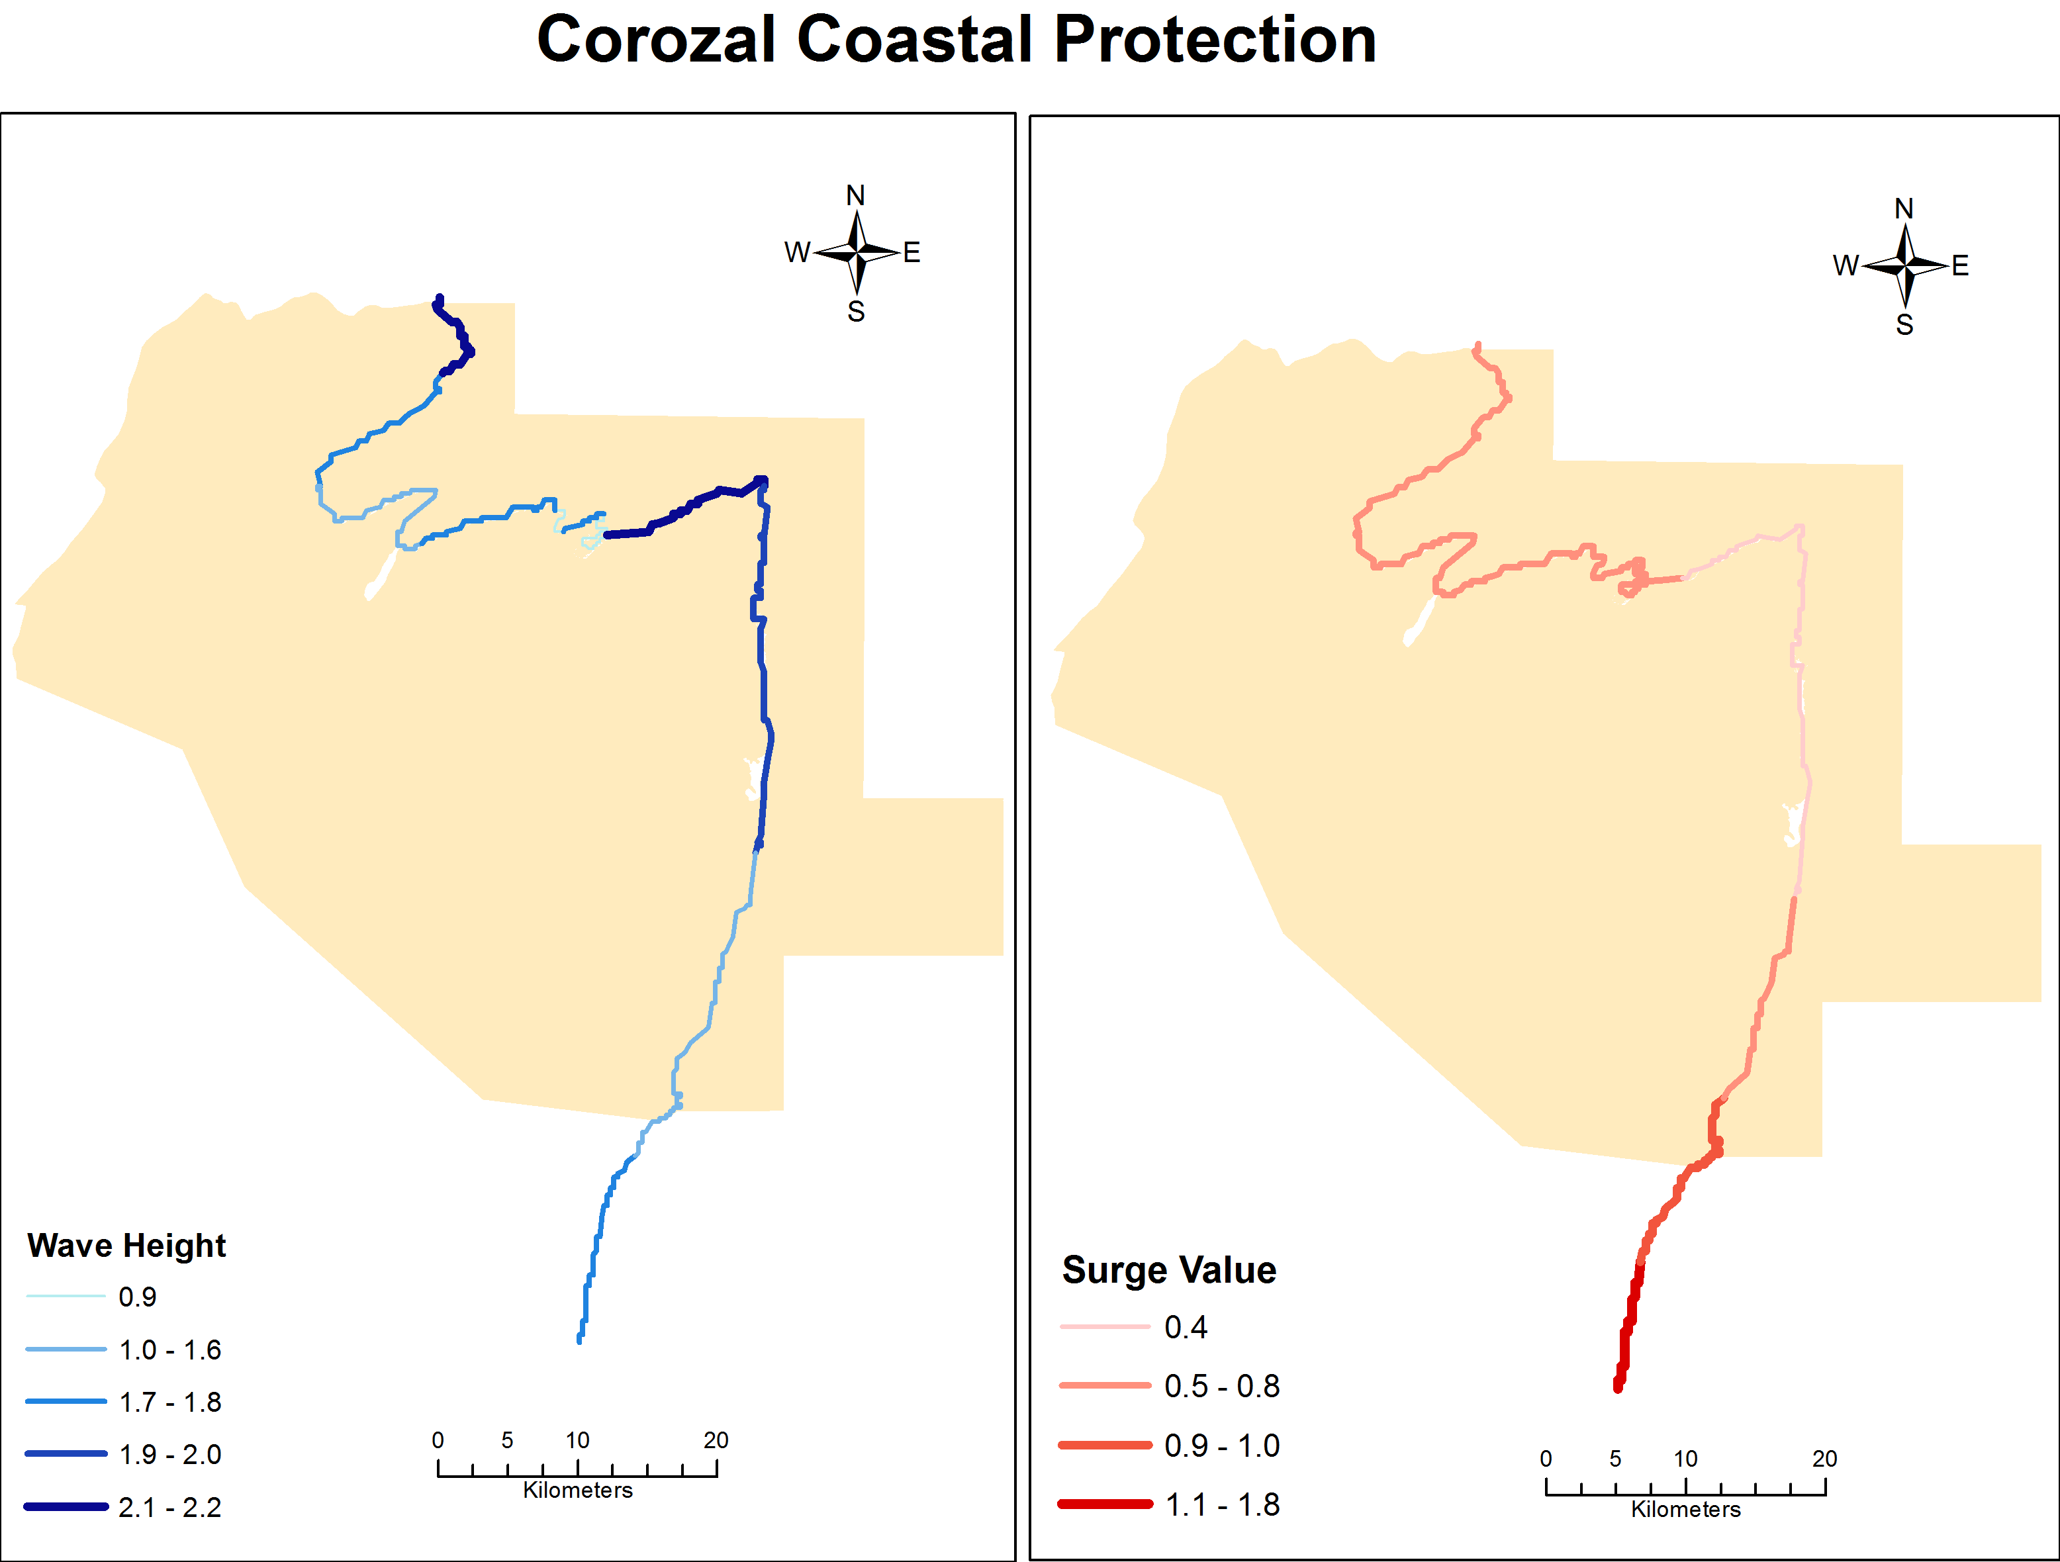
Figure 32: Coastal protection services offered by coastal vegetation (mangroves) along the Corozal district
(Source: CZMAI, 2010)
The Shipstern Nature Reserve (SNR), which is a combination of forest and coastal lagoon systems, provides a range of ecosystem services. Its coastal wetlands provide flood and water quality control in receiving freshwater from the New River, Barracouta Pond and Freshwater Creek watersheds and filters agrochemicals and sediments before exiting to the Caribbean Sea. The forested areas of Shipstern is important in sourcing water to the Freshwater Creek and Barracouta Pond watersheds and is a source of game meat to communities in the area. Buffer communities such as Sarteneja and Chunox harvest plant species for house construction and livestock enclosures. The latter is only permitted with the consent of officials from SNR. The more inland areas of Honey Camp and Freshwater Creek also contain water-provisioning services owing from the lowland broad-leaved moist forests and supply game meat from various species, such as peccary and deer. Timber is an important provisioning service within the Freshwater Creek Forest Reserve. Freshwater Creek is considered an important secondary node for the northeast biological corridor (Wildtracks 2011). The Honey Camp National Park provides vital connectivity between SNR and the Crooked Tree Wildlife Sanctuary in an area vastly dominated by agriculture ventures.

Caye Caulker
The Caye Caulker Forest and Marine Reserve provide crucial ecosystem services to the tourism destination of Caye Caulker. Of primary importance is the shoreline protection function of the coral reefs, particularly the reef crest, and those of the mangroves. Coastal vulnerability models show that wave height and surge are greatly reduced on the leeward side of the island owing largely to the interlinked system of reefs and mangroves (Figure 33). These mangroves also provide critical nursery habitats for a range of commercial fish species, another important service – food, provided by this protected area complex. Littoral forests also provide some element of shoreline protection against storms. The most important service provided by these protected areas is tourism. Caye Caulker is one of Belize’s major destinations for diving and snorkeling, with visitors frequenting its coral reefs and attractions such as Shark and Ray Alley. In 2014 a reported 83,361 tourists visited Caye Caulker (BTB, 2014). Finally the coral reefs and mangrove habitats of Caye Caulker provide fisheries resources that contribute to Belize’s annual export market and also supply the local fisheries market, primarily restaurants and the tourism industry.
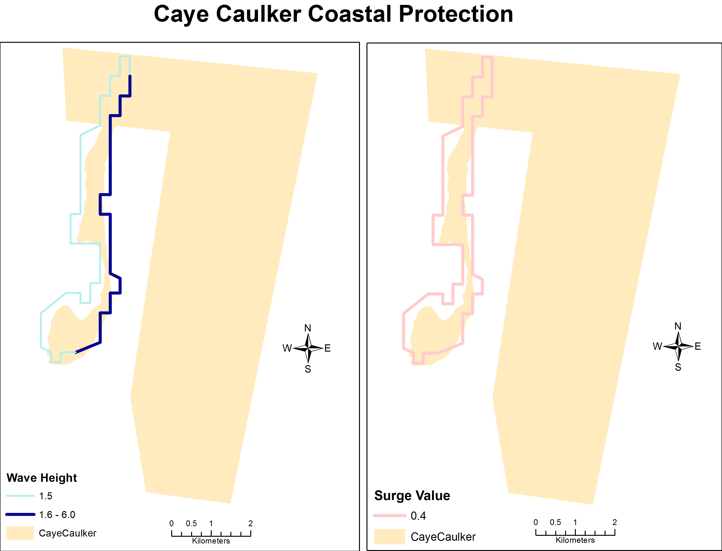
Figure 33: Coastal protection services offered by coastal vegetation (mangroves) along Caye Caulker
(Source: CZMAI, 2010)

Chiquibul-MPR Complex
The Chiquibul-MPR Complex supports the country with many ecosystem services comprised of direct and indirect benefits. As a part of the MMM that leads to the MMMC, it indirectly influences the coastal environment of the Port Honduras Marine Reserve and southern barrier reef (Hammond et al., 2011). This area provides multiple provisioning services including timber from the Chiquibul and Mountain Pine Ridge Forest Reserves, food in the form of game meat to communities in the surrounding areas, water from the Belize River Watershed and all its tributaries, and mineral resources (granite, gold and gravel). The Belize River is the main source of the majority of our potable water supply, particularly to Cayo and Belize districts (Figure 34).
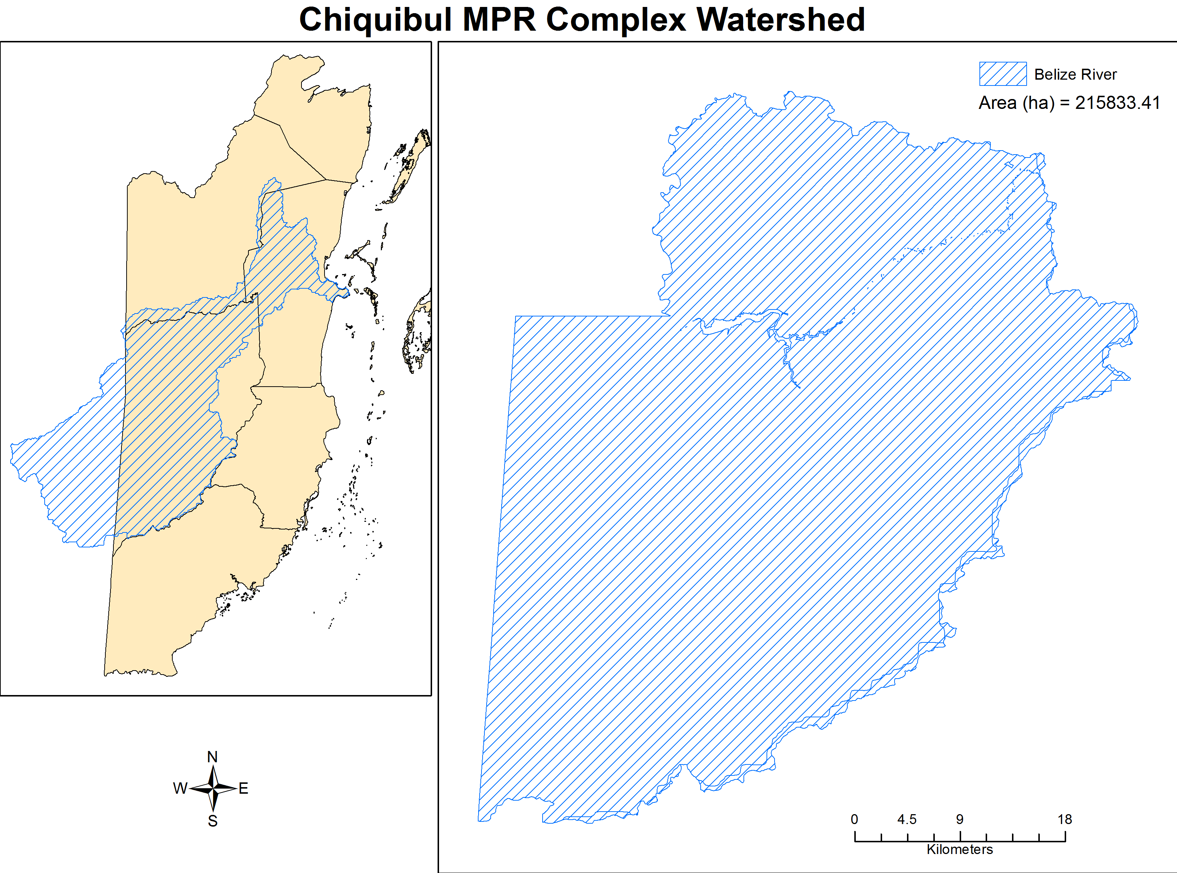
Figure 34: Major watersheds providing water provision and regulation services in Chiquibul-MPR Complex
(SOURCE: HydroSHEDS, 2007

Besides these provisioning services the Chiquibul-MPR Complex also gives important regulating and supporting services such as flood and erosion control by containing water from excessive rainfall and preventing erosion and sedimentation from affecting coastal and urban areas. It provides significant carbon sequestration and soil formation through the extensive area of broad leaf forests within its boundaries along with a wealth of genetic resources. Indirectly, the Chiquibul-MPR Complex contributes to the maintenance of coastal water quality by filtering sediments from the Belize Barrier Reef lagoon, which then ensures healthy nursery habitats important for fisheries productivity and healthy reefs that support diving and snorkeling tourism. Finally within this complex there are several archaeological sites and natural features that provide cultural services, in particular for recreation and aesthetics. These include the famous Caracol Archaeological Reserve, the extensive Chiquibul Cave System (largest in Belize), Las Cuevas, NohochCh’en the best-known sinkhole and the Natural Arch (Meerman and Moore, 2009; Salas and Meerman, 2008).

Toledo
The Toledo District, comprised of the MMM and MMMC, contains significant extent of forests and biodiversity resources that hold important ecosystem services for the communities of Southern Belize and the country. The area is a significant source of water owing to the many watersheds located within it including major ones like Monkey River, Deep River, Rio Grande, Golden Stream, Moho and Temash Rivers (Figure 35). This water is crucial to the communities and agricultural sector in the district. The Toledo study area also provides timber services via the various forest reserves, such as Columbia Forest and Deep River Forest Reserves, contained within its borders. Rosewood and mahogany are two commercially important species harvested in the region, along with pine. Game meat is another important ecosystem service derived from the forests of Toledo.
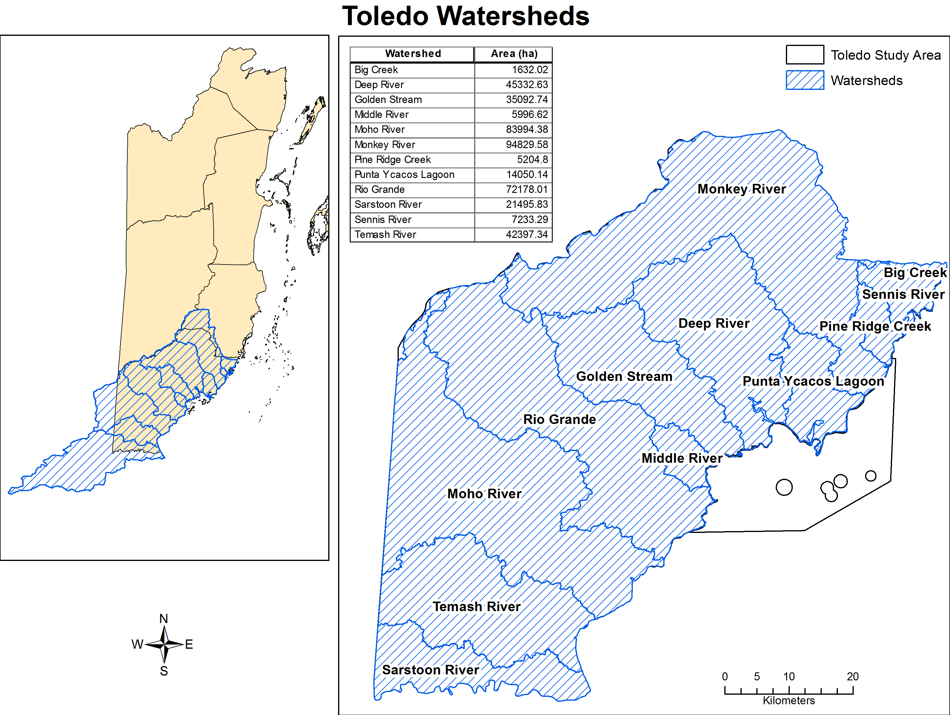
Figure 35: Major watersheds providing water provision and regulation services in Toledo Area
(SOURCE: HydroSHEDS, 2007)

Along the coast, the Port Honduras Marine Reserve (PHMR) provides critical nursery and adult habitat that supports fish biomass for communities of southern Belize. The coastline along the PHMR provides important coastal protection services by reducing the wave height and particularly surge from storms (Figure 36). The Toledo region also provides important flood regulation and sediment control via the MMMC where sediment and agricultural runoff is filtered through the protected areas across this ridge-to-reef gradient. The southern barrier reef complex is buffered from land-based influences through the estuarine function of the Port Honduras Marine Reserve, which provides water quality control for the Sapodilla Cayes Marine Reserve. The forested areas in the uplands also provide important carbon sequestration and soil formation services.
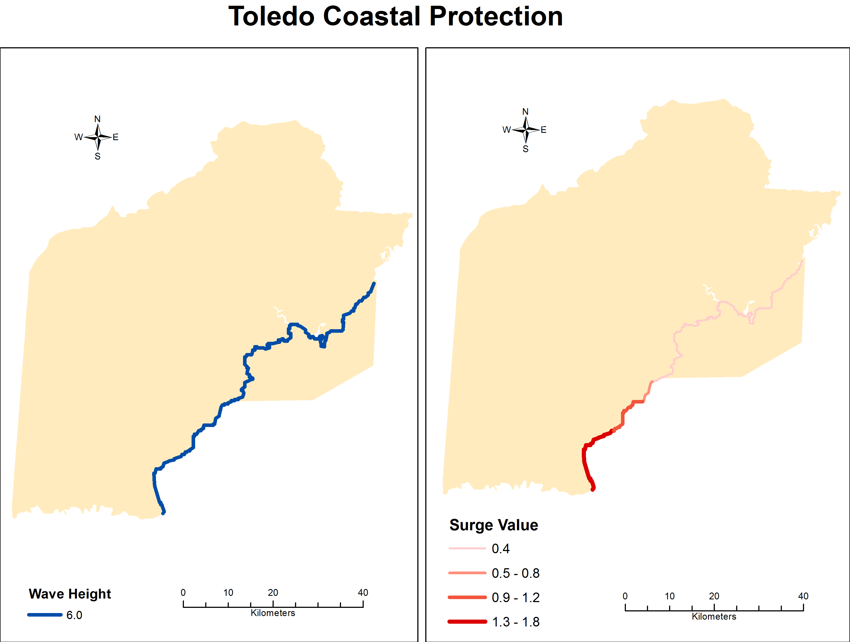
Figure 36: Coastal protection services offered by coastal vegetation (mangroves) along Toledo
(Source: CZMAI, 2010)

Climate Resilience
Climate change projections are presented for all four areas under B1 and A2 scenarios. These two scenarios represent the mid-point of economic development, where both B1 and A2 are in the middle in regards to economic growth and technological advancement. The BI scenario represents an integrated and eco-friendly world where there is rapid economic growth, a decrease in material intensity and more emphasis in clean and resource efficient technology; this scenario is also characterized by a high level of environmental and social consciousness. The A2 scenario represents a differentiated world where there are lower trade flows and slower technological change. This scenario is characterized by self-reliant nations and there is less emphasis on economic, social, and cultural interactions between regions. Therefore these two scenarios present the most likely results of climate change given the various approaches countries have committed to adapt or by achieving more self-reliance.

All areas are expected to experience a high change in precipitation. Although this figure reflects only the magnitude of the change and not the direction, i.e. positive or negative change, a recent study that looked at assessing the potential impacts of climate and land use change on Belize’s water resources shows that the changes in all the major watersheds encompassed by the proposed tourism development areas or under which the proposed areas are encompassed, will likely be negative. These watersheds are likely to experience decreased precipitation (Cherrington et al., 2015) (See Appendix 3). Table 18 shows precipitation changes for three of the four study areas.

Table 18: PRECIPITATION CHANGES FOR WATERSHEDS WITHIN COROZAL, CHIQUIBUL-MPR COMPLEX AND TOLEDO
Destination | Watershed | CNRM-CM5 |  | HadGEM-2 ES |  | MIROCS |  | MRI-CGM3 |  | NorESM1-M |  | Average
 |  | RCP 2.6 | RCP 8.5 | RCP 2.6 | RCP 8.5 | RCP 2.6 | RCP 8.5 | RCP 2.6 | RCP 8.5 | RCP 2.6 | RCP 8.5 | RCP 2.6 | RCP 8.5
Chiquibul - MPR | Belize River | -3.10% | -0.50% | -3.20% | -13.20% | -13.70% | -7.50% | 2.20% | -11.50% | 2.00% | -21.20% | -3.16% | -10.78%
Corozal | Barracouta Pond
 | Freshwater Creek
 | New River | -2.60% | 0.40% | -5.60% | -16.80% | -13.20% | -6.20% | -6.20% | -17.80% | 2.50% | -20.70% | -5.02% | -12.22%
 | Northern River | -3.00% | 0.60% | -4.90% | -14.90% | -10.50% | -2.10% | -8.50% | -19.90% | 3.40% | -20.30% | -4.70% | -11.32%
 | Rio Hondo | -1.60% | 0.80% | -5.50% | -15.70% | -12.20% | -6.00% | -5.10% | -18.20% | 2.40% | -19.70% | -4.40% | -11.76%
Toledo | Big Creek
 | Deep River | -2.70% | -1.10% | -0.30% | -14.30% | -17.30% | -11.10% | 4.30% | -8.00% | -1.40% | -26.00% | -3.48% | -12.10%
 | Golden Stream | -2.70% | -1.60% | 0.00% | -15.60% | -18.40% | -12.60% | 4.80% | -6.90% | -2.60% | -27.20% | -3.78% | -12.78%
 | Middle River
 | Moho River | -2.30% | -2.30% | -0.30% | -15.90% | -17.90% | -13.50% | 4.10% | -7.60% | -2.50% | -27.00% | -3.78% | -13.26%
 | Monkey River | -3.20% | -0.70% | -0.30% | -12.90% | -16.20% | -9.20% | 2.90% | -9.70% | -0.50% | -25.00% | -3.46% | -11.50%
 | Pine Ridge Creek
 | Punta Ycacos Lagoon
 | Rio Grande | -2.40% | -1.80% | -0.30% | -16.00% | -18.30% | -13.10% | 5.00% | -6.80% | -2.50% | -26.90% | -3.70% | -12.92%
 | Sarstoon River | -1.80% | -3.40% | 1.00% | -14.10% | -16.30% | -13.50% | -2.00% | -10.90% | -2.50% | -27.50% | -4.32% | -13.88%
 | Sennis River
 | Temash River | -2.60% | -2.90% | 0.40% | -17.20% | -19.10% | -15.00% | 3.30% | -6.60% | -4.10% | -28.80% | -4.42% | -14.10%

Corozal
There is very little formal literature, assessments or studies on the climate resilience of the Corozal District, besides spatial data on the predicted models for changes in air temperature, precipitation and sea level rise. See section 5.1.3.5 for model of sea level rise. In the Corozal district high to very high negative changes in precipitation are predicted for B1 and A2 scenarios, respectively (Figure 37). The latter will most likely to result in reduced rainfall for the area. This means that agriculture and ecosystem productivity will most likely be affected due to increased drought conditions. In regards to changes in air temperatures, the B1 scenario predicts a very low increase in air temperature for Corozal, while the A2 scenario predicts very low changes along the coast and medium changes more inland; a very minute portion of the area is expected to experience high change (Figure 38).
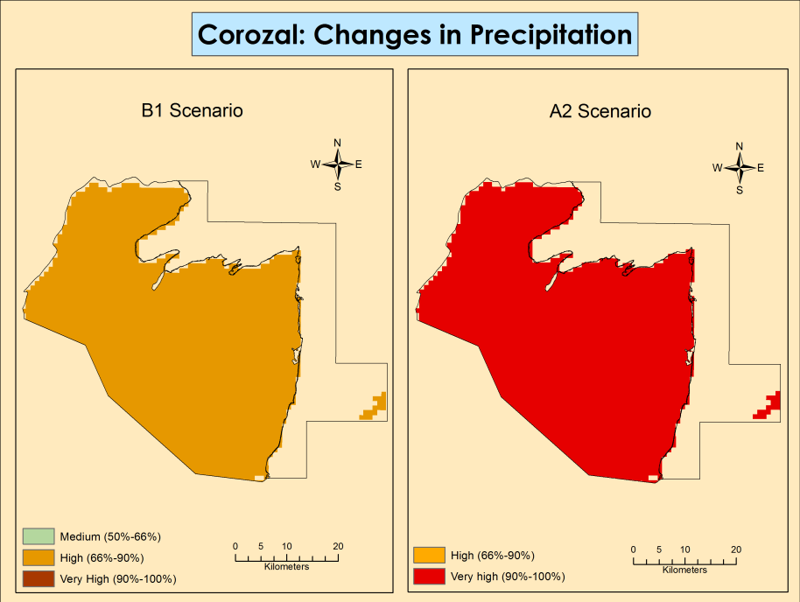
Figure 37: Changes in precipitation for B1 and A2 scenarios for Corozal
(Source: TNC, 2012)
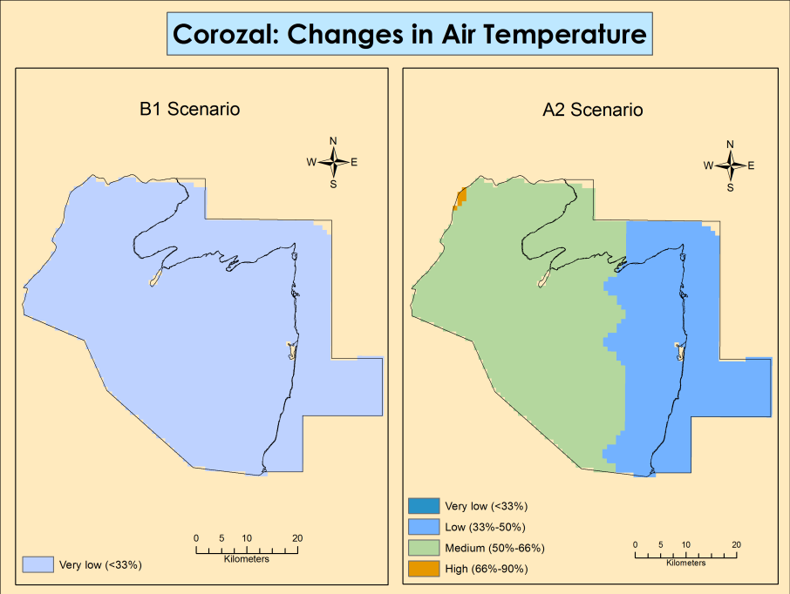
Figure 38: Changes in air temperature for B1 and A2 scenarios for Corozal
(Source: TNC, 2012)

The PA rationalization report provides the most comprehensive analysis and estimates of climate resilience for the various regions of the country (Figure 39) (Wildtracks, 2013). It indicates that the Northern forests of Belize are very resilient since they cover a broad range of tolerances and have adapted from past changes in climate. The sheer size, extent, intact condition and connectivity of the Northern forests confer resilience to climate change. The mangroves that form the coastal lagoons in the Corozal district are able to migrate up elevation gradient as sea level rises. This will slow the loss of land area and the erosion rate. Coastal vegetation has a natural resilience to storms with high capacity to regenerate from severe tropical storm events.
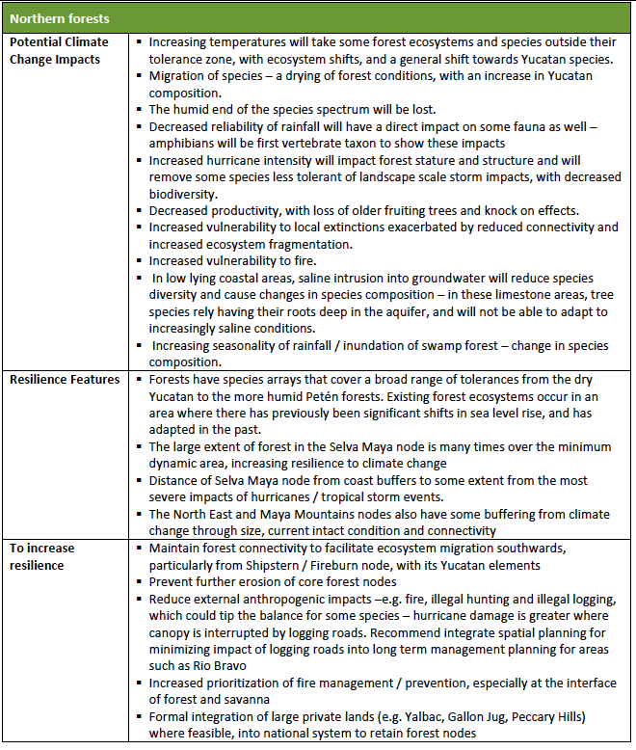
Figure 39: Climate change predictions and resilience for Northern Belize
(Source: Wiltracks 2013)

Caye Caulker
Similar to the Corozal District there is very little formal literature, assessments or studies on the climate resilience of Caye Caulker, besides spatial data on the predicted models for changes in air temperature, precipitation and sea level rise. See section 5.1.3.5 for model of sea level rise. For Caye Caulker there is a similar negative change in precipitation with high to very high changes in precipitation, most likely decreased rainfall, projected (Figure 40). The Caye Caulker area is projected to experience very low change in air temperature under both B1 and A2 scenarios (Figure 41). This bodes well for the tourism industry with minimal increases in temperatures predicted for this area.
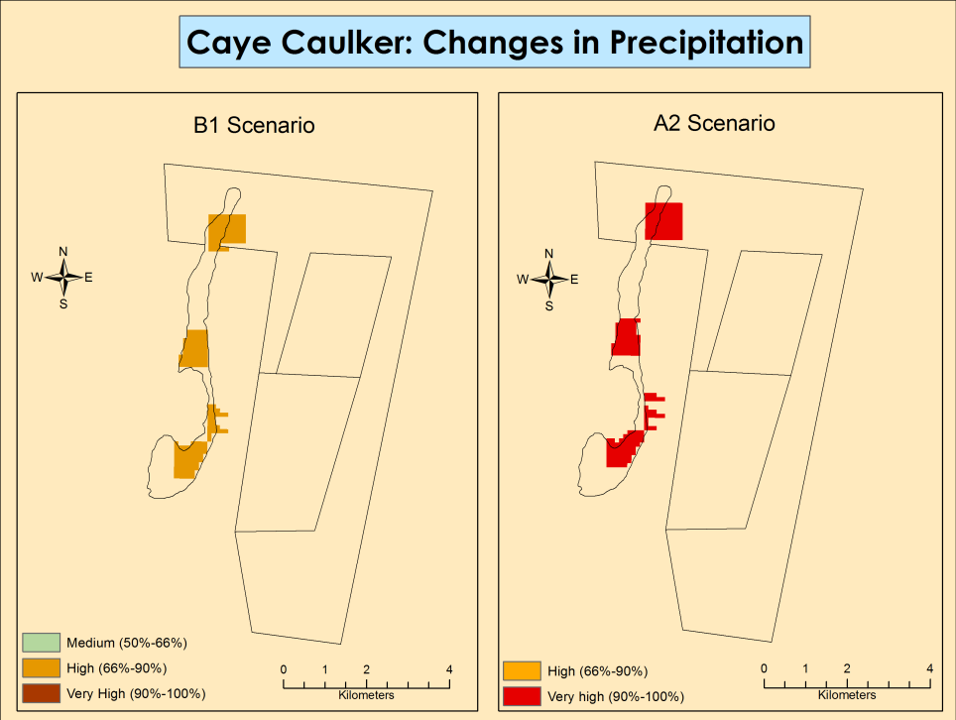
Figure 40: Changes in precipitation for B1 and A2 scenarios for Caye Caulker
(Source: TNC, 2012)

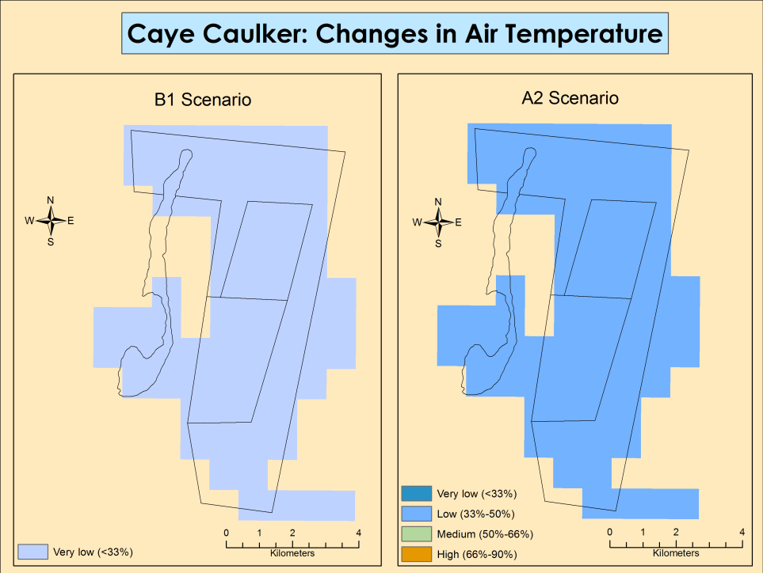
Figure 41: Changes in air temperature for B1 and A2 scenarios for Caye Caulker
(Source: TNC, 2012)

Chiquibul-MPR Complex
In the Chiquibul-MPR Complex a high change in precipitation is expected under the B1 scenario and a very high change under the A2 scenario (Figure 42). This most likely means an overall significant reduction in rainfall for this region affecting productivity and water regulation services. Air temperature is predicted to show a very low change under the B1 scenario but a very high change under the A2 scenario (Figure 43). This change will most likely be an increase in temperature.
Wildtracks 2013, in the PA Rationalization exercise provided the best available summary of climate resilience for the forests of the Chiquibul-Mountain Pine Ridge Complex (see Figure 44). The forests in this complex cover a broad range of tolerances from dry to more humid and this combined with the large extent of forested area (many times over the minimum area required) increases resilience. The several replicates of ecosystems types geographically separated, increases resilience to hurricanes along with rugged terrain that rapidly decreases storm strength.
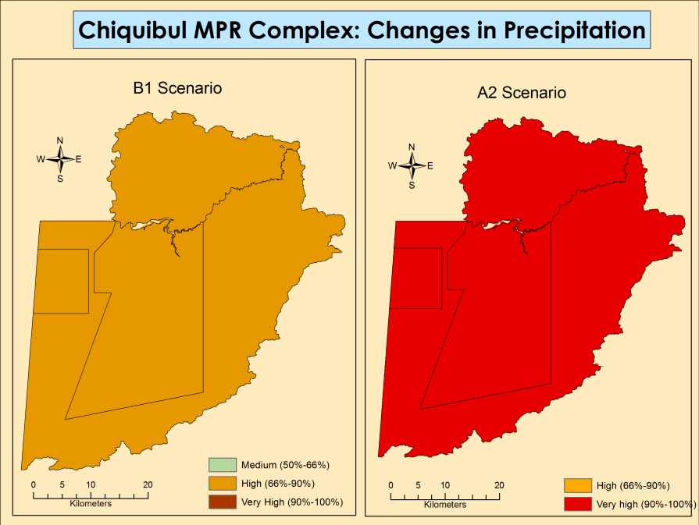
Figure 42: Changes in precipitation for B1 and A2 scenarios for Chiquibul-MPR Complex
(Source: TNC, 2012)

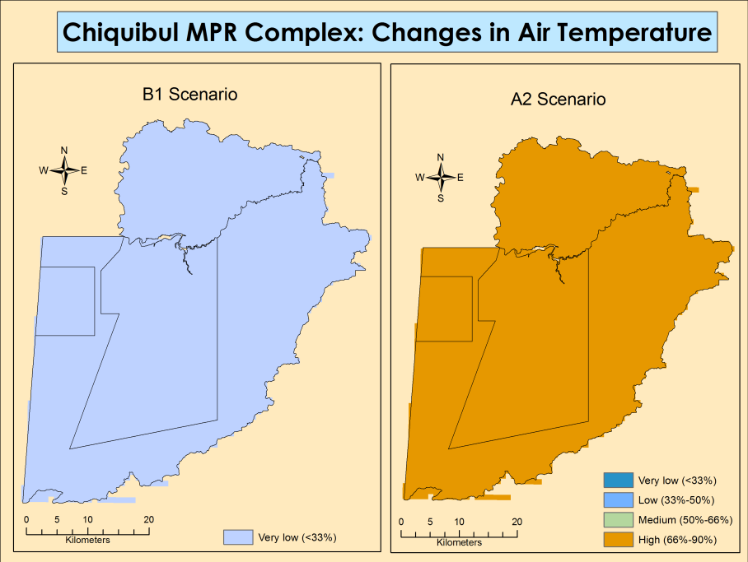
Figure 43: Changes in air temperature for B1 and A2 scenarios for Chiquibul-MPR Complex
(Source: TNC, 2012)

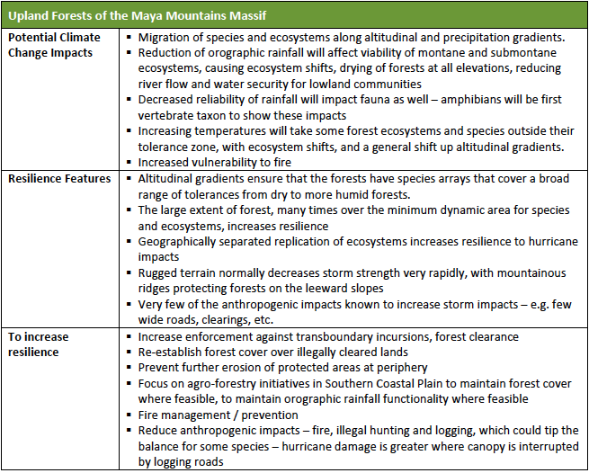
Figure 44: Climate change predictions and resilience for upland forest of the Maya Mountain Massif
(Source: Wildtracks, 2013)

Toledo
In Toledo a high to very high change in precipitation is also predicted under the two scenarios which has significant implications for agriculture and ecosystem productivity, since this change is most likely a reduction in rainfall (Figure 45). Under the B1 scenario very low changes in air temperature is predicted however the A2 scenario shows a mostly high change in air temperature with medium change mainly on the northern coast of the district (Figure 46).
As with the other study areas, very little available studies or assessments exist on climate resilience beyond vulnerabilities predictions presented above. There is some analysis completed through the PA Rationalization for the Maya Mountain Massif presented in Figure 44, but there are also resilience features and recommendations for increasing resilience for the Southern Coastal Forests (Figure 47). These forests occur in areas exposed to large seasonal shifts in water regimes and have natural resilience. They have also been historically exposed to significant shifts in sea level rise and frequent anthropogenic fires and have adapted, also indicating resilience. The substantive area under protection in the Maya Mountain Marine Corridor increases resilience of the area. It is noted that resilience can be further increased by maintaining forest connectivity, having good fire management and prevention, preventing further erosion of important forest nodes and reducing external anthropogenic impacts (Figure 47). See section 5.1.3.5 for model of sea level rise.
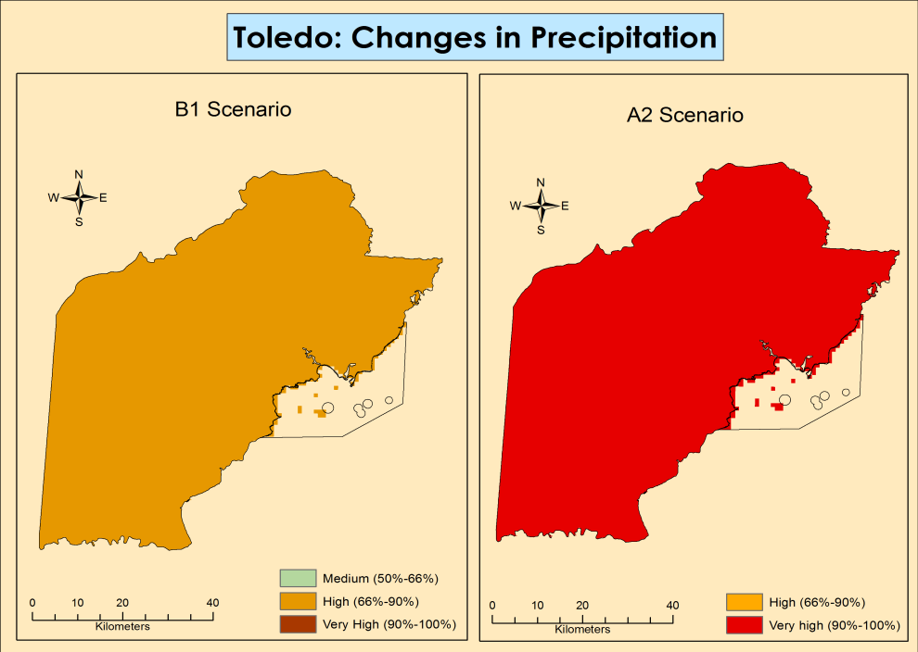
Figure 45: Changes in precipitation for B1 and A2 scenarios for Toledo
(Source: TNC, 2012)

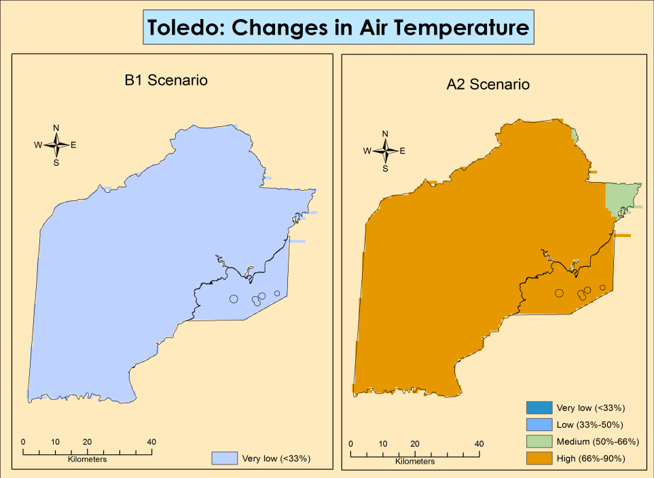
Figure 46: Changes in air temperature for B1 and A2 scenarios for Toledo
(Source: TNC, 2012)
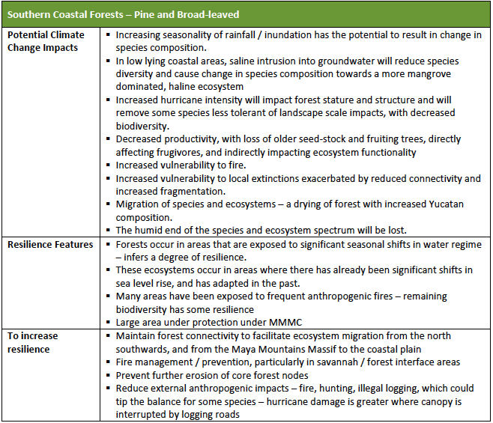
Figure 47: Climate change predictions and resilience for Southern coastal forests - pine and broad leaved
(Source: Wildtracks, 2013)

Sea level rise
Sea level rise will naturally only affect the coastal influenced areas: Corozal, Caye Caulker and Toledo. Along the coast of Corozal heading south of the country shows very high impact from sea level rise (Figure 48). Within the Corozal Bay there is low to medium impact from sea level rise predicted. For Caye Caulker the models show mostly low-medium impact from sea level rise with the exception of the southern tip of the Caye, which will have high impact from sea level rise (Figure 48). For Toledo, there is very low-low impact from sea level rise predicted, with areas around the Payne’s Creek National Park showing medium to high impact (Figure 48).

Figure 48: PREDICTED IMPACT OF SEA LEVEL RISE FOR ALL FOUR AREAS
(SOURCE: TNC, 2012)

ECONOMIC VALUATION OF ECOSYSTEM SERVICES

Five ecosystem services were selected to conduct an economic valuation of their contribution to the Belizean economy based on the existing literature, for the four study areas. These ecosystem services were selected according to the availability of information from previous studies and locally available updated statistics. These ecosystem services include: shoreline protection by mangroves tourism, fisheries, carbon, timber and water supply.

Shoreline Protection
Table 19 shows the economic contribution of mangroves using the Cooper et al., (2009) methodology with one data gap. We were unable to identify areas classified as vulnerable (based on the 25 year storm event) and so we made the assumption that all mangrove areas are vulnerable when making the calculations. Using this method, mangroves contribute US $24.6-$28.8 million in avoided damages (Table 19). This gives a higher range in value when compared to the results in Table 20, which presents the economic contribution of mangroves using the annual average value of mangroves (for avoided damages) of US$2775-4000, as determined by Cooper et al., (2009). This value was applied to mangroves in each study area to obtain the total value for each area. This is a much more conservative value than the first calculation above, following the methodology from Cooper et al., (2009) and it is therefore recommended that this latter value be used given the uncertainties in the original methodology.
Based on Table 20 therefore, mangroves contribute between a total of US $18.2-26.2 million annually for these four areas combined, with Toledo having the largest avoided damages value of US $11.4-$16.5 million due to the large extent of mangroves within 1 km of the coast in the district. Caye Caulker not surprisingly has the least value due to the small area of mangroves it possesses. However given the scale of tourism and urban development directly within 100 m of the coastline on Caye Caulker, the weighting of the US $0.6-$0.9 million is worth considerably more for this area in proportion to other areas.

Table 19: Avoided damage value of mangroves in the various study areas using Cooper et al., 2009 methodology
Area | Area classified as protected (sq ft) | % shoreline stability from mangroves | 2015 Land value per sq ft (US$) | Avoided damages value (US$) per year
Corozal | 238,624,053 | 19-24% | $5.74 | $10.1-$13.2 million
Caye Caulker | 23,358,762 | 24-25% | $12.35 | $2.7-$2.9 million
Punta Gorda | 442,746,545 | 20.7-22.5% | $3.2 | $11.7-$12.8 million
TOTAL |  |  |  | $24.6-$28.8 million

Table 20: Avoided damage value of mangroves in the various study areas using the average annual value of US$2,775 – $4,000 per ha per year for mangroves within 1 km of the coast (Cooper et al., 2009).
Area | Total Mangrove Area (Ha) | Average price per Ha ($US)/low | Average price per Ha ($US)/high | Avoided damage value (US$) per year
Corozal | 2216.89 | $2,775.00 | $4,000.00 | $6.2-$8.9 million
Caye Caulker | 217.01 | $2,775.00 | $4,000.00 | $0.6-$0.9 million
Toledo | 4113.25 | $2,775.00 | $4,000.00 | $11.4-$16.5 million
TOTAL |  |  |  | $18.2-$26.2 million

Tourism
Based on calculations and assuming that the average daily expenditure captures all expenses for visitors while in Belize, including visits to attractions and tours, the total revenue from tourism for the four study areas is US $96.7 million (Table 21). When broken down by area, Caye Caulker contributes the most in tourism revenue of US $63.7 million. This is not surprising considering that this location is a much more developed tourism destination than the other three areas.

Table 21: Total revenue from tourism for Caye Caulker, Corozal, Mountain Pine Ridge and Toledo.
Area | Number of visitors per year | Average daily expenditure (US$) | Average length of stay | Total Revenue from tourism ($US)
Caye Caulker | 83,361 | $114.05 | 6.7 days | $63,699,058
Corozal | 13,243 | $112.12 | 6.7 days | $9,948,195
San Ignacio | 12,118 | $145.18 | 6.7 days | $11,786,912
Toledo | 10,526 | $159.25 | 6.7 days | $11,230,979
TOTAL |  |  |  | $96,665,143

When the summaries for the 2015 exit surveys, commissioned by the IDB and the Ministry of Tourism, are examined it was noted that visitors to the Corozal area cited that 37.1% also dived/snorkeled while on their visit. Since there are no reef sites near the coast of Corozal it was assumed that these visitors also conducted dives/snorkels in northern reef sites, San Pedro and Caye Caulker. This is direct tourism revenue that also needs to be included in the estimated revenue from tourism for Corozal as this may not have been captured in the average daily expenditure for Corozal, since the visits to the cayes would be considered another destination. The data from the Statistical Institute of Belize was cited for a single destination. In determining the amount of visitors diving vs. snorkeling the estimates cited in Cooper et al., (2009) was used, where they used data from the VEMS survey of 59% snorkeling and 27% dive.
The total revenue was calculated using the percentage and number of visitors to Corozal that said they dived, adjusted by 20% to give a conservative estimate accounting for uncertainty in the data. Gross adjusted revenue from diving by visitors to Corozal less the GST is US $491,296 (Table 22 a) and gross adjusted revenue from snorkeling by visitors to Corozal is US $248,964 (Table 22 b). When this figure is combined with the tourism revenue from Table 21, the total direct impact form tourism for Corozal is US $10,688,454 (Table 23).

Table 22 a & b: Additional revenue generated from diving and snorkeling on northern cayes (San Pedro/Caye Caulker) by visitors to Corozal District.
Table 22a
Dive Type | Proportion dives sold | Number of divers | Number of dive trips (4/diver) | Average price of trip | Dive Revenue (US$) | Gear rental revenue (US$) | Dive revenue (20% less) (US$) | Gear rental revenue (20% less) (US$)
1 tank | 10% | 133 | 531 | $51.56 | $27,361 | $7,004 | $21,888 | $5,603
2 tank | 72% | 955 | 3820 | $109.04 | $416,578 | $50,430 | $333,262 | $40,344
3 tank | 10% | 133 | 531 | $161.56 | $85,728 | $7,004 | $68,583 | $5,603
long-distance | 8% | 106 | 424 | $240.62 | $102,142 | $5,603 | $81,714 | $4,483
TOTAL |  |  |  |  | $631,809 | $70,042 | $505,447 | $56,034
Less GST |  |  |  |  | $552,833 | $61,287 | $442,266 | $49,029
Total Revenue |  |  |  |  | $614,120 |  | $491,296

Table 22b
Snorkel trip | Proportion snorkel trips sold | Number of snorkelers | Number of snorkel trips (1.5/pers.) | Average price of trip | Snorkel revenue (US$) | Gear rental revenue (US$) | Revenue (20% less) (US$) | Gear rental revenue (20% less) (US$)
1/2 day | 55% | 1594 | 2391 | $47.89 | $114,529 | $8,370 | $91,623 | $6,696
full day | 35% | 1015 | 1522 | $103.65 | $157,733 | $5,326 | $126,187 | $4,261
long distance | 10% | 290 | 435 | $156.81 | $68,181 | $1,522 | $54,545 | $1,217
TOTAL |  |  |  |  | $340,444 | $15,218 | $272,355 | $12,175
Less GST |  |  |  |  | $297,889 | $13,316 | $238,311 | $10,653
Total Revenue |  |  |  |  | $311,205 |  | $248,964

We used the 1.2-1.4 multiplier cited by Cooper et al., (2009) in our calculations for indirect impact. The total indirect impact of tourism for all four areas was US $19.3-38.7 million for a total combined value of US $116.0-$135.3 million (Table 23) for both the direct and indirect impacts of tourism.
Table 23: Total direct and indirect impact of tourism for Caye Caulker, Corozal, Mountain Pine Ridge and Toledo
Area | Total Direct Impact of tourism (US$) | Total Indirect Impact of tourism (US$) | Total Impact (Direct and Indirect) (US$)
Caye Caulker | $63,699,058 | $12,739,812-$25,479,623 | 76.4-89.2 million
Corozal | $10,688,454 | $2,137,691-$4,275,382 | 11.9-13.9 million
Mountain Pine Ridge | $11,786,912 | $2,357,382-$4,714,765 | 14.1-16.5 million
Toledo | $11,230,979 | $2,246,196-$4,492,392 | 13.5-15.7 million
TOTAL | $97,405,403.00 | $19,481,081-$38,962,161 | $116.9-136.4 million

Coastal Ecosystem Services
The benefits transfer methodology from Hargreaves-Allen (2011) was used to determine the ecosystem services value of the major coastal ecosystems in the study areas: mangroves, coral reefs, seagrasses and estuaries. The biggest limitation with these calculations is the lack of data in determining the values per service for Belize. Values were projected as similar considering that the 2011 study was within the region at Exuma Cayes, Bahamas. However, there are large uncertainties in the total value of ecosystem services for these areas in Belize and these figures must be taken as very conservative, primarily since the values from Hargreaves-Allen (2011) were derived using previous literature on similar locations and are inherently data limited.

Mangroves
Based on the benefits transfer approach adopted by Hargreaves-Allen (2011) and using data values from similar regions and ecosystems, the total economic value of the ecosystem services provided by mangroves are shown below in Table 24 a-c for each study area. The highest value was for the Corozal district, due to this area having the largest amount of mangroves, with an estimated value of US$10,177,322.60. Toledo mangroves were valued US$3,688,171.07 and Caye Caulker only US$106,896.37. When compared to the value of just shoreline protection using the cost avoidance methodology ( Table 20), these estimates are significantly lower and may be greatly underestimated, especially since some services, such as flood control, waste treatment and nutrient cycling could not be quantified (Appendix 6 a)

Table 24 a-c: Mangrove Ecosystem Service Values for Corozal, Caye Caulker and Toledo
Table 24a
Ecosystem Service - Corozal | US$ value /km2 /year (2009) | Likely accuracy | Value (US$)
Fisheries support | 8,100 | High | $1,673,460.00
Biodiversity | 7,060 | High | $1,458,596.00
Water filtration | 943 | High | $194,823.80
Coastal protection | 9,100 | Low | $1,880,060.00
Raw materials | 4,980 | Medium | $1,028,868.00
Amenity | 1,210 | Low | $249,986.00
Carbon storage | 12,568 | Medium | $2,596,548.80
Recreational CS | 3,300 | Medium | $681,780.00
TOTAL | 49,261 |  | $10,177,322.60
Table 24b
Ecosystem Service – Caye Caulker | US$ value /km2 /year (2009) | Likely accuracy | Value (US$)
Fisheries support | 8,100 | High | $17,577.00
Biodiversity | 7,060 | High | $15,320.20
Water filtration | 943 | High | $2,046.31
Coastal protection | 9,100 | Low | $19,747.00
Raw materials | 4,980 | Medium | $10,806.60
Amenity | 1,210 | Low | $2,625.70
Carbon storage | 12,568 | Medium | $27,272.56
Recreational CS | 3,300 | Medium | $7,161.00
TOTAL | 49,261 |  | $106,896.37
Table 24c
Ecosystem Service - Toledo | US$ value /km2 /year (2009) | Likely accuracy | Value
Fisheries support | 8,100 | High | $606,447.00
Biodiversity | 7,060 | High | $528,582.20
Water filtration | 943 | High | $70,602.41
Coastal protection | 9,100 | Low | $681,317.00
Raw materials | 4,980 | Medium | $372,852.60
Amenity | 1,210 | Low | $90,592.70
Carbon storage | 12,568 | Medium | $940,966.16
Recreational CS | 3,300 | Medium | $247,071.00
TOTAL | 49,261 |  | $3,688,171.07

Seagrass Beds
The value of ecosystem services provided by seagrass beds was calculated using the same methodology as above (Hargreaves-Allen, 2011). The total economic value of ecosystem services provided by seagrass beds are shown in Table 25a-c. The highest value was once again from the Corozal district (Table 25a), due the extensive area of seagrass within the Corozal Bay Wildlife Sanctuary, with an estimated value of US$33,487,165.60. Toledo was next with US$13,217,646.40 and Caye Caulker with a value of US$604,578.10 (Table 25 b-c). Similar to mangroves, it is assumed that this methodology greatly underestimates the full value of seagrass beds since there were gaps in data for the value of some services (Appendix6 b).
Table 25 a-c: Seagrass Ecosystem Service Values for Corozal, Caye Caulker and Toledo
Table 25a
Ecosystem Service - Corozal | US$ value /km2 /year (2009) | Likely Accuracy | Value (US$)
Raw materials | 290 | Medium | $210,424.00
Fisheries support | 12,600 | Medium | $9,142,560.00
Carbon sequestration | 241 | Medium | $174,869.60
Nursery function | 16,200 | Low | $11,754,720.00
Waste treatment | 16,820 | Low | $12,204,592.00
TOTAL | 46,151 |  | $33,487,165.60
Table 25b
Ecosystem Service - Caye Caulker | US$ value /km2 /year (2009) | Likely Accuracy | Value (US$)
Raw materials | 290 | Medium | $3,799.00
Fisheries support | 12,600 | Medium | $165,060.00
Carbon sequestration | 241 | Medium | $3,157.10
Nursery function | 16,200 | Low | $212,220.00
Waste treatment | 16,820 | Low | $220,342.00
TOTAL | 46,151 |  | $604,578.10
Table 25c
Ecosystem Service - Toledo | US$ value /km2 /year (2009) | Likely Accuracy | Value (US$)
Raw materials | 290 | Medium | $83,056.00
Fisheries support | 12,600 | Medium | $3,608,640.00
Carbon sequestration | 241 | Medium | $69,022.40
Nursery function | 16,200 | Low | $4,639,680.00
Waste treatment | 16,820 | Low | $4,817,248.00
TOTAL | 46,151 |  | $13,217,646.40

Estuaries
Although there is very limited spatial and published data on estuaries in Belize, their importance in regards to ecosystem services and their economic value is recognized. Using the benefits transfer methodology Hargreaves-Allen (2011), the value of ecosystem services provided by estuaries in the two study areas: Corozal and Toledo, were calculated (Table 26 a-b). The spatial layer – Ecosystems 2011, did not highlight estuarine areas. This had to be interpreted from wetland areas that included estuaries based on expert knowledge of the specific area. This most likely did not capture all estuarine areas for the analysis and may be underestimating the area. The Corozal district had the highest value for estuaries owing to the large network of wetlands along the coast linked to watersheds, US$18,232,483.00 (Table 10a). Toledo’s estuaries along the Payne’s Creek/Port Honduras area had a value of US$4,843,736.90 (Table 26b).
Table 26 a-b: Estuary Ecosystem Service Values for Corozal, Caye Caulker and Toledo
Table 26a
Ecosystem Service - Corozal | US$ value /km2 /year (2009) | Likely accuracy | Value (US$)
Raw materials | 3570 | Medium | $831,810.00
Biological control | 111.5 | Medium | $25,979.50
Fisheries support | 23,218 | Medium | $5,409,794.00
Waste treatment | 47,242 | Medium | $11,007,386.00
Subtotal | 74,142 | $17,275,086.00
Fishing CS | 113/day 9 | High
Subtotal | 4,109 |  | $957,397.00
Total | 78,251 |  | $18,232,483.00
Table 26b
Ecosystem Service - Toledo | US$ value /km2 /year (2009) | Likely accuracy | Value (US$)
Raw materials | 3570 | Medium | $220,983.00
Biological control | 111.5 | Medium | $6,901.85
Fisheries support | 23,218 | Medium | $1,437,194.20
Waste treatment | 47,242 | Medium | $2,924,279.80
Subtotal | 74,142 | $4,589,389.80
Fishing CS | 113/day 9 | High
Subtotal | 4,109 |  | $254,347.10
Total | 78,251 |  | $4,843,736.90

Coral Reefs
There are small coral reef areas within the Caye Caulker and Toledo areas that contain significant ecosystem services for these areas despite their size. Applying the Hargreaves-Allen (2011) benefits transfer methodology, the value of ecosystem services from these areas was calculated. Both areas had less than 15 km² of coral reefs with a value between US$1,000,000.00-1,830,000.00 (Table 27a-b). As in the case of the other ecosystems presented above, the value of the coral reefs are conservative and quite likely greatly underestimated, as there are significant gaps in information for the various services with data relevant to Belize (Appendix 6c). When compared with just estimates of diving, snorkeling and total impact from tourism at Caye Caulker (Table 22 and Table 23), this value of US$1.8 million is very low and suggests major inconsistencies in the valuation based on data limitations.
Table 27 a-b: Coral Reef Ecosystem Service Values for Corozal, Caye Caulker and Toledo
Table 27a
Ecosystem Service – Caye Caulker | US$ value / km2/ year (2009) | Likely accuracy | Value (US$)
Waste treatment | 8,300 | Medium | $116,200.00
Biological control | 700 | Medium | $9,800.00
Habitat refugia | 1,000 | Medium | $14,000.00
Raw materials | 3,860 | Medium | $54,040.00
Cultural value | 140 | Low | $1,960.00
Coastal protection | 20,000 | Medium | $280,000.00
Fisheries production | 20,600 | Medium | $288,400.00
Biodiversity | 4000 | Low | $56,000.00
Sub total | 58,600 | $820,400.00
Individual values (per person / day) | US$ value per user (2009)
Dive and snorkel recreation (48,000 days) | 227 / day 6 | High
Sports fishing (7,500 days) | 113 / day 7 | High
Sub total | 72,046 | $1,008,644.00
Total | 130,646 | $1,829,044.00
Table 27b
Ecosystem Service – Toledo | US$ value / km2/ year (2009) | Likely accuracy | Value (US$)
Waste treatment | 8,300 | Medium | $66,732.00
Biological control | 700 | Medium | $5,628.00
Habitat refugia | 1,000 | Medium | $8,040.00
Raw materials | 3,860 | Medium | $31,034.40
Cultural value | 140 | Low | $1,125.60
Coastal protection | 20,000 | Medium | $160,800.00
Fisheries production | 20,600 | Medium | $165,624.00
Biodiversity | 4000 | Low | $32,160.00
Sub total | 58,600 | $471,144.00
Individual values (per person / day) | US$ value per user (2009)
Dive and snorkel recreation (48,000 days) | 227 / day 6 | High
Sports fishing (7,500 days) | 113 / day 7 | High
Sub total | 72,046 | $579,249.84
Total | 130,646 | $1,050,393.84

Carbon
The ability of Belize’s forests to sequester and store carbon and the potential value of this ecosystem service has been under discussion since the mid-late 1990’s, when the first carbon sequestration project for the region was set up at the Rio Bravo Management and Conservation Area in Northern Belize. However, the idea of carbon and Reduced Emissions for Deforestation and Forest Degradation (REDD) as a sustainable development option for the country has only become more widespread in the last few years. Figure 49 and Figure 50 show differential distributions in above ground carbon (AGC) for Corozal, and the Chiquibul including its buffer areas combined with Toledo, respectively. Figure 50 shows the Chiquibul and Toledo areas combined since these are contiguous and illustrating them together allows viewing of a more holistic picture.
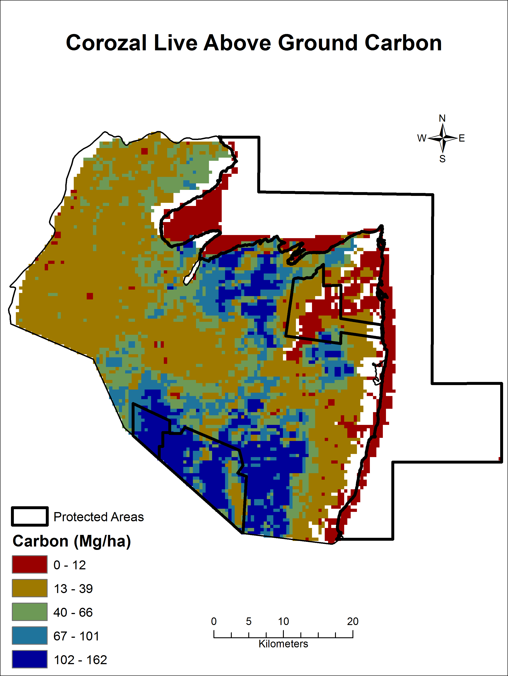
Figure 49: ABOVE GROUND CARBON DISTRIBUTION FOR COROZAL AREA
(SOURCE: BACCINI ET AL.)
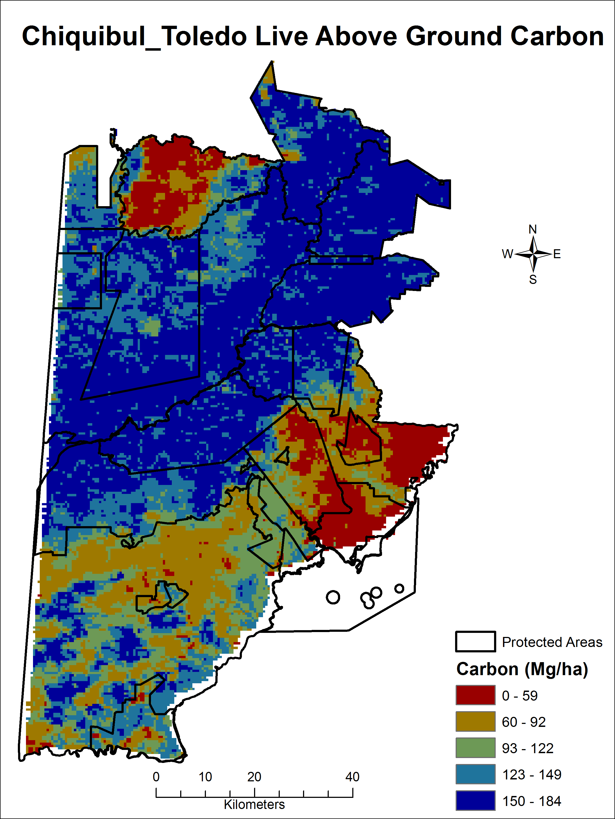
Figure 50: ABOVE GROUND CARBON FOR THE CHIQUIBUL (INCLUDING BUFFER AREAS) AND TOLEDO
(SOURCE: BACCINI ET AL.)

Carbon stocks have a direct proportional relationship with biomass and therefore, Figure 49 clearly illustrates that the highest carbon stocks in Corozal are currently located in the Freshwater Creek Forest Reserve area and adjacent private lands, as well as in the north central portion of the District where communities such as Chunox are located. Figure 50 illustrates that the highest above ground carbon stocks are located partially in the Chiquibul but especially in the buffer broad leaf forest reserve areas (Sibun and Sittee Forest Reserves and part and Maya Mountain Forest Reserve), national parks (Cockscomb Basin Wildlife Sanctuary) and the Bladen Nature Reserve. The MPR and Deep River Forest Reserves, comprised mostly of pine forest/pine savanna vegetation, have much lower carbon stocks as do the now heavily denuded Vaca Forest Reserve and Caracol Archaeological Reserve.
Table 28 shows the actual figure values for average biomass, AGB, below ground carbon (BGB) and total biomass for the same areas illustrated in Figure 49 and Figure 50. Average biomass per hectare is highest for the Chiquibul and buffer areas.
Table 28: Biomass values for Corozal, Chiquibul and buffer areas, and Toledo
Region | Area (ha) | Average Biomass (Mg/ha) | AGB (Mg) | BGB (Mg) | Total Biomass (Mg)
Corozal | 190,786 | 4.38 | 835,837 | 91,200 | 927,037
Chiquibul & buffer areas including Mountain Pine Ridge Forest Reserve | 348,127 | 13.2 | 4,597,226 | 415,844 | 5,013,070
Toledo | 430,874 | 9.82 | 4,231,681 | 386,283 | 4,617, 964

Table 29 illustrates the total amount of carbon per geographic area of interest and its estimated dollar value. The Chiquibul-Mountain Pine Ridge area and buffer areas show the highest values, followed by Toledo and then Corozal. The ranges of the estimated total carbon values are large but reflect the current variability in carbon market prices.
Table 29: Total carbon and estimated total carbon values for Corozal, Chiquibul INCLUDING ITS buffer areas and Toledo
Region | Total Carbon (Tonnes)[1] | Estimated Average Total Carbon Value (million US$) | Estimated Range of Total Carbon Value (million US$)
Corozal | 463,518 | 2.22 | 0.93 – 6.03
Chiquibul & buffer areas including Mountain Pine Ridge Forest Reserve | 2,506,535 | 12.03 | 5.01 – 32.58
Toledo | 2,308,982 | 11.08 | 4.62 – 30.02

Timber
Figure 51 to Figure 53 summarize the main areas within each of the geographic areas of interest (except Caye Caulker) with timber harvesting potential. Figure 51 shows the Corozal area for which the the total area with timber potential amounted to 47,971 hectares. Figure 52 illustrates the broadleaf and pine area with harvestable potential in the Chiquibul Forest; the total area of broadleaf forest was 47,193 hectares and total area of pine forest was 8,241 hectares. For the Mountain Pine Ridge Forest Reserve the average per hectare stocking of recoverable pine timber estimated from the sample data was 17,000 bdft per hectare. In the entire area of pine forest in the Reserve (8,241 hectares) the estimated total recoverable sawn lumber was 140,097,000 bdft. Figure 53 shows the timber areas within Toledo; the average per hectare stocking of recoverable pine timber estimated from the sample data was 1,248 bdft per hectare. In the entire area of productive pine forest in Toledo (4,281 hectares) the estimate total recoverable sawn lumber was 5,342,688 bdft. For the Southern Coastal Plains the area of broadleaf forest was 117,128 hectares and total area of Pine forest was 4,281 hectares.
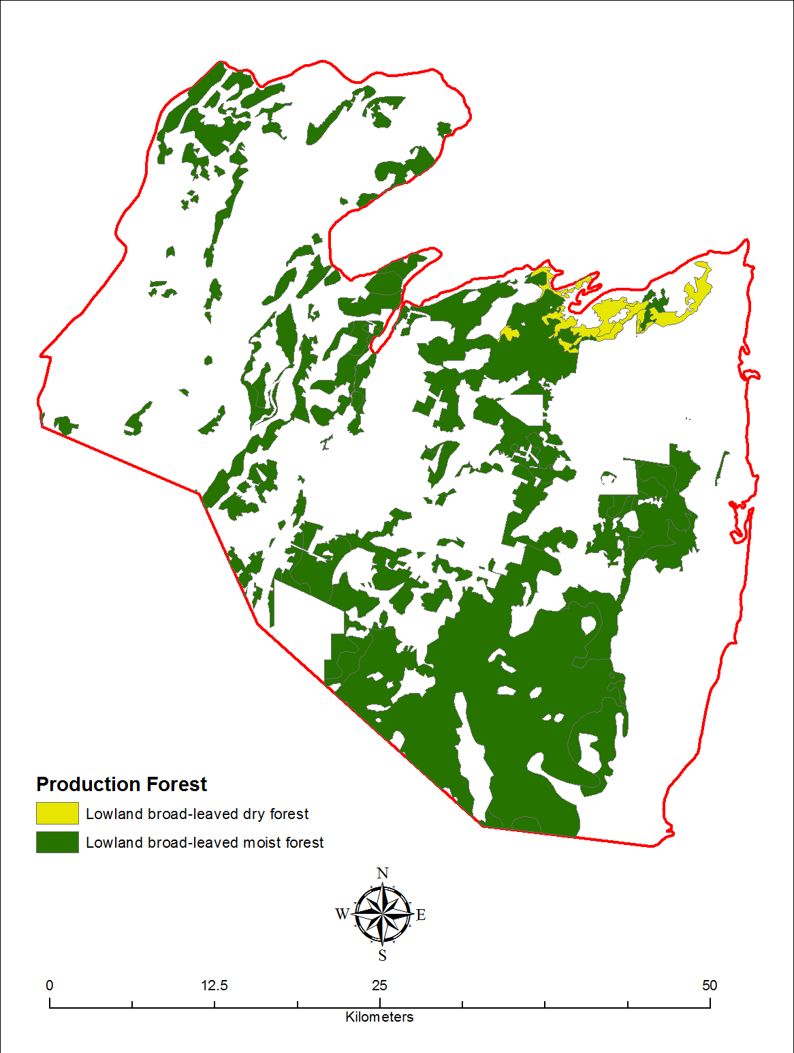
Figure 51: Timber production forests in the Corozal Study Area based on - species composition of the ecosystem and legal status of the land

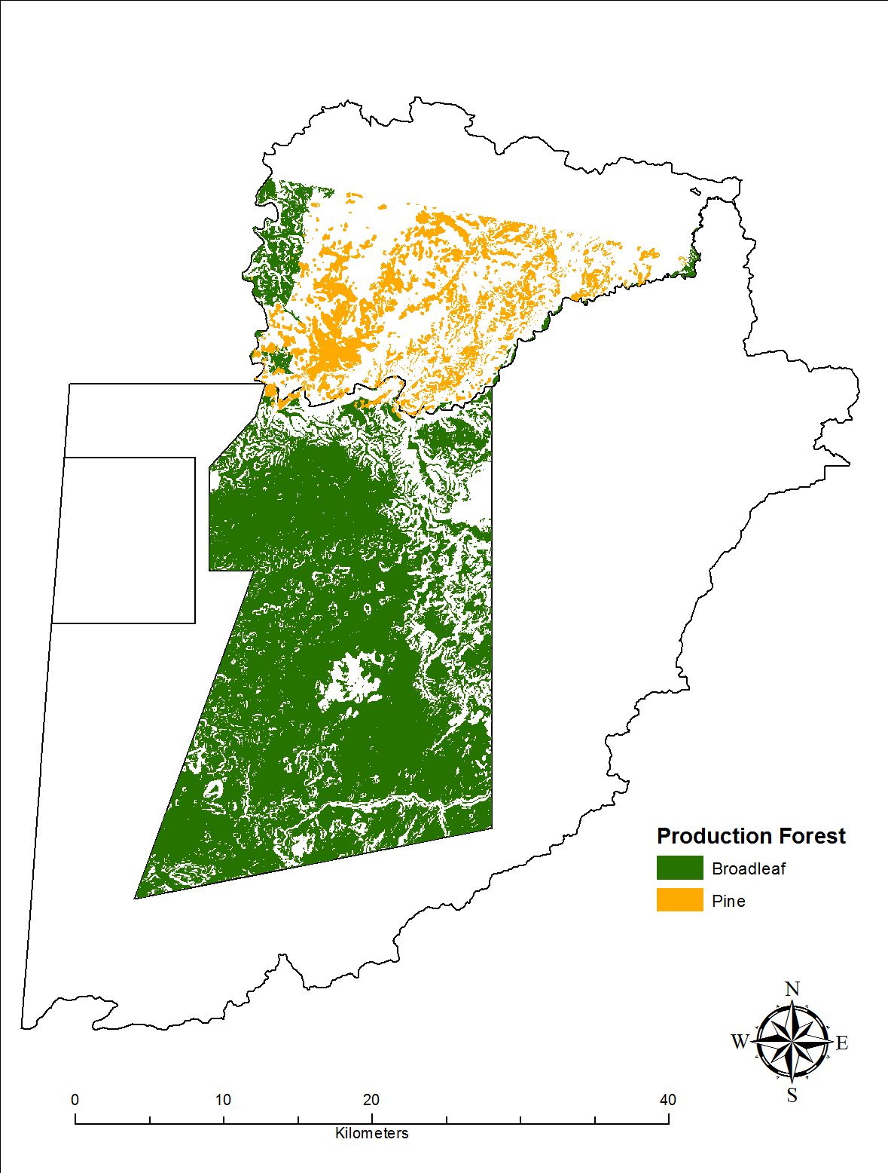
Figure 52: Timber production forests in the Chiquibul-MPR Complex based on - species composition of the ecosystem, legal status of the land and slope
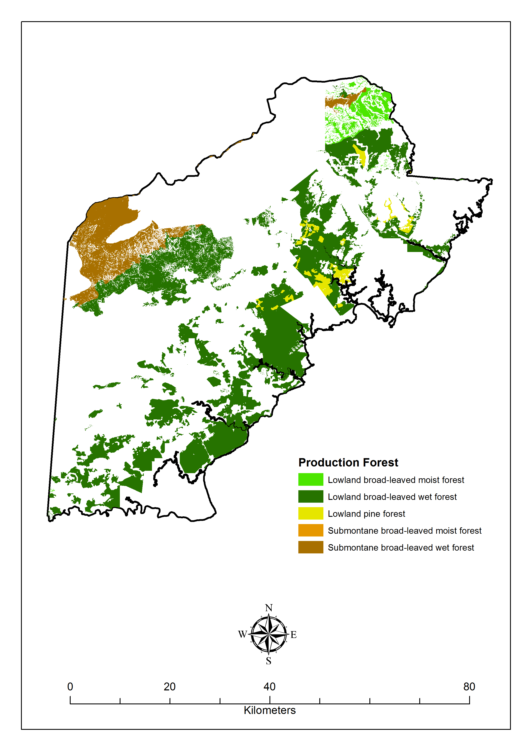
Figure 53: Timber production forests in the toledo study area based on - species composition of the ecosystem, legal status of the land and slope of the land

In terms of timber value estimated based on timber stocking in the areas of interest, Table 30 illustrates the current value of timber stocks in the Corozal area. The total estimated value of timber stocks or hardwoods in this area is between 22.35 and 23.68 million BZD depending on whether only local or export markets are considered. The only current export markets considered in this assessment are for prime species such as mahogany and cedar. Table 31 below shows the results for the Chiquibul-MPR forest based on species group. The total estimated value of timber stocks in this area is between 442.23 and 461.58 million BZD depending on whether only local or export markets are considered for prime species. Approximately 64-66 percent of the total current timber value in the Chiquibul-MPR complex is from pine in the Mountain Pine Ridge Forest Reserve. Table 32 illustrates the economic valuation results for timber in Toledo. The total estimated value of timber stocks in this area is between 439.54 and 550.66 million BZD depending on whether only local or export markets are considered for prime and elite species such as rosewood. Of the areas assessed Toledo has the most value in timber stocks and most of this is concentrated around select and elite species.

Table 30: total current values for timber stocks in Corozal Area
Species group | Total current timber value (BZ $) | Total current timber value with export (BZ $)
Elite | $ 15,801,407 | $ 15,801,407
Prime | $ 2,346,693 | $ 3,677,087
Select | $ 4,202,691 | $ 4,202,691
TOTAL | $ 22,350,792 | $ 23,681,185

Table 31: Total current values for timber stocks in the Chiquibul-MPR Complex
Species group | Total current timber value (BZ $) | Total current timber value with export (BZ $)
Elite | $ 33,228,964 | $ 33,228,964
Pine | $ 294,203,700 | $ 294,203,700
Prime | $ 35,947,701 | $ 55,303,461
Select | $ 78,846,108 | $ 78,846,108
TOTAL | $ 442,226,473 | $ 461,582,233

Table 32: Total current values for timber stocks in Toledo Area
Species group | Total current timber value (BZ $) | Total current timber value with export (BZ $)
Elite | 92,133,240 | 198,622,537
Pine | 11,219,644 | 11,219,644
Prime | 8,163,039 | 12,790,855
Select | 339,245,320 | 339,245,320
TOTAL | 439,541,599 | 550,658,712

Water Supply

Table 33 and Table 34 summarize the results of the assessment of the annual water supply and its value in three of the study areas: Corozal, Chiquibul-MPR Complex and Toledo. Since water supply estimates are based on surface water supply by rivers, Caye Caulker was not considered. Table 33 shows the water supply by watershed and total water supply in each of the study areas. The Corozal area has the smallest water supply at 40,344.56 million USG and Toledo has the highest water supply at 2,529, 208.80 million gallons. The Chiquibul-MPR complex has a water supply of 315, 230.44 million USG.

Table 33: Water supply by watershed in three study areas - Corozal, Chiquibul-MPR Complex and Toledo
Study Area | Watershed | Total Water Supply  (million L) | Percentage of watershed within study area (%) | Water supply in study area  (million USG)
Corozal | Barracouta Pond | 95.32 | 99.69 | 25.10
 | Rio Hondo | 657,758.93 | 12.60 | 21,893.95
 | New River | 389,318.45 | 14.25 | 14,655.70
 | Northern River | 23,233.06 | 12.84 | 788.06
 | Freshwater Creek | 12,037.08 | 93.77 | 2,981.75
 | TOTAL | 1,082,442.84 | - | 40,344.56
Chiquibul-MPR Complex | Belize River | 3,306,398.81 | 36.09 | 315,230.99
 | TOTAL | 3,306,398.81 |  | 315,230.99
Toledo | Deep River | 265,573.21 | 99.38 | 69,722.03
 | Golden Stream | 207,959.23 | 99.96 | 54,915.03
 | Middle River | 35,123.81 | 99.81 | 9,261.10
 | Moho River | 2,463,282.74 | 99.75 | 649,103.50
 | Monkey River | 28,674.64 | 77.30 | 5,855.50
 | Pine Ridge Creek | 203.23 | 99.84 | 53.60
 | Rio Grande | 1,272,270.83 | 99.86 | 335,627.79
 | Sarstoon River | 4,118,720.24 | 97.94 | 1,065,636.72
 | Sennis River | 2,425.03 | 97.42 | 624.10
 | Temash River | 1,283,767.86 | 99.74 | 338,253.77
 | Big Creek | 3,250.09 | 18.13 | 155.66
 | TOTAL | 9,681,250.91 | - | 2,529,208.80
- 1 L =0.264172 USG

Table 34 shows the estimated current and net present values for the total water supply in the study areas assessed. Total current values based on both rural and urban water rates were estimated, with lower estimates resulting from using rural rates. The range of current values estimated for the study areas are as follows: 201.72-351.80 million BZD for Corozal; 1,576.15-2,748.81 BZD for Chiquibul-MPR complex and 16,945.70-22,054.70 for Toledo. Net Present Values were lower than the lowest total value estimates and were 194.46 million BZD for Corozal; 1,519.41 million BZD for Chiquibul-MPR Complex and 12,190.79 million BZD for Toledo.

Table 34: Current and net present value of water supply in the three study areas
Study Area | Water supply in study area  (million USG) | Total Current Value (million BZD) based on rural rates | Total Current Value (million BZD) based on urban rates | Total Net Present Value (million BZD)
Corozal | 40,344.56 | 201.72 | 351.80 | 194.46
Chiquibul-MPR complex | 315,230.99 | 1,576.15 | 2,748.81 | 1,519.41
Toledo | 2,529,208.80 | 16,945.70 | 22,054.70 | 12,190.79
.

THREATS TO BIODIVERSITY AND ECOSYSTEM SERVICES IN BELIZE

Within the defined study areas of Corozal, Caye Caulker, Chiquibul-MPR Complex and Toledo there are varying ecosystems, each with specific ecological and economic significance. Although these study areas contain protected areas and have been recognized for their economic significance based on the services they provide, they are nevertheless threatened by natural disasters and anthropogenic activities. Information on the major threats to the ecosystems within these study areas was obtained from the management plans of the protected areas and other ecological studies conducted. The major threats are summarized in Table 35 below for each major ecosystem type, with their associated ecological and economic significance. The main threats affecting the areas were similar, with deforestation, coastal development, pollution, agricultural and land runoff, illegal harvesting, natural disasters and illegal/unsustainable fishing among the most common.
Table 35: Threats to major ecosystems within Corozal, Caye Caulker, Chiquibul-MPR Complex and Toledo.
Ecosystem | Ecological Significance | Economic / welfare significance | Threats
Beaches | Habitat for borrowing littoral species;  Nesting area especially for endangered species such as the American Saltwater Crocodile and marine turtles | Recreation  Tourism | Natural Disaster  Erosion  Pollution
Coral Reefs | Biologically diverse aquatic ecosystem;  Habitat for commercially important species of finfish, conch, lobster;  Habitat for endangered species of fish, mammals and corals; Shoreline protection | Commercial and Subsistence Fishing  Eco-Tourism  Formation of beaches  Protection from natural disaster | Coast development  Dredging  Illegal and Unsustainable fishing  Invasive species (lionfish)  Natural Disasters  Oil Spills/Leaks  Physical damage from tourist activities  Pollution and runoff (including sewage)  Vessel groundings
Estuaries | Habitat for marine, terrestrial and migratory species;  Nursery and breeding habitat especially for endangered species such as the West Indian Manatee, Bull Shark;  Flood Control;  Primary Production | Commercial and Subsistence Fishing  Recreation  Sports Fishing | Coastal Development  Illegal and Unsustainable fishing  Illegal poaching  Land Clearing adjacent to areas (mangroves)  Pollution and runoff from agriculture  Coastal Erosion
Fresh water Ecosystems | Habitat for aquatic species including endemic species  Temporary Habitat for migratory species of birds (lagoons);  Flood Control;  Primary Production | Fishing  Gold Mining | Agricultural runoff  Erosion of riverine banks  Improper garbage and sewage disposal  Introduction of exotic/invasive species
Low Land Broad-leaved Forest | Biologically Diversity;  Carbon sequestration;  Corridor connectivity;  Habitat for endemic species;  Habitat for species including those of international concern;  Primary production;  Protection of the headwaters of many watersheds | Eco-Tourism  Game Species  Granite  Medicinal Plants  Non-timber forest products (xaté, palms, seeds)  Recreational Use  Timber extraction  Traditional Use products | Agricultural Incursions  Deforestation  De-reservation of protected areas of land  Habitat fragmentation  Illegal harvesting and hunting  Mining and Oil exploration  Unsustainable extraction  Military training exercises
Low Land Pine Forest | Habitat for species;  Globally endangered ecosystem;  Support of distinctive bird fauna;  Nesting for parrots | Timber  Eco-Tourism | Agricultural Incursions  Deforestation  Fire  Southern Pine Bark Beatle infestations  Unsustainable and Illegal Logging  Illegal hunting and harvesting of species (parrots)
Mangroves/Littoral Forest | Carbon sequestration;  Filtration and water quality control;  Habitat for marine and terrestrial species;  Nursery and breeding habitat;  Nutrient cycling;  Productivity;  Shoreline protection | Commercial and Subsistence Fishing  Erosion Control  Harvesting of native palms and coconuts  Recreational Fisheries (cayes)  Shoreline Stabilization | Coastal Development for tourism  Deforestation  Improper sewage disposal  Invasive species  Poaching  Pollution and runoff from agriculture/aquaculture  Coastal Erosion
Savannah | Flood Control  Water Retention  Endemic Biodiversity | Subsistence hunting  Non-timber Forest Product Extraction  Timber (Pine)  Eco-Tourism | Agricultural incursions  Fire  Deforestation  Urban & rural expansion
Seagrass Beds | Carbon sequestration; Habitat and food source for species of international importance (West Indian Manatee);  Habitat for species including commercial species;  Nursery habitat;  Nutrients and productivity | Commercial and Subsistence fisheries  Filtration of sediments  Stabilization of shoreline | Improper sewage disposal  Dredging  Improper dumping of garbage  Oil spills/leaks
Shrubland | Habitat for species including those of international importance  Rich soils | Hunting in adjoining water systems  Farming | Fire  Flooding  Erosion  Anthropogenic activities
Yucatan Dry Forest  SNR | Forest connectivity;  Habitat for flora and fauna including endemic species;  Temporary habitat for migratory species of birds;  Unique ecosystem in Belize | Commercial hardwood  Game Species  Medicinal Plants  Non-timber products | Illegal logging and hunting  Natural Disasters  Oil exploration  Unsustainable Harvesting
Brackish Saline Lake  Shipstern Nature Reserve | Flood regulation;  Habitat and feeding ground for fauna including migratory and endangered species;  Nutrient cycling;  Water quality control | Subsistence fishing | Unsustainable harvesting

Table 36: FIRE RISK FOR COROZAL AND CHIQUIBUL-TOLEDO AREA
Destination | Total Area at Risk (ha) | Area at High Risk (ha) | Percentage at High Risk
Corozal | 192594.23 | 15069.31 | 0.0008 %
Chiquibul-Toledo | 784361.31 | 58420.04 | 7.45 %

Table 37: DEFORESTATION OF COROZAL, CHIQUIBUL-MPR COMPLEX AND TOLEDO AREA
Destination | Forest 2010 (ha) | Forest 2014 (ha) | Deforested 2010-2014 (ha)
Corozal | 72729.55 | 65076.79 | 7652.76
Chiquibul – MPR | 203647.08 | 194529.61 | 9117.47
Toledo | 309537.78 | 302936.64 | 6601.14

Corozal

Habitat fragmentation and particularly deforestation for agriculture and development pose serious threats to biodiversity. Figure 54 provides the hotspots for deforestation from 2010-2014. For the size of deforested area in Corozal see Table 37. Illegal use of the resources, such as logging, hunting and fishing have long been illicit activities conducted within reserves by buffer communities as well communities not within the vicinity, such as those near Shipstern Nature Reserve. Earlier fishing pressures from the local communities have resulted in decreased population of manatees and smalltooth sawfish (Wildtracks, 2011). Agricultural incursions for sugarcane plantations are fragmenting the forest of Fresh Water Creek Forest Reserve, thereby reducing its resilience to climate change and increasing susceptibility to fire. Figure 55 details the fire risk for the Corozal Area with noted hotspots within and around agricultural lands and communities (see Table 36 for area and percentage at high risk). Wide range species such as the white-lipped peccary depend on the continuous forest of reserves within the area. Hence reduced forest connectivity could endanger their survival and existence in northern Belize. Further de-reservation of Fresh Water Creek Forest Reserve would also compound the threats on biodiversity and the integrity of the ecosystem. Similarly, threats to biodiversity at Honey Camp National Park are a result of agricultural expansion in the adjacent areas, hunting and fishing (APAMO, 2011). The critically endangered Central American River Turtle, which was once found in HCNP, were absent from 2010 surveys. Fish stock and game species have also significantly decreased in the national park and can be attributed to illegal hunting and fishing.

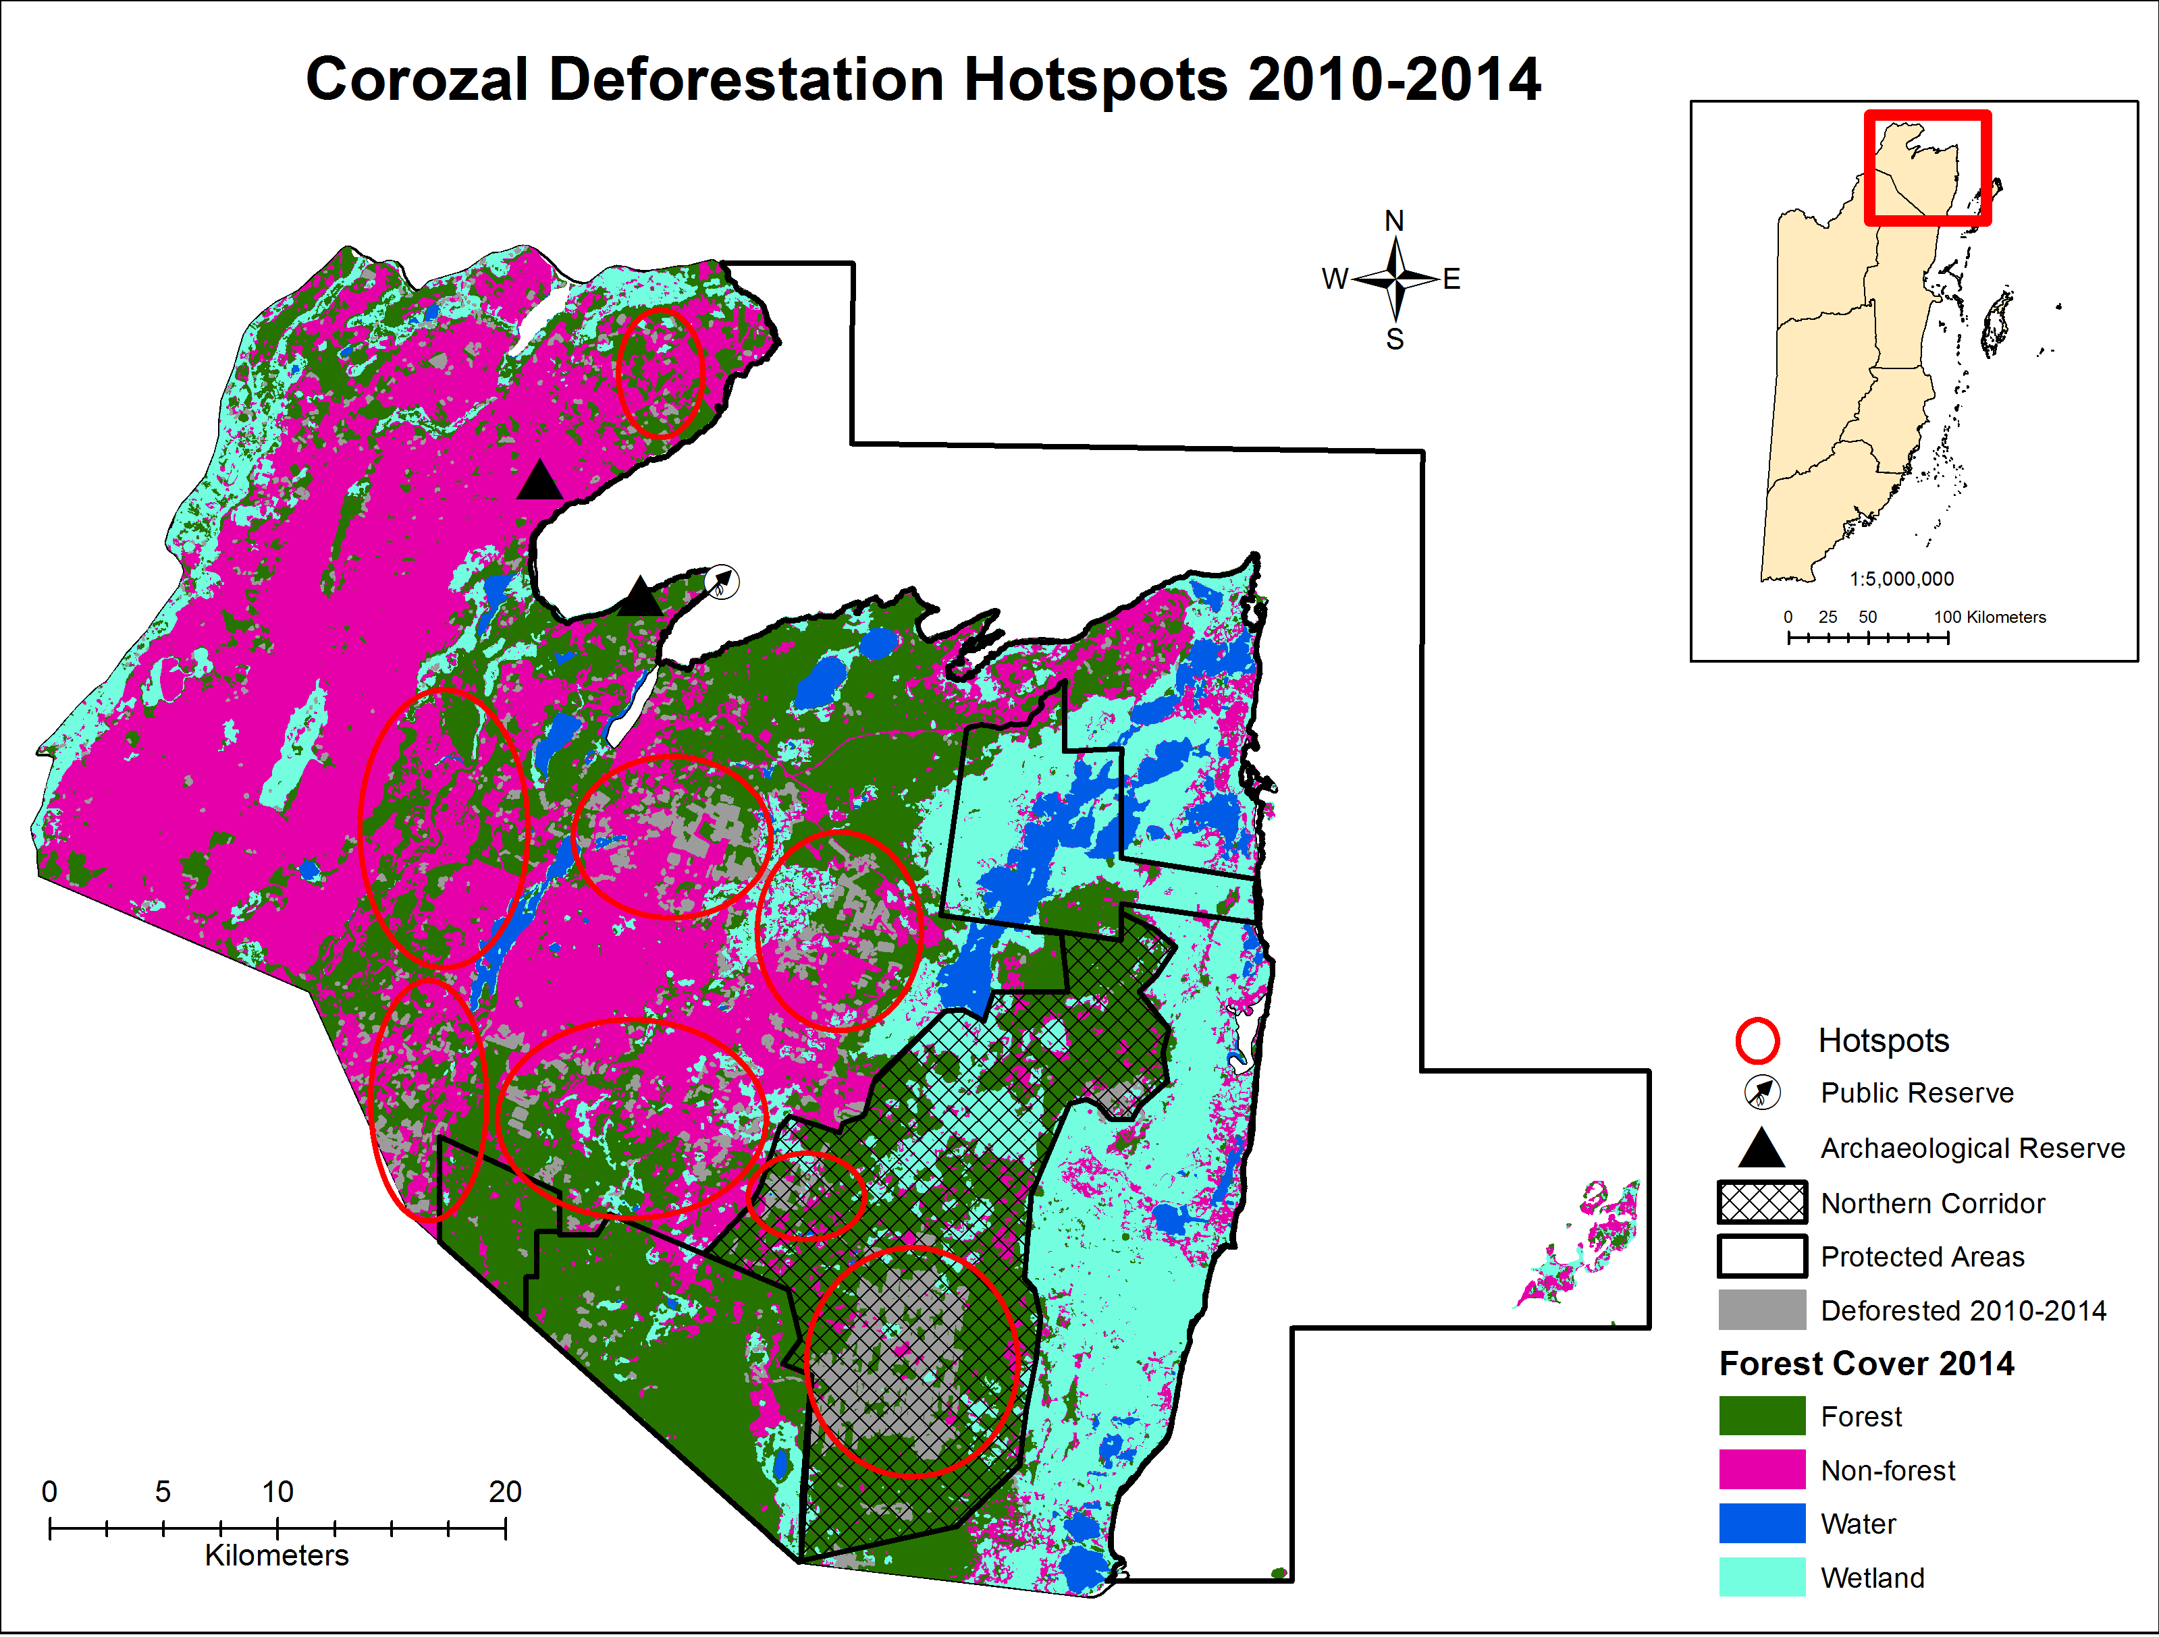
Figure 54: Deforestation hotspots in the Corozal Area for 2010-2014
(SOURCE: BASED ON FOREST COVER 2014)
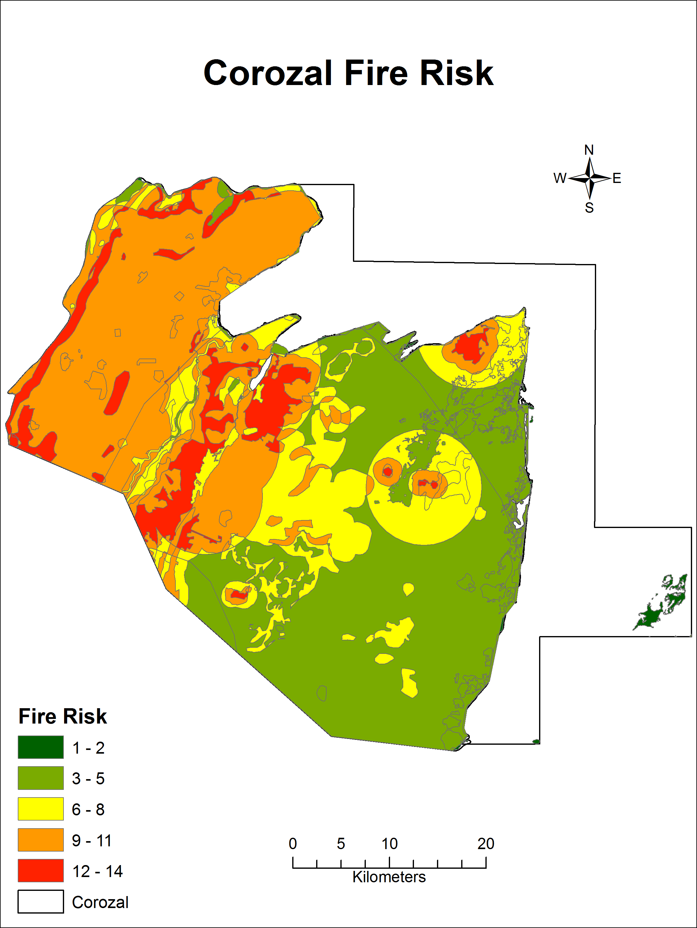
Figure 55: FIRE RISK FOR COROZAL AREA
(SOURCE: BERDS, 2004)
In the Corozal Bay Wildlife Sanctuary the greatest threats come from pollution due to agricultural and land runoff and from clearing of mangroves for coastal development. Data from the Coastal Zone Management Plan on the impact of human use on the marine environment shows the influence of agricultural runoff (Figure 56) but also highlights coastal fishing and dredging as other major impacts. Oil exploration is identified as a threat to northern Corozal (Figure 56). In terms of tourism use and potential impacts, this is limited to areas in and around Corozal town and Sarteneja with marine recreation concentrated in the coastal waters off Sarteneja (Figure 57). Coastal erosion is also a risk for areas, due to the lack of available data for mapping, coastal erosion was not mapped as in the case of other threats. Sea level rise is a significant threat to the Corozal district, as Figure 58 shows medium to very high vulnerability to sea level rise for the entire district.

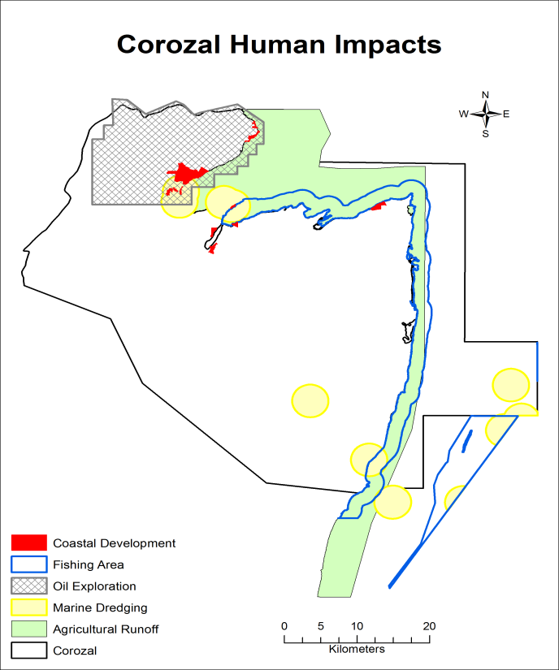
Figure 56: Impact of human activities in the Corozal Area
(SOURCE: CZMAI, 2010)
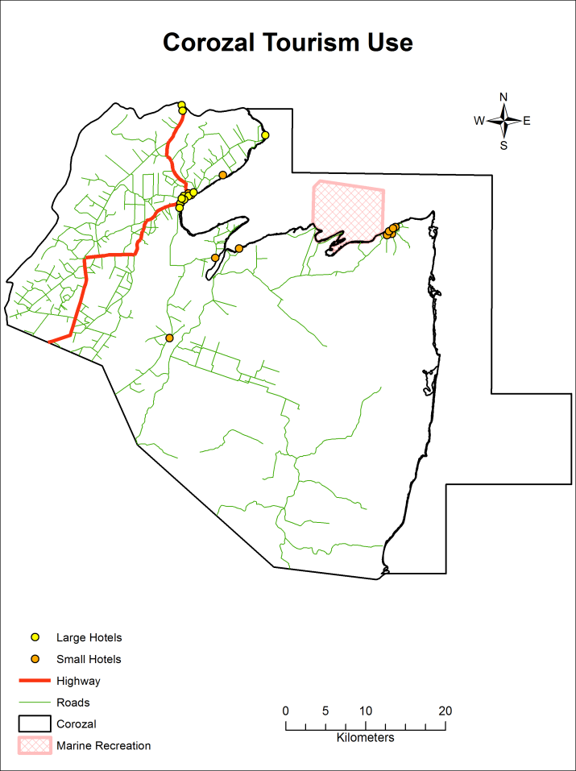
Figure 57: Tourism USe in the Corozal Area
(SOURCE: MTCCA, 2012/13)
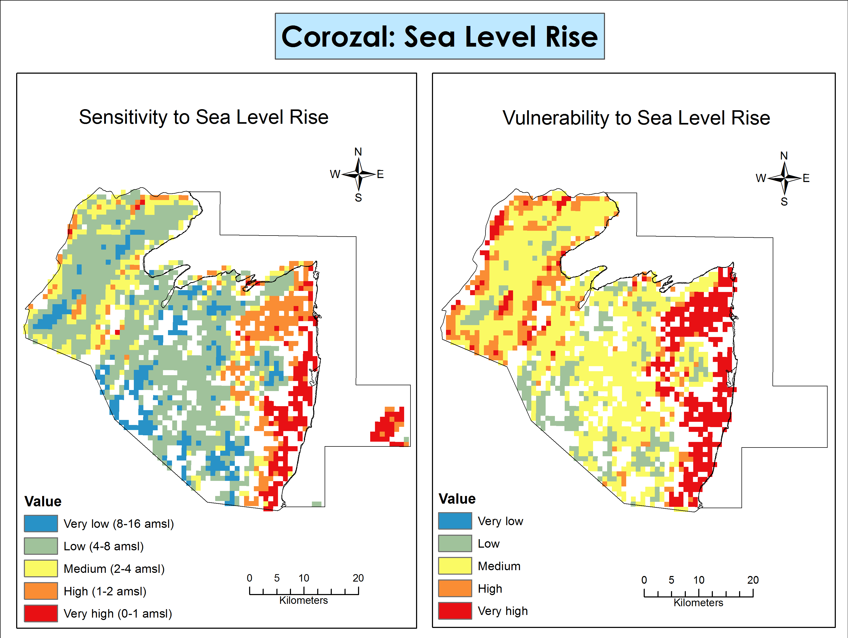
Figure 58: Vulnerability and sensitivity to sea level rise in the Corozal Area
(SOURCE: TNC, 2012)

Caye Caulker
Deforestation for coastal development is a major treat to the littoral and mangrove forests of Caye Caulker. Figure 59 depicts the hotspots of deforestation on the Caye Caulker and in the Caye Caulker Forest Reserve. Development in the vicinity also results in a multitude of negative effects on ecosystems, including dredging, filling of land, land clearing and building of canals (McRae, 2004). Figure 60 shows the extent of the major human impacts that affect Caye Caulker based on data from the Coastal Zone Management Plan, with dredging and fishing two significant threats besides coastal development. The tourism footprint (hotels) is concentrated to the south central portion of the caye with marine recreational activities such as diving, snorkeling, kayaking, etc. occurring around the entire caye (Figure 61). This level of development around the south-central region has resulted in increased sediment levels, habitat destruction and loss of shoreline vegetation (McRae, 2004). This presents a threat to the terrestrial and submerged systems of the forest and the marine reserve. Over fishing is also a threat to the coral reefs of the adjacent portion of the Belize Barrier Reef. Surprisingly Caye Caulker is not vulnerable to sea level rise. The entire island of Caye Caulker is at risk of coastal erosion. Although the reefs and mangroves provide some form of protection on the eastern portion of the island, the protection does not eliminate the threat of coastal erosion that results from wave action and is compounded by the removal of mangrove and littoral forest.
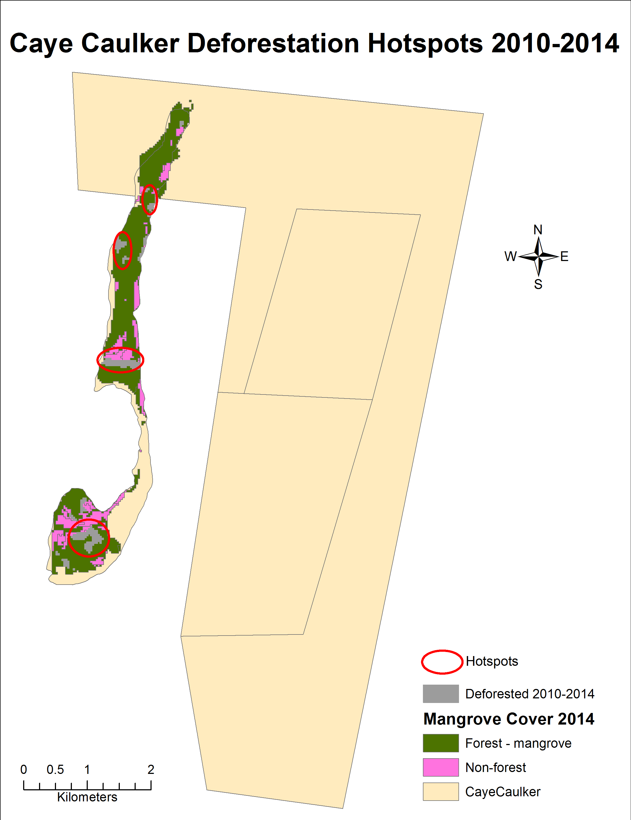
Figure 59: Hotspots of deforestation for Caye Caulker for 2010-2014
(SOURCE: BASED ON FOREST COVER 2014)
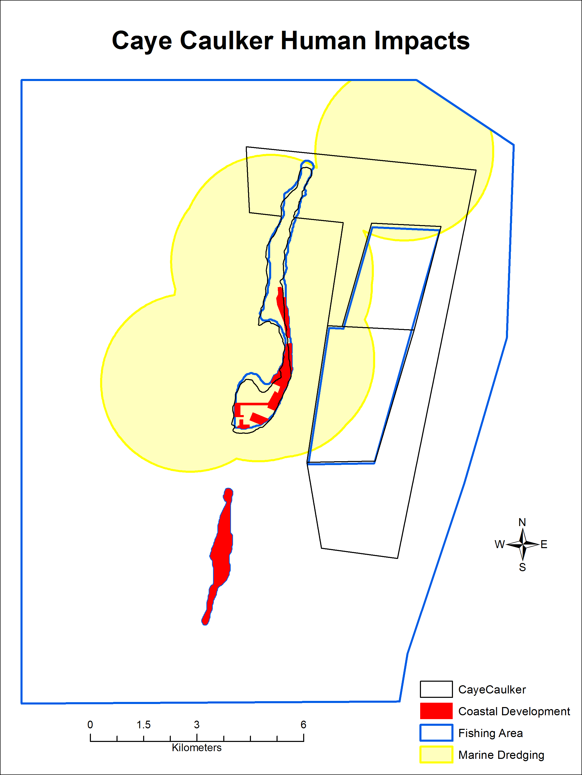
Figure 60: Impact of human activities in Caye Caulker
(SOURCE: CZMAI, 2010)

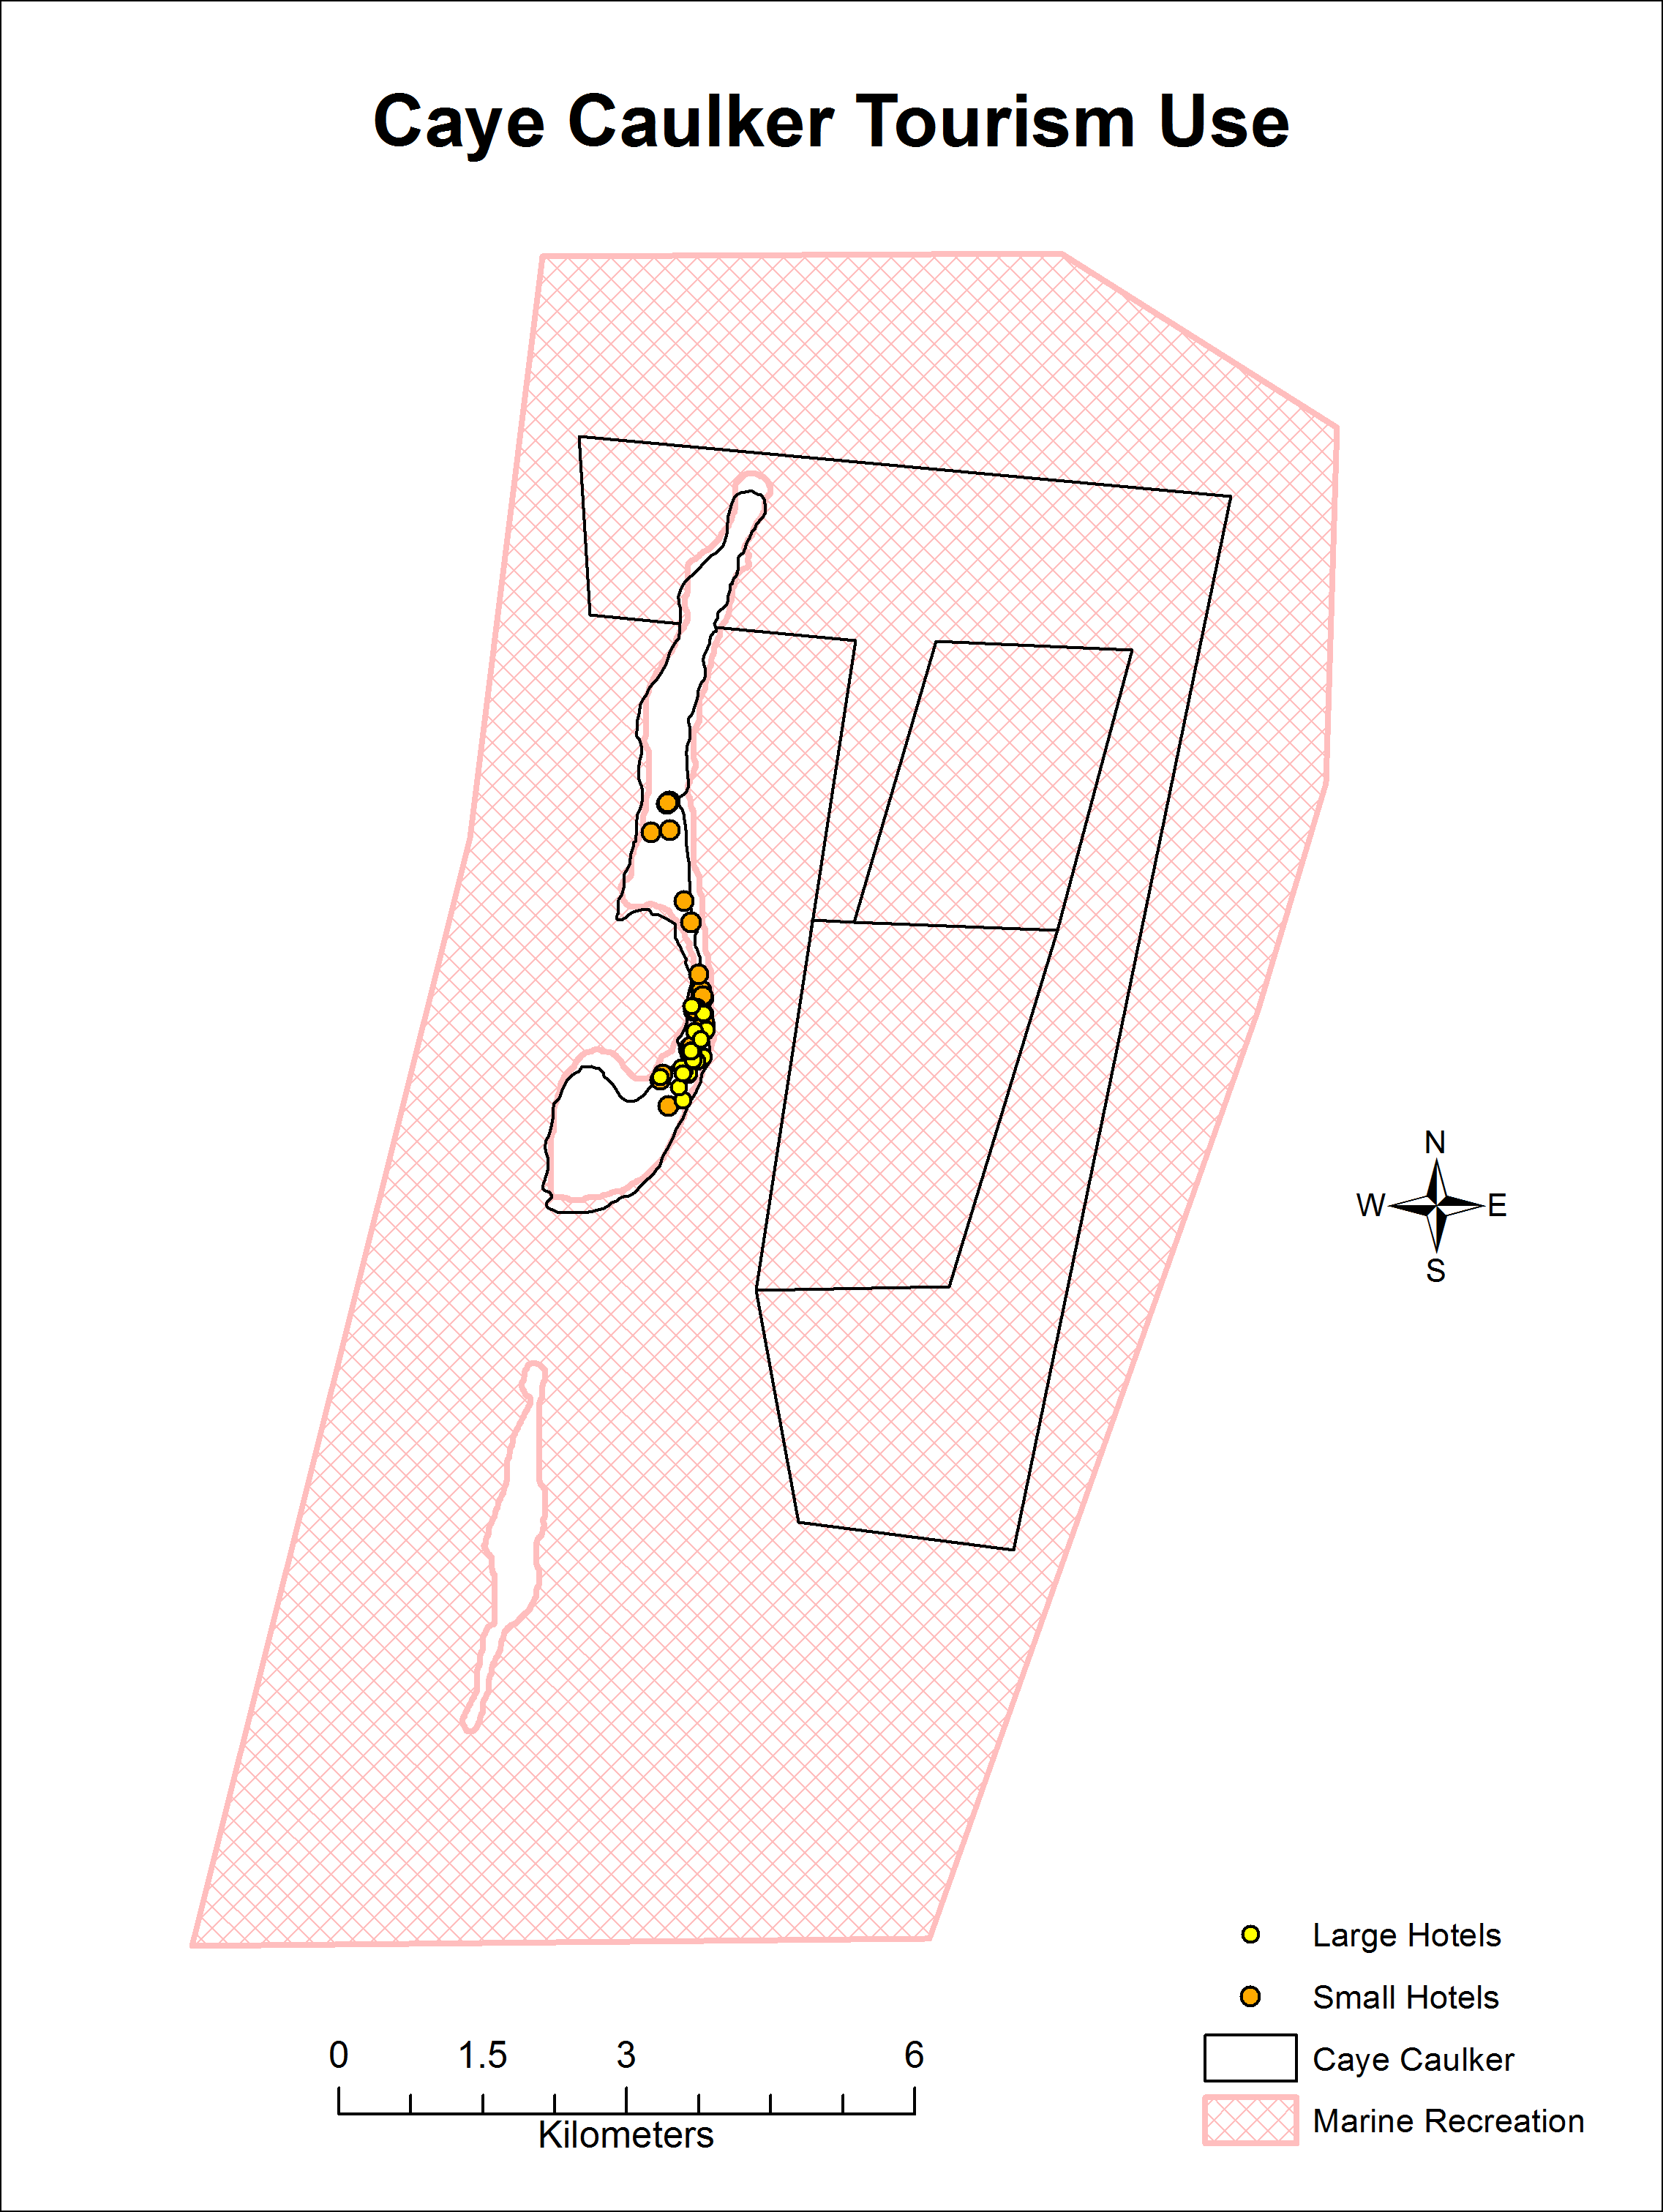
Figure 61: Tourism Use for Caye Caulker
(SOURCE: MTCCA, 2012/13)

Chiquibul-MPR Complex
Within the Chiquibul-MPR Complex there are various threats to the biodiversity and the functioning of the ecosystem. Major threats to the area are a result of incursion, land use change and legal and illegal extraction of resources (Salas et al., 2008). Guatemalans enter the remote forested areas illegally and clear large portions of the land for agriculture and resource extraction. Milpa farming results in the removal of large expanses of broadleaf forest cover. To exemplify Milpa farming has resulted in the clearing of approximately 12,185 acres of land within the Chiquibul Forest Reserve (CRF) (FCD, 2012). Figure 62 shows the hotspots for deforestation in the Chiquibul-MPR Complex. The result of which directly impacts fauna biodiversity via the removal of habitat (see Table 37 for size of deforested areas). Removal of these forested areas including the pine forest has increased the occurrences of fires in the area. Fires caused by anthropogenic activities are also a threat as are fires caused by the excessive build-up of fuel load from limited management and agriculture practices in the MPR. Figure 63 shows the fire risk for the Chiquibul-MPR Complex and shows that this risk is highest in the MPR (see Table 36 for size of areas with high fire risk). Resource extraction is not just confined to one forest product but several including xate leaf, commercial timber species, seeds, poaching of scarlet macaws and hunting of game meat. Land use changes for agroindustry, hydroelectricity, logging and mining have also imposed additional threats to the ecological integrity of the ecosystem (Briggs et al., 2013). Clearing of forest for the construction of roads, mainly for timber and mining, has caused increased fragmentation, increased hunting pressure and changes in the population dynamics of the area. Harvesting of parrots for the pet trade is also of major concern within the area. Hydroelectric development compromises the integrity of the watershed including its aquatic and riparian areas. Pollutants from agriculture, improper waste disposal, and water pollution from the hydroelectric facilities affects the watersheds of the region. Illegal extraction of products such as Xate has led to the increased hunting and poaching of game and other species, Baird’s Tapir, Black howler monkey and the scarlet macaws in the area. The latter is likely to change the structure of the ecosystem due to the removal of a few species. Timber, NTFP, oil and mineral extraction have all imposed changes on the landscape hence affecting biodiversity.

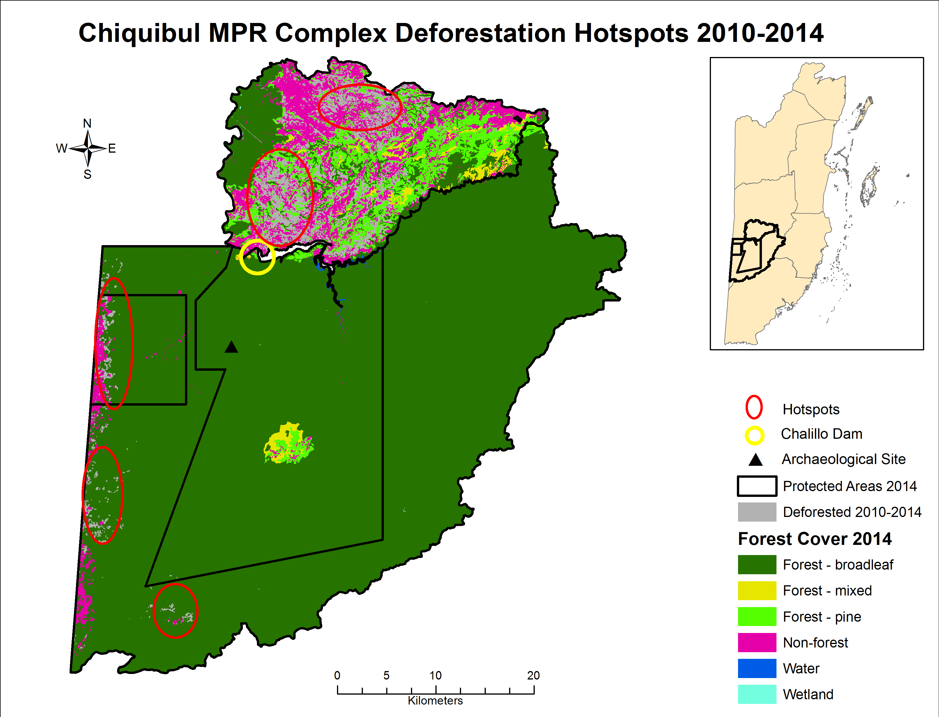
Figure 62: Deforestation hotspots in the Chiquibul Mountain Pine Ridge Complex 2010-2014
(SOURCE: BASED ON FOREST COVER 2014)

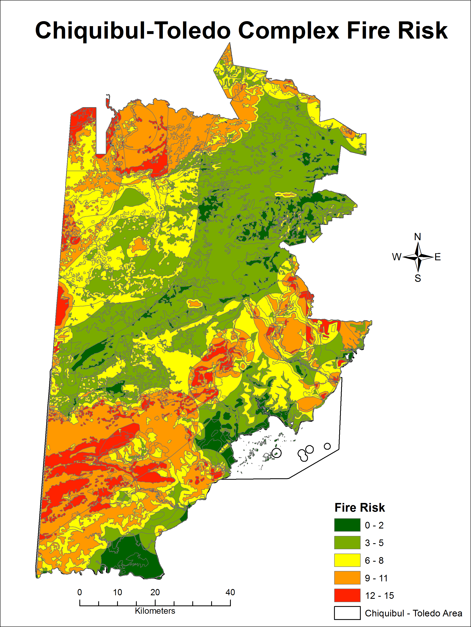
Figure 63: Fire risk in the Chiquibul Mountain Pine Ridge Complex and Toledo Area
(SOURCE: BERDS, 2004)

Toledo
Within the southern region of Belize there are many threats, each with severe effects on the various ecosystems. Threats to the ecosystems could significantly decrease the biodiversity of the area, and in some cases may result in the complete loss of sensitive species. Unsustainable extraction, illegal activities, habitat fragmentation, incursions (agricultural, population, and transboundary) and deforestation have been identified as threats to the southern PAs. Most of the PAs in the southern districts are surrounded by agricultural ventures: citrus, rice fields and milpa farming. Agricultural incursions would result in the removal of broadleaf forests, reduction in ecosystem services as a result of forest removal and increased risk of fire. Figure 64 shows the deforestation hotspots in the Toledo Area for 2010-2014, while Table 37 details the size of the deforested areas for 2010 – 2014. Fire reduces the forest’s capacity to regenerate and reduces soil viability; it is a major threat to the Toledo District (Figure 63). For the size of the area at high risk of fires within the Toledo area, see figures and percentages within Table 36. The Aguacaliente Wildlife Sanctuary and the Bladen Nature Reserve (BNR) are at risk of agricultural incursions as the adjacent lands are being used for agricultural purposes and there is an increased possibility of these activities extending into the PAs in the future (APAMO, 2011; Miller et al., 2011). The incursion of populations in areas adjacent to the PAs would result in increased agricultural prospects, hunting, logging, fishing and deforestation of the area (Miller et al., 2011).
Transboundary incursions at Columbia River Forest Reserve (CRFR) threaten commercial and non-commercial forest species in addition to game species. Habitat destruction is the major threat to mammalian species at the BNR, in the case of the Central American Spider Monkey it has led to population decrease. In the case of species such as the scarlet macaw, white-lipped peccary and ornate hawk-eagle, which rely on large blocks of contiguous forest to maintain viable populations, habitat destruction and deforestation, such of the clearing of land for agricultural prospects in the buffer areas, will negatively affect the species within the Cockscomb Basin Wildlife Sanctuary (CBWS). The killing of near threatened species such as jaguars in adjacent cattle farms is also of concern at CBWS. The latter can be attributed to land clearing which has caused further fragmentation of the jaguar’s habitat. Also, adjacent Land Use Change (LUC), which involves the clearance of habitat, results in increase fires and temperatures, decrease in humidity and changes in rainfall patterns. The illegal hunting and fishing by buffer communities places an additional stress on the ecosystem. The increase in settlements adjacent to the PAs such as BNR and the CBWS has resulted in increased illegal hunting within the protected areas reducing the populations of the great curassow and crested guan (Wildtracks, 2004). Game species such as the white-lipped peccary, red brocket, white tailed deer, paca and armadillo are all illegally hunted within the confines of Payne’s Creek National Park (PCNP). Commercial logging at the PCNP before the 1990’s has significantly impacted the biodiversity and ecosystem services of the area (TIDE, 2005). Non-commercial forest products have also been targeted for construction, food, medicinal plants and ceremonial products. The removal of large quantities would result in changes in the composition of the ecosystem and also threatens its use as a habitat. Additionally at the CRFR hydro-electric facility development up stream changes the water quality and flow while also reducing the extent of the broadleaf forest (Wildtracks, 2009). Agrochemical pollution also reduces water quality in addition to increasing harm to threatened amphibian species within PAs.
On the marine side, at Port Honduras Marine Reserve (PHMR), transboundary incursions target the commercially valuable marine species of the area, decreasing their populations and reducing the effectiveness of sustainable harvesting by many Belizean communities. Illegal fishing in the PHMR has caused a noticeable decrease in commercially valuable species of area. TIDE conducted a study for commercial benthic species within zones at the marine reserve in 2014. The results of this study revealed that conch densities in all zones are at a critical low, lobster abundance in general use zone is higher than in replenishment zone and sea cucumber densities have decreased in the general use zone and replenishment zone (Foley, Barona & Irvine, 2014). Similarly there has also been a decline in the abundance of reef fish in the reserve especially the snappers, groupers and herbivorous fishes (Foster et al., 2012). Coral bleaching, diseases and increased macroalgal cover, due to agricultural runoff and other land-based activities, increasingly affect the coral reefs. Erosion is a threat to the coastal areas located in Toledo. As mentioned above coral reef and mangroves provide some reduction in the effects of wave action, however protection does not eliminate the risk. Other threats include unsustainable development along the coast which alters the marine environment and the introduction of invasive species such as the lionfish which threaten local fish populations.
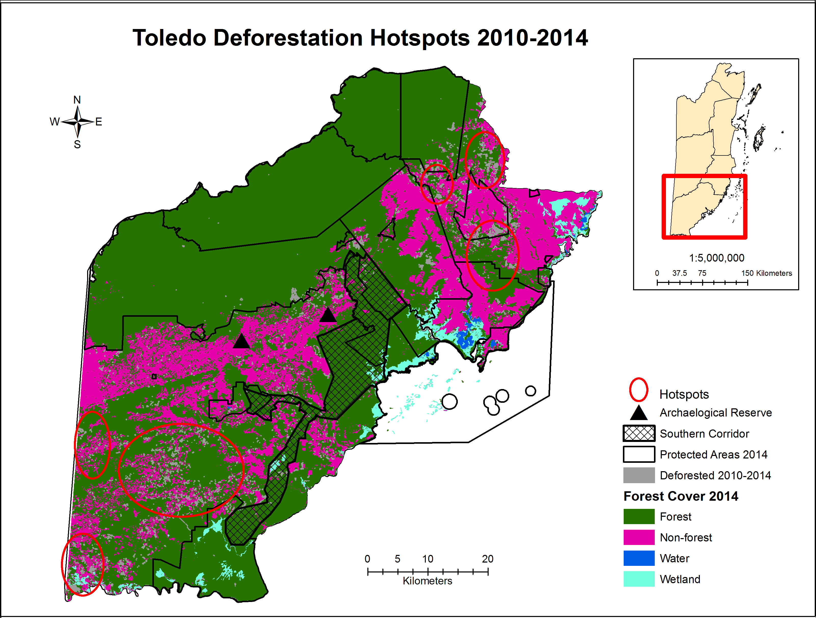
Figure 64: Deforestation hotspots of the Toledo Area 2010-2014
(SOURCE: BASED ON FOREST COVER 2014)

Human use has impacted the coastal-marine environment primarily through agricultural runoff and fishing (Figure 65). With oil exploration highlighted as another potential threat to the area given the interest in exploration, although none is currently occurring in the PHMR and marine area off Toledo. The tourism footprint in the Toledo district is small and scattered with the greatest concentration in and around Punta Gorda with a few hotels more inland (Figure 66). Marine recreation extends more away from the coast and more towards the reef.
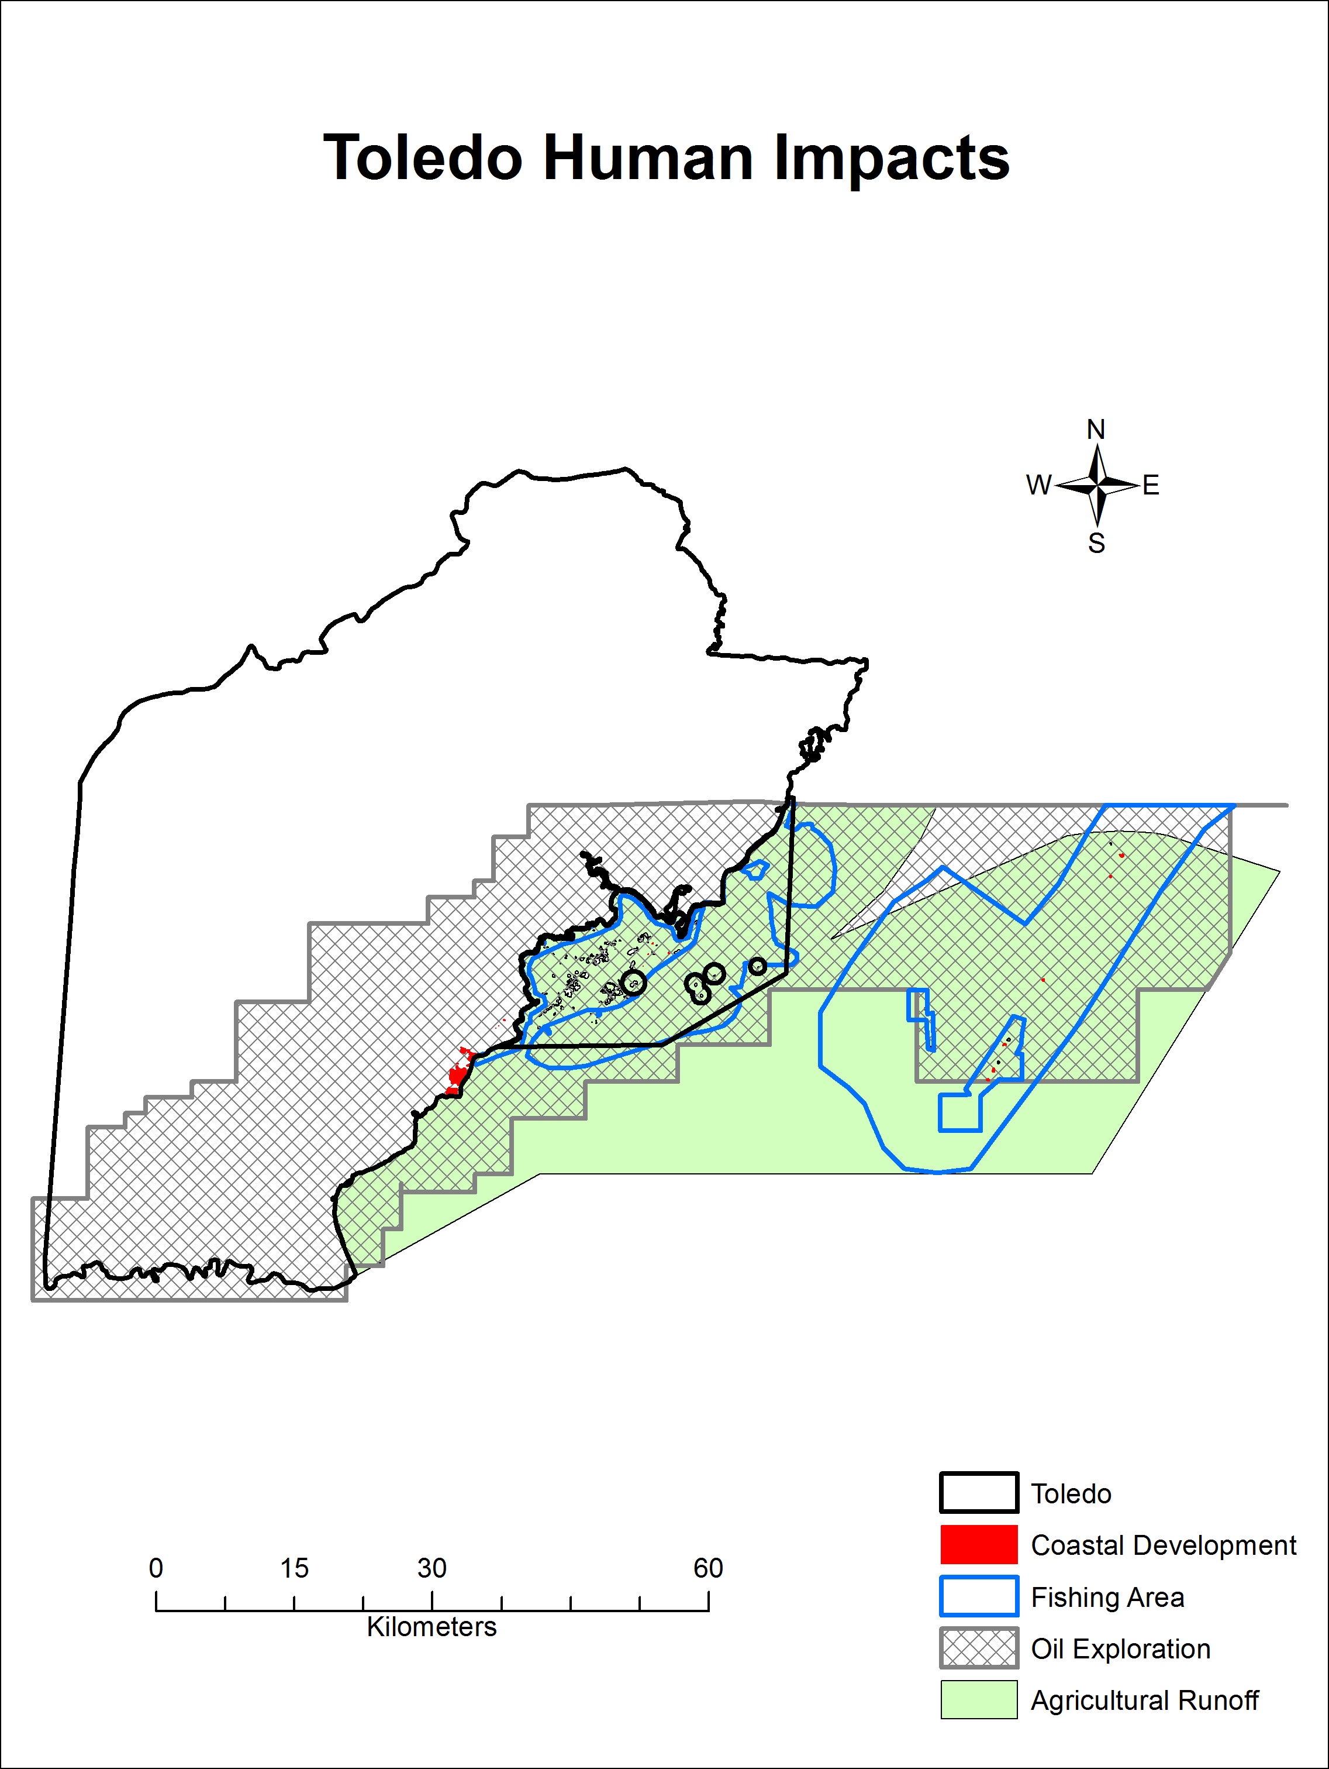
Figure 65: Impact of human activities in the Toledo Area
(SOURCE: czmai, 2010)
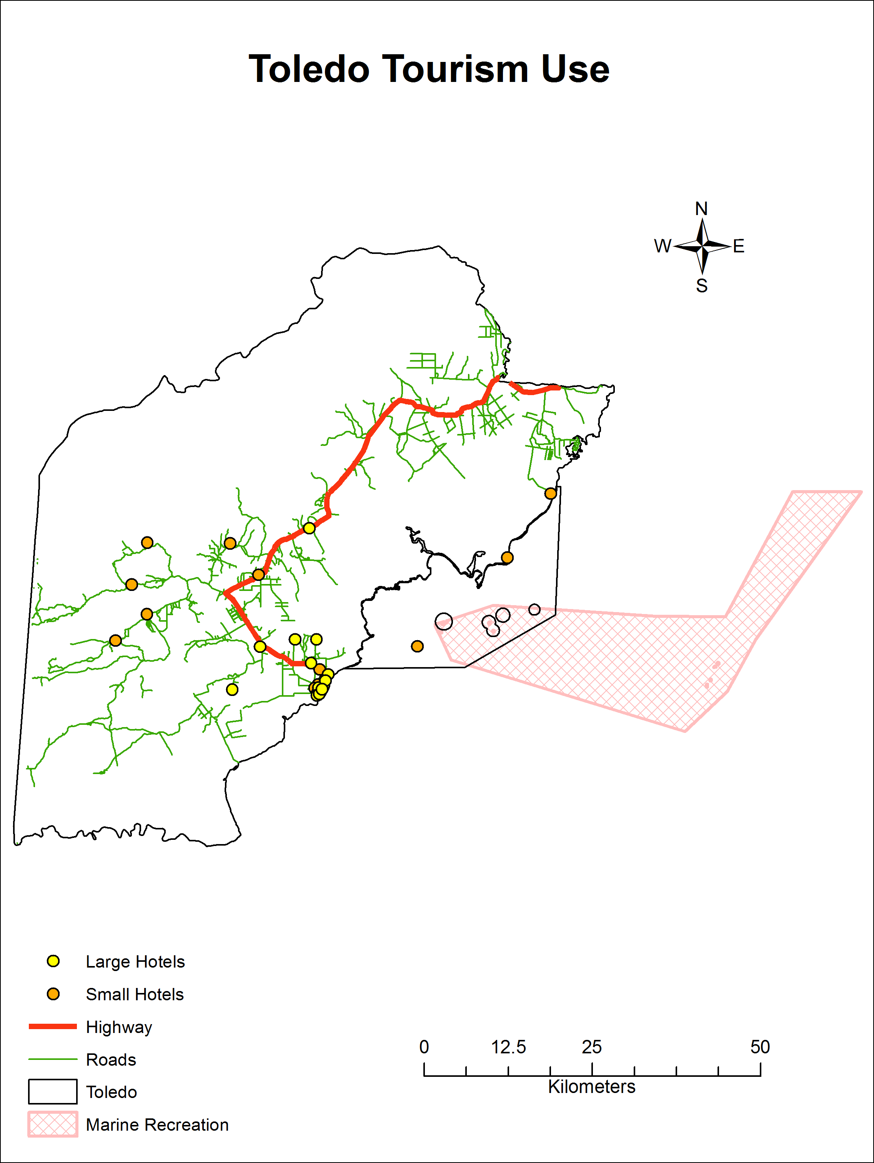
Figure 66: Tourism use in the Toledo Area
(SOURCE: MTCCA, 2012/13)

Toledo shows medium to very high vulnerability to sea level rise with medium vulnerability along rivers and high to very high vulnerability along the coast (Figure 67). This indicates potential for damage to infrastructure, migration of mangroves and loss of shoreline due to erosion.
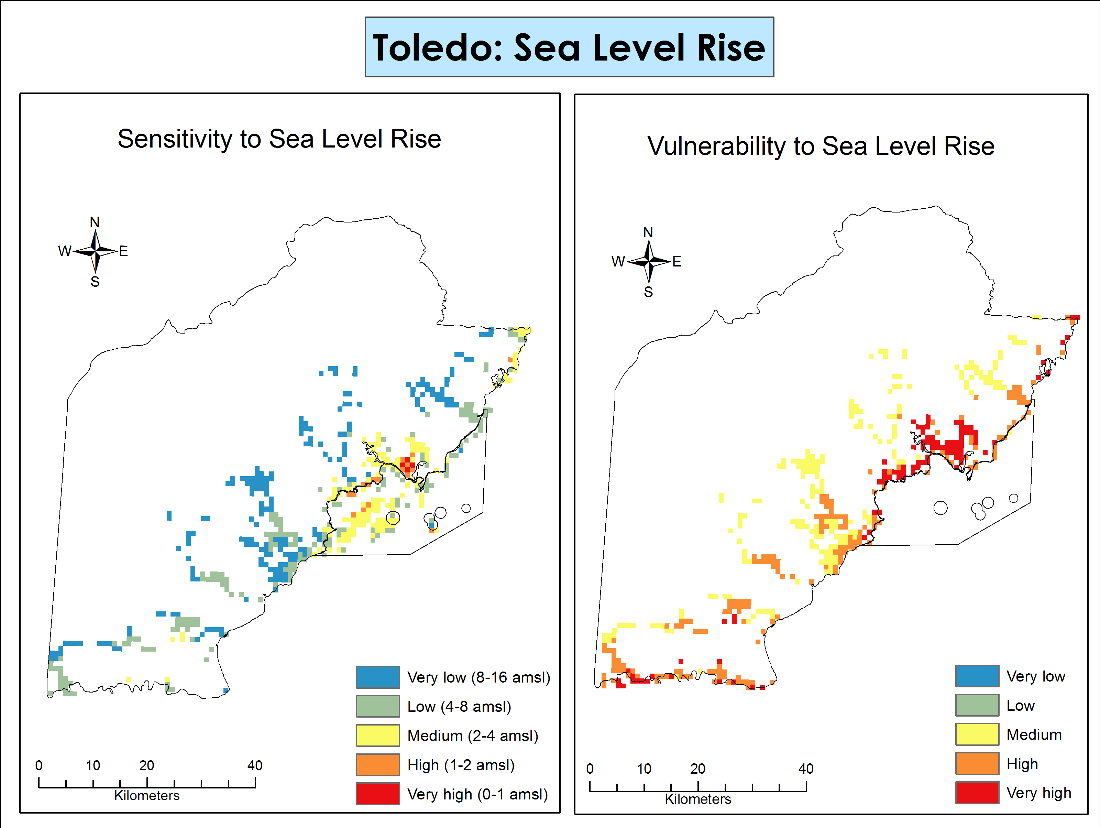
Figure 67: VULNERABILITY AND SENSITIVITY TO SEA LEVEL RISE IN THE TOLEDO AREA
(SOURCE: TNC, 2012)

SUMMARIZED MAIN FINDINGS

The subsequent summery tables were included to provide an overview of the main findings located in Section 5 of this report.
Table 38: SUMMARY TABLE OF BIODIVERSITY, SPECIES OF CONSERVATION CONCERN, SPECIEAL FEATURES AND THREATS BY AREA
Area | Biodiversity | Species of Conservation Concern | Special Features | Threats
Corozal | - 47 species of mammals  - 17 species of amphibians  - 67 species of reptiles  - 274 species of birds  - 26 species of fish  - 267 species of plants | - Goliath Grouper  - Hawksbill Turtle  - Acropora Corals  - West Indian Manatee  - American Crocodile  - Margay  - Jaguar  - Baird’s Tapir  - Mahogany  - Spanish Cedar | - Corozal Bay Wildlife Sanctuary feeding and calving site for the West Indian Manatee  - Contains the only stromatolite formation in Belize  - Endemic Black Catbird (only mainland occurrence at Shipstern Nature Reserve)  - Semi-deciduous Yucatan forest  - Northern portion of the Northern East Corridor  - Connectivity between SNH and Crooked Tree Wildlife Sanctuary via Honey Camp NP  Resilience Factors  - Has connectivity to larger Selva Maya Forest  - Distance of Selva Maya Forest from coast provides some buffering against climate change impacts  - Tolerances of species cover a broad range | Deforestation from agriculture (legal and illegal)  Fires  Illegal and unsustainable fishing and hunting  Pollution and runoff from agriculture  Coastal development  De-reservation  Sea level rise
Caye Caulker | - 5 species of mammals  - 14 species of reptiles  - 173 species of birds  - 147 species of fish  - 67 species of plants  - 21 species of insects  - 135 species of marine invertebrates  - 8 species of sharks and rays  - 38 species of hard and soft corals | - American Crocodile  - Hawskbill Turtle  - Green Turtle  - Nassau Grouper  - Queen conch  - White crowned pigeon  - Yucatan vireo  - Staghorn coral  - Elkhorn corals  - Bottlenose dolphins | - Endemic Black Catbird | Deforestation from unsustainable coastal development  Pollution and runoff from urban activities  Poorly-planned tourism  Unsustainable fishing  Illegal fishing  Coastal Erosion
Chiquibul-MPR Complex | - 28 species of mammals  - 44 species of reptiles  - 94 species of birds  - 26 species of amphibians  - 10 species of fishes  - 584 species of insects  - 662 species of plants | - Cycad (Zamia decumbens)  - Big-leaved Mahogany  - Central American Spider Monkey  - Morelett’s Treefrog  - Baird’s Tapir  - Jaguar  - Scarlet Macaw  - Margay  - Neotropical River Otter  - Ocellated Turkey | - Storehouse for the country’s biodiversity  - Endemic Species - Maya Mountain Frog, Cave Chulin and Mountain Molly  - 15 endemic plant species  - Nesting area for the Scarlet Macaw  Resilience Features  - Broad range of tolerance for species due to altitudinal gradients.  - Large extent of forest cover  - Replication of ecosystems that are geographically separated  - Rugged Terrain which would decrease storm strength  - Few anthropogenic impacts that would increase storm impacts (deforestation and wide roads) | Illegal harvesting (poaching and hunting)  Deforestation from agricultural incursions  Logging  Mining  Oil exploration  Fires
Toledo | Range of species for the Toledo area:  - 13 - 96 species of mammals  - 146 - 337 species of birds  - 11 – 118 species of fish  - 4 – 41 species of amphibians  - 8 – 53 species of reptiles  - 152 - 300 species of plants | - Great hammerhead shark  - Elkhorn coral  - Nassau Grouper  - West Indian manatee  - Queen conch  - Hawksbill turtle  - Loggerhead turtle  - Jabiru stork  - Morelet’s Crocodile  - Harpy Eagle | - 43 distinct ecosystems  - Tropical Evergreen Lowland Peat Shrubland with Sphagnum  - Tropical evergreen seasonal broad-leaved lowland swamp forest Aguacaliente variant  - Tropical evergreen seasonal broad-leaved submountane elfin shrubland and woodland – 100% in CBWS  - Aguacaliente an important wetland for migratory birds  - Endemic species cycad, Zamia decumbens  - Large breeding population of Yellow Headed Parrots at PCNP  - Southern Corridor  Resilience Features  - Forest always exposed to significant seasonal water regime changes  - Existing history of adaptation to sea level rise  - Areas have been exposed to frequent anthropogenic fires (signals resilience)  - Large expanse under protection | Unsustainable extraction  Deforestation  Agricultural incursions  Illegal and unsustainable hunting and fishing  Logging (commercial and illegal)  Agricultural runoff  Sea level rise  Coastal Erosion

Table 39: SUMMARY TABLE OF ECOSYSTEM SERVICES WITH CORRESPONDING VALUES AND CLIMATE RESILIENCE
Area | General Ecosystem Services | Ecosystem Services Valued (USD) | Climate Resilience
Corozal | Fisheries  Water quality control  Water provisioning  Coastal Protection  Tourism  Food provisioning (game species)  Non-timber production (species – harvested for construction)  Timber production | Shoreline Protection 6.2-8.9 million  Tourism 11.9-13.9 million  Carbon 0.9-6.0 million  Timber 11.8 million  Water Supply 97.2 million | Low resilience due to high to very high levels of decreased precipitation;  high to very high impacts from sea level rise along the coast from Sarteneja southwards
Caye Caulker | Coastal Protection (mangroves and reefs)  Fisheries  Tourism | Shoreline Protection 0.6-0.9 million  Tourism 76.4-89.2 million | High to very high levels of decreased precipitation  Very low change in air temperature  Medium to high impact from sea level rise
Chiquibul-MPR Complex | Timber production  Food provisioning services (game meat)  Mineral resources (granite, goal and gavel)  Water provisioning  Carbon sequestration  Soil formation | Tourism 14.1-16.5 million  Carbon 5.0-32.6 million  Timber 230.8 million  Water Supply 759.7 million | High to very high levels of decreased precipitation  Very low to very high changes in air temperature
Toledo | Water quality control  Coastal protection (mangroves and reefs)  Timber production  Food provisioning services (game meat)  Fisheries  Carbon sequestration  Soil formation | Shoreline Protection 11.4-16.5 million  Tourism 13.5-15.7 million  Carbon 4.6-30.0 million  Timber 275.3 million  Water Supply 6.1 billion | High to very high levels of decreased precipitation  Very low to high changes in air temperature  Very low to high impacts from sea level rise

RECOMMENDATIONS

GENERAL RECOMMENDATIONS

1. Tourism development must be focused to give the greatest social and economic gains at the least environmental costs.
Justification: This is the only model that can lead to bonafide sustainable tourism development in the areas of focus, truly creating a more even balance of all three pillars of sustainable development. If the investments of STP II are not made following this recommendation, the reality is that in the tourism sector, economic and socio-political considerations often override or are prioritized over environmental considerations (Huggins 2015).
2. Development financed by STP II should be concentrated in the most poverty stricken and undeveloped areas that coincide with areas of high biodiversity or vulnerability to climate change. These would correspond to areas within Belize’s two poorest Districts, Corozal and Toledo.
Justification: Following this recommendation would create a win-win situation in which poverty would be reduced while safeguarding the ecosystem services of these areas. In the case of Toledo, the results of this review indicate that of all the areas studies, this is the destination with the most ecosystem service values (see Table 39) but poor because it is underdeveloped. Toledo therefore presents maximum potential for maximum biodiversity and ecosystem service gains if the industries developed in the area are of a sustainable nature. Contrary to Toledo, based on the results of this review, Corozal has less ecosystem service values and natural resources. However, the area presents unique biodiversity and features that would easily allow for the creation of sustainable tourism products that can aid the areas sustainable development. Based on the data, the Corozal area is the area with the most need for development that is of a sustainable nature as this is the area most vulnerable to climate change impacts as well as the area with the highest level of threat of conversion of natural ecosystems for unsustainable agriculture and other uses. Efforts need to be concentrated in Corozal to avoid more poverty and loss of natural capital.
3. Of all four areas covered in this review, Caye Caulker is recommended for the least investment from STP II. Project investments in Caye Caulker should be used to complement investments from the already existing large tourism revenue base in order to make the island’s tourism product more sustainable and reduce impacts to the island’s ecosystems.
Justification: Based on the economic valuation results Caye Caulker is the destination that already derives the most economic gains from tourism; tourism values for Caye Caulker are as much as 7.5 times higher than in all the other areas (see Table 39). Therefore less investment from the project is recommended for this area as such investment should be used to develop a more sustainable tourism product by supporting and catalyzing existing tourism investments.
4. Development and marketing of new and existing tourism products at all destinations should be guided by carrying capacity studies at these destinations in order to ensure sustainability; we therefore, recommend that any project investments are accompanied and informed by such studies.
Justification: The biodiversity review findings (see Table 39) show each of the four areas reviewed to have special features that can be or are already being marketed as part of tourism products; in addition, the threats review shows the large human footprint that is already impacting the destinations, particularly Corozal and Caye Caulker. Based on this, it is important to understand what the visitation limits for these areas are if the tourism product is not to erode over time and to ensure sustainability. Not all areas are suitable for mass tourism, yet this is currently the fastest growing sector of tourism in the country. Therefore, carrying capacity data needs to clearly inform destinations and tourism product development.
5. Improve visitor safety and minimize environmental impact through the development and implementation of safety and visitor impact standards and systems for all destinations.
Justification: Based on the biodiversity findings and ecosystem mapping, new tourism development financed by STP II will be centered on nature based experiences and adventure in natural areas. Safety risks for such tourism are potentially higher, and impact from visitation to natural sites with no prior tourism will be higher. This warrants not just safety and visitor impact reduction guidelines but safety and visitor impact reduction standards and systems that can be implemented and monitored. Currently, enforcement of existing safety and visitor impact guidelines is inadequate and there are still major gaps to address in these key areas.
6. Development and implementation of a monitoring and evaluation framework for STP II that integrates data collection for indicators already identified for national biodiversity, ecosystem services, sustainable development and protected area management effectiveness monitoring.
Justification: One of the main limitations of this biodiversity and ecosystem service mapping review was the lack of data to more comprehensively evaluate and valuate biodiversity and ecosystem services in the various destinations, e.g. valuation of cultural values, data on coastal erosion etc. In addition, even in instances when data do exist, it is often difficult to obtain metadata that serves to validate its robustness. In light of this, we recommend that STP II incorporate a monitoring component for biodiversity, ecosystem services and sustainable development such that a baseline can be established for key indicators and subsequent monitoring can be done to measure whether the implementation of STP II is truly resulting in biodiversity and ecosystem service gains. Any monitoring through the project should be coordinated with and complement existing national efforts.

COROZAL AREA

- Develop a community-based ecotourism zone in Corozal, focused on forested and wetland areas in the eastern part of the district and in Corozal Bay; communities would include Progresso across to Sarteneja including the northern corridor, protected areas and lagoon systems. Specific recommendations for tourism product development based on current work of protected area and conservation groups in the area in consultation with community groups include:

- Upgrading of road infrastructure for reliable access to Progresso-Sarteneja community belt
- Tourism infrastructure installed on the ground in these locations: water access ways (docks), toilets, picnic areas, etc.
- Capacity-building for and development of sport fishing in the area
- Infrastructure development to support opening up of the manatee and primate rehabilitation facility in Sarteneja to tourist visitation
- Securing of land title for Kakantulix Archaeological Site by Institute of Archaeology in order to ensure its availability for future development as a national archaeological site
- Development of birding especially within wetland areas of Shipstern Nature Reserve and Honey Camp National Park and lagoon networks in the area
- Tours for manatee and crocodiles in Shipstern lagoon, other lagoon networks and CBWS
- Community management of tourism product by Sarteneja, Fireburn, Copper Bank, Chunox communities through tour guide associations, concessions and access agreements with private land owners and protected area managers
- Sustainable tourism development in the area should avoid developing areas highly susceptible to impacts of sea level rise and coastal erosion, particularly Sarteneja to Shipstern lagoon and its coastal area, and retain coastal mangrove buffers by designating conservation areas
Justification: The results of the threat review (see Table 38) show that the main threats negatively affecting the biodiversity and ecosystem services in the Corozal area are: unsustainable development for agriculture and other business ventures by large business companies or groups and unsustainable resource use by people from communities trying to obtain basic needs and secure livelihoods. The analysis of available data indicates that a large amount of deforestation has already occurred in the Corozal area where the agriculture frontier had historically been concentrated in the western portion of the district, but that this frontier is advancing to the east, within the last remaining broadleaf areas of the district, some of which comprise a large portion of the Northern Biological Corridor. Tourism development and adoption of sustainable agricultural practices that promote both the retention and the active restoration of broadleaf areas in the eastern portion of the district is key for several reasons. Only those whose lives and livelihoods have been improved from sustainable use of the resources, e.g. through employment in sustainable tourism, can understand the value of biodiversity and ecosystem services. Community involvement in sustainable tourism will bring about increased ownership and public participation in the protection and wise use of the natural resources in the area, for example advocating the adoption of more sustainable agricultural practices in areas such as Little Belize, which are under intensive agricultural production.
The results of the review also indicate that the Corozal area is very vulnerable to climate change impacts. Areas along the coast from Sarteneja southwards have high to very high impacts from sea level rise predicted to affect this area, making it vulnerable to erosion and coastal inundation.
Finally, the recommendations above will enable maintenance of key ecosystem services and biodiversity. The area has a wealth of biodiversity including 274 bird species, West Indian manatee, American crocodile, stromatolites, and the endemic Black Catbird; and ecosystem services including fisheries, water quality control, water provisioning, coastal protection, tourism, food provisioning, non-timber production and timber production. Owing to its extensive system of lagoons and mangroves that provide water quality and flood control and shoreline protection; development must ensure that these services are maintained and continued. Forested areas in the east constitute the last blocks of habitat suitable as a healthy water catchment and aquifer recharge zone for the district before precipitation hits the drier agricultural belt. The northern part of Belize is already the driest part of the country and given the climate change projections for an even drier future climate in the area, consideration of the above is especially important. Broadleaf forests also act as buffer zones helping to maintain the health of the extensive coastal wetlands of the area, including the mangrove areas, which serve a coastal protection function against storms, and act as nursery areas for fisheries that help sustain communities such as Sarteneja, Chunox and Copperbank.

CAYE CAULKER

- Create a more sustainable tourism product within the existing area and promote more nature based activities using the marine and forest reserves. Specifically:
- Install a tertiary level sewage treatment system for Caye Caulker to receive and treat sewage waste.
- Implement building setbacks, building standards and pier guidelines through Village Council and other local planning body (Caye Caulker Coastal Advisory Committee – CZMAI)
- Prevent development of leeward mangroves and littoral forests throughout the island, and of the Caye Caulker Forest Reserve through its re-designation to a national park
- Establish bird and nature tours through mangrove boardwalk and littoral forest trails
- Enhance snorkel and dive tours to shark ray alley and other “rich” coral reef areas through proper tour guiding and implementation of safety and visitor impact reduction systems
Justification: Caye Caulker’s current tourism product is based on the coastal resources valued at over 76 million USD and therefore, it is highly critical that ecosystems be wisely managed for the long term. Caye Caulker has seen rapid expansion without adequate or proper infrastructure to handle solid and sewage waste. No sewage treatment system in place has had a negative impact on biodiversity and ecosystem services through leaching of effluent into coastal waters negatively affecting the health and productivity of the coral reefs.
In addition, Caye Caulker is a coastal area below sea level and based on the results of this review has medium to high impact from sea level rise predicted. The leeward mangroves provide greater shoreline and erosion protection than windward ones and will be impacted moderately by sea level rise. These are most sensitive to impacts from sea level rise and provide greatest shoreline protection.
Finally, Caye Caulker Forest Reserve holds a rare and rapidly disappearing forest type – littoral forests, which needs to be maintained. This forest reserve is currently under-utilized with great potential for littoral forest/mangrove bird watching. The endemic Black Catbird and 174 bird species have been recorded for this area. Historically tourism on the island is largely sun and sea recreation based with diving and snorkeling as primary activities and therefore we are recommending potential expansion of nature based activities through use of the forest reserve. However, since forest reserves are more prone to de-reservation, the best way to safeguard the biodiversity and tourism potential of the area is through its re-designation as a national park.

CHIQUIBUL-MPR COMPLEX

- Upgrade road infrastructure to provide all weather access from the George Price Highway to the Mountain Pine Ridge.
- Improve and expand visitor facilities and overall tourism product in the Mountain Pine Ridge, through community/private sector/public partnerships. Specifically:
- Install tourism infrastructure on the ground in several ready to go locations off the main Mountain Pine Ridge road: toilets, picnic areas, etc.
- Develop accommodation and amenities infrastructure catering to middle income visitors
- Manage tourism product through tour guide associations, concessions and access agreements with private land owners and protected area manager.

Justification: The Mountain Pine Ridge’s potential as a tourism destination has long been highlighted but ignored as shown by the results of the tourism valuation for this review (see Table 39). However, the area has very high ecosystem service values, some of the highest of any other area that was covered in this review, particularly for timber, carbon and water supply (see Table 39). In addition, the area provides major watershed protection to the Belize River watershed, our principal and most important critical watershed because it supplies water to the majority of Belize’s population and is under the highest level of threat from unsustainable development.
Hence, our recommendations for the entire Mountain Pine Ridge-Chiquibul Forest center on focusing tourism development from STP II investments in the Mountain Pine Ridge. The MPR road is the main artery into Caracol and the Chiquibul Forest as well as several ready to go sites within the MPR. The MPR presents a great opportunity for nature-based tourism with its already existing large network of secondary road infrastructure that leads to a variety of waterfalls, mountain vistas and other landscape features.
Upgrading of the road will allow for improved access and resources from the Belize side for protection of the Chiquibul, which is one of Belize’s key biodiversity areas, and improved management of the MPR. Sustainable tourism development within the MPR presents an opportunity that could by extension help to secure biodiversity gains in the neighboring Chiquibul Forest. Geographically, the MPR is the gateway into the Chiquibul Forest and Caracol, and is located close to several Belizean communities. Due to its proximity to Belizean communities as well as distance from the border in comparison to the Chiquibul and Caracol, the MPR also suffers less from safety concerns and/or presents a location from where these would be more easily dealt with.
One of the best opportunities presented by having an all-weather road going through the Mountain Pine Ridge is year round access to Caracol, our premiere archaeological site. Currently, local tour operators including well-established businesses like Ian Anderson’s Caves Branch Jungle Lodge often find it more feasible and cost effective to take tours to Tikal rather than to Caracol, mainly due to the condition of the road getting to Caracol. Last year, Ian Anderson’s Caves Branch Jungle Lodge alone spent BZ$250,000 within Guatemala to enable their guests to visit Tikal (Ian Anderson, pers. comm.); there are many other Belizean tour operators running tours to Tikal so the amount of funds spent in Guatemala via Belize is likely at least an order of magnitude larger. These funds could easily be spent in Belize if there was sure access to Caracol.
The MPR is a forest reserve whose management as such is suffering from the lack of personnel and resources for the past two decades. With additional resources, such as from increasing tourism visitation and instituting a fee to enter and visit the reserve, the area could once again be well managed again for timber producing a more financially sustainable model based on the combination of income-generating activities. Because the area has few businesses and stakeholders that can speak for it, over the past few years, portions of the MPR have been de-reserved. The development of sustainable tourism in this area could help to finance its management as a forest reserve and help to build support from a larger group of stakeholders for its continued protection. Additional presence, investment and support in the gateway to the Chiquibul and Caracol should pave the way for addressing some of the issues that pose a challenge to tourism development within the entire Chiquibul-MPR complex and increase its resilience by having greater enforcement against incursions and clearing, re-establishing cleared forests, preventing further erosion, fire management and reduction in anthropogenic impacts.
The entire MPR-Chiquibul complex presents an opportunity for tourism that has only been partially tapped, if at all in some areas, due to its rugged terrain and isolation from local communities, poorly maintained (as in MPR) or non-existent road infrastructure and security issues originating from illegal transboundary incursions by Guatemalans. As can be seen from the preliminary mapping exercise, on a coarse scale the complex remains forested, with deforestation mostly taking place along the border area with Guatemala and including the Caracol Archaeological Reserve area. But since the complex comprises a large area, further analysis on the degradation of ecosystem services, distribution of biodiversity and landscape features of interest, as well as safety/security concerns would be needed in order to determine which areas and activities should be developed for tourism within the Chiquibul Forest.
In addition to developing a more accessible tourism product in the Mountain Pine Ridge, it is important to note that to realize significant gains in retention of Belize’s main carbon stocks, tourism investment in buffer areas to the Chiquibul, namely Cockscomb Basin Wildlife Sanctuary and even the rugged Sibun Forest Reserve need to be explored. Cockscomb Basin Wildlife Sanctuary is already fairly accessible and has considerable infrastructure but perhaps needs better marketing. Unlike Cockscomb, the Sibun Forest Reserve is largely unknown except to a handful of professionals and scientists. However, it is worth exploring its tourism potential further due to its rugged terrain with waterfalls and mountainous views, local communities nearby and access through the Hummingbird Highway.

TOLEDO AREA

Develop tourism product centering around communities practicing small scale agriculture and agroforestry in the midst of a large network of forested protected areas.
- The largest biodiversity gains via sustainable tourism in the Toledo area could be obtained by focusing investments in the eastern swath of the district in the southern Biological Corridor and the Sarstoon-Temash National Park.
Justification: The review shows that the Toledo district is experiencing an expansion in agriculture, leading to habitat conversion, but that it currently has a large block and network of protected areas, from the Maya Mountains to the lowland savannas. Due to its wetter climate, Toledo is well-suited for agriculture and is already a leader in agroforestry and other more sustainable land use practices, but there is also encroachment by communities into protected areas. Hence, in the Toledo area, there is an opportunity for protected area managers and communities to work together to develop tourism activities.
This eastern swath represents a variety of ecosystems and land tenure types and includes Toledo’s best mangrove habitat along the Port Honduras Marine Reserve, as well as the Southern Biological Corridor and the Sarstoon-Temash National Park. Several communities located within the Southern Biological Corridor could become participants in safeguarding an area of community lands for retaining the connectivity of large animal populations if they are able to make a living from tourism. Focusing on this area would also help greatly towards building resilience to climate change for the District and helping to maintain the reefs and associated systems.

- The coastal region around the Payne’s Creek National Park and across the Port Honduras Marine Reserve should be marketed as a nature based destination: haven for sighting marine wildlife, such as the manatee, and promoted for sport fishing.
- Enhance and promote sport fishing within the Payne’s Creek National Park and Port Honduras Marine Reserve.
- Establish manatee and wildlife tours with the Payne’s Creek and Port Honduras area
- Develop outposts in Payne’s Creek and Port Honduras with basic infrastructure to accommodate day visitors based on established carrying capacity.

Justification: The lower reaches of the Maya Mountain Massif and the Maya Mountain Marine Corridor represent an interconnected series of protected areas, which function as a ridge-to-reef system with major biodiversity stores and ecosystem services ranging from water provision, timber, food (game meat and fish), flood regulation and coastal water quality control. This area has very high vulnerability to sea level rise and represents the largest area of coastal mangrove in Toledo, which provide important shoreline protection services. This system of estuaries and mangroves needs to be conserved to ensure maintenance of shoreline protection and reduction of loss or damage of infrastructure due to climate change.
This estuary also provides critical habitat for permit, tarpon, snook and bonefish, which has major significance for sport fishing tours. The unique ridge to reef area can be marketed with the inland, forested protected areas and archaeological sites, where tours can capitalize on the wealth of biodiversity of both terrestrial and marine ecosystems within fairly close vicinity.
Major infrastructure development is not recommended in Payne’s Creek or Port Honduras since these are the areas with the greatest predicted impact from sea level rise in Toledo and should not accommodate high levels of infrastructure investment. These areas also provide important habitat for variety of species of conservation concern and are sensitive to high levels of visitation.

REFERENCES

Association of Protected Areas Management Organization. 2011. The directory of protected areas in Belize. Retrieved from http://protectedareas.gov.bz/additional-resources/

Baccini, A., Goetz, S., Walker, W., Laporte, N., Sun, M., Sulla-Menashe, D.,… Houghton, R. 2012. Estimated carbon dioxide emissions from tropical deforestation improved by carbon-density maps. Nature Climate Change. Retrieved from http://dx.doi.org/10.1038/NCLIMATE1354

Bailey, M., Meerman, J.,Vazquez, M., Parish, A. 2007. Rapid assessment of anthropogenic impacts on select transboundary aatersheds of the mesoamerican barrier reef system (MBRS) Region. Mesoamerican Barrier Reef System Project. Belize.
Belize Water Services. (2013) Annual Report 2012-2013.
Boles, E., Buck, D., Esselman, P. 2008. Synthesis of water resources conservation, management and research activities in the watershed of Belize. Belize: The Nature Conservancy.

Briggs, V., Mazzotti, F., Harvey, R., Barnes, T., Manzanero, R., Meerman, J., … Walker, Z. 2013. Conceptual ecological model of the chiquibul/maya mountain massif, Belize. Human and Ecological Risk Assessment, 19.

Cesar, H. 2002. Coral Reefs: Their functions threats and economic value.

Cesar, H., Burke, L., Pet-Soede, L. 2003. The economics of worldwide coral reef degradation. Cesar Environmental Economics Consulting.

Chave, J.,Andalo, C., Brown, S., Cairns, M.A., Chambers, J.Q., Eamus, D.,…. Yamakura, T. 2005. Tree allometry and improved estimation of carbon stocks and balance in tropical forests. Oecologia, 145(1), 87-99

Cherrington, E. 2014. Technical report: Basic assessment of key ecosystems coverage of Belize protected areas.

Cherrington, E. 2014. Technical report: Basic assessment of key ecosystems coverage of Belize protected areas.
Cherrington, E., Kay, E. & Waight-Cho, I. 2015. Modelling climate and land use change impacts on Belize’s water resources in the 2050s. Belize: CATHALAC & University of Belize Environmental Research Institute.

Cherrington, E.A., Ek, E., Cho, P., Howell, B.F., Hernandez, B.E., Anderson, E.R. … Irwin, D.E. 2010. Forest cover and deforestation in Belize: 1980-2010. Panama City, Panama: Water Center for the Humid Tropics of Latin America and the Caribbean (CATHALAC)

Constanza, R., Perez-Maqueo, O., Martinez, M., Sutton, P., Anderson, S., Mulder, K. 2008. The value of coastal wetlands for hurricane protection. AMBIO: A Journal of the Human Environment, 37(4), 241 – 248.

Cooper, E., Burke, L., & Bood, N. 2009. Coastal capital Belize-: The economic contribution of Belize’s coral reefs and mangroves. World Resources Institute. Retrieved from http://www.wri.org/publications.

de Groot, R., Brander, L., Van der Ploeg, S., Costana, R., Bernard, F., Braat, L., … Van Beukering, P. 2012. Global estimates of the value of ecosystems and their services in monetary units. Ecosystem Service, 1(1), 50 – 61.

Dudley, N., Stolton, S., Belokurov, A., Krueger, L., Lopoukhine, N., MacKinnon, K.,…Sekhran, N. (2010). Natural solutions: protected areas helping people cope with climate change. Switzerland and USA: IUCNWCPA, TNC, UNDP, WCS, The World Bank and WWF.

Emerton, L.& . Bos, E. 2004. Value counting ecosystems as an economic part of water infrastructure. Gland, Switzerland and Cambridge, UK: IUCN.

Fedler, A. 2008. Economic impact of recreational fishing for bonefish, permit and tarpon in Belize for 2007. Gainesville, Florida: Human Dimensions Consulting and Friends of Turneffe Atoll.

Foley, J., Barona, T., Irvine, T. 2014. Port honduras marine reserve commercial benthic species update: 2009 – 2014. Toledo, Belize: Toledo Institute for Development and Environment.

Forest Trends’ Ecosystem Marketplace. 2014. Executive Summary - Sharing the Stage: State of the Voluntary Carbon Markets 2014). Washington, DC: 1-22.

Foster, N., Mosher, M., Daly, A., Heller, A., Walker, Z. 2012. Port honduras marine reserve management plan 2012 – 2017. Toledo, Belize: Toledo Institute for Development and Environment.

Friends of Conservation and Development. 2012. The official newsletter of friends of conservation and development. Belize.

Gartzia, O. 2014. Biodiversity synthesis report - 2013. Belize: Ya’axche Conservation Trust.

Halcrow Group Limited. 2010. Country poverty assessment: Final report. Belize: Government of Belize and the Caribbean Development Bank.

Hammond, D., Busby, G., Hartwell, R. 2011. Final Report: Economic valuation of the environmental goods and services of the maya mountain massif and the maya mountain marine corridor (terrestrial area). Belize: Government of Belize, Ministry of Natural Resources, Fisheries Department and National Protected Areas Commission.

Hargreaves-Allen, V. 2011. The economic value of ecosystems services in the exumas cays: Threats and opportunities for conservation. Conservation Strategy Fund

Hijmans, R., Cameron, S., Parra, J., Jones, P., Jarvis, A. 2005. Very high resolution interpolated climate surfaces for global land areas. International Journal of Climatology 25, 1967 – 1978.
Kay, E., Dickerson, A., Urbina, Y., Lizama, D., Correa, E., Cruz, F., … Mai, A. 2015. Central Belize Corridor: Conservation Action Plan – 2015-2018/Summary.

Lands and Survey Department. 2012. Environmental statistics for belize: 2010. Belize: Ministry of Natural Resources and Agriculture
Lavell, A., Oppenheimer, M., Diop, C., Hess, J., Lempert, R., li, J., … Myeong, S. 2012. Climate change: New dimensions in disaster risk, exposure, vulnerability, and resilience. UK and USA; Intergovernmental Panel on Climate Change
Maya Mountain Marine Corridor Conservation Action Strategy (Final Draft). 2008.

McRae, E. 2004.Caye Caulker forest and marine reserve integrated management plan 2004-2009. Belize: Coastal Zone Management and Institute and Belize Fisheries Department.

Meerman, J. 1993a. Checklist of the birds of the shipstern nature reserve. Occasional Papers of the Belize Natural History Society, 2, 70 – 82.
Meerman, J. 1993b. Checklist of the reptiles and amphibians of the shipstern nature reserve and sarteneja, Corozal district, Belize, 2, 65 – 69.
Meerman, J. 1993c. Fish of the shipstern nature reserve. Occasional Paper of the Belize Natural History Society, 2, 61- 64.
Meerman, J. 1993d. Mammals of the shipstern nature reserve. Occasional Papers of the Belize Natural History Society, 2, 83 – 85.
Meerman, J. 1993e. Provisional annotated checklist of the flora of the shipstern nature reserve. Occasional Papers of the Belize Natural History Society, 2, 8 – 36.
Meerman, J. 2012. Belize ecosystems map: 2011 update. National Protected Areas Policy and Systems Plan. Retrieved from www.biodiversity.bz
Meerman, J., Boomsma, T. 1993. Biodiversity of the shipstern nature reserve. Occasional Paper of The Belize Natural History Society, 2, 1 – 7.
Meerman, J., Howe, A., Choco, S., Ack, A., Choc, E., Kok, S., Muku, A. 2006. Rapid ecological assessment: Aguacaliente wildlife sanctuary. . Belize: Aguacaliente Management Team and Belize Tropical Forest Studies.

Meerman, J., Moore, A. 2009. Chiquibul cave system management plan 2010-2015. Belize: Institute of Archaeology.

Meerman, J.C., Herrera, P., Howe, A .2003. Rapid ecological assessment sarstoon temash national park, Toledo District, Belize; Sarstoon Temash Institute for Indigenous Management.

Millennium Ecosystem Assessment. 2005.Ecosystems and human well-being: biodiversity synthesis. Washington, DC: World Resources Institute.

Miller, N., Wicks, N. 2011. Bladen nature reserve management plan. Toledo, Belize: Ya’axche Conservation Trust.

Mumby, P.J., Flower, J., Chollett, I., Box, S.J., Bozec, Y., Fitzsimmons, C., … Williams, S.M. 2014. Towards reef resilience and sustainable livelihoods: A handbook for caribbean coral reef managers. Exter, United Kingdom: University of Exeter.

National Oceanic and Atmospheric Administration. 2008. Technical guide: Nonpoint-Source pollution and erosion comparison tool (N-SPECT) Version 1.5. Charleston, South Carolina USA: NOAA Coastal Service Center, 60.

Neitsch, S., Arnold, j., Kiniry, J., Williams, J. 2011. Soil and water assessment tool theoretical documentation, Verson 2009. Colleg Station, Texas: Texas Water Resource Institute Technical Report.
Parker, T., Holst, B., Emmons, L., Mayer, J. 1993. A biological assessment of the columbia river forest reserve, Toledo district, Belize. Washington, DC USA: Conservation International
Pendleton, L. (ed.). 2008. The economic and market value of coasts and estuaries: What’s at stake? Arlington Virginia USA: Restore America’s Estuaries. Retrieved from http://www.estuaries.org/?id=208.

Public Utilities Commission. (2015). Public notice: Belize water services limited 2014-15 Full tariff review proceeding initial decision. Belize: Public Utilities Commission.
Russi, D., ten Brink, P., Farmer, A., Badura, T., Coates, D., Förster, J., … Davidson, N. 2013. The economics of ecosystems and biodiversity for water and wetlands. London, UK: Institute for European Environmental Policy.

Saatchi, S. S., Harris, N.L., Brown, S., Lefsky, M., Mitchard, E. T. A., Salas, W., … Hagen, S. 2011. Benchmark map of forest carbon stocks in tropical regions across three continents. Proceedings of the National Academy of Sciences, 108(24), 9899-9904.

Salas, O., Meerman, J. 2008. Chiquibul national park management plan 2008-2013. Belize: Friends of Conservation and Development and the Forest Department.

Schuhmann, P. 2012. The valuation of marine ecosystems goods and services in the wider caribbean region. Barbados: Centre for Resource Management and Environmental Studies Technical Report, (63), 57.

Statistical Institute of Belize. 2010. Belize population and housing census country report 2010. Belize: Statistical Institute of Belize.

Toledo Institute for Development and Environment. 2005. Payne’s creek national park management plan. Toledo, Belize: Toledo Institute for Development and Environment.

Turner, R., Paavola, J., Cooper, P., Farber, S., Jessamy, V., Georgiou, S. 2002. Valuing nature: lessons learned and future research directions. United Kingdom: The Center for Social and Economic Research on the Global Environment.

Walker, P., Walker, Z., Awe, J., Catzim, N. 2008. Summary Report: Technical assessment of the maya mountains massif system. Belmopan, Belize: Forest Department/TNC.

Wicks, N. 2009. Maya golden landscape biodiversity research, inventory and monitoring strategy and protocols. Belize: Ya’axche Conservation Trust.

Wicks, N. 2012. Golden stream private protected lands management plan. Toledo, Belize: Ya’axche Conservation Trust.

Wildtracks. 2004. Cockscomb basin wildlife sanctuary management plan 2005 – 2010. Belize: Belize Audubon Society.

Wildtracks. 2008. Final report: Conservation action planning southern Belize reef complex.

Wildtracks. 2009. Strategic management plan: Columbia river forest reserve 2011 – 2015. Belize: Belize Forestry Department, Ya’axché Conservation Trust, UNDP, GEF, Flora and Fauna International
Wildtracks. 2011. Management plan shipstern nature reserve: 2011 – 2016. Belize: International Tropical Conservation Fund.

Wildtracks. 2012. Corozal bay wildlife sanctuary management plan 2013 – 2018. Belize: Sarteneja Alliance for Conservation and Development.

Wildtracks. 2013. Rationalization exercise of the Belize national protected areas system.

Wildtracks. 2015. Summary: Northern Belize coastal complex management action planning outputs, 2015-2020. Belize.

World Bank. 2015. Carbon pricing watch 2015. Washington, DC: World Bank. Doi: 10.1596/978-1-4648-0268-3.

APPENDICES

Appendix 1: Protected Areas by Study Area

Study Area | Protected Areas
Corozal Area | Corozal Bay Wildlife Sanctuary
 | Shipstern Private Reserve
 | Freshwater Creek Forest Reserve
 | Grants Land Public Reserve
 | Honey Camp National Park
 | Cerro Maya Archaeological Reserve
 | Santa Rita Archaeological Reserve
Caye Caulker | Caye Caulker Forest Reserve
 | Caye Caulker Marine Reserve
Chiquibul-MPR Complex | Chiquibul National Park
 | Chiquibul Forest Reserve
 | Caracol Archaeological Reserve
 | Mountain Pine Ridge Forest Reserve
Toledo Area | Cockscomb Basin Wildlife Sanctuary
 | Bladen Nature Reserve
 | Swasey Bladen Forest Reserve
 | Deep River Forest Reserve
 | Columbia River Forest Reserve
 | Paynes Creek National Park
 | Port Honduras Marine Reserve
 | TIDE Private Reserve
 | Nim Li Punit Archaeological Reserve
 | Golden Stream Corridor Preserve
 | Lubantun Archaeological Reserve
 | Rio Blanco National Park
 | Sarstoon Temash National Park
 | Aguacaliente Wildlife Sanctuary
 | Machaca Creek Forest Reserve
 | Mango Creek Forest Reserve
 | Monkey Caye Forest Reserve
 | Maya Mountain Forest Reserve

Appendix 2: List of protected areas that form the Maya Mountain Marine Corridor (MMMC Conservation Action Strategy 2008)

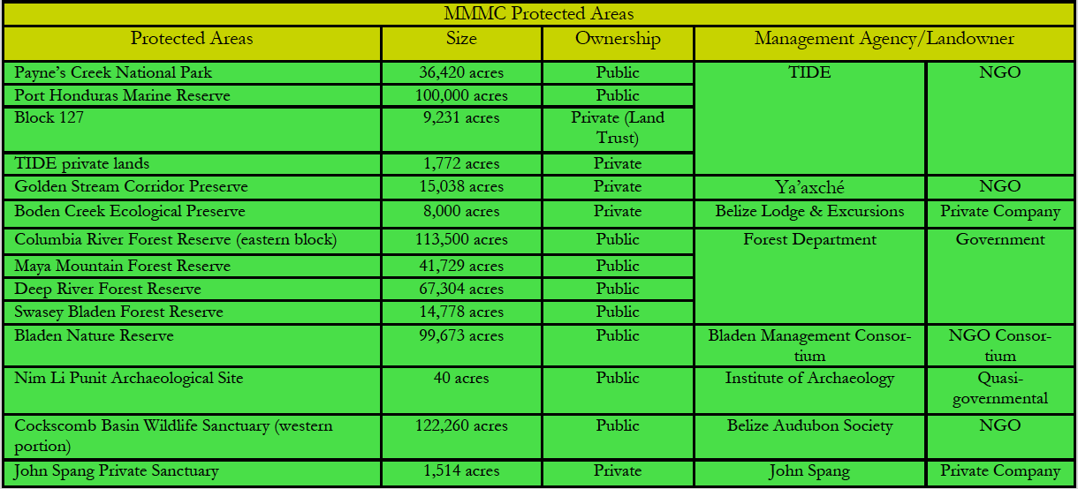

Appendix 3: Mean annual change in rainfall for major watersheds in proposed tourism development areas for 2050, under best (RCP2.6) and worst case (RCP8.5) scenarios for select global climate change models (Adapted from Cherrington et. al. (2015)). Figures in red denote negative changes.

Watershed | CNRM-CM5 |  | HadGEM-2 ES |  | MIROC5 |  | MRI-CGCM3 |  | NorESM1-M
 | RCP2.6 | RCP8.5 | RCP2.6 | RCP8.5 | RCP2.6 | RCP8.5 | RCP2.6 | RCP8.5 | RCP2.6 | RCP8.5
Rio Hondo | -1.6% | 0.8% | -5.5% | -15.7% | -12.2% | -6.0% | -5.1% | -18.2% | 2.4% | -19.7%
New River | -2.6% | 0.4% | -5.6% | -16.8% | -13.2% | -6.2% | -6.2% | -17.8% | 2.5% | -20.7%
Northern River | -3.0% | 0.6% | -4.9% | -14.9% | -10.5% | -2.1% | -8.5% | -19.9% | 3.4% | -20.3%
Belize River | -3.1% | -0.5% | -3.2% | -13.2% | -13.7% | -7.5% | 2.2% | -11.5% | 2.0% | -21.2%
Monkey River | -3.2% | -0.7% | -0.3% | -12.9% | -16.2% | -9.2% | 2.9% | -9.7% | -0.5% | -25.0%
Deep River | -2.7% | -1.1% | -0.3% | -14.3% | -17.3% | -11.1% | 4.3% | -8.0% | -1.4% | -26.0%
Golden Stream | -2.7% | -1.6% | 0.0% | -15.6% | -18.4% | -12.6% | 4.8% | -6.9% | -2.6% | -27.2%
Rio Grande | -2.4% | -1.8% | -0.3% | -16.0% | -18.3% | -13.1% | 5.0% | -6.8% | -2.5% | -26.9%
Moho River | -2.3% | -2.3% | -0.3% | -15.9% | -17.9% | -13.5% | 4.1% | -7.6% | -2.5% | -27.0%
Temash River | -2.6% | -2.9% | 0.4% | -17.2% | -19.1% | -15.0% | 3.3% | -6.6% | -4.1% | -28.8%
Sarstoon River | -1.8% | -3.4% | 1.0% | -14.1% | -16.3% | -13.5% | -2.0% | -10.9% | -2.5% | -27.5%

Appendix 4: Extent of mangroves in hectares by study area

COROZAL
Mangrove Type | Area in Ha
Medium Height | 2,233.91
Tall | 277.02
Dwarf | 8,052.67
Mangrove Savanna | 10,091.58
Mangrove in mixed forest | 3.15
TOTAL | 20,658.33

CAYE CAULKER
Mangrove Type | Area in Ha
Medium Height | 202.41
Tall | 14.6
TOTAL | 217.01

TOLEDO
Mangrove Type | Area in Ha
Medium Height | 579.71
Tall | 382.96
Dwarf | 6,523.97
TOTAL | 7,486.64

Appendix 5: Average Daily Expenditure ($US) by Purpose of visit by Places Stayed¹, 2014

Location |  | Holiday/Leisure | Business | Visit Friends | Religion | Other | Total
Belmopan | $ | 182.51 | 171.55 | 118.7 | 98.4 | 165.97 | 164.58
 | No. of cases | 79 | 14 | 13 | 14 | 6 | 126
Belize | $ | 147.26 | 197 | 104.76 | 160.51 | 111.88 | 149.95
 | No. of cases | 267 | 43 | 27 | 28 | 10 | 375
Corozal | $ | 112.12 | 139.58 | 55.78 | 186.85 | 187.5 | 120.34
 | No. of cases | 55 | 2 | 7 | 12 | 1 | 77
Orange Walk | $ | 127.65 | 263.89 | 54.17 | 90.5 | 86.11 | 121.92
 | No. of cases | 42 | 3 | 6 | 6 | 2 | 59
San Ignacio/ | $ | 145.18 | 188.18 | 84.08 | 158.4 | 86.06 | 143.91
Cayo
 | No. of cases | 450 | 7 | 16 | 29 | 6 | 508
Dangriga/ | $ | 174.32 | 202.46 | 107.23 | 99.24 | 109.39 | 165.99
Stann Creek
 | No. of cases | 215 | 7 | 12 | 15 | 6 | 255
Toledo/PG | $ | 159.25 | 177.92 | 111.81 | 148.05 | 101.67 | 151.71
 | No. of cases | 35 | 4 | 6 | 8 | 2 | 55
Ambergris Caye | $ | 187.54 | 233.44 | 121.29 | 128.3 | 160.41 | 186.13
 | No. of cases | 1088 | 24 | 17 | 21 | 14 | 1164
Caye Caulker | $ | 114.05 | 148.39 | 102.02 | 129.73 | 123.63 | 114.73
 | No. of cases | 639 | 4 | 9 | 23 | 8 | 683
Other Island | $ | 190.63 | 415.63 | 72.41 | 224.85 | 143.1 | 190.02
 | No. of cases | 129 | 2 | 5 | 3 | 1 | 140
Placencia | $ | 165.93 | 214.42 | 67.88 | 147.73 | 151.88 | 163.25
 | No. of cases | 260 | 9 | 11 | 4 | 4 | 288
¹Source data based on visitors staying at one location only
Source: Statistical Institute of Belize

Appendix 6: Mangrove, Seagrass, Coral Reef and Estuary Ecosystem Values (Hargreaves-Allen 2011)
- Mangroves
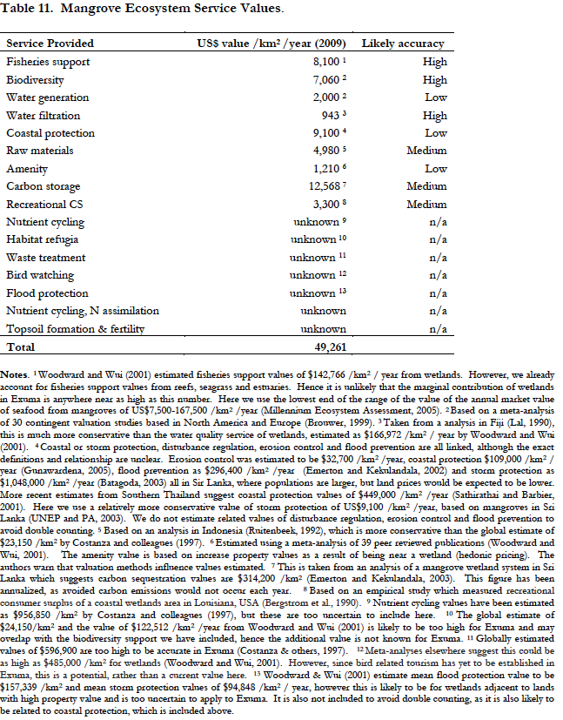
- Seasgrass
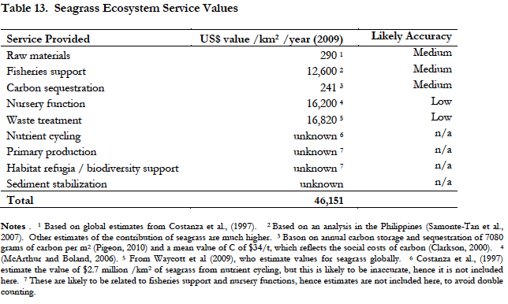

- Coral Reefs

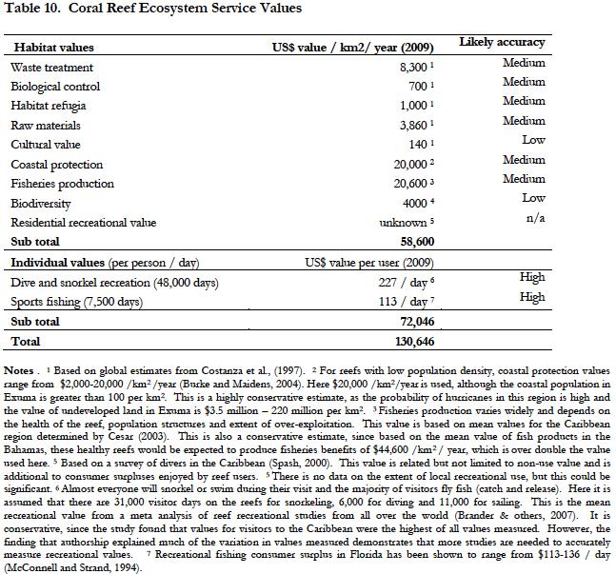

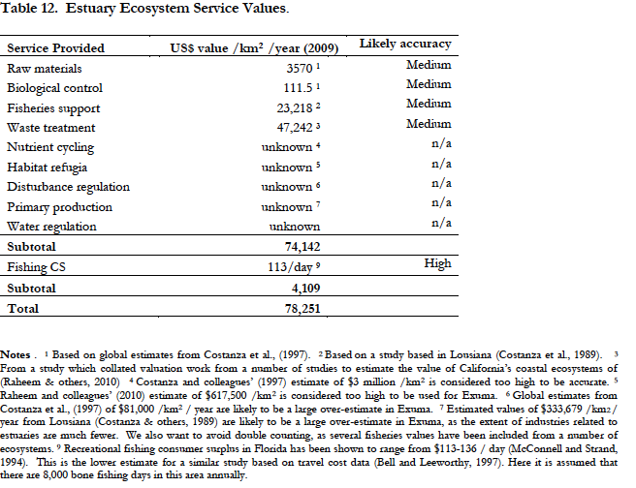

APPENDIX 7: FIGURE NUMBER AND THE SOURCE OF DATA LAYERS USED
FIGURE NUMBER AND CAPTION | SOURCE OF DATA LAYERS
FIGURE 1: BIOLOGICAL CORRIDORS AND PROTECTED AREAS BY TYPE | BERDS, 2011  NPAS, 2014
FIGURE 2: COROZAL AREA WATERSHEDS AND PROTECTED AREAS BY TYPE | NPAS, 2014
FIGURE 3: COROZAL CORRIDOR AND PROTECTED AREAS BY TYPE | BERDS, 2011  NPAS, 2014
FIGURE 4: COROZAL AREA SETTLEMENTS | BERDS, 2010
FIGURE 5: LAND COVER FOR COROZAL AREA BASED ON 2010 DATA LAYER | Emil Cherrington , 2010
FIGURE 6: COROZAL AREA ECOSYSTEMS BASED ON 2011 DATA LAYER | BERDS, 2011
FIGURE 7: FOREST COVER FOR COROZAL AREA BASED ON 2014 DATA LAYER | Emil Cherrington, 2014
FIGURE 8: MANGROVE AREAS IN COROZAL BASED ON 2014 DATA LAYER | Emil Cherrington, 2014
FIGURE 9: CAYE CAULKER AREA ECOSYSTEMS (2011) AND PROTECTED AREAS (2014). BLACK CIRCLE INDICATES LOCATION OF THE SPLIT ON THE ISLAND. | BERDS, 2011  NPAS, 2014
FIGURE 10: CAYE CAULKER AREA 2014 FOREST COVER AND PROTECTED AREAS (LANDSAT IMAGE (LEFT) AND MAP (RIGHT). PINK CIRCLE INDICATES LOCATION OF THE SPLIT ON THE ISLAND | Emil Cherrington, 2014  NPAS, 2014
FIGURE 11: CHIQUIBUL-MPR COMPLEX WITHIN BELIZE AND BELIZE RIVER WATERSHED (LEFT) AND ITS PROTECTED AREAS (RIGHT) | NPAS, 2014
FIGURE 12: LAND COVER (2010) OF PROTECTED AREAS IN THE CHIQUIBUL-MPR COMPLEX | Emil Cherrington, 2010  NPAS, 2014
FIGURE 13: ECOSYSTEMS (2011) OF THE CHIQUIBUL-MPR COMPLEX | BERDS, 2011
FIGURE 14: FOREST COVER (2014) OF PROTECTED AREAS IN THE CHIQUIBUL-MPR COMPLEX | Emil Cherrington, 2014  NPAS, 2014
FIGURE 15: TOLEDO AREA WATERSHED WATERBODIES AND PROTECTED AREAS BY TYPE | BERDS, 2010  NPAS, 2014
FIGURE 16: TOLEDO AREA CORRIDORS AND PROTECTED AREAS BY TYPE | BERDS, 2011  NPAS, 2014
FIGURE 17: TOLEDO AREA SETTLEMENTS | BERDS, 2010
FIGURE 18: TOLEDO AREA LAND COVER (2010) | Emil Cherrington, 2010
FIGURE 19: TOLEDO AREA ECOSYSTEMS (2011) | BERDS, 2011
FIGURE 20: TOLEDO AREA FOREST COVER (2014) | Emil Cherrington, 2014
FIGURE 21: TOLEDO AREA MANGROVE COVER (2014), PROTECTED AREAS AND WATERSHEDS | Emil Cherrington, 2014
FIGURE 27: DISTRIBUTION OF AVAILABLE RECORDS OF SPECIES OF CONSERVATION CONCERN WITHIN THE COROZAL DISTRICT | NPSAP/BERDS  CZMAI, 2010 & 2012
FIGURE 28: DISTRIBUTION OF RECORDS OF SPECIES OF CONSERVATION CONCERN FOR CAYE CAULKER | NPSAP/BERDS  CZMAI, 2010 & 2012
FIGURE 29: DISTRIBUTION OF RECORDS OF SPECIES OF CONSERVATION CONCERN FOR CHIQUIBUL-MPR COMPLEX | NPSAP/BERDS
FIGURE 30: DISTRIBUTION OF SPECIES OF CONSERVATION CONCERN WITHIN THE TOLEDO DISTRICT | NPSAP/BERDS  CZMAI, 2010 & 2012
FIGURE 31: MAJOR WATERSHEDS PROVIDING WATER PROVISION AND REGULATION SERVICES IN COROZAL | HyrdoSHEDS, 2007
FIGURE 32: COASTAL PROTECTION SERVICES OFFERED BY COASTAL VEGETATION (MANGROVES) ALONG THE COROZAL DISTRICT | CZMAI, 2010
FIGURE 33: COASTAL PROTECTION SERVICES OFFERED BY COASTAL VEGETATION (MANGROVES) ALONG CAYE CAULKER | CZMAI, 2010
FIGURE 34: MAJOR WATERSHEDS PROVIDING WATER PROVISION AND REGULATION SERVICES IN CHIQUIBUL-MPR COMPLEX | HyrdoSHEDS, 2007
FIGURE 35: MAJOR WATERSHEDS PROVIDING WATER PROVISION AND REGULATING SERVICES IN TOLEDO AREA | HyrdoSHEDS, 2007
FIGURE 36: COASTAL PROTECTION SERVICES OFFERED BY COASTAL VEGETATION (MANGROVES) ALONG TOLEDO | CZMAI, 2010
FIGURE 37: CHANGES IN PRECIPITATION FOR B1 AND A2 SCENARIOS FOR COROZAL | TNC, 2012
FIGURE 38: CHANGES IN AIR TEMPERATURE FOR B1 AND A2 SCENARIOS FOR COROZAL | TNC, 2012
FIGURE 39: CLIMATE CHANGE PREDICTIONS AND RESILIENCE FOR NORTHERN BELIZE | (source Wildtracks 2013)
FIGURE 40: CHANGES IN PRECIPITATION FOR B1 AND A2 SCENARIOS FOR CAYE CAULKER | TNC, 2012
FIGURE 41: CHANGES IN AIR TEMPERATURE FOR B1 AND A2 SCENARIOS FOR CAYE CAULKER | TNC, 2012
FIGURE 42: CHANGES IN PRECIPITATION FOR B1 AND A2 SCENARIOS FOR CHIQUIBUL-MPR COMPLEX | TNC, 2012
FIGURE 43: CHANGES IN AIR TEMPERATURE FOR B1 AND A2 SCENARIOS FOR CHIQUIBUL-MPR COMPLEX | TNC, 2012
FIGURE 44: CLIMATE CHANGE PREDICTIONS AND RESILIENCE FOR UPLAND FOREST OF THE MAYA MOUNTAIN MASSIF | (source Wildtracks 2013)
FIGURE 45: CHANGES IN PRECIPITATION FOR B1 AND A2 SCENARIOS FOR TOLEDO | TNC, 2012
FIGURE 46: CHANGES IN AIR TEMPERATURE FOR B1 AND A2 SCENARIOS FOR TOLEDO | TNC, 2012
FIGURE 47: CLIMATE CHANGE PREDICTIONS AND RESILIENCE FOR SOUTHERN COASTAL FORESTS - PINE AND BROAD LEAVED | (source Wildtracks 2013)
FIGURE 48: PREDICTED IMPACT OF SEA LEVEL RISE FOR ALL FOUR AREAS | TNC, 2012
FIGURE 49: ABOVE GROUND CARBON DISTRIBUTION FOR COROZAL AREA | Baccini et. al (Biomass data)
FIGURE 50: ABOVE GROUND CARBON FOR THE CHIQUIBUL (INCLUDING BUFFER AREAS) AND TOLEDO | Baccini et. al (Biomass data)
FIGURE 51: TIMBER PRODUCTION FORESTS IN THE COROZAL STUDY AREA BASED ON - SPECIES COMPOSITION OF THE ECOSYSTEM AND LEGAL STATUS OF THE LAND | ?
FIGURE 52: TIMBER PRODUCTION FORESTS IN THE CHIQUIBUL-MPR COMPLEX BASED ON - SPECIES COMPOSITION OF THE ECOSYSTEM, LEGAL STATUS OF THE LAND AND SLOPE | ?
FIGURE 53: TIMBER PRODUCTION FORESTS IN THE TOLEDO STUDY AREA BASED ON - SPECIES COMPOSITION OF THE ECOSYSTEM, LEGAL STATUS OF THE LAND AND SLOPE OF THE LAND | ?
FIGURE 54: DEFORESTATION HOTSPOTS IN THE COROZAL AREA FOR 2010-2014 | Based on Forest Cover 2014
FIGURE 55: FIRE RISK FOR COROZAL AREA | BERDS, 2004
FIGURE 56: IMPACT OF HUMAN ACTIVITIES IN THE COROZAL AREA | CZMAI, 2010
FIGURE 57: TOURISM USE IN THE COROZAL AREA | MTCCA, 2012/13
FIGURE 58: VULNERABILITY AND SENSITIVITY TO SEA LEVEL RISE IN THE COROZAL AREA | TNC, 2012
FIGURE 59: HOTSPOTS OF DEFORESTATION FOR CAYE CAULKER FOR 2010-2014 | Based on Forest Cover 2014
FIGURE 60: IMPACT OF HUMAN ACTIVITIES IN CAYE CAULKER | CZMAI, 2010
FIGURE 61: TOURISM USE FOR CAYE CAULKER | MTCCA, 2012/13
FIGURE 62: DEFORESTATION HOTSPOTS IN THE CHIQUIBUL MOUNTAIN PINE RIDGE COMPLEX 2010-2014 | Based on Forest Cover 2014
FIGURE 63: FIRE RISK IN THE CHIQUIBUL MOUNTAIN PINE RIDGE COMPLEX AND TOLEDO AREA | BERDS, 2004
FIGURE 64: DEFORESTATION HOTSPOTS OF THE TOLEDO AREA 2010 - 2014 | Based on Forest Cover 2014
FIGURE 65: IMPACT OF HUMAN ACTIVITIES IN THE TOLEDO AREA | CZMAI, 2010
FIGURE 66: TOURISM USE IN THE TOLEDO AREA | MTCCA, 2012/13
FIGURE 67: VULNERABILITY AND SENSITIVITY TO SEA LEVEL RISE IN THE TOLEDO AREA | TNC, 2012

See Appendices 7 for Figures and sources of all data layers.
LIDAR is a remote sensing method used to examine the surface of the Earth using light from a laser; is often referred to as Light Detection and Ranging. The Geoscience Laser Altimeter System (GLAS) is a space-based LIDAR. The Moderate Resolution Imaging Spectroradiometer (MODIS) is a remote sensing satellite instrument used to obtain imagery for the Earth.
LIDAR is a remote sensing method used to examine the surface of the Earth using light from a laser; is often referred to as Light Detection and Ranging. The Geoscience Laser Altimeter System (GLAS) is a space-based LIDAR. The Moderate Resolution Imaging Spectroradiometer (MODIS) is a remote sensing satellite instrument used to obtain imagery for the Earth.
Area determined based on 2014 Mangrove Habitat Map that takes into account all mangrove types along the coast.
Percent of shoreline stability contributed by mangroves in each area derived from Cooper et al., 2009.
Value of land based on internet searches and local consultation with real estate companies for each area. Coastal land classified as land within 100 m of coast, inland as land further than 100 m from the coast, as defined in Cooper et al., 2009.
The value of avoided damages provided by mangroves is presented in a range based on the upper and lower ranges of percentage shoreline stability derived from Cooper et al., 2009 and using the 4% factor to account for the probability of the 25 year storm occurring.
Total mangrove area determined from the 2014 Mangrove Habitat Map.
Avoided damage value is based on the average annual value per Ha for mangroves derived from Cooper et al., 2009.
Source BTB based on annual visitation statistics for 2014 by destination. For Mountain Pine Ridge the visitation records for 2014 maintained by the Forest Department were utilized.
Source Statistical Institute of Belize; average daily expenditure for leisure and recreation visitors, includes all expenses except for air travel and insurance.
Source Statistical Institute of Belize, average length of stay for leisure and recreation visitors.
Data on number of visitors based on 2015 exit surveys conducted under the IDB Phase II sustainable tourism project. Rates and figures based on methodology from Burke et al. 2009.
Prices represent the current average cost of diving in San Pedro and Caye Caulker, northern sites that would be visited by Corozal tourists. These costs were obtained from internet searches and consultations with dive shops.
Dive gear rental figures are from Burke et al. 2009 based on an estimate of 60% of divers renting dive gear at $22 US.
The revenue is reduced by 20% to provide a low-end estimate for percent of visitors who dive based on Burke et al. 2009 methodology.
Prices represent the current average cost of snorkeling in San Pedro and Caye Caulker, northern sites that would be visited by Corozal tourists. These costs were obtained from internet searches and consultations with dive shops.
Snorkel gear rental figures from Burke et al. 2009 are based on an estimate of 70% of snorkelers renting gear for $5 US.
Total Indirect Revenue was calculated using a multiplier range of 1.2 to 1.4 to account for uncertainty in the data based on similar study (Cooper et al., 2009 methodology).
Information for beaches was obtained from management plans for both the Caye Caulker Forest and Marine Reserve and Port Honduras Marine Reserve.
Information for coral reefs was obtained from management plans for both the Caye Caulker Forest and Marine Reserve and Port Honduras Marine Reserve.
Information obtained from management plan for the Corozal Bay Wildlife Sanctuary.
Information obtained from the Technical Assessment of the MMM
Information obtained from management plans for Chiquibul National Park, Columbia River Forest Reserve and Bladen Nature Reserve,
Information obtained from Technical Assessment of the MMM.
Information obtained from the management plans for Corozal Bay, Caye Caulker Forest and Marine Reserve and Port Honduras Marine Reserve.
Information obtained from the Summary of the Central Belize Corridor: Conservation Action Plan.
Information obtained from the Caye Caulker Forest and Marine Reserve Management Plan.
Information obtained from management plan for Cockscomb Basin Wildlife Sanctuary.
Information obtained from management plan for Shipstern Nature Reserve.
See footnote above.
Deforestation values in this table are not inclusive of mangrove forest. They only reflect deforestation of broadleaf and pine forest.
Biodiversity values for the Corozal Area were based primarily on values for Shipstern Nature Reserve (SNR) due to the lack of data for other PAs in the area. These figures and species lists were obtained from the SNR Management Plan, see bibliography for details. Completed species list is within the management plan.
Threats for the area obtained from Shipstern Nature Reserve Management Plan and Directory of Protected areas, see bibliography for details.
Threats for the area obtained from Caye Caulker Forest and Marine Reserve Integrated Management Plan, see bibliography for details.
Biodiversity values for the Chiquibul-MPR Complex area based primarily on values for the Chiquibul National Park (CNP), as these were the only available data for the area. Due to its interconnectedness species CNP are believed to also occur in the adjacent PAs. Values obtained from the CNP Management Plan
For a full list of species of conservation concern for the Chiquibul National Park, see Annex 2 of the Chiquibul National Park management Plan, details for plan in bibliography.
Threats also obtained from the CNP Management Plan
Biodiversity values were based primarily on values from six PAs (AWS, CRFR, BNR, GSCP, CBWS, PCNP and PHMR). Due to the lack of specific species list within each of the documents for the six PAs, for cross referencing, a range of species values was used for Toledo. With this range there was no miscounting of species as some species are known to exists in more than one PA. For a list of management plans and rapid ecological assessments used, please see section on biodiversity for Toledo (5.1.1.4) and the corresponding references within the bibliography to attain individual biodiversity values for each of the PAs in Toledo.
All Shoreline Protection values cited in this table are based on avoided damage value of mangroves in the various study areas using the average annual value of US$2,775 – $4,000 per ha per year for mangroves within 1 km of the coast (Cooper et al., 2009).
Tourism value given is based on tourist visitation to or through the Mountain Pine Ridge and assumes inclusion of all tourist visitation to Caracol Archaeological Site

