Document of the Inter-American Development Bank

jamaica
Energy Management and Efficiency Program
(JA-G1003)
Gender Assessment

Prepared by: Andrea Monje Silva (SCL/GDI)

- Context and Gender Diagnostic
Jamaica is the third largest island in the Caribbean region with an area of 11,000 square kilometers (km²) and a population of 2.72 million people, of which 50.6% are women. According to Global Gender Gap Report (GGGR) developed by the World Economic Forum (WEF) Jamaica was ranked as the 65th country in the world (out of 145), the 13th country in Latin America and the Caribbean (LAC) and fifth country in the Caribbean that has closed over 70% of gender gaps. This report measures progress in fourth dimensions: health, education attainment, political participation and economic participation.
In Jamaica, progress in terms of gender equality has been reached primarily thanks to improvements in women’s education and health. Women’s life expectancy has increased from 75.2 years in 2000 to 78.1 years in 2015 (compared to 73.3 years for men), female mortality rate, under-5 has decreased from 19.1/1000 deaths to 13.7/1000 in the same time period and prevalence of HIV for females between 15 and 24 years old has also decreased from 1.3% to 0.6% between 2000 and 2015. Additionally, female school enrollment in secondary and tertiary education is greater than those of men: 77.5% vs 69.7%, respectively, in 2015 for secondary education and 38.4% vs. 16.9%, respectively, in 2015 for tertiary education. Moreover, women’s enrollment in tertiary education has increased from 19.9% to 38.4% between 2000 and 2015. In relation to women’s political participation, progress has been slower but Jamaica is classified around the regional average: women represent 20% of the total number of ministers, higher than Mexico (17.6%), Brazil (15.4%) or Uruguay (14.3%), among others in 2015; and they represent 28.6% of the total number of senators, higher than the regional average of 25.5% in 2015.
In terms of economic participation, Jamaica has the fifth highest female labor force participation rates of the Caribbean (56.2%, see graphic 1). However, this rate hides other realities: 1) female labor participation is still 13.8 percentage points lower than male participation (72%); 2) women earn between 8% and 17% less than man; and 3) occupational segregation is still prominent in the country, for example women represent over 64% of the employees of the hotel and restaurant sector, but only 19.7% of the transport sector and 20% of the electricity, gas and water supply sector (see graphic 2). Lower earnings can be explained, in part, by occupational segregation since women tend to work in sectors that are less competitive, have lower salaries, less benefits and offer little professional growth.

Graphic 1 – Labor Force Participation Rate in the Caribbean, 2013 (by sex)

Note: Data available only for 8 countries for 2013
Source: ILO (2013). ILOSTAT Database: Caribbean

Graphic 1 – Percentage of Female and Male Labor Force by Sectors, Jamaica 2014

Source: Statistical Institute of Jamaica (2014). Labor Force by Industry: January 2014.

Women’s Participation in the Intervened Agencies
In order to have a better understanding of the female participation rate within the executing agency and the buildings that will benefit from program, the project team collected data on the female/male composition of the maintenance staff and facility managers of a representative sample of buildings (Health, Education and Public Agency – HEPA government facilities), as well as the executing agency (Petroleum Corporation of Jamaica—PCJ), the Policy team of Ministry of Science, Energy and Technology (MSET). With the project, approximately 80 HEPA government facilities will benefit from retrofitting, and this intervention will be accompanied by training programs for maintenance staff, facility managers, and technical staff. Furthermore, energy awareness training will be conducted to provide critical knowledge on energy efficiency and conservation measures and their roles in minimizing energy use and maximizing energy efficiency measures. These trainings will be extended to general employers including, but not limited to, teachers and students in the case of schools, and doctors, nurses, and all administrative staff in the case of hospitals. To have a general idea of the composition of these maintenance staff, the team collected data from a sample size of six building which showed that 22.5% of the staff was women. In relation to executing agencies, staff composition data was collected on PCJ and MSET and women represent 15%, 30% and 53%, respectively (see detailed list on annex 1 of this document).

- Gender Additionality: Justification and Intervention
The main objective of this non-reimbursable co-financing operation which complements the EMEP loan (3877/OC-JA) is to promote a more efficient use of energy resources that would free public funds through avoided oil imports, helping the GOJ to create fiscal space for productive spending. The specific objectives and expected results of this operation are: (i) reduced electricity consumption in public buildings resulting in avoided GHG emissions and (ii) support to capacity building for energy planning

Taking into account the gender context described in the previous section, as well as the objective of this project, this section will present why the project will include gender as additionality.

Justification
Worldwide, female employment distribution by sectors confirm that women work primarily employed in sectors such as communication services (31%), agriculture (27%) and retail (21%), but hardly work in sectors such as energy and transport (electricity and mining combined make up for 1% of total number of women working in those sectors and transport and telecommunications make up for 2%, see graphic 2).

Graphic 2 - Female and Male Employment Distribution by Sectors

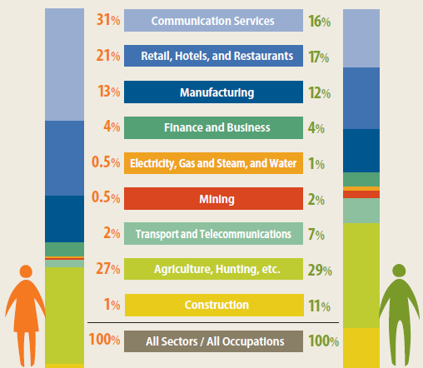

Source: World Bank (2012). World Development Report 2012: Gender Equality and Development.

The concentration of female and males in different sectors constitute one of the most significant areas where gender inequality manifest itself the most when analyzing labor markets, and it is closely related to gender income gaps. In fact, a study by the American organization Wider Opportunities for Women found that in the US women that work in traditional sectors, such as services and retails, earn between 20% and 30% less than women that work in no traditional sectors (such as metalwork or truck drivers). Moreover, these non-traditional sectors tend to offer better benefits for its employees since they are highly unionized and offer the possibilities of professional growth through promotions. When analyzing specifically the energy sector, a survey carried out by PayScale Human Capital in the US states that the position of energy manager is very well paid, with an average of US$ 74,000 per year, close to what a mechanical engineer makes in the US (between US$ 58k to US$ 80k), and more than a social worker or a retail manager (average salary of US$ 42k per year for both). Additionally, over 90% of energy managers declared benefiting from health insurance (compared to only 70% of retail managers) and being extremely satisfied with their jobs. However, like in the rest of the world, women are still under-represented in these positions: only 19% of the people working as energy managers are female in the US. As for the transport sector, the same survey states that the position of traffic technician is well paid, with an average of US$ 48,000 per year. Additionally, over 81% of traffic technicians declared benefiting from health insurance (compared to only 70% of retail managers) and being extremely satisfied with their jobs. However, like in the rest of the world, women are still under-represented in these positions: only 9% of the people working as traffic managers are female in the US.

Table 2 - Monthly Average Female Salary by Type of Work, USA
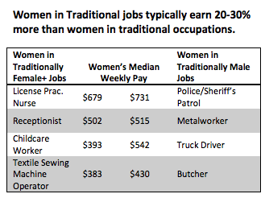
Source: Wider Opportunities for Women (2010). Women and Nontraditional Work. Washington DC.
Moreover, in 2013, worldwide over 6.5 million direct and indirect jobs were created in the renewable energy sector and according to the International Renewable Energy Agency (IRENA) more than 16.7 million jobs could be generated in this sector by 2030. For example, the United States is seeing a rapid rise in deployment of solar photovoltaic (PV) in particular, along with strong investment in wind in several states and a leading focus on development of advanced biofuels. Overall, wind jobs in the US have increased by almost half—43%--since last count to 73,000, whilst total solar employment surged 22% to 173,800 in 2014. And the employment of women in the US solar industry is on the rise, increasing from 26,700 to 37,500 last year. In the LAC region, Brazil has created a considerable number of jobs in the renewable energy sector. For example, in 2013, 32,000 people were employed in the wind industry; however, the sector is predominantly male since women only account for 20 to 24% of total jobs. As for the transport sector and related services, the sector could generate around 40,000 jobs for every US$ 1 million invested. However, as mentioned before, women are still not benefiting from this job creation.

Additionally, when analyzing the type of positions that women occupy in non-traditional sectors, it can be highlighted that very few of them have technical or decision-making positions. In exchange, they tend to occupy more administrative and support positions, which tend to have lower salaries and offer less opportunities for professional growth. For example, according to an Ernst and Young survey, worldwide women made up 5% of executive board members, 19% of non-executive directors’ members and 14% of senior management leadership positions in the top 200 power and utilities companies in 2016. When analyzing the Latin American and Caribbean (ALC), the region has the highest percentage of female executive directors, but they only represent 9% of the total number (or 2 executive directors when looking at absolute numbers). Moreover, in ALC 7% of non-executive directors and 17% of senior management leaders are women (see graphic 1). Overall, women in the region represent only 19.7% of the total number of employees in the electricity, gas and water sector.
Graphic 1 – Geographical Breakdown of Women in Strategic Roles in top 200 utilities
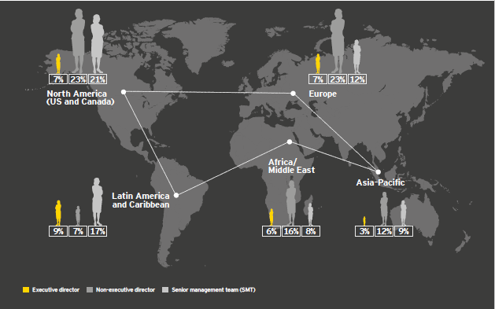
Source: Ernst and Young (2016). Women in Power and Utilities: Index 2016.
Taking this into account, increasing women’s participation in non-traditional sectors, as well as in more technical positions could help them to: i) increase their incomes; ii) provide them with more social benefits in the short and long term (health insurance, maternity leave and social security during retirement); and iii) grow professionally since they could have the possibility of being promoted within their companies. Moreover, taking advantage of women’s potential (they represent 50% of the population and possess over half of university degrees around the world) can result in: i) greater productivity for the energy sector; ii) respond to an increasing demand of workers in this growing sector; and iii) promote economic growth in the country.

Occupational segregation is also a reality in Jamaica. In fact, even if Jamaican women’s labor participation is one of the highest of the Caribbean, the rate is still lower than men (56.2% vs 70%, respectively in 2013). Women in Jamaica earn between 8 and 17% less than man. And they are highly concentrated in sectors that are less stable and have lower salaries and benefits. For example, women represent only 20% of the electricity sector and 19.7% of the transport sector. Therefore, energy and transport projects financed by the IDB represent not only a support to strengthen those sectors, but also an opportunity to improve and expand economic opportunities for women.

Gender Intervention
The Energy Management and Efficiency Program (JA-G1003) will include several activities to train and certify maintenance staff and facility managers in the 7 public hospitals retrofitted. Some of the training will focus on: key technical and operational aspects of maintaining new building systems, and how energy efficiency and conservation measures can be implemented and sustained. Taking into consideration high occupational segregation in the energy sector in Jamaica, this project will include a gender target aimed at promoting women’s participation the technical trainings mentioned before. Hence, the gender target will aim at ensuring that at least 25% of people trained by this project are women. To reach this target, the project will include as a participation requirement that all institutions participating in the trainings send at least one woman from their teams to benefit from these trainings. By including this target, the project expects that women will gain new skills, develop their professional networks and be exposed to new technologies, resulting in better job opportunities in the EE&C sector.

Gender Indicator:
Output indicator
Indicator | Unit | Baseline | Target | Verification Method
Women participating in trainings | % | 0 | 25 | List of participant and follow-up monitoring to participants

Annex 1
Hospital, Schools and Executing Agencies Staff by sex
Name of the Staff | Sex | % of female
Mandeville Regional Hospital
Alwyn Miller | Male | 25%
Marcia Francis | Female
Herschel Ismail | Male
Richard Copeland | Male
Marcus Garvey Technic School
Rohan Francis | Male | 20%
Sheyon Sherwood | Male
Andre Russell | Male
Derron Pottinger | Male
Monica McIntyre | Female
Cornwall Western Regional Hospital
Sian McLaughlin | Male | 0
Joseph Ramsay | Male
Steve Lawrence | Male
Kingston Public and Victoria Jubilee Hospitals
Nadia Adams Richards | Female | 50%
Raul Morgan | Male
Ebony Heart Academy
Robert Green | Male | 40%
Charlene Edwards | Female
Stephen Clarke | Male
Dr. Sasha-Shim-Hue | Female
Donald Sergeon | Male
Falmouth Hospital
Darion Thompson-Smith | Male | 0
Carlington McLennon | Male
Damian Leslie | Male
PCJ’s REED Engineers Team Composition
Graig Tattray | Male | 30%
Jannelle James | Female
Kevin Gallimore | Male
Kemar Mantock | Male
Shane Silvera | Female
Rasheed McCallum | Male
Niconor Reece | Male
Claon Rowe | Male
Charles Koomson | Male
Denise Tulloch | Female
MSET (IRP) Policy team Composition
Fitzroy Vidal | Male | 43%
Horace Buckley | Male
Jody Grizzle | Female
Mark Williams | Male
Yvonne Barret Edwards | Female
Olivene Dahlia Rhodes | Female
Omar Alcock | Male

World Bank (2015). GenderStats.
World Bank (2015). GenderStats.
World Bank (2015). GenderStats.
IPU (2015). Women in Politics.
ILO (2013). ILOSTAT Database: Barbados.
Bellony, Annelle; Hoyos Alejandro; and Nopo, Hugo (2010). Gender Earning Gaps in the Caribbean: Evidence from Barbados and Jamaica. IDB: Washington DC.
Statistical Institute of Jamaica (2014). Labor Force by Industry: January 2014.
Of which, 73 financed with the JA-L1056 and 8 with the JA-G1003.
The underutilization of the labor force influences the performance of the economy in a sub-optimal level of the economy since it produces less of what could, resulting in a low economic growth for country.
PayScale Human Capital (2016). Energy Manager Salary in the US.
PayScale Human Capital (2016). Energy Manager Salary in the US.
Marcos, Paloma (2014). Gender and Renewable Energy: Wind, Solar, Geothermal and Hydroelectric Energy. IDB: Washington, DC.
Aguilar, Lorena (2015). Unleashing the Power of Women in the Renewable Energy Sector
Marcos, Paloma (2014). Gender and Renewable Energy: Wind, Solar, Geothermal and Hydroelectric Energy. IDB: Washington, DC.
Ernst and Young (2016). Women in Power and Utilities: Index 2016.
IDB (2015). Sistema de Información de Mercados Laborares y Seguridad Social.
Several studies have demonstrated that gender equality has negative impact in the economic development of a country. See: Cuberes and Teignier (2011 and 2015); Klasen (2002); and Dollar and Gatti (1999), among others.
Bellony, Annelle; Hoyos Alejandro; and Nopo, Hugo (2010). Gender Earning Gaps in the Caribbean: Evidence from Barbados and Jamaica. IDB: Washington DC.
All training costs will be funded under the JA-L1056. However, all maintenance staff and facility managers in the 7 public hospitals retrofitted under JA-G1003 will benefit (at no cost).
On average, about 4 facility managers per building will be trained. This includes under the JA-L1056 loan operation approximately 292 facility managers, and under the JA-G1003 28. In total, approximately 320 professionals will be trained in the overall context of the EMEP program.

