Document of the Inter-American Development Bank

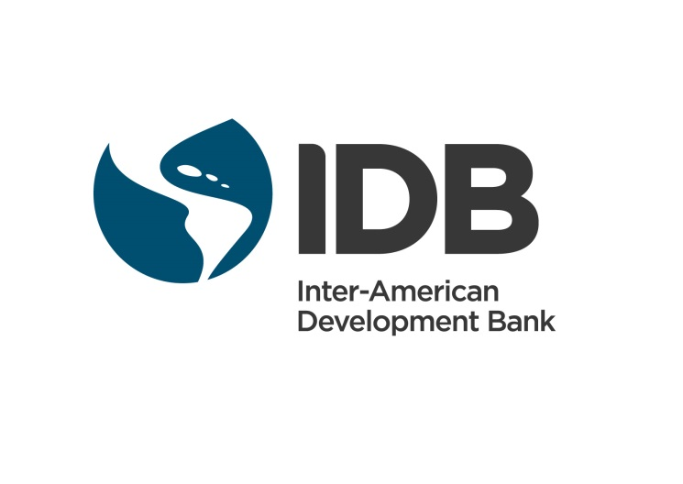

Brazil
Strategic Program for Transportation Infrastructure and Logistics in Paraná
BR-L1434

Environmental and Social MANAGEMENT REPORT
(ESMR)
08/04/2017

This document was prepared by:
Zachary Hurwitz and Patricia Henriquez (VPS/ESG)

ENVIRONMENTAL AND SOCIAL MANAGEMENT REPORT (ESMR)
Operation Name: | Strategic program for Transportation Infrastructure and Logistics in Paraná.
Operation Number: | BR-L1434
Operation Details
IDB Sector | Transport
Type of Operation | Multiple Works
Impact Categorization | B
Disaster Risk Rating | Moderate
Borrower | State of Paraná
Executing Agency | The State of Paraná, through the Departamento de  Estradas de Rodagem do Paraná (DER-PR)
IDB Loan US$ (and total project cost) | $235,000,000 (total project cost $435,000,000)
Applicable Policies/Directives | OP-102; OP-703 (B.01, B.02, B.03, B.04, B.05, B.06, B.07, B.09, B.10, B.11, B.12, B.17); OP-704; OP-710; OP-761;  OP-765
1. Executive Summary
The scope of this ESMR addresses Component 2 of the multiple works Program. Component 2 of the Program will finance construction, including earthworks and paving of 4 new greenfield by-passes, totaling 28.03km; paving of 3 existing roads, totaling 120.23km; and restoration and lane expansion of 9 existing paved highways, totaling 54.58km. An additional 36 km of projects are estimated to be included at a future date in the Program, but have currently not been identified by the Executing Agency. The sample projects include the construction of one greenfield bypass totaling 6.00 km; the repaving of four existing highways, totaling 121,51km; and the restoration and lane expansion of one existing highway, totaling 4.24 km. The Right of Way (ROW) required for construction of each sample project varies between 25-50 meters.

The eligibility criteria for future projects to be included in the Program (as established in the Annex to the Loan Contract) exclude Category “A” projects. Due diligence confirmed that limited physical resettlement is required for the sample projects. In addition, DER will compensate for the use of parcels of landowner and landholder properties currently located in the ROW.

The operation has been classified as Category “B” as defined by the Environmental Safeguards and Compliance Policy OP-703, due to confirmation during due diligence of its local, negative environmental and social impacts, principally related to the preparation of the ROW, for which mitigation measures are readily available. Disaster risk for the Program has been classified as “moderate,” related to the risk that erosion due to severe floods, hail, and severe wind events may limit traffic and access to land for neighboring communities.

The most significant potential impacts and risks associated with the sample projects include limited physical resettlement; livelihood impacts on households and/ or businesses located in the ROW; informal settlement of households and/or businesses in the ROW; suppression of native vegetation including Atlantic Forest fragments; mortality of terrestrial fauna due to road crossing; and generation of waste. These impacts have been minimized during the planning process by DER, such that remaining impacts are readily mitigated during Program execution.

Environmental and social assessments, which include Resettlement Plans, have been developed for each sample project in compliance with IDB policies and have been disclosed by the IDB and the executing agency. With the support of the IDB, DER has developed a Strategic Environmental Assessment (SEA) and an Environmental and Social Management Framework (ESMF) for the Program to assure compliance with IDB policies of each future project to be incorporated to the Operation, including a Resettlement Framework (RF), a Stakeholder Engagement Framework (including a Grievance Mechanism), a Disaster Risk Management Framework, and a Framework for the Management of Critical Natural Habitat fragments. Public consultation has occurred on each sample project, in compliance with OP-703 (B.6), and occurred on the SEA and ESMF as well as each sample project Final Resettlement Plan prior to OPC. Implementation of the ESMF and DER´s own procedures and guidelines will assure compliance with IDB policies throughout Program execution.

2. Operation Description
The proposed Program is a Multiple Works operation that contemplates the construction of 24 highway projects, including new, greenfield bypasses, repaving of existing roads, and highway restoration and expansion, totaling 239km, located in diverse locations across the state of Parana, Brazil. The execution timeline will take place between 2018-2022.

The sample projects of the Program have been identified by the borrower in collaboration with the IDB and includes one greenfield bypass totaling 6.00km; four projects to repave existing roads, totaling 121.58km; and one project to restore and expand an existing highway, totaling 3.90km (see Annex 3 for details). The scope of the Bank’s Environmental and Social Due Diligence was the entire five-year Program of DER, which currently includes 16 projects, with the same objectives and timeline as the activities that would be financed by the Bank under the present Operation. The largest number of workers on any given project at the height of works is estimated to be 200.

A number of federally-demarcated and declared indigenous lands (Kaingang and Guaraní), federally- and state-protected conservation areas, and Key Biodiversity Areas exist in the State of Paraná (Figure 1). In addition, the state contains remnants of Atlantic Forest habitat, considered high in biodiversity and endemism, subtropical moist broadleaf forest (restinga), wetlands, and mangroves (Figure 2). Due diligence confirmed that of these critical habitats, only Atlantic Forest fragments will be affected by the sample projects of the Program, for which restoration or compensation measures are required. A number of traditional communities, including quilombola and faxinal (communal agro-pastoral) communities (Figure 3), also exist in the Program area. Due Diligence confirmed that faxinal communities, but not quilombolas or indigenous communities, will experience limited impacts due to construction (see “Indigenous Peoples” below).

One of the sample projects will require opening of a new road and suppression of native vegetation, while the remaining five sample projects will utilize already-intervened land located in urban and rural contexts. All sample projects will require suppression of some native vegetation including Atlantic Forest fragments. All sample projects require a ROW between 25-50 meters (see Annex 4 for the ROW per project). No new construction easements or waste disposal sites will be created for implementation of the roads; all works will take place within the existing or the expanded Right of Way.

Annex 4 describes the works and ESHS contexts of each of the sample projects (see Annex 6 for reference maps).

3. Key Impacts, Risks, and Mitigation Measures
Assessment Requirements
OP-703 (Environment and Safeguards Compliance Policy): B.3 (Screening and Classification), B.4 (Other Risk Factors), and B.5 (Environmental Assessment and Plans Requirements)
In compliance with OP-703, Environmental and Social Assessments (ESAs) were developed for all sample projects. The Bank supported the development of Complimentary Environmental and Social Assessments, including new Resettlement Plans, for each sample project. Each environmental and social assessment contains an alternatives analysis that led to the minimization of impacts on Critical Habitat.

In addition, the IDB supported the development of a new Strategic Environmental Assessment and an Environmental and Social Management Framework for the Program, which have been divulged on the IDB website. The ESMF includes an RF, a Stakeholder Engagement Framework including a Grievance Mechanism, a Disaster Risk Management Framework, and a Framework for the Management of Critical Natural Habitat fragments. Implementation of the ESMF and DER´s own procedures and guidelines will assure compliance with IDB policies throughout Program execution.

All environmental and social assessments for sample projects have obtained or are in the process of obtaining environmental licenses from state environmental agency Instituto Ambiental do Paraná (IAP).

As a condition of the Loan and included in the Operational Manual, DER is creating a Program execution unit that includes dedicated environmental and social staff who will lead the implementation of the Program ESMPs and RPs, and who will serve as contact point to the IDB. Due diligence confirmed that DER has a USD $9.78 million budget for implementation of the Program ESMPs including resettlement and compensation, and a budget of USD $17.4 million for technical, environmental, and social supervision of the Program, for which DER will contract a third party.

Consultation
OP-703 (Environment and Safeguards Compliance Policy): B.6 (Consultation); and Consultation requirements of OP-710 (Involuntary Resettlement Policy), OP-765 (Indigenous Peoples Policy), OP-761 (Gender Equality in Development Policy), and OP-704 (Disaster Risk Management Policy) as applicable
A round of public consultations (7 events) on the sample projects took place between April 24th and May 22nd, 2017 in the municipalities of Marechal Candido Rondon, Coronel Domingo Soares, São Mateus do Sul, Irati, Mato Rico, Castro and Colombo, Paraná, which entailed the presentation of the ESAs and ESMPs of each project. The meetings accounted approximately 1150 participants consisting of owners of the areas and businesses affected by the project, civil society organizations, community associations and cooperatives, and municipal and other government representatives, from the area of influence of each project. The methodology for these public consultations was developed with the support of the IDB in accordance with OP-703 (B.6).

The consultations were publicized through invitations, posters, radio spots and publications in regional newspapers. The posters were located in strategic points of the municipalities, prioritizing places with greater concentration and traffic of pedestrians, such as supermarkets and businesses. Consultation events were also publicized on social media (Facebook) and DER’s website. The project summary and ESA were made available on DER’s website for consultations.

The consultation events were carried out in the following order: (i) presentation of objectives and agenda; (ii) indicating communication channels for participation after consultation face-to-face (an email and a telephone number to continue providing feedback, any question and/or suggestion); (iii) general explanation of the Program; (iv) explanation of technical aspects (main impacts of works and mitigation measures); (v) round of Q&A. It was possible to identify the need to adjust some engineering projects. Some of the issues raised by participants were: (i) access to bus stops; (ii) pedestrian crossing, particularly by students of schools in the area; (iii) project budget to ensure completion; (iv) compensation of landowners; (v) interference of works in access to properties; (vi) local employment, among others. More detail is provided in the consultation reports included in the final versions of the ESAs.

Consultation (6 events) on the RPs for each of the sample projects took place prior to OPC, between June 29th and July 6th, 2017, which entailed the presentation of the key elements of the RP. The final RPs include a consultation report. The consultations were publicized through invitations and radio spots. The local municipalities were responsible for delivering the invitations and providing transportation to the events in Irati and Mato Rico. The project summary and RPs were made available on DER’s website for consultations and printed copies were available in DER’s regional office. The meetings accounted approximately 250 participants. Most of the questions were regarding the expropriation process, schedule and compensation measures.

Consultations were also an opportunity to continue updating the census of the RPs of the sample projects, since the information about the areas to be expropriated was gathered a few years ago. Some landowners agreed to fill out a socio-economic survey during consultations.

A consultation on the SEA and ESMF (including the RF) took place prior to OPC on July 13th, 2017 in Curitiba. Specific consultations with the faxinal communities of Marmeleiro de Baixo and Paiol Grande, which are in the area of direct influence of the São Mateus do Sul-Irati project, took place on June 2nd and 3rd, respectively. Additionally, informational sessions were organized with representatives of these communities on May 24th. The main concerns expressed during these consultations were related to road access during construction, and it was clarified that no detours will be required, and that access to the school and church along the road will be guaranteed and properly signposted. All consultation activities were documented and disclosed by the IDB, and on DER´s website.

The results of all consultations, including for the SEA/ESMF and all sample projects and their Resettlement Plans, were included in the final versions of these documents and disclosed on the IDB website, prior to OPC.

Landowners affected by the ROW of each of the sample projects will be kept informed during Program execution through the implementation of the procedures described by the Stakeholder Engagement Framework and Resettlement Framework included in the ESMF, comply with OP-703 (B.6), OP-710, and OP-765. Continual implementation of these procedures will assure compliance of the Program with OP-703 (B.6) throughout Program execution. In addition, the Executing Agency must obtain non-objection from the IDB for each ESA for subsequent projects, which must include a summary of Public Consultation activities, including regarding a Resettlement Plan, if physical or economic resettlement is necessary.

DER has an established centralized Grievance Redress Mechanism for all its operations, and will strengthen this mechanism to receive grievances during Program execution. It consists of a dedicated telephone line, website, and staff based in each of the regional offices of DER throughout the state, through which one may submit grievances.

Information Disclosure
OP-703 (Environment and Safeguards Compliance Policy): B.5 (Environmental Assessment and Plan Requirements);
OP-102 (Access to Information Policy)
In compliance with OP-102, the environmental and social assessment and Resettlement Plan of each Program sample project, and the Strategic Environmental Assessment for the Program and its Environmental and Social Management Framework (including a Resettlement Framework) for the Program, were disclosed on the IDB website prior to Analysis Mission.

All environmental and social assessments of subsequent projects during Program execution will be disclosed on the IDB website. The results of all consultations, including for the SEA/ESMF and all sample projects and their Resettlement Plans, were included as part of the final versions of these documents that were delivered to the IDB prior to OPC. These final versions, which include the public consultations reports, were disclosed on the IDB website prior to OPC.

Environmental and Social Impacts and Risks
OP-703 (Environment and Safeguards Compliance Policy): B5 (Environmental Assessment Requirements), B8 (Transboundary Impacts), B9 (Natural Habitats and Cultural Sites), B10 (Hazardous Materials), B11 (Pollution Prevention and Abatement), and B12 (Projects Under Construction)
Due diligence confirmed that potential environmental and social impacts and risks associated with the construction of each of the sample projects include (i) potential fragmentation of critical natural habitat, including Atlantic Forest; (ii) suppression of natural habitat; (iii) increased mortality of fauna associated with wildlife crossing; (iv) resettlement and livelihood impacts for households located within the Right of Way; (v) an increase in vehicular traffic which could result in increased emissions, noise, and accidents; (vi) generation of waste, including gas emissions and spills of toxic liquids such as petrochemicals; (vii) dust, noise, and light pollution; (viii) erosion of soil and vegetation; (ix) risks to worker health and safety; (x) potential impacts to cultural heritage and archaeological sites; and (xi) risk of conflicts with local populations related to worker influx, and potentially inadequate management of community relations. See Annex 4 for a table of impacts and risks per sample project.

Due diligence confirmed that potential environmental and social impacts and risks associated with the operation of each of the sample projects include: (i) fragmentation of habitat connectivity and fauna migration; (ii) mortality of fauna; (iii) potential long-term risk of increased vehicular traffic and associated emissions, noise, and accidents; (iv) potential risk of increased migration, unplanned urbanization and development, and increases in land value; and (v) natural disaster risks on the livelihoods of project-affected communities, associated with the risk of erosion in the area of influence of the projects, due to drought, severe floods, hail, and severe wind events. See Annex 4 for a table of impacts and risks per sample project.

The existing ESMPs for the sample projects are varied, according to the scope of works the nature of the associated impacts and risks (see Annex 5 for a list of ESMPs per sample project). At a minimum, each ESMP includes a Waste Management Plan, an Erosion Control Plan, a Traffic Management Plan, a Degraded Area Restoration Plan, a Fauna Rescue Plan, a Vegetation Suppression Control Plan, an Environmental Education Plan, an Emergency Response Plan, and a Social Communication Plan, that comply with IDB policies. In addition, through the support of the IDB, complimentary ESMPs were developed for each sample project, which include improved Social Baselines and Biodiversity Baselines, a Gender Action Plan, a Resettlement Plan, a Disaster Risk Assessment and Management Plan, and a Grievance Redress Mechanism. See Annex 5 for a table of existing mitigation plans for each sample project.

The project will have moderate risks and impacts related to resettlement since limited physical displacement is required; in one of the sample projects, households will be moved within the same property. In addition, most of the land affected by the expansion of the ROW represents a small percentage of each property. A Resettlement Plan (RP) has been prepared for each sample project and a Resettlement Framework (RF) as part of the ESMF. The costs for resettlement and compensation are considered in the project budget.

Livelihoods and Resettlement
OP-710 (Involuntary Resettlement Policy)
Due diligence identified that 5 of the 6 sample projects will involve physical resettlement. The quantity of property holders to be resettled in these 5 projects, including both legal title holders and irregular land holders, is currently estimated at a total of 39. This number will be confirmed during the Cadaster of Physical Properties and the Socioeconomic Cadaster, which DER will execute as part of its expropriation procedure, and will be included in updated Resettlement Plans prior to first disbursement.
In addition, due diligence identified that all sample projects involve livelihood loss, due to the expropriation of a percentage of properties of small-, medium-, and large-sized landowners for use of the Right of Way. These landowners will be compensated in line with OP-710.
As part of the complimentary environmental and social studies, DER procedures were reviewed for both resettlement as well as for compensation for losses associated with use of the ROW for construction activities. In order to comply with OP-710, formal and informal landowners, landholders, and occupants and people whose income depends on the activities carried out on the property were included as part of the preliminary baseline. These considerations were taken into account for the aforementioned Cadasters for the final versions of the Resettlement Plans, which were delivered to the IDB and disclosed on the IDB website prior to OPC.
DER’s procedures for both resettlement and livelihood restoration compensate for the value of land, as well as of structures, improvements, and crops among other goods. The valuation of land is based on land use capacity and economic activity that might be compromised and may need support and/or adaptive measures. These procedures include the inventory and measurement of affected goods, a methodology for determining their value, and negotiation with the landowner to determine an agreement. In the case of irregular occupation of lands, DER procedures compensate for goods and services held by the occupant, but not for the value of the land which complies with OP-710.

Due diligence confirmed that an estimated US $2.4 million has been budgeted for land acquisition and resettlement during the execution of the Program, which will be financed by the counterpart. Due diligence also confirmed that DER has budgeted a total of US $520,000 for compensation for livelihood loss in the Right of Way during execution of the Program, which will be financed by the counterpart. The procedure for signing contracts and payment of compensation must be established in the ESMP of the environmental and social assessment of each project as described by the RF in the ESMF, which must obtain the non-objection of the IDB. As part of Program eligibility criteria, DER must justify to the Bank that the price of land is reasonable according to market price, and that acquisition of such land complies with the requirements of the Involuntary Resettlement Policy (OP-710).

An RF has been developed as part of the ESMF to assure that compensation is executed in compliance with OP-710 during execution of the Program. Individual Resettlement Plans for the sample projects were developed and have been disclosed by the IDB.

Consultation (6 events) on the RPs for each of the sample projects took place between June 29th and July 6th, 2017, which entailed the presentation of the key elements of the RP. The final RPs include a consultation report. These events were also an opportunity to continue updating the census of the RPs of the sample projects, since the information about the areas to be expropriated was gathered a few years ago.

The Bank deems DER’s centralized Grievance Mechanism adequate to address livelihood impacts experienced in the Right of Way during construction. Quarterly reports will be prepared by DER and presented to the Bank, documenting the grievances and status of resolution.

Indigenous Peoples
OP-765 (Indigenous Peoples Policy)
In Brazil, traditional communities are defined to include indigenous, quilombolas, and faxinal communities; they are protected through the Federal Decree No. 6040/2007, which institutes the National Policy for Sustainable Development of Traditional Peoples and Communities. In 3 of the sample projects, indigenous, quilombola or faxinal communities were identified in the respective municipality. The complimentary environmental and social studies supported by the IDB further analyzed the location of these communities vis-à-vis the area of influence of each project and the degree to which they would be negatively affected by works. In addition to these studies, the interviews conducted for the Coronel Domingo Soares and São Mateus do Sul-Irati projects also contributed to the screening and identification of impacts for the quilombola and faxinal communities, respectively.

Regarding the São Mateus do Sul-Irati Project, due diligence confirmed that the faxinal community of Paiol Grande (Municipality of Sao Mateus do Sul) is located in the area of direct influence of the project and Marmeleiro de Baixo (Municipality of Reboucas),1.5 km from one of the intersections part of the work (See Figure 4). However, it was determined that these communities would not suffer from either resettlement or livelihood loss, as neither their lands nor economic activities would be affected; any additional effects, such as increased traffic or noise pollution, are easily mitigated by the existing ESMPs and DER procedures. Interviews with representatives of these communities were held on May 10th, 2017, and informational sessions held on May 24th with participation of members of the communities. Specific culturally appropriate consultations with the faxinal communities of Marmeleiro de Baixo and Paiol Grande took place on June 2nd and 3rd, respectively. The consultation report in the final version of the complimentary environmental and social assessment includes information from this additional consultation.

Regarding the Coronel Domingo Soares project, due diligence confirmed the location of the Terra Indígena Palmas as 4.5km directly south. However, it was confirmed that the TI Palmas would not experience impacts, as access to the TI is only via the municipal road Rua dos Caigangues, which is located 9km away (see Figure 5). Auxiliary activities related to the Project such as the installation of a cement plant and project easement areas will be at a linear distance of 12 km to the TI Palmas, while the areas for obtaining construction materials (sand and stone) are situated 96 km, 7 km and 4 km, respectively. It is noteworthy that these areas are already exploited economically and can be used as a source as their operating licenses are duly regularized. It was concluded that the paving work of PR-912 will not affect the TI Palmas, since the trucks that will transport the construction supplies will not pass through the Rua dos Caigangues, but will travel by PR-449 and PRC-280, which connects the State of Paraná from east to west, and already has a high traffic of heavy vehicles.

Regarding the Coronel Domingo Soares project, there are 3 quilombolas located in the Municipality of Palmas: Adelaide Maria Trindade Batista, Castorina Maria da Conceição and Tobias Ferreira, located one next to another, and at a linear distance of 5 km. According to the interviews carried out by SEIL / DER in the 3 communities, they use the PR-912 highway only sporadically, like other users. The routes used by the Tobias Community to access other locations are the Pitanga Municipal Road and Presidente Getúlio Vargas road (approximately 2.1 km), as well as the PR-449. Already the communities Adelaide and Castorina, as they are located within the urban area of the Municipality of Palmas, use several municipal roads. Auxiliary activities related to the Project such as the installation of a cement plant and project easement areas will be at a linear distance of approximately 9 km from the perimeter of the communities, while the areas for obtaining construction materials (sand and stone) are located at a linear distance of approximately 89 km, 16 km and 4 km respectively. These areas are already economically exploited and have their operating licenses regularized. Truck traffic due to the pavement works will not use the access roads of quilombola communities.

Regarding the Contorno de Castro project, there are 4 quilombola communities in the Municipality of Castro: Serra do Apon (29.6km from the project), Limitão (22.3km), Mamans (27.8 km); and Tronco (17.5km). It was considered that these communities would not be affected by the project due to their distance. Construction materials (sand, stone) would be obtained from areas already economically exploited and can only be used as a source if they have their operating licenses in order. The trucks required to transport the construction supplies would not use the access road to quilombola communities.

The eligibility criteria for the Program exclude Category A projects, defined as those that cause significant, irreversible impacts on indigenous people, quilombolas, or faxinal communities. Requirements of local legislation as executed by the Instituto Ambiental do Paraná and by FUNAI are sufficient for the analysis of any potential moderate impacts and risks to indigenous peoples and traditional peoples during the execution of the Program; therefore, an Indigenous Peoples Framework was not required as part of the ESMF. Nonetheless, during Program execution, the Environmental and Social Assessment of each respective project must obtain non-objection by the IDB to determine compliance with OP-765.

Gender Equality
OP-761 (Gender Equality in Development Policy)
As part of the Gender Action Plans developed in the complimentary studies required for the sample projects, several measures were developed to: (i) encourage the application and hiring of women during construction through communication campaigns and the creation of employment training courses; (ii) create awareness campaigns aimed at workers to be respectful with female co-workers and respective monitoring of any related grievances in order to identify abusive practices; (iii) contractual clauses to ensure compliance with labor laws, particularly, regarding women’s rights. These measures are applicable to areas both in the Right of Way as well as near work sites or camps. The IDB requires the Executing Agency to include these measures in the Terms of Reference for and in each ESA of the program, which must be submitted to the IDB for non-objection.

Due diligence confirmed that in all sample projects, expropriation is needed for small percentages of the total property due to expansion of the ROW, and certain landholders will require compensation for livelihood losses. The social baselines for the sample projects do not include gender-disaggregated data.

The Resettlement Plans and Resettlement Framework include criteria related to gender when determining vulnerability of affected people, for carrying out the socio-economic cadaster and compensation determination.
Disaster Risk Management
OP-704 (Disaster Risk Management Policy)
Due diligence confirmed that the disaster risk of the Program is moderate. Individual disaster risk assessments were developed with the support of the IDB as part of the respective complimentary environmental and social assessments for each of the sample projects. The DRAs identify drought, severe floods, hail, and severe wind events as the most common natural disasters present in the State of Paraná during the period 1980-2014. These natural disasters present the risk of erosion, which can structurally damage pavement, generate the formation of mud and quagmires, and may cause ruptures in the concrete tubes and surface layer of the roads, thus limiting traffic and access to land for neighboring communities until road repair commences.

To reduce these risks, the DRMPs each propose an Emergency Response Group be developed in coordination between the Executing Agency and the Civil Defense Force to respond to natural disaster risks in the context of the Program. In addition, each sample project incorporates the design and implementation of drainage ditches with capacity to manage 100-year flood events. A Disaster Risk Management Framework was also developed as part of the ESMF, and its directives must be incorporated into the environmental and social assessment of each project during Program execution, for which DER must obtain non-objection from the IDB.

Supervision
OP-703 (Environment and Safeguards Compliance Policy): B.5 (Environmental Assessment and Plans Requirements) and B.7 (Supervision and Compliance)
Due diligence confirmed that DER has budgeted USD $17,410,715 for technical, environmental, and social supervision of Program execution. Supervision activities will be executed by DER’s Assessoria Ambiental, DER’s established unit to oversee environmental and social management actions and compliance with state legislative requirements. The Assessoria Ambiental is largely composed of Environmental Engineers and a Geospatial Scientist based in Curitiba, and Forestry experts based regionally. The Assessoria Ambiental has less capacity and expertise in managing social impacts and risks, and has traditionally been supported in this regard by the units responsible for land acquisition and litigation. The institutional capacity building activities to be financed by the loan include increasing the Assessoria Ambiental’s expertise and capacity in social issues.

Supervision activities will also be executed in conjunction with an external consultant team to be hired specifically to support execution of the ESMPs. This team is composed of one technical, one environmental, and one social coordinator, the Terms of Reference and Work Plan for whom will be shared with the IDB to receive non-objection.

In accordance with the category “B” classification of the Program, DER is required to report to the IDB on Program compliance through an Environmental and Social Compliance Report, every six months during the duration of the Program. In addition, the IDB will undertake supervision missions as required to evaluate Program compliance with the applicable policies and directives per requirements of OP-703 B.7 (Supervision).

4. Legal Requirements
In order to meet the requirements of the Bank’s Environmental and Social Safeguard Policies, the Executing Agency will comply to the satisfaction of the Bank with the ESHS contractual terms and conditions set forth below and detailed hereto. These terms and conditions can only be modified with the prior written consent of the Bank, including clearance by ESG.

A. ESHS Conditions of the Loan Agreement
The following ESHS conditions are required to be fulfilled to the satisfaction of the Bank and will be included in the Loan Agreement in order to comply with the Bank’s ESHS Safeguard Policies.

1. Conditions to be Met Prior to the First Disbursement of the Loan
- The Executing Agency shall present evidence of the creation of the program execution unit and the hiring or assignment of its members, in accordance with the execution arrangements previously agreed upon with the Bank. This condition is considered fundamental to assure implementation of all Environmental and Social Management Plans and Resettlement Plans in compliance with OP-703, as described in Section 3 “Assessment Requirements.”

2. Conditions of Execution for Compliance During the Life of the Loan
- The Executing Agency shall, and shall cause every contractor, operator or any other Person performing Project related activities to, design, build, operate, maintain and monitor the Project, each Project activity and sub-Project, comply with (i) the Bank’s ESHS Safeguard Policies, as well as their respective implementation guidelines (ii) the ESHS requirements established by the current national legislation of Brazil; (iii) the ESHS requirements established by the ESMR, EAs, and all updates agreed to by the Bank; and (iv) any specific ESHS plans, including Corrective Action Plans (CAPs). This condition is considered fundamental to assure implementation of all Environmental and Social Management Plans and Resettlement Plans in compliance with OP-703, as described in Section 3 “Assessment Requirements.”

- The Executing Agency shall not, without the prior written consent of the Bank, engage in any of the following activities with respect to the Project, any Sub-Project, and any auxiliary works necessary for Project execution: Category A projects as defined by the Bank, including significant, irreversible impacts on legally demarcated or declared indigenous peoples’ lands, quilombola and faxinal communities, and impacts on Unidades de Conservação de Proteção Integral. This condition is considered fundamental to assure compliance with the eligibility criteria of the Program.

- Six (6) months prior to the start of Project operations, the Executing Agency shall present the operation stage ESHS Plans and shall report to the Bank about their implementation including any required consultation with stakeholders, as part of the Environmental and Social Compliance Report (ESCR). This condition is considered fundamental to assure implementation of all Environmental and Social Management Plans and Resettlement Plans in compliance with OP-703, as described in Section 3 “Assessment Requirements” and “Supervision.”

- The Executing Agency shall comply with the following ESHS conditions:
- No later than 90 days prior to the start of the resettlement activities (desapropriação e reintegração de posse) for each sample project, DER shall submit to the Bank an updated version of the Final Resettlement Plan of each respective sample project. This condition is considered fundamental to assure implementation of all Environmental and Social Management Plans and Resettlement Plans in compliance with OP-703, as described in Section 3 “Assessment Requirements” and “Livelihoods and Resettlement.”

- Prior to commencing civil works on the first project of the Program, the Executing Agency must present evidence that DER has adjusted its technical norms and procedures in accordance with the recommendations described in the ESMF for the implementation of the Critical Habitat Management Framework, the Resettlement Planning Framework, the Stakeholder Engagement Framework, and the Disaster Risk Management Framework. This condition is considered fundamental to assure implementation of all Environmental and Social Management Plans and Resettlement Plans in compliance with OP-703, as described in Section 3 “Assessment Requirements”, “Environmental and Social Impacts and Risks,” “Disaster Risk Management,” and “Livelihoods and Resettlement.”

- Prior to commencing civil works on each project, DER must obtain all necessary environmental licenses for each project from the state environmental agency, and obtain the IDB’s non-objection to the environmental and social assessment according to the project’s risk categorization as defined by the ESMF, of each project. Each environmental and social assessment must contain documentation that demonstrates implementation of the ESMF, in addition to those requirements set forth by the state environmental agency. This condition is considered fundamental to assure implementation of all Environmental and Social Management Plans and Resettlement Plans in compliance with the Environmental and Safeguards Compliance Policy of the Bank, the relevant aspects of which are described in Section 3.

3. Monitoring, Reporting and Supervision
- For the purposes of monitoring supervision of ESHS compliance, the following requirements shall apply:

    - The Executing Agency shall prepare and present to the Bank’s satisfaction, an ESHS Compliance Report (ESCR), in the form and content agreed upon with the Bank, as part of the semiannual progress report during Program execution, and yearly for two years after Project Technical Completion;

    - The Executing Agency shall fully cooperate with the Bank, or an ESHS Consultant on its behalf, to carry out Project supervision and prepare supervision reports in order to (i) verify compliance of the implementation of the ESHS requirements for the Project and (ii) address any ESHS impact or liability which has not been adequately mitigated or compensated; to this end, the Executing Agency shall allow and collaborate with the Bank and any ESHS Consultant, including requiring and facilitating access to Sub-Project documentation and sites.

Key Performance Indicators During Program Execution to be Included in the Operating Manual:
Impact or Risk | Performance Indicator | Expected Result
Significant, irreversible environmental and social impacts and risks | Number of Category A projects financed by the Program | 0
Significant adverse environmental and social impacts and risks on Indigenous Peoples | Number of projects financed by the Program that impact Indigenous Peoples | 0
Land acquisition or compensation for use of the Right of Way | Percentage of persons receiving compensation according to OP-710 and best practices for the use of properties during construction | 100%
Suppression of critical natural habitat, including Atlantic Forest fragments | Area of critical natural habitat suppressed for access roads and Right of Way | Net positive impact
Disaster risk in relation to access roads, especially erosion due to drought, severe floods, hail, and severe wind events | Percentage of access roads that are constructed with adequate drainage and slope stabilization | 100%
Gender inequality during project execution | Percentage of environmental and social assessments and Resettlement Plans that incorporate gender equality | 100%
Landholders affected by the Right of Way are unaware of the project and mitigation plans, and have not participated in their formulation | Percentage of environmental and social assessments that document public consultations and stakeholder engagement | 100%

5. Summary of Compliance with IDB Safeguard Policies
See below.

Summary of Compliance with IDB Safeguard Policies
Policies / Directives | Applicable Policy / Directive Aspect | Compliance Status and Rationale with Policy / Directive Requirements | Requirements / Actions / Plans
OP-703 Environment and Safeguards Compliance Policy
B.2 Country Laws and Regulations | Obtain local environmental licenses and permits | Compliance achievable through specific conditions established in legal documentation for actions over a defined period of time. All sample projects have complied with requirements of obtaining, or are in the process of obtaining, environmental permits. | The Executing Agency must obtain all necessary environmental licenses for each subproject prior to commencing civil works on each project.
B.3 Screening and Classification | Environmental and social risk categorization and high risk categorization | In compliance. The Program has been classified as Category “B” after due diligence confirmed its limited environmental and social impacts, for which mitigation options are readily available. All sample projects have been screened and classified in the Strategic Environmental Assessment for the Program, and the ESMF establishes rules for classification of additional subprojects. Eligibility criteria have been established excluding Category A projects as defined by the IDB as significant, irreversible impacts on legally demarcated or declared indigenous peoples’ lands, quilombola and faxinal communities, and impacts on Unidades de Conservação de Proteção Integral. | Monitor.
B.4 Other Risk Factors | Executing agency capacity | Compliance achievable through specific conditions established in legal documentation for actions over a defined period of time. DER procedures for mitigation, especially social impacts and risks, are adequate but not fully in line with IDB safeguard policies. The Program will finance institutional capacity building including of the Assessoria Ambiental, and dedicated environmental and social consultants will be hired to support the Assessoria Ambiental in the implementation of the ESMF. | Monitor.
B.5 Environmental Assessment and Plans Requirements | Assessment of environmental impacts and risks, and mitigation action plans and strategy | Compliance achievable through specific conditions established in legal documentation for actions over a defined period of time. Planos de Controle Ambiental (PCA) or Relatorios Ambientais Simplificados (RAS) were developed according to local local licensing requirements. In addition, Complimentary Environmental and Social Assessments for each sample project, a Strategic Environmental Assessment, and an ESMF were developed with the support of the IDB for each sample project in the Program. | DER must obtain non-objection of the ESA for each additional subproject financed by the Program prior to commencing civil works on each project.
B.5 Social  Assessment and Plans Requirements | Assessment of social impacts and risks, and mitigation action plans and strategy | Compliance achievable through specific conditions established in legal documentation for actions over a defined period of time. Planos de Controle Ambiental (PCA) or Relatorios Ambientais Simplificados (RAS) were developed according to local local licensing requirements. In addition, Complimentary Environmental and Social Assessments for each sample project, a Strategic Environmental Assessment, and an Environmental and Social Management Framework were developed with the support of the IDB for each sample project in the Program. | DER must obtain non-objection of the ESA for each additional subproject financed by the Program prior to commencing civil works on each project.
B.6 Consultation | Prior consultation with project-affected communities regarding impacts, risks, and mitigation strategy | Compliance achievable through specific conditions established in legal documentation for actions over a defined period of time. Consultations on each sample project occurred during the months of April and May 2017. Specific consultations with Faxinal communities took place during early June 2017. Consultation on the SEA/ESMF took place in July 2017. | DER must obtain non-objection of the ESA for each additional subproject financed by the Program, including evidence of public consultation, prior to commencing civil works on each project.
B.7 Supervision and Compliance | Program and project supervision and monitoring. | In compliance. DER has budgeted adequate resources for environmental and social supervision over the duration of the Program. The IDB will execute annual supervision.
B.8 Transboundary Impacts | Not applicable (policy not relevant). | Not applicable (policy not relevant).  B.8 was not triggered because none of the projects will generate transboundary impacts or risks.
B.9 Natural Habitats | Natural habitat and critical natural habitat | Compliance achievable through specific conditions established in legal documentation for actions over a defined period of time. None of the sample projects affect Critical Natural Habitat, and the amount of vegetation to be suppressed by the sample projects is limited. Each of the sample projects contains a Vegetation Suppression Control Program and Erosion Control Program. Some sample projects include Habitat Connectivity or Restoration Programs. One endangered flora species, Araucaria, was found in the area of influence of all projects, while three endangered or threatened fauna species were also encountered. | Implement the Critical Natural Habitat Framework on each of the projects to be financed by the Program to assure maximum avoidance, and submit project ESAs to the IDB for non-objection, prior to commencing civil works on each project of the Program.
B.9 Invasive Species | Use of invasive species for reforestation of suppressed vegetation | In compliance. DER procedures prohibit use of invasive species in reforestation activities. None of the sample projects involve invasive species in reforestation activities
B.9 Cultural Sites | Demarcated and declared indigenous lands, cultural heritage. | Compliance achievable through specific conditions established in legal documentation for actions over a defined period of time. None of the sample projects are expected to affect cultural sites. ESAs for future subprojects will be submitted for IDB non-objection to determine if there are any impacts on indigenous lands or cultural heritage and categorize accordingly. | Submit project ESAs to the IDB for non-objection, prior to commencing civil works on each project of the Program.
B.10 Hazardous Materials | Avoid impacts associated with production, acquisition, use, and final disposal of hazardous materials | Compliance achievable through specific conditions established in legal documentation for actions over a defined period of time. No hazardous materials will be used for project construction. DER procedures for waste management are in compliance with the requirements of B.10. | Submit project ESAs to the IDB for non-objection, prior to commencing civil works on each project of the Program.
B.11 Pollution Prevention & Abatement | Reduce or eliminate emissions, including gas, liquid, and solid | Compliance achievable through specific conditions established in legal documentation for actions over a defined period of time. The The pollution prevention and abatement measures for each of the sample projects are in compliance with B.11. | Submit project ESAs to the IDB for non-objection, prior to commencing civil works on each project of the Program.
B.12 Projects under Construction | Not applicable (policy not relevant). | Not applicable (policy not relevant).  B.12 was not triggered because none of the projects is currently under construction.
B.13 Noninvestment Lending and Flexible Lending Instruments | Not applicable (policy not relevant). | Not applicable (policy not relevant).  B.13 was not triggered because the modality of the operation is not noninvestment lending or a flexible lending instrument.
B.14 Multiple Phase and Repeat Loans | Not applicable (policy not relevant). | Not applicable (policy not relevant).  B.14 was not triggered because the operation modality is not a multiple phase or repeat loan.
B.15 Co-financing Operations | Not applicable (policy not relevant). | Not applicable (policy not relevant).  B.15 was not triggered because the operation is not co-financed.
B.16 In-Country Systems | Not applicable (policy not relevant). | Not applicable (policy not relevant).  B.16 was not triggered because In-Country Systems are not being used for this operation.
B.17 Procurement | Incorporate sustainable procurement into loan agreement, operating manual, and bidding documents. | In compliance. Procurement policies and construction contracts of the Executing Agency comply with IDB requirements. | Monitor.
OP-704 Natural Disaster Risk Management Policy
Disaster Risk Assessment | Determination of disaster risk during Program preparation | Compliance achievable through specific conditions established in legal documentation for actions over a defined period of time. Disaster Risk Assessments have been developed for each of the sample projects that identify erosion due to drought, rain, hail, and wind as the main natural disaster risk to nearby communities. A Disaster Risk Assessment Framework has been developed as part of the ESMF. | Develop a Disaster Risk Assessment as part of the ESA required for each new subproject, in accordance with the DRAF, prior to commencing civil works on each subproject.
Disaster Risk Management Plan | Prevent and reduce vulnerability related to disaster risk | Compliance achievable through specific conditions established in legal documentation for actions over a defined period of time. Disaster Risk Management Plans have been developed for each sample project in compliance with OP-704, that recommend the creation of Emergency Response Group that act in coordination with the Civil Defense Force to manage natural disaster risks. In addition, drainage ditches have been designed in each of the sample projects to withstand 100-year flood events. A Disaster Risk Management Framework has been developed as part of the ESMF. | Develop a Disaster Risk Management Plan as part of the ESA required for each new subproject, in accordance with the DRAF, prior to commencing civil works on each subproject.
OP-710 Operational Policy on Involuntary Resettlement
Resettlement Minimization | Avoid or reduce resettlement to the maximum extent possible | Compliance achievable through specific conditions established in legal documentation for actions over a defined period of time. The eligibility criteria for the Program excludes Category “A” projects as defined by the IDB. 5 of the sample projects involve limited physical resettlement. Most of the land required for the expansion of the ROW represent a small percentage of each property. An RF has been developed as part of the ESMF.  DER delivered the Final Resettlement Plans of the sample projects prior to OPC. The Final RPs include best estimates of the Cadaster of Physical Properties and the Socioeconomic Cadaster, which will need to be updated in coordination with DER’s procedure for expropriation. | Obtain non-objection to the ESA prior to commencing civil works on each project to assess the level of impacts regarding resettlement (physical displacement, impacts on quilombola and faxinals communities and indigenous territories). Monitor implementation of the RF, including the grievance mechanism, during Program execution to assure compliance of compensation for any type of affectation, according to OP-710.  Deliver to the IDB updated Resettlement Plans for each sample project, which shall include an updated Cadaster of Physical Properties and updated Socioeconomic Cadaster, which DER will execute as part of its expropriation procedure, no later than 90 days prior to the start of the resettlement activities (desapropriação e reintegração de posse) of each project.
Resettlement Plan Consultations | Consultation, availability of information, transparency, and participation of resettled populations in action plan | Compliance achievable through specific conditions established in legal documentation for actions over a defined period of time. The eligibility criteria for the Program excludes Category “A” projects as defined by the IDB. 5 of the sample projects involve limited physical resettlement. Most of the land required for the expansion of the ROW represent a small percentage of each property. An RF and a Stakeholder Engagement Framework have been developed as part of the ESMF. DER delivered the final Resettlement Plans of the sample projects (each includes a consultation report) prior to OPC.  The Final RPs include best estimates of the Cadaster of Physical Properties and the Socioeconomic Cadaster, which will need to be updated in coordination with DER’s procedure for expropriation. | Obtain non-objection to the ESA prior to commencing civil works on each project to assess the level of impacts regarding resettlement (physical displacement, impacts on quilombola and faxinal communities and indigenous territories).  Monitor implementation of the RF and Stakeholder Engagement Framework, including the GRM, during Program execution to ensure that meaningful consultation is taking place for the following subprojects and GRM is being properly being implemented.  Deliver to the IDB updated Resettlement Plans for the sample projects, which shall include an updated Cadaster of Physical Properties and updated Socioeconomic Cadaster, which DER will execute as part of its expropriation procedure, no later than 90 days prior to the start of the resettlement activities (desapropriação e reintegração de posse) of each project.
Impoverishment Risk Analysis | Avoid impoverishment through resettlement to the greatest extent possible | Compliance achievable through specific conditions established in legal documentation for actions over a defined period of time. Impoverishment risk analysis has been developed as part of the RF of the ESMF. DER delivered final Resettlement Plans of the sample projects prior to OPC.  The Final RPs include best estimates of the Cadaster of Physical Properties and the Socioeconomic Cadaster, which will need to be updated in coordination with DER’s procedure for expropriation. | Obtain non-objection to the ESA prior to commencing civil works on each project to assess the level of impacts regarding resettlement (physical displacement, impacts on quilombola and faxinal communities and indigenous territories). Monitor implementation of the RF during Program execution to assure compliance of compensation for any type of impact, according to OP-710.  Deliver to the IDB updated Resettlement Plans for the sample projects, which shall include an updated Cadaster of Physical Properties and updated Socioeconomic Cadaster, which DER will execute as part of its expropriation procedure, no later than 90 days prior to the start of the resettlement activities (desapropriação e reintegração de posse) of each project.
Resettlement Plan or Resettlement Framework (Prior to Analysis Mission/Board Approval | Resettlement Plan or Resettlement Framework (Prior to Analysis Mission/Board Approval | Compliance achievable through specific conditions established in legal documentation for actions over a defined period of time. An RF has been developed for the Program. DER delivered final Resettlement Plans of the sample projects prior to OPC.  The Final RPs include best estimates of the Cadaster of Physical Properties and the Socioeconomic Cadaster, which will need to be updated in coordination with DER’s procedure for expropriation. | Obtain non-objection to the ESA prior to commencing civil works on each project to assess the level of impacts regarding resettlement (physical displacement, impacts on quilombola and faxinals communities and indigenous territories). Monitor implementation of the RF during Program execution to assure compliance of compensation for any type of impact, according to OP-710.  Deliver to the IDB updated Resettlement Plans for the sample projects, which shall include an updated Cadaster of Physical Properties and updated Socioeconomic Cadaster, which DER will execute as part of its expropriation procedure, no later than 90 days prior to the start of the resettlement activities (desapropriação e reintegração de posse) of each project.
Livelihood Restoration Program | Restore livelihoods of resettled populations to equal or better conditions | Compliance achievable through specific conditions established in legal documentation for actions over a defined period of time. The eligibility criteria for the Program excludes Category “A” projects as defined by the IDB. 5 of the sample projects involve limited physical resettlement. Most of the land required for the expansion of the ROW represent a small percentage of each property and certain landholders will require compensation for livelihood losses (households and/ or businesses located in the ROW). An RF has been developed as part of the ESMF. DER delivered the final Resettlement Plans of the sample projects prior to OPC.  The Final RPs include best estimates of the Cadaster of Physical Properties and the Socioeconomic Cadaster, which will need to be updated in coordination with DER’s procedure for expropriation. | Obtain non-objection to the ESA prior to commencing civil works on each project to assess the level of impacts regarding resettlement (physical displacement, impacts on quilombola and faxinals communities and indigenous territories). Monitor implementation of the RF during Program execution to assure compliance of compensation for any type of impact, according to OP-710.  Deliver to the IDB updated Resettlement Plans for the sample projects, which shall include an updated Cadaster of Physical Properties and updated Socioeconomic Cadaster, which DER will execute as part of its expropriation procedure, no later than 90 days prior to the start of the resettlement activities (desapropriação e reintegração de posse) of each project.
Consent (Indigenous Peoples and other Rural Ethnic Minorities) | Obtain Free, Prior, and Informed Consent from Indigenous Peoples that are involuntarily resettled or economically displaced | In compliance. None of the sample projects involve resettlement of indigenous, quilombola or faxinal communities. The 2 faxinal communities located in the area of direct influence of the São Mateus do Sul project will not be subject to physical nor economic displacement. The eligibility criteria for the Program excludes Category “A” projects as defined by the IDB. | Obtain non-objection to the ESA prior to commencing civil works on each project to assess the level of impacts regarding resettlement (physical displacement, impacts on quilombola and faxinals communities and indigenous territories). Monitor implementation of the RF, including the grievance mechanism, during Program execution to assure compliance of compensation for any type of impact, according to OP-710.
OP-765 Operational Policy on Indigenous Peoples
Sociocultural Evaluation | Identify potential affected indigenous peoples, lands, and resources and assess potential risks and impacts | In compliance. Indigenous peoples, lands, and resources have been identified and assessments show no expected impacts. Traditional communities including faxinais and quilombolas were identified in 3 projects of the sample. Assessments show no impacts on quilombola communities. No specific impacts were identified on the lands or economic activities of faxinal communities. It was determined that these communities would not suffer from either resettlement or livelihood loss, as neither their lands nor economic activities would be affected; any additional effects, such as increased traffic or noise pollution, are easily mitigated by the existing ESMPs and DER procedures. | Obtain non-objection to the ESA prior to commencing civil works on each project to assess the level of impacts on quilombola and faxinal communities and indigenous territories. The ESA/ESMP should include social concerns and vulnerabilities of these communities. If a project affecting these communities is found eligible, ESMF guidelines would be followed, regarding consultations and resettlement and/or livelihood restoration impacts, as needed.  Eligibility criteria have been established excluding Category A projects as defined by the IDB as significant, irreversible impacts on legally demarcated or declared indigenous peoples’ lands, quilombola and faxinal communities,
Good-faith Negotiations |  | Compliance achievable through specific conditions established in legal documentation for actions over a defined period of time. Interviews with representatives of faxinal communities were done on May 10th, 2017, informational sessions on May 24th, and Specific consultations with the faxinal communities of Marmeleiro de Baixo and Paiol Grande took place on June 2nd and 3rd, respectively.  Consultation reports were delivered to the IDB that include information from all additional consultations and informational events that have taken place and were included in the final versions of the sample project Environmental and Social Assessments delivered to the Bank prior to OPC. | Obtain non-objection to the ESA prior to commencing civil works on each project to assess the level of impacts regarding resettlement (physical displacement, impacts on quilombola and faxinal communities and indigenous territories). If a project affecting these communities is found eligible, ESMF guidelines would be followed, regarding consultations and resettlement and/or livelihood restoration impacts, as needed.
Agreement with Affected Indigenous Peoples | Not applicable (policy not relevant). | Not applicable (policy not relevant). No significant adverse impacts were identified.
Indigenous Peoples Protection, Compensation, and Development Plan or Framework prior to Board Approval | Not applicable (policy not relevant). | Not applicable (policy not relevant). No significant adverse impacts were identified on indigenous, quilombola and faxinal communities.
Discrimination Issues Assessed and Addressed | Not applicable (policy not relevant). | Not applicable (policy not relevant).
Transborder Impacts Addressed | Not applicable (policy not relevant). | Not applicable (policy not relevant). Transborder impacts are not generated by the Program.
Impacts on Isolated Indigenous Peoples Addressed | Not applicable (policy not relevant). | Not applicable (policy not relevant). Isolated Indigenous Peoples are not present in the State of Paraná.
OP-761 Operational Policy on Gender Equality in Development
Gender-based Exclusion Addressed | Introduce measures to  prevent, avoid, or mitigate any adverse impacts and/or risks of gender-based  exclusion identified in the project risk analysis. | In compliance. The environmental and social assessments of the sample projects include a Gender Action Plan to promote access to employment opportunities and training and implement a code of conduct among the workers of the constructions. The impacts and mitigation measures for the workers’ camps would be addressed in the ToR for the contractor. The Resettlement Plans include criteria to identify vulnerability related to gender and determining adequate compensation measures. The ESMF includes measures to promote gender equality in the Stakeholder Engagement Framework and the RF. | Obtain non-objection to the ESA prior to commencing civil works on each project, to assure that gender-based exclusion is addressed.
Equal Access to Project Benefits/ Compensation Measures | Take care that conditions do not limit the  access of women or men, as the case may be, to project participation and  benefits. | In compliance. The environmental and social assessments of the sample projects include a Gender Action Plan to promote access to employment opportunities and training and implement a code of conduct among the workers of the constructions. The impacts and mitigation measures for the workers’ camps would be addressed in the ToR for the contractor. The Resettlement Plans include criteria to identify vulnerability related to gender and determining adequate compensation measures. The ESMF includes measures to promote gender equality in the Stakeholder Engagement Framework and the RF. | Obtain non-objection to the ESA prior to commencing civil works on each project, to assure that equal access to project benefits and compensation measures is addressed.
Uneven Impact Burden Addressed | Incorporate a  gender analysis into its social impact and risk assessments. Where the analysis so indicates, include measures in a timely manner to prevent or mitigate  these impacts in the risk management plans and monitor those measures. | In compliance. The environmental and social assessments of the sample projects include a Gender Action Plan to promote access to employment opportunities and training and implement a code of conduct among the workers of the constructions. The impacts and mitigation measures for the workers’ camps would be addressed in the ToR for the contractor. The Resettlement Plans include criteria to identify vulnerability related to gender and determining adequate compensation measures. The ESMF includes measures to promote gender equality in the Stakeholder Engagement Framework and the RF. | Obtain non-objection to the ESA prior to commencing civil works on each project, to assure that impact data is disaggregated by gender.
Disaggregation of Impact Data by Gender | Disaggregate project impacts and beneficiaries by gender  (number and percentage) | Compliance achievable through specific conditions established in legal documentation for actions over a defined period of time. Social Baselines of the sample projects were not disaggregated by gender for the fit-for-disclosure Resettlement Plans. Final Resettlement Plans were delivered to the IDB prior to OPC, with an estimation of gender disaggregated data. | Deliver to the IDB updated Resettlement Plans for the sample projects, which shall include an updated Cadaster of Physical Properties and updated Socioeconomic Cadaster with gender-disaggregated data, which DER will execute as part of its expropriation procedure, no later than 90 days prior to the start of the resettlement activities (desapropriação e reintegração de posse) of each project.
Consultation of Affected Women | In project-related  consultations, seek the inclusion of the women and men affected in a  gender-sensitive and socio-culturally appropriate manner. | Compliance achievable through specific conditions established in legal documentation for actions over a defined period of time. Consultations on each sample project took place between April 24th and May 22nd, 2017. The attendance in these consultations reflects an equal participation. DER delivered the final Resettlement Plans of the sample projects (each includes a consultation report) prior to OPC. | Obtain non-objection to the ESA prior to commencing civil works on each project, to assure that affected women have been consulted.
OP-102 Access to Information Policy
Disclosure of Environmental and Social Assessments Prior to Analysis Mission | Disclosure of Environmental and Social Assessments Prior to Analysis Mission | In compliance. All environmental and social assessments for each sample project (including respective consultation report), Resettlement Plans, as well as the SEA/ESMF, were disclosed prior to Analysis Mission.
Disclosure of Final ESMP/ESMF, RP/RF, IPP/IPF before Board Approval | Disclosure of Final ESMP/ESMF, RP/RF, IPP/IPF before Board Approval | In compliance. DER delivered the final Resettlement Plans of the sample projects (each includes a consultation report), and the Final SEA/ESMF, prior to OPC.
Provisions for Disclosure of Environmental and Social Documents during Project Implementation | Disclosure of Environmental and Social Documents during Project Implementation | In compliance. The RF establishes disclosure of all environmental and social documents during project implementation. The IDB will disclose all environmental and social documents on the IDB website during project implementation.

Annex 2. ESHS Documents Approved and Disclosed to Date by the IDB

Environmental and Social Assessments of the Program sample – disclosed June 2nd, 2017
Relatório Ambiental Simplificado Contorno Oeste de Marechal Candido Rondon
Relatório Ambiental Simplificado Contorno Norte de Castro (Lote 2)
Plano de Controle Ambiental Rodovia PR-239. Pitanga-Mato Rico
Relatório Ambiental Simplificado Rodovia PR-912. Trecho: Coronel Domingos Soares – Palmas
Plano de Controle Ambiental Rodovia: PR-364. Trecho: São Mateus do Sul – Irati
Plano de Controle Ambiental Rodovia: PR-417. Trecho: Curitiba – Colombo Lote 1

Complementary Environmental and Social Assessments of the Program sample – disclosed June 2nd (preliminary) and August 4th (final), 2017
Contorno Oeste de Marechal Candido Rondon
Contorno Norte de Castro (Lote 2)
Rodovia PR-239. Pitanga-Mato Rico
Rodovia PR-912. Trecho: Coronel Domingos Soares – Palmas
Rodovia: PR-364. Trecho: São Mateus do Sul – Irati
Rodovia: PR-417. Trecho: Curitiba – Colombo Lote 1

Final Resettlement Plans of the Program sample – disclosed August 4th, 2017.
Contorno Oeste de Marechal Candido Rondon
Contorno Norte de Castro (Lote 2)
Rodovia PR-239. Pitanga-Mato Rico
Rodovia PR-912. Trecho: Coronel Domingos Soares – Palmas
Rodovia: PR-364. Trecho: São Mateus do Sul – Irati
Rodovia: PR-417. Trecho: Curitiba – Colombo Lote 1

Strategic Environmental Assessment and Environmental and Social Management Framework (including RF) – disclosed June 2nd (preliminary) and August 4th (final), 2017.

Annex 3. Table of Sample Projects Considered in the Program
Type | Name | Length | Cost R$ | Estimated land acquisition (ha) | Estimated resettlement (properties) | Environmental Studies and Licenses
Construction of new bypass | Contorno Oeste de Marechal Candido Rondon | 6.0 km | R$ 18,038,184 | 30 | 2 | A Relatório Ambiental Simplificado (RAS) was prepared in 2013. The project has obtained a Licença Prévia and a Licença de Instalação
Paving of existing bypass | Contorno Norte de Castro (Lote 2) | 2.6 km | R$ 130,000,000 | 63 | 6 | A RAS was prepared in September 2014. The project has obtained a Licença Ambiental Simplificada – LAS.
Paving of existing highway | Rodovia PR-239. Pitanga-Mato Rico | 43.12km | R$ 122,099,908 | 240 | 33 | A Plano de Controle Ambiental (PCA) was prepared in October 2013. The project has obtained a Licença Prévia and a Licença de Instalação.
Paving of existing highway | Rodovia PR-912. Trecho: Coronel Domingos Soares – Entroncamento com PR-449 (Palmas) | 28.0 km | R$ 49,552,017 | 55 | 0 | A Variável Ambiental (Simplified Environmental Assessment) was prepared in January 2014, a PCA is being prepared. The project has obtained a Licença Prévia and a Licença de Instalação.
Paving of existing highway | Rodovia: PR-364. Trecho: São Mateus do Sul – Entroncamento com BR-153 (Irati) | 48.96 km | R$ 139,871,188 | 126 | 1 | A PCA was prepared in July 2014. The project has obtained a Licença Ambiental Simplificada – LAS.
Restoration and lane expansion of existing highway | Rodovia: PR-417. Trecho: Curitiba – Colombo Lote 1 | 3.9 km | R$ 29,705,641 | 17 | 1 | A PCA was prepared in 2015. The project has obtained a Licença Prévia and a Licença de Instalação.

Annex 4. Key Impacts and Risks of the Program Sample

Project | Environmental, social, health, and safety context | Schedule for implementation
Contorno de Mal. Cândido Rondon  The project is a greenfield 6km highway bypass that includes the installation of 2 bearing tracks of 3.50 m, transverse bulging of 2% for each side of the shaft, and drainage ditches for 100-year precipitation. The project requires a new, 30m Right of Way, 15m on each side of the centerline.  Fencing boundaries will also be installed to prevent the passage of animals from neighboring properties, carried out with barbed wire and reinforced concrete posts. | The project area of influence is characterized as rural and intervened. An estimated total of 0.89 ha of native vegetation fragments will be suppressed, including 0.36 ha of Areas de Preservacao Permanente which may house Atlantic Forest fragments, yet accurate calculations have yet to be made.  One flora species of concern per the IUCN Red List was observed, auracaria angustifolia (critically endangered, CR). No fauna of concern were observed per the Red List.  No indigenous, quilombola, or traditional communities were found in the area of influence of the project.  The 30m Right of Way intercepts 22 properties which DER will expropriate, compensating the property owners for the value of their land and any structures and goods found therein. | Implementation of the project will take approximately 12 months and will begin in 2018.
Contorno de Castro  (Lote 2)  The project is the paving of a 2.6km highway bypass that includes the installation of pavement, drainage system for 100-year precipitation, and horizontal signaling. Fencing boundaries will also be installed to prevent the passage of animals from neighboring properties, carried out with barbed wire and reinforced concrete posts.  The project requires a 50m Right of Way, 25m on each side of the centerline. The existing ROW is 40m. | The project area of influence is characterized as rural and intervened. An estimated total of 0.72 ha of native vegetation fragments will be suppressed, including 0.18 ha of Areas de Preservacao Permanente which may house Atlantic Forest fragments, yet accurate calculations have yet to be made.  One flora species observed is listed as critically endangered per the IUCN Red List, auracaria angustifolia. Two fauna species of concern were observed that appear on the Red List: Brachyteles arachnoides (endangered, EN), and Leontopithecus caissara (CR).  No indigenous, quilombola, or traditional communities were found in the area of influence of the project  The 25m Right of Way intercepts 6 properties which DER will expropriate, compensating the property owners for the value of their land and any structures and goods found therein. | Implementation of the project will take approximately 12 months and will begin in 2018.
Entr. PR-449 - Coronel Domingos Soares  The project is a 28km highway that includes the duplication of the road with implantation of right-hand bike lane. After duplication, the stretch will become a single track with a bearing track and drainage track for 100-year precipitation.  The project requires a 25m Right of Way, 12.5m on each side of the centerline. The existing ROW is 10m. | The project area of influence is characterized as mixed urban and rural, and intervened. An estimated total of 33.13 ha of native vegetation fragments will be suppressed, including 1.59 ha of Areas de Preservacao Permanente which may house Atlantic Forest fragments, yet accurate calculations have yet to be made.  One flora species observed is listed as critically endangered per the IUCN Red List, auracaria angustifolia. Two fauna species of concern were observed that appear on the Red List: Brachyteles arachnoides (endangered, EN), and Leontopithecus caissara (CR).  Terra Indígena Palmas is 4.5km directly south of the project and there are 3 quilombolas located in the Municipality of Palmas: Adelaide Maria Trindade Batista, Castorina Maria da Conceição and Tobias Ferreira, located one next to another, and at a linear distance of 5 km. However, it was confirmed that these communities would not experience resettlement or livelihood loss.  The 25m Right of Way intercepts 34 properties which DER will expropriate, compensating the property owners for the value of their land and any structures and goods found therein. | Implementation of the project will take approximately 12 months and will begin in 2018.
São Mateus do Sul -Irati  The project is a 48.96km highway that includes the expansion of shoulders from 1.3m to 2.0m on each side and drainage track for 100-year precipitation.  The project requires a 40m Right of Way, 20m on each side of the centerline. The existing ROW is already 40m. | The project area of influence is characterized as mixed urban and rural, and intervened. An estimated total of 105.96 ha of native vegetation fragments will be suppressed, including 9.01 ha of Areas de Preservacao Permanente which may house Atlantic Forest fragments, yet accurate calculations have yet to be made.  One flora species of concern per the IUCN Red List was observed, auracaria angustifolia (critically endangered, CR). No fauna of concern were observed per the Red List.  No indigenous or quilombola were found in the area of influence of the project, but the faxinal community of Paiol Grande (Municipality of Sao Mateus do Sul) is located in the area of direct influence of the project and Marmeleiro de Baixo (Municipality of Reboucas) is 1.5 km from one of the intersections part of the work. However, it was determined that neither communities would experience resettlement or livelihood loss. Faxinal communities are agro-pastoral families who employ communal land ownership.  The 40m Right of Way intercepts 74 properties which DER will expropriate, compensating the property owners for the value of their land and any structures and goods found therein. | Implementation of the project will take approximately 24 months and will begin in 2018.
Pitanga – Mato Rico  The project is a 43.12 highway that includes the installation of pavement and road improvements, and drainage track for 100-year precipitation.  The project requires a 40m Right of Way, 20m on each side of the centerline. The existing ROW is 7m. | The project area of influence is characterized as rural and intervened. An estimated total of 79.17 ha of native vegetation fragments will be suppressed, including 12.51 ha of Areas de Preservacao Permanente which may house Atlantic Forest fragments, yet accurate calculations have yet to be made.  One flora species of concern per the IUCN Red List was observed, auracaria angustifolia (critically endangered, CR). No fauna of concern were observed per the Red List.  No indigenous, quilombola, or traditional communities were found in the area of influence of the project.  The additional 40m Right of Way intercepts 169 properties which DER will expropriate, compensating the property owners for the value of their land and any structures and goods found therein. | Implementation of the project will take approximately 24 months and will begin in 2018.
Curitiba - Colombo  (Lote 1)  The project is a 3.9km highway that consists of duplication with three bearing ranges for each track, construction, as well as improvement of the highway. For pedestrians who use the highway, sidewalks are provided on both sides and in its entirety. For cyclists, a bicycle path was also designed of 760m width on the left side, and 3100m width on the right. Drainage can withstand 100-year precipitation.  The project requires a 40m Right of Way, 20m on each side of the centerline. The existing ROW is already 40m. | The project area of influence is characterized as urban and intervened. An estimated total of 2.40 ha of native vegetation fragments will be suppressed, including 0.59 ha of Areas de Preservacao Permanente which may house Atlantic Forest fragments, yet accurate calculations have yet to be made.  One flora species observed is listed as critically endangered per the IUCN Red List, auracaria angustifolia. Two fauna species of concern were observed that appear on the Red List: Brachyteles arachnoides (endangered, EN), and Leontopithecus caissara (CR).  No indigenous, quilombola, or traditional communities were found in the area of influence of the project.  The 40m Right of Way intercepts 24 properties which DER will expropriate, compensating the property owners for the value of their land and any structures and goods found therein. | Implementation of the project will take approximately 18 months and will begin in 2018.

Annex 5. Existing Mitigation Measures and Compliance of the Sample Project

Project | Compliance of existing mitigation plans
Contorno de Mal. Cândido Rondon | The project will require a 30-meter Right of Way. The existing ESMP contains a Social Communication Program, an Environmental Education Program, a Land Acquisition Program, a Plan for the Recuperation of Local Biodiversity, a Solid Waste Management Plan, a Noise Monitoring Plan, a Greenhouse Gas Emissions Control Plan, a Water Quality Monitoring Program, an Environmental Supervision Program, a Traffic Management Plan for Easement Areas, and a Health and Occupational Safety Program, that comply with IDB policies.  In addition, the IDB supported the development of a complimentary ESMP that includes a Social Baseline, a Biodiversity Baseline, a Disaster Risk Assessment and Management Plan, a Gender Action Plan, a Grievance Redress Mechanism, and a Resettlement Plan, that comply with IDB policies.
Contorno de Castro  (Lote 2) | The project will require a 50-meter Right of Way. The existing ESMP contains a Solid Waste Management Program, a Noise Control and Monitoring Program, an Air Quality Control and Monitoring Program, a Surface Water Control and Monitoring Program, a Vegetation Suppression Control Program, a Flora Rescue Program, a Degraded Areas Recuperation Program, an Environmental Education (Fauna) Program, a Fauna Rescue Program, a Wildlife Crossing and Mortality Monitoring Program, a Social Communication Program, a Traffic Management Program During Construction, an Accident Reduction Program, and a Program to Promote Employment of Local Workforce, that comply with IDB policies.  In addition, the IDB supported the development of a complimentary ESMP that includes a Social Baseline, a Biodiversity Baseline, a Disaster Risk Assessment and Management Plan, a Gender Action Plan, a Grievance Redress Mechanism, and a Resettlement Plan, that comply with IDB policies.
Entr. PR-449 - Coronel Domingos Soares | The project will require a 25-meter Right of Way. The existing ESMP contains mitigation measures including a Noise, Dust, and Gas Control Plan, an Erosion Control Plan, a Water Resources Management Plan, a Waste Management Plan, a Vegetation Suppression Control Plan, a Fire Control Plan, a Habitat Connectivity Plan, a Plan to Control Illegal Hunting, a Vector Control Plan, a Traffic Management Plan, an Accident Reduction Plan, a Plan to Promote Employment of Local Workforce, and a Plan for Resource Efficiency, that comply with IDB policies.  In addition, the IDB supported the development of a complimentary ESMP that includes a Social Baseline, a Biodiversity Baseline, a Disaster Risk Assessment and Management Plan, a Gender Action Plan, a Grievance Redress Mechanism, and a Resettlement Plan, that comply with IDB policies.
São Mateus do Sul -Irati | The project will require a 40-meter Right of Way. The existing ESMP contains an Erosion Control Program, a Forest Fragment Maintenance Program, a Program to Control Environmental Risk in the Easements, a Social/Environmental Communicatoin and Information Program, a Program to Control Mineral Exploration, an Environmental Education Program, a Program for Capacity-Building of Contractors, a Wildlife Management Program, a Fauna Monitoring Program, a Program for Wildlife Crossings and Mortality, a Degraded Areas Restoration Program, a Monitoring Program, an Accident Monitoring Program, a Water Quality Monitoring Program, an Emergency Response Plan, and an Environmental Compensation Program, that comply with IDB policies.  In addition, the IDB supported the development of a complimentary ESMP that includes a Social Baseline, a Biodiversity Baseline, a Disaster Risk Assessment and Management Plan, a Gender Action Plan, a Grievance Redress Mechanism, and a Resettlement Plan, that comply with IDB policies.
Pitanga – Mato Rico | The project will require a 40-meter Right of Way. The existing ESMP contains an Erosion Control and Monitoring Program, a Solid Waste Management Program, a Water Resources Monitoring Program, a Degraded Areas Restoration Program, a Flora Rescue Program, a Forest Fragment Maintenance Program, an Environmental Compensation Program, a Vegetation Suppression Control Program, an Environmental Education Program (Fauna), a Wildlife Crossing and Monitoring Program, a Traffic Management Program, and a Social Communication Program, that comply with IDB policies.  In addition, the IDB supported the development of a complimentary ESMP that includes a Social Baseline, a Biodiversity Baseline, a Disaster Risk Assessment and Management Plan, a Gender Action Plan, a Grievance Redress Mechanism, and a Resettlement Plan, that comply with IDB policies.
Curitiba - Colombo  (Lote 1) | The project will require a 40-meter Right of Way. The existing ESMP contains an Accident Monitoring Program, a Vegetation Monitoring Program, a Drainage Efficiency Monitoring Program, a Solid Waste Management Compliance Program, a Social Communication Program, an Emergency Response and Contingency Program, and a Workers’ Environmental Education Program, that comply with IDB policies.  In addition, the IDB supported the development of a complimentary ESMP that includes a Social Baseline, a Biodiversity Baseline, a Disaster Risk Assessment and Management Plan, a Gender Action Plan, a Grievance Redress Mechanism, and a Resettlement Plan, that comply with IDB policies.

Annex 6. Reference Maps

Figure 1. Location of sample projects (red) in relation to declared and demarcated indigenous lands (orange), federal and state protected areas (green), and Key Biodiversity Areas (lavender), in the State of Paraná

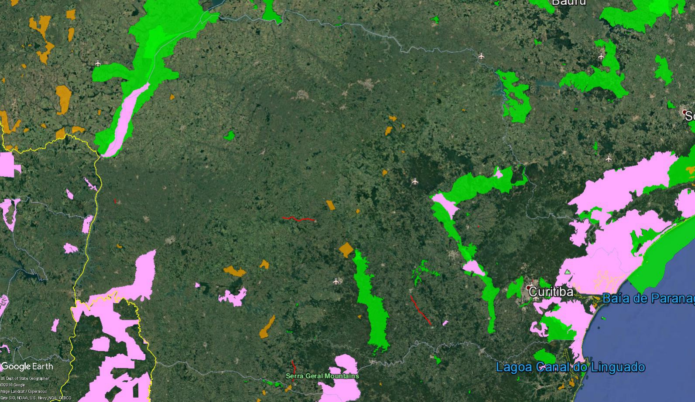

Figure 2. Location of sample projects (grey) in relation to land cover in the state of Paraná, including Atlantic Forest (dark green) non-forest natural habitat (light green), Mangue (mangrove, orange), Restinga (subtropical moist broadleaf forest, yellow), and urban areas (red), 2014-15

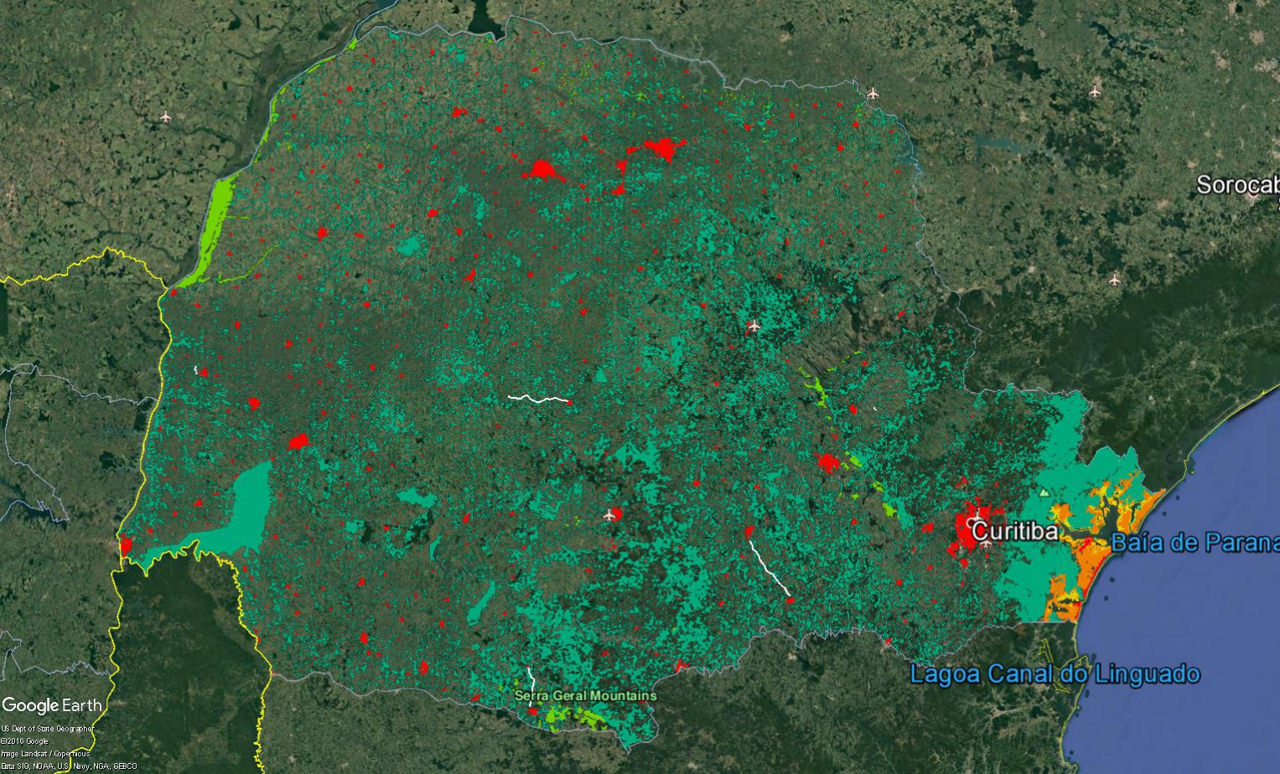

Figure 3. Location of sample projects (red) in relation to quilombola (blue) and faxinal (yellow) communities.

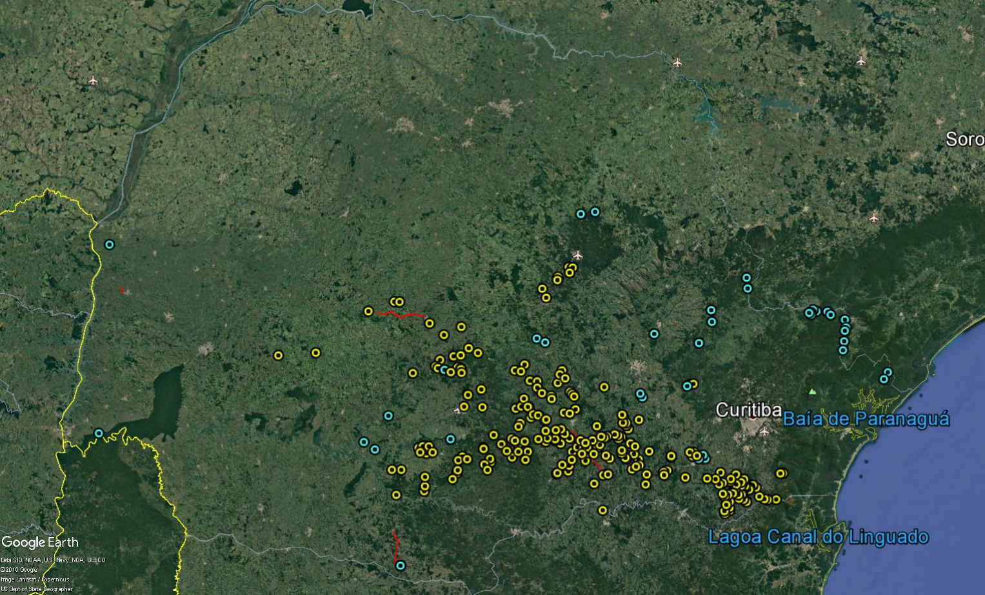

Figure 4. Location of Faxinal Communities in Relation to the Sao Mateus do Sul-Irati Project
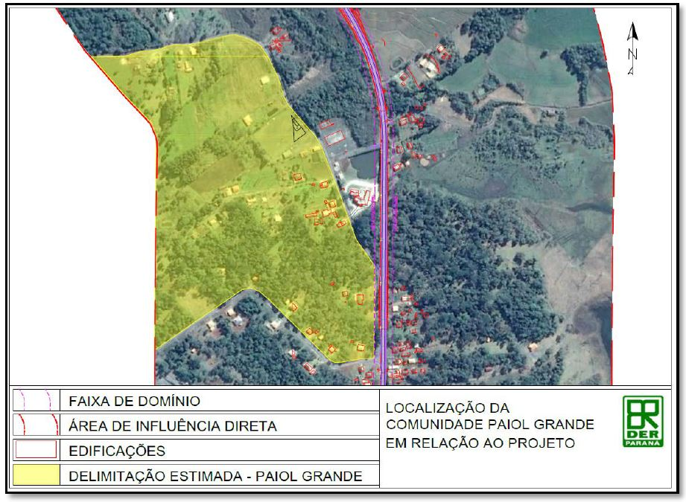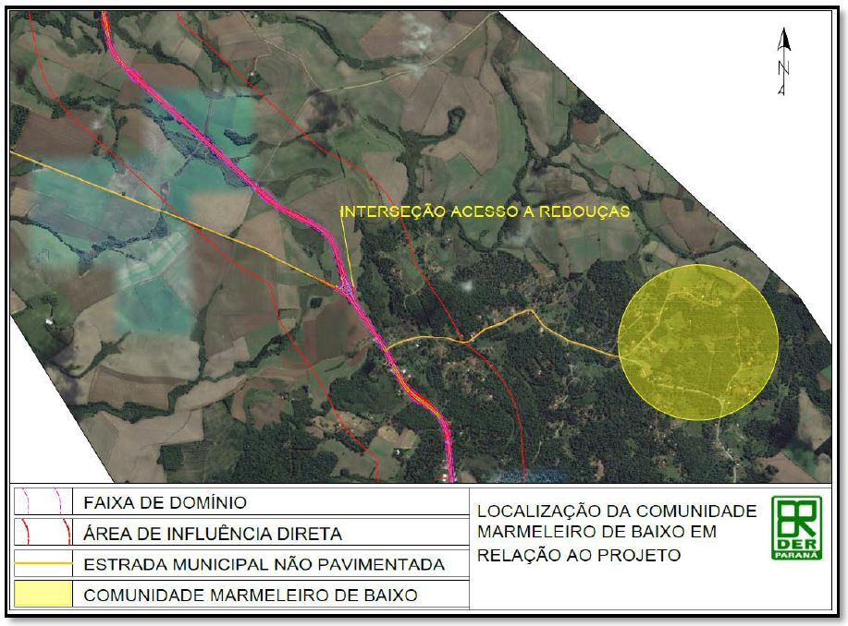

Figure 5. Terra Indígena Palmas in Relation to the Coronel Domingos Soares Project

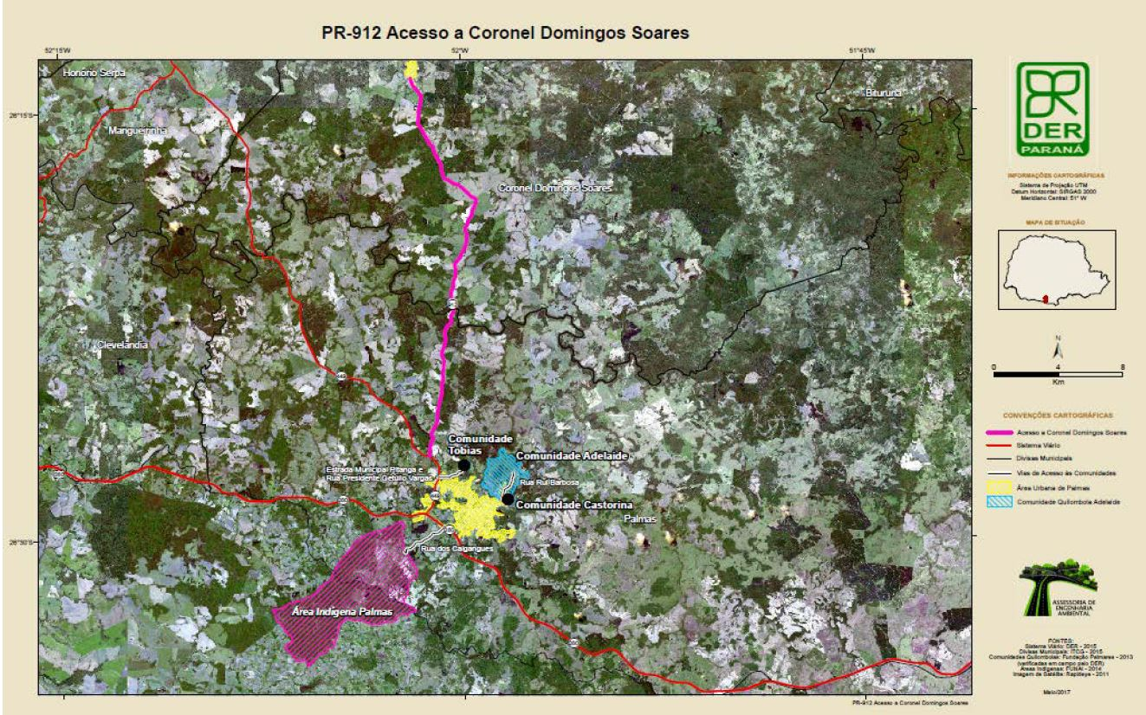

In most cases, the percentage of property to be expropriated is between 1-10%. However, in the Pitanga-Mato Rico sample project, for example, 39% of one household will require expropriation due to expansion of the ROW.
Faxinal communities are rural settler communities that are considered a form of differentiated peasant organization in the south of Brazil. These communities have peculiar forms of territorial appropriation, based on the communal use of areas for animal breeding and forest resources, and private use for polyculture subsistence, with the sale of a small surplus.
Please note that ESG is working on preparing a compliance checklist.

