INTER-AMERICAN DEVELOPMENT BANK

NICARAGUA

SAN JACINTO, GEOTHERMAL POWER PROJECT
(NI-L1057)

Category B Project

Environmental and Social Management Report
(ESMR)

June 25, 2010
TABLE OF CONTENTS

1. INTRODUCTION p.4

2. PROJECT DESCRIPTION pp.4-6

3. INSTITUTIONAL AND REGULATORY CONTEXT pp.6-8

4. ENVIRONMENTAL AND SOCIAL CONDITIONS pp.8-9

5. ENVIRONMENTAL AND SOCIAL IMPACTS AND RISKS pp.9-12

6. ENVIRONMENTAL, SOCIAL, HEALTH AND SAFETY MANAGEMENT pp.12-15

7. PUBLIC CONSULTATION p.15

8. RECOMMENDATIONS pp.15-17

APPENDIX

List of Figures pp. 19-26

Photos pp.27-33
Draft Environmental and Social Action Plan pp.34-40

ACRONYMS

ACGIH American Conference of Governmental Industrial Hygienists
EIA Environmental Impact Assessment
EHS Environmental, Health, and Safety
ESAP Environmental and Social Plan
GHGs Greenhouse Gas Emissions
IDB Inter American Development Bank
IFC International Finance Corporation
MARENA Ministry of Environment and Natural Resources
OHS Occupational Health and Safety
OSHA Occupational Safety and Health Administration
PENSA Polaris Energy Nicaragua S.A.
PPA Power Purchase Agreement
SJT San Jacinto-Tizate
SOP Standard Operational procedures
TL Transmission line
WHO World Health Organization

I. INTRODUCTION

1.1 The Inter-American Development Bank “IDB” or the “Bank” has been approached by Polaris Energy Nicaragua S.A. (PENSA, the Borrower) to provide financing up to USD 40 M for the San Jacinto Geothermal Power project. PENSA, is a Nicaraguan company created for the sole purpose of developing the Project. PENSA is wholly owned subsidiary of Canadian Polaris Geothermal Inc. (“PGI”, or the “Sponsor”), which was recently merged with Ram Power Inc. (“RPI”) to form Ram Power Corp (“Ram”). The company owns the San Jacinto-Tizate (SJT) geothermal concession covering a 40 km² area near León, Nicaragua. Since June 2005, PENSA has operated a 10 MW geothermal power project on this site (2 turbines of 5 MW each). The company is now expanding its operations by adding 72 MW of new capacity through two turbines of 36 MW each, referred to as Phase 1 and Phase 2. The company is currently selling and will continue to sell its entire output energy under a long term power purchase agreement (“PPA”) with affiliates of Union Fenosa S.A. (“Union Fenosa”), as operators of the national grid (the “National Grid”). Upon completion, both Phases will be operated as a single integrated facility and will share a common geothermal resource steam gathering system, Power Purchase Agreement, transmission line, generation license, concession area, and environmental permit. Financing for the Project is being divided in Phase 1 and Phase 2 such that each corresponds to the 36 MW turbines. IDB has been asked to consider providing financing for Phase 2. Both phases were considered in the environmental and social due diligence process.

1.2 The Company has hired different experienced international contractors and suppliers to perform the drilling, civil work and equipment assembling activities: ThermaSource, Inc. of the US in drilling, Constructora Queiroz Galvão of Brazil in construction, and Fuji Electric Corporation of America in turbine supply.

II. PROJECT DESCRIPTION

2.1 The San Jacinto-Tizate Geothermal Power Project is located in the Department of León (Western Nicaragua), in the Municipality of Telica, approximately 90 km from Managua and 20 km from the City of León (see Appendix, Fig. 1). The Project site is approximately 2 km to the north of the village of San Jacinto, a small settlement of approximately 1,400 inhabitants (see Appendix, Fig. 2). The company owns the SJT geothermal concession covering a 40 km² area (see Appendix, Fig. 3) and has been in commercial operation since June 2005 with a 10 MW geothermal plant (see Appendix, Photos 1-2). PENSA has owned the generation license since 2003 and is the legal holder of the concession area, the holding of the concession is subject to PENSA complying with all the obligations set out in the geothermal exploitation concession agreement (addendums) signed with the government of Nicaragua in 2001. This agreement stipulates that Phase 1 drilling must be completed by June 3, 2008 and Phase 2 drilling must be completed by March 2011. PENSA’s term for the SJT geothermal concession is 25 years, which can be extended an additional 10 years. The concession agreement requires commissioning for Phase I by April 2011 and Phase II by March 26, 2012.

2.2 The concession itself is divided into an eastern section, the “Eastern sector”, as well as an undeveloped western section, the “Western sector” (see Appendix, Fig. 4). The estimated total potential capacity of the entire concession is 200 MW. Both phases 1 and 2 of the Project are concentrated in the Eastern sector of the concession (see Appendix, Fig. 4). The development of the Western sector (which would constitute phase 3) is envisioned by PENSA, though no clear plans have been finalized on that matter. The operational area associated with the Project encompass an area of 4 km² which includes the power plant and well platforms, 2.3 km of pipes corridor, access roads (less than 3 km) and a right-of-way of a 138 kV transmission line of 12.5 km in length (see Appendix, Fig. 5). The project footprint is located in highly intervened fragmented dry habitat, which is sparsely inhabited, though some subsistence farming activities such as cattle grazing takes place in the Eastern sector of the concession (see Appendix, photos 3-5).

2.3 Completion of Phase 2 and commencement of commercial operations is expected to occur in December 2011, at which time PENSA will decommission the existing 10 MW facility to replace it with more efficient capacity and technology in two identical phases of 36 MW net electrical-output condensing steam turbines. The new facilities will use Fuji turbines each utilizing a single flash system feeding a condensing steam turbine. A flash system is used at sites that produce high temperature water i.e. between 175-300^{ο} C. Within this type of system, the geothermal fluid, which consists mainly of water and steam, is brought to the surface under pressure. When the fluid reaches surface where the pressure is lower, the fluid “flashes” to steam within low pressure tanks and the fluid and steam phases are separated. The steam phase is directed to the turbine for generation. The remaining fluid, along with the condensed steam, is then injected back into the geothermal reservoir to be reheated. The Company currently has 560 tons per hour of steam in five production wells, which is sufficient to generate approximately 65 MW of capacity. The 2010 drilling program includes one reinjection well in Phase 1 and up to five production wells as part of Phase 2. Drilling is expected to be completed by December 2010. The new drillings will utilize the existing power plant design, including existing pipeline. Additional pipelines will be constructed to connect the new wells. The majority of the new piping and drill pads will be constructed on existing rights of way and PENSA owned lands. Some minor additional land purchases may be required.

2.4 The majority of work was done during Phase 1; Phase 2 requires the minor acquisition of land and negotiated Right of Ways (ROWs) to accommodate drilling pads and pipeline connections. The transmission line (TL) has been in existence and operational since 2005, and was simply upgraded in the first half of 2010 to carry another circuit with additional poles as required to bear the increased weight load. PENSA negotiated with twelve (12) land owners to secure title to the existing easements for TL where 16 new poles were constructed. Poles were installed between March and May 2010. There was no purchase of additional land. Though PENSA has rights of expropriation all over the concession area, all of the required land was acquired via negotiated, market-based transactions without significant issues. The upgrade to the TL will be completed under Phase I. No further land issues are expected for Phase 2 of the project.

2.5 Phase 2 is currently under construction (see Appendix, photos 6-7).

Phase 2 - Milestones
- Signed contract for steam turbine / generator January, 2010, Completed
- Initiate construction of Phase 2 portion of powerhouse February, 2010, Completed
- Start drilling for Phase 2 wells May, 2010, Underway
- Order power plant long lead items June to August, 2010
- Contractor notice to proceed August 1, 2010
- Complete Phase 2 resource development December, 2010, In progress
- Steam turbine / generator site arrival May, 2011, In progress
- Project mechanical completion October, 2011
- Start Steam field construction November, 2010
- Project completion December, 2011

2.6 There is a long history of surveys; studies and drilling that were undertaken within the San Jacinto Tizate geothermal field prior to production. Indeed, the geology of the San Jacinto Tizate area has been studied extensively since the 1950s. In 1953, the first wells were drilled at the SJT field by Noranda Mines and in the 1960s, geoscientific investigations were undertaken in an attempt to determine the geothermal potential. Later, in 1992, a Russian-Nicaraguan company, Intergeoterm drilled seven wells in the San Jacinto-Tizate field, ranging in depth from 725 meters to 2,336 meters; of these wells, three were deemed adequate for commercial production. The thermal features of the field were extensively mapped and results demonstrated a very high potential for the development of a geothermal plant. But at that time, Intergeoterm was unable to arrange financing for the development of the field. In 2001, PENSA acquired control of Intergeoterm as part of the privatization of Nicaragua's energy sector.

III. INSTITUTIONAL AND REGULATORY CONTEXT

3.1 The Company has all required permits, licenses, land and concessions for the completion and operation of both Phases of the SJT Project. The PPA has been in place for more than five years and has been amended as required to accommodate up to 72 MW of new capacity. The Company has all required environmental permits to operate the new expansion plant. Phase I financing has been obtained and construction for both Phase 1 and Phase 2 is underway.

3.2 Nicaraguan legislation Electrical Industry Law, 1972 requires that electrical generation projects obtain an environmental permit from the Ministry of the Environment and Natural Resources (Ministerio del Ambiente y los Recursos Naturales de Nicaragua or “MARENA”). Issuance of the permit requires an Environmental Impact Assessment (“EIA”), (Decree 76-2006) The EIA was submitted to MARENA in July 2003, and it concluded that the main environmental impacts (air quality and noise) can be easily mitigated. The SJT Project was viewed as generating significant positive socio-economic impact (through increased employment and electrical generation) and positive environmental impact (by mitigating climate change). MARENA issued an environmental permit in September 2003. An updated EIA for the project was completed in November 2008 to reflect modifications to the initial project 66 MW to 72MW. All environmental approvals were amended and updated in 2009.

3.3 The project is also subject to numerous national laws, regulations and standards. Among the most relevant are: Exploration and Exploitation of Geothermal Resources Law (Law 443); General Environmental and Natural Resources Law (Law 217); Provisions of the Penal Code (Law 641) relating to environmental and natural resource crime; Decree 76-2006 on Environmental Evaluation; Ban on Cutting, Exploitation and Marketing of the Forestry Resource (Act 585); General Law on National Waters (Law 620); Technical Air Quality Standard (NTON 05 012-02); Nicaraguan Labor Code (Law 195); Minimum Wage Law (Law 625); and General Law on Hygiene and Occupational Safety (Law 618).

3.4 Numerous directives of IDB’s OP 703 Environment and Safeguard Policy apply for to this project. The project triggers the following directives: (B.5) As environmental Assessments have been realized; (B.6) As public consultations have been performed; (B.7) As IDB will supervise compliance during supervision; (B.10) As the project involves the handling of hazardous materials; (B.11) Potential of the project to cause air, soil or water contamination; (B.12) As the project is under construction and (B.15) as the project is co-financed by IFC and other financial institutions. Given the likeliness of the development of Phase 3 of the project during the lifespan of Phase 2 financing, the project also triggers the Directive B.4 (Other risk factors). As mentioned previously, the Phase 3 would consist in the development of the Western sector of the concession area owned by PENSA to achieve a total installed capacity of 200 MW. The environmental and social aspects related to Phase 3 are of particular importance due to the presence of the Telica-Rota Natural Reserve which part of its territory overlapped with the Western sector of the concession area (see Appendix, Fig. 3). In light of this, IDB’s loan agreement would contain specific covenants related to the future development of phase 3 (see section 8, alinea 8.2 and 8.3). The Project does not trigger the IDB’s OP 710 Involuntary Resettlement Policy, or the IDB’s OP 765 Indigenous Peoples Policy. Given the scope and nature of the project and its potential impacts, the project has been classified as a category B project.

3.5 The EIA prepared in 2003 and updated in 2008 does not fully meet the requirements of the IDB’s OP 703 Environment and Safeguards Compliance Policy. As part of the Environmental and Social action Plan (ESAP) established between the Lenders and PENSA (see Appendix), additional studies, such as the completion of a more detailed social baseline and water uses are required and, are currently under way. The socioeconomic baseline will include: (a) a more complete picture of land tenure, ownership, and use within the project site and concession area, (b) current economic/livelihood activities within the project’s influence area (c) more detailed information of sources potable water and water usage by the local community within the project site and concession area, water-quality data, and periodic monitoring of water supplies (well and surface sources utilized) within the project site and concession area, (d) issues related to land/resource access and any impacts thereof as a result of PENSA’s activities and (e) more precise demographic data for the project site and the concession area. Per the timeline established in the ESAP (see Appendix), these studies would be completed by the end of 2010 and results will be transmitted to IDB. It is recommended to incorporate in IDB’s loan agreement, compliance of PENSA with actions and timeline established in the ESAP (see Section 8, alinea 8.4). The project is expected to be in compliance with OP-703 once additional studies are completed.

3.6 Financing from the International Financing Corporation (IFC) is also contemplated and the Project is required to meet relevant IFC’s Performance Standards and EHS Guidelines, and World Bank group’s geothermal power generation guidelines.

IV. ENVIRONMENTAL AND SOCIAL CONDITIONS

4.1 The Project’s area does not encompass habitats that could be considered critical or natural. The habitat is fragmented on the most part of the Eastern sector of the concession (see Appendix, photos 3-5). The EIA states that no threatened or endangered species have been recorded in the project’s area of influence. No indigenous people live in the area and there has been no evidence to date of any historic or prehistoric archaeological sites finds. The closest designated protected zone is the volcanic complex Telica-Rota Natural Reserve (see Appendix, Fig. 2, 3) which is located in the Western sector of the concession. The boundaries of the Project’s operational area are about 2 km from the boundary of the Reserve and are sufficiently separated from the areas of project’s operation to not be impacted (see Appendix, Fig. 6).

4.2 The Telica-Rota Nature Reserve was created in 1983, it covers an area of approximately 9,053 ha of which 6,846 ha pertain to the Telica volcano and the remaining area pertains to the Rota Volcano (see Appendix, Fig. 2). The protected area is ranked at Category IV of the IUCN. All the volcanoes located on the Pacific coast of Nicaragua were declared in 1983 as national reserves (see Appendix, Fig. 7). MARENA is in charge of the management of the reserve. The management plan of the reserve states that geothermal development within the San Jacinto Tizate concession is not an activity that would pose a prejudice to the reserve if it is properly managed. In addition, the contour line of the reserve is at 300 m and the project is being developed between 150 and 200 m contour lines. On the portion of the western sector of the natural reserve, there are small hamlets or isolated farms with an approximate population of 3,800 inhabitants. Similarly to the overall region, the protected area presents a high level of anthropogenic intervention. Wood extraction is also used as a fuel for consumption as well as for commercialization. The agricultural areas are submitted to slash and burn methods as part of the soil preparation for planting.

4.3 A large part of the vegetation in the operational area of the Project and surroundings has been extremely modified throughout the years by agriculture activities, cattle farming and wood cutting for fuel. A substantial part of the area is covered by pasture land. There is an abundance of grazing lands, vast prairies; thin forests with somewhat dense tree patches of 4 to 10 m in height, where caducifolias or subcaducifolias prevail, and arboreal species are limited to more elevated zones of the volcanic complexes present. In addition, it is important to highlight that an area where geothermal activities is high does not usually have abundant vegetation as the existing soil conditions (high level of acidity) and its high temperature are not prone to development of vegetation.

4.4 Throughout the concession area, natural volcanic manifestations such as fumaroles, mud pools and hot springs are visible and contribute to introduce contaminants in the soil, water and atmosphere. Main contaminants usually associated with volcanic manifestations are: salt, metals (e.g., arsenic, strontium and mercury), boron, nitrates and hydrogen sulfide gas.

4.5 In the area of the project, most of the surface watercourses have a short path and are intermittent. Relative to groundwater, both phreatic and artesian aquifers are present in the area as well as hot and cold springs. The chemical composition of waters present in the area is variable, analysis performed indicate a calcium bicarbonate composition for springs and calcium bicarbonate and sulfates for the wells of the zone of El Tizate. Also, the analysis show natural contamination of geothermal origins, evidenced by abnormal values of mercury, silica, salinity and chloride found. Though, analyzed present values are below the limits accepted by the World Health Organization (WHO) standards for human consumption.

4.6 In terms of human occupation, the Project’s operational area is located 2 km to the north of the village of San Jacinto, a small settlement of 1400 inhabitants. The village is isolated from the Project site by low hills and therefore is invisible to villagers. Four communities dispersed into small dwellings are also found in the Eastern sector of the concession area namely: El Chorro (245 inhabitants), El Apante Central (401 inhabitants), La Cruz del Apante (243 inhabitants), El Ojochal de Liston (128 inhabitants), (see Appendix, Fig. 2). Sparse subsistence farming and low-scale non- intensive livestock activity predominates in the area. The area is populated by mestizo inhabitants who refer to people of mixed European and Amerindian ancestry and there has been no evidence to date of any historical or pre-historical archaeological sites or finds.

4.7 The rural population in the area of the Project gets water for human consumption through bored wells or naturally occurring springs. PENSA has documented the location of 20 water wells and streams in the project area of direct influence (see Appendix, Fig. 8).

V. ENVIRONMENTAL AND SOCIAL IMPACTS AND RISKS

Potential impacts during construction

5.1 Potential negative environmental impacts and risks during construction phase will be mainly associated with drilling and testing of up to five new production wells, a reinjection well, construction of power plant buildings and installation of equipment. Main construction impacts are: (i) potential contamination of soil and ground water by drilling mud (essentially a suspension of a natural clay material - bentonite - with some additives added), drilling mud with cuttings, or through the reinjection of the geothermal fluid (essentially a mixture of hot water and steam, at temperatures that can reach 290°C, with dissolved salts and gases); (ii) increased water demand from wells drilling and testing and for the cooling system; (iii) potential land contamination due to the disposal of drilling mud and solid wastes; (iv) noise and vibrations generated during drilling; and (v) effects of drilling on groundwater aquifers, nearby hot springs, natural thermal features, and induced seismicity and/ground subsidence; (v) incremental impacts associated with the easement and construction of a second circuit of an existing 12.5 km long transmission line; (vi) increase heavy traffic and potential traffic accident in the vicinity of the project site; (vii) noise and dust emissions; and (viii) soil erosion and loss of vegetation.

5.2 Most of these construction impacts and risk can be adequately mitigated through the implementation of appropriate management plans and standard operating procedures (SOPs).

5.3 Regarding the potential risk of contamination of aquifers during wells drilling; the geothermal production zones used by PENSA are separated from the groundwater aquifers used for potable water by thousands of meters of rock and soil. The drilling in the first several hundred meters is only done with water (no oil-based fluids). All wells employ multiple strings of leak-proof casings (several thousand feet) that are cemented to surface to prevent seepage into the groundwater (see Appendix, photo 7). These casings are and will be pressure tested every five years. In 2005, PENSA provided support to the Nicaraguan Institute of Territorial Studies (INETER) to conduct a hydrological study of the concession area. According to the company and the Independent Environmental and Technical Consultant retained by the Lenders who reviewed the documentation, the study confirmed that there was no communication between the PENSA supply wells and local community wells (isotopic data were used).

Potential impacts and risks during project operation

5.4 Once in operation, main impacts and risks are: (i) an increased level of seismicity in the region; (ii) land subsidence; (iii) surface and underground water contamination due to accidental spills; (iv) mud contamination; (v) air emissions of hydrogen sulfide; (vi) health and occupational accidents; and (vii) increased exposure of community and workers to explosions, well blowouts and pipeline failures.

5.5 One of the potential risks relates to an increased level of seismicity in the region of the project. Although it typically occurs naturally, seismicity, as reported in the scientific literature, has at times been induced by human activity, including development of geothermal fields, through both production and injection operations. In these cases, seismicity has resulted in the form of low magnitude events known as “micro earthquakes” which have Richter magnitudes below 2 or 3 and which are generally not felt by humans. The injection of geothermal fluid back into the geothermal system can sometimes cause these micro earthquakes to occur in the vicinity of the injection site. Seismicity typically takes place in areas with high levels of tectonic activity, such as volcanic regions and fault zones. As the San Jacinto Tizate project is located between two volcanoes and is part of a chain of volcanoes located along the Pacific coast of Nicaragua (see Appendix, Fig. 7), it is naturally vulnerable to seismicity. According to the scientific literature, it is very difficult to distinguish between geothermal-induced and naturally occurring events.

5.6 Land subsidence, or the slow, downward sinking of land, may also be a potential risk; subsidence may occur if the geothermal reservoir pressure declines. It is worth mentioning that declining pressure geothermal reservoir is a situation that would lead to a premature termination of geothermal production. Though, through proper injection technology and management, the company can generally maintain the normal reservoir pressure.

5.7 Based on explanations above, the probability of a type 2 disaster risk scenario, i.e. a situation in which the project itself has a potential to exacerbate risk to human life, property, the environment or the project itself, is low. Though, per its geographic location, the project is likely to be exposed to natural hazards (type 1 risk) such as volcanic and seismic activities. Though, these risks are unlikely to cause an interruption of the project. Magnitude of the earthquakes in the region is usually below 2 and 3 on the Richter scale, and major volcanic eruptions are unlikely. The project has been designed to resist to earthquakes.

5.8 Another category of risk may be related to accidental spills of geothermal waters due to well blowouts during drilling, leaking piping or wellheads, or overflow from well sumps. However, these incidents are rare and can be easily detected and remediated. In a geothermal facility, geothermal water is isolated during production, injected back into the geothermal reservoir, and separated from groundwater by thickly encased pipes, making the facility virtually free of water pollutants. A well casing is composed of thick specialized pipe surrounded by cement in order to prevent any contamination as the geothermal fluids are put back into the reservoir. As geothermal fluids contain varying concentrations of toxic minerals and are extremely hot when they reach the surface, they are not released into surface waterways. The reinjection back in the system reduces surface water pollution and increases geothermal reservoir sustainability

5.9 Mud contamination also presents potential risk. When the geothermal fluid is brought to surface, the brine constitutes a mix of mud and water, the mud will go through a “dewatering” process, the water will be reused or injected and the mud combined with drill cuttings would be dried. Each well produces roughly 300 m³ of cuttings (basically rock fragments) and about 480 m³ of mud. Even though PENSA uses only water-based drilling muds, these may be potentially hazardous if they contain heavy metals, drilling fluids residues, or other contaminants. The mud will then be tested to determine its hazardous waste content. PENSA will specifically test for the levels of the following contaminants: arsenic, chromium, mercury and nickel. PENSA will use the California 22 Hazardous Waste Regulatory Criteria as a reference value to assess the metals maximum contaminant levels. If contaminant levels are below the toxicity level, the drill cuttings will be treated by a “land-farming” technique which involves drying, blending with native soils, and reuse for road maintenance, future construction, or other recycling activities If any treatment is required, it will take place in a sump which will be lined by a geomembrane (see Appendix, photo 8). The drill cuttings/mud will then be transported to a land farming site (see Appendix, photo 9). The drill cuttings/mud will be monitored over time to ensure that any residual contaminants are within acceptable international limits. The Drilling Cuttings Management Plan stipulates that contaminated mud, if any, will be confined on a permanent basis. The ESAP, which would be part of IDB’s Loan agreement, include the requirement to monitor of heavy metals in the drilling cuttings/mud before and after treatment and, requires the testing and management of leachate in the land farming area.

5.10 Geothermal power plants release very few air emissions because they do not burn fuel like fossil fuel plants. Geothermal plants emit only trace amounts of nitrogen oxides, almost no sulfur dioxide or particulate matter, and small amounts of carbon dioxide. The primary pollutant some geothermal plants must sometimes abate is hydrogen sulfide, which is naturally present in many subsurface geothermal reservoirs. With the use of advanced abatement equipment, however, emissions of hydrogen sulfide are regularly maintained below even California state standards. In the case of San Jacinto there is only a moderate low gas concentration in the steam (in production to date) with measured amounts at 0.45 wt%, of which only about 8% is H₂S. The development is also of modest size; the plant is located on an elevated and well ventilated site and is at some distance from inhabited areas.

5.11 Other risks are mostly related to human health and well-being. Drilling activities represents risk for the workers as heavy equipment is operated. The climatic conditions are also harsh and may lead to human health problems. Pipeline failure, explosions, well blowouts are also potential risks related to the operation of a geothermal plant.

VI. ENVIRONMENTAL, SOCIAL, HEALTH AND SAFETY MANAGEMENT

6.1 Phase 2 of the project is located within the existing footprint of Phase 1. The potential environmental and social impacts and risks are limited in magnitude and are site- specific. Project impacts, are for the most part reversible, and can be avoided, controlled and/or mitigated with readily available standard environmental management practices and appropriate technology.

6.2 PENSA has defined a series of management plans and standard operational procedures (SOPS) to properly manage Environmental, Social and Health and Safety (ESHS) impacts and risks. Main management plans include: (a) a drilling cuttings management plan, (b) a solid waste management plan (c) discharge and emissions control and pollution prevention and (d) environmental monitoring procedures for noise, air quality, and surface waters. Main standard operational procedures include: a) Safety and Health Program b) Emergency Response Plan c) Environmental Program Policy, d) Training and Awareness, d) Auditing, and e,. The due diligence will validate project’s categorization) community grievance mechanism. PENSA also established procedures to limit risks to workers and communities, for instance, all pipes (which transport the steam or geothermal fluids) and other surfaces are insulated and labeled to prevent exposure to heat and potential burns, and well heads are fenced to prevent entrance of persons and animals (see Appendix, photo 11). In addition, in each production and reinjection wells, there is a security guard in place, his role is to alert PENSA should a problem occur and ensure that no individuals are on site. Though, as observed during the two site visits, people living in the concession do not frequent the project area on a permanent basis.

6.3 The main PENSA contractor, the Brazilian contractor Queiroz Galvão, has an integrated quality, environmental, social, health and safety management system which is certified with ISO 9001, ISO 14001, and OHSAS 18001, and they are also currently implementing SA 8000 procedures, audits etc. All PENSA contractors have the obligations to follow PENSA’s corporate policies and procedures. The Health and Safety Manager of PENSA meets on a weekly basis with Queiroz Galvão. During these meetings, the company is updated on work-related incidents, construction progress and issues encountered, if any. PENSA keeps records of accidents within the company and its principal contractors. For instance, in 2008, there were a total of 28 accidents/incidents among PENSA and its contractors. All accidents reported were of a minor nature, with the exception of one worker who lost a portion of a finger during drilling operations. For 2009, there were a total of 6 accidents among PENSA and its contractors. As part of the ESAP, PENSA is currently developing a consolidated Occupational Health and Safety (OHS) manual, including an OHS Policy, standard plans and procedures, expected benchmark/goals, indicators for incident and accident reports (e.g. frequency, severity, etc), corrective actions, reporting, and training.

6.4 In order to properly manage potential issues related to an unlikely contamination of the groundwater used by the local communities for water consumption, PENSA has recently developed and started implementing a water quality monitoring program for community water sources. As stated previously, PENSA will start in June 2010 studies to assess the quality of 15 community water sources located in the area of the influence of the operation (see Appendix, Fig. 8, photo 12). These studies will be carried out quarterly for a period of one year. The quarterly monitoring will use US Clean Water Standards. As the project will start its operation in December 2011, data collected would constitute the baseline data and would be used as reference values during project’s operation.

6.5 PENSA has developed a comprehensive drill cuttings management plan, a well-designed and consistent monitoring of drilling cuttings pre- and post-treatment is critical to determine whether land spreading is the appropriate treatment. PENSA will line all new mud pits with geomembranes (see Appendix, photo 8), which is a requirement of the Environmental Permit. The existing ESAP includes a requirement to revise and expand the Drill Cuttings Management Plan, including additional monitoring and mitigation measures if results demonstrate a level of contamination exceeding the standards of reference (California 22 standards).

6.6 Air emissions consist primarily of carbon dioxide (CO₂) and hydrogen sulfide (H₂S) in the waste steam and around well heads. These two parameters are measured continuously during drilling operations and ambient levels are measured on a semi-annual basis since 2006 around well platforms, power plant, and the rock muffler. Ambient CO₂ and H₂S levels are well within the Occupational Safety and Health Administration (OSHA), American Conference of Governmental Industrial Hygienists (ACGIH) and WHO standards in all of the monitoring data reviewed.

6.7 It is worth mentioning that in relation to the amount of power they produce, geothermal plants emit only very small amounts of GHGs, and this project would contribute to reduce the carbon footprint of energy generation in Nicaragua. In 2004 PENSA completed the process of documenting, applying for and registering for Certificates of Environmental Reduction (“CERs”) under the United Nations Framework Convention on Climate Change Clean Development Mechanism (CDM) process. In April 2006, PENSA became the first company in Nicaragua to be registered by the UNFCC to sell its carbon emission reduction credits produced from the SJT Project. The 72 MW project is expected to displace approximately 58,036 MWe per annum of thermal power generation, hence reducing the region’s carbon emissions by approximately 394,801 tCO2 per annum. Project estimated emission of GHG is 42,727 tCO2 per annum.

6.8 As part of the ESAP, PENSA must present, in a form and content acceptable to the Lenders, a Natural Disasters Preparedness Plan identifying hazards, assessing the different risks in case of: volcanic eruptions, hurricanes and flooding, earthquakes, natural and man-made forest fires, land subsidence, well blow-out and spill and contaminants release. This Plan is currently under development and it will better define roles and responsibilities with other stakeholders (government, contractors, and local communities) articulating clear chains of command and communication procedures in case of a natural hazard.

6.9 PENSA appears to have an adequate staff capacity and expertise and organizational structure to manage environmental, health and safety issue. There is a full time professional Social and Environmental Manager located on site. The Social and Environmental Manager is responsible for overseeing all site activities (both construction and normal operations) to ensure compliance with the requirements of the Environmental Permit and overall good practice, including periodic monitoring of environmental impacts as they affect air and water quality and noise emissions. The Social and Environmental Manager is also responsible for managing local community relationships. PENSA hired a Safety Officer who is in-charge of ensuring compliance with the company’s OHS plans and procedures. Overall, PENSA has a total of 123 employees, 43 of whom work in the field, 35 in the plant and operations, 28 in base camp support roles and 17 in the Managua office.

6.10 PENSA is in the process of finalizing its Corporate Manual which will include OHS policy and procedures. PENSA has identified the main OHS risks associated with construction and operation of the project and has developed procedures and training to adequately address these risks, outlining the different tasks/activities’ intrinsic risks, the required training, restrictions, and personal protection equipment (PEP) necessary to be able to perform such tasks/activities. Additionally, PENSA’s personnel carry H₂S sensors when working in confined spaces and other places where this gas could accumulate (e.g. well cellars) and use self-contained breathing equipment when there is a risk of elevated gas concentrations. Ambient H₂S concentration is also monitored at well sites and near the plant. Finally, there is an on-site doctor at the base camp during normal working hours (medical service is extended to 24 hour coverage during drilling operations).
6.11 Because traffic would be increased during the construction period, PENSA held training sessions with local communities to prevent any traffic related incidents. PENSA is committed to closely monitor the speed of its truck drivers and its contractors upon entrance to the site. PENSA has disciplinary measures in place to enforce respect of the employee driving policy.

VII. PUBLIC CONSULTATION

7.1 A series of public consultation meetings were organized in 2005-2006, and a second series of meetings were organized in November 2008. All meetings took place in San Jacinto to present the geothermal project and the main results of the EIAs. According to public consultation transcripts included in the EIA, concerns expressed by local communities were mostly related to jobs availability and potential impacts of the project on water quality. PENSA established a Memorandum of Understanding with the Community of San Jacinto in which PENSA agreed to made every effort to provide jobs to people residing in the region. The company has also established a local recruitment policy. Once available, the results of the monitoring program on water quality sources would be disclosed to communities and regulators. The EIA of the project is disclosed on PENSA’s corporate website, www.ram-power.com, and is available for consultation at the project office in San Jacinto. New consultation meetings will be organized in 2010 and 2011 to disclose the ESAP to communities located in the vicinity of the project. As part of the ESAP and, once additional social baseline studies would be completed, PENSA will develop a forma Community Relations and Engagement Plan.

7.2 The EIA of the project has been disclosed to the public in accordance with IDB’s Operational Policy OP-102 - Disclosure of Information, locally, at IDB’s Public Information Center in Washington, DC and at the Country Representative Office.

VIII. RECOMMENDATIONS

8.1 The Bank (IDB) will require as part of the Loan Agreement that PENSA and all portions of the Project shall, at all times during the life of the Loan Agreement, comply with each of the following:

1. All applicable environmental, health and safety, social and labor regulatory requirements
- All applicable IDB’s environmental and social safeguard policies, including OP-703 Environment and Safeguards Compliance Policy and OP-102 Disclosure of Information Policy.
- All requirements associated with any environmental, health and safety, social and labor related permits, authorizations, or licenses that apply to the Project or EISA.
- All environmental, health and safety, social, and labor requirements of the Project contracts, and any subsequent modifications.
- All aspects and components of all of the Project’s environmental, health and safety, social and labor document, including the Environmental and Social Action Plan currently being developed.
- Consult with IDB before approving or implementing any and all substantive changes to the Project or its timetable which could potentially have negative environmental, social, labor, or health and safety effects.
- Send written notice of any and all noncompliance with any environmental, health and safety, social and labor requirement of the loan agreement and any significant environmental, social, labor, health and safety accident, impact, event, claim or material complaint.
- Ensure that all parties contracted for construction and operation activities of the Project comply with the applicable environmental, labor, social and health and safety requirements of the loan agreement.
- Implement ongoing information disclosure and consultation activities related to environmental, social, and health and safety aspects of the Project.
8.2 As part of the loan agreement, PENSA agrees to obtain IDB´s non-objection prior to undertaking any activities for the development of the Western Sector of the Concession Area (including exploration activities), such non-objection not to be unreasonably withheld.

1. In order to obtain IDB´s non-objection, PENSA will: (i) submit to IDB any environmental and social documentation deemed necessary by IDB to fully assess the potential environmental and social impacts and risks of the proposed activities for the development of the Western Sector of the Concession Area, and (ii) if requested by IDB, provide IDB (or its Consultants) with access to the proposed site of said activities in order for IDB to carry its own due diligence.

8.3 PENSA shall not undertake any activities for the development of the Western Sector of the Concession Area (including exploration activities) without IDB’s written non- objection.

8.4 Prior to the date of Financial Closing, PENSA must submit in a form and substance satisfactory to the IDB the final Environmental and Social Action Plan (ESAP) incorporating the necessary actions to achieve compliance with IDB’s environmental and social requirements.

8.5 Prior to each disbursement, PENSA shall certify compliance with all environmental social, and health and safety requirements in the loan agreement, including the Project’s environmental and social management plans and the ESAP.

8.6 PENSA shall as a specific requirement for Project Completion present in a form and substance satisfactory to the Bank a final Construction Phase Environmental and Social Report.

8.7 During the life of the Loan Agreement, PENSA must prepare and submit an Environmental and Social Compliance Report, in form, content and frequency acceptable to the Bank (at least quarterly during construction phase and first year of operation, and annually after the first year of operation).

8.8 The Bank will monitor the Project’s environmental, health and safety, social and labor aspects via internal Bank supervision actions (e.g., site visits, review of documentation, etc.) and will contract an external independent environmental consultant to perform more detailed supervision/monitoring actions during Project’s construction and first year of operation. In addition, the Bank will have the right, as part of the Loan Agreement, to contract for the performance of an independent environmental, health, and safety audit, if needed.

APPENDIX

Figure 1. Project location
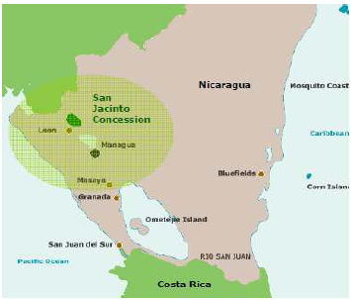
Note: The San Jacinto concession area corresponds to the small rounded green shape located 90 km North East of Managua.

Figure 2. Population settlements within the concession area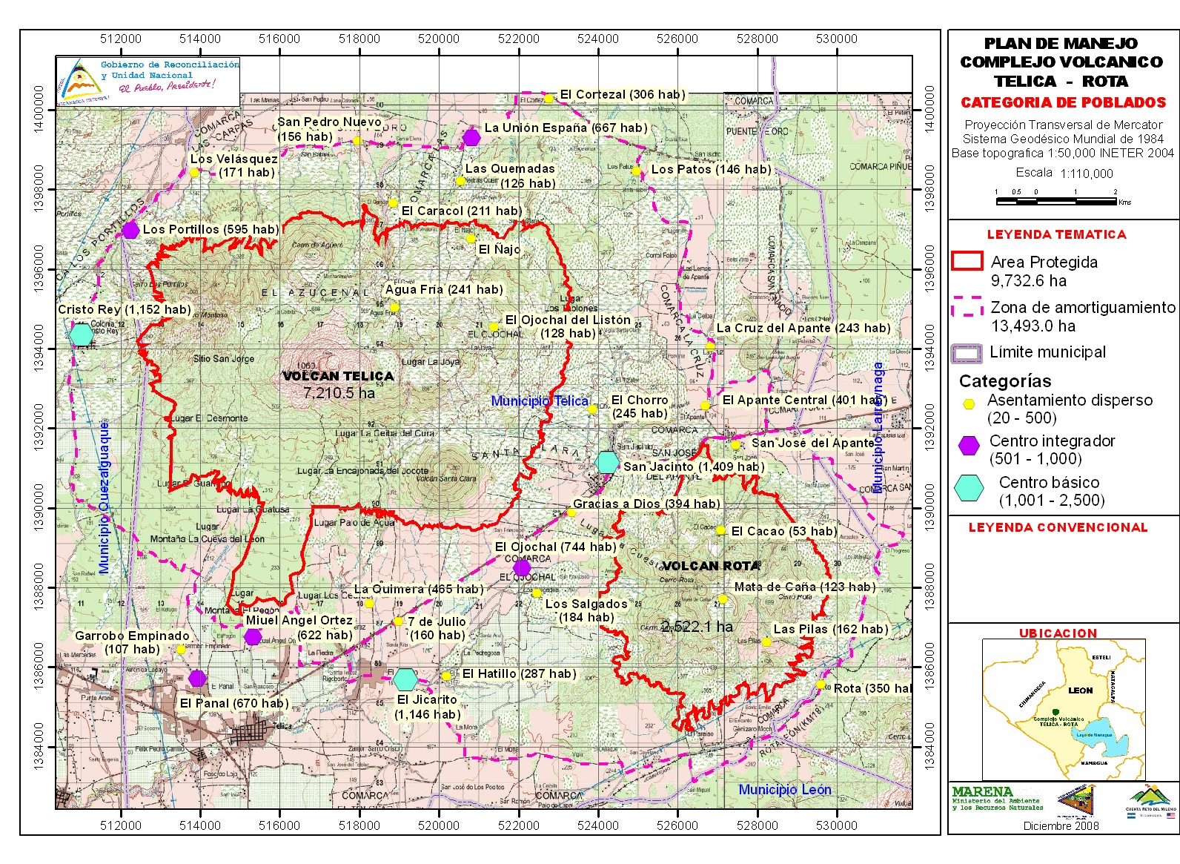

Figure 3. Perimeter of the concession area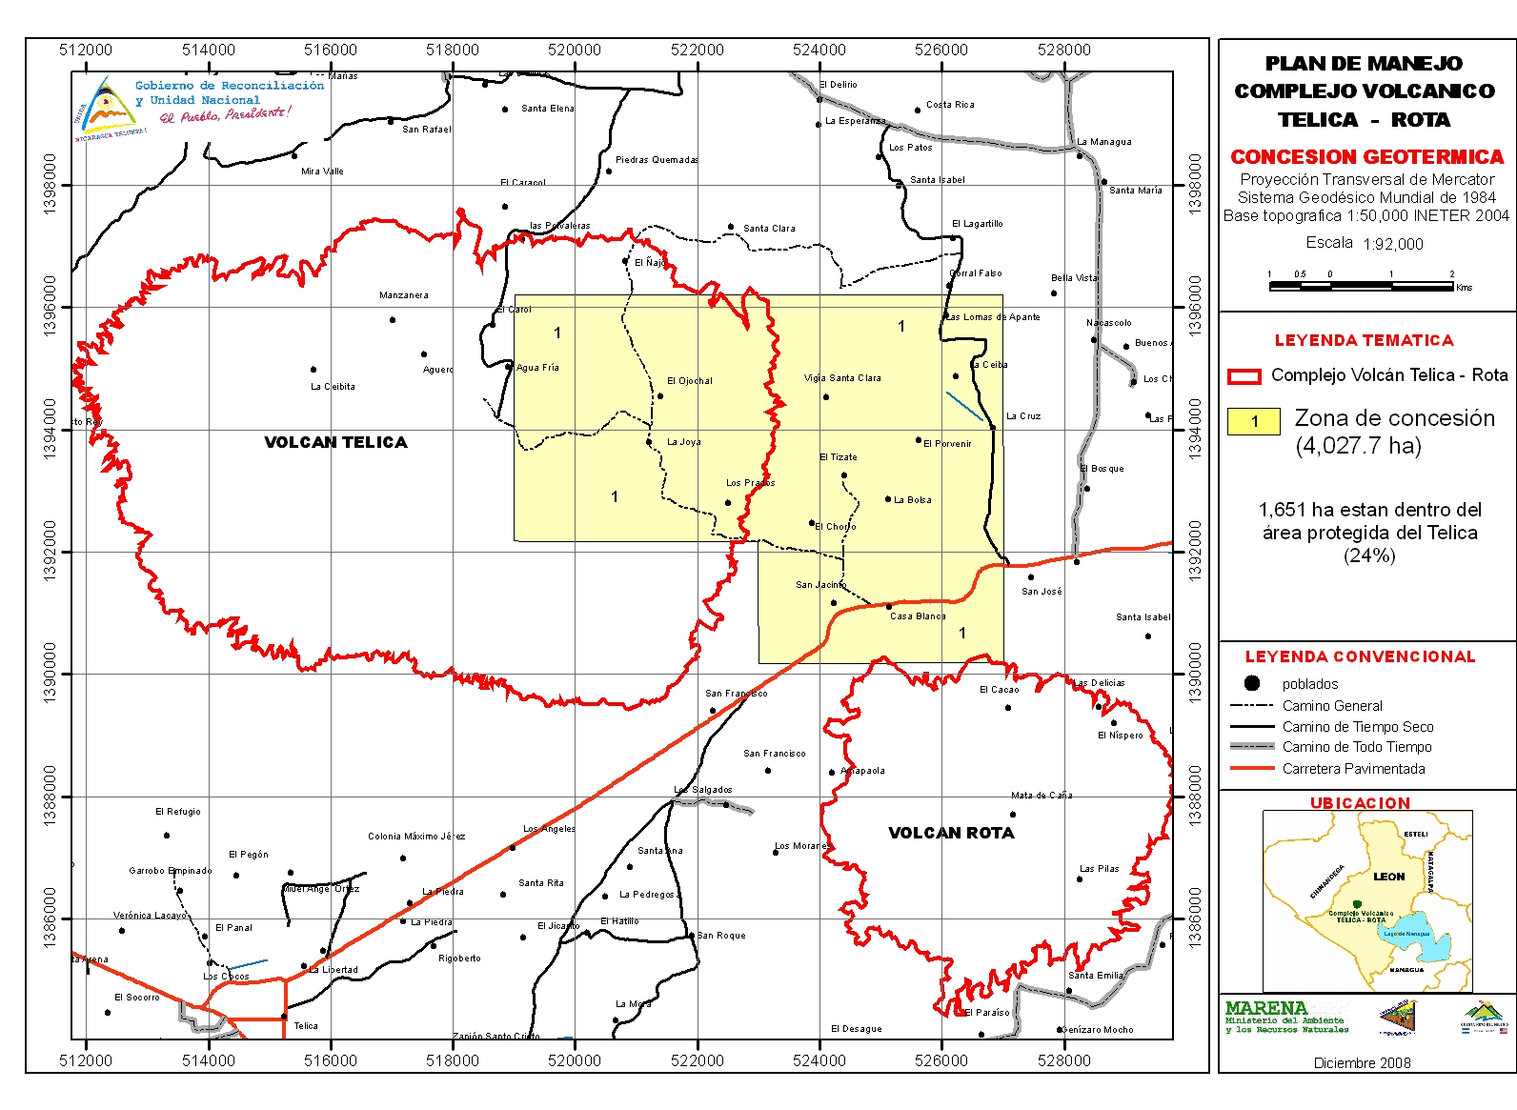 Note: Delineated in red, the Natural reserve of Telica Rota

Figure 4. Location of the Western and Eastern sectors of the concession area
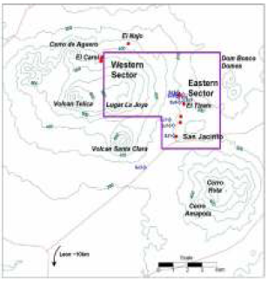

Figure 5. Area of direct and indirect influence of the project
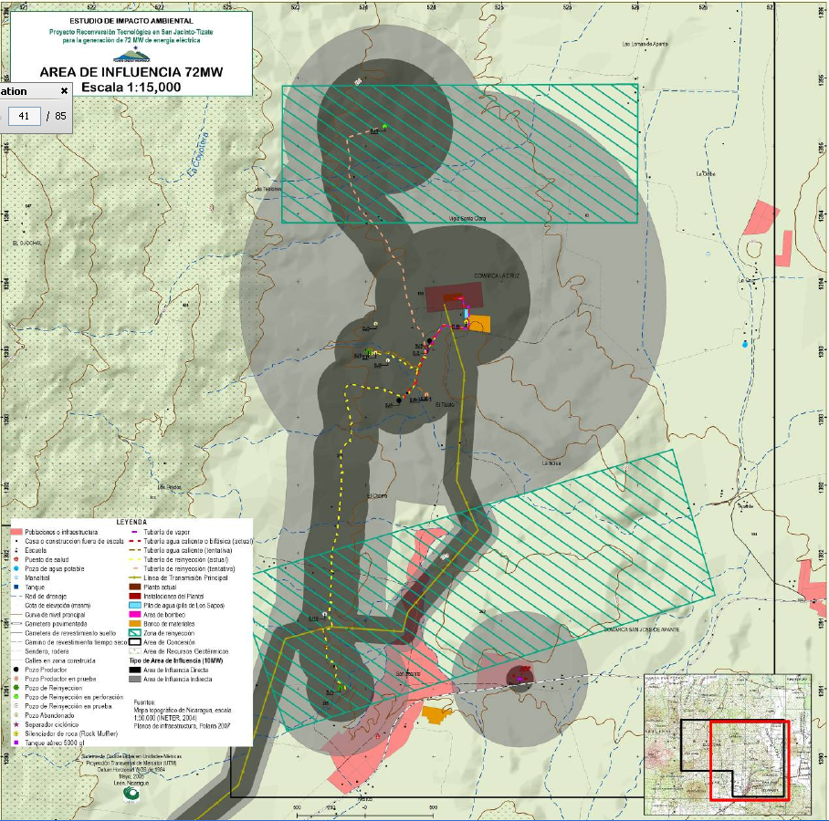

Note: Area highlighted in dark brown is the direct area of influence while the area highlighted in grey is the indirect area of influence. Dashed lines in yellow, pink and purple colors represent the pipes which either transports the steam or the geothermal fluid that will be reinjected. The green dashed rectangles correspond to the reinjection zones. The reddish brown areas represent the areas occupy by the proposed plant and existing infrastructures. The continuous yellow line corresponds to the transmission line.

Figure 6. Tectonic features of the concession area, location of plant site, well and, monitoring stations

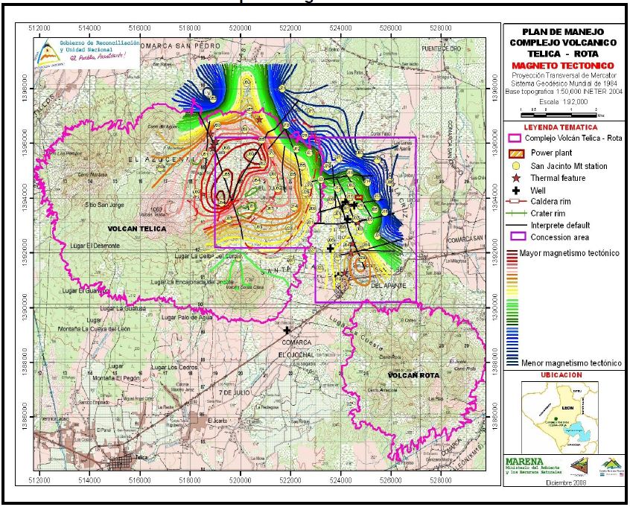 Note: The power plant and operational area are highlighted in dashed orange color and it is located at the intersection of 52 400 and 139 400 of the map coordinates.

Figure 7. Location of volcanoes,along the Pacific coast of Nicaragua.
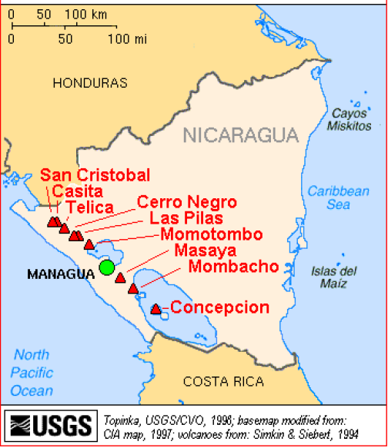

Figure 8. Water sources within the concession area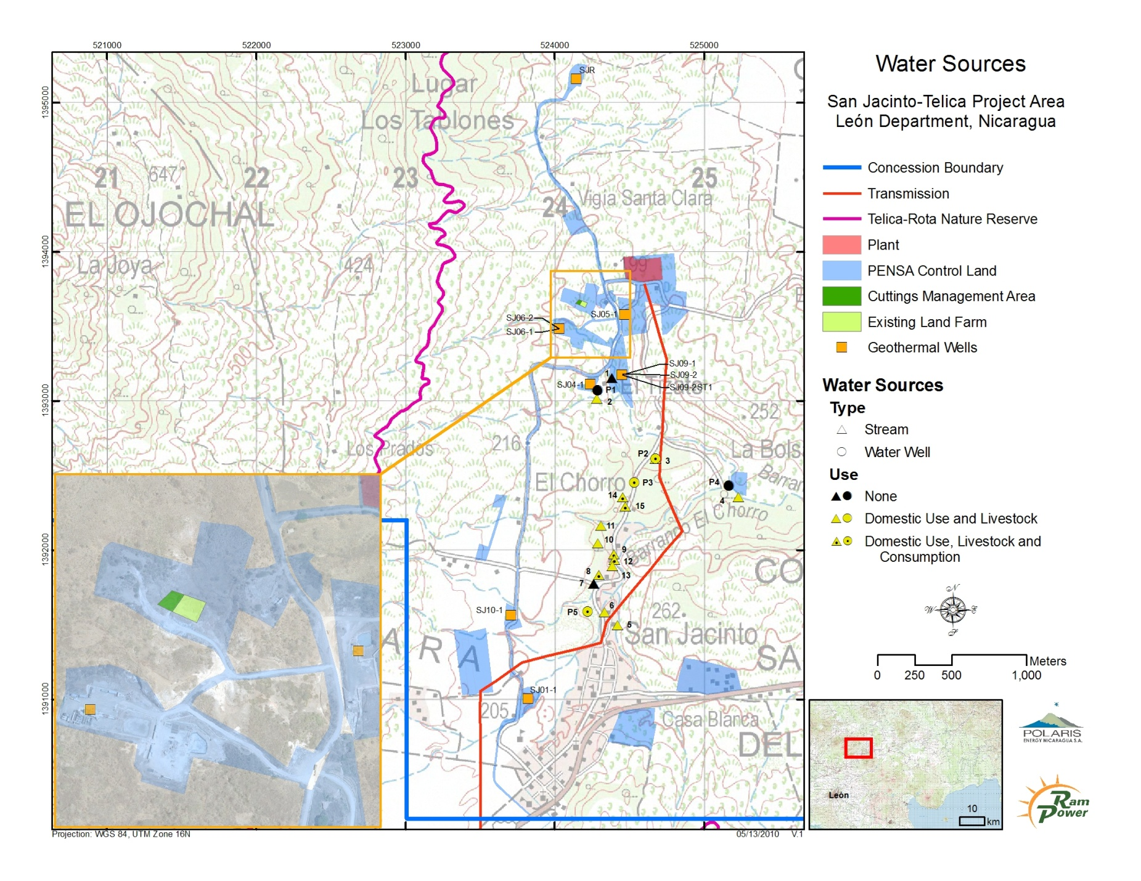

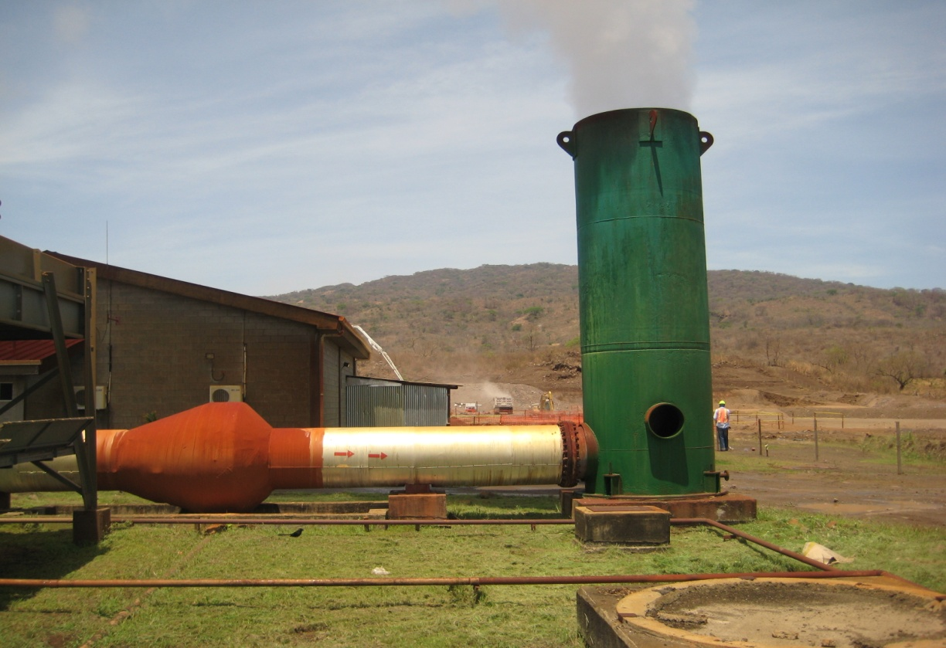
Photo 1. Existing 10 MW facilities, to be decommissioned.
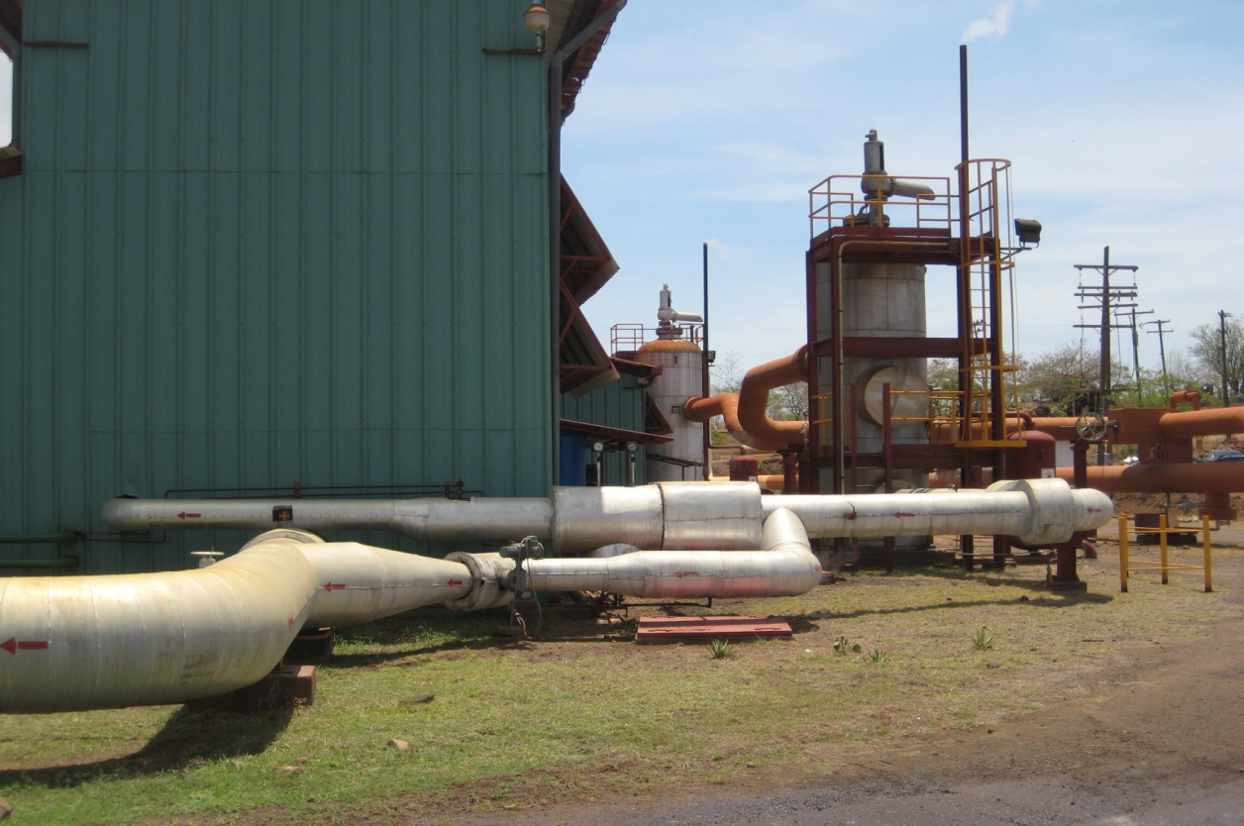
Photo 2. Existing 10 MW facilities, to be decommissioned.
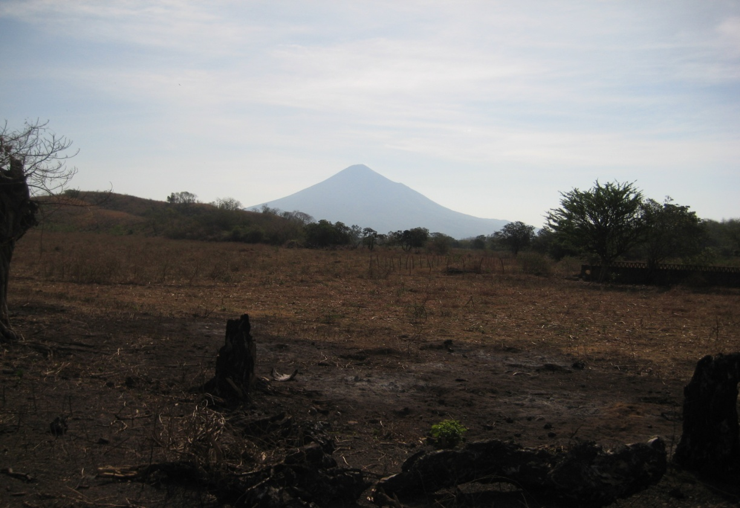

Photo 3. Eastern Sector of the concession area and on the background the Telica volcano
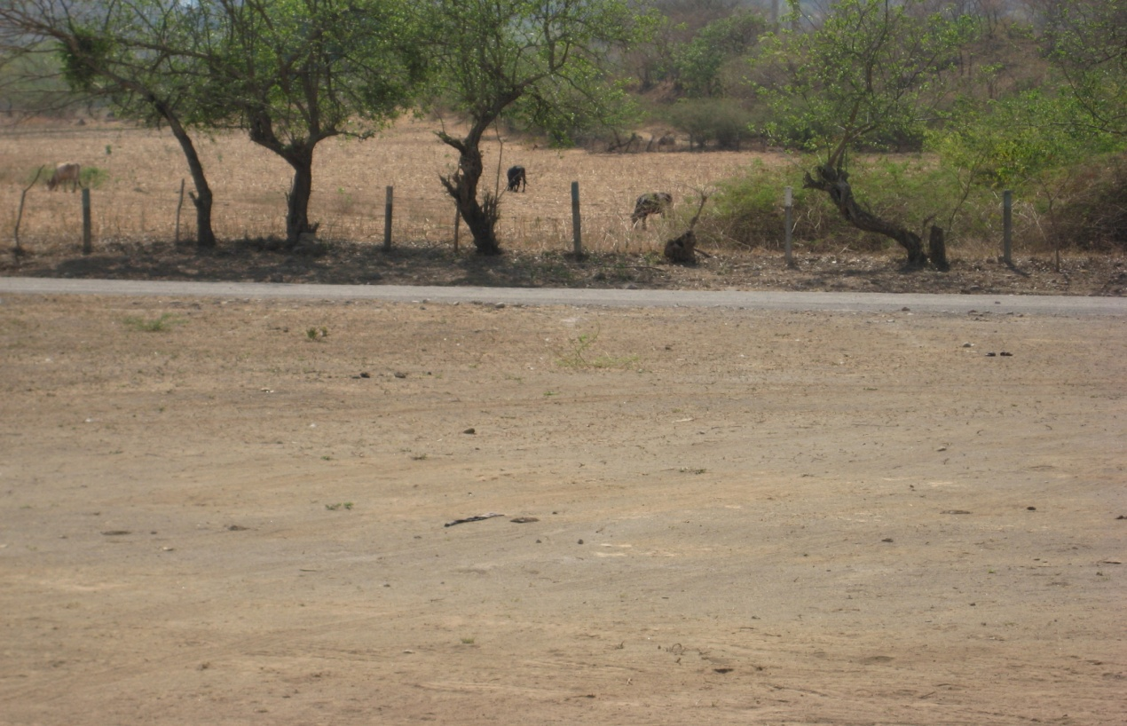
Photo 4. Eastern Sector of the concession area and, on the background cattle grazing.

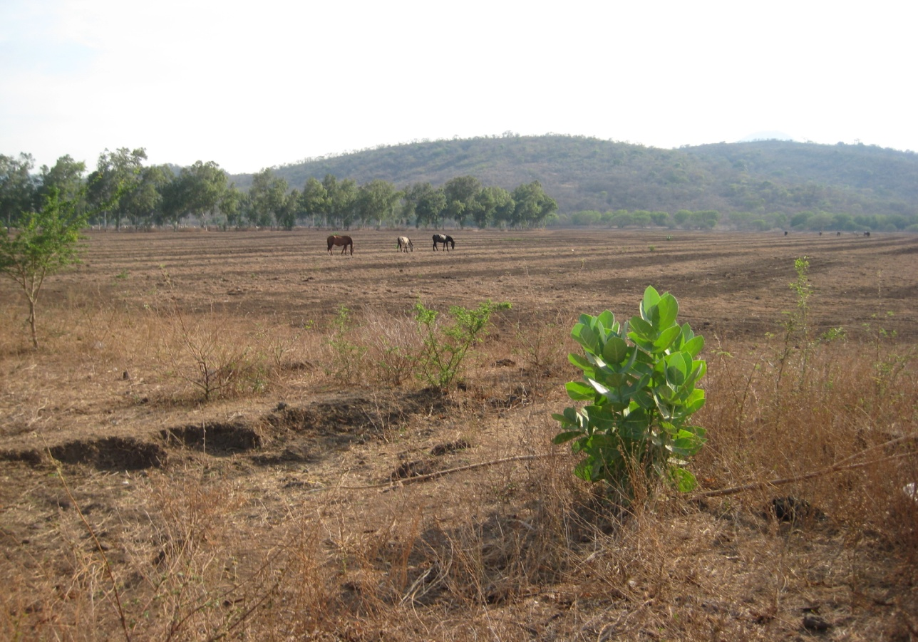
Photo 5. Eastern sector of the concession area and, on the background horses grazing
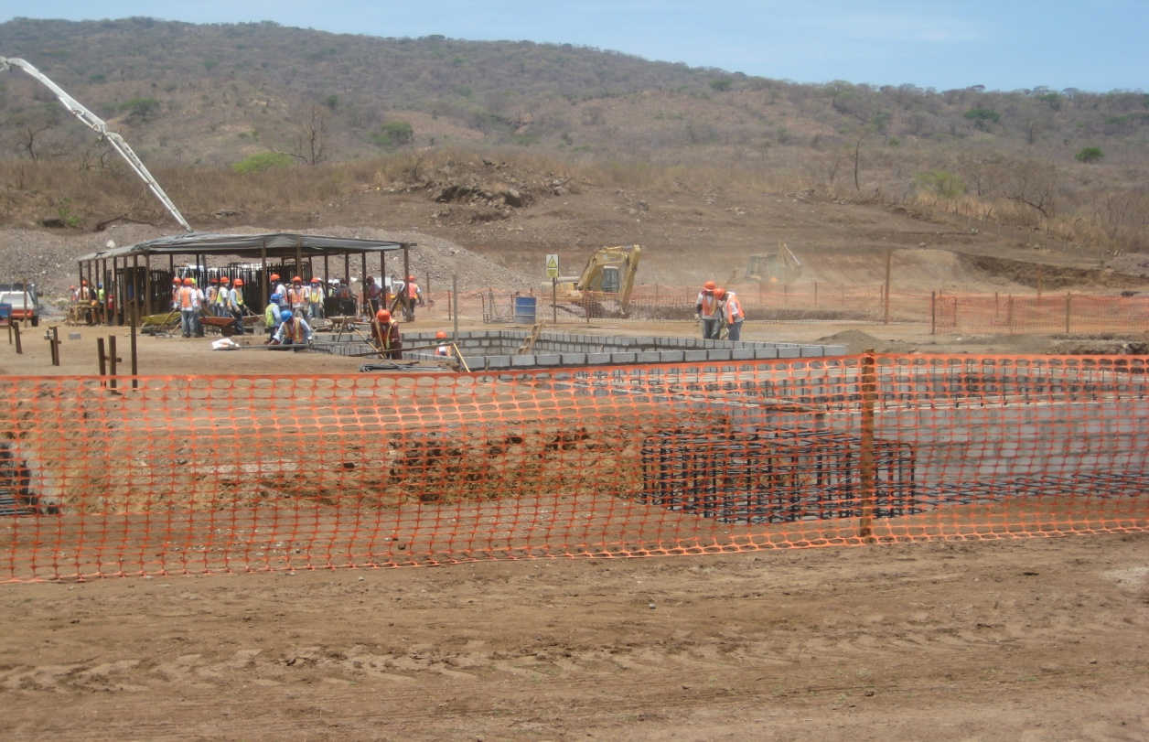
Photo 6. Construction site, as can be seen foundations of the two turbines were built

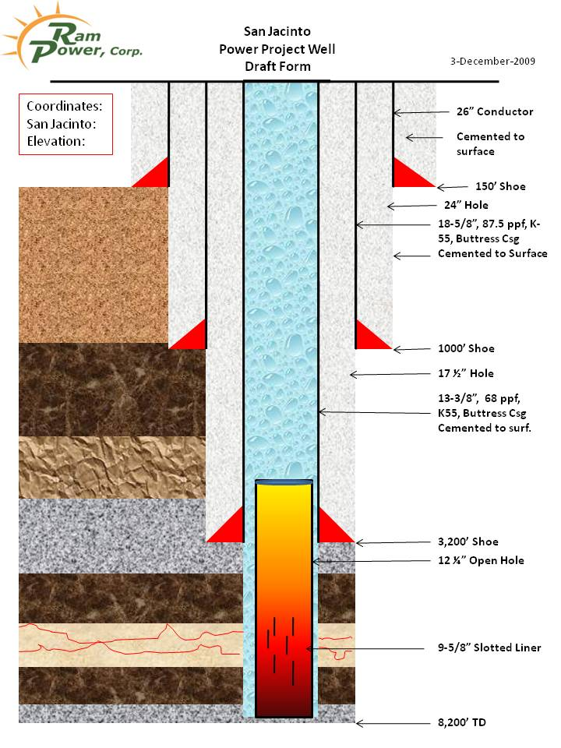

Photo 7. Generic casing design for a geothermal well. Casing strings is cemented to surface to prevent groundwater contamination.

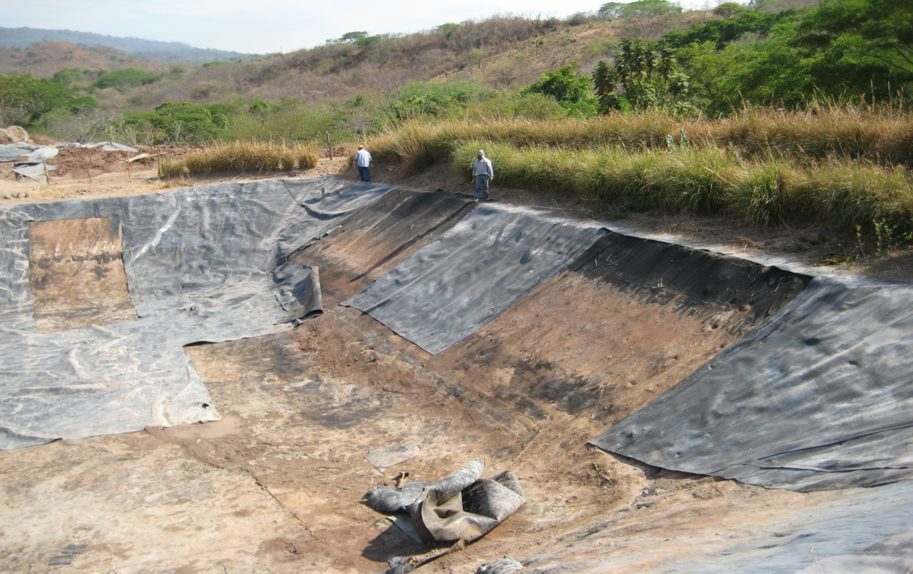

Photo 8. Mud pit, as can be seen a geomembrane is currently being installed. The mud will be “dewatered”, tested and, treated if necessary before going to the land farming site.

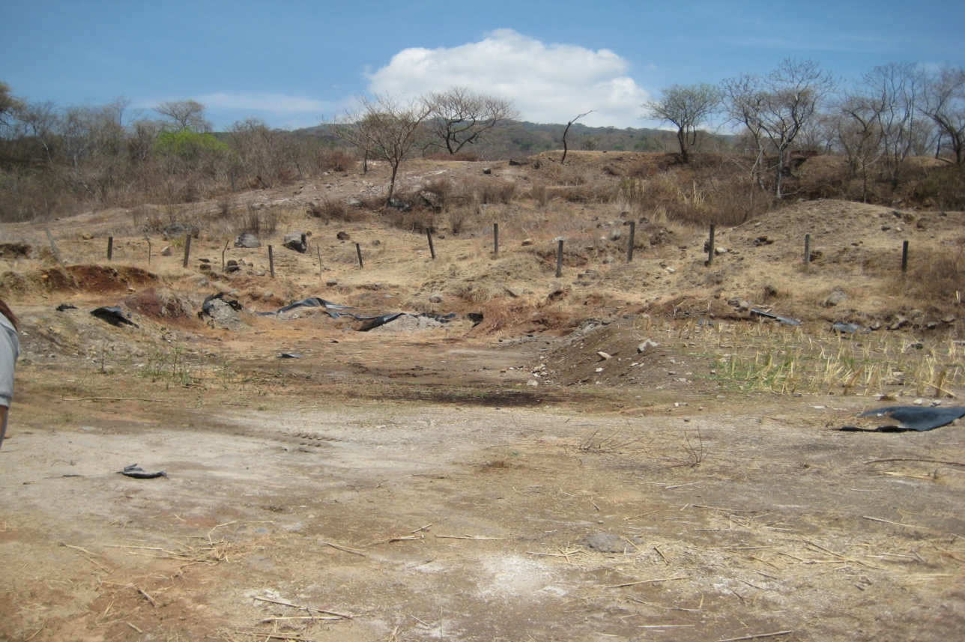 Photo 9. Existing Land farming site. The mud will be monitored over time to ensure that residual contaminants are below acceptable international limit. The perimeter would be fenced and the site would not be accessible to people neither to cattle.
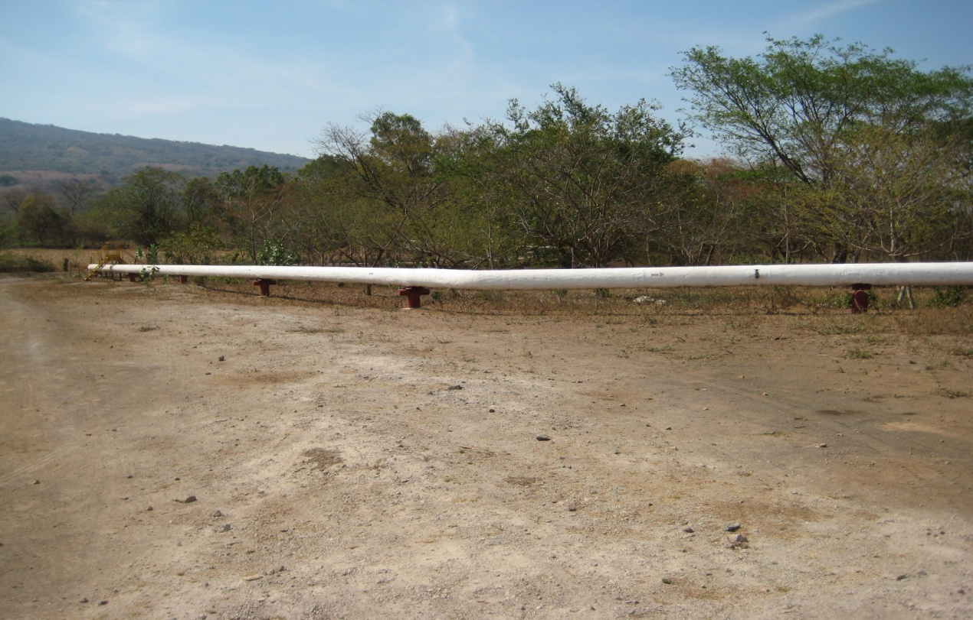

Photo 10. A pipe conducting the steam from the well to the existing two turbines. Throughout the Eastern sector of the concession area, there is 750 m of pipe that is located within the direct area of influence of the project and 1.5 km of pipe that is located in the indirect area of influence. The piping system is also used to transport the geothermal fluid that is reinjected in one of the existing reinjection wells.
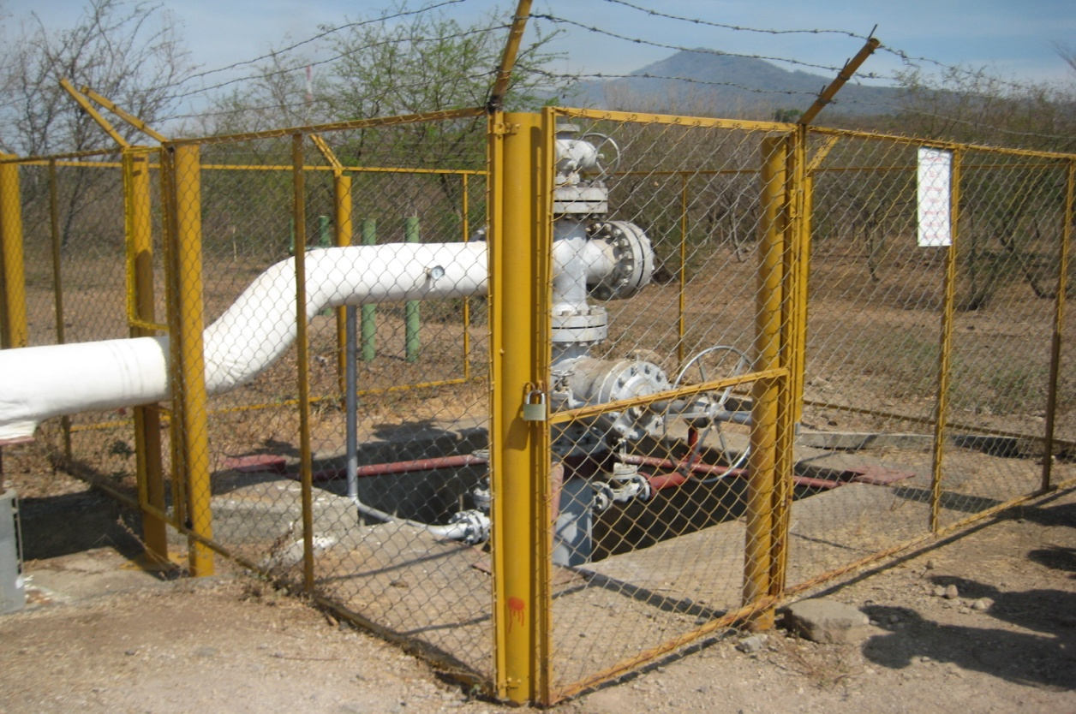

Photo 11. A production well with the pipe conducting the steam. There are five existing production wells within the concession area, and, all are fenced.
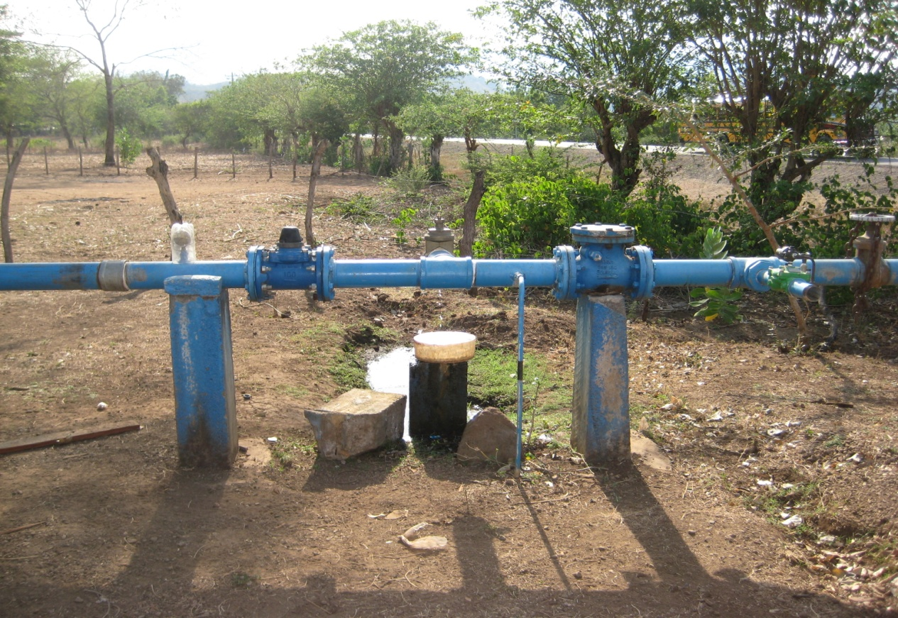
Photo 12. One of the water wells for the community of San Jacinto

San Jacinto-Tizate Geothermal Power Project Phase II – Environmental and Social Action Plan (ESAP)
Issue | Actions | Deadline | Responsible
PS1- Social and Environmental Assessment and Management System
1.- EIA: contains some important gaps with respect to potential socioeconomic impacts, risks and opportunities associated with the project and particularly, demographic data, livelihood and resource-use issues, and land tenure. | Per the outline provided by the Lenders:  - Undertake a Rapid Social Assessment (RSA) to improve the socioeconomic baseline of the project, geo-referencing the people directly affected by the project, characterizing land tenure, source of their livelihood/income, water supplies, etc.  - ToRs presented in form and content acceptable to Lenders  - Review proposals  - Report in form and content acceptable to the Lenders | - Done.  - 1 August 2010  - 1 January 2011 | Environmental and Social Manager, working with strategic partners such as third party consultants, agencies or NGOs as needed.
 | - Develop a Community Relations and Engagement Plan that includes:  - Impacts management/mitigation measures based on RSA).  - Potential risk mitigation (from the community/to the community) (based on RSA)  - CSR and corporate philanthropy activities, including goals and indicators (optional)  - External Grievance Mechanism  - Local employment strategy | - 1 July 2011  - 1 July 2011  - 1 July 2011  - Done  - Done

2.- Phase 3: PENSA may decide, within the lifetime of Phase 1 and 2 financing, to explore and exploit the Western Sector of the concession that lies within the Telica-Rota Nature Reserve. This would trigger both PS5 and PS6 and require that the Client develop policies, procedures and plans that are in full conformance with these two Performance Standards, as well as PS1. | In the event that PENSA undertakes any exploration or development activities in the Western Sector:  - The Company must present to Lenders the ToRs for these environmental and social assessments, and they must be fully compliant with all IFC Performance Standards (particularly PS1, PS5 and PS6) and otherwise acceptable in form and content to Lenders.  - Planning. The Company and its contractors must plan all exploration and development activities in the Western Sector in strict conformance with all IFC Performance Standards and particularly PS1, PS5 and PS6.  - Implementation. The Company and its contractors will implement all exploration and development activities in the Western Sector in strict conformance with all IFC Performance Standards and particularly PS1, PS5 and PS6. This would include, policies and procedures related to Land Acquisition and Compensation (PS5) and implementation of avoidance, mitigation, or compensation measures as necessary in response to any Natural or Critical Habitats identified (PS6). | - As soon as ToRs are developed  - Prior to any exploration or development activities in the Western Sector.  - Prior to any exploration or development activities in the Sector | Environmental and Social Manager.
3.- Environmental and Social Management System (ESMS): Detail environmental, social, and occupational health and safety plans and procedures commensurate to the potential impacts and risks must be developed, and are required under PS1. | PENSA present in form and content acceptable to the Lenders the ESMS to provide a mechanism for environmental and social management of the project development and operations. PENSA’s ESMS must include, update and/or adapt Ram Power’s Corporate Manual to include at a minimum:  - Drilling Muds & Cutting Management Plan  - Community Water Monitoring Plan  - SOP for SF6 Management  - SOP for Well Blow-Outs  - Mitigation & Monitoring (M&M) Plan  i. A matrix based on ESIA and incorporating regulatory, IFC and other requirements, plus targets and indicators (construction and operation phases)  ii. SOP for M&M, including identification and updating of Environmental & Social (E&S) impacts, responsibilities, reporting, management review (ENV 201: Issue management, ENV-203: Environmental Business/Project Planning, ENV-206: Environmental Records, ENV-207: Environmental Auditing]  iii. SOP for Compliance and Conformance [ENV-104: Legal and Regulatory Compliance]  - Training Plan  i. Initial focus on priority SOPs and plans (including those identified above and below)  ii. Include key contractors  - Safety and Health  - SOPs for Social Management  - Human Resources  - Emergency Preparedness and Response | (a) thru (e) 1 October 2010  - 1 January 2011  - See PS 2  - See PS 1  - See PS 2  - See PS 3 | Environmental and Social Manager, Site Construction Manager and Operations Personnel (construction and drilling) and Contractors
4.- Procurement and Construction Contractor’s Compliance: During the site visit the P&C contractor, CQG (as defined in CTA), presented a generic, integrated environmental and occupational health and safety management program (ESHSMP), which need to be customized to the site. | PENSA will present to lenders:  - A updated, site- and project-specific Environmental Management Plan from CQG that covers the covers all subcontractors and addresses the most significant E&S impacts arising from construction. This must include:  - Clear procedures for reporting EHS incidents/accidents  - Clear procedures for correcting cases of non-compliance and non-conformance  - Clear procedures for communicating with and reporting to PENSA  - Available copies of CQG’s audit certificates and verification reports for its integrated ISO 9001-14001 and OHSAS 18001 certification.  - Procedures or evidence of supervision and oversight by PENSA | (a) 1 October 2010 (tentative date)  (b) 1 October 2010 (tentative date)  (c) 1 October 2010 | Environmental and Social Manager
PS2- Labor and Working Conditions
5.- HR: PENSA is in the process of merging HR policies and procedures and has an “Internal Regulation for Personnel” (Reglamento Interno de Personal) that implements the requirements of Art. 255 of the Labor Code and includes a number of areas relevant to PS2. | Present in form and content satisfactory to the Lenders, the revised and approved Internal Regulation for Personnel that will include:  - An Internal Grievance Mechanism  - A standard employee contract/offer letter  - Demonstrate contractor’s compliance with Core Labor Standards either by contract provisions or inter-company documentation. | 1 October 2010 | Environmental and Social Manager and HR Manager
6.- OHS:. Ram Power Corporate Manual includes standard OHS procedures, but this must be updated and adapted to the Project. | Present, in form and content satisfactory to the Lenders, the updated, adapted and/or revised PENSA OHS Policies and procedures included in the Ram Power Corporate Manual.  (a) SOP-303 RPC Accident Reporting & Investigation – including OSHAS industry standards and indicators  (b) SOP-101 RPC Safety Policy/Philosophy Statement.  (c) SOP-201 RPC Safety & Health Programs.  - SOP-301 RPC Plant Safety Rules.  - SOP-302 RPC Visitor Safety.  - SOP-307 RPC Behavior Based Safety Processes.  - SOP-308 RPC Housekeeping.  - SOP-309 RPC Safety Communications | (a) 1 October 2010  (b) thru (h) April 2011 | Environmental and Social Manager and Site Construction Manager, Corporate H&S Manager, Safety Officer
PS3 – Pollution Prevention and Abatment
7,- PPA/EPRP: No PENSA site specific pollution prevention and abatement (PPA) procedures or plan was available during the appraisal site visit. PENSA does have an Emergency Preparedness and Response Plan (EPRP) but this needs to be revised, expanded and then more broadly implemented. | (a) PENSA will present its Pollution Prevention and Control measures. This will include:  - Drilling Muds & Cuttings Management Plan, to include a more comprehensive and systematic monitoring program, improved management of leachate in the land-farming areas, identification and treatment/clean-up needs of former disposal sites and unlined mud pits.  - Noise monitoring and abatement plan.  - Air emission and air quality monitoring and abatement.  - Solid waste management.  - Sulfur hexafluoride (SF6) phase-out plan, including safe disposal of existing stocks according to the recommendations of the Montreal and Kyoto Protocols, respectively and industry best practices. (i.e. update SOP-724 Sulfur Hexafluoride Handling).  - HazMat Plan. The plan should be developed in conjunction with purchasing managers and PENSA contractors and should identify specific storage, handling and disposal requirements (including specialized training).  (b) PENSA should revise its EPRP and integrate it with other relevant corporate documents to:  - Address all natural emergency situations (volcanic and earthquakes, flooding, and fires.  - Mechanical failures such as: explosion, spills, well blowouts, pipeline leaks, hydrogen sulfide leaks, etc.).  - Define roles and responsibilities with other stakeholders, including government entities, local communities and key contractors and to have clear chains of command and communications procedures.  - Include in the procedures which address people living adjacent to wells, pipelines and other project infrastructure (emergency boundaries, possible evacuation, communication, training, etc.). See #11 PS4.  - Complete regular annual training and drill | - 1 October 2010  - 1 October 2010  - 1 January 2011  - 1 January 2011  - June 2011  - 1 January 2011, (Preliminary plan)  April 2011, Final plan  For items (i) and (ii), January 2011  For items (iii) til (v) July 2011 | Environmental and Social Manager, Operations staff
8.- Resource Efficiency: PENSA has no energy or water efficiency program and practices in place. | PENSA will analyze existing patterns of energy and water use and develop and present, in form and content to the Lenders, a plan with targets and indicators to improve efficient use of both. | Phase II commissioning date plus 6 months – ca. June 2012 | Environmental and Social Manager
9.- Decommissioning Plan: At the time of appraisal PENSA did not have a decommissioning program. | PENSA to present, in form and content acceptable to the Lenders:  (a) Decommissioning Plan of BPUs, establishing as minimum standardized well plugging and abandonment procedures, legacy issues, community H&S risks and monitoring.  (b) Final decommissioning plan of all facilities | (a) At least 3 months prior to decommissioning of BPUs  (b) 3 years prior to closure of operation | Environmental and Social Manager
PS4 – Community Health, Safety, and Security
10.- Water Sources for local communities: Project construction and operation activities are water intensive. Even though, geothermal production zones and groundwater aquifers used for potable water are separated by thousands of meters of rock and soil, and there is documented evidence supporting the fact that PENSA’s process water is unlikely to contaminate local drinking, domestic, and agricultural water sources (superficial or underground). | PENSA will develop, in form and content acceptable to the Lenders, a Community Water Monitoring SOP including, (a) clear identification (geo-referenced in relation to all production and reinjection -existing and planned- well sites.) of all the community water sources and use, (b) establish the standard sampling protocol (e.g. frequency and parameters to measure), and (c) reporting/communicating results of the water monitoring program to regulators.  The proposed water monitoring in the footprint of the project is: (d) Measure/document the water quality and abundance of all community sources at least once a year, (e) For the first year, selected wells will be sampled every three months, to formulate a baseline, review, and concluding additional measures. These selected wells will be prioritized i) wells for human use ii) water sources having the largest number of users and iii) wells near geothermal wells. | (a), (b), (d), (e) 1 October 2010  (c) 1 July 2011 [see PS1 (b) (iii)] | Environmental and Social Manager
11.- Community Emergency Prevention and Preparedness: The plant and most well sites are not located near any large communities or settlements. Nonetheless, potential natural and project-related risks to nearby people and communities include volcanic and seismic activity, fires, subsidence, flooding, exposure to escaping H₂S, hot water or steam, pipeline failures, well blow-outs, and transportation-related accidents. At the time of appraisal, PENSA did not have a Community Emergency Prevention and Preparedness Program. | PENSA will develop as part of its Emergency Preparedness and Response Plan, a separate chapter that addresses community emergency response and preparedness and includes a description of nearby communities and dwellings potentially at risk. See PS3 (7) (b) (iii) | January 2011, Preliminary Plan  April 2011, Final Plan

The decommissioning of the existing 10 MW facility would be done by a contractor hired by PENSA, the reusable facilities such as the turbines and generators would be reconditioned, packed and exported to potential buyers. PENSA will submit a complete decommissioning plan for the facilities before December 2011. The plan would be reviewed to ensure that no major environmental issues will result from the decommissioning of the two existing turbines.
Categories go from I to VI, Category I being associated with more restrictive protection status.
Given the low magnitude of earthquakes that may be produced by a geothermal plant and taking into consideration that the identification of the source of origin of these potential earthquakes is almost impossible to determine, especially when a project is located within an area with natural tectonic activity, it does not appear appropriate to trigger IDB’s Natural Risks Disaster Policy for this project.
The ESAP (enclosed in Appendix), provides additional information on the measures that will be taken by PENSA to achieve compliance with the Bank’s policies and Safeguards.
IDB’s decision with respect to non-objection will be based on IDB´s evaluation of whether the proposed activities for the development of the Western Sector of the Concession would pose a significant risk to the IDB-financed Project, or to sensitive environmental areas and-or populations in the area of direct influence of such proposed activities that are not adequately addressed by environmental and social mitigation and management measures.

