Document of the Inter-American Development Bank

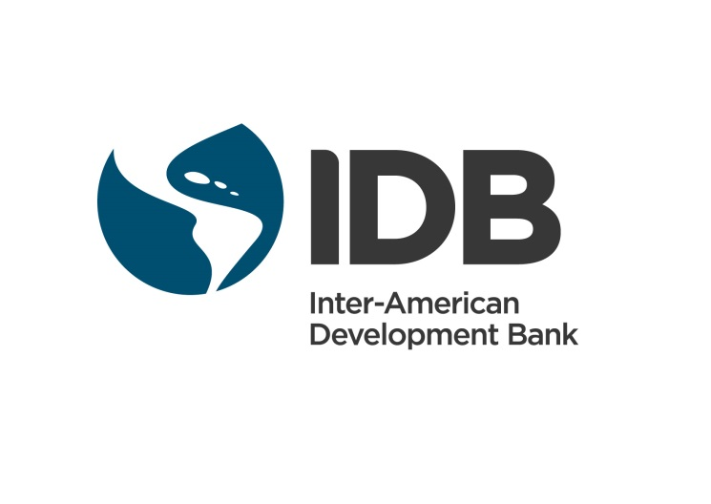

BAHAMAS

SKILLS FOR CURRENT AND FUTURE JOBS IN THE BAHAMAS

(BH-L1037)

Environmental and Social Management Report
(ESMR)

AUGUST 2016

This document was prepared by Fernando Yitzack Pavon (LMK/CJA), Project Team Leader; Laura Ripani (SCL/LMK), Alternate Team Leader; Maria Victoria Fazio (SCL/LMK), Mario Castaneda (FMP/CBH); Bettina Hennig (LEG/SGO); Camille Davis-Thompson (CCB/CBH); and Ethel Muhlstein (SCL/LMK).

Table of Contents

- Introduction
- Summary Table

- Project Description
- Key Project Infrastructure Components and Schedule
- Environmental and Social Setting
- Project Schedule and Workforce
- Alternative Analysis

- Compliance Status and Project Standards
- Environmental and Social Appraisal Process
- IDB Policies and Directives
- Project Standards and Requirements

- Key Environmental and Social Impacts, Risks and Mitigation
- Summary of Key Impacts and Risks
- Environmental Impacts and Risks
- Social Impacts and Risks
- Cumulative Impacts
- Natural Disasters Risks
- Positive Impacts

- Management and Monitoring of Environmental, Social, Health and Safety and Labor Impacts and Risks
- Description Of Management Systems And Plans
- Monitoring and Supervision
- Environmental and Social Safeguard Performance Indicators

- Requirements to be Included in the Legal Documents
- Throughout the Life of the Loan
- Prior to Board
- Prior to Each Disbursement
- Prior to First Disbursement
- Prior to Construction

LIST OF ACRONYMS

CNH Critical Natural Habitat
DoL Department of Labour
DPW Department of Public Works
EA Environmental Assessment
EHS Environmental Health and Safety
EIA Environmental Impact Assessment
ESA Environmental and Social Analysis
ESG Environmental Safeguards Unit of the Bank
ESMR Environmental and Social Management Report
ESMP Environmental and Social Management Plan
GIS Geographic Information Systems
MLNI Ministry of Labour and National Insurance
MWUD Ministry of Works and Urban Development
NDR Natural Disaster Risk
NH Natural Habitat
PES Public Employment Services
ROW Right Of Way

- INTRODUCTION

 | - Summary Table
Country |  | Bahamas
Sector |  | Labour Markets
Project Name |  | Skills for Current and Future Jobs in The Bahamas
Borrower and / or Sponsor |  | The Commonwealth of The Bahamas
Executing Agency and / or Company |  | Ministry of Labor and National Insurance (Components 1 and 3)  Ministry of Works and Urban Development (Component 2)
Transaction Type |  | Flexible financing facility
Total Project Cost (in US Dollars) |  | US$50 million
IDB A-Loan (if applicable) |  | IBD (OC) : US$25 million
B-Loan/Co-lenders |  | Government of the Bahamas (US$25 million)
Environmental Category |  | B

- PROJECT DESCRIPTION

- Key Project Infrastructure Components

  - The general objective of this program is contribute to increasing the employability and quality of employment of beneficiaries of the Programme by improving access to quality jobs in the Bahamas, especially for youth. The Programme will have the following specific objectives: (i) increase relevant skills and employability in productive jobs of programme beneficiaries; (ii) improve the effectiveness of the Public Employment Services; and (iii) enhance the capacity of the labour market´s intelligence systems.

  - Component 2 of the project, which is the infrastructure component (US$24.5 million) is comprised the construction of a Leadership in Energy and Environmental Design (LEED) certified 43,500 sq. ft. area of a new building to house the Department of Labour (DoL) and the country’s “flagship” one-stop-shop center that will serve as the national standard for other islands’ one-stop-shops, and to provide a new, modernized, and LEED certified environment best suited to the needs of job-seekers.

  - LEED is an acronym for Leadership in Energy and Environmental Design (LEED) Green Building Rating System™ certification. It designates environmentally responsible—sometimes referred to as ”green” or “sustainable”—commercial buildings designed, built and operated to use the building location optimally, minimize non-renewable energy use, reduce water consumption, while offering healthy settings in which to work and live. Reductions in consumption of resources like water, energy are believed to provide economic gains of up to 25% of the operational cost of LEED-certified buildings, what implies economic gains on the overall lifespan of the infrastructure that compensate initial setup costs.

  - Clarence A. Bain Building: The construction of the new building will take place at the current site of the Clarence A. Bain Building, intersection of Thompson Boulevard and Moss St, Nassau, Bahamas. The project contemplates the demolition of the Clearance A. Bain Building, and builds on site a new 43,500 sq. ft. LEED-certified facility.

Figure 1: DoL’s (Clarence A. Bain Building) current site and proposed site for new LEED-Certified facility to be supported by this project (red)

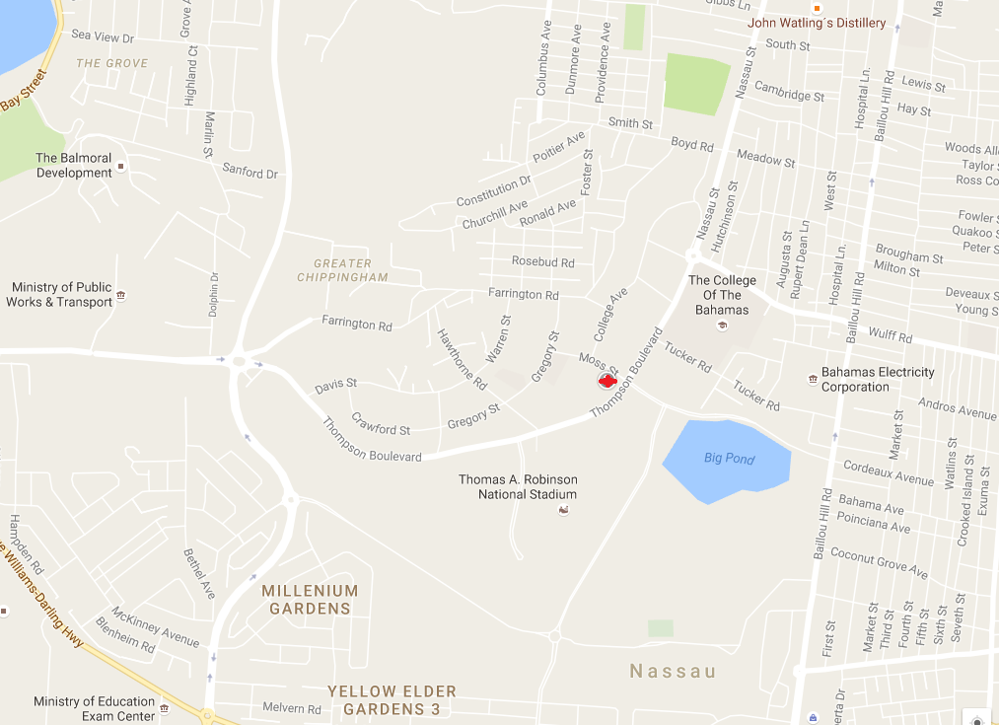

Figure 2: The position of the site sits on a developed area of the city of Nassau.

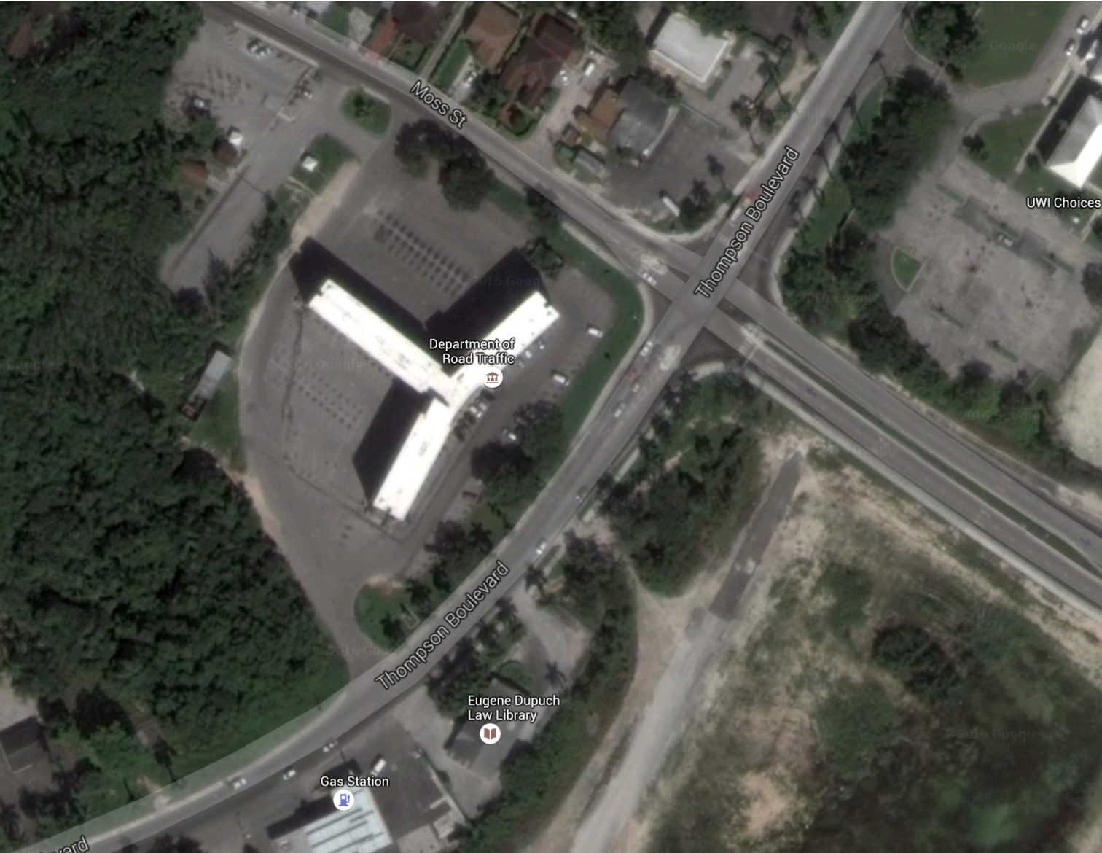

  - New LEED-Certified facility: The new facility will utilize the location of a developed area; hence, no new areas suitable for this type of infrastructure will be needed. The project will finance the design of a “green” or “sustainable”— building, and build to use the building location optimally, minimize non-renewable energy use, reduce water consumption. According to the U.S. Green Building Council, LEED-certified buildings are resource efficient. They use less water and energy and reduce greenhouse gas emissions.
  - The process will take place in two phases. Phase one: Demolition of old Clarence A. Bain Building and design of the new 43,500 sq. ft. LEED-certified facility. Phase two: Construction of new building facility.
  - Phase One: The bidding process for demolition is expected to occur in late 2016, the contract will be awarded by December 2016. Bidding process for the design is expected to occur October 2016 and the contract will be awarded by January 2017.
  - Phase Two: The bidding process for is expected to occur in 4Q 2017, the contract will be awarded by December 2017, and the construction will start by January 2018. The length of the construction is expected to take 24 months.

- Environmental and Social Setting
  - As shown in Figure 1, the project is specifically located within a developed are of the City of Nassau. Much of the city has been already impacted by human activities.
  - Much of the landscape of the surrounding areas will not be affected by the construction.

Protected areas
  - The project building falls entirely within the city of Nassau, the capital, largest city, and commercial center of the Commonwealth of the Bahamas. The city recorded a population of 246,329 in the 2010 census, or 70 percent of the entire population of the Bahamas. The area where the building will sit is not considered as Critical Natural Habitat according to IDB policy. These areas are already crossed by roads, and there are also existing transmission lines going through these areas.

Social Setting
  - Given that the location of the building site is currently government owned and developed, it is not anticipated that the project will affect private lands or that there will be land use conversion as result of the project. In the case of needing to obtain the right of access to properties, the executing agency will be responsible for the acquisition of access permits and land use payments to property owners.
  - The majority of the houses, buildings and communities in the impacted areas have electricity, telephone and running water, as well as social services like health care and schools.
  - Given that the project area covers a specific small area within the city of Nassau, indigenous communities will not be affected.
- Project Schedule and Workforce

  - Based on information provided in the project documentation and gathered during the consultation phase of the design of the project, construction of the project is expected to begin in January 2018 with an estimated 24 month construction period. Currently the project has not obtained all the necessary permits including the environmental license to begin construction.

  - A peak workforce of approximately 200 people is expected during construction. The workforce will be personnel of the company that will win the bidding. The workforce will be local and no worker camps will be constructed on the site.

- Alternative Analysis

2.16 The Environmental and Social Impact of the project only analyzes the proposed activities as the new infrastructure, there is no alternative analysis possible.

- COMPLIANCE STATUS AND PROJECT STANDARDS

- Environmental and Social Appraisal Process:

3.1 Bahamas National Trust Act 1959. This Act establishes The Bahamas National Trust as the entity that advises the Government on areas for preservation and conservation. It gives the Trust the power to create by-laws to be in effect in the protected areas it establishes. These areas are of environmental, historical and/or cultural importance. The Act was amended in 2010.

3. 2 Conservation and Protection of the Physical Landscape of The Bahamas Act 1997. This Act prohibits all significant excavation, landfill operation, quarry mining or mining of physical natural resources (such as sand) without permission of the Director of Physical Planning. The Act also gives the Director the authority to request an Environmental Impact Assessment (EIA) for any excavation or land reclamation activities. It also provides for the protection of trees that are rare and of historical significance and imposes stiff penalties for violators of this law.

3. 3 Environmental Health Services Act 1987. This Act promotes conservation and maintenance of the environment and also addresses the control of contaminants and pollutants that may adversely affect the environment and human health. The Act also outlines regulations with respect to water supplies, solid and liquid waste, beaches, seaports, harbours and marinas.

3.4 Wild Birds Protection Act 1952. This Act provides for the protection of wild birds. The Act lists several species including the White-Crowned Pigeon, Whistling Duck and Yellow-Crowned Night Heron.

3.5 The Ministry of Works and Urban Development (MWUD) through their Executive Unit will be responsible to develop the corresponding studies that will include the Environmental and Social Assessment mandated by Law. It will be also responsible for the correct project categorization and environmental license needed.

3.6 Under Bahamian legislation this project is considered of low risk, nonetheless, an Environmental Assessment has been commissioned. Necessary permit is required though but will be issued by the Government of Bahamas in response to the submission of an ‘environmental form’.
- IDB Policies and Directives
3.4 The Project triggers the following directives of IDB’s OP-703 Environmental and Safeguards Policy: B.1, Bank Policies; B.2, Country Laws and Regulations; B.3, Screening and Classification; B.5, Environmental Assessment Requirements; B.6., Consultations; B.7, Supervision and Compliance. The OP-102, Disclosure of Information Policy also applies for this Project. It does not expected that any economical resettlement activities, involuntary resettlement, impact to natural or critical areas will occur in relation to the Project. The Project has been classified by the Bank as a Category B with low risk operation.
3.5 Table 1, below, illustrates the Project’s capacity to comply with IDB’s various policies and directives.

Table 1: Project Compliance Table

Policy / Directive | Applicable Aspect | Compliance Rationale
OP-703 Environmental and Safeguards Compliance
B.1 Bank Policies | Compliance with applicable IDB policies | The project is currently fulfilling commitments made to the Bank in order to be in full compliance with all IDB policies and directives.
B.2 Country laws | Compliance with country laws and regulations | The project is currently in compliance with Bahamian laws and regulations.
B.3 Screening and Classification | Application of appropriate classification | The Project has been screened for its potential environmental and social impacts and has been classified as a Category B operation.
B.5 EA Requirements | Application of adequate assessment process | In accordance with the Bank policies for Category B projects, An Environmental and Social Assessment and the Environmental Social Management Plan have been prepared for the operation.
B.6 Consultations | In Process | The project will conduct public consultation meetings with the local community. To date, the local stakeholders (ConSoc) support the operation.
B.7 Supervision and Compliance | Internal supervision and reporting | The Executing Agency will submit quarterly compliance reports during construction and annual compliance reports during operations.
OP-710 Involuntary Resettlement | Not applicable | No involuntary resettlement in the form of physical displacement is expected as a result of the project.
OP-704 Disaster Risk Management Policy | In process. Operation classifies as Low | Compliance requirements expected to be met. The operation is expected to have low vulnerability to disaster risks, but increase to moderate through 2100 depending on the rate of sea level rise. However, mitigation measures are included in the ESMF to address flooding.  The Disaster Risk Management Plan (DRMP) is incorporated into the Environmental and Social Management Plan (ESMP) to reduce these risks as a part of the project’s construction and operation phases.
OP-270 Gender Equality | Avoiding gender discrimination within the Project or as a result of the Project. Providing opportunities for women. | Women will be priority beneficiaries of the programs developed in Component I of the program (increase employability and quality of employment of beneficiaries). The vocational counseling for job insertion and vocational counselors' training will include gender mainstreaming to ensure women are encouraged to be open to non-traditional occupations opportunities. Within the strategic communication of the programme, focus will be placed on the private sector engagement process to effectively stimulate demand for young females.
OP-102 Access to Information Policy | Project information disclosure | The project has adequately disseminated information in the local community. Public consultation meetings have occurred. IDB will also make relevant project information available on its website.

- Project Standards and Requirements
  - The company awarded the tender will carry out the project according to the Bahamas Law and the Environmental and Social Management Plan (ESMP). The engineering works plan must include exact position coordinates using longitude and latitude for locations of the new infrastructure. The siting of the new DoL facility and access roads must avoid critical natural habitat; if this is not possible, the impact must be minimized by siting new infrastructure on already converted land.
  - The Project will follow a project-specific ESMP. The ESMP shall also outline other compliance information including Environmental Health and Safety (EHS), Natural Disaster Risk (NDR) and monitoring and auditing.

- ENVIRONMENTAL AND SOCIAL IMPACTS AND RISKS AND MITIGATION
- Summary of Key Environmental and Social Impacts and Risks
  - Key impacts relate to new infrastructure that will be installed. This includes the construction of LEED-certified 43,500 sq. ft. of the new DoL building. The environmental and social risks that will result from these activities are expected to be low as the project will use existing developed land.
  - The project does not involve physical or economic displacement of beneficiaries nor is it foreseen, or planned as part of this project.

- Environmental Impacts and Risks
  - Potential negative environmental impacts and risks during the construction phase will be mainly associated with the erection of LEED-certified 43,500 sq. ft. of the new DoL building. Main construction impacts are: (i) materials; (ii) Air quality and dust; (iii) Waste management; (iv) Landscape and visual; (v) Water resources; (vi) Ecology; (vii) Coppice; (viii) Noise and vibration; (ix) Traffic and transport; and (x) Contaminated land. The main Risk identified in the Environmental and Social Analysis (ESA) is related to Natural Disasters. These impacts and risks can be adequately mitigated or eliminated through the implementation of appropriate management plans.
  - New DoL building: Construction – Materials, Any toxic or hazardous chemicals to be utilized on site can be done so according to Material Safety Data Sheet (MSDS) guidance and safety protocols can be established by project management.
  - Air quality and dust - Impairment to air quality can be reduced when no illegal construction activities occur during this project. Construction equipment should be properly maintained to ensure they do not impair air quality. Construction methodologies and best practices can be employed to minimize generation of quantities of dust that can impair air quality including watering of the site.
  - Waste management - All waste can be properly disposed of according to regulations and standards of the Department of Environmental Health Services (DEHS) and the Water and Sewerage Corporation (WSC). Waste management will need to include proper disposal of chemical waste, including cleaning products and paints.
  - The new DoL building and access roads should be carried out in such a way as to avoid Critical Natural Habitat and Cultural sites. This will be possible by siting new infrastructure on already converted land. The project is located in urbanized areas that are not sensitive in natural habitat matters, cultural environments or archeological areas. No native vegetation should be removed for access road construction.
  - Landscape and visual - Protected trees removed should be replaced at a ratio of 2:1 as per the Conservation and Protection of the Physical Landscape Act or as directed by the Department of Physical Planning. Any landscaping for this project can involve use of native plant species. No invasive or potential invasive species as identified in the 2013 National Invasive Species Strategy should be utilized for landscaping. The design and landscaping of the site can minimize or eliminate this impairment on completion of construction by maintaining buffer zones of native vegetation throughout the project site and minimizing clearing of land in the new building design.
  - Water resources – Chemical and fuel management of the site can ensure that groundwater and freshwater resources are not negatively impacted. Spill response protocols can be established for effectively dealing with spills in the event of an accident to minimize any pollution of water resources. Potable or fresh water will be provided by the Water and Sewerage Corporation so there will not need to be extraction of groundwater resources.
  - Ecology – Efforts can be made to minimize negative impacts to all remaining coppice habitats by preserving as much of it as possible during construction and operation phases. This can be achieved through selective clearing of the site rather than bulldozing the entire area.
  - Coppice - Land clearing should be limited to footprint of the building and associated infrastructure. Where possible, large trees should be avoided during construction. If trees must be removed, they should be replaced with endemic or native species. Construction equipment should be inspected and cleaned prior to deployment to the project site to avoid introduction of invasive plants.
  - Potential noise impacts caused by the installation of the new infrastructure is not expected to be significant; however, construction activities should be for a limited time period to minimize disturbance to humans in neighboring communities as well as birds and other animals at the project site. Once construction is completed in as short a timeframe as possible, there should be no long-term damage to residents hearing and the animals should return to habitats they normally utilize.
  - Traffic and transport - All workers utilizing vehicles and equipment should have adequate training and skills in their proper and safe handling. Equipment to be utilized for this project moving from other sites should be inspected and cleaned, as necessary, to ensure they do not introduce invasive plant material, such as seeds.
  - Contaminated land - Any toxic or hazardous chemicals to be utilized on site will be done so according to Material Safety Data Sheet guidance and safety protocols as established by project management. Staff should be trained in spill response measures to effectively handle such incidents.
  - Community health and safety hazards specific to the project are related to public access and the amount of heavy equipment and large vehicles required to transport demolition material, and other construction material and have been adequately addressed in the Project’s Environmental Management Plan, including adopting appropriate risk prevention procedures and emergency planning during construction. Traffic management will need to be monitored throughout the construction process.
  - Employment of appropriate design and planning methodologies can result in construction and operation of the new building in a sustainable manner. Utilizing the recommended mitigation measures can eliminate or minimize any negative environmental impacts that may occur during construction and operation phases. Using green design through LEED certification is another way to mitigate for any negative environmental impacts. The GOBH has expressed its commitment to implementing the recommended mitigation measures and executing the project in a manner that respects the natural resources of the site and is environmentally sustainable.
  - Natural Disaster. Disaster risk assessment (DRA) involves assessing the potential natural and manmade project risks that can occur. In New Providence, disaster risks include coastal and inland flooding, storm surge and sea level rise. The Intergovernmental Panel on Climate Change (IPCC) estimates sea level rise through 2050 for The Bahamas as 20 mm and 70 mm through 2100 (ERM, 2016). There is concern that these estimates are too conservative and sea level rise may be as high as 1 m through 2100. The risk would be low at this time, but increase to moderate through 2100 depending on the rate of sea level rise. A mitigating measure for sea level rise would entail construction with elevated foundations.

- Social Impacts and Risks
  - New DoL Facility: Construction– The project has already identified the land for the siting of the new DoL building and access roads. It is not foreseen that land acquisition or physical displacement may be necessary for this phase. There are no significant risks associated to the operation phase.
- Cumulative Impacts
  - It is unlikely that any significant cumulative impacts will be associated with this project due to the nature of the activities that will be financed.

- Natural Disaster Risks

  - 4.14 The operation is expected to have low vulnerability to disaster risks, but increase to moderate through 2100, depending on the rate of sea level rise, given that The Bahamas is prone to natural disasters that could impact the functioning of the infrastructure such as hurricane and flooding. A Natural Disasters Risk assessment should be included within the ESMP so that the Executing Agency will have taken in consideration for the optimal functioning of the Project. The Disaster Risk Management Plan (DRMP) is incorporated into the Environmental and Social Management Plan (ESMP) to reduce these risks as a part of the project’s construction and operation phases.

- Positive Impacts
  - The project will provide better facilities for job seekers to use the Public Employment Services. The new facilities are expected to attract and provide services to more individuals, which will increase the use of the service to 15,840 job seekers (20% increase).

  - The project will also benefit 952 enterprises (20% more firms). The new facilities are expected to attract and provide services to more companies, which will increase the use of the service.

- MANAGEMENT AND MONITORING OF ENVIRONMENTAL, SOCIAL, HEALTH AND SAFETY AND LABOR IMPACTS AND RISKS
- Description of Management Systems and Plans
  - The Project will operate under the ESMP developed within the EA in line with the Bank’s policies regarding Environmental Management Systems. The ESMP includes regular monitoring of the facilities and quarterly reports will be prepared during construction concerning noise, air emissions, traffic issues, waste management, health, safety and labor performance, trainings, as well as other issues. Detailed logs will be maintained to document worker trainings, worker health certificates, work site incidents and accidents, waste registers, and vehicle maintenance. The ESMP will be revised to include the Natural Disaster Risk Management Plan. A quarterly report will be provided to the Bank during construction.
  - The most relevant social activities implemented by the Borrower to develop a good relationship with the local communities include:

- Public Consultations. The Project will conduct public consultation meetings with community members and local authorities prior to construction phase (phase 2). The consultation sessions will provide an opportunity for interested people to learn about the project and have their doubts and concerns addressed by company representatives. Community engagement will continue through the construction phase.
- Community Relations Plan. Its goal is to establish community participation mechanisms and build positive relationships with interested groups to avoid or minimize potential social conflict situations during project execution. This plan provides both a general framework and specific procedural guidance for a continuous dialogue between the local population and representatives of the company.
- Grievance Mechanism. The project has implemented a Grievance Mechanism to allow stakeholders an opportunity to voice their opinions, concerns, complaints, or comments outside of the public consultation meetings and throughout the construction phase of the project. These comments will be recorded, as well as the Project’s responses to these comments. Issues will be tracked to determine how the Project responds to complaints and interacts with the complainant to resolve outstanding issues. The Grievance Mechanism will be accessible to individuals impacted by the project.
- Monitoring and Supervision
  - This project includes different levels of supervision. The most relevant ones include (i) Internal project supervision during the construction phase conducted by the Borrower; (ii) Bank supervision, carried out regularly by the project team.
  - The Borrower will conduct quarterly internal audits and send quarterly EHS, NDR and monitoring reports to the IDB during the construction phase, and semi-annual during the first year of the operation phase.
  - The Bank will conduct semi-annual supervision missions during the construction phase and one annual mission during the first year of the operating phase.
- Environmental and Social Safeguard Performance Indicators
  - In the case of environmental and social indicators, the projects will be assessed in terms of compliance with the IDB Safeguard Policies and compliance with local regulations.
- REQUIREMENTS TO BE INCLUDED IN THE LEGAL AGREEMENTS
  - The conditions described below only apply to Component 2 of the project to the extent no infrastructure is contemplated to be financed under Component 1 and/or Component 3. Such conditions are required to be fulfilled at different stages throughout the life of the loan, in form and substance satisfactory to IDB, as further described below.

Prior to First Disbursement
  - The restrictions described below for new infrastructure must be included in the Terms of Reference as conditions for the bidding process.
  - A revised Environmental and Social Management Plan (ESMP) included in an Environmental Impact Assessment (EIA) shall be presented by MWUD for approval to the Bank. Both shall reflect the restrictions to the positioning of new infrastructure that will be constructed.

Prior to beginning construction work of Component 2
  - The Borrower itself or through the Executing Agency (MWUD) shall provide evidence satisfactory to the Bank that the following conditions have been fulfilled: (i) MWUD, in its capacity as Executing Agency shall incorporate into all contractors’ contracts detailed regulations and penalties for non-compliance by such contractors with policies, plans and programs (including mitigation measures) applicable to the project. This will include detailed procedures and timeframes for reporting environmental, health and safety related incidents/accidents and a specific monitoring program to assess causes of incidents/accidents and track performance of the corrective measures; (ii)MWUD, in its capacity as Executing Agency shall demonstrate to the Bank that all pending land use permits have been obtained. Copies of relevant permits, contracts, and agreements shall be submitted to the Bank; (iii) MWUD, in its capacity as Executing Agency shall show evidence of the contracting of an independent environmental and social consultant, who shall certify compliance with the ESMP and EHS requirements.

Throughout the Life of the Loan
  - The IDB will require that the Project and each party involved in the project including construction companies and operators, and any contractors and sub-contractors at all times during the life of the Loan Agreement, comply with the requirements described below.
    - All applicable environmental, social, health and safety, and labor regulatory requirements of the Bahamas.
    - All requirements associated with any environmental, social, health and safety, and labor related permits, authorizations, or licenses that apply to the Project, the Borrower or any party responsible for executing the Project or its mitigation measures.
    - All environmental, social, health and safety, and labor requirements of the Project contracts and any subsequent modifications.
    - All relevant IDB policies such as the Environment and Safeguards Compliance Policy (OP-703), the Disaster Risk Management Policy (OP-704) and the Disclosure of Information Policy (OP-102), and the Gender and Equity in Development Policy (OP-270) and their respective guidelines.
    - All aspects and components of all of the Project’s ESMP, EHS and NDR documents. The requirements indicated in the ESMP should follow a LEED design criteria.
  - MWUD, in its capacity as Executing Agency, shall provide evidence of supervision and oversight of the contractors for the implementation of Component 2.
  - MWUD, in its capacity as Executing Agency will submit on a quarterly basis during the construction phase of the works of Component 2, and semiannually during the first year of the operation phase of such works, a report certifying compliance with the requirements of the ESMP, EHS and NDR of the project, including any corrective action plan, if applicable.

The construction (procurement process) will contemplate including purchase of hardware, based on technical assessments (IT) for a possible turn-key delivery.
2010 Census of Population and Housing: New Providence. Department of Statistics of the Bahamas. August 2012. p. 3.

